Suggested Revisions
Towards the IEEE Std 802.22.3-Draft1.0

Gianfranco Miele and Gianni Cerro
Date: March 13th, 2017 [Comment version 1.0 ]

Suggestions
Following are the modification suggestions to the standard version 1.0.

- Replace fig 7 in section 5.3.2.1 at pag 23 with

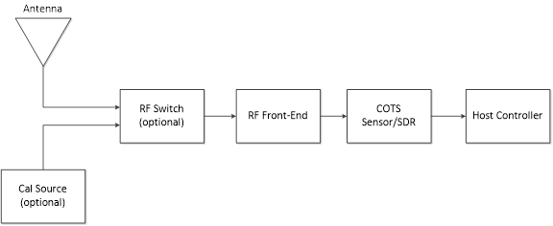
and modify the figure caption in this way “SSD Simplified Hardware Model Block Diagram”
- Modify the caption of the Figure 7 in section 5.3.2.1 at page 24 caption in “Figure 7: SSD Functional Elements”
- Replace Figure 7 in section 5.3.2.1 at page 25 with this new fig.
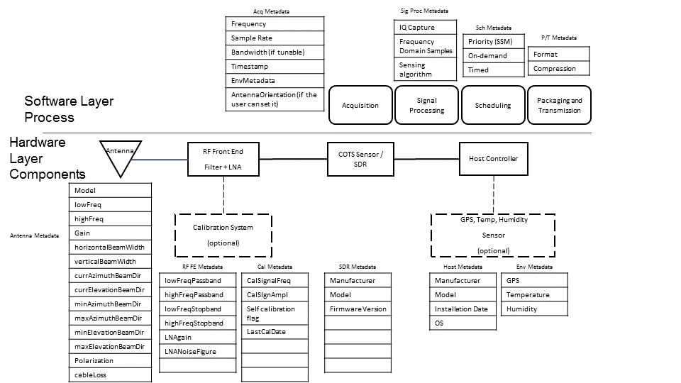
This is the proposed new figure caption “Figure 9: SSD model: Hardware layer components and Software layer processes with relative metadata”
- Move metadata in section 7.1 deleting di old chapter 7 and the metadata info in the following sections 5.4.3, 5.4.4, 5.4.5, 5.4.6 and 5.4.7
In the following the new section 7.1

7.1 SSD hardware metadata specification

7.1.1 Top level hardware metadata

Parameter | Values | Description
Antenna | 0 | Number of antennas
Calibration source |  | Present/absent
RF switch |  | Present/absent[M2]
RFFilter |  | Present/absent
LNA
Sensor |  | COTS/SDR

7.1.2 Antenna Metadata
Antenna metadata is reported in the table below. In the second column of the table the class of the metadata is specified.
Metadata Name | Metadata class
Antenna Model | Class A
Freq. Range Min | Class A
Freq. Range Max | Class A
Type | Class A
Gain | Class A
Polarization | Class A
Height | Class A
Horz. Beam Width | Class A
Vert. Beam Width | Class A
Min Azi. Beam Dir. | Class A
Max Azi. Beam Dir. | Class A
Min Elev. Beam Dir. | Class A
Max Elev. Beam Dir. | Class A
Curr. Azi. Beam Dir. | Class B
Curr. Elev. Beam Dir. | Class B
Cable loss | Class A
A detailed description of the field of each metadata is reported in the table below

Name | Type | Editable | Content
Antenna Model | string | “0” | It contains a string with the model of the antenna that is installed.
Freq. Range Min | float | “0” | Min frequency value expressed in Hz
Freq. Range Max | float | “0” | Max frequency value expressed in Hz
Type | string | “0” | Antenna type
Gain | float | “0” | Antenna gain expressed in dBi
Polarization | string | “0” | Antenna polarization [“VL”|“HL”|“LHC”|“RHC”|“Slant”]
Height | float | “0” | Antenna heigh in m.
Horz. Beam Width | float | “0” | Horizontal 3-dB beamwidth expressed in degrees
Vert. Beam Width | float | “0” | Vertical 3-dB beamwidth expressed in degrees
Min Azi. Beam Dir. | float | “0” | minimum direction of main beam in azimuthal plane expressed in degrees from N
Max Azi. Beam Dir. | float | “0” | maximum direction of main beam in azimuthal plane expressed in degrees from N
Min Elev. Beam Dir. | float | “0” | minimum direction of main beam in elevation plane expressed in degrees from horizontal plane
Max Elev. Beam Dir. | float | “0” | maximum direction of main beam in elevation plane expressed in degrees from horizontal plane
Curr. Azi. Beam Dir. | float | “0” if fixed antenna is used  “1” if an antenna with beam steering capability is used. | Current direction of main beam in azimuthal plane expressed in degrees from N
Curr. Elev. Beam Dir. | float | “0” if fixed antenna is used  “1” if an antenna with beam steering capability is used. | Current direction of main beam in elevation plane expressed in degrees from horizontal plane
Cable loss | float | “0” | Cable loss expressed in dB of the cable connecting the antenna with the RF front-end
7.1.3 RF Front-end metadata
RF Front-end metadata is reported in the table below. In the second column of the table the class of the metadata is specified.
Metadata Name | Metadata class
Low Freq Passband | Class A
High Freq Passband | Class A
Low Freq Stopband | Class A
High Freq Stopband | Class A
LNA Gain | Class A
LNA Noise Figure | Class A
A detailed description of the field of each metadata is reported in the table below
Name | Type | Editable | Content
Low Freq Passband | float | “0” | Low passband frequency evaluated at -1 dB and expressed in Hz
High Freq Passband | float | “0” | High passband frequency evaluated at -1 dB and expressed in Hz
Low Freq Stopband | float | “0” | Low stopband frequency evaluated at -60 dB and expressed in Hz
High Freq Stopband | string | “0” | High stopband frequency evaluated at -60 dB and expressed in Hz
LNA Gain | float | “0” | Low Noise Amplifier Gain expressed in dB
LNA Noise Figure | float | “0” | Noise Figure of LNA expressed in dB
7.1.4 Calibration Metadata
Calibration metadata is reported in the table below. In the second column of the table the class of the metadata is specified.
Metadata Name | Metadata class
Cal. Sig. Freq. | Class A
Cal. Sig. Ampl. | Class A
Self Calibration flag | Class A
Last Cal. Date | Class A
A detailed description of the field of each metadata is reported in the table below
Name | Type | Editable | Content
Cal. Sig. Freq. | float | “0” | Frequency of the internal calibration source expressed in Hz
Cal. Sig. Ampl. | float | “0” | Amplitude of the internal calibration source expressed in dB
Self Calibration flag | boolean | “0” | This is set to “1” if the sensor performs a periodical self calibration procedure. Otherwise it is set to “0” if the self calibration is performed after a user request
Last Cal. Date | string | “0” | The time stamp of the last calibration expressed as HH:MM:SS YYYY/MM/DD
7.1.5 SDR Metadata
SDR metadata is reported in the table below. In the second column of the table the class of the metadata is specified.
Metadata Name | Metadata class
SDR Manufacturer | Class A
SDR Model | Class A
Firmware version | Class A
A detailed description of the field of each metadata is reported in the table below
Name | Type | Editable | Content
SDR Manufacturer | string | “0” | Manufacturer of the sensor used
SDR Model | string | “0” | Model of the sensor used
Firmware version | string | “0” | Current firmware version
7.1.6 SSD Host Metadata
Host metadata is reported in the table below. In the second column of the table the class of the metadata is specified.
Metadata Name | Metadata class
Manufacturer | Class A
Model | Class A
Installation Date | Class A
OS | Class A

A detailed description of the field of each metadata is reported in the table below

Name | Type | Editable | Content
Manufacturer | string | “0” | Manufacturer of the host
Model | string | “0” | Model of the host
Installation Date | string | “0” | The date when SSD has been installed expressed as YYYY/MM/DD
OS | string | “0” | Operating System installed on the host

7.1.7 Environmental Metadata

Environment metadata is reported in the table below. In the second column of the table the class of the metadata is specified.

Metadata Name | Metadata class
GPS | Class C
Temperature | Class C
Humidity | Class C

A detailed description of the field of each metadata is reported in the table below

Name | Type | Editable | Content
GPS | Array of float | “0” | [Latitude expressed in decimal degrees (-90°-90°)  Longitude expressed in decimal degrees (-180°-180°)
Temperature | float | “0” | Environment temperature expressed in K
Humidity | float | “0” | Environment relative humidity expressed in percentage

7.1.8 SSD Software metadata

For Software metadata, they are the result of a processing of acquired data samples. No reason to have editable attribute, since they cannot be modified but they are just readable by the final user. Modifications are allowed by the SSM as specific task initial settings.

7.1.8.1 Algorithm specification
Algorithm | Value | Notes
Unspecified | 0
Energy Detection | 1 | Default
Direction Finding | 2
Cyclostationary | 3
Wideband | 4

7.1.8.2 Acquisition metadata
Acquisition metadata is reported in the table below. In the second column of the table the class of the metadata is specified.

Metadata Name | Metadata class
Frequency | Class B
Sample Rate | Class B
Bandwidth | Class B
Time Stamp | Class C

A detailed description of the field of each metadata is reported in the table below

Name | Type | Content
Frequency | float | Actual center frequency of the acquisition process
Sample Rate | float | Sample rate used for A/D conversion
Bandwidth | float | Acquisition spectrum interval width.
Time Stamp | float | Time information expressed in seconds from January,1 1970.

7.1.8.3 Signal Processing metadata
Signal Processing metadata is reported in the table below. In the second column of the table the class of the metadata is specified.

Metadata Name | Metadata class
IQ capture | Class B
Frequency Domain Samples | Class B
Sensing algorithm | Class B

A detailed description of the field of each metadata is reported in the table below

Name | Type | Content
IQ capture | Boolean | Tag to describe if data content is IQ samples format
Frequency Domain  samples | Boolean | True if frequency spectrum
Sensing algorithm | Enumerate | Numerical association to one of the implemented sensing algorithms (list 0—5 described in algorithm specification table)

7.1.8.4 Scheduling metadata
Scheduling metadata is reported in the table below. In the second column of the table the class of the metadata is specified.

Metadata Name | Metadata class
Priority | Class B
On-Demand | Class B
Timed | Class A

A detailed description of the field of each metadata is reported in the table below

Name | Type | Content
Priority | enumerate | ss  Numerical association to one of the listed scheduling techniques (0 – RR round robin; 1 – FCFS (first come first served), 2 – SJF (shortest job first). The techniques can allow pre-determined scanning operations or contemplate possibility of on-demand task.
On-Demand | boolean | If true, it allows to schedule on-demand sensing tasks in real time. Requests can also be asynchronous and be served according to the priority rules.
Timed | boolean | Tasks are planned to be executed at a certain time in a day. If multiple tasks have to be executed in the same time, priority rules to transfer data to SSM apply.

7.1.8.5 Packaging and transmission metadata
Packaging and transmission metadata is reported in the table below. In the second column of the table the class of the metadata is specified.

Metadata Name | Metadata class
Format | Class C
Compression | Class C

A detailed description of the field of each metadata is reported in the table below

Name | Type | Content
Format | Enumerate | Numerical association with a listed sequence of data coding techniques
Compression | Enumerate | Lossless or lossy data compression technique used

7.1.9 SSD Task Control metadata
7.1.9.1 Scheduler Specification

Algorithm | Value | Notes
Unspecified | 0
Host Controller | 1
Embedded Job Controller | 2
Multilevel | 3

7.1.9.2 SSD Output Specification
Algorithm | Value | Notes
Unspecified | 0 | Invalid
Time domain IQ | 1 | Default
Freq domain IQ | 2
Time domain Amp, Phase | 3
Freq domain Amp, Phase | 4

