IEEE Standard for Information Technology—
Telecommunications and information exchange between systems
Wireless Regional Area Networks (WRAN)—
Specific requirements
Part 22.3: Spectrum Characterization and Occupancy Sensing

Sponsor
LAN/MAN Standards Committee
of the
IEEE Computer Society
Approved Date XX
IEEE-SA Standards Board

Abstract: This standard specifies the architecture, abstraction layers, interfaces and metadata requirements for Spectrum Characterization and Occupancy Sensing (SCOS) system, a defines performance parameters, units and measures. This SCOS system comprises one or more semi-autonomous Spectrum Sensing Devices which scan electromagnetic spectrum, digitize it and perform processing, transmitting the resultant data with appropriate metadata to a central storage and processing system, according to rules, policies or instructions imposed on the Spectrum Sensing Devices by a management system.
Keywords: radio spectrum sensing, spectrum monitoring, signal characterization, cognitive radio, IEEE 802.22.3, WRAN standards

•
IEEE Standards documents are developed within the IEEE Societies and the Standards Coordinating Committees of the IEEE Standards Association (IEEE-SA) Standards Board. The IEEE develops its standards through a consensus development process, approved by the American National Standards Institute, which brings together volunteers representing varied viewpoints and interests to achieve the final product. Volunteers are not necessarily members of the Institute and serve without compensation. While the IEEE administers the process and establishes rules to promote fairness in the consensus development process, the IEEE does not independently evaluate, test, or verify the accuracy of any of the information or the soundness of any judgments contained in its standards.

Use of an IEEE Standard is wholly voluntary. The IEEE disclaims liability for any personal injury, property or other damage, of any nature whatsoever, whether special, indirect, consequential, or compensatory, directly or indirectly resulting from the publication, use of, or reliance upon this, or any other IEEE Standard document.
The IEEE does not warrant or represent the accuracy or content of the material contained herein, and expressly disclaims any express or implied warranty, including any implied warranty of merchantability or fitness for a specific purpose, or that the use of the material contained herein is free from patent infringement. IEEE Standards documents are supplied “AS IS.”

The existence of an IEEE Standard does not imply that there are no other ways to produce, test, measure, purchase, market, or provide other goods and services related to the scope of the IEEE Standard. Furthermore, the viewpoint expressed at the time a standard is approved and issued is subject to change brought about through developments in the state of the art and comments received from users of the standard. Every IEEE Standard is subjected to review at least every five years for revision or reaffirmation, or every ten years for stabilization. When a document is more than five years old and has not been reaffirmed, or more than ten years old and has not been stabilized, it is reasonable to conclude that its contents, although still of some value, do not wholly reflect the present state of the art. Users are cautioned to check to determine that they have the latest edition of any IEEE Standard.

In publishing and making this document available, the IEEE is not suggesting or rendering professional or other services for, or on behalf of, any person or entity. Nor is the IEEE undertaking to perform any duty owed by any other person or entity to another. Any person utilizing this, and any other IEEE Standards document, should rely upon his or her independent judgment in the exercise of reasonable care in any given circumstances or, as appropriate, seek the advice of a competent professional in determining the appropriateness of a given IEEE standard.

Interpretations: Occasionally questions may arise regarding the meaning of portions of standards as they relate to specific applications. When the need for interpretations is brought to the attention of IEEE, the Institute will initiate action to prepare appropriate responses. Since IEEE Standards represent a consensus of concerned interests, it is important to ensure that any interpretation has also received the concurrence of a balance of interests. For this reason, IEEE and the members of its societies and Standards Coordinating Committees are not able to provide an instant response to interpretation requests except in those cases where the matter has previously received formal consideration. A statement, written or oral, that is not processed in accordance with the IEEE-SA Standards Board Operations Manual shall not be considered the official position of IEEE or any of its committees and shall not be considered to be, nor be relied upon as, a formal interpretation of the IEEE. At lectures, symposia, seminars, or educational courses, an individual presenting information on IEEE standards shall make it clear that his or her views should be considered the personal views of that individual rather than the formal position, explanation, or interpretation of the IEEE.

Comments for revision of IEEE Standards are welcome from any interested party, regardless of membership affiliation with IEEE. Suggestions for changes in documents should be in the form of a proposed change of text, together with appropriate supporting comments. Recommendations to change the status of a stabilized standard should include a rationale as to why a revision or withdrawal is required. Comments and recommendations on standards, and requests for interpretations should be addressed to:
Secretary, IEEE-SA Standards Board
445 Hoes Lane
Piscataway, NJ 08854
USA
Authorization to photocopy portions of any individual standard for internal or personal use is granted by The Institute of Electrical and Electronics Engineers, Inc., provided that the appropriate fee is paid to Copyright Clearance Center. To arrange for payment of licensing fee, please contact Copyright Clearance Center, Customer Service, 222 Rosewood Drive, Danvers, MA 01923 USA; +1 978 750 8400. Permission to photocopy portions of any individual standard for educational classroom use can also be obtained through the Copyright Clearance Center.

Introduction
This standard specifies the functional elements, system architecture, abstraction layers, interfaces and metadata requirements for Spectrum Characterization and Occupancy Sensing (SCOS) system, with some limited definition of performance parameters, units and measures. It is intended to incorporate elements of existing standards and technology components to make it fast to implement using “off the shelf” hardware and software modules. The standard is intended to be flexible to make it forward-compatible as both radio sensing hardware and software technology develops, with an emphasis on using shared, virtualized, Internet-connected computing resources. The reference architecture describes one or more semi-autonomous Spectrum Sensing Devices which scan electromagnetic spectrum, digitize it and perform some level of processing, transmitting the resultant data with appropriate metadata to a Spectrum Sensing Management System. This command and control system manages scan requests from users, manages and advertises to users the scanning resources available to it from its connected Sensing Devices, and packages and forwards scan data to specified destinations according to rules, policies or instructions imposed by operator of the SCOS system.
Notice to users
Laws and regulations
Users of these documents should consult all applicable laws and regulations. Compliance with the provisions of this standard does not imply compliance to any applicable regulatory requirements. Implementers of the standard are responsible for observing or referring to the applicable regulatory requirements. IEEE does not, by the publication of its standards, intend to urge action that is not in compliance with applicable laws, and these documents may not be construed as doing so.
Copyrights
This document is copyrighted by the IEEE. It is made available for a wide variety of both public and private uses. These include both use, by reference, in laws and regulations, and use in private self-regulation, standardization, and the promotion of engineering practices and methods. By making this document available for use and adoption by public authorities and private users, the IEEE does not waive any rights in copyright to this document.
Updating of IEEE documents
Users of IEEE standards should be aware that these documents may be superseded at any time by the issuance of new editions or may be amended from time to time through the issuance of amendments, corrigenda, or errata. An official IEEE document at any point in time consists of the current edition of the document together with any amendments, corrigenda, or errata then in effect. In order to determine whether a given document is the current edition and whether it has been amended through the issuance of amendments, corrigenda, or errata, visit the IEEE Standards Association web site at http://ieeexplore.ieee.org/xpl/standards.jsp, or contact the IEEE at the address listed previously.

For more information about the IEEE Standards Association or the IEEE standards development process, visit the IEEE-SA web site at http://standards.ieee.org.
Errata
Errata, if any, for this and all other standards can be accessed at the following URL:
http://standards.ieee.org/reading/ieee/updates/errata/index.html. Users are encouraged to check this URL for errata periodically.

Interpretations
Current interpretations can be accessed at the following URL: http://standards.ieee.org/reading/ieee/interp/
index.html.
Patents
Attention is called to the possibility that implementation of this standard may require use of subject matter covered by patent rights. By publication of this standard, no position is taken with respect to the existence or validity of any patent rights in connection therewith. A patent holder or patent applicant has filed a statement of assurance that it will grant licenses under these rights without compensation or under reasonable rates, with reasonable terms and conditions that are demonstrably free of any unfair discrimination to applicants desiring to obtain such licenses. Other Essential Patent Claims may exist for which a statement of assurance has not been received. The IEEE is not responsible for identifying Essential Patent Claims for which a license may be required, for conducting inquiries into the legal validity or scope of Patents Claims, or determining whether any licensing terms or conditions provided in connection with submission of a Letter of Assurance, if any, or in any licensing agreements are reasonable or non-discriminatory. Users of this standard are expressly advised that determination of the validity of any patent rights, and the risk of infringement of such rights, is entirely their own responsibility. Further information may be obtained from the IEEE Standards Association.
Participants
At the time this standard was submitted to the IEEE-SA for approval, the following voting members had participated in the IEEE P802.22.3 Task Group:

TBC

Major contributions to this standard were made by the following individuals:

TBC

The following members of the balloting committee voted on this TBC. Balloters may have voted for approval, disapproval, or abstention.

When the IEEE-SA Standards Board approved this on TBC, it had the following membership:

Richard H. Hulett, Chair
John Kulick, Vice Chair
Robert M. Grow, Past Chair
Judith Gorman, Secretary

*Member Emeritus

Also included are the following nonvoting IEEE-SA Standards Board liaisons:

Satish Aggarwal, NRC Representative
Richard DeBlasio, DOE Representative
Michael Janezic, NIST Representative

Patricia Gerdon
IEEE Standards Program Manager, Document Development

Catherine Berger
IEEE Standards Project Editor

Contents
1. Overview 11
1.1 Scope 11
1.2 Purpose 11
1.3 Application 12
2. Normative References 13
3. Abbreviations and acronyms 13
4. System Architecture 13
4.1 Topology 13
4.2 Entities 13
4.3 Functions 15
4.4 Reference Models 16
4.5 Actor 16
4.6 Spectrum Sensing Device (SSD) 16
4.7 Spectrum Sensor Manager (SSM) 20
4.8 Data Manager 20
5. Interfaces, Messaging and Primitives 20
5.1 System Interfaces 21
5.2 Messaging 23
5.3 Primitives 25
6. Procedures 27
6.1 State Diagram 27
6.2 Messaging Chart for State Changes 27
6.3 Operations and Security 27
6.4 Data Ownership 28
6.5 Security Systems 28

Annex A Informative: Reference Applications 29
A.1 White Space device radio operator (assuming a CR can use an 802.22.3 SCOS) 29
A.2 National regulators 29
A.3 Scientific community: 29
A.4 Law enforcement and public order 29
A.5 Network Operator 29
Annex B Normative Functional Requirements 31
B.1 High level functional requirements 31
B.2 Regulatory requirements 31
B.3 Policy Requirements 31
B.4 Sensor Location-Fixing Requirements 31
B.5 Technical Requirements 32
B.6 Security Requirements 32
Annex C Normative - SCOS Metadata Specification 34
C.1 SSD metadata specification 34
6.6 System Units and Parameters 39
6.7 Metadata Formats 40
Annex D Informative: Regulatory Technical requirements 43
Annex E Device and System Security Recommendations 44
Annex F Implementation Guidelines/Notes 45
F.1 Management Reference Architecture 45
Annex G (normative) IEEE 802.22 regulatory domains and regulatory classes requirements 51
G.1 Regulatory domains, regulatory classes, and professional installation 51
G.2 Radio performance requirements 52
Annex H (informative) Sensing 53
H.1 References 53
Annex I (informative) Bibliography 54

IEEE Standard for Information Technology—
Telecommunications and information exchange between systems
Wireless Regional Area Networks (WRAN)—
Specific requirements
Part 22.3: Standard for Spectrum Characterization and Occupancy Sensing
IMPORTANT NOTICE: This standard is not intended to ensure safety, security, health, or environmental protection. Implementers of the standard are responsible for determining appropriate safety, security, environmental, and health practices or regulatory requirements.

This IEEE document is made available for use subject to important notices and legal disclaimers.
These notices and disclaimers appear in all publications containing this document and may
be found under the heading “Important Notice” or “Important Notices and Disclaimers
Concerning IEEE Documents.” They can also be obtained on request from IEEE or viewed at http://standards.ieee.org/IPR/disclaimers.html.

- Overview
  - Scope
The purpose of the Spectrum Characterization and Occupancy Sensing (SCOS) system is to acquire and make available data from networks of sensors. It is intended to establish a platform that enables “spectrum sensing as a service” and collective measurement efforts.

The standard leverages interfaces and primitives that are derived from IEEE Std. 802.22-2011, and uses commonly used network transport mechanisms to achieve the control and management of the system. Interfaces and primitives are provided for conveying value-added sensing information to various spectrum sharing database services. This standard specifies a device operating in the bands below 1 GHz and a second device operating from 2.7 GHz to 3.7 GHz, but is not inherently limited to these bands.

  - Purpose
The purpose is to specify operating characteristics of the components of the Spectrum Characterization and Occupancy Sensing System. The intent of this standard is to create an open platform where elements of the architecture are characterised in terms of the capabilities they offer to other elements, defined through abstractions and interfaces with standardised metadata sets attached to scan data, allowing users of the data to manipulate it in independent systems according to their requirements.

The SCOS system is defined around “Actors” which use the platform to query the “Sensing Manager” (SSM) for the capabilities of “Sensing Devices” (SSD) associated with it, request for tasks to be placed in the scan scheduler, and once the scan is complete for the spectrum data and associated metadata to be sent back to the Data Manager (DM) for transmission to one or more Data Stores. There is no mandate around hardware standards or sensing techniques, instead each sensing task has metadata describing the sensing device’s parameters (e.g. antenna gain, amplifier/SDR noise floor, software libraries used), the sensing task and environmental parameters (device location, operating conditions). This moves the requirement to understand and correctly process the sensing data to the user of the system.

The Sensing Manager allows the operator of the SCOS system to apply policies in terms of what the sensing device may do (e.g. not allow hi-res raw scans in sensitive military bands, prioritise resources for particular users, etc). These policies could be imposed by the SCOS operator, a national regulator or law enforcement agency in a very granular way.

Although spectrum database design and visualization are critical element to spectrum management, we limit the scope of this standards to details required to establish machine to machine communications between user (Actor), Sensing Manager, Sensing Device, Data Manager and Data Store to which the scan data is transmitted. User data management and visualization is left for users to meet business and/or organizational goals. This standard does, however, define a number of elements to permit the subjective user to assess data quality at reception.

  - Application
Various national regulators and government authorities are developing regulatory and policy frameworks to allow cooperative spectrum sharing approaches in order to optimize spectrum utilization. There is emphasis on greater spectrum efficiencies, spectrum sharing and spectrum utilization, which requires not only database-driven configuration of the radios, but systems that can provide spectrum occupancy at a particular location and at a particular time.

The IEEE 802.22.3 standard described in this document will help fulfil this need by creating a Spectrum Characterization and Occupancy Sensing (SCOS) system. This will improve knowledge of spectrum utilization and support shared spectrum applications, hence benefitting the regulators and users alike.

The Spectrum Occupancy Sensing (SCOS) System has many applications which include:
1. On-demand spectrum survey and report
2. Collaborative spectrum measurement and calibration
3. Labelling of systems using the spectrum
4. Spectrum planning
5. Spectrum mapping
6. Coverage analysis for wireless deployment
7. Terrain and topology - shadowing and fading analysis
8. Quantification of the available spectrum through spectrum observatories [2, 13],
9. Complement the database access for spectrum sharing by adding in-situ awareness and faster decision making.
10. Space-Time-Frequency spectrum hole identification and prediction where non-time-sensitive tasks can be performed at certain times and at certain locations, when the spectrum use is sparse or non-existent
11. Identification and geolocation of interference sources.

The Spectrum Characterization Occupancy Sensing (SCOS) systems may be deployed to characterize many bands such as VHF/UHF, L, S, C and X bands.

- Normative References
Sections of the IEEE P1900.6 standard defining the M-SAPs.
To be completed…
- Abbreviations and acronyms
Actor – A human or machine entity that interacts with the SSM to query scan resources or request scans to be scheduled
RF – Radio Frequency
RFI – Radio Frequency Interference
SCOS – Spectrum Characterization and Occupancy Sensing
SD or SSD – Spectrum Sensing Device
SM or SSM – Spectrum Sensing Manager
DM – Data Manager
- System Architecture
  - Topology
The SCOS system consists of a single SSM, which communicates over any standard network transport with one or more SSDs. The SSDs shall not communicate with each other, or directly with the user of the SCOS system (Actor). One or more Actors may communicate directly with one or more SSMs, but each communication is independent of the others.

The topology downstream is hence N:1:N for Actor:SSM:SSD, and similarly upstream it is N:1:N for SSD:DM:DataStore.

Provision has been made for an SSM Proxy, where an SSM can communicate with other SSMs as if they were associated SSDs.

Provision has also been made for proxying, which allows a non 802.22.3 compliant SSD to associate with and be controlled by an SSM, as well cascading of systems, where one 802.22.3 compliant SSM to be associated with, and delegate tasks to, another 802.22.3 SCOS system.
  - Entities
Figure 1. Architecture Block Diagram illustrates the functional components within the SCOS system. Note that all arrows in this diagram refer to connections made over a standard network transport (the choice of which is up to the implementer of the SCOS system).

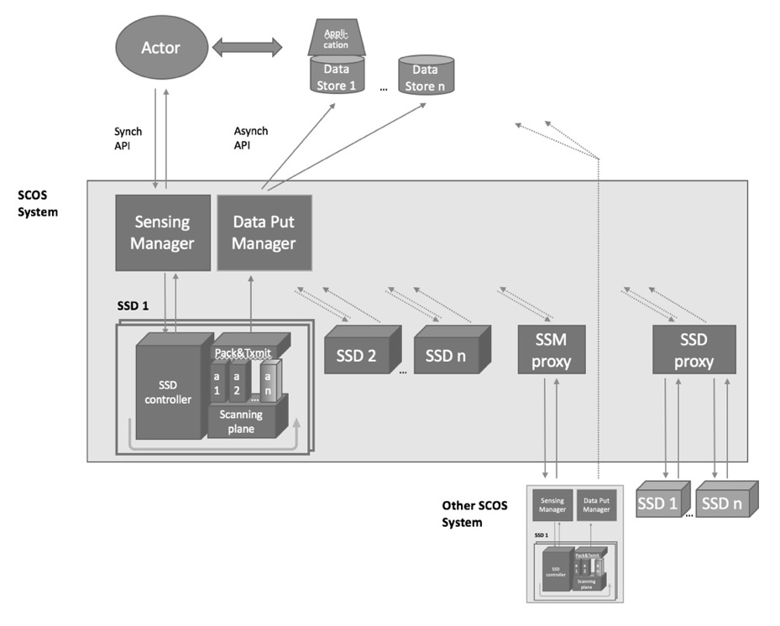
Figure 1. Architecture Block Diagram

- Actor is the entity that initiates a spectrum monitoring request to one or more Spectrum Sensing Managers (SSM). Actors can be human or machine, and have various levels of privileges regarding what spectrum information collection can be initiated. Actors would determine where sensing data is to be transmitted, and authorization to access that data would rest with the owner of that data storage entity. and what spectrum information can be accessed from a Data Store.
  - An Actor (user of the SCOS system) and SSM (Sensing Manager) communicate by REST API to ask for available resources, and request a scan.
- Data Store is a data base for storing spectrum information collected from the sensing network. There can be multiple Data Stores that sensing data is transmitted to by the Data Manager, and these can be, but not necessarily, associated with a specific Actor.
  - The Data Manager transmits data to the Data Store via a Message Queue, and the Actor interacts with the Data Store using their chosen mechanisms (out of scope of this standard)
- Spectrum Sensing Manager (SSM or Sensing Manager) manages a collection of Spectrum Sensing Devices (SSD). Requests for spectrum measurements from Actors are inserted into a scan schedule on the SSM for all its attached SSDs, as far as possible under a set of slot availability rules. This schedule is synched to the appropriate SSDs associated with the SSM. Data from the SSDs are collected at the Data Manager for transmission to one or more Data Stores for long term storage and processing.
  - The SSM is associated with SSDs (Sensing Devices) through a synchronous interface, where the SSM enumerates and holds a list of available resources for each SSD.
  - The SSM stores and manages a schedule of scans against the sensing resources, and synchronizes this schedule with all SSDs both on a change being made and periodically to ensure correct state.
  - Typically (but not necessarily) the SSM and Data Manager would be running on the same physical server.
- Data Manager receives transmissions of packaged scan data from SSDs, and retransmits it to one or more destinations, as defined by the policies associated with each Actor (source of scan requests)
  - The “Data Manager” applies any policies and then handles the Store & Forward to one or more data stores using a Message Queue or Streaming Mechanism
  - Typically (but not necessarily) the SSM and Data Manager would be running on the same physical server.
- The Sensing Manager and Data Manager together form the SCOS Manager, and can be on the same platform or separate platforms.
- Spectrum Sensing Device is the sensing hardware that collects the spectrum data requested by the SSM on behalf of each Actor. The SSDs may exist with various levels of sophistication. The less sophisticated might be capable of measuring only one band, at only one resolution with little on-board processing. Other sensors may incorporate sophisticated antenna techniques, multiple bands, calibration processes, on-board data processing and/or storage and/or be capable of mobile operation.
  - An SSD performs the scans in the schedule, and transmits the data and associated metadata through an asynchronous interface (message queue, or real time stream) to a “Data Manager” that performs system data validation (i.e. that a transmission is received completely, partial scans are consolidated, etc).
- SSM Proxy lets one SSM talk to another, with the downstream SSM appearing as if it were an SSD with a set of resources it provides. This downstream SCOS system would need to be 802.22.3 compliant.
- SSD Proxy lets an SSM talk to any other proprietary sensing hardware, acting as a software translation mechanism that translates between commands/metrics/etc. It would need to be custom written for the particular device it talks to.

  - Functions
The proposed architecture is composed of five key elements: an Actor (s), a spectrum sensing device (SSD), a spectrum sensing management system (SSM), a Data Manager (DM) and Data Store(s). The flow of instructions and data is described in Figure 2: SCOS Functional Block Diagram.

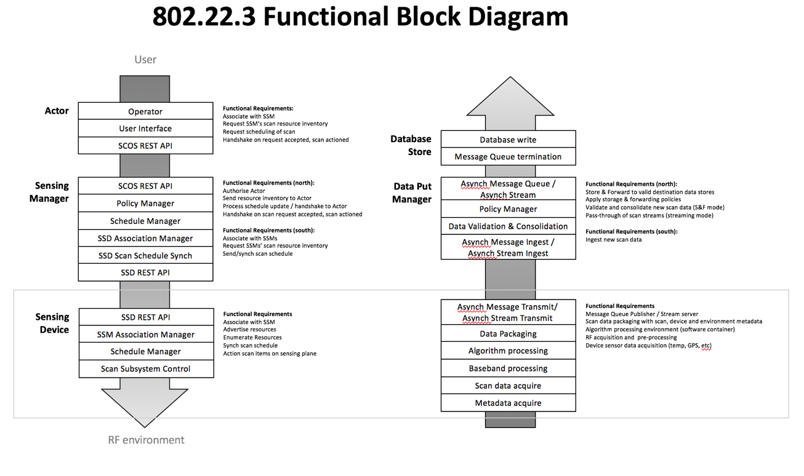
Figure 2: SCOS Functional Block Diagram

This diagram can be extended with the concept of proxying to allow SCOS systems to be cascaded, or the use of non 802.22.3 compliant sensing devices.

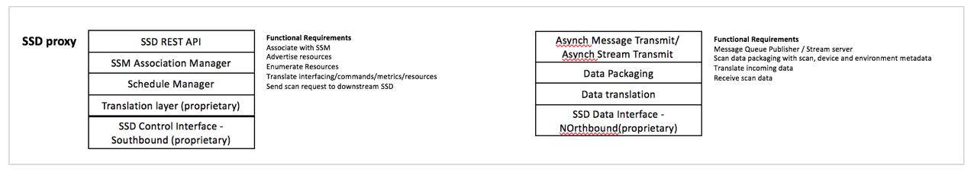
Figure 3: SSD Proxy

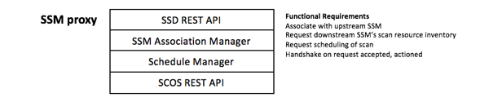
Figure 4: SSM Proxy

  - Reference Models
    - Actor
Actors are human or machine entities that can query SCOS resources and request scans to be performed.

There are at least three main classes of consumers of spectrum data:

Type A Actor: are specifically looking for current sensing information, and request specific scans to obtain specific data (e.g. law enforcement).
Type B Actor: have a requirement to keep spectrum information up to date (e.g. spectrum occupancy database operators), and will need to request periodic scans to achieve this.
Type C Actor: those that want to read spectrum information from a data store that is already populated with their required data. These users are not contemplated in this standard.

In general it should be assumed that a Type A Actor would have higher priority in terms of scan resources, as governed by a Policy expanded on below.

    - Spectrum Sensing Device (SSD)
SSDs convert radiative electromagnetic energy into a voltage, which is then sampled. The samples can then be processed in various ways to provide information on the immediate RF environment, e.g., amplitude statistics versus frequency, amplitude and phase versus time at a given frequency, occupancy statistics, angle of arrival.
      - Hardware Model
A simplified hardware block diagram of a general SSD model is depicted in Figure 5. SSD hardware designs are not required to have each component shown in the block diagram. Specifics for each component (e.g., presence, model, operational parameters), however, is required metadata when SSD capabilities are queried by the SSM. This SSD definition metadata will also accompany the output data messages.

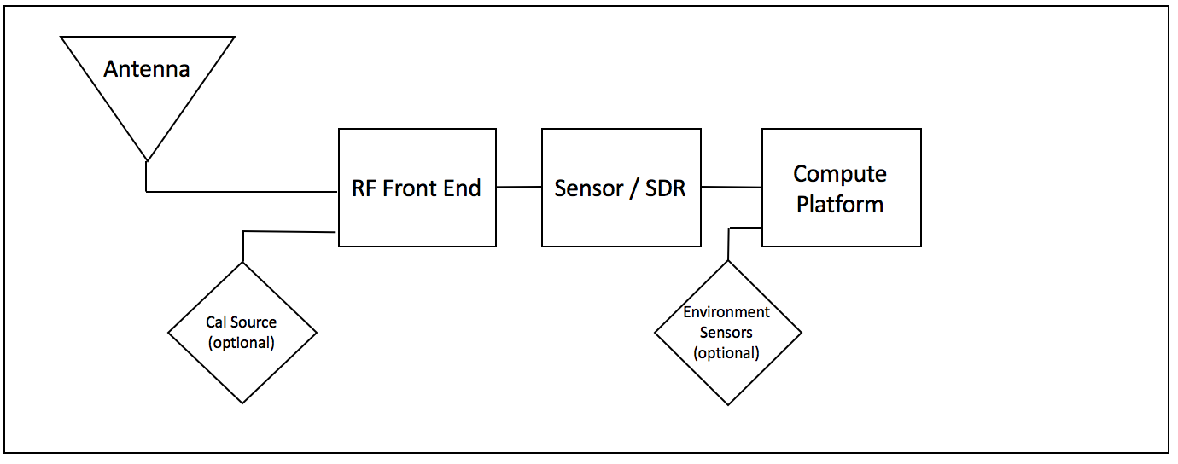
Figure 5: SSD Simplified Hardware Model Block Diagram

The SSD is composed of the following functional elements, as follows:
- Section 1 – Antenna: An antenna used to detect RF energy. This is fed to Section 2 over a hardware interface (interconnect cable)
- Section 2 – Signal Conditioning Unit: An RF front end unit consisting of (all or some of) an RF switch (optional, with the ability to accept an optional calibration signal), filter, Low Noise Amplifier, mixer. This sends the conditioned signal to Section 3 over an analogue hardware interface (interconnect cable/track).
- Section 3 – Signal Extraction Unit: Analogue Digital Converter, spectrum analyser or Software Defined Radio to act as a baseband processor, performing a demodulation of the conditioned signal and acquires the baseband signal. This sends a digitised signal over a digital interface (interconnect)
- Section 4 – Compute Platform: that provides
  - A signal processing function with a signal detection and/or classification algorithm. It sends detection/classification data to metadata consolidation and packaging function over a software interface.
  - A metadata consolidation and data packaging function that combines sensing data with environmental inputs (where implemented), hardware, operating and system-configured metadata. It sends data packages to the transmission system over a software interface.
  - A transmission unit that transmits scan data to the destination system over a best-effort IP connection.

The Compute Platform sends necessary command and control signals to Section 2 (Conditioning Unit) and Section 3 (Extraction Unit). It receives data from the Sensor/SDR, and polls any environment sensor input devices for necessary metadata items, such as GPS location. Interaction of the various elements is described in Figure 6: SSD Functional Elements.

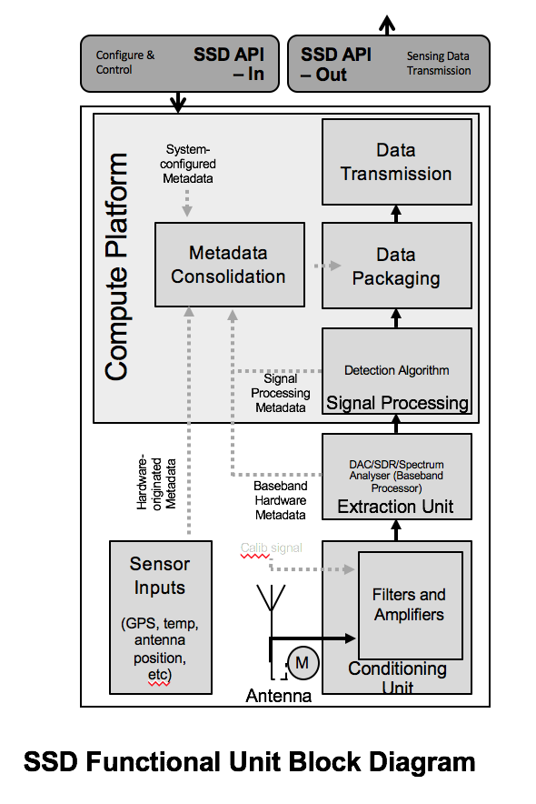
Figure 6: SSD Functional Elements
This block diagram can be split into the hardware layer and the software processes that run alongside. These hardware blocks or software services can/will generate metadata that is associated with each item.

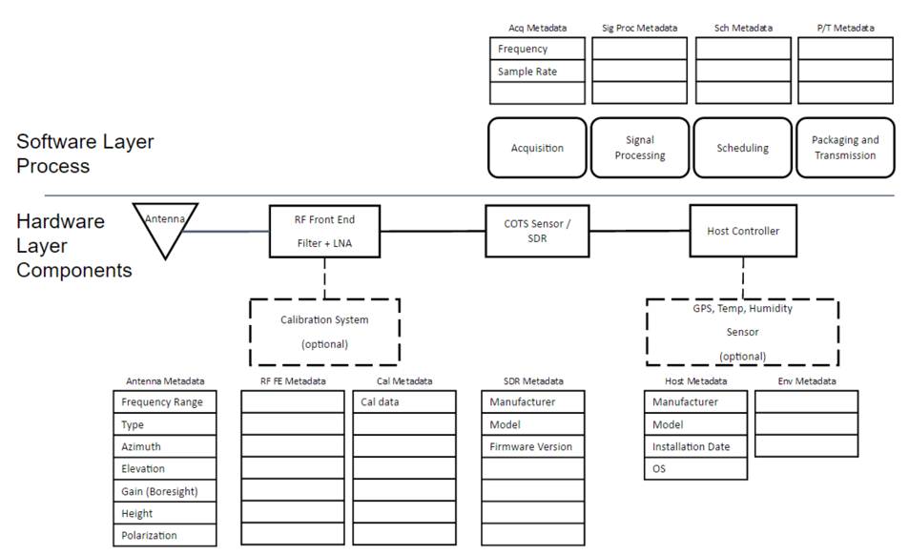
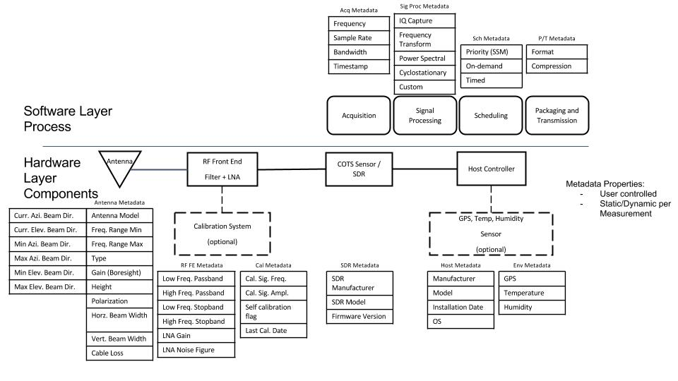
Figure 9: SSD model: Hardware layer components and Software layer processes with relevant metadata

      - SSD Calibration Model
A calibration can be done in the lab at build/commissioning time, and stored as a calibration file on the SSD.

Further, an SSD with a self-calibration capability can be instructed through an administrative interface (not USER request) to perform a calibration using a local calibration source.

      - SSD Algorithm Model
The Algorithm models shall be described in terms of inputs into black box: the identity of the USER and SSM requesting the scan, the measurement parameters, which algorithm is to be used; and outputs from the black box: the identity of the USER and SSM requesting the scan, the requested scan parameters, the identification of the algorithm model, and the processed results.

<Define use cases>
Normative model: general energy detection algortithm
At least one algorithm model is defined – a general energy detection algorithm.
<Trigger event algorithm>
<DF algorithm>
<Cyclostationary>

It is the responsibility of the SSM operator to publish algorithm definitions externally. Code does not need to be publicly accessible.

Allow for the development of advanced algorithms, e.g., DF.

  - Spectrum Sensor Manager (SSM)
    - SSM Association
SSM’s receive and manage association requests from SSDs

    - SSM Task Scheduling
Scheduling is defined in terms of scan intervals that take up slots in a calendar schedule. These slots will include slots for long scans; and slots for very short scans to ensure fair allocation of scan resources.

Scheduling requests from a USER will be defined in terms of duration, time, repetition, etc, as well as a flag to inducate whether the desired scan slots are “Exact Time” slots or “Nearest Time” slots. The scheduler on the SSM will use this to try meet the USER request (and either confirm the scan schedule is accepted or refused).

  - Data Manager
    - DM Functional Specification

- Interfaces, Messaging and Primitives
Figure 5 illustrates the basic SCOS interactions model.

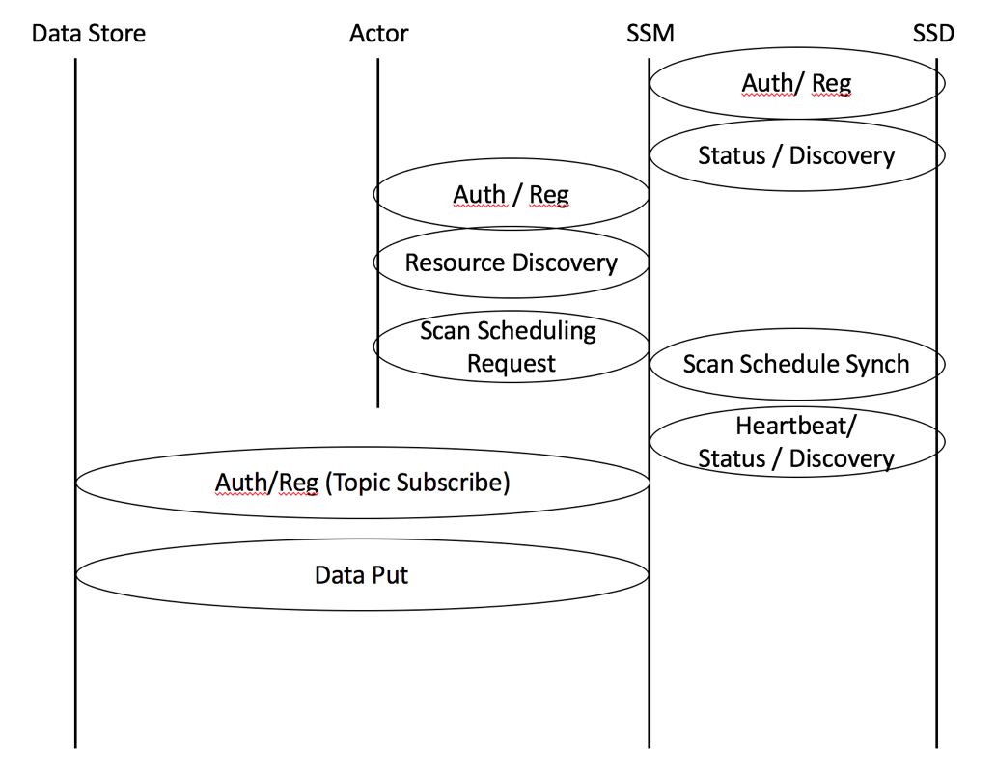
Figure 5. Basic Interface Structure

  - System Interfaces
    - Actor to SSM Interface
      - Authentication and Registration
These procedures define the association and authentication process for an SSM and USER entity to connect and communicate. They include facilities to prevent spoofing based on shared key exchange. Once an SSM is authenticated and registered to a USER, the USER can then discover the capabilities of the SSM and its associated SSD’s. The USER may then define and make sensing requests to the SSM, which include a designation of the DBstore(s) to which the data is to be sent. The SSM will notify the USER when measurements are successfully completed (or not) and available at the DBstore.
      - Resource Discovery
Resource Discovery is the process of informing the USER of what capabilities that the SSM has with regard to what types of measurements, what bands can be measured and associated measurement parameters that can be specified and controlled and over what locations. This takes the form of a resource/capability descriptor and the current scan schedule per SSD.
      - Scan Request
The Scan Request message from the USER to the SSM includes the parameters of the desired spectrum measurement to be made and any associated processing to be performed by either the SSD or the SSM. This scan request is wrapped in a scheduling task description, defining the time the scan is to be made, the repetition rate (if applicable), the locations, etc. When the scan parameters in their scheduling wrapper are received by the SSM it will be validated as possible to be executed (i.e. the resources requested meet the SSMs schedule of resources available), and either acknowledged as being queue, or a refusal is returned to the USER. If a scan schedule is upated for a particular SSD, it is then replicated down to that SSD.

    - SSM to SSD Interface
      - Authentication and Registration
These procedures define the association and authentication process for an SSD and SSM entity to connect and communicate. They include facilities to prevent spoofing based on shared key exchange. Once an SSD is authenticated and registered to a SSM, the SSM can then discover the capabilities of the SSD. An SSM will have associated with it at least one SSD. The SSM may then assign sensing requests to the appropriate set of SSDs in order to fulfill the sensing request of the USER.
      - Status and Discovery
The Status and Discovery process serves two functions. The first is to inform the SSM of what capabilities that the SSD has with regard to what types of measurements, what bands can be measured and associated measurement facilities (such calibration, antenna control, mobility, storage, processing) that can be specified and controlled and over what locations. The SSD will transmit a package describing its capabilities and available resources at time of authentication/discovery, and if there is any change in its configuration. The second function is to maintain association with the SSM. It will transmit a period heartbeat to indicate it is still associated with the SSM. If it is to disconnect, it will transmit a disassociation message (e.g. if it is rebooting or about to go into an offline mode).

      - Scan Request
The Scan Request message originating from the SSM is sent to the appropriate SSDs for execution as a scan schedule. It includes the parameters of the desired spectrum measurement to be made based on knowledge of the SSD’s capabilities. This request will include the time to make the measurement, the repetition rate (if applicable), the locations, etc. and the format of the measured data. In the case of a single, once-off scan, the schedule will indicate no repitition.

    - Data Manager to Data Store Interface
      - Authentication and Registration
These procedures define the association and authentication process for a Data Store and DM entity to connect and communicate. They include facilities to prevent spoofing based on shared key exchange. Once a Data Store is authenticated and registered with a DM, the DM is then authorized to cause data to be delivered to the Data Store based on the privileges of the Data Store and the DM. The Data Stores can be grouped into Data Store Groups, where a transmission of data from the DM is delivered to multiple Data Stores.
      - Data Manager
These procedures define and enable the storage of data from the DM to the Data Store. The successful reception of this data initiates a notification of the initiating Actor that requested that data.

    - Actor to Data Store Interface
      - Authentication and Registration
These procedures define the association and authentication process for a Data Store and Actor entity to connect and communicate. They include facilities to prevent spoofing based on shared key exchange. Once a Data Store is authenticated and registered to an Actor, the Actor is then authorized to cause data to be delivered to the Data Store, and read that data.

      - Resource Discovery
Resource Discovery is the process of informing the Actor of what capabilities that the Data Store has with regard to what types of data can be stored, at what rate, at what access level, and in what quantity can be specified. It may also initiate that association of a particular Data Store with a specific SSM that will be providing the data.

  - Messaging
The communication between each of the entities defined above can be grouped and defined within the Interface Categories shown in Figure 6. Message Sequence and described below.
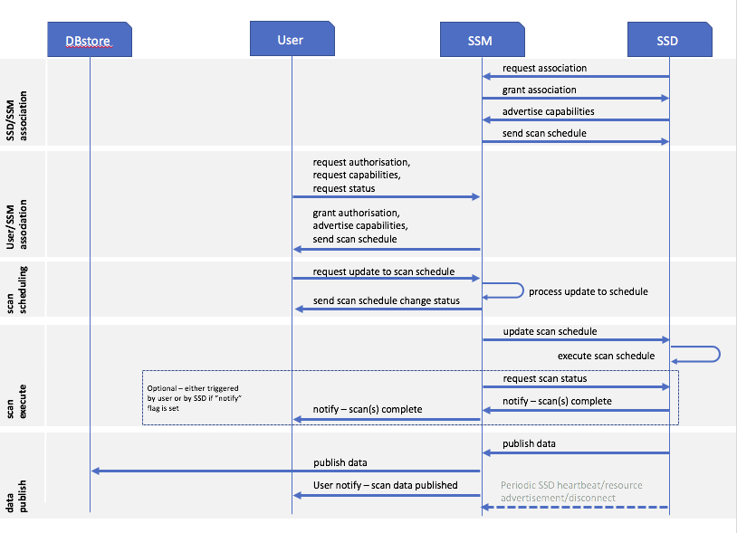
Figure 6. Message Sequence

    - Transmission – from SSD to SM / from Platform Control to SM
Northbound (SSD to platform): The package is transmitted to a remote system that ingests and validates data, and stores for further processing, with ACK back to SSD that packages were received.
Southbound (platform to SSD): Control messages are transmitted to SDD for execution by SSD, with ACK that control messages was received, and response code that instruction was accepted/rejected.

      - Message queues
The SSM devices use MQTT to speak to a MQ server instance (e.g. RabbitMQ). The MQ server instance maps the MQTT topics from the SSM into queues which the SSM ingest layer monitors and processes messages out of.

All traffic from the SSM to the SSM’s goes via AMQP queues into the MQ server instance which maps it out to the appropriate MQTT topics. The SSM pick up messages on any topics to which they have subscribed.

      - Message Queue security
The MQTT segment has security based on TLS with pre-generated certificates.

      - Message Queue QOS
All messaging on the MQTT side makes use of QOS 1. When using QoS level 1, it is guaranteed that a message will be delivered at least once to the receiver. The message can also be delivered more than once. If a message is delivered more than once it should start a counter and a clock. If the clock/counter exceeds a threshold it should create an alert on the administration console that there is a comms or ingest fault.

The SSM’s use a non clean session when connecting which ensures that messages sent to the client when non connected will be queued and delivered on reconnection. On the RabbitMQ the messages are queued on a topic for a client for up to 30 minutes before being discarded (this threshold for discussion).

The MQ server must use persistent queues for all applicable queues. Messages should survive a restart.

    - DM to Data Store
Package must be reliably, securely and scaleably received and transmitted to data store

Messages are processed inside the SSM using an ESB application. The ESB application architecture allows for small discrete message handlers to be written to deal with each type of message. Using a load balanced and multiple instances of the servers the load can be shared out across multiple servers.

Handlers are written for each of the types of messages. These handle unpacking and persistence of the incoming data. In some circumstances messages may be forwarded on to a task processor for further processing or analysis. All messages are persisted in a database.

      - Data Store move to Storage
Data moved into structured database

    - Form Actor to SSM: Platform Control Messages
HTTP service endpoints are implemented in the ESB application to allow for the triggering of outbound control messages to the SSDs through a southbound interface.

A variety of task requests can be predefined by the SSM policy such as different scan modes of the SSM, defining different timeframes, scan parameters, etc:

- Test Mode: one ping and one raw scan every 15 minutes
- Mobile Mode: one ping and one raw scan every 10 minutes
- Static Mode: one ping and one TV channel scan every 15 minutes. one raw scan every ½ hour.

These messages can be used to trigger SSD scan activity, or for system management.

  - Primitives
SSD and SSM messages will be in JavaScript Object Notation (JSON). JSON is a language-independent data-interchange format that is easy for humans to read and write. There are code and functions readily available in C, C++, C#, Java, JavaScript, MATLAB, Perl, and Python for parsing and generating JSON. It is a lightweight alternative to XML, commonly used to transmit data between server and browser applications.
The data fields in the JSON message descriptions below are required fields. If an attribute is not relevant to the sensor implementation, then the value is set to NaN or "NaN". Each message (in general) will begin with a header comprised of attribute-value pairs in ASCII characters. The first five fields are the same for all messages; they are:
1. Ver = Schema/data transfer version with the major.minor.revision syntax (string)
2. Type = Type of JSON message (string) {“Sys”, ”Loc”, or “Data”}
3. SensorID = Unique identifier of sensor (string of URL unreserved characters)
4. SensorKey = Authentication key given out by MSOD (integer)
5. t = Time [seconds since Jan 1, 1970 UTC] (long integer)

The following are specific formatting rules to be followed to avoid problems when messages are ingested into MSOD: (1) All timestamps, i.e., t (defined above)and t1 (to be defined in Data message description) will be reported as seconds since 1/1/1970 midnight UTC in the UTC time zone. (2) String values must only contain URL unreserved characters (i.e., uppercase and lowercase letters, decimal digits, hyphen, period, underscore, and tilde), and (3) Field names cannot start with an underscore because that convention is reserved for MSOD internal use.

    - SSD<>SSM Messages

      - SSD-SSM Association Primitives
SSD Association:
SSD Send:
SSD associate {
Association [request new, request refresh, request disassociate]
SSD Device ID
Public Key} | SSM would have all possible SSDs’ public keys that can associate
SSM Reply:
SSM associate {
SSD Device ID
Association state granted [new, refresh, disassociate]
SSD association max TTL | Tells SSD how long before it gets auto disconnected
SSD association remaining TTL} | Tells SSD how long left on clock

      - SSD-SSM Scheduling Primitives

SSD Advertise:
SSD Send:
SSD spec {
Fmin
Fmax
Resolution
Algorithm Type 1..n
Antenna type
Antenna direction
GPS available
GPS location
…etc } | All standard defined metadata types
SSM Reply:
SSM scan schedule for (SSD Device ID)
Scan 1 time {
Scan Schedule Sequence Number | Unique to scan
Time Start Offset | Time in minutes from start of week
Time Slots | How many minutes to block
Repeat start offset | Interval to repeat start
Number of repeats | How many repeats (anything outside week window are dropped)
Scan 1 spec {
Fmin | Desired Fmin
Fmax | Desired Fmax
Resolution | Desired res
Algorithm Type | Give desired algorithm type
Antenna type | Give expected antenna type
Antenna direction | Give expected/desired antenna direction
GPS enable | Yes/No
GPS location | Give expected GPS location
…etc } | All standard defined metadata types
Scan 1 destination {
Actor public key | Actor’s public key identifier
MQ topic or URL of data destination} | Where data will be published to
Etc … Scan n
SSD reply on scan execute:
Scan Schedule Sequence Number
Scan Completion Code | 1 – complete, 2 – incomplete, 3 – rejected
Scan Completion Fstart | Freq where scan was to start
Scan Completion Fend | Freq that was attained (“0” for invalid)
Scan parameter that caused rejection | If Completion Code 3, this gives problem metric
Scan Time to Complete

- Procedures
  - State Diagram

  - Messaging Chart for State Changes

  - Operations and Security
    - SSM Policy
A policy layer in the SSM at the northbound and southbound API will ensure that the SSM is operated within requirements of a local authority (national regulator, law enforcement, military, etc).
The policy on the southbound interface will determine, based on the USER type, (e.g. how a central authority can define what kinds of sensing can be done in what bands, what data governance rules there are, etc
-- resource allocation – what kinds of users are authorized to request resources from the sensor network and in which priority (i.e. if a sensing network is resource constrained, who gets first dibs on the sensors)

Policy on the northbound interface (SSM>DBstore) will have rules for how sensing data may be distibuted, and data storage policies. This would include which scan data takes priority if local storage in the store&forward buffer is running out due to a failed transmission link, and how long certain USER data is allowed to be stored in the local store&forward buffer.

Policy file: It is envisioned in the first version of this standard that the SSM stores a policy file which is installed manually by Sensing Operator (through mechanism such as SSH and update pull, or remote SCP).
Security Considerations

    - SSM Administration
Administrative functions on the SSDs and SSMs are largely assumed to be implementer-specific, and out of scope for the standard, but recommendations are included in the informative annex.

This interface shall have a secure mechanism to administer the system, allowing:
- performing of calibrations
- updating firmware
- changing configuration of SSD, and making associated changes to the SSD configuration file
- triggering reboots and other hardware maintenance functions.

The administration interface must be a secure interface with key exchange, and these keys must not be the same as keys used for USER<>SSM<>SSD authentication.

  - Data Ownership
The entity that builds/owns the SCOS owns the data it acquires. It can sell this data. Once that transaction takes place. The client has ownership, which is not necessarily exclusive - i.e., SCOS can sell it to other clients.

  - Security Systems
    - Threat overview

    - Authorisation, authentication, identity

    - Security design between each architecture layer
      - Physical security

      - Data transmission security

    - Security and redundancy model for data stores

Informative: Reference Applications

White Space device radio operator (assuming a CR can use an 802.22.3 SCOS)
Either the network operator or device operator using spectrum sensing to identify primary or other secondary users of particular channels. Spectrum sensing either built into the radio devices or standalone sensing units.

National regulators
National radio regulators would use a system comprising spectrum sensing devices to feed into a national spectrum utilization database for assignment management and planning purposes, and generating historical records for compliance monitoring and enforcement.

Devices deployed in various scenarios:
- Fixed devices at key locations and high sites
- Mobile devices on vehicles that travel widely and can create a sample set of spectrum utilization through snapshots at time or location intervals
- Devices either at fixed locations or periodically moved to create location-based spectrum utilization datasets
- Nationally deployed in a swarm of a given device density to create real-time national spectrum utilization maps and for validation of Spectrum Geolocation databases.

Scientific community:
Scientists using sensitive radio frequency systems (e.g. radio-telescopes) struggle with RF interference. SCOS devices can let them identify RFI and the location of their sources.

Law enforcement and public order
Law enforcement and other authorities are increasingly dealing with problems stemming from radio-controlled or radio-connected systems.

Illegal drone use: These include people flying radio-controlled unmanned aerial vehicles (drones) in prohibited places. SCOS systems can be used to detect characteristic transmissions of drone operation in areas such as in the airfield flight traffic area.

Detecting jamming devices: A problem area for security staff and law enforcement is the use of radio jammers to interfere with remote control devices like vehicle keyless entry systems or radio links for alarm systems. SCOS devices can be used to identify and locate jamming systems.

Detecting unauthorized mobile phone use: Controlled and high security areas such as prisons will frequently prohibit the use of cellular phones in certain areas, but may not jam operating frequencies because of other regulations. Identifying and locating transmissions allows direct action to be taken on equipment users.

Network Operator
Radio planning for fixed radio deployment.
Spectrum forensics for identifying sources of interference.

Normative Functional Requirements

High level functional requirements
- Radio energy is detected up by an antenna on Spectrum Sensing Device and transferred through an interconnect to a signal pre-conditioner containing mixers/filters/amplifier segments, according to pre-determined hardware parameters
- Signal is transferred to the SSD’s SDR to produce baseband signal, quantised by ADC and passed in digital form to be processed by a sensing technique, the nature of which is stored in metadata associated with the scan, with the method described in informative section of standard, Annex G (informative)
Sensing.
- This sensing data is packaged along with key metadata within the SSD and stored locally for transmission. Metadata includes:
  - scan time, scan duration, scan location, device identifiers and other scan-related metadata
  - hardware parameters of antenna and radio front end
  - system configuration information
- The package is (a) transmitted to a remote system that (b) ingests and validates data, and (c) stores for further processing
- The back-end management system exchanges control information with SSDs
e.g. device management, operation validation, integrity of information chain verification, maintenance tasks

Regulatory requirements
This standard should provide mechanisms to meet the regulatory requirements of national operators that have defined parameters or requirements for spectrum sensing in various applications. These regulatory requirements would take two forms: the first is technical requirements for sensitivity, resolution, etc. The second is limitations on how and where sensing might be done where there are sensitivities around privacy, military use and other national policies and regulations.

Policy Requirements
To allow for granularity in what the SCOS systems can do, but also ensure spectrum occupancy or utilization data is not exposed in contravention of national policy or regulation, it is proposed that the SSM would be able to apply policies to allow or disallow certain functionality in the SSDs, or disallow transmission of the data to third party systems.

These policies would be determined by the SSM operator in accordance with their requirements and that of local authorities (e.g. a national regulator or network operator), and cascaded down to any connected SSDs. These policies would allow sensing only according to allowed metrics (e.g. no hi-resolution raw scans in military radar bands), and limit sensing data transmission to certain classes of third party systems.

Sensor Location-Fixing Requirements
The SCOS device can convey the location of the sensors to the aggregation entity such as the SSM. The instruction to use available location capabilities on the SSD (e.g. GPS location) will be part of the scan schedule instruction from the Actor requiring the scan. This feature allows the SSM or the aggregation entity to localize the proximity of the signal source location allowing more efficient spectrum management. This location fixing capability will be implemented by the system operator to be in accordance with local regulatory requirements.

Technical Requirements

Device classes and complexity
The following sensing device categories may be considered:

- Energy Efficient Sensing Devices: This standard should provide mechanisms of energy efficient operations, eg. solar powered or battery operated spectrum sensors for monitoring applications.
- Small form factor devices: Devices that can fit the spectrum sensing function within a small form factor (e. g. a USB dongle, cell phone etc.)
- Advanced Spectrum Sensing Devices: Advanced Spectrum Sensing Devices with capable Radio Frequency Front Ends (RFFE) and dedicated resources for spectrum sensing may be considered.
- Non-dedicated Devices with Sensing Capability: A number of consumer and professional radio devices contain radio receivers that can be used as sensing devices, including mobile phone handsets, Wi-Fi access points (from 802.11ac) and Dynamic Spectrum Access radio systems (including 802.22).

Number of devices
This standard shall support at least one Spectrum Sensing Device to cover a location or area, communicating with a back-end Spectrum Sensing Management System (SSM), but will extend to describing an architecture and interfaces for multiple SSDs potentially communicating with multiple SSM instances.

Real-time applications
The sensing devices will be performing spectrum sensing functions according to its scheduler (which is managed by its SSM), which can be updated in near-real time (dependant on speed of communication between Actor, SSM and SSD), or perform scans at scheduled intervals based on pre-configured schedules. However, the spectrum sensing reporting of data is out on a Best Effort basis, since the SCOS System uses the chosen available transport mechanism (e. g. 802.11, 802.22, Ethernet, Cable, Cellular etc.).

The SCOS system will benefit if sensing reports from various sensors are provided on a reasonable time-scales (e. g. minutes) so that the information is not stale. However, this is not a mandatory requirement. Also, the messaging format may be defined such that it does not produce excessive overhead penalty on the transport layer being used.

It is envisioned that real-time streaming will be provided for in future drafts of 802.22.3.

Channelization
This standard may specify a Spectrum Manager entity that can command various sensors to go and sense in certain bands, or it may even specify the spectrum sensors to ignore certain bands from sensing, and impose channelization maps for sensors to meet local regulations or technical requirements.

Security Requirements
This standard mandates secure authentication and authorisation between Actor and SSM, SSD and SSM, SSM and Data Manager, and Data Manager and Data Store. Traffic between these components must also be encrypted. The specific security technology to be used is not mandated in this standard, but recommended best practices are described in Annex B. Note that the security model does not extend past transmission to the Data Store. Responsibility for securing the spectrum data at destination remains the responsibility of the operator of that store.

The technology model is designed to ensure that data derived from SCOS devices and SSM are not used as an attack vector against White Space Databases, regulator spectrum management databases, etc. It is also designed to ensure that only authorised Actors can make use of the SCOS resources, and that they are correctly identified to enable correct application of the relevant system policies.

Intra-device Layer Security (physical interfaces)
This standard defines security mechanisms to ensure integrity of sensing chain from antenna to data store.

- Antenna to amplifier/filters: physical security of device in terms of cable/connectors (tampering such as substituting antenna, physical such as connector corrosion)
- Amplifier to SDR: cable connectors or PCB connections
- SDR to processing unit: cable connectors or PCB connections
- Enclosure for active elements: Protection against moisture, dust ingress. Screening against RFI from external sources. Screening to protect antenna elements against RFI from active elements.

(NOTE – this section needs considerable attention)

Inter-Layer Security

Network Layer
Since this standard uses any available transport mechanism for data transmission, it will not recommend its own security mechanisms, but will use the existing security mechanisms of the transport mechanism being used (e.g. network 802.11 using Transport Layer Security,

Application Layer
Data transmissions should be secured on the application layer using mechanisms to guarantee the integrity and confidentiality of sensing and control data transmissions. This standard does not specify the technology used, but recommended implementation practices are noted in Annex B: Device and System Security Recommendations.

Security of sensed data
This Standard shall not support mechanisms that expose user data modulated onto signals. For example, any kind of demodulation of the signals that may interfere with the privacy of the users shall not be not be supported. However, the SCOS system shall support sophisticated spectrum sensing methods such as cyclostationary processing that can detect signals and characterize their modulation type.

Normative - SCOS Metadata Specification
According to SCOS architecture and components, there is the need to add additional pieces of data, i.e. metadata, able to identify a peripheral node, SSD, on the basis of its own capabilities, and to tag occupancy results with information such as location, swept frequency, sensing algorithm etc. (proper definition and detailed explanation of employed metadata is given in sections C.1 and C.1.7).
It is necessary to classify such information in order to give them a priority order and to reduce the amount of exchanged data for each scanning request.

Metadata can be categorized into Classes, having different purposes:
- Class A (System Metadata) includes all pieces of data that are related to factory information and remain constant for the entire lifespan of the component (SSD);
- Class B (Current Status Metadata) includes data describing the actual configuration of the device, in terms of hardware (positioning, antenna configuration, battery level) and software (frequency settings, sampling rate, sensing algorithm, available local memory etc.);
- Class C (data related metadata), specifying parameters strictly related to performed sensing action (scanned time, timestamp, atmosphere conditions, amount of data to be read, estimated noise level);
Class A and Class C metadata are not subjected to any change since they are offered as a response to a specific query (in SSD association process and Sensing request, respectively).
Class B metadata are provided to SSM, after a specific user request, and can be subjected to modification and special settings by the Actor. They must be provided to the SSM before a scanning section starts, and they must be accompanied by an additional information bit, indicating their editing property (0, non-editable parameter; 1, editable parameter).

Each metadata must respect JSON message syntax and each message must contain the following fields:
- Name
  - This is a text field that contains the metadata name;
- Type
  - This field contain the data type [string|float|int|boolean];
- Editable
  - This field contain a boolean information. In particular it indicates the status of being editable of a specific piece of metadata (set to 0 for Class A and C, settable to 0 or 1 for Class B);
- Content
  - This field contain the content of the metadata.

SSD metadata specification

Top level hardware metadata
Parameter | Values | Description
Antenna | 0 | Number of antennas
Calibration source |  | Present/absent
RF switch |  | Present/absent
RFFilter |  | Present/absent
LNA
Sensor |  | COTS/SDR

Antenna Metadata
Antenna metadata is reported in the table below. In the second column of the table the class of the metadata is specified.

Metadata Name | Metadata class
Antenna Model | Class A
Freq. Range Min | Class A
Freq. Range Max | Class A
Type | Class A
Gain | Class A
Polarization | Class A
Height | Class A
Horz. Beam Width | Class A
Vert. Beam Width | Class A
Min Azi. Beam Dir. | Class A
Max Azi. Beam Dir. | Class A
Min Elev. Beam Dir. | Class A
Max Elev. Beam Dir. | Class A
Curr. Azi. Beam Dir. | Class B
Curr. Elev. Beam Dir. | Class B
Cable loss | Class A

A detailed description of the field of each metadata is reported in the table below

Name | Type | Editable | Content
Antenna Model | string | “0” | It contains a string with the model of the antenna that is installed.
Freq. Range Min | float | “0” | Min frequency value expressed in Hz
Freq. Range Max | float | “0” | Max frequency value expressed in Hz
Type | string | “0” | Antenna type
Gain | float | “0” | Antenna gain expressed in dBi
Polarization | string | “0” | Antenna polarization [“VL”|“HL”|“LHC”|“RHC”|“Slant”]
Height | float | “0” | Antenna heigh in m.
Horz. Beam Width | float | “0” | Horizontal 3-dB beamwidth expressed in degrees
Vert. Beam Width | float | “0” | Vertical 3-dB beamwidth expressed in degrees
Min Azi. Beam Dir. | float | “0” | minimum direction of main beam in azimuthal plane expressed in degrees from N
Max Azi. Beam Dir. | float | “0” | maximum direction of main beam in azimuthal plane expressed in degrees from N
Min Elev. Beam Dir. | float | “0” | minimum direction of main beam in elevation plane expressed in degrees from horizontal plane
Max Elev. Beam Dir. | float | “0” | maximum direction of main beam in elevation plane expressed in degrees from horizontal plane
Curr. Azi. Beam Dir. | float | “0” if fixed antenna is used  “1” if an antenna with beam steering capability is used. | Current direction of main beam in azimuthal plane expressed in degrees from N
Curr. Elev. Beam Dir. | float | “0” if fixed antenna is used  “1” if an antenna with beam steering capability is used. | Current direction of main beam in elevation plane expressed in degrees from horizontal plane
Cable loss | float | “0” | Cable loss expressed in dB of the cable connecting the antenna with the RF front-end

RF Front-end metadata
RF Front-end metadata is reported in the table below. In the second column of the table the class of the metadata is specified.

Metadata Name | Metadata class
Low Freq Passband | Class A
High Freq Passband | Class A
Low Freq Stopband | Class A
High Freq Stopband | Class A
LNA Gain | Class A
LNA Noise Figure | Class A

A detailed description of the field of each metadata is reported in the table below

Name | Type | Editable | Content
Low Freq Passband | float | “0” | Low passband frequency evaluated at -1 dB and expressed in Hz
High Freq Passband | float | “0” | High passband frequency evaluated at -1 dB and expressed in Hz
Low Freq Stopband | float | “0” | Low stopband frequency evaluated at -60 dB and expressed in Hz
High Freq Stopband | string | “0” | High stopband frequency evaluated at -60 dB and expressed in Hz
LNA Gain | float | “0” | Low Noise Amplifier Gain expressed in dB
LNA Noise Figure | float | “0” | Noise Figure of LNA expressed in dB

Calibration Metadata
Calibration metadata is reported in the table below. In the second column of the table the class of the metadata is specified.

Metadata Name | Metadata class
Cal. Sig. Freq. | Class A
Cal. Sig. Ampl. | Class A
Self Calibration flag | Class A
Last Cal. Date | Class A

A detailed description of the field of each metadata is reported in the table below

Name | Type | Editable | Content
Cal. Sig. Freq. | float | “0” | Frequency of the internal calibration source expressed in Hz
Cal. Sig. Ampl. | float | “0” | Amplitude of the internal calibration source expressed in dB
Self Calibration flag | boolean | “0” | This is set to “1” if the sensor performs a periodical self calibration procedure. Otherwise it is set to “0” if the self calibration is performed after a user request
Last Cal. Date | string | “0” | The time stamp of the last calibration expressed as HH:MM:SS YYYY/MM/DD

SDR Metadata
SDR metadata is reported in the table below. In the second column of the table the class of the metadata is specified.

Metadata Name | Metadata class
SDR Manufacturer | Class A
SDR Model | Class A
Firmware version | Class A

A detailed description of the field of each metadata is reported in the table below

Name | Type | Editable | Content
SDR Manufacturer | string | “0” | Manufacturer of the sensor used
SDR Model | string | “0” | Model of the sensor used
Firmware version | string | “0” | Current firmware version

SSD Host Metadata
Host metadata is reported in the table below. In the second column of the table the class of the metadata is specified.

Metadata Name | Metadata class
Manufacturer | Class A
Model | Class A
Installation Date | Class A
OS | Class A

A detailed description of the field of each metadata is reported in the table below

Name | Type | Editable | Content
Manufacturer | string | “0” | Manufacturer of the host
Model | string | “0” | Model of the host
Installation Date | string | “0” | The date when SSD has been installed expressed as YYYY/MM/DD
OS | string | “0” | Operating System installed on the host

Environmental Metadata
Environment metadata is reported in the table below. In the second column of the table the class of the metadata is specified.
Metadata Name | Metadata class
GPS | Class C
Temperature | Class C
Humidity | Class C

A detailed description of the field of each metadata is reported in the table below

Name | Type | Editable | Content
GPS | Array of float | “0” | [Latitude expressed in decimal degrees (-90°-90°)  Longitude expressed in decimal degrees (-180°-180°)
Temperature | float | “0” | Environment temperature expressed in K
Humidity | float | “0” | Environment relative humidity expressed in percentage

SSD Software configuration metadata

Algorithm specification
Algorithm | Value | Notes
Unspecified | 0
Energy Detection | 1 | Default
Direction Finding | 2
Cyclostationary | 3
Wideband | 4

System Definitions and Interfaces (NOTE THAT THIS SECTION BELOW OVERLAPS WITH MATERIAL ABOVE, TO BE RESOLVED)
Definitions of units, measurements for each defined parameter in the standard
The parameters defined in the previous section need a detailed definition. In the following, they will be defined in detail, a priority grid (paradigm MoSCoW adopted) will be provided and canonical measurement units will be given.
According to MoSCoW paradigm, used in software engineering requisite classification, a parameter can belong to the following categories:
M (MUST HAVE): very high priority parameter, it cannot be missed in the data exchange process;
S (SHOULD HAVE): medium priority parameter, it is requested to be present but in rarely cases he could be skipped.
C (COULD HAVE): low priority parameter, it could be useful if present but its absence would not affect negatively the system;
W (WISH LIST): optional parameter, to be used if room: not actually needed.
  - System Units and Parameters
Stage 1 parameters:

Antenna gain (M): the ratio of the power received by the antenna and the power received by a hypothetical lossless isotropic antenna.
Antenna type (M): according to its shape and radiation pattern, different antenna types can be used for SCOS purposes, if they can provide requested accuracy results.
Antenna bandwidth (M): the frequency range over which an antenna can work well.
Amplifier gain (M): it is the difference (in dB) or the ratio between the power at the exit stage and that one at the input stage of the amplifier.
Antenna orientation and polarization (if non omnidirectional antenna is used) (S): The polarization of an antenna is intended the orientation of the electric field (E-plane) of the radio wave wrt the Earth's surface. It depends of the physical structure of the antenna and its orientation.
Insertion loss (into amp) (S): it refers to the attenuation the received field experiences passing through the wire connecting the antenna to the amplifier.
Return loss (S): it is defined as the power loss of the signal due to the reflections in correspondence with impedance discontinuity along the transmission line.
Analytically, it is defined as: $RL \left(dB\right)=10 \log_{10}(\frac{P_{i}}{Pr})$, where P_{i} is the incident power, P_{r} the reflected power.
Noise figure (S): noise level estimation through the analysis of a surely vacant channel.
Filter parameters (C): filter defined by typology (LPF, HPF, BPF, RBF) and cut-off frequencies.
Antenna impedance (C): the output impedance of the antenna.

Stage 2 parameters:

Input parameters:
Channel to be sensed (M): frequency interval to be scanned, it can be provided through starting and stop frequency, or by using a LUT (look-up table), where a correspondence between a unique code and channel features is provided, in order to minimize data exchange communication overhead.
Max Scan time (S): it is the amount of time a SSD must spend in order to acquire the signal and perform sensing. No data packaging time included.
Resolution bandwidth setting (S): it is actually defined as the ratio between the frequency interval under analysis and the number of frequency bins of the FFT process. Higher the RBW, higher the probability to detect very narrowband signals, such as wireless microphones.
Sensing method to be adopted (C): if more than one sensing method is loaded into SSD, the SSM could send a code corresponding to one of those methods, especially if different performance is ensured by different sensing methods.

Output Metadata:
SSD hardware ID/key (M): alphanumeric code indicating the specific SSD, for fixed stations it could be related to the sensor position.
Scan parameters (S) (channel, scan time, sensing method, resolution bandwidth): definition corresponds to input parameters but they are provided back to the SSM in order to ack the system that requested parameters have been correctly set and used.
Temperature/humidity (S) (in order to evaluate if the SSD hardware is working in normal operating condition): in some atypical conditions (extremely hot or extremely cold) the SSD hardware may provide inaccurate results or they could be corrected by a correcting factor depending on the temperature/humidity pair.
Battery level (C) (if the SSD is battery powered): indicated as the percentage wrt the full charge value, under a threshold sensing could be considered not reliable and recharging could be enabled by SSM.
Sensor location coordinates (M for mobile devices, C for fixed stations): latitude and longitude or distance from a reference point or node. Values can be provided by a GPS sensor embedded in SSD.
    - Key minimum sensing parameters
In order to be compliant with SCOS framework, every SSDs must show, on testing scenario, performance in terms of two figures of merit:
- Detection Probability (P_{d}): $\frac{\sum_{i=0}^{N_{b,o}}{B_{o,i}}}{B_{o,tot}}$
- False Alarm Probability (P_{fa}): $\frac{\sum_{i=0}^{N_{b,f}}{B_{f,i}}}{B_{f,tot}}$

Where B_{o,i} , B_{o,tot} , B_{f,i} and B_{f,tot} represent the i^{th} detected occupied bandwidth inside the actually occupied frequency interval, the total occupied bandwidth, the i^{th} detected occupied bandwidth inside the free frequency interval, the total free frequency bandwidth, respectively.

According to SCOS purposes, P_{d} must be greater than 90% and P_{fa} less than 10% for every operating conditions, down to the minimum sensitivity level, defined in Section Error! Reference source not found..

    - Standard system units
Parameter | Unit of measurement
Antenna gain | dBi
Antenna bandwidth | MHz
Antenna Impedance | Ω
Insertion loss | dB/m
Return loss | dB
Amplifier gain | dB
Scan time | ms
Resolution bandwidth | kHz
Temperature | K
Humidity | %rh
Battery level | %
Sensor Location coordinates | DD°MM’SS’’ N/S (latitude)  DD°MM’SS’’ W/E (longitude)

  - Metadata Formats
Definition of metadata to be captured at each layer
Parameter | Data type | Format
Antenna gain | Numerical | integer
Antenna type | enumerator | - Dipole antenna  - Half-wave dipole antenna  - Monopole antenna  - Etc.
Antenna bandwidth | Numerical | Double (two digits after decimal mark)
Antenna impedance | Numerical | Integer
Antenna orientation | Numerical | Roll
Antenna polarization | Enumerator | - Horizontal  - Vertical  - Circular  - Elliptical  Etc.
Insertion loss | Numerical | Double (two digits after decimal mark)
Return loss | Numerical | Double (two digits after decimal mark)
Amplifier gain | Numerical | Double (two digits after decimal mark)
Filter parameter:
Filter type | Enumerator | - LPF  - HPF  - BPF  - Etc
Cut-off frequencies | Numerical | Double (two digits after decimal mark)
Channel to be sensed | Numerical | Double (two digits after decimal mark)
Channel to be sensed | Enumerator | List of channel
Max scan time | Numerical | Integer
Sensing method to be adopted | Enumerator | - Energy detection  - cyclostationarity  - matched filter  - Etc
Resolution bandwidth setting | Numerical | Integer
SSD hardware ID/key | Alphanumeric
Battery level | Numerical | integer
Temperature | numerical | Double (one digit after decimal mark)
Humidity | Numerical | Integer
Sensor Location coordinates | alphanumeric | DD°MM’SS’’ N/S (latitude)  DD°MM’SS’’ W/E (longitude)

SSD Task Control metadata

Scheduler Specification
Algorithm | Value | Notes
Unspecified | 0
Host Controller | 1
Embedded Job Controller | 2
Multilevel | 3

SSD Output Specification
Algorithm | Value | Notes
Unspecified | 0 | Invalid
Time domain IQ | 1 | Default
Freq domain IQ | 2
Time domain Amp, Phase | 3
Freq domain Amp, Phase | 4

Informative: Regulatory Technical requirements

Various countries will have differing requirements here, but a few countries already have definitions in place that should be observed. For example, in the FCC rules for the VHF/UHF TV bands, the FCC requires a spectrum sensing detection accuracy as specified by the Table 1: FCC Sensing sensitivity requirements.

Table 1: FCC Sensing sensitivity requirements
Regulatory domain | Type of signal | Sensing detection threshold  (in dBm) | Data fusion rule for distributed sensingª | Monitoring requirements
USA | ATSC | –114  (averaged over 6 MHz) | “OR” rule | Detection threshold referenced to an omni-directional receive antenna with a gain of 0 dBi
USA | NTSC | –114  (averaged over 100 kHz) | “OR” rule | Detection threshold referenced to an omni-directional receive antenna with a gain of 0 dBi
USA | Wireless microphone | –107  (averaged over 200 kHz) | “OR” rule | Detection threshold referenced to an omni-directional receive antenna with a gain of 0 dBi
ªThe value “1” indicates detection.

Other requirements for the 2.7 GHz to 3.7 GHz band shall be defined based on the evolving regulations. For example, the spectrum sensing devices in the 2.7 GHz to 3.7 GHz can sense for Radar Signals and provide that information to the Spectrum Access System (SAS) that is being defined in these bands.

Device and System Security Recommendations
* Remote access to SSD hardware through remote secure shell (SSH) and similar technologies must not use the same keys as SSM/SSD interface keys

* Devices’ physical characteristics must be evaluated and enumerated at build validation and testing, with hardware and configuration parameters written to file /DEVICEHARDWAREPARAMETERS.CONFIGFILE (placeholder) and stored in non-writable file

* Any changes to hardware configuration (e.g. change of antenna) must be recorded in DEVICEHARDWARECONFIGCHANGES.LOGILE and changes made to relevant parameters in D..H...P...CONFIGFILE, either through manual editing of config file or through a secure remote update mechanism (e.g. scripted SCP file revision).

Implementation Guidelines/Notes
<Currently this section contains miscellaneous notes>
Tasking API, Mission API and Data Request API: The Mission API would be the equivalent of the SCOS API (i.e. where the Actor requests a scan schedule); the Task API would be the SSD API (i.e. the SSM sending an schedule update to a specific SSD). The Data Request API would not be included in the current design, as the retrieval of scan data would be between the Actor and the Data Store, which is implementation dependent.

Management Reference Architecture

Spectrum Sensing Platform – Sensing Service Control

Spectrum sensing API
The spectrum sensing platform provides spectrum sensing as a service using Spectrum sensing API. This is the northbound interface from the block diagram.
We identify following four types of API
- Registration (ID, key exchange, authorisation)
- Query (sensor model, signal processing capability (occupancy, characterisation, calibration, df), health, availability, location)
- Configuration (sensing config, scheduling config, calibration, [operational])

- Notification of Change (reverse Query)
- Notification of Busy (TBC?)

With the Registration API, an SSA can enable/disable usage of the API. Configuration API enables an SSA to configure the SSP for desired purpose. Using Query API, an SSA can request real-time data or past data. (Inference regarding secondary spectrum-access is purposefully excluded from the SSP API. For example, Is it safe to transmit? This spectrum-access inference logic is considered to be in the apps that are using the spectrum-sensing platform.)

The coordination API is optional. It can be used in circumstances wherein the Apps wants to provide information about secondary spectrum-access. For example, an SSA may use the real-time sensing data and infer feasibility of secondary spectrum-access. This SSA would grant spectrum-access parameters to secondary user radios and use the coordination API to notify the secondary spectrum access to SSP.

Following diagram captures the high-level summary of the SSP API.
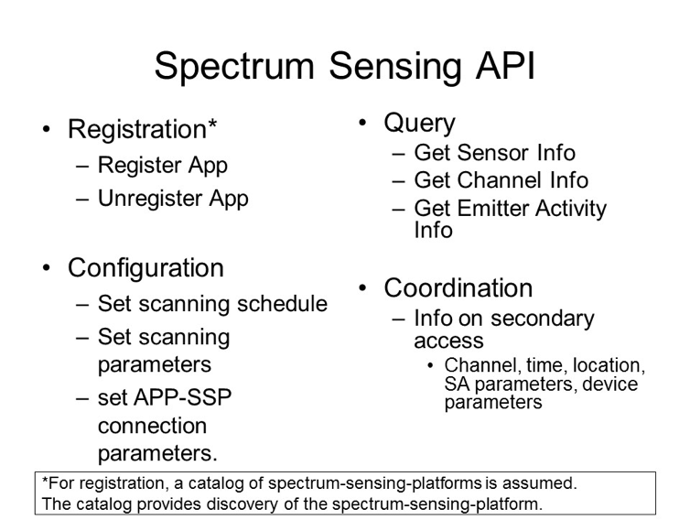

Example spectrum sensing API design
The spectrum sensing requirements vary significantly in terms of geographies (different countries have different regulations) and they have been evolving over time. The requirements also vary depending on frequency-bands. Thus, there is a need for configurability and extensibility for SSP API. In this regard, policy-based interface is very much appealing. Furthermore, we may consider developing semantics for sensing-data and ontology-driven sensing policy (OWL). Following diagram shows some examples of possible SSP API.
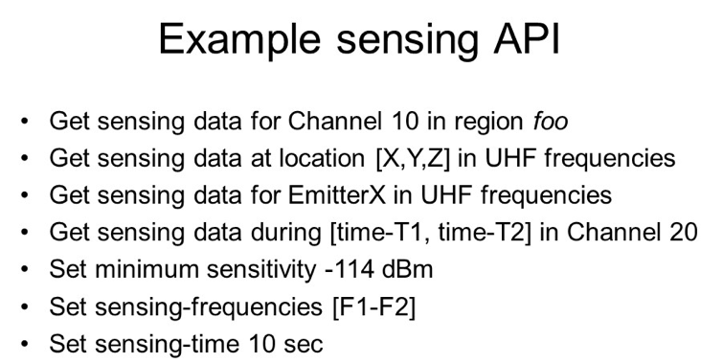

Message Exchange
SSA API requests and SSP API response are encapsulated in messages. Each message has a message-ID, message-Type, and the message body. Following diagram identifies various message types.
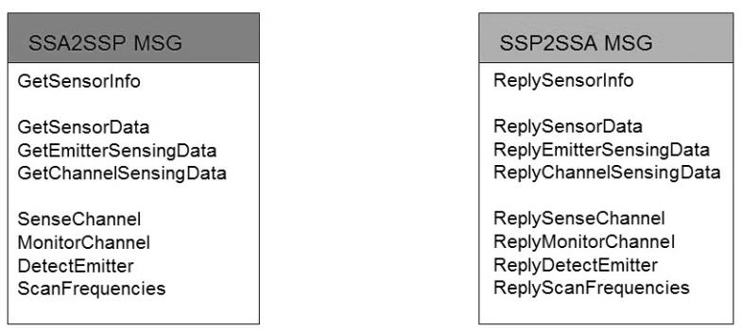

Following sequence diagram illustrates message exchange between SSA and SSP.
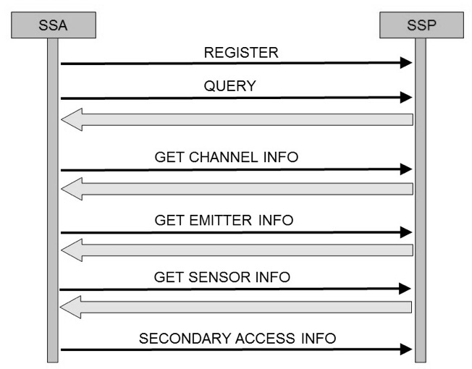

Spectrum Sensing Control
The spectrum sensing platform provides spectrum sensing service by controlling the spectrum sensing devices (SSD) with southbound interface. There are following 3 types of API
- Registration: Allows to add/remove an SSD to SSP
- Control: Controlling the sensing function and schedule of an SSD
- Query: Requesting sensing data from an SSD

Sensing Functions
There exist multiple sensing techniques/algorithms from energy detection to exploiting cyclostationarity and signal statistics. Some sensors may be able to report occupancy in terms of aggregate RF-power received at the sensor location while higher end sensors may be able to estimate location and received power (RP) in the presence of cochannel interface and noise.

Sensing Schedule
The SSP may need to scan a wide range of frequencies at a specific periodicity. Thus, SSP may in tur define a sensing schedule for each of SSDs. The schedule may be adapted in response to certain events or policies from the SSAs.

Examples
Following are a few examples of the interface between the SSP and SSD.

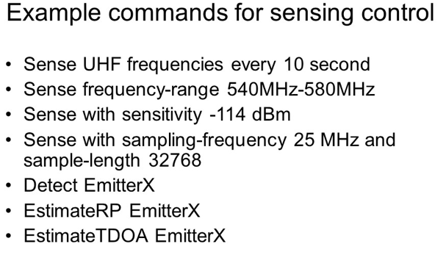

Message Exchange
The message from SSP to SSD is formatted in the similar way (has message-ID, message-type, and actual message). Following diagram shows some of the message types.
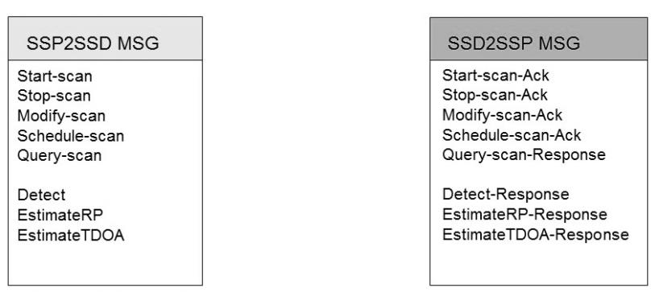

Following sequence diagram illustrates the message exchange between SSP and SSD.

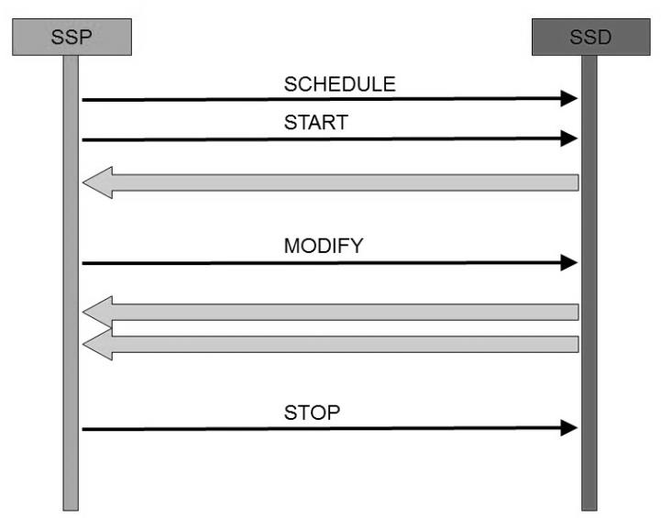

Data Store
SSP collects and stores the sensing data to provide the services defined under the SSP APi. One of the popular approaches is to use relational database. Following diagram illustrates records for (a) sensing measurement, (b) SSD (c) SSA.
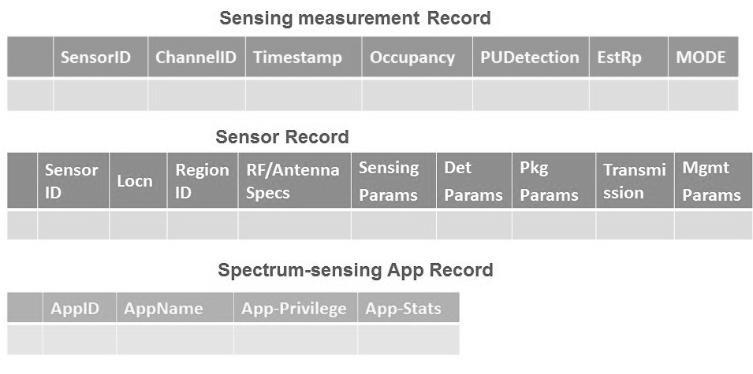
Alternate approach could be to develop spectrum sensing semantics based data-store.

Management and Maintenance
The back-end management system exchanges control information with SSDs
Manage them
- Device health reports – power, temperature, location, GPS health, OS/environment health, network health, storage health, scheduled and by query
- Manage by device, group, Class of device
Validate their operation
- Run test scans against known data points (e.g. from WSDB)
Verify integrity of information chain
- Software tools to validate process chain
Perform maintenance
- Push updates to devices (software, OS, firmware, certifications)
- Perform remote reboots, resets
- Shell into device to do diagnostics

(normative)
IEEE 802.22 regulatory domains and regulatory classes requirements
This annex describes the various technical parameters and specifications required by the various regulatory domains for operation of the IEEE Std 802.22 in the TV bands.

Regulatory domains, regulatory classes, and professional installation
Table F.1 specifies the regulatory domains and licensing regime where the IEEE 802.22 systems are planned to be authorized to operate in the TV bands.

Table F.1—Regulatory domains
Geographic  area | Regulatory domain ISO 3166 (3 Bytes) | Licensing regime | Approval  authority
United States | USA | Unlicensed | FCC
Canada | CAN | Licensed | IC
United Kingdom | GBR | — | OFCOM
— | — | — | —

1921HTable F.2 specifies the authorized regulatory classes under their respective regulatory domains.
Table F.2—Regulatory classes

Regulatory domain | Regulatory class and profile
 | Fixed | Personal portable
USA | Stationary fixed | Mode I & IIª
CAN | Stationary fixed | N/A
— | — | —
ªThe behavioral limits sets for Modes I and II are defined in the FCC Report and Order. However, IEEE Std 802.22 will only operate in portable nomadic Mode II.

Table F.3 specifies the requirement for professional installation of the WRAN BS and CPEs.

Table F.3—Professional installation requirement

Regulatory domain | Type of terminal |  | Definition of professional installer
 | BS | CPE
USA | Professionally installed | Professionally installed | A professional installer is a competent individual or team of individuals with experience in installing radio communications equipment and who normally provides service on a fee basis—such an individual or team can generally be expected to be capable of ascertaining the geographic coordinates of a site and entering them into the device for communication to a database.
CAN | Professionally installed | N/A | Same as for USA.
— | — | — | —

Radio performance requirements

Sensitivity and Noise

(informative)
Sensing
This annex contains descriptions of a number of sensing techniques. A sensing technique is an implementation of the spectrum sensing function.

…

References

(informative)
Bibliography

At the time of publication, the editions indicated were valid. All standards and specifications are subject to revision, and parties to agreements based on this standard are encouraged to investigate the possibility of applying the most recent editions of the references listed below.

The Institute of Electrical and Electronics Engineers, Inc. 3 Park Avenue, New York, NY 10016-5997, USA Copyright © 2011 by the Institute of Electrical and Electronics Engineers, Inc. All rights reserved. Published 1 July 2011. Printed in the United States of America. IEEE and 802 are registered trademarks in the U.S. Patent & Trademark Office, owned by the Institute of Electrical and Electronics Engineers, Incorporated. PDF: ISBN 978-0-7381-6723-7 STD97146 Print: ISBN 978-0-7381-6724-4 STDPD97146 IEEE prohibits discrimination, harassment and bullying. For more information, visit http://www.ieee.org/web/aboutus/whatis/policies/p9-26.html. No part of this publication may be reproduced in any form, in an electronic retrieval system or otherwise, without the prior written permission of the publisher.

