IEEE P802.22  
Wireless RANs

|  |  |  |  |  |
| --- | --- | --- | --- | --- |
| Review of P1900.6 key elements and applicability to 802.22.3 | | | | |
| Date: 2016-10-28 | | | | |
| Author(s): | | | | |
| Name | Company | Address | Phone | email |
| Roger Hislop | Internet Solution |  |  | [roger.hislop@is.co.za](mailto:roger.hislop@is.co.za) |
|  |  |  |  |  |

Abstract

This document outlines some of the architectural qualities of P1900.6 (“IEEE Standard for Spectrum Sensing

Interfaces and Data Structures for Dynamic Spectrum Access and Other Advanced Radio Communication Systems”) as compared to the proposed 802.22.3 SCOS standard, and provides a summary of main use cases, objectives and functional elements (system primitives and interfaces).

Note: Where text is in green in indicates changes to the original 1900.6-2011 specification (either the “a” or “b” revisions shows)

**Year 2016** – October 28, 2016

**Notice:** This document has been prepared to assist IEEE 802.22. It is offered as a basis for discussion and is not binding on the contributing individual(s) or organization(s). The material in this document is subject to change in form and content after further study. The contributor(s) reserve(s) the right to add, amend or withdraw material contained herein.

**Release:** The contributor grants a free, irrevocable license to the IEEE to incorporate material contained in this contribution, and any modifications thereof, in the creation of an IEEE Standards publication; to copyright in the IEEE’s name any IEEE Standards publication even though it may include portions of this contribution; and at the IEEE’s sole discretion to permit others to reproduce in whole or in part the resulting IEEE Standards publication. The contributor also acknowledges and accepts that this contribution may be made public by IEEE 802.22.

**Patent Policy and Procedures:** The contributor is familiar with the IEEE 802 Patent Policy and Procedures

<[**http://standards.ieee.org/guides/bylaws/sb-bylaws.pdf**](http://standards.ieee.org/guides/bylaws/sb-bylaws.pdf)>, including the statement "IEEE standards may include the known use of patent(s), including patent applications, provided the IEEE receives assurance from the patent holder or applicant with respect to patents essential for compliance with both mandatory and optional portions of the standard." Early disclosure to the Working Group of patent information that might be relevant to the standard is essential to reduce the possibility for delays in the development process and increase the likelihood that the draft publication will be approved for publication. Please notify the Chair <[**Carl R. Stevenson**](mailto:carl.stevenson@ieee.org)> as early as possible, in written or electronic form, if patented technology (or technology under patent application) might be incorporated into a draft standard being developed within the IEEE 802.22 Working Group. **If you have questions, contact the IEEE Patent Committee Administrator at <**[**patcom@ieee.org**](mailto:patcom@ieee.org)**>**.

1. Comparison of elements of 802.22.3 platform/architecture to P1900.6b

P1900.6 is “Spectrum Sensing Interfaces and Data Structures for Dynamic Spectrum Access and other Advanced Radio Communication Systems”

* 1. Architecture
* multiple spectrum databases each utilizing one or more spectrum sensing infrastructures in parallel;
* multiple parallel spectrum sensing infrastructure each capable to serve one or more spectrum databases;
* one or more further clients to a spectrum sensing infrastructure that take responsibility for operations and maintenance tasks, or monitor or approve operations of the sensing infrastructure or parts of it.

Note key terms in the P1900.6 documentation: Cognitive Engine (CE), Data Archive (DA), Cognitive Radio (CR)

* 1. Generic Use Cases
* Database queries available sensors in order to update stored information
* CR asks a DB for transmission availability and permissions (such as maximum allowed interference, transmit power, band etc;)
* CR asks a DB for transmission availability or some specific data which are stored in DB; based on the received information CR initiate the sensing procedure, after that the DB will be informed about the decision and updates the data base entries
* CR performs sensing itself and updates database

**Reference Model Simplified version**

1900

1900

**Distributed Model**

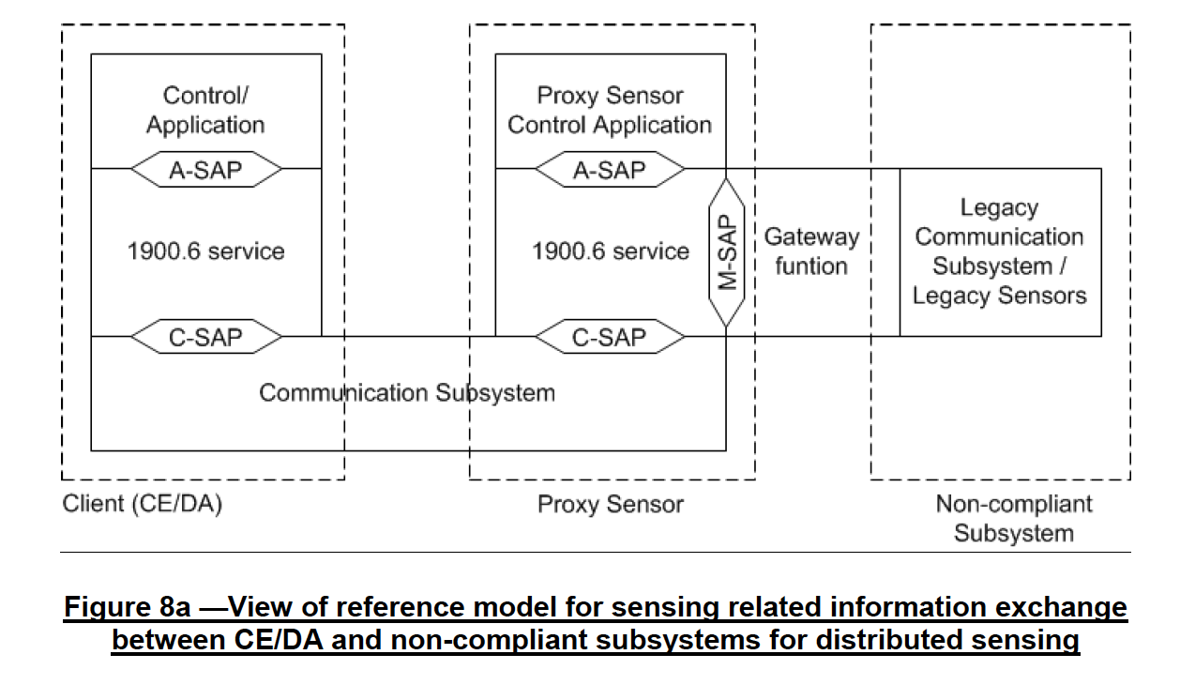

**Architecture comparison (for further discussion):**

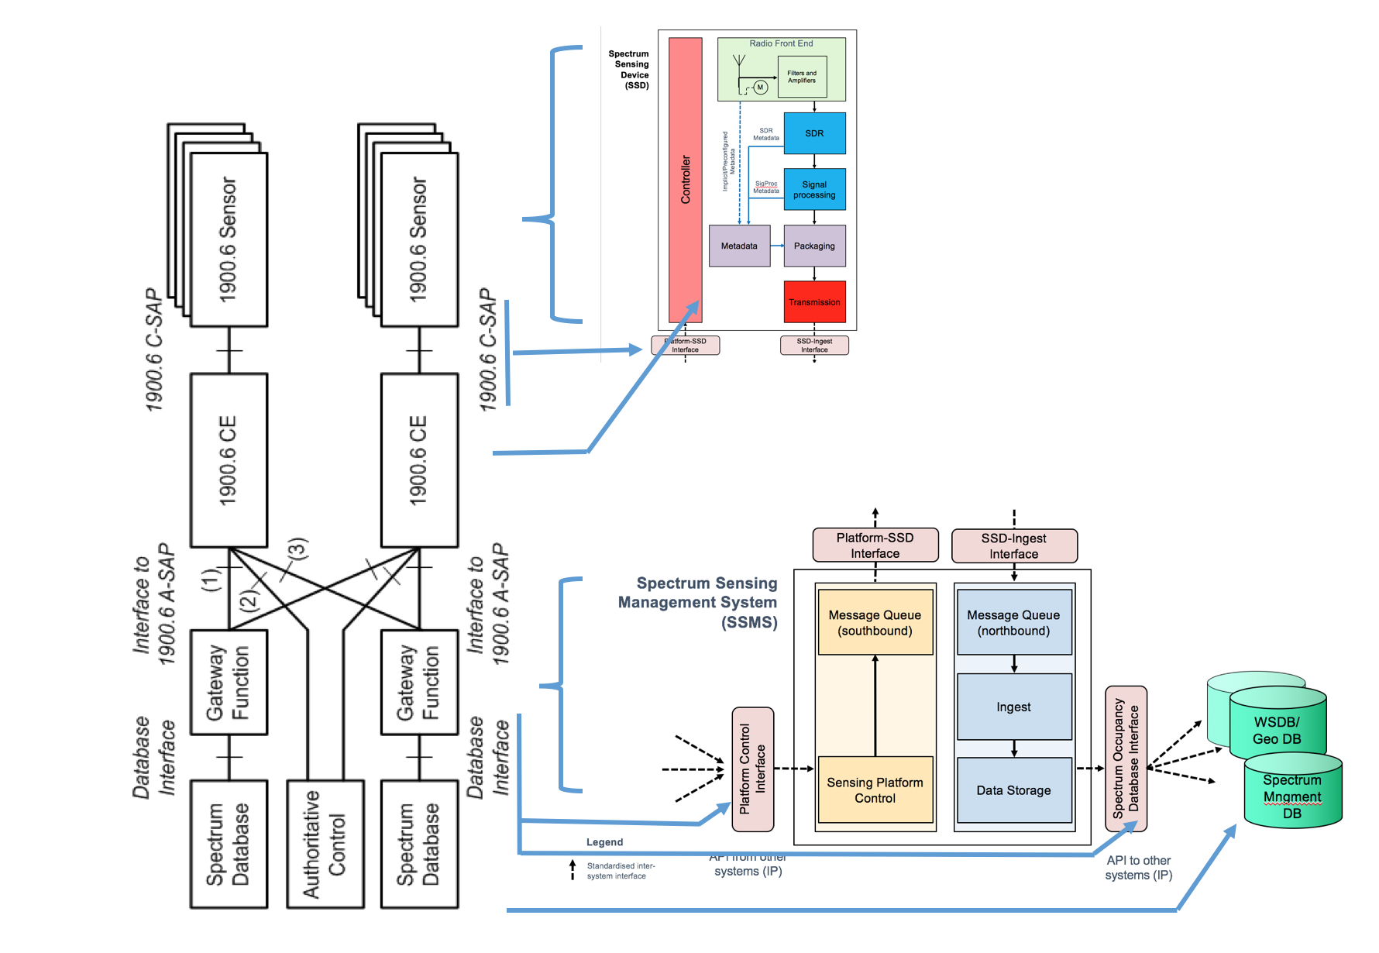

* 1. System model

Scenario 1: Single CE/DA and single Sensor

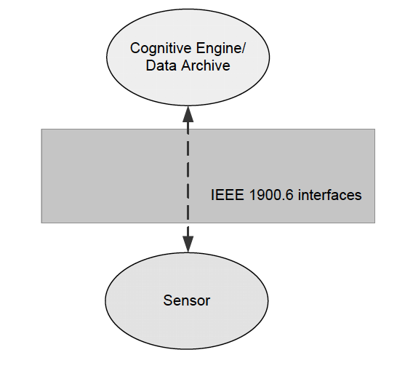

Scenario 2: Single CE/DA and multiple Sensors

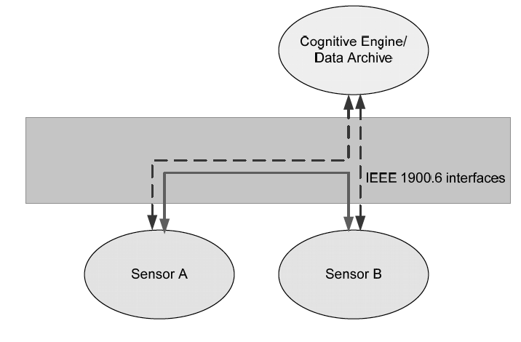

Scenario 3: Multiple CE/DA and single Sensor

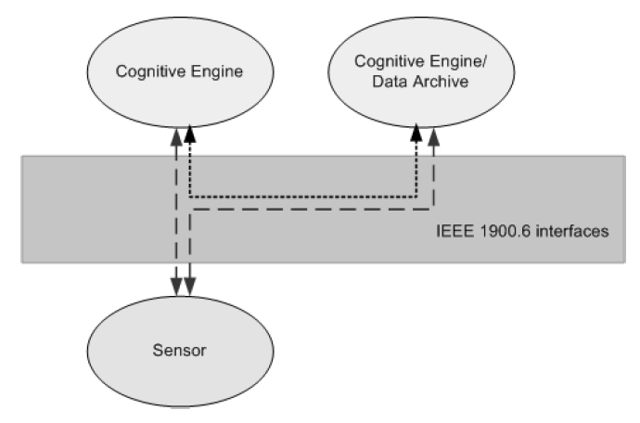

Scenario 4: Single CE/DA, multiple sensors that may act as a gateway to non-compliant subsystems

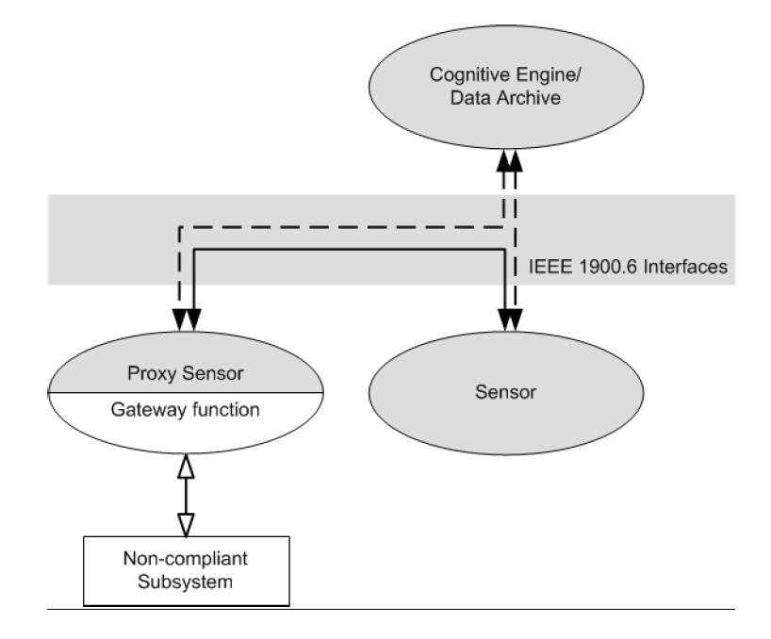

Scenario 5: Single CE/DA, single Sensor and a single CE, DA or Sensor hosting gateway function as service interface towards client spectrum database (P1900.6b)

1900

Scenario 6: Single CE/DA, single Sensor and spectrum database as a 1900.6 compliant entity (SD) (P1900.6b)

**1900**

* 1. Basic Method for sensing

This method is important to note in terms of process of locking/unlocking configuration. Note later the primitives summarised will omit the lock/unlock fields to save space/complexity in this doc. Functionality exists to query the sensor capabilities, set sensing system characteristics, and then acquire sensing data.

**1900**

1. Primitives and Interfaces
   1. Measurement SAP (M-SAP)

The M-SAP provides a set of generic primitives or method for IEEE 1900.6 SAP users to control spectrum sensing and to obtain sensing-related information from spectrum sensing.

The IEEE 1900.6 logical entities obtain the following services from the M-SAP:

**Measurement capabilities discovery services**

These provide a set of primitives or method through which the IEEE 1900.6 SAP user obtains the information related to the measurement capabilities of the associated measurement module.

Get_Supported_Spectrum_Measurement_Description: obtains the information related to the capability of the spectrum measurement module.

MeasurementCapabilityTransID

Status

MeasuRange

SensingMode

DataSheet.ADDAResolution

DataSheet.AngleResolution

DataSheet.FrequencyResolution

DataSheet.LocationTimeCapability

DataSheet.LoggingFunctions

DataSheet.RecordingCapability

DataSheet.SweepTime

LockStatus

DataArchiveAssisted (1900.6a)

MeasuRangeSimul (1900.6a)

**Measurement configuration discovery services**

These provide a set of primitives or method through which the IEEE 1900.6 SAP user obtains the information related to the measurement capabilities of the associated measurement module.

Get_Sensor_PHY _Description: obtains the information related to physical configuration of the spectrum measurement module.

SensorPHYProfileID,

Status,

Datasheet.CalibrationData,

Datasheet.CalibrationMethod,

Datasheet.ChannelFiltering,

Datasheet.DynamicRange,

Datasheet.NoiseFactor,

Datasheet.PhaseNoise,

LockStatus

Get_Sensor_Antenna _Description: obtain the information related to the antenna configuration of the spectrum

measurement module.

SensorAntennaProfileID,

Status,

Datasheet.AntennaBandwidth,

Datasheet.AntennaBeamPointing,

Datasheet.AntennaBeamwidth,

Datasheet.AntennaDirectivityGain,

Datasheet.AntennaGain,

Datasheet.AntennaHeight,

Datasheet.AntennaPolarization,

LockStatus

Get_Sensor_Location _Description: Obtain the information related to the location of the spectrum measurement

module. Note that the spectrum measurement module represents the location of the measurement.

SensorLocationTransID,

Status,

AbsSensorLocation,

RelSensorLocation,

PostSensorAddress (1900.6a)

LockStatus

**Measurement configuration services**

These provide a set of primitives or method through which the IEEE 1900.6 SAP user configures the spectrum measurement module.

Set_Sensor_Measurement_Obj: set the measurement objective of the spectrum measurement module.

SensorMeasurementObjID,

StartTime,

EndTime,

Bandwidth

Set_Sensor_Measurement_Profile: set the measurement profile of the spectrum measurement module.

SensorMeasurementProfileID,

SensingMode,

ChOrder,

ChList,

SensingDuration, (1900.6a)

SensingPeriod, (1900.6a)

ReportRate,

Scan.LowerThreshold,

ReportingMode,

SequenceSamplingPeriod, (1900.6a)

AutoCorrSamplingPeriod, (1900.6a)

ChMeasuSimul (1900.6a)

Set_Sensor_Measurement_Performance: set the target performance of the spectrum measurement module

SensorMeasurementPerformanceID,

PerfMetric.Pd,

PerfMetric.Pf

PerfMetric.Time, (1900.6a)

RATID (1900.6a)

**Information services**

These provide a set of primitives or methods through which the IEEE 1900.6 SAP user collects the information related to the measurement configuration of the spectrum measurement module.

Sensor profile collection

Get_Sensor_Manufacturer_Profile: collect the information related to the manufacturer of the spectrum measurement module.

SensorManufacturerProfileID ,

Status,

SensorID.VendorID,

SensorID.ProductID,

SensroID.Serial (1900.6a)

LockStatus

Get_Sensor_Power_Profile: collect the information related to the power consumption of the spectrum measurement module.

SensorPowerProfileID,

Status,

BatteryStatus,

Datasheet.PowerConsumption,

LockStatus

Measurement profile collection

Get_Measurement_Profile: obtain the information related to the spectrum measurement that has been carried out.

SensorMeasurementProfileID,

Status,

ConfidenceLevel,

ReportMode,

SensingMode,

ReportRate,

TimeStamp,

Scan.LowerThreshold,

MeasuBandwidth,

LockStatus

Get_Measurement_Location_Information: collect the information related to the location where the spectrum measurement has been carried out.

MeasurementLocationTransID,

Status,

AbsSensorLocation,

RelSensorLocation,

LockStatus

Signal measurement collection

Get_Signal_Measurement_Value: collect the measured value related to the measured signals.

SignalMeasurementID,

Status,

SignalDesc,

LockStatus

Channel measurement collection

Get_Channel_Measurement_Value: collect the measured value related to the measured channels.

ChannelMeasurementID,

Status,

Bandwidth,

NoisePower,

SignalLevel,

LockStatus

RAT measurement collection

Get_RAT_ID_Value: collect the measured value related to the measured Radio Access Technology (RAT).

RATIDValueRequestTransID,

Status,

RATID,

LockStatus

Management

Notify: used by the measurement module to report its status to IEEE 1900.6 SAP user.

Type,

Status,

Reason

* 1. Communication Service Access Point (C-SAP)

The C-SAP is used for the exchange of sensing-related information (cf. 6.1) between Sensors and their clients. The client role can be taken by a Sensor, CE, or DA. It abstracts services of the communication by providing a set of generic primitives or method and mapping these primitives to transport protocols.

The IEEE 1900.6 SAP users obtain the following services from the C-SAP:

⎯ Sensing-related information send service

⎯ Sensing-related information receive service

⎯ Information services

Sensing_Related_Information_Send/Recieve.request .response

InfoSource, InfoSource

InfoDestination, InfoDestination

Route, Route

ReportMode, ReportMode,

SecLevel, SecLevel,

ReportRate, ReportRate,

SensingRelatedInformation Status

Timeout

LockStatus

Get_CommSubsys_Profile: obtain the information related to the capabilities of a communication subsystem.

Status,

Comm_Subsys_ID,

Comm_Subsys_

Notify: used by the communication subsystem to notify a status change to the IEEE 1900.6 SAP user through the C-SAP.

Type,

Status,

Reason

* 1. Application service access point (A-SAP)

Used by the control/application (cf. 5.1) to interact with IEEE 1900.6 service. It provides a set of primitives or method for IEEE 1900.6 SAP users to control spectrum sensing and obtain sensing related information from spectrum sensing.

Sensor discovery service

Get_Sensor_Logical_ID

Obtain a list of available sensors

Status,

ListOfSensors,

LockStatus

Get_CommSubsys_ID: used by the control/application to obtain a list of available communication subsystems.

Status,

ListOfCommSubsys,

LockStatus

Advertisement: used by the control/application of an IEEE 1900.6 client to generate an advertisement beacon. The advertisement beacon serves both for notification of presence of the client as well as synchronization of the sensors attached to the client.

AdvertInterval

TimeSync

ClientLogID

LinkSetup: used by the control/application of an IEEE 1900.6 client to set up a link for information

exchange.

LinkTermination: used by the control/application of an IEEE 1900.6 client to terminate an established link

for sensing related information exchange with a sensor.

**Sensing-related information access service**

Read_Sensing_Related_Info: used by the control/application to read sensing-related information.

.request

SensingInfoList,

ClientLogID,

ClientPriorityFlag,

SensorLogID,

SensorPriority

.response

Status,

Information,

LockStatus

Write_Sensing_Related_Info.request: used by the control/application to write sensing-related information.

SensingInfoList,

Information,

ClientLogID,

ClientPriorityFlag,

SensorLogID,

SensorPriority

**Management and configuration services**

Lock: used by the control/application to lock IEEE 1900.6 logical entities or communication

subsystems for exclusive use and to prevent other controls/applications from accessing those resources.

Unlock: used by the control/application to unlock IEEE 1900.6 logical entities or communication

subsystems from exclusive use.

BreakLock: used by the control/application to break the lock of IEEE 1900.6 logical entities or

communication subsystems so that it can access those resources.

Trigger: used by the control/application to trigger an event.

EventID,

TriggerTime,

Timeout

Comm_Management: returns the results of the communication management request issued by the

control/application.

Status,

CommManagementTransID,

NetworkTopology,

LockStatus

**Information services**

The sensing information service provides a set of primitives or method through which the control/application obtains information such as ID and capability of the IEEE 1900.6 clients through the ASAP.

Get_ Client_Profile: used by the control/application to obtain the profile such as ID and capability of IEEE 1900.6 clients.

Status

ClientLogID,

Client_Capability,

LockStatus

Notify: used by the control/application to notify a status change to IEEE 1900.6 service.

Type,

Status,

Reason

Get_Data_Source_List: used by the control/application to identify the data sources which can exchange sensing related information and other relevant data with the data archive.

Status,

ListOfDataSourceLogIDs,

ListOfDataSourceTypes

6.3.22f 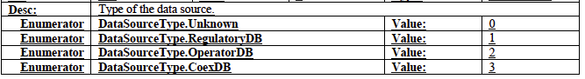

1. Device parameters – Physical Sensing Metrics

**Measurement capabilities discovery services in M-SAP**

Get_Supported_Spectrum_Measurement_Description.response

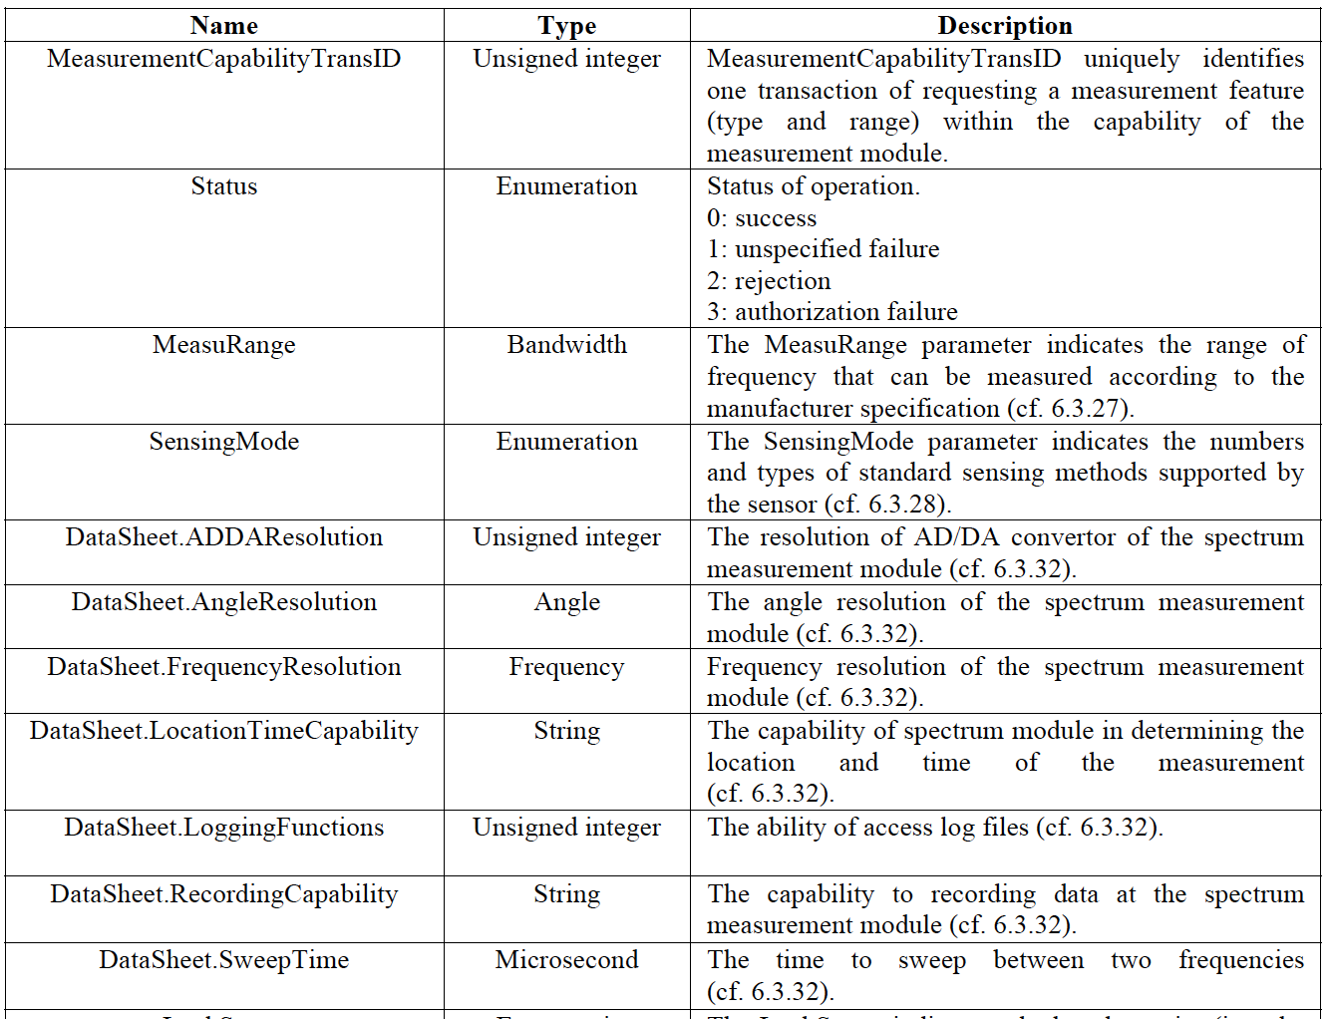

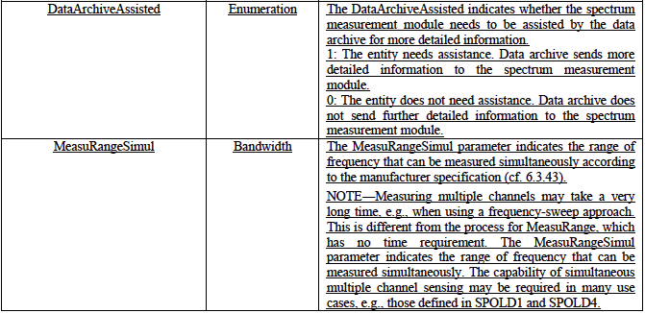 (P1900.6a)

**Measurement configuration discovery services**

Get_Sensor_PHY_Description.response

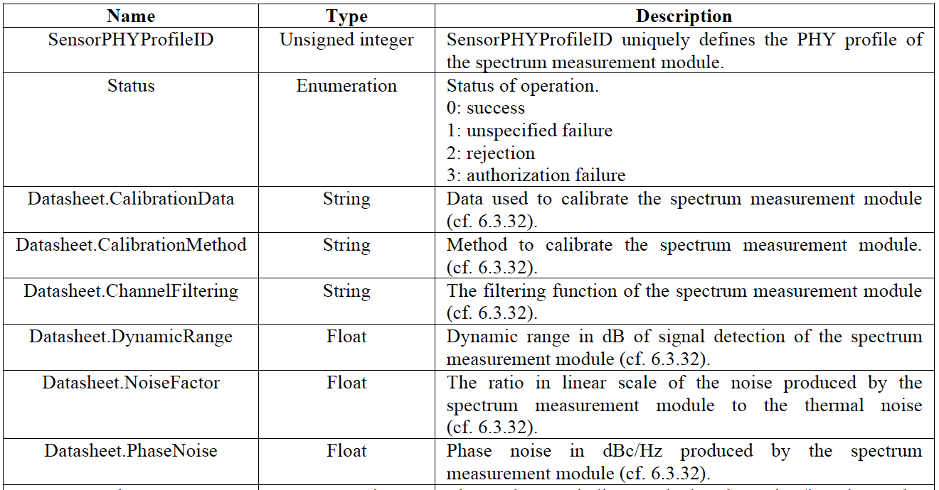

Get_Sensor_Antenna_Description.response

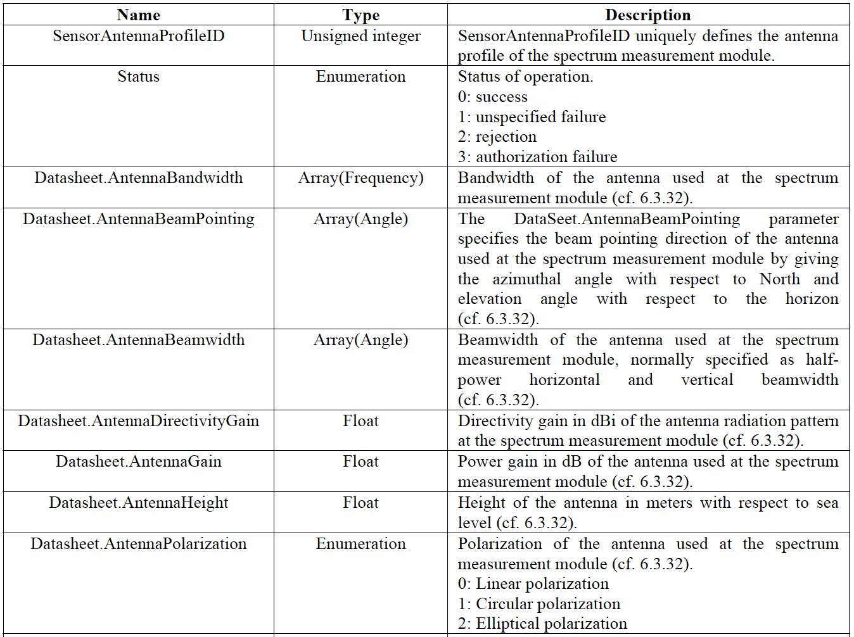

Get_Sensor_Location_Description.response

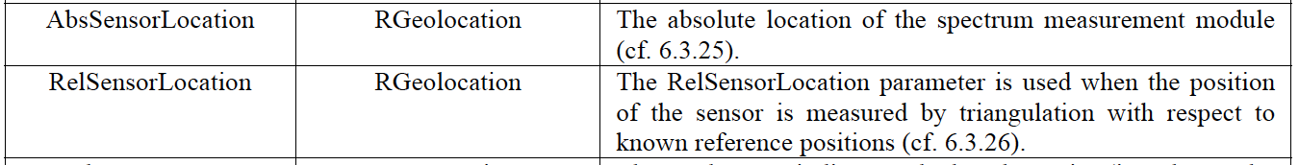

6.3.28 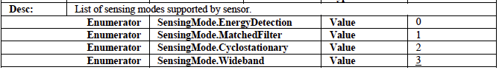 (P1900.6a)

6.3.32 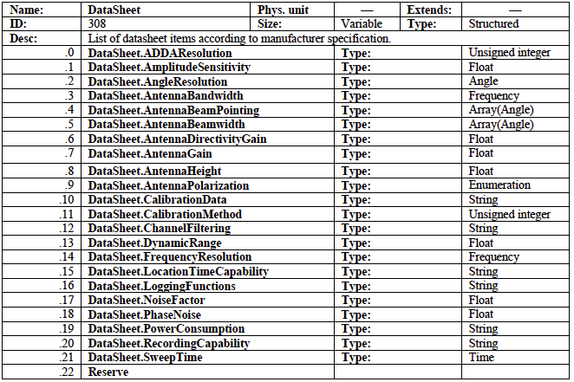

* 1. Hardware parameters – Sensing Device Configuration Metrics

Measurement configuration services in M-SAP

Set_Sensor_Measurement_Obj.request (sensing objective)

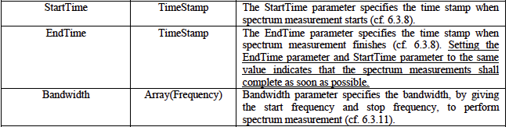 (amended P1900.6)

Note: Timestamp value. Seconds and microseconds since midnight (UTC) of January 1, 1970.

Set_Sensor_Measurement_Profile.request

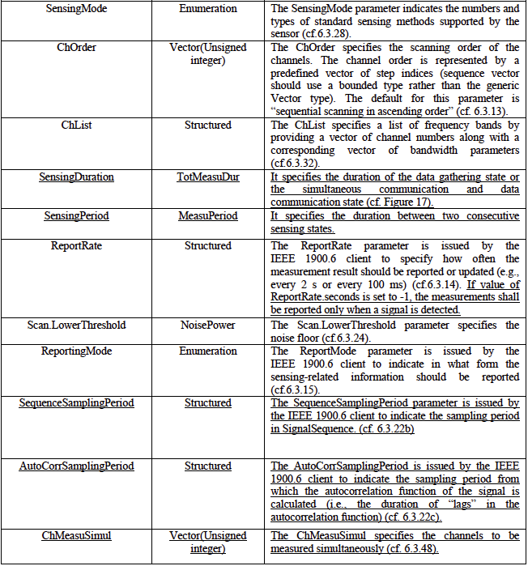 (amended P1900.6)

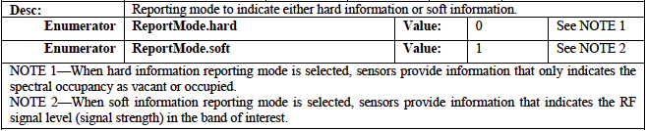

Set_Sensor_Measurement_Performance.request

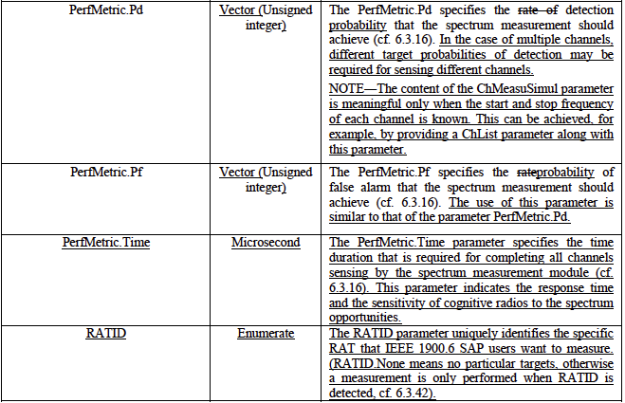 (amended P1900.6)

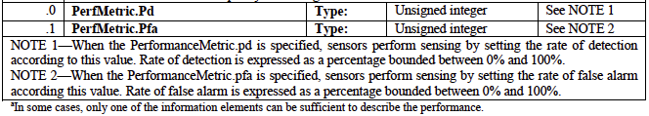

**Information services**

Get_Sensor_Manufacturer_Profile.response

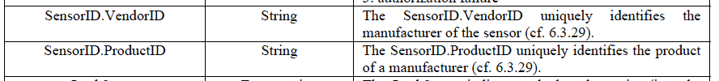

Get_Sensor_Power_Profile.response

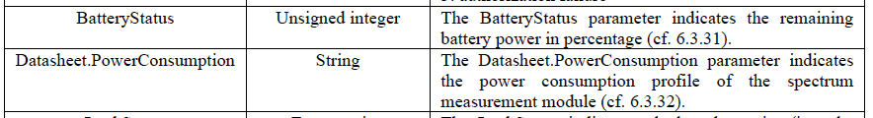

Get_Sensor_Measurement_Profile.response

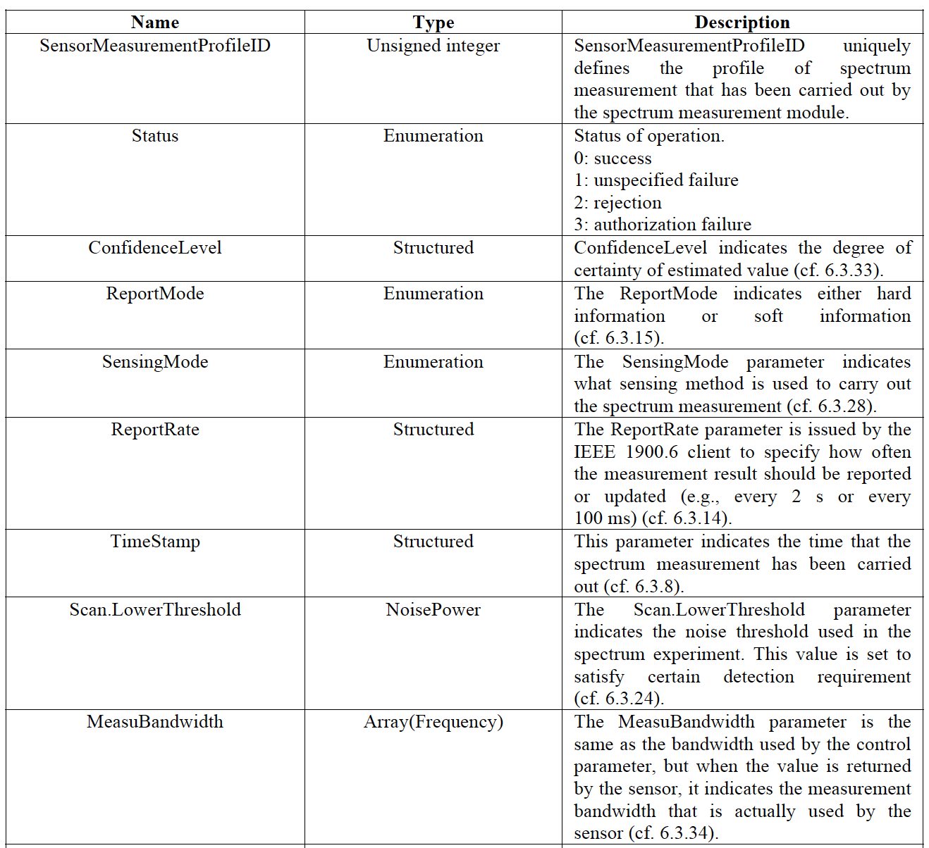

6.3.33 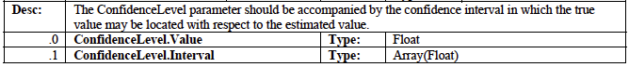

6.3.24 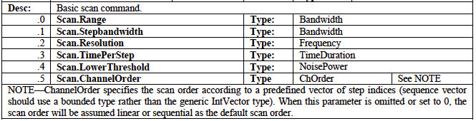

Get_Measurement_Location_Information.response

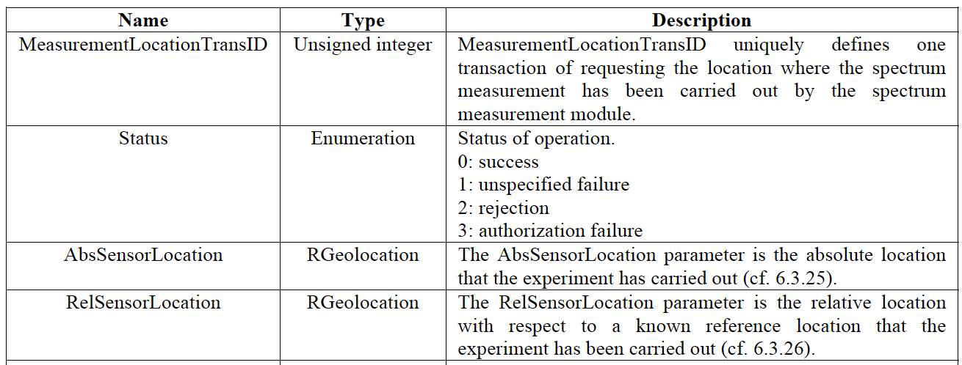

Get_Signal_Measurement_Value.response

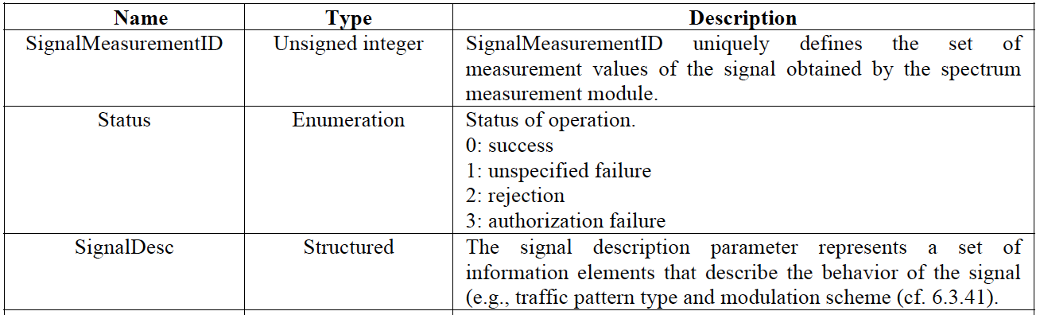

6.3.41 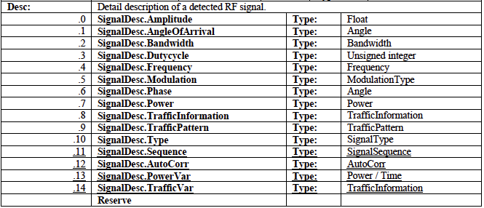

Get_Channel_Measurement_Value.response

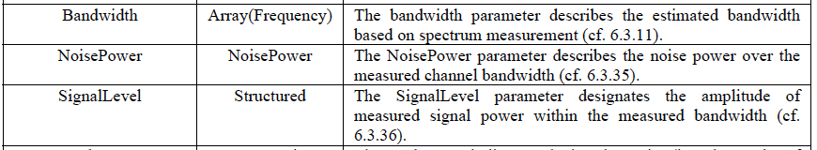

6.3.35 

6.3.36 

Get_RAT_ID_Value.response

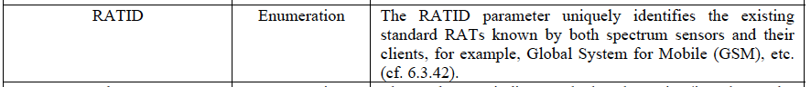

6.3.42 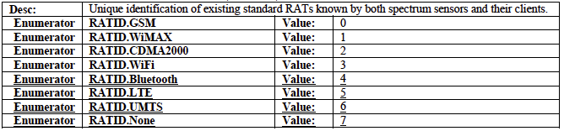 (amended P1900.6)