Relevance of VITA-49 to 802.22.3

Elements that may be directly applicable in proposed IEEE SCOS standard

Summary of VITA-49:
- Transport-layer protocol designed for radio equipment interoperability
- Standardization of digitized signal sample streams for software radio systems
- Standardization of metadata transport between system elements
- Enhancements for transmitters, control functions, status monitoring, and event triggering

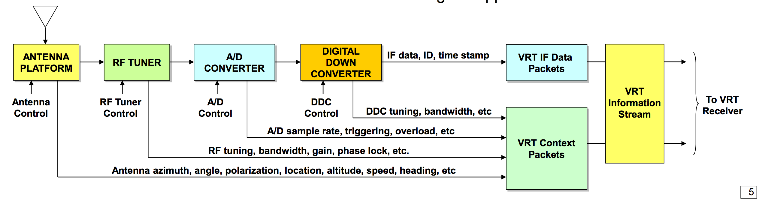
from http://embeddedtechtrends.com/2016/PDF_Presentations/T11-Pentek.pdf

Radio functions supported in VITA 49.0 to 49.2

VITA standard | SCOS requirement | Requirement for standard
Support for transmitters or transmit data-only receivers | No relevant to SCOS | None
Control of radio equipment – tuning, scanning, bandwidth, antenna position, gain, etc.  Provided for in VITA 49.2 Receiver Context Packets and new Control Packets | This is a key requirement for SCOS | To be implemented in SSD controller via SSD-SSMS Control interface
Interrogation of radio equipment – operational status, capabilities, system health, etc  Provided for in VITA 49.2 Control Packets | This is highly desirable for a flexible “SCOS platform” approach | To be implemented SSD-SSMS Control interface querying SSD controller
Support for sending spectral data – only time samples.  (addressed in VITA-49.2 “Signal Data Packets”) | Raw spectrum data is useful in a number of use cases | To be implemented in SSMS to request SCOS raw spectrum scans.

Some key elements relevant to 802.22.3 SCOS
(from VITA-49.0-2007/D0.21)

VRT Streams
These are split onto Data Packets and Context Packets (which would now include Control Packets in 49.2). Packets are placed into streams, and Data and Context streams are paired using pair identifiers.

“A Context Packet Stream shall be paired with at most one Data Packet Stream. This pairing shall be indicated on the link by the sharing of a Stream ID between the Data Packet Stream and the paired Context Packet Stream.”

Note: for 802.22.3 SCOS, “streams” may not be appropriate as the SCOS requirement is not necessarily for a synchronous sensing capability, or for real-time streaming of sensing data. However, it may be advantageous to implement this kind of design (even if the streams are “virtual” inside the Spectrum Sensing Device (SSD) which gathers a sequence into a package of sensing data which is then transmitted over the SSD-SSMS Ingest interface.

Context Fields

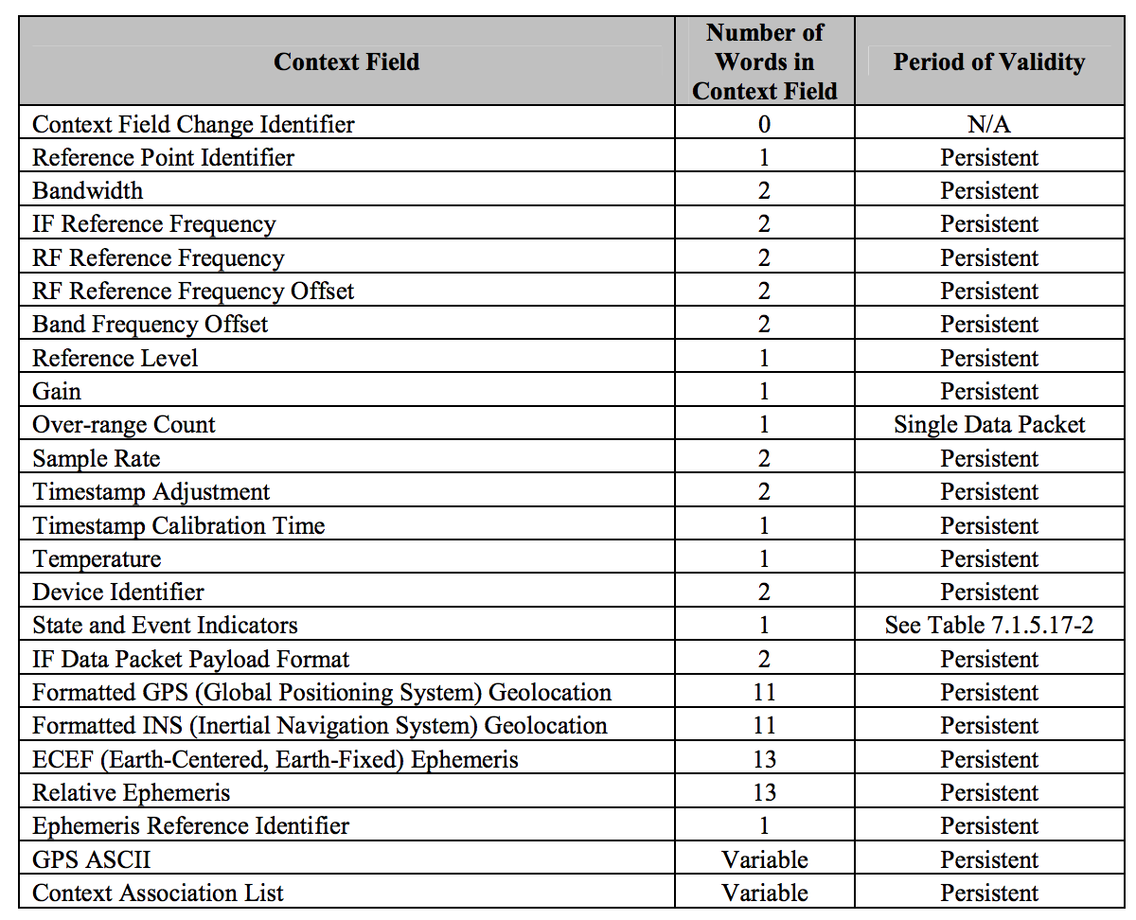

Context Field Change Indicator: In many systems it is desirable to periodically send Context information updates even when the Context information has not changed.
Reference Point Identifier: Indicates the point in the system where the Context applies.
Bandwidth Field: Describes the amount of usable spectrum at the output of a process.
IF Reference Frequency Field: 1. Work in conjunction with the RF Reference Frequency field to identify the original RF frequency band from which a digital or analog IF signal has been translated. 2. Identify the center of the band described by the Bandwidth field. The value in this field may be equal to the band center, or in some cases it may work in conjunction with the IF Band Offset field to indicate the band center.
RF Reference Frequency Field: The original frequency that was ultimately translated to the IF Reference Frequency is specified with the RF Reference Frequency field.
RF Reference Frequency Offset Field: provides a method to send an update in only a single Context packet when the tuner frequency changes, avoiding potential link congestion.
IF Band Offset Field: Used to specify the frequency offset from the IF Reference Frequency to the center of the band.
Reference Level Field: Relates the physical signal amplitude at the Reference Point (as identified by the Reference Point ID) with the values of the Data Samples in an IF Data packet payload (in dBm)
Gain Field: Describes the amount of signal gain or attenuation from the Reference Point to the Described Signal (dB).
Over-range Count Field: Conveys the number of over-range Data Samples in a single paired Data packet.
Sample Rate Field: Expresses the sample rate of the Data Samples in the payload of the paired Data Packet Stream (Hz).
Timestamp Adjustment Field: The Timestamp field in the IF Data packet is often used to give the time of signal digitization. The Timestamp Adjustment field is used to adjust this Timestamp so that together they reflect the Reference Point Time.
Timestamp Calibration Time: Conveys the date and time at which the Timestamp in the Data and Context packets was known to be correct.
Temperature Field: Conveys the temperature of some process or process component that may affect some aspect of the Described Signal (C).
Device Identifier Field: Identifies the manufacturer and model of the device generating an IF Context Packet Stream (IEEE OUI).
State and Event Indicator Field: Convey a set of binary indications and a limited number of non-binary state indications. It contains eight predefined Indicator bits and user defined bits.
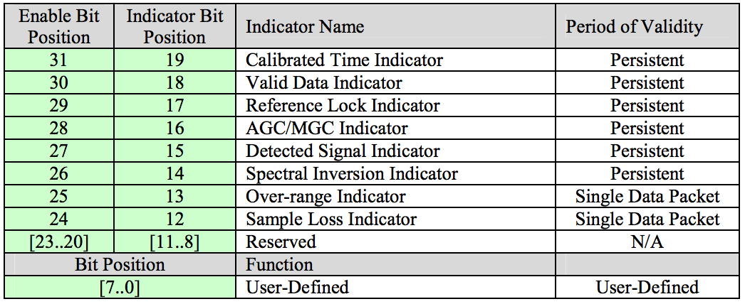

Data Packet Payload Format: Specifies the packing and content of the payload of the paired Data Packet Stream
Formatted GPS Geolocation and INS Fields: GPS (Global Positioning System) and INS (Inertial Navigation System) Geolocation fields share the same format
ECEF (Earth-Centered, Earth-Fixed) Ephemeris Field: Provides a format to convey location in Earth-Centered, Earth-Fixed Cartesian coordinates.
Relative Ephemeris Fields: Same format as the ECEF Ephemeris field
Ephemeris Reference Identifier: Identifies the process whose location serves as the origin for the Relative Ephemeris.
GPS ASCII Field: Some GPS devices output their information in the form of formatted ASCII strings, known as GPS “sentences.”

Other fields that are recommended that may be of interest for 802.22.3 SCOS metadata are accuracy paremeters:

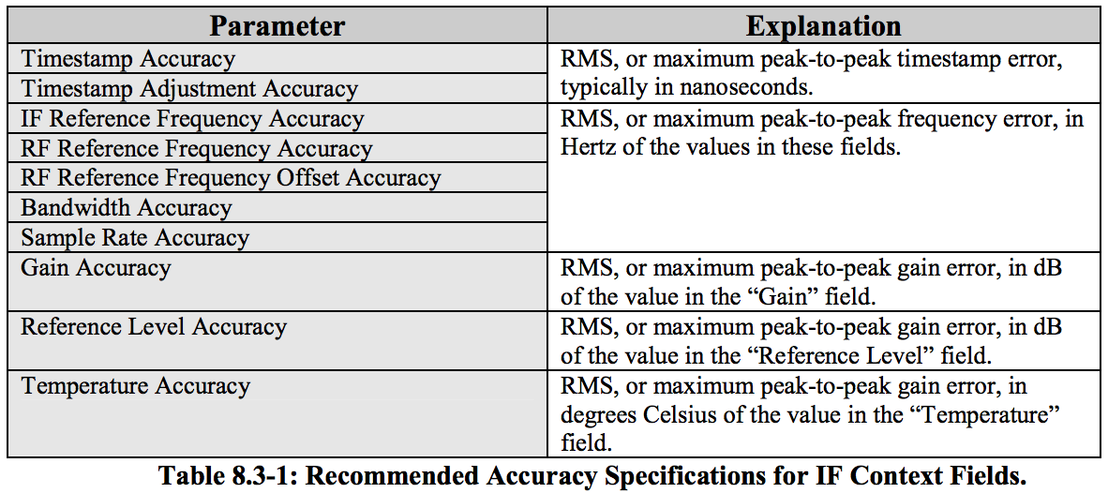

Also, some recommended “system specific” items:
• Receiver noise figure.
• Receiver tuning range.
• Equipment operating temperature range.
• Maximum required power.

