IEEE P802.22
Wireless RANs
P802.22b Coexistence Assurance Document
Date: 2014-11-05
Author(s):
Name | Company | Address | Phone | email
Chang Woo Pyo | NICT | Japan |  | cwpyo@nict.go.jp
Apurva N. Mody | BAE Systems / WhiteSpace Alliance | USA |  | apurva.mody@baesystems.com  apurva.mody@WhiteSpaceAlliance.org
Gabriel Villardi | NICT | Japan |  | gpvillardi@nict.go.jp
Keat-beng Toh | Hitachi Kokusai | Japan |  | Toh.keatbeng@h-kokusai.com
Shigenobu Sasaki | Niigata University | Japan |  | shinsasaki@ieee.org
Sunghyun Hwang | ETRI | Korea |  | shwang@etri.re.kr

Section 1.Introduction
Abstract
This serves as the coexistence assurance document for P802.22b in meeting the requirement of the 5 criteria.
Notice: This document has been prepared to assist IEEE 802.22. It is offered as a basis for discussion and is not binding on the contributing individual(s) or organization(s). The material in this document is subject to change in form and content after further study. The contributor(s) reserve(s) the right to add, amend or withdraw material contained herein.

Release: The contributor grants a free, irrevocable license to the IEEE to incorporate material contained in this contribution, and any modifications thereof, in the creation of an IEEE Standards publication; to copyright in the IEEE’s name any IEEE Standards publication even though it may include portions of this contribution; and at the IEEE’s sole discretion to permit others to reproduce in whole or in part the resulting IEEE Standards publication. The contributor also acknowledges and accepts that this contribution may be made public by IEEE 802.22.

Patent Policy and Procedures: The contributor is familiar with the IEEE 802 Patent Policy and Procedures
<http://standards.ieee.org/guides/bylaws/sb-bylaws.pdf>, including the statement "IEEE standards may include the known use of patent(s), including patent applications, provided the IEEE receives assurance from the patent holder or applicant with respect to patents essential for compliance with both mandatory and optional portions of the standard." Early disclosure to the Working Group of patent information that might be relevant to the standard is essential to reduce the possibility for delays in the development process and increase the likelihood that the draft publication will be approved for publication. Please notify the Chair Apurva Mody <apurva.mody@ieee.org> as early as possible, in written or electronic form, if patented technology (or technology under patent application) might be incorporated into a draft standard being developed within the IEEE 802.22 Working Group. If you have questions, contact the IEEE Patent Committee Administrator at <patcom@ieee.org>.

The IEEE 802 has approved the following standards for operataion in the TV Band White Spaces whose operation may span from 54 MHz to 862 MHz: IEEE Std. 802.22-2011, IEEE Std. 802.11af -2013, and IEEE Std. 802.15.4m-2014.

This document outlines the features of the P802.22b amendment and the coexistence between like and unlike systems when they appear in this band. Today, the regulations for the TV band whitespaces are still emerging and there has not been enough deployement of communication systems, also known as whitespace devices (WSDs). The unique characteristics of TV whitespace today allow spectrum etiquette and coexistence enabled through the geo-location databases.

The IEEE 802.22 systems propose to serve large regional areas spanning anywhere from 10 km to 30 km, whereas IEEE 802.11af/ IEEE 802.15.4m propose to serve smaller areas spanning few hundred meters to a few km. As a result, 802.22 systems fall in the Fixed Device category as defined by some of the regulations that have been specified for TV Band White Spaces [5], typicaly using 1 Watt of conducted and 4 Watts of radiated power, whereas IEEE 802.11af and IEEE 802.15.4m typically fall into personal portable Mode II and Mode I device category [5].

In the United States, after the proposed incentive auctions [1] of the TV channels, FCC is likely to allow the operation of low power personal portable devices in the Guard Bands and the Duplex Gaps [4], however, the Fixed 4 Watt devices will be prohibited from operating on those channels. Also, personal portable low power devices are allowed to operate on channels that are adjacent to the TV Broadcast services, where as Fixed 4 Watt devices are prohibited from operating on those channels.

As a result, at the highest level, co-existence between IEEE 802.22 and IEEE 802.11af / IEEE 802.15.4m systems is facilitated as a by-product of the regulatory rules that have been defined.

Table 1: FCC Transmit Power Limitations [5]
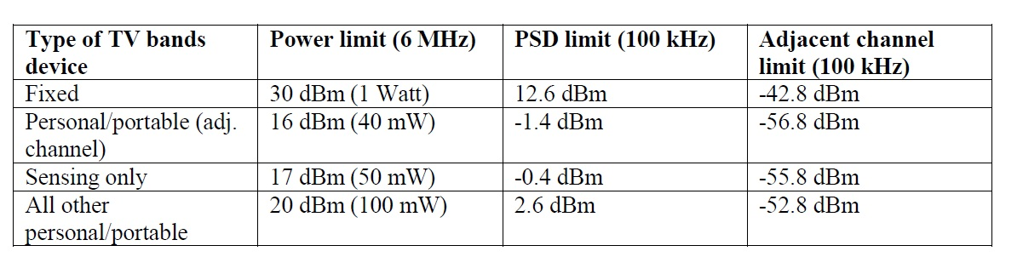

Section 2.P802.22b PHY Operation Modes (OMs)

The 802.22b amendament supports two types of PHYs: PHY Operation Mode 1 (PHY OM1) and PHY operation mode 2 (PHY OM2). The details of each PHY OM are shown in below.

PHY OM1

PHY OM1 is the same defined in IEEE Std. 802.22-2011 except for additional data rates.

Table 2 – System Parameters for PHY OM1

Parameters | Specifications
Frequency Range | 54~862 MHz
Channel bandwidth | 6, 7, or 8 MHz
Transmit Power | 1 Watt maximum conducted power for CPEs and BS in the USA regulatory domain.
Multiple Access | OFDMA
FFT Size (N_{FFT}) | 2048
Duplex | TDD

PHY OM2

PHY OM2 is newly defined in the 802.22b amendament.

Table 3 – System Parameters for PHY OM1
Parameters | Specifications
Frequency Range | 54~862 MHz
Channel bandwidth | 6, 7, or 8 MHz
Transmit Power | 1 Watt maximum conducted power for CPEs and BS in the USA regulatory domain.
Multiple Access | OFDMA
FFT Size (N_{FFT}) | 1024
Duplex | TDD

Section 3. P802.22b Coexistence Features

Geo-location Database and IEEE 802.19.1 Enabled Co-existence

The FCC and other regulatory domains [5, 6, 7] require the use of a geo-location database to ensure that unlicensed devices operating in this band do not interfere with licensed users.

P802.22b incorporates database access mechanisms prescribed by the FCC Part 15.700 rules to avoid interfering with the protected license holders.

The 802.22b systems provide their Geolocation information to the database in order to get the available channels for their configuration of operation.

It is possible for the Geolocation Database to enable co-existence between dissimilar systems. Such co-existence mechanisms are discussed in the UK Ofcom regulatory rules [6] where the WSDs may provide their Technology Identifiers to the Geolocation Database. In the US, some Database Aministrators have suggested providing this co-existence technology between dissimilar systems as a value added services.

Finally it is also possible to deploy IEEE 802.19.1 systems that can facilitate co-existence between dissimilar WSD systems.

Transmit Power Control

The 802.22b amendment, as mandated by regulations, utilizes TPC as a means for maintaining the transmitted signal at a level that meets, but does not exceed that necessary for robust communication. Transmit power control is another technique that may be used to minimize interference between systems.

Coexistence Protocols

Self-Coexistence

With regards to self-coexistence, the P802.22b amendament provides the coexistence beacon protocol (CBP) which is used to exchange coexistence beacons to achieve efficient self-coexistence among overlapping IEEE P802.22b cells. The combination of the incumbent protection and self-coexistence mechanisms forms a MAC layer that is highly flexible and adaptive to the environment, and can react to sudden changes.

CBP frame contains a common information of superframe control header and frame control header of 802.22, 802.22b PHY OM1, or 802.22b PHY OM2. If a CPE receives CBP frame transmitted by other WRAN, the CPE performs self-coexistence by spectrum etiquette or quite period scheduling/spectrum sensing.

Spectrum etiquette

Figure 1 shows the fundamental logic as incorporated in the P802.22b for Spectrum Etiquette mechanism. Figure 2 shows the concept of operation of the Spectrum Etiquette as defined in the IEEE P802.22b. Spectrum etiquette is used to select primary and backup channels that are orthogonal when sufficient channels are available. Note, while currently 802.22 systems exchange the spectrum etiquette information amongst themselves, in future the IEEE 802.22 systems may send this information back to the database or an IEEE 802.19.1 co-existence server, and this database/802.19.1 will facilitate co-existence. In fact such Technology Identifier feedback to database has been discussed in the proposed TV White Space rules specified by the UK Ofcom [6].

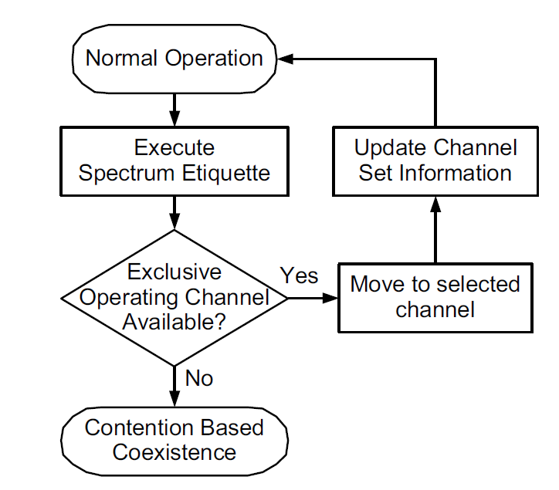
Figure 1 – Spectrum Etiquette Operation

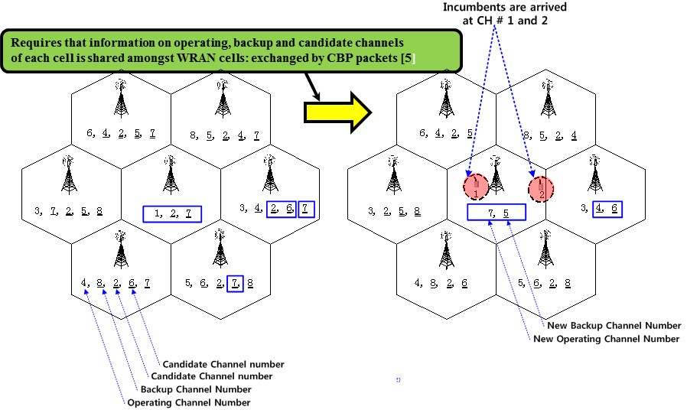
Figure 2 – Example of Spectrum Etiquette Operation

Quiet Period (QP) scheduling and Spectrum Sensing

For detecting the presence of incumbents, as well as dissimilar systems such as 802.11af and 802.15.4m in the operating channel, the 802.22b amendament schedules network-wide quiet periods for sensing. During these quiet periods, all network traffic is suspended and base stations and CPEs perform in-band sensing. This process is coordinated by the BS, which is responsible for scheduling the quiet periods.

On-Demand Frame Contention (ODFC)

On-demand frame contention as contention based coexistence is used when a single TVWS channel must be shared between systems. ODFC allows up to Sixteen 802.22 systems to share a single channel, using Time Division contention of the frames in a super-frame between various 802.22 systems. Our simulation results indicate that the ODFC contention algorithm provides a fair allocation of frames to various users [8]. While currently, the ODFC has been proposed for intra-system co-existence between the 802.22 systems, it is possible in future to extend it to inter-system co-existence where some of the Frames may be freed up for IEEE 802.11af / IEEE 802.15.4m systems.
Figure 3. On Demand Frame Contention (ODFC) Mechanism as incorporated in P802.22b.

The Table 3 below shows the Summary of the Coexistene Cases between the P802.22b Amendment and various other IEEE 802 standards that have been approved for operation in the TV Band White Spaces. It also shows the co-existence mechanisms that may be used to facilitate intra, and inter-system co-existence.

Table 3 Summary of Coexistence Cases and Methods

Senarios | Coexistence with Dissimilar Systems in TVWS |  | Coexistence Methods
Case 1 | P802.22b PHY OM1 | 802.22 | - Database enabled channel management  - Spectrum etiquette  - QP scheduling and Spectrum sensing  - On-demand frame contention
Case 2 | P802.22b PHY OM2 | 802.22 | - Database enabled channel management  - 802.19.1 enabled inter-system coexistence  - Spectrum etiquette enabled throught geo-location databases  - QP scheduling and Spectrum sensing
Case 3 | P802.22b PHY OM1 | P802.22b PHY OM2
Case 4 | P802.22b | 802.11 af
Case 5 | P802.22b | 802.15.4m

Section 5.Conclusion

This coexistence assurance document shows the main features of P802.22b amendament, and provides the incumbent protection and coexistence features of P802.22b which will improve coexistence between like and unlike systems in the TV Band White Spaces.

References:

[1] http://hraunfoss.fcc.gov/edocs_public/attachmatch/FCC-10-174A1.pdf

[2] Doc # 802.11-11/0177r1 “11af Coexistence Assurance Document” https://mentor.ieee.org/802.11/dcn/11/11-11-0177-01-00af-coexistence-assurance.doc

[3] Doc # 802.15-13/166r3 “TG 15.4m Coexistence Assurance Document” https://mentor.ieee.org/802.15/dcn/13/15-13-0166-03-004m-tg-15-4m-coexistence-assurance-document-cad.pdf

[4] FCC-12-118A1 (2012-10-Incentive Auction)

[5] FCC-12-36A1 “THIRD MEMORANDUM OPINION AND ORDER”

[6] Ofcom TV whitespaces: approach to coexistence,
http://stakeholders.ofcom.org.uk/consultations/white-space-coexistence/

[7]IDA Syngapore: PROPOSED REGULATORY FRAMEWORK FOR TV WHITE SPACE OPERATIONS IN THE VHF/UHF BANDS, http://www.ida.gov.sg/Policies-and-Regulations/Consultation-Papers-and-Decisions/Store/Proposed-Regulatory-Framework-for-TV-White-Space--Operations-in-the-VHF-UHF-Bands

[8] W. Hu, “Adaptive On Demand Channel Contention,” https://mentor.ieee.org/802.22/dcn/08/22-08-0078-00-0000-adaptive-on-demand-channel-contention.ppt

[9] FCC 14-144A1 Amendment of Part 15 of the Commission’s Rules for Unlicensed Operations in the Television Bands, Repurposed 600 MHz Band, 600 MHz Guard Bands and Duplex Gap, and Channel 37 – ET Docket No. 14-165

