IEEE P802.22
Wireless RANs
A-WRAN Descriptions
Date: 2014-07-03
Author(s):
Name | Company | Address | Phone | email
cwpyo | NICT |  |  | cwpyo@nict.go.jp
Abstract
Notice: This document has been prepared to assist IEEE 802.22. It is offered as a basis for discussion and is not binding on the contributing individual(s) or organization(s). The material in this document is subject to change in form and content after further study. The contributor(s) reserve(s) the right to add, amend or withdraw material contained herein.

Release: The contributor grants a free, irrevocable license to the IEEE to incorporate material contained in this contribution, and any modifications thereof, in the creation of an IEEE Standards publication; to copyright in the IEEE’s name any IEEE Standards publication even though it may include portions of this contribution; and at the IEEE’s sole discretion to permit others to reproduce in whole or in part the resulting IEEE Standards publication. The contributor also acknowledges and accepts that this contribution may be made public by IEEE 802.22.

Patent Policy and Procedures: The contributor is familiar with the IEEE 802 Patent Policy and Procedures
<http://standards.ieee.org/guides/bylaws/sb-bylaws.pdf>, including the statement "IEEE standards may include the known use of patent(s), including patent applications, provided the IEEE receives assurance from the patent holder or applicant with respect to patents essential for compliance with both mandatory and optional portions of the standard." Early disclosure to the Working Group of patent information that might be relevant to the standard is essential to reduce the possibility for delays in the development process and increase the likelihood that the draft publication will be approved for publication. Please notify the Chair Apurva Mody <apurva.mody@ieee.org> as early as possible, in written or electronic form, if patented technology (or technology under patent application) might be incorporated into a draft standard being developed within the IEEE 802.22 Working Group. If you have questions, contact the IEEE Patent Committee Administrator at <patcom@ieee.org>.

5 | TR | In the legacy/base standard, the BS ID and other parameters in the CBP MAC PDU, are carried in the SCH data that is copied into the CBP MAC PDU header that is defined in Table 8 of the base standard. In the current draft, the A-BS ID comes from the FCH PHY-OM2, while most of the other parameters come from the ExtFCH. The “SCH data” field of Table 8 only accommodates the legacy structure of the coexistence parameters, and doesn’t accommodate how this data is spread over the FCH PHY-OM2 and/or ExtFCH. No specific resolution is provided in this section. | Modify “SCH Data” field of Table 8 to accommodate the relevant data as structured in SCH, FCH PHY-OM2, and/or FCH PHY-OM2+ExtFCH. --or-- Add a second/new CBP MAC PDU format, that is exclusive for use by A-BS, A-CPE, and newer S-CPEs that reflects the relevant data that is spread over FCH PHY-OM2 and ExtFCH. Refer to section 6 of 22-14/128r0

- Proposed Resolution

Table 8 in 802.22 Standard is shown in below.
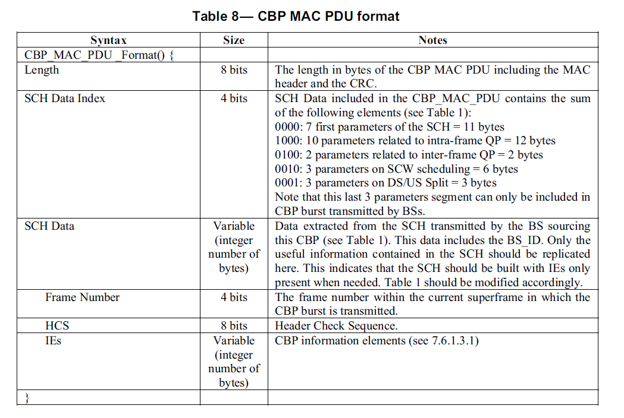

- Revise the title of Table 8 from “CBP MAC PDU format” to “CBP MAC PDU format (PHY OM1)”

- Add Table 8a for “CBP_MAC_PDU format (PHY OM2)” as follows

Table 8a – CBP MAC PDU format (PHY OM2)
Syntax | Size | Notes
CBP_MAC_PDU_Format() {
Length | 8 bits | The length of bytes of the CBP MAC PDU including the MAC header and the CRC.
FCH and Extended FCH Index | 4 bits | FCH and Extended FCH Data included in the CBP_MAC_PDU contains the sum of the following elements (see Table A1 and Table B1)  0000: 8 first parameters of the FCH for PHY OM2 (Table A1) = 11 bytes  1000: 10 parameters related to intra-frame QP of the Extended FCH (Table B1) = 12 bytes  0100: 2 parameters on related to inter-frame QP of the Extended FCH (Table B1) = 2 bytes  0010: 3 parameters on SCW scheduling of the Extended FCH (Table B1) = 6 bytes  0001: 3 parameters on DS/US Split of the Extended FCH (Table B1) = 3 bytes  Note that this last 3 parameters segment can only be included in CBP burst transmitted by A-BSs
FCH and Extended FCH Data | Variable (interger number of bytes) | Data extracted from the FCH and Extended FCH transmitted by A-BS sourcing this CBP. This data includes the A-BS_ID. Only the useful information contained in the FCH and Extended FCH should be replicated here. This indicates that the FCH and Extended FCH should be built with IEs only present when needed. Table A1 and Table B1 should be modified accordingly.
HCS | 8 bits | Header Check Sequence.
IEs | Variable (interger number of bytes) | CBP information elements (see 7.6.1.3.1)
}

