IEEE P802.22  
Wireless RANs

|  |  |  |  |  |
| --- | --- | --- | --- | --- |
| Comment resolution for CID #56 | | | | |
| Date: 2014-07-10 | | | | |
| Author(s): | | | | |
| Name | Company | Address | Phone | email |
| Masayuki Oodo | NICT | 3-4, Hikarino-oka, Yokosuka, 239-0847, Japan |  | moodo@nict.go.jp |
| Chang-Woo Pyo | NICT | 3-4, Hikarino-oka, Yokosuka, 239-0847, Japan |  | cwpyo@nict.go.jp |
| Gabriel Porto Vilardi | NICT | 3-4, Hikarino-oka, Yokosuka, 239-0847, Japan |  | gpvillardi@nict.go.jp |

Abstract

This document proposes the texts for missing portions in 9a.7.1, 9a.8.1, 9a.8.2, 9a.9.1, 9a.9.2, 9a.9.4, 9a.10, 9a.11, 9a.12, and 9a.13. This corresponds to comment resolution for CID #56.

**Notice:** This document has been prepared to assist IEEE 802.22. It is offered as a basis for discussion and is not binding on the contributing individual(s) or organization(s). The material in this document is subject to change in form and content after further study. The contributor(s) reserve(s) the right to add, amend or withdraw material contained herein.

**Release:** The contributor grants a free, irrevocable license to the IEEE to incorporate material contained in this contribution, and any modifications thereof, in the creation of an IEEE Standards publication; to copyright in the IEEE’s name any IEEE Standards publication even though it may include portions of this contribution; and at the IEEE’s sole discretion to permit others to reproduce in whole or in part the resulting IEEE Standards publication. The contributor also acknowledges and accepts that this contribution may be made public by IEEE 802.22.

**Patent Policy and Procedures:** The contributor is familiar with the IEEE 802 Patent Policy and Procedures

<[**http://standards.ieee.org/guides/bylaws/sb-bylaws.pdf**](http://standards.ieee.org/guides/bylaws/sb-bylaws.pdf)>, including the statement "IEEE standards may include the known use of patent(s), including patent applications, provided the IEEE receives assurance from the patent holder or applicant with respect to patents essential for compliance with both mandatory and optional portions of the standard." Early disclosure to the Working Group of patent information that might be relevant to the standard is essential to reduce the possibility for delays in the development process and increase the likelihood that the draft publication will be approved for publication. Please notify the Chair Apurva N. Mody <[**apurva.mody@ieee.org**](mailto:apurva.mody@ieee.org)> as early as possible, in written or electronic form, if patented technology (or technology under patent application) might be incorporated into a draft standard being developed within the IEEE 802.22 Working Group. **If you have questions, contact the IEEE Patent Committee Administrator at <**[**patcom@ieee.org**](mailto:patcom@ieee.org)**>**.

**Summary**

CID #56 is summarized in the Table below.

|  |  |  |
| --- | --- | --- |
| CID | Comments | Suggested Remedy |
| #56 | There is an incomplete subcluase, such as 9a.7.1, 9a.8.1, 9a.8.2, 9a.9.1, 9a.9.2, 9a.9.4, 9a.10, 9a.11, 9a.12, and 9a.13. | Complete the subclase in sentences. |

**Comment Resolutions: Accepted**

Proposed texts for the missing portions in 9a.7.1, 9a.8.1, 9a.8.2, 9a.9.1, 9a.9.2, 9a.9.4, 9a.10, 9a.11, 9a.12, and 9a.13 are provided in the following pages.

In this proposal, if one item in PHY mode 2 (specified under Section 9a) has completely the same specifications as corresponding specifications in PHY mode 1 (specified under Section 9), we describe as follows, “Refer to 9.x *subsection title* of this standard”.

**9a.7 Channel coding**

Refer to “9.7 Channel coding” of this standard.

**9a.7.1 Data scrambling**

Refer to “9.7.1 Data scrambling” of this standard.

**9a.7.2 Forward Error Correction (FEC)**

The binary convolutional code is mandatory (9a.7.2.1) and there is another optional mode (9a.7.2.2).

**9a.7.2.1 Binary Convolutinal code (BCC) mode (mandatory)**

**9a.7.2.1.1 Binary convolutional coding**

Refer to “9.7.2.1.1 Binary Convoluton coding” of this standard.

**9a.7.2.1.2 Puncturing**

Refer to “9.7.2.1.2 Puncturing” of this standard.

**9a.7.2.1.3 OFDM slot concatenation**

The encoding block size shall depend on the number of OFDM slots allocated and the modulation specified for the current transmission. Concatenation of a number of OFDM slots shall be performed in order to allow for transmission of larger blocks of coding where it is possible, with the limitation of not exceeding the largest block size for the corresponding modulation and coding. Table IA1 specifies the concatenation index for different modulations and coding.

For any modulation and coding, the following parameters are defined:

— *j* : index dependent on the modulation level and FEC rate

— *n* : number of allocated OFDM slots

— *k* : floor (*n* / *j*)

— *m* : *n* mod *j*

Table IB1 shows the rules used for OFDM slot concatenation.

**Table IA1—** **Concatenation index for different modulations and coding**

|  |  |
| --- | --- |
| **Modulation and Rate** | ***j*** |
| QPSK 1/2 | 6 |
| QPSK 2/3 | 4 |
| QPSK 3/4 | 4 |
| QPSK 5/6 | 2 |
| 16-QAM 1/2 | 3 |
| 16-QAM 2/3 | 2 |
| 16-QAM 3/4 | 2 |
| 16-QAM 5/6 | 1 |
| 64-QAM 1/2 | 2 |
| 64-QAM 2/3 | 1 |
| 64-QAM 3/4 | 1 |
| 64-QAM 5/6 | 1 |
| 256-QAM 1/2 | 1 |
| 256-QAM 2/3 | 1 |
| 256-QAM 3/4 | 1 |
| 256-QAM 5/6 | 1 |
| 256-QAM 7/8 | 1 |
| 4D-TCM 48QAM | 1 |
| 4D-TCM 48QAM | 1 |

**Table IB1— OFDM slot concatenation rule**

|  |  |
| --- | --- |
| **Number of slots** | **Slots concatenated** |
| | 1 block of *n* slots |
| | If (*n* mod *j* = 0)  *k* blocks of *j* slots  else blocks of *j* slots  1 block of ceil(($m+j)/2)$ slots  1 block of floor(($m+j)/2)$ slots |

Table IC1 defines the basic sizes of the useful data payloads (in bytes) to be encoded in relation with the selected modulation type, encoding rate, and concatenation rule.

**Table IC1—Useful data payload for an FEC Block**

|  |  |  |  |  |  |  |  |  |  |  |  |  |  |  |  |  |  |
| --- | --- | --- | --- | --- | --- | --- | --- | --- | --- | --- | --- | --- | --- | --- | --- | --- | --- |
|  | QPSK | | | | 16-QAM | | | | 64-QAM | | | | 256-QAM | | | | |
| Encod-ing rate | 1/2 | 2/3 | 3/4 | 5/6 | 1/2 | 2/3 | 3/4 | 5/6 | 1/2 | 2/3 | 3/4 | 5/6 | 1/2 | 2/3 | 3/4 | 5/6 | 7/8 |
| Data Payload (byte) | 6 |  |  |  |  |  |  |  |  |  |  |  |  |  |  |  |  |
|  | 8 |  |  |  |  |  |  |  |  |  |  |  |  |  |  |  |
|  |  | 9 |  |  |  |  |  |  |  |  |  |  |  |  |  |  |
|  |  |  | 10 |  |  |  |  |  |  |  |  |  |  |  |  |  |
| 12 |  |  |  | 12 |  |  |  |  |  |  |  |  |  |  |  |  |
|  | 16 |  |  |  | 16 |  |  |  |  |  |  |  |  |  |  |  |
| 18 |  | 18 |  |  |  | 18 |  | 18 |  |  |  |  |  |  |  |  |
|  |  |  | 20 |  |  |  | 20 |  |  |  |  |  |  |  |  |  |
| 24 | 24 |  |  | 24 |  |  |  |  | 24 |  |  | 24 |  |  |  |  |
|  |  | 27 |  |  |  |  |  |  |  | 27 |  |  |  |  |  |  |
| 30 |  |  |  |  |  |  |  |  |  |  | 30 |  |  |  |  |  |
|  | 32 |  |  |  | 32 |  |  |  |  |  |  |  | 32 |  |  |  |
| 36 |  | 36 |  | 36 |  | 36 |  | 36 |  |  |  |  |  | 36 |  |  |
|  |  |  |  |  |  |  |  |  |  |  |  |  |  |  | 40 |  |
|  |  |  |  |  |  |  |  |  |  |  |  |  |  |  |  | 42 |

**9a.7.2.2 Multidimensional Trellis Coded Modulation (MD-TCM) mode (optional)**

Refer to “9.7.2.2 Multidimensional Trellis Coded Modulation (MD-TCM) mode (optional)” of this standard.

**9a.8 Constellation mapping and modulation**

**9a.8.1 Data modulation**

Refer to “9.8 Constellation mapping and modulation” of this standard except for the table 227. Table 227 is replaced with Table ID1.

**Table ID1—Number of coded bits per OFDM slot (NCBPS) and corresponding number of**

**data bits for different modulation constellation and coding rate combinations**

|  |  |  |  |
| --- | --- | --- | --- |
| **Constellation Type** | **Coding rate** | **NCBPS** | **Corresponding**  **number of data bits** |
| QPSK | 1/2 | 96 | 48 |
| QPSK | 2/3 | 96 | 64 |
| QPSK | 3/4 | 96 | 72 |
| QPSK | 5/6 | 96 | 80 |
| 16-QAM | 1/2 | 192 | 96 |
| 16-QAM | 2/3 | 192 | 128 |
| 16-QAM | 3/4 | 192 | 144 |
| 16-QAM | 5/6 | 192 | 160 |
| 64-QAM | 1/2 | 288 | 144 |
| 64-QAM | 2/3 | 288 | 192 |
| 64-QAM | 3/4 | 288 | 216 |
| 64-QAM | 5/6 | 288 | 240 |
| 256-QAM | 1/2 | 384 | 192 |
| 256-QAM | 2/3 | 384 | 256 |
| 256-QAM | 3/4 | 384 | 288 |
| 256-QAM | 5/6 | 384 | 320 |
| 256-QAM | 7/8 | 384 | 336 |
| 4D-TCM 48QAM | 10/11for 4D-symbol | 264 | 240 |
| 4D-TCM 192QAM | 14/15 for 4D-symbol | 360 | 336 |

**9a.8.1.1 QAM with multidimensional trellis coded modulation**

Refer to “9.8.1.1 QAM with multidimensional trellis coded modulation” of this standard.

**9a.8.2 Pilot modulation**

Refer to “9.8.2 Pilot modulation” of this standard.

**9a.9 Control mechanisms**

**9a.9.1 Downstream synchronization**

Refer to “9.9.1 Downstream synchronization” of this standard.

**9a.9.2 Upstream synchronization**

Upstream synchronization shall be achieved through initial ranging and periodic ranging processes. The initial ranging transmission burst is specified 9a.9.3.1.2. The periodic ranging transmission burst is specified in 9a.9.3.1.3. Upstream synchronization shall ensure that all US transmissions are received at the BS with which the CPEs are associated within ±25% of the shortest cyclic prefix as given in Table HE1—, i.e., ±1.429 s or ±8sampling periods.

**9a.9.3 Opportunistic upstream bursts**

A ranging channel is composed of one or more groups of six adjacent subchannels, using the symbol structure defined in 9a.6.3.1, where the groups are defined starting from the first subchannel. Subchannels are considered adjacent if they have successive logical subchannel numbers. The indices of the subchannels that compose the ranging channel are specified in the US-MAP message. BS shall allocate ranging, bandwidth (BW) request or UCS notification allocation as a multiple subchannels.

**9a.9.3.1 CDMA bursts**

The number of subchannels for the ranging channel and the number of symbols for each transmission (CDMA initial ranging, CDMA periodic ranging, CDMA BW request and CDMA UCS notification) are specified in the US-MAP_IE.

CPEs are allowed to collide on the ranging channel. To still provide reliable transmission, each CPE randomly chooses one ranging code from the subgroup of specified binary codes that is defined in 9a.9.3.1.1. These codes are then BPSK modulated onto the subcarriers in the ranging channel. The length of these binary codes is the same as the number of subcarriers in the ranging channel.

**9a.9.3.1.1 CDMA codes**

The binary codes shall be the pseudo-noise codes produced by the PRBS generator described in Figure BW1, which illustrates the following polynomial generator: 1+ *x*1 + *x*4+ *x*7+ *x*15. The PRBS generator shall be initialized by the seed b15...b1 = 0,0,1,0,1,0,1,1,s0,s1,s2,s3,s4,s5,s6 where s6 is the LSB of the PRBS seed, and s6:s0=US_PermBase, where s6 is the MSB of the US_PermBase.



**Figure BW1— PRBS generator for ranging code generation**

The binary ranging codes shall be subsequences of the pseudo-noise sequence appearing at its output *Ci*. The length of each ranging code is 144 bits. These bits are used to modulate the subcarriers in a group of six adjacent subchannels. The bits are mapped to the subcarriers in increasing frequency order of the logical subcarriers, such that the lowest indexed bit modulates the subcarrier with the lowest subcarrier index and the highest indexed bit modulates the subcarrier with the highest index. The index of the lowest numbered subchannel in the six shall be an integer multiple of six.

For example, the first 144 bit obtained by clocking the PN generator as specified and by setting US_PermBase = 0, the first code shall be 00110000010001... The next ranging code is produced by taking the output of the 145th to 288th clock of the PRBS generator, etc.

The number of available codes is 256, numbered 0...255. Each BS uses a subset of these codes, where the subgroup is defined by a number *S*, 0<*S*<255. The group of codes shall be between *S* and (*S*+*O*+*N*+*M*+*L*) mod 256

* The first *N* codes produced are for initial ranging. Clock the PRBS generator 144 × (*S* mod 256) times to 144 × ((*S* + *N*) mod 256) – 1 times.
* The next *M* codes produced are for periodic ranging. Clock the PRBS generator 144 × ((*N* + *S*) mod 256) times to 144 × (*(N* + *M* + *S*) mod 256) – 1 times.
* The next *L* codes produced are for BW request. Clock the PRBS generator 144 × ((*N* + *M* + *S*) mod 256) times to 144 × ((*N* + *M* + *L* + *S*) mod 256) – 1 times.
* The next *O* codes produced are for UCS notification. Clock the PRBS generator 144 × ((*N* + *M* + *L* + *S*) mod 256) times to 144 × ((*N* + *M* + *L* + *O* + *S*) mod 256) – 1 times.

The BS shall separate colliding codes and extract timing (ranging) and power information by using a correlation function. The time (ranging) and power measurements shall be used by the system to compensate for the various BS-CPE-BS propagation distances. In the process of CPE code detection, the BS will also get the Channel Impulse Response (CIR) for the transmission link from the specific CPE. The precise timing offset shall be estimated by terrestrial ranging (see 10.5.2).

**9a.9.3.1.2 Initial-ranging transmission**

The initial ranging transmission shall be used by all CPEs to synchronize to the system when attempting to associate. The initial ranging transmission will be used for detecting and adjusting the timing offset and adjusting the transmission EIRP level. The initial-ranging transmission is performed using two or four consecutive symbols starting, as indicated in the US-MAP for the CPE, on the first symbol after the TTG.

These symbols shall be generated according to Equation (11), except that $0≤t≤2T_{s}$. A time-domain illustration used for the initial-ranging transmission is shown in Figure BX1.



(11)

where

* *t* is the time, elapsed since the beginning of the subject OFDMA symbol
* *ck*is a complex number; the data to be transmitted on the subcarrier whose frequency offset index is *k*, during the subject OFDMA symbol. It specifies a point in a QAM constellation
* *Tg* is the guard time
* *Ts* is the OFDMA symbol duration, including guard time
* * f* is the subcarrier frequency spacing

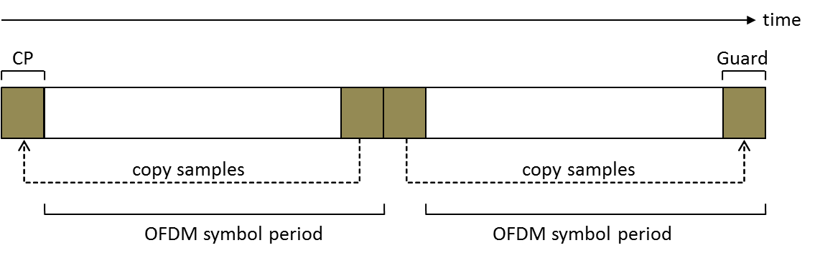

**Figure BX1—Initial-ranging transmission**

The BS can allocate two consecutive initial ranging slots; onto those slots, the CPE shall transmit the two consecutive initial ranging codes (starting code shall always be a multiple of 2), as illustrated in FigureBY1.

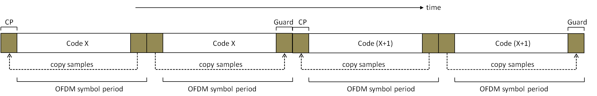

**Figure BY1—Initial-ranging transmission, using two consecutive initial ranging codes**

**9a.9.3.1.3 CDMA periodic-ranging, BW-request, and UCS notification transmission**

Periodic-ranging transmissions shall be sent periodically by CPEs identified by the BS for system periodic ranging. Bandwidth-request transmissions shall be for requesting upstream allocations from the BS. UCS notification transmissions shall be used for reporting detection of an incumbent. These transmissions shall be sent only by CPEs that have already associated with the base station. To perform periodic-ranging, bandwidth-request or UCS notification transmission, the CPE can send a transmission in one of the following manners.

1. Modulate one ranging code on the ranging subchannel for a period of one OFDM symbol. Ranging subchannels shall be dynamically allocated by the MAC layer at the BS and indicated by the number of subchannels in the US-MAP_IE. A time domain illustration of the periodic-ranging, bandwidth-request or UCS notification transmission is shown in Figure BZ1.

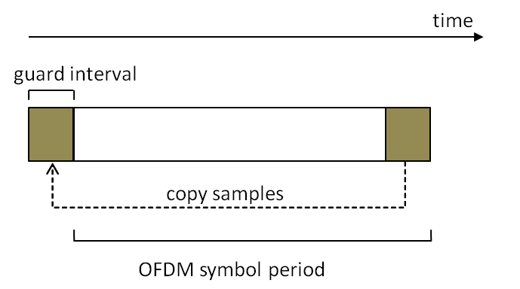

**Figure BZ1—Periodic-ranging/Bandwidth-request/UCS notification transmission using one code**

1. Modulating three consecutive ranging codes (starting code shall always be a multiple of three) on the ranging subchannel for a period of three OFDMA symbols (one code per symbol). Ranging subchannels are dynamically allocated by the MAC and indicated in the US-MAP. A time-domain illustration of the periodic ranging, BW-request, or UCS notification transmission is shown in Figure CA1.

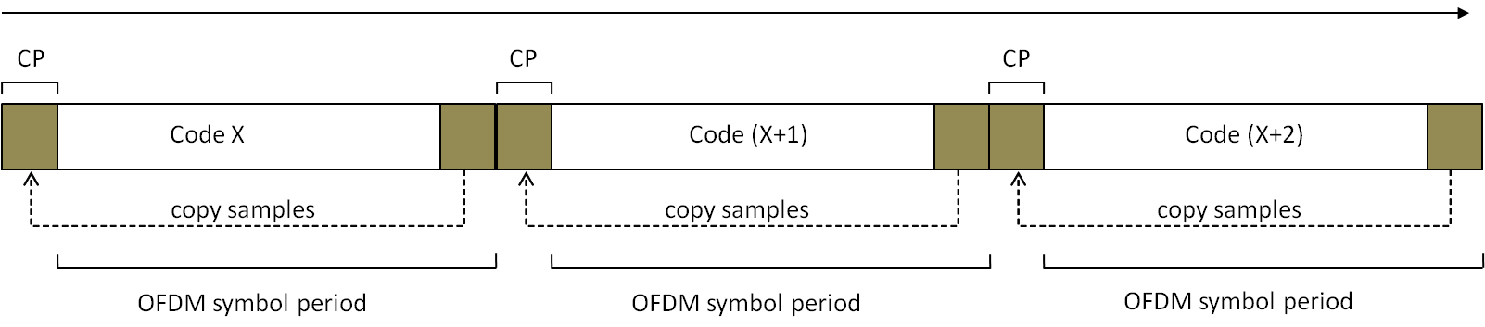

**Figure CA1—Periodic-ranging/Bandwidth-request/UCS notification transmission using three consecutive codes**

**9a.9.3.1.4 Ranging, BW request, and UCS notification opportunity windows**

For CDMA ranging, BW-request and UCS notification transmission, the ranging opportunity size is the number of symbols required to transmit the appropriate ranging/BW-request/UCS notification code (1, 2, 3, or 4 symbols), and is denoted *N*1. *N*2 denotes the number of subchannels required to transmit a ranging code. In each allocation of ranging/BW-request/UCS notification, the opportunity size (*N*1) is fixed and conveyed by the corresponding US-MAP_IE that defines the allocation.

The ranging allocation is subdivided into slots of *N*1 OFDMA symbols by *N*2 subchannels, in a time first order, i.e., the first opportunity begins on the first symbol of the first subchannel of the ranging allocation, the next opportunities appear in ascending order in the same subchannel, until the end of the ranging/BW-request/UCS notification (or until there are less than *N*1 symbols in the current subchannel), and then the number of subchannel is incremented by *N*2. The ranging allocation is not required to be a whole multiple of *N*1 symbols, so a gap may be formed (that can be used to mitigate interference between ranging and data transmissions). Each CDMA code shall be transmitted at the beginning of the corresponding slot. See Figure CB1.

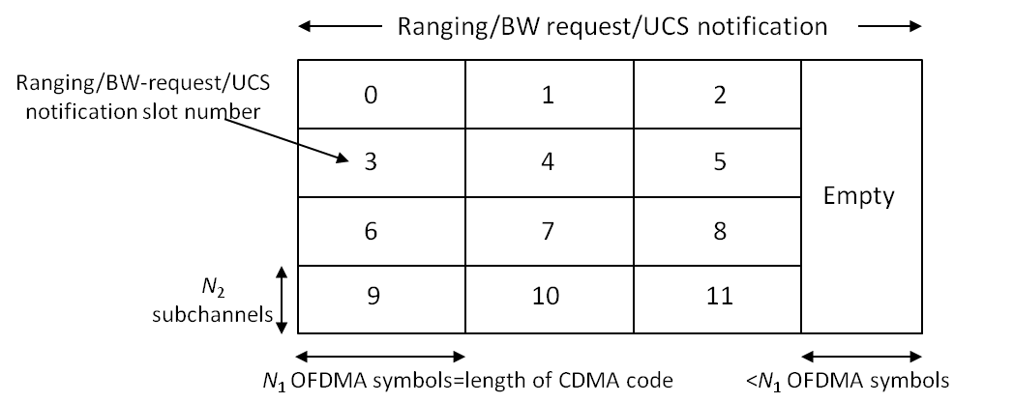

**Figure CB1—Example of Ranging/BW request/UCS notification opportunities windows**

**9a.9.4 Power control**

Refer to “9.9.4 Power control” of this standard.

**9a.9.4.1 Transmit Power control boundaries and EIRP limits**

Refer to “9.9.4.1 Transmit Power control boundaries and EIRP limits” of this standard.

**9a.9.4.2 Transmit Power Control mechanism**

Refer to “9.9.4.2 Transmit Power Control mechanism” of this standard except for the table 228. Table 228 is replaced with Table 9a.9.4.2.

**Table 9a.9.4.2 — Normalized CNR per modulation for BER= 2×10–4**

|  |  |  |
| --- | --- | --- |
| **Modulation FEC rate** | **Normalized CNR (dB)** | |
| **AWGN**  (default) | **Multipath channel[1]**  (*informative*) |
| CDMA code | TBD | TBD |
| QPSK, rate:1/2 | TBD | TBD |
| QPSK, rate:2/3 | TBD | TBD |
| QPSK, rate:3/4 | TBD | TBD |
| QPSK, rate:5/6 | TBD | TBD |
| 16-QAM, rate:1/2 | TBD | TBD |
| 16-QAM, rate:2/3 | TBD | TBD |
| 16-QAM, rate:3/4 | TBD | TBD |
| 16-QAM, rate:5/6 | TBD | TBD |
| 64-QAM, rate:1/2 | TBD | TBD |
| 64-QAM, rate:2/3 | TBD | TBD |
| 64-QAM, rate:3/4 | TBD | TBD |
| 64-QAM, rate:5/6 | TBD | TBD |

**9a.10 Network synchronization**

For multiple A-WRAN cells implementation, it is required that all BSs be time synchronized within a tolerance of ±8 TU (equivalent to 1.429μs for 6 MHz, 1.224 μs for 7 MHz BW and 1.071 μs for 8 MHz BW). It should be noted that any filtering at the output of the OFDM modulator to help meeting the rejection required by the RF mask (see 9a.13) will create temporal dispersion that will consume part of the cyclic prefix capability provided for alleviating channel time spreading.

In the event of a loss of synchronization with the common clock or with nearby A-WRAN BSs, the BS shall continue to operate and shall automatically resynchronize through the synchronization process described in 7.23.

For multiple A-WRAN cells implementation, frequency references derived from a common timing reference shall be used to control the frequency accuracy of Base-Stations as specified in 7.23, provided that they meet the frequency accuracy requirements of 9a.11. This applies during normal operation and during loss of timing reference.

**9a.11 Frequency Control requirements**

Refer to “9.11 Frequency Control requirements” of this standard.

**9a.12 Antenna**

**9a.12.1 Antenna reference patterns**

**9a.12.1.1 CPE transmit/receive antenna reference pattern**

Refer to “9.12.1.1 CPE transmit/receive antenna reference pattern” of this standard.

**9a.12.1.2 Sensing antenna reference pattern**

Refer to “9.12.1.2 Sensing antenna reference pattern” of this standard.

**9a.12.1.3 BS transmit/receive antennas**

Refer to “9.12.1.3 BS transmit/receive antennas” of this standard.

**9a.12.2 Antenna interface**

**9a.12.2.1 TRU/AU physical interface**

Refer to “9.12.2.1 TRU/AU physical interface” of this standard.

**9a.12.2.2 TRU/AU messaging interface**

Refer to “9.12.2.2 TRU/AU messaging interface” of this standard.

**9a.12.2.3 AU antenna information mapping**

Refer to “9.12.2.3 AU antenna information mapping” of this standard.

**9a.13 RF mask**

Refer to “9.13 RF mask” of this standard.

1. The multipath channel used for the calculations is defined on 6 paths as follows: excess delay: –3, 0, 2, 4, 7 and 11 μsec; relative amplitude: –6, 0, –7, –22, –16, and –20 dB; the phase for each path is random. The delay, amplitude and phase are assumed to be constant over the period of one symbol.