IEEE P802.22
Wireless RANs
TGb LB1 CID 232 Discussion
Date: 2014-03-31
Author(s):
Name | Company | Address | Phone | email
Ranga Reddy | Self |  |  | ranga.reddy@me.com
Abstract
Proposed resolution for Comment ID 232, as listed in the TGb Letter Ballot 1 comment database, DCN: 22-13/158r0 (or latest revision).
R0: Initial draft providing description of TD-LTE operation and some suggestions on how to handle comment resolution

Notice: This document has been prepared to assist IEEE 802.22. It is offered as a basis for discussion and is not binding on the contributing individual(s) or organization(s). The material in this document is subject to change in form and content after further study. The contributor(s) reserve(s) the right to add, amend or withdraw material contained herein.

Release: The contributor grants a free, irrevocable license to the IEEE to incorporate material contained in this contribution, and any modifications thereof, in the creation of an IEEE Standards publication; to copyright in the IEEE’s name any IEEE Standards publication even though it may include portions of this contribution; and at the IEEE’s sole discretion to permit others to reproduce in whole or in part the resulting IEEE Standards publication. The contributor also acknowledges and accepts that this contribution may be made public by IEEE 802.22.

Patent Policy and Procedures: The contributor is familiar with the IEEE 802 Patent Policy and Procedures
<http://standards.ieee.org/guides/bylaws/sb-bylaws.pdf>, including the statement "IEEE standards may include the known use of patent(s), including patent applications, provided the IEEE receives assurance from the patent holder or applicant with respect to patents essential for compliance with both mandatory and optional portions of the standard." Early disclosure to the Working Group of patent information that might be relevant to the standard is essential to reduce the possibility for delays in the development process and increase the likelihood that the draft publication will be approved for publication. Please notify the Chair Apurva Mody <apurva.mody@ieee.org> as early as possible, in written or electronic form, if patented technology (or technology under patent application) might be incorporated into a draft standard being developed within the IEEE 802.22 Working Group. If you have questions, contact the IEEE Patent Committee Administrator at <patcom@ieee.org>.
Introduction

This document provides some background operation on TD-LTE operation and proposes a possible resolution to CID 232 in the TGb LB1 ballot. Some initial discussion was started in DCN 22-14/47r0. This contribution builds upon the discussion in 22-14/47r0. The comment database is located in DCN: 22-13/158r0 (or latest revision), and is described in the table below. The last column is a proposed remedy as described in 22-14/47r0.

232 | Peter Flynn | TI | 7 | 7.3, 7.4 | - | 15~22 | - | T | A significant opportunity exists to use 802.22 for small cell backhaul applications. The ability to transport 3GPP frames efficiently over an 802.22 network will be a highly valuable objective. It would also be highly valuable to show how LTE MAC layer would inter-operate with 802.22 MAC layer. Closer alignment with this industry standard will promote adoption of the 802.22 in the existing market place by both device manufacturers and the wireless cellular carrier community. | Consider alignment with .5ms 3GPP frame size and super frame structure. Consider a third PHY structure which would be aligned with 3GPP frames, which is a well established industry standard (http://www.3gpp.org), to achieve a seemless integration and highest possible efficiency when used in LTE small cell backhaul.

In this document we will discuss the following:

- 3GPP TD-LTE frame structure configuration options
- 3GPP LTE/SAE network interfaces
- 3GPP LTE channelization vs 802.22 channelization
- Comment on 22-14/47r0
- Coexistence vs Backhaul
- Discussion on Resolution

This contribution was put together to partially educate 802.22 voter/members, on what configuration options and interfaces exist in TD-LTE, so what we can develop a resolution is correct from a protocol perspective and uses the correct terminology.

1. 3GPP TD-LTE Frame Structure Configuration Options

In LTE, each radio frame is 10ms long and is comprised of 10, 1ms-long subframes. These subframes are arranged in one of two ways, depending on the Frame Structure Type. Frame Structure Type 1, or FDD, means that all 10 subframes in the frame are dedicated to DL in one frequency channel and all 10 subframes, in another (time-aligned) frame in separate frequency channel are dedicated to UL. In Frame Structure Type 2, or TDD, multiple subframes can assigned to be DL or UL within a radio frame on a single frequency channel. Figure 1 below shows how subframes, in either Frame Structure Type 1 or 2, are further subdivided into 0.5ms entities known as slots.

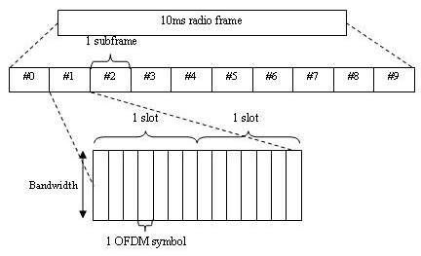
- Subframes & Slots [1]

In Frame Structure Type 2, TD-LTE, there are 7 different configurations for the distrubtion of UL and DL subframes within the 10ms radio frame. Figure 2 below shows the distribution of UL and DL subframes as defined by each TDD configuration value.

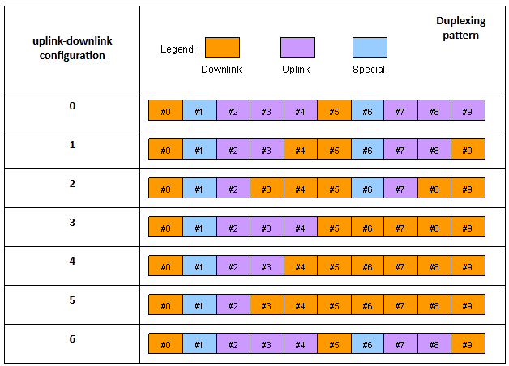
- UL/DL Subframe Configuration [1]
As shown in Figure 2, in TD-LTE, there is a third type of subframe, known as the “Special” subframe. Special subframes are allocated to provide a transition from DL to UL subframes. Within each special subframe, symbols can be allocated for DL transmission (DwPTS symbols), then as a GP (Guard Period), and finally for UL transmission (UpPTS). some symbols in the special subframe is still allocated for DL transmission (DwPTS). The GP symbols in the Special subframe are symbols where no transmission is allowed, which allows the TD-LTE UE to switch from Rx in DL to Tx in UL (similar to how 802.22 uses RTG/TTG). Figure 3 below shows the arrangment of the DwPTS, GAP, and UpPTS symbols.

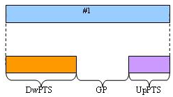
- Distribution of symbols in Special Subframe [1]
In TD-LTE, the # of symbols allocated for DwPTS, GP, an UpPTS itself can take on several configurations, each of which has a variant dependent on the cyclic prefix type configured for use in the TD-LTE system. Figure 4 below describes all of these configurations.

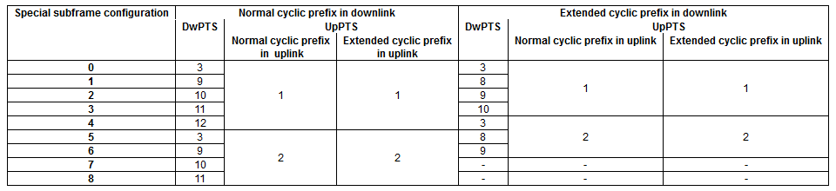
- DwPTS/GP/UpPTS Configuration Options [1]

2. LTE/SAE Network Interfaces

As a standards body, 3GPP have developed the Release 8+ specification set to define the air interface and network interfaces for fututre cellular broadband. LTE refers specifically to the air interface portion of network. SAE, or Service Architecture Evolution, deals with the 3GPP specification of the network interfaces and the components of the carriers Enhanced Packet Core (EPC). There are various entities in the EPC that provide services LTE UE devices, such as authentication, provisioning, hand-over management, etc. Figure 5 below is a diagram of the SAE EPC interfaces.

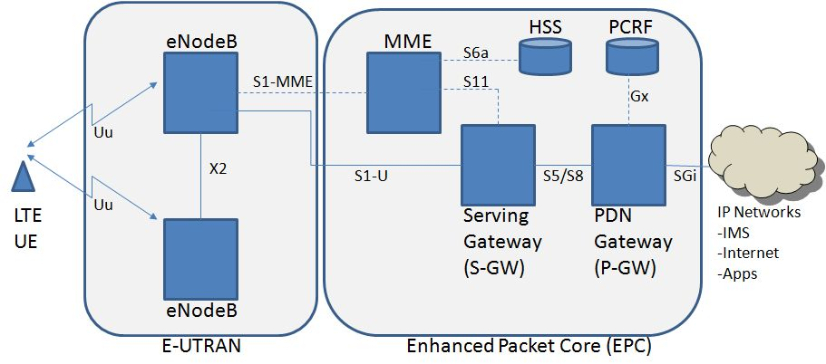
- 3GPP SAE EPC Network Diagram [3]

The purpose of each of these interfaces is as described below [4]:

- Uu: Air interface between UE and eNodeB
- X2: exchanging data/control between LTE eNodeB’s
- S1/MME: Interface for the control application between eNodeB’s and MME
- S1/U: Interface to exchange user data coming from LTE UEs and the S-GW, and allow the S-
GW to provide a routing/anchor point during handover
- S3: provides interconnection for the SGSN and MME, allowing information exchange
necessary for inter-3GPP technology mobility
- S4: Interface between SGSN and S-GW, supporting data exchange between legacy GPRS
network and S-GW, as well as handover between legacy GPRS and newer 3GPP networks
- S5/S8: User-plane/mangement function tunnelling between S-GW and P-GW. Allows P-GW to
provided different IP services to UE and used by UE as S-GW during mobility
- S6a: Interface used to transer UE service subscription and authentication information, used to
authenticate UE and allow/disallow access to the system
- Gx: Transfer QoS policy and user data accounting/charging info between PCRF and P-GW
- S11: Control interface between MME and S-GW to manage UE data bearers (e.g. service f
lows)
- SGi: Interface between P-GW and INTERNET/intranets

As an example, the following series of figures are provided to show the protocol stack used to transport control and user data on the S1/MME, S1/U, and X2 interfaces.

- Interface protocol structure for S1-MME [5]
- Interface protocol structure for S1-U [5]

- X2 Interface protocol structure [6]

3. 3GPP LTE Channelization

TD-LTE eNodeB’s can occupy spectrum in 1.4, 3, 5, 10, 15 or 20 MHz channels. In terms of breaking up that spectrum to allocate BW to UE’s, basic unit of transmission in LTE is called the Resource Block (RB). The frequency x time resource that make up a RB is defined as 12 subcarriers x 1 symbols. In each RB the subcarrier separation is 15 kHz. This subcarrier separation is applied to all channel sizes, so channels are actually differentiated by the number of RB’s for that channel size and the FFT allowed for that channel size (e.g. 128, 256, 512, 1024, 2048, 2048).

Currently in 802.22, we support operation for 6, 7, or 8 MHz channels, all of which use a 2048-FFT. The basic unit of transmission is defined as a slot, whose frequency x time resources is defined as 28 subcarriers x 1 symbol. Since 802.22 has a single FFT size, the subcarrier spacing varies is either ~3.35, ~3.91, and ~4.46 kHz.

4. Comment on 22-14/47r0

There are a couple of issues this contribution and the formatting of the proposed resolution bring up:

Issue 1:
Proposed modifications suggested may require 802.22 A-CPEs or R-CPE to require knowledge of the TD-LTE DL/UL subframe configuration options as discussed in Figure 2, as well as the Special Subframe configuration show in Figure 3 and Figure 4. However, 22-14/47r0 doesn’t seem to provide explanation for this.

Issue 2:
Allocating resources in a DRZ or AZ for 5ms given the half-frame assumed in 22-14/47r0 may not be possible. As shown in Figure 2, the DL/UL and UL/DL transition does exist in a “clean” spot that would allow us to evenly split the 10ms TD-LTE radio frame into to 2 half-frames. For example, in Figure 2, using the UL/DL configuration 0 option for a TD-LTE frame, we have a transition at approximately 1+ ms into the frame, and then another at 6+ ms into the frame. Thus we end up with 2 DL regions (from subframes 0-1, 5-6) and 2 UL regions (2-4, 7-9), that we would have to schedule within DL/UL relay and access zones w/in the 802.22b frame structure.

Issue 3:
If all networks operating in the area are time synchronized, via a satellite (e.g. GPS/GLONASS) or network time protocol, then accommodating a TD-LTE DL/UL region would be difficult, as our control region would in the beginning of the frame would overlap with the 1st and/or 2nd subframes (subframes 0 and 1 in Figure 2). If the 802.22 transmissions overlap, it would at least make more difficult, if not prevent the TD-LTE UE from properly synchonizing and interacting with the TD-LTE network. To support a method as described the 802.22b framing and timing can not be directly aligned.

Issue 4:
22-14/47r0 does mention accommodating BW for carrying the TD-LTE frame. In addition to this, we must also ensure that the 802.22b A-CPE is allocated with 1 DS service flow to carry traffic to the TD-LTE network, and 1 US service flow to carry traffic from the TD-LTE network.

Issue 5:
As brought up in Section 3, TD-LTE channelization differs from 802.22b channelization. How will we accommodate different sizes and combination of TD-LTE channels in 6, 7, or 8 MHz TVWS channels that 802.22 is currently designed around? For example in a 6 MHz channel we can accommodate 4 1.4 MHz TD-LTE channels, 2 3 MHz TD-LTE channels, 1 5 MHz channel, 2 1.4 MHz + 1 3 MHz channels, etc. The distributions of subchannels withing the TD-LTE frame region shown in 22-14/47r0 between multiple

There may be other issues not brought up here that will have to be discussed later.

5. Coexistence vs Backhaul

22-14/47r0 does a good job of getting the discussion started on handling CID 232. As show in Section 4 of this contribution there are some hurdles that may have to be overcome to implement the solution discussed in 22-14/47r0. However, the solution proposed in 22-14/47r0 may not be addressing the commentor properly. The technical solution addressed in 22-14/47r0 seems to address the coexistence between TD-LTE and 802.22.

Namely, a lot of the solutions suggested in that contribution as well as the issues brought up in this contribution, lend themselves to the problem of aligning frames, and allocating BW to regions so as to prevent each of these systems from stepping on each other. The method described in 22-14/47r0 lends itself to the intra-system coexistence as defined in 802.22. The current system allows 802.22 networks to share configuration information with other 802.22 networks, so they can align their transmissions in an effort to share the spectrum, or they can contend for it.

If the goal is to provide coexistence, then we need some way for the TD-LTE and 802.22 networks to share the configuration information necessary to support this (see Issue 1 in Section 4). In order to do this we would need some form of beaconing protocol to exchange the information over the air; manually configure the TD-LTE information on the 802.22 A-CPE, and vice-versa; or rely on some network-based coexistence framework (e.g. 802.19.1).

Designing a beacon protocol to work with 802.22 and TD-LTE and manually configuring the TD-LTE info into the A-CPE are impractical solutions. Making use of a coexistence framework (network-based) to exchange network information between networks of disparate technologies may work. At this time, no such framework exists or is in place. We can rely on the framework being developed by the IEEE 802.19, but that requires further study.

Now, having discussed it, coexistence may not have been the intention of the author of 22-14/47r0 or the commentor for CID 232. If this is the case, then we are discussing using the 802.22/802.22b network to provide backhaul for TD-LTE systems. Figure 5 in Section 2 of this contribution provides a diagram of all LTE/SAE network interfaces. Providing backhaul for TD-LTE systems essentially entails using 802.22 MR-BS/R-CPE/A-CPE to provide interconnection for traffic/control data sent over most of the interfaces (excluding the Uu interface) between various EPC components shown in Figure 5.

Of all of the EPC interfaces, the S1/MME, S1/U, and X2 interfaces would benefit the most from being interconnected using 802.22b devices. This is because these interfaces deal with interconnecting EPC elements to TD-LTE eNodeB’s and for providing interconnection between the eNodeB’s themselves. Figures 6-8 in Section 2 of this contribution show the protocol stacks used by the S1/MME, S1/U, and X2 interfaces. Application traffic from control applications (S1AP, X2AP) that are encapsulated by SCTP at the transport layer (L4 of TCP/IP stack), then IPv4/IPv6 at IP layer (Layer 3 of TCP/IP stack) before handed to MAC and PHY for that interface. Data traffic for these interfaces is encapsulated at the application layer by a tunnel protocol (GTP-U), before being encapsulated by UDP/IP, before being handed to the MAC and PHY of these interfaces.

In normal LTE deployments a wired backhaul is provided to carry data over these interfaces. The wired backhaul is some form of copper/fiber interconnect that will carry the Ethernet frames that encapsulate the data from these interfaces. We can insert 802.22b MR-BS/R-CPE/A-CPE into these inerfaces by plugging the IP/Ethernet interfaces on the TD-LTE components into the 802.22b devices. Once this is done, we can use either the IP or Ethernet Convergence Sublayer and Packet Convergence Sublayer rules for mapping items from the CS to service flows in the 802.22 network. Two service flows are provisioned for each A-CPE that is providing an interconnect over the S1/MME, S1/U, and/or X2 interfaces of a TD-LTE/EPC component. One service flow is for DS traffic going to that component, the other is for US traffic coming from that component.

6. Discussion on Resolution

It is the recommendation to use 802.22b systems/devices to provide backhaul and not persue the coexistence aspect of this time. The IP and Ethernet CS is well defined in the base 802.22 standard. What is needed is to possibly define a standard set of IP/Ethernet CS rules for service flow mappings to handle the S1/MME, S1/U, and X2 interfaces. This can be done within the 802.22b standardization process, or by implementors and network operations.

Specific text modifications to resolve this comment will be provided at a later date.

References:

[1] IEEE P802.22b WRAN Amendment: Enhancement for broadband services and monitoring applications Draft 1.0 WG Letter Ballot Template, DCN 22-13/158r2, https://mentor.ieee.org/802.22/dcn/13/22-13-0158-02-000b-802-22b-letter-ballot-1-comment-database.xls

[2] “FDD & TDD Duplexing – MATLAB & Simulunk”, http://www.mathworks.com/help/lte/ug/fdd-and-tdd-duplexing.html

[3] http://www.rcrwireless.com/lte/wp-content/uploads/2013/01/Network-diagram.jpg

[4] Rumney, Moray, “LTE and the Evolution to 4G Wireless: Design and Measurement Challenges”, Chapter 4, Section 4.2.2, Agilent Technologies, 2009

[5] 3GPP, “3rd Generation Partnership Project; Technical Specification Group Radio Access Network; Evolved Universal Terrestrial Radio Access Network (E-UTRAN); S1 general aspects and principles”, 3GPP TS 36.410 v8.3.0

[6] 3GPP, “3rd Generation Partnership Project; Technical Specification Group Radio Access Network; Evolved Universal Terrestrial Radio Access Network (E-UTRAN); X2 general aspects and principles (Release 8)”, 3GPP TS 36.420 v8.1.0

[7] Pyo, Chang-woo, “Comment Resolution related to Collaboration of Other Systems”, IEEE 802.22 DCN 22-14/47r0

