IEEE P802.22  
Wireless RANs

|  |  |  |  |  |
| --- | --- | --- | --- | --- |
| Proposed Text of PHY technical items related to Section 9.4 and 9.5 of the Std.802.22-2011 | | | | |
| Date: 2013-06-06 | | | | |
| Author(s): | | | | |
| Name | Company | Address | Phone | email |
| Masayuki Oodo | NICT | 3-4, Hikarino-oka, Yokosuka, 239-0847, Japan |  | moodo@nict.go.jp |
| Zhang Xin | NICT | 20 Science Park Road, #01-09A/10 TeleTech Park, Singapore |  | amy.xinzhang@ieee.org |
| Chunyi Song | NICT | 3-4, Hikarino-oka, Yokosuka, 239-0847, Japan |  | songe@ieee.org |
| Keiichi Mizutani | NICT | 3-4, Hikarino-oka, Yokosuka, 239-0847, Japan |  | mizk@nict.go.jp |
| Chang-Woo Pyo | NICT | 3-4, Hikarino-oka, Yokosuka, 239-0847, Japan |  | cwpyo@nict.go.jp |
| Pin-Hsun Lin | NICT | 3-4, Hikarino-oka, Yokosuka, 239-0847, Japan |  | pslin@nict.go.jp |
| Gabriel Porto Vilardi | NICT | 3-4, Hikarino-oka, Yokosuka, 239-0847, Japan |  | gpvillardi@nict.go.jp |
| Hiroshi Harada | NICT | 3-4, Hikarino-oka, Yokosuka, 239-0847, Japan |  | harada@ieee.org |

Abstract

This document contains the proposed text of PHY technical items related to Section 9.4 and 9.5 of the current 802.22 standard.

**Notice:** This document has been prepared to assist IEEE 802.22. It is offered as a basis for discussion and is not binding on the contributing individual(s) or organization(s). The material in this document is subject to change in form and content after further study. The contributor(s) reserve(s) the right to add, amend or withdraw material contained herein.

**Release:** The contributor grants a free, irrevocable license to the IEEE to incorporate material contained in this contribution, and any modifications thereof, in the creation of an IEEE Standards publication; to copyright in the IEEE’s name any IEEE Standards publication even though it may include portions of this contribution; and at the IEEE’s sole discretion to permit others to reproduce in whole or in part the resulting IEEE Standards publication. The contributor also acknowledges and accepts that this contribution may be made public by IEEE 802.22.

**Patent Policy and Procedures:** The contributor is familiar with the IEEE 802 Patent Policy and Procedures

<[**http://standards.ieee.org/guides/bylaws/sb-bylaws.pdf**](http://standards.ieee.org/guides/bylaws/sb-bylaws.pdf)>, including the statement "IEEE standards may include the known use of patent(s), including patent applications, provided the IEEE receives assurance from the patent holder or applicant with respect to patents essential for compliance with both mandatory and optional portions of the standard." Early disclosure to the Working Group of patent information that might be relevant to the standard is essential to reduce the possibility for delays in the development process and increase the likelihood that the draft publication will be approved for publication. Please notify the Chair Apurva N. Mody <[**apurva.mody@ieee.org**](mailto:apurva.mody@ieee.org)> as early as possible, in written or electronic form, if patented technology (or technology under patent application) might be incorporated into a draft standard being developed within the IEEE 802.22 Working Group. **If you have questions, contact the IEEE Patent Committee Administrator at <**[**patcom@ieee.org**](mailto:patcom@ieee.org)**>**.

**Summary of this document**

In this document, based on the proposed (1K FFT-based) PHY, detailed texts regarding “frame structure” and “CBP packet format”are proposed. This item corresponds to Section 9.4 of 802.22 Standard as shown below.

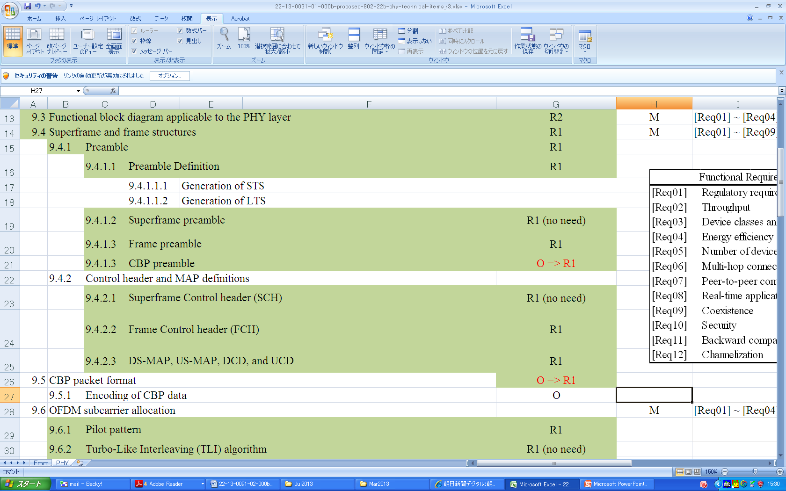

Proposed table of contents regarding the frame structure for 1-K FFT-based PHY is as follows.

9.X.4 Frame structure

9.X.4.1 Preamble

9.X.4.1.1 Frame preamble

9.X.4.1.2 CBP preamble

9.X.4.2 Control header and MAP definitions

9.X.4.2.1 Frame Control Header (FCH)

9.X.4.2.2 DS-MAP, US-MAP, DCD, and UCD

9.X.5 CBP packet format

Details of each subsection are described in the following pages.

**9.X.4 Frame structure**

The basic frame structure is shown in Figure 9.X.4-1. See 7.4 for a full description of the frame structure.

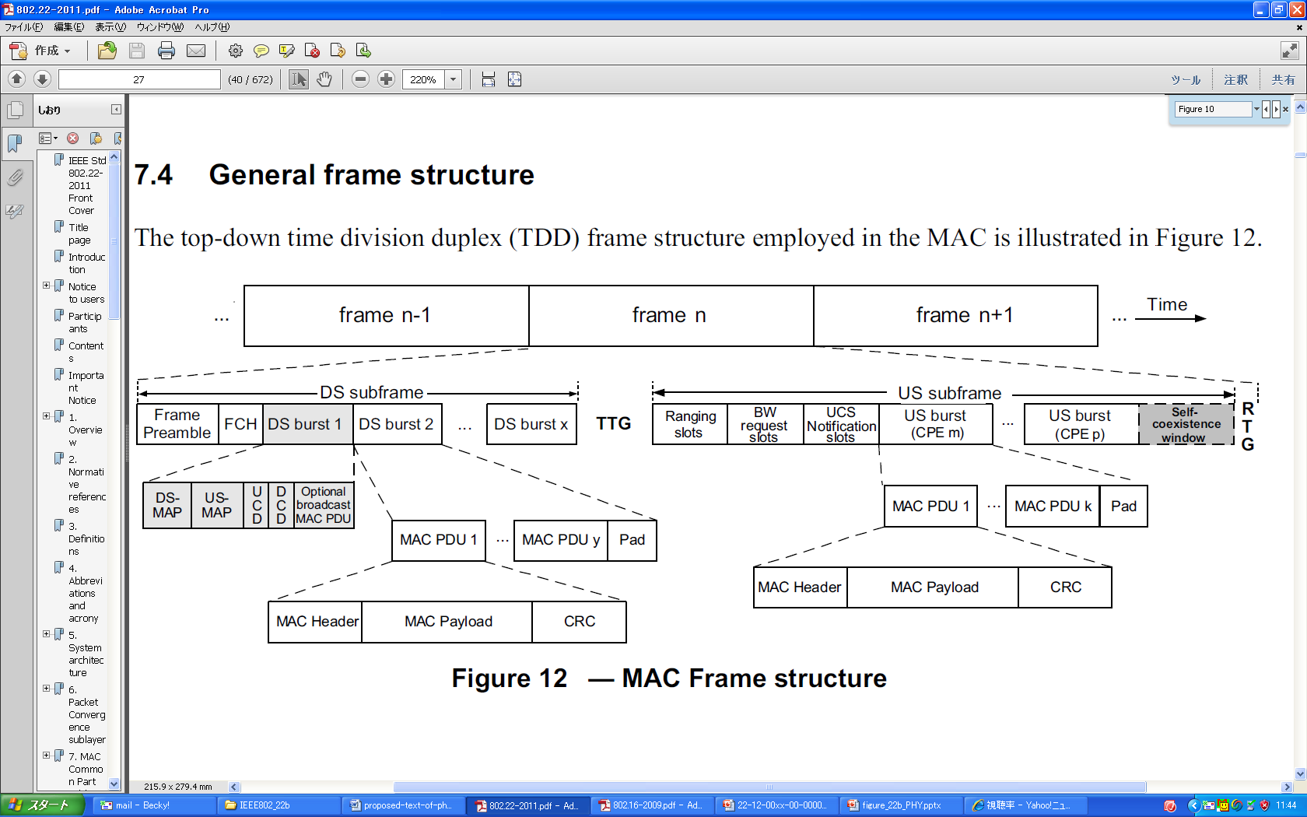

**Figure 9.X.4-1 —Basic frame structure**

Each frame contains a preamble, header, and data bursts.

For both normal and self-coexistence operational modes, the first symbol shall be the frame preamble. The second to fifth symbols shall contain the FCH, and DS-MAP, US-MAP, when needed, DCD and UCD, and data bursts if there is some room left. The FCH specifies the length of the first MAP that will immediately follow the FCH.

In each frame, a TTG shall be inserted between the downstream and upstream bursts to allow the CPE to switch between the receive mode and transmit mode and to absorb the signal propagation time. A RTG shall be inserted at the end of each frame to allow the BS to switch between its receiving mode and transmit mode (see Figure Figure 9.X.4-2).



**Figure 9.X.4-2 —Example of a time/frequency structure of a frame**

The values indicated in Table 9.X.4-1 for the TTG and RTG shall be used for the specified cyclic prefixes and channel bandwidth options.

**Table 9.X.4-1— WRAN frame parameters**

|  |  |  |  |
| --- | --- | --- | --- |
| **Cyclic**  **Prefix** | **Number of symbols**  **per frame1** | **Transmit-receive**  **turnaround gap2 (TTG)** | **Receive-transmit**  **turnaround gap3 (RTG)** |
| **BW** | **6 MHz 7MH 8MHz** | **6 MHz 7MH 8MHz** | **6 MHz 7MH 8MHz** |
| 1/4 | 41  48  55 | 1185 TU  1382 TU  1579 TU | 1056 TU  1232 TU  1408 TU |
| 1/8 | 46  54  61 | 1185 TU  1382 TU  1579 TU | 672 TU  592 TU  1665 TU |
| 1/16 | 48  57  65 | 1185 TU  1382 TU  1579 TU | 1504 TU  848 TU  1280 TU |
| 1/32 | 50  59  67 | 1185 TU  1382 TU  1579 TU | 960 TU  592 TU  1280 TU |

NOTE 1—Indicates the DS/US payload symbols and symbols for FCH, DS/US MAP and DCD/UCD. Here, one frame preamble symbol is assumed. Different values may apply when the frame carries more header symbols.

NOTE 2—Example of TTG set to absorb the propagation delay NOTE 3—Portion of symbol left over to arrive at the 10 ms frame period.

**9.X.4.1 Preamble**

**~~9.X.4.1.1 Preamble definition~~**

(This subsection is deleted)

**~~9.X.4.1.2 Superframe preamble~~**

(This subsection is deleted)

**9.X.4.1.1 Frame preamble**

(This subsection describes the specifications as a new text.)

The first symbol of the DS transmission is the preamble. Three different preamble carriersets are defined, differing in the allocation of subcarriers. Those subcarriers are modulated using a boosted BPSK modulation with a specific pseudo-noise (PN) code.

The preamble carrier-sets are defined using Equation (9.X.4.1.1-1).

*PreambleCarrierSetn* = *n* + 3*k*  (9.X.4.1.1-1)

where

*PreambleCarrierSetn* specifies all subcarriers allocated to the specific preamble

*n* is the designating number of the preamble carrier-set indexed 0, 1, and 2

*k* is a running index. 0...283

Each segment uses a preamble composed of a single carrier-set in the following manner:

— Segment 0 uses preamble carrier-set 0 (*n* =0).

— Segment 1 uses preamble carrier-set 1 (*n* =1).

— Segment 2 uses preamble carrier-set 2 (*n* =2) .

In the case of segment 0, the DC carrier will not be modulated at all, and the appropriate PN will be discarded. Therefore, the DC carrier shall always be zeroed.

Each segment eventually modulates each third subcarrier. As an example, Figure 9.X.4.1.1-1 depicts the preamble of segment 0. In this figure, subcarrier 0 corresponds to the first subcarrier used in the preamble symbol.

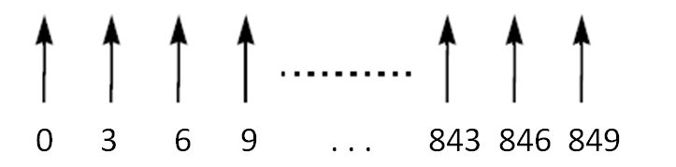

**Figure 9.X.4.1.1-1 —Example of basic structure of preamble (for the case of *n* =0)**

The PN series modulating the preamble carrier-set is defined in Table 9.X.4.1-1. The series modulated depends on the segment used and IDcell parameter. The defined series shall be mapped onto the preamble subcarriers in ascending order. Table 9.X.4.1.1-1 includes the PN sequence in an hexadecimal format. The value of the PN is obtained by converting the series to a binary series (*Wk*) and mapping the PN starting from the MSB of each symbol to the LSB (0 mapped to +1 and 1 mapped to –1). For example, for Index = 0, IDcell=0, and Segment = 0 (the first row of Table 9.X.4.1.1-1), *Wk* = 101001101111..., and the mapping shall follow: –1 +1 –1 +1 +1 –1 –1 +1 –1 –1 –1 –1....

For the preamble symbol, there will be 86 guard band subcarriers on each side of the spectrum.

The symbols in the DS preamble shall be modulated according to Equation (9.X.4.1-2).

$Re\left\{\text{PreambleModulated}\right\}=4∙\sqrt{2}∙\left(\frac{1}{2}-W\text{k}\right) , Im\left\{\text{PreambleModulated}\right\}=0$ (9.X.4.1-2)

**Table 9.X.4.1.1-1—Preamble modulation series per segment and Cell ID**

|  |  |  |  |
| --- | --- | --- | --- |
| **Index** | **Cell ID** | **Segment** | **Series to modulate (*Wk*)** |
| 0 | 0 | 0 | 0xA6F294537B285E1844677D133E4D53CCB1F182DE00489E53E6B6E77065C7EE7D0ADBEAF |
| 1 | 1 | 0 | 0x668321CBBE7F462E6C2A07E8BBDA2C7F7946D5F69E35AC8ACF7D64AB4A33C467001F3B2 |
| 2 | 2 | 0 | 0x1C75D30B2DF72CEC9117A0BD8EAF8E0502461FC07456AC906ADE03E9B5AB5E1D3F98C6E |
| 3 | 3 | 0 | 0x5F9A2E5CA7CC69A5227104FB1CC2262809F3B10D0542B9BDFDA4A73A7046096DF0E8D3D |
| 4 | 4 | 0 | 0x82F8A0AB918138D84BB86224F6C342D81BC8BFE791CA9EB54096159D672E91C6E13032F |
| 5 | 5 | 0 | 0xEE27E59B84CCF15BB1565EF90D478CD2C49EE8A70DE368EED7C9420B0C6FFAF9AF035FC |
| 6 | 6 | 0 | 0xC1DF5AE28D1CA6A8917BCDAF4E73BD93F931C44F93C3F12F0132FB643EFD5885C8B2BC |
| 7 | 7 | 0 | 0xFCA36CCCF7F3E0602696DF745A68DB948C57DFA9575BEA1F05725C42155898F0A63A248 |
| 8 | 8 | 0 | 0x024B0718DE6474473A08C8B151AED124798F15D1FFCCD0DE574C5D2C52A42EEF858DBA5 |
| 9 | 9 | 0 | 0xD4EBFCC3F5A0332BEA5B309ACB04685B8D1BB4CB49F9251461B4ABA255897148F0FF238 |
| 10 | 10 | 0 | 0xEEA213F429EB926D1BDEC03ABB67D1DE47B4738F3E929854F83D18B216095E6F546DADE |
| 11 | 11 | 0 | 0xC03036FA9F253045DF6C0889A8B83BAEFCF90EB993C2D79BD911CA84075061AA43DA471 |
| 12 | 12 | 0 | 0x1E68EC22E5E2947FB0A29E4CC70597254B36C60331EACF779FE752D3F55DC41ABFC7DC9 |
| 13 | 13 | 0 | 0x63A57E75A0434F035AAC4504B265081D497F10C77928B71797C5D6C6824DC0F23BE34EE |
| 14 | 14 | 0 | 0xC57C4612816DE981C58FD6F8DE9DD41F2422ADBC522B0CE31F9A6D5F2A126DC08F69FB1 |
| 15 | 15 | 0 | 0x978256AF184E7ED17789B33D324C711B36BFBCCE5446EB03687E9A0A839C7CE156104D2 |
| 16 | 16 | 0 | 0x011EC823157DD73150640CEB7DDB0A1F8F91E09599A851D5C7CAF687CFB752D297D82FC |
| 17 | 17 | 0 | 0xC6DE82BEB7F57B9120E8A376D85C8F70FDC65BC660402DAC4AE6002EA2740C4F9E5973C |
| 18 | 18 | 0 | 0x4C74929D6F9FAB9E5BB761026038E076F6824295E0AF397806ECEBC6DC713F03ACDC27C |
| 19 | 19 | 0 | 0x13E1E85C2234D0F3418001A35F135E10C6C918C36BC659FDA9D655D288A0BDAA8BF489D |
| 20 | 20 | 0 | 0xFD4AF2D8F4F08F1A7DF59291C9AEE788F641B8231CFB813376E0BEB68DFCFCBBE552445 |
| 21 | 21 | 0 | 0xEBBC77A493AA0C62C62F25EE5E8D0701F50386F49026FA31487C9FD5C5206CE4EB00576 |
| 22 | 22 | 0 | 0x134F936F9E875842587ADCA92187F2FC6D62FFC3A833D8CDE465F9972ABAA83763AAEB7 |
| 23 | 23 | 0 | 0x3CD1DA70670BC73363D1B4A66D280FF6AA7636D07ECF32BA26101E5EBA1594FB8A0420A |
| 24 | 24 | 0 | 0x918296B2937C2B6F73CF98F85A81B723D1C69DBDF3E019749C582DA22E789562729D475 |
| 25 | 25 | 0 | 0xC323981B8B2240865F48D61AE1B3B61D88522B7358952F949D4308CA15D1EE8FDFA683F |
| 26 | 26 | 0 | 0x7514A6FA5FBB250C5C8CE96F791D676036C344A44B24284477B44CB3E758F8BCD58F05B |
| 27 | 27 | 0 | 0x84C7FEC6E977FA1EC0C7CC9E0D067C73D8F846F82ABB3456D2104E1448D5A58D5975152 |
| 28 | 28 | 0 | 0x4841AFC277B86A0E067AF319422F501C87ACBFBDD66BFEA3644F879AE98BA8C5D605123 |
| 29 | 29 | 0 | 0xF35EA87318E459138A2CE69169AD5FD9F30B62DA04ED21320A9F59893F0D176752152FD |
| 30 | 30 | 0 | 0xA0C5F35C5971CD3DC55D7D2B9FD27AA17A198583F580EB0800744EE5B6B3648DEA95840 |
| 31 | 31 | 0 | 0xA6D3D33AD9B56862DBF076E3ACE6A3150510CCC8BE77DE4E6E10EB5FE163765647D07DF |
| 32 | 0 | 1 | 0x52849D8F020EA6583032917F36E8B62DFD18AD4D77A7D2D8EC2D4F20CC0C75B7D4DF708 |
| 33 | 1 | 1 | 0xCC53A152209DEC7E61A06195E3FA633076F7AE1BAFFE83CE565087C0507BA596E0BD990 |
| 34 | 2 | 1 | 0x17D98A7E32CCA9B142FE32DB37B2BF726E25AA7A557FFB5C400B47A38B16CF18E1EDE63 |
| 35 | 3 | 1 | 0xA5BA8C7E2C795C9F84EBBD425992766BDE5549A7A9F7EF7E44AFD941C6084568638FE84 |
| 36 | 4 | 1 | 0x33E57E78A5696255CA61AE36027036DA619E493A0A8F95D9915C6E61F3006CB9706BEBA |
| 37 | 5 | 1 | 0x09961E7309A9B7F3929C370C51910EBAB1B4F409FA976AE8679F354C84C4051F371F902 |
| 38 | 6 | 1 | 0x508A9EBAEF3C7E09CFCFC0B6F444A09B45A130EFC8C5B22BCE87213854E7C9D329C9ADC |
| 39 | 7 | 1 | 0xAACEEF9BCDC82E4AD525185B07CBABCB74861D16F7C25CFBA917B05463AD65391AF840D |
| 40 | 8 | 1 | 0x23060ACC5A125DAB207EEEE47B4EEE1E8466BD17DDA2EB3CD90D2AB7A758C213E6D7FE5 |
| 41 | 9 | 1 | 0xCA55521667BDA8B6F1B205201A51B3A0C05DE9EA06BC73268730A81A992777021F46055 |
| 42 | 10 | 1 | 0x05ADFCA2F8207DC6FF8D1A85A1DD4694D4C48A838C4F833C532710021AC448A7B62B8DD |
| 43 | 11 | 1 | 0x218C951223D7B712DC98F8B5217388A830003C5F2A00F232DD3475D2FC78C25B8D88FF9 |
| 44 | 12 | 1 | 0x79B94D24D721121EF678B7156F8D2666DE712BBF3837C85A9518781903146A7B4D42A28 |
| 45 | 13 | 1 | 0x58AABEF6A6BDE4011CAC583C5104B2C6FC5A2980F856373E5931A3C690245327581FA13 |
| 46 | 14 | 1 | 0x427D1AD18E338E16FCE6E23B4AD6D82A2144D53048F2665AA94577AFABD26889FCB1F9F |
| 47 | 15 | 1 | 0x337FE0E4C15A22471AE0F6B6F91161A7DE2E1403D73587D5C8355105D2F70642B2CE425 |
| 48 | 16 | 1 | 0xA3FCAA311B536AC9DB39FED9F4E996506B3181C58D6B7E04157A3FD463F60468765BCFD |
| 49 | 17 | 1 | 0xF484FD1F57F53A4A749B86148E0B1D0653667CE1393198875DDB0AE9179BBBDAAD53A11 |
| 50 | 18 | 1 | 0xA3E9ECF1E6048562BC89DB6168E708855F0D4AD29F859EF36C9160DF407D85426233632 |
| 51 | 19 | 1 | 0x890519376D1FFAA2894EABCD6663B0A3C2411982C17B01270E0FB0B289D4BC8C3B83D |
| 52 | 20 | 1 | 0x09847B6187BB5F6F6728B4ED610088FAD9DADFC00748E9DCD8A0CE320D6C991654ABE05 |
| 53 | 21 | 1 | 0x3285AE0A3D196313659C37BE1C94D61D20F11FD49D9FDF9D1026FF5763F02CB78AE135C |
| 54 | 22 | 1 | 0x0069D3F34D0D455AFB45FEFDF716333B785C6BDA90DA23F1CC68BC6A1DBC916C595DA3E |
| 55 | 23 | 1 | 0xAA977A8BCA39381E7C35A1ACC7C4F60421C0862BFD6106C7C025B0676EA0EF68972DD8F |
| 56 | 24 | 1 | 0xF310745C497094ABE56E0490C0800319DBE290553E696B6859635AF03B121F79D925D19 |
| 57 | 25 | 1 | 0x964DFD350B9C7DFDC7F6F7C43283A76F0D613E48A5520D1DAF761C6F47E389B43A023F5 |
| 58 | 26 | 1 | 0x6D767B88D28A455CC3B56C942BAFD8E465A50FD2C22FE6162E03A9AAC3C1CC899800610 |
| 59 | 27 | 1 | 0xC5491C6CA3D998906EC1482F815B74B7C2E3816B682ACC6009AB7EFF34BF0E9CE59C754 |
| 60 | 28 | 1 | 0x6D8EE32D30E19D93A0E5AD8226BAE9CF6FCBA17CF6E67FDC5A15A81ECB8908BEDD77C80 |
| 61 | 29 | 1 | 0x98F8BFDF774C7A249418E6FF4723D6E6AB2F091CDE4DE1CE11D3BD463B509FB716940FD |
| 62 | 30 | 1 | 0x65300BAD8FFA21BC7DC2C1F79FA97A9F469CCC9E270A61759F34D6276F57CBEB009CD21 |
| 63 | 31 | 1 | 0x6F36BB6D5A7DC4FB720439E91FF0DE86DD6C4B93CFC4271F2BCC6169616E3AEAA19E360 |
| 64 | 0 | 2 | 0xD27B00C70A8AA2C036ADD4E99D047A376B363FEDC287B8FD1A7794818C5873ECD0D3D56 |
| 65 | 1 | 2 | 0xE7FDDCEED8D31B2C0752D976DE92BEA241A713CF818C274AA1C2E3862C7EB7023AF35D4 |
| 66 | 2 | 2 | 0x87BF4954022D30549DF7348477EACB97AC3565B838460CC62F242883313B15C31370335 |
| 67 | 3 | 2 | 0x82DD830BEDE4F13C76E4CF9AEF5E42609F0BDDCB000A742B6372DD5225B0C3114494746 |
| 68 | 4 | 2 | 0x4E06E4CF46E1F5691938D7F40179D8F79A85216775384BD97966DB4BBF49FB6FAB8F945 |
| 69 | 5 | 2 | 0x64164534569A5E670FDB390D09C04802DD6A16B022CADC77EDD7464AFED43C773A8DC76 |
| 70 | 6 | 2 | 0xFB8769A81AA9DB607F14A6A95948401F83057CDC9C9C3996BA5821403A49F00A4E35191 |
| 71 | 7 | 2 | 0x77710D6F40B4F79CC63F678551C3EC18FA9DF2C82E6C8F415DADFD63264B7513180070E |
| 72 | 8 | 2 | 0x503F196BBF93C238BFD5E735E5AE52E0DAE64F5E2F4C3B92E553F51303C4A64C4403BF3 |
| 73 | 9 | 2 | 0x5FD4A6894566678C95B9D5A59DDE5366799045FEB03A2BAA74094140E9068C61C2E972C |
| 74 | 10 | 2 | 0x95B584DC40C8B5DEAD63D48FCE65B1E61BAB4C597D921DB12677141E2FFE7C0AA3DA0D5 |
| 75 | 11 | 2 | 0x985763AB6CC8934DB8A0BE738A7AF1D1FA3958C1F9E2D6A51A163E47A0A6E5FEB759FDD |
| 76 | 12 | 2 | 0xFD8D45F00D943AD986BD353D61C6746DBF8A309B6AE1C173B880D957B76DC031A957E8D |
| 77 | 13 | 2 | 0xAE4323534F6EFB1A20169328417885EF304FA220389FA9C2607E5A406F4CE4A7498A39F |
| 78 | 14 | 2 | 0xE5205579893BE184CB9948C28E2F9AAF699D47B6E5E0B219CBEAFE4BEC8D561BD809E34 |
| 79 | 15 | 2 | 0xAB11D6941478D36D5695CE813070DC1E32122A39083E53FE373660AEB125D83383FBDCA |
| 80 | 16 | 2 | 0x188A09C46F1F11206FF9F15CFB5F6CD2F26C4BF485EE37D3650A595064F76CE34E40EAD |
| 81 | 17 | 2 | 0x4B1CDE25539A56CEDC45FE7F54C38CF155F4FB1AE868F6C3952D07014BF828E810BDE2D |
| 82 | 18 | 2 | 0x16CA8F8C6A879E865E3611EAC389D56AFA3E4E84CDBB73567BA4A160249C4B680A7D9BC |
| 83 | 19 | 2 | 0x39D2B08AA0E2E8781476027B41AD72F8D9838B7001AADFD33A92D81E56ECBB2C9378D58 |
| 84 | 20 | 2 | 0x8C258BC80D4AD125F335A5151EDF9E9A463E06C5C8D046F82E5DC3D73EF4D2231C5D14F |
| 85 | 21 | 2 | 0x41A029C6356C825585179C5348EDF07A3AC2022539AC28DC4CD3C1DFADC8EE9644CD939 |
| 86 | 22 | 2 | 0x0D70A77CBE9804913BFBEC4FBF917C5CD3580F6062BBAD3F99ECEBB4A9EBB87523AB722 |
| 87 | 23 | 2 | 0x6A00A30901F9FDE44B4F1ECED44E0BCB943B29519F313BE4496D34F39B154FC2384CB75 |
| 88 | 24 | 2 | 0x95351107A8BE6ABFC24C1292FE1A0FE677CBFD04F2E81178CAA9D294730EF9C946F676E |
| 89 | 25 | 2 | 0x01F21470FD9B1E0B3C6B2F7C0412A15764C277D61BA2EE3B3769DE7ADACB2BB29918FB7 |
| 90 | 26 | 2 | 0xA578ABFE155369440FA3D4DF757CCA596469B80A0E56BFE6010DD63E67CEDB86BB1EF39 |
| 91 | 27 | 2 | 0x1E1CFFAB031836777DE5D168A9246C559574C74CCC06405EB406B8DDB7C9A6EF54A66A5 |
| 92 | 28 | 2 | 0x354149C2CA19A735F9CD04AF4922E8ECE6509B978B951F946FD4AD36C7F9C83624205E7 |
| 93 | 29 | 2 | 0x5A27E60DEA547D0D41897A03199F28A967AC51728E3B38325B4FBECF1B85A7EE9B04182 |
| 94 | 30 | 2 | 0x784DA3B16B810FE3B851060AD7BD27D9D9457F6C8899A13D311E531B855C15ECE6D3A2F |
| 95 | 31 | 2 | 0xD7DFBC65797633A8C13D3EEC781D48952338136063B579D69437B28B744B5A4BE18AFA9 |

**9.X.4.1.2 CBP preamble**

**The CBP preamble shall have a duration of 1 OFDM symbol. The PN series modulating the CBP preamble carrier-set is defined in Table 9.X.4.1.2-1. The series modulated depends on the segment used and CBP ID parameter. The defined series shall be mapped onto the CBP preamble subcarriers in ascending order. Table 9.X.4.1.2-1 includes the PN sequence in a hexadecimal format. The value of the PN is obtained by the same manner as described in 9.X.4.1.1.**

**Table 9.X.4.1.2-1—Preamble modulation series per segment and CBP ID**

|  |  |  |  |
| --- | --- | --- | --- |
| **CBP Index** | **CBP ID** | **Segment** | **Series to modulate (*Wk*)** |
| 0 | 0 | 0 | 0x61AF26BD39A9FFF52826625E04ADA299385A373FA946D837D754  E6CFEBB26F5C03B87CF |
| 1 | 0 | 1 | 0xD77D97CDB93DBEAA65CAFA146F40D72B5E80944F750E07325DC  164ED60F32434BC7187D |
| 2 | 0 | 2 | 0x4529D9CA65AF49C1C39BDC18CFAB87E03FE4DAFC0A48FF1457  D46B0DF66B414A23ACDDB |
| 3 | 1 | 0 | 0x33AC0261DAA57C1D611EBA1C730D50AFEE5BE3E849030A4E891  BC8C5F4C78DCDDFEA263 |
| 4 | 1 | 1 | 0xBED48C704F02A84F03BCD299D919DA56F7B71EDF8A0F8A25E8F  8496F95A44CE2B9F74C9 |
| 5 | 1 | 2 | 0x0ECCBE0902EBF4B4C29506014A3706622784B7B2D5153E10AD311  2DC5E45277A32E79DE |
| 6 | 2 | 0 | 0x7CB4937889C7DFD9AA2D37235E06F993D3D4F5D515B39CA652F6  2397C08457D66BC5A36 |
| 7 | 2 | 1 | 0x43F23F6CAC6C43896B3EDBF00E1CBD42E2CC75E2A996448F0FC  F17F6779DD6E356FED11 |
| 8 | 2 | 2 | 0x72C8A209FBC4A568BEF03BCFE1B0D959F977B0963780B4E54E2B  9A1016344ACB7EE3E3A |
| 9 | 3 | 0 | 0x77AEB9E50DC3727849A94FBFFCDB5B9589AF50ABD8A58808B96  63058E17A2EBC496DF43 |
| 10 | 3 | 1 | 0x667123C89077FE4AAAEF15C635E976C6811682D478FFC7B721A76  B5A38697DF4FB7D2CE |
| 11 | 3 | 2 | 0xCBD6C5C9BE55B0BE76AD03392E8A8AB9A86063DB31B79280B44  7980BB841FD7E9DC6B9B |
| 12 | 4 | 0 | 0xC7D7DEF8B3C9C8667D8D65063B4DAD1FF69445C87CA71DA955  D0CA23970E988A6EA4C83 |
| 13 | 4 | 1 | 0xFB246ABD92F9E560CB2BEC2317204C9CE22AD3BD19EA02E90F5  F3B7F4F65538D8ED098E |
| 14 | 4 | 2 | 0x29E74579472FDD8FFC2700B2BF33C649989DD8153093A7CA08B50  F7A5E4BAED108A0F0D |
| 15 | 5 | 0 | 0xA27F29D8D6CCD7EB4BBE303C3E9E95802DB98BFD5B8ED03B88  304359D92E3EC108CA3C8 |
| 16 | 5 | 1 | 0x3FE70E26FA00327FE3B2BE6BC5D5014F588F09C17D222C146DD6  8B4824692A651888C76 |
| 17 | 5 | 2 | 0x41E91307EC58801CFF2C7E9CFEFBEB71681FAE2BEAEC72D4E45  56E99345D3BA4B369B59 |

**9.X.4.2 Control header and MAP definitions**

**9.4.2.1 Superframe Control header (SCH)**

(This subsection is deleted)

**9.X.4.2.1 Frame control header (FCH)**

The frame control header is transmitted as part of the downstream PDU in the DS subframe. The length of the FCH shall be 3 bytes and contain information as specified in Table XXX (to be described in MAC section). The FCH shall be sent in the first subchannel of the symbol immediately following the frame preamble symbol. The FCH shall be encoded using QPSK rate 1/2 with four repetitions using the binary convolutional channel coding . The FCH contains the downstream frame prefix as described in XXX(to be determined in MAC section), and specifies the length of the DS-MAP message that immediately follows the downstream frame prefix and the repetition coding used for the DS-MAP message.

**9.X.4.2.2 DS-MAP, US-MAP, DCD, and UCD**

The length of the DS-MAP PDU is variable and is defined in the FCH (9.X.4.2.1.1). This PDU shall be encoded using the binary convolutional channel coding specified in 9.X.7.2.1.1 and transmitted using the PHY mode 4 listed in Table 9.X.2-1 in the logical subchannel immediately following the FCH. The length of the US-MAP, DCD and UCD, when present, shall be specified at the beginning of the DS-MAP in that order. The number of subchannels required to transmit these fields shall be determined by their respective lengths in number of OFDM slots. These fields shall be transmitted using PHY mode 4. If this number exceeds the number of subchannels, the transmission of these PDUs will continue in the next slot starting with the first logical subchannel. The unused subchannels in the last slot of the frame header shall be used for DS transmissions.

**9.X.5 CBP packet format**

The format of the CBP packet is shown in Figure 9.X.5-1. The CBP packet consists of a preamble portion and a data portion. The CBP preamble is one OFDM symbol in duration and is generated as described in 9.X.4.1.2. The format of the CBP data portion is the same as the data portion of the normal zone of the DS as described in 9.X.6.2.

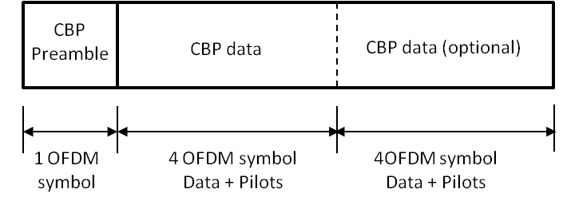

**Figure 9.X.5-1 CBP packet format**