IEEE P802.22  
Wireless RANs

|  |  |  |  |  |
| --- | --- | --- | --- | --- |
| Proposed Text of PHY technical items related to Section 9.4 of the Std.802.22-2011 | | | | |
| Date: 2013-07-16 | | | | |
| Author(s): | | | | |
| Name | Company | Address | Phone | email |
| Masayuki Oodo | NICT | 3-4, Hikarino-oka, Yokosuka, 239-0847, Japan |  | moodo@nict.go.jp |
| Zhang Xin | NICT | 20 Science Park Road, #01-09A/10 TeleTech Park, Singapore |  | amy.xinzhang@ieee.org |
| Chunyi Song | NICT | 3-4, Hikarino-oka, Yokosuka, 239-0847, Japan |  | songe@ieee.org |
| Keiichi Mizutani | NICT | 3-4, Hikarino-oka, Yokosuka, 239-0847, Japan |  | songe@ieee.org |
| Chang-Woo Pyo | NICT | 3-4, Hikarino-oka, Yokosuka, 239-0847, Japan |  | cwpyo@nict.go.jp |
| Pin-Hsun Lin | NICT | 3-4, Hikarino-oka, Yokosuka, 239-0847, Japan |  | pslin@nict.go.jp |
| Gabriel Porto Vilardi | NICT | 3-4, Hikarino-oka, Yokosuka, 239-0847, Japan |  | gpvillardi@nict.go.jp |
| Hiroshi Harada | NICT | 3-4, Hikarino-oka, Yokosuka, 239-0847, Japan |  | harada@ieee.org |

Abstract

This document contains the proposed text of PHY technical items related to Section 9.4 of the current 802.22 standard.

**Notice:** This document has been prepared to assist IEEE 802.22. It is offered as a basis for discussion and is not binding on the contributing individual(s) or organization(s). The material in this document is subject to change in form and content after further study. The contributor(s) reserve(s) the right to add, amend or withdraw material contained herein.

**Release:** The contributor grants a free, irrevocable license to the IEEE to incorporate material contained in this contribution, and any modifications thereof, in the creation of an IEEE Standards publication; to copyright in the IEEE’s name any IEEE Standards publication even though it may include portions of this contribution; and at the IEEE’s sole discretion to permit others to reproduce in whole or in part the resulting IEEE Standards publication. The contributor also acknowledges and accepts that this contribution may be made public by IEEE 802.22.

**Patent Policy and Procedures:** The contributor is familiar with the IEEE 802 Patent Policy and Procedures

<[**http://standards.ieee.org/guides/bylaws/sb-bylaws.pdf**](http://standards.ieee.org/guides/bylaws/sb-bylaws.pdf)>, including the statement "IEEE standards may include the known use of patent(s), including patent applications, provided the IEEE receives assurance from the patent holder or applicant with respect to patents essential for compliance with both mandatory and optional portions of the standard." Early disclosure to the Working Group of patent information that might be relevant to the standard is essential to reduce the possibility for delays in the development process and increase the likelihood that the draft publication will be approved for publication. Please notify the Chair Apurva N. Mody <[**apurva.mody@ieee.org**](mailto:apurva.mody@ieee.org)> as early as possible, in written or electronic form, if patented technology (or technology under patent application) might be incorporated into a draft standard being developed within the IEEE 802.22 Working Group. **If you have questions, contact the IEEE Patent Committee Administrator at <**[**patcom@ieee.org**](mailto:patcom@ieee.org)**>**.

**Summary of this document**

In this document, based on the proposed (1K FFT-based) PHY, detailed texts regarding “frame structure” are proposed. This item corresponds to Section 9.4 of 802.22 Standard as shown below.

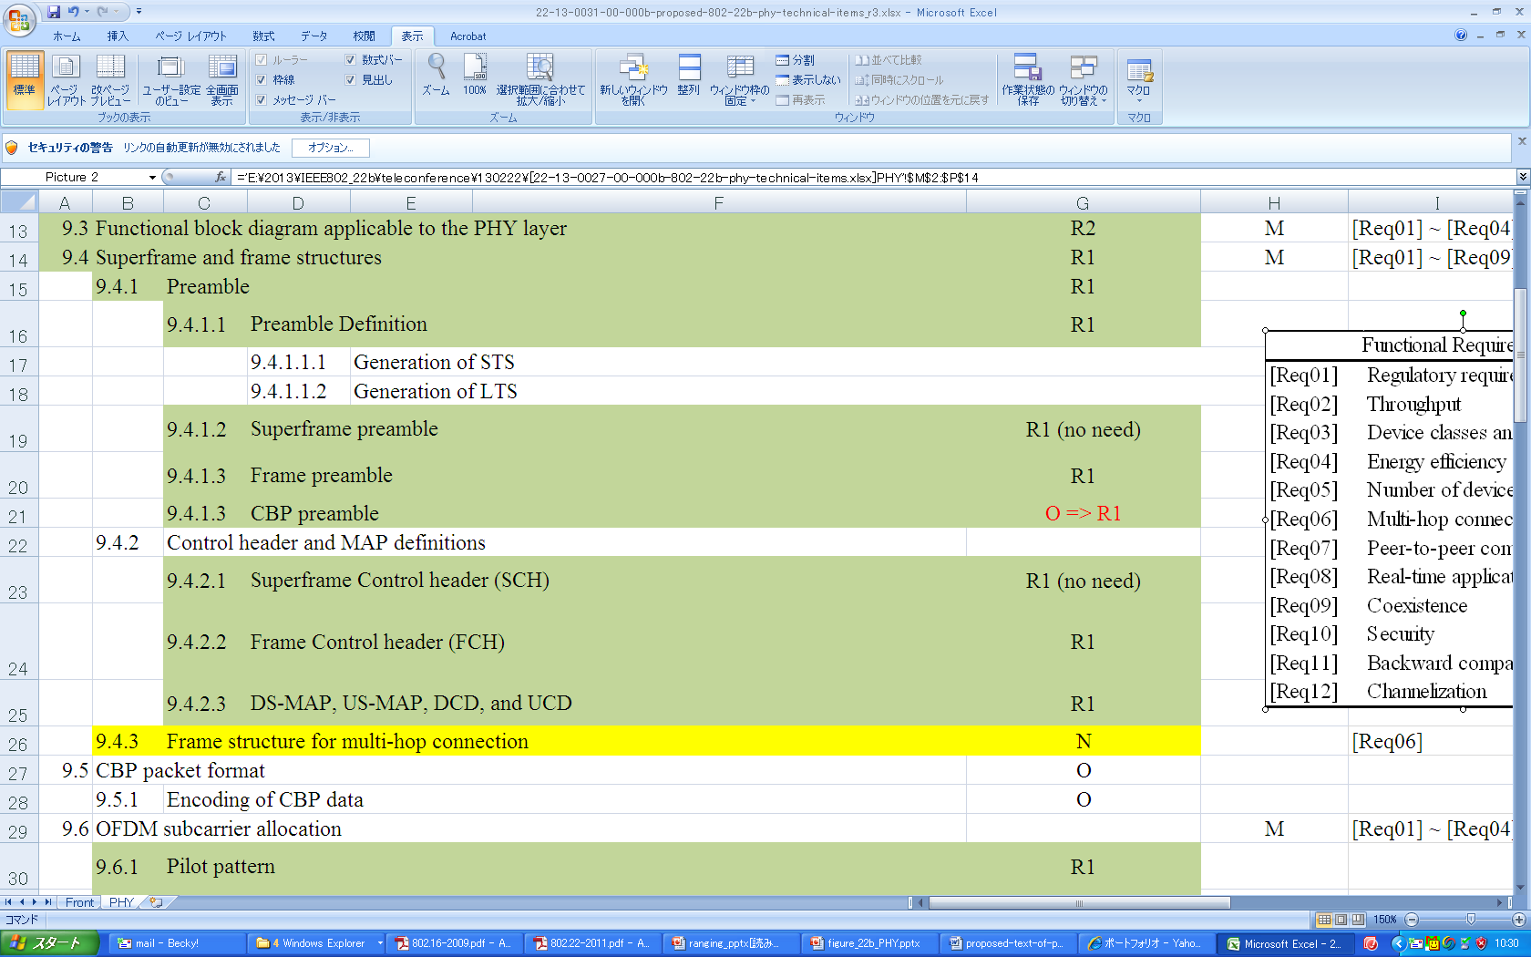

Proposed table of contents regarding the frame structure for 1-K FFT-based PHY is as follows.

9.X.4 Frame structure

9.X.4.1 Preamble

9.X.4.1.1 Frame preamble

9.X.4.1.2 CBP preamble (TBD)

9.X.4.2 Control header and MAP definitions

9.X.4.2.1 Frame Control Header (FCH)

9.X.4.2.2 DS-MAP, US-MAP, DCD, and UCD

Details of each subsection are described in the following pages.

**9.X.4 Frame structure**

The basic frame structure is shown in Figure 9.X.4-1. See 7.4 for a full description of the frame structure.

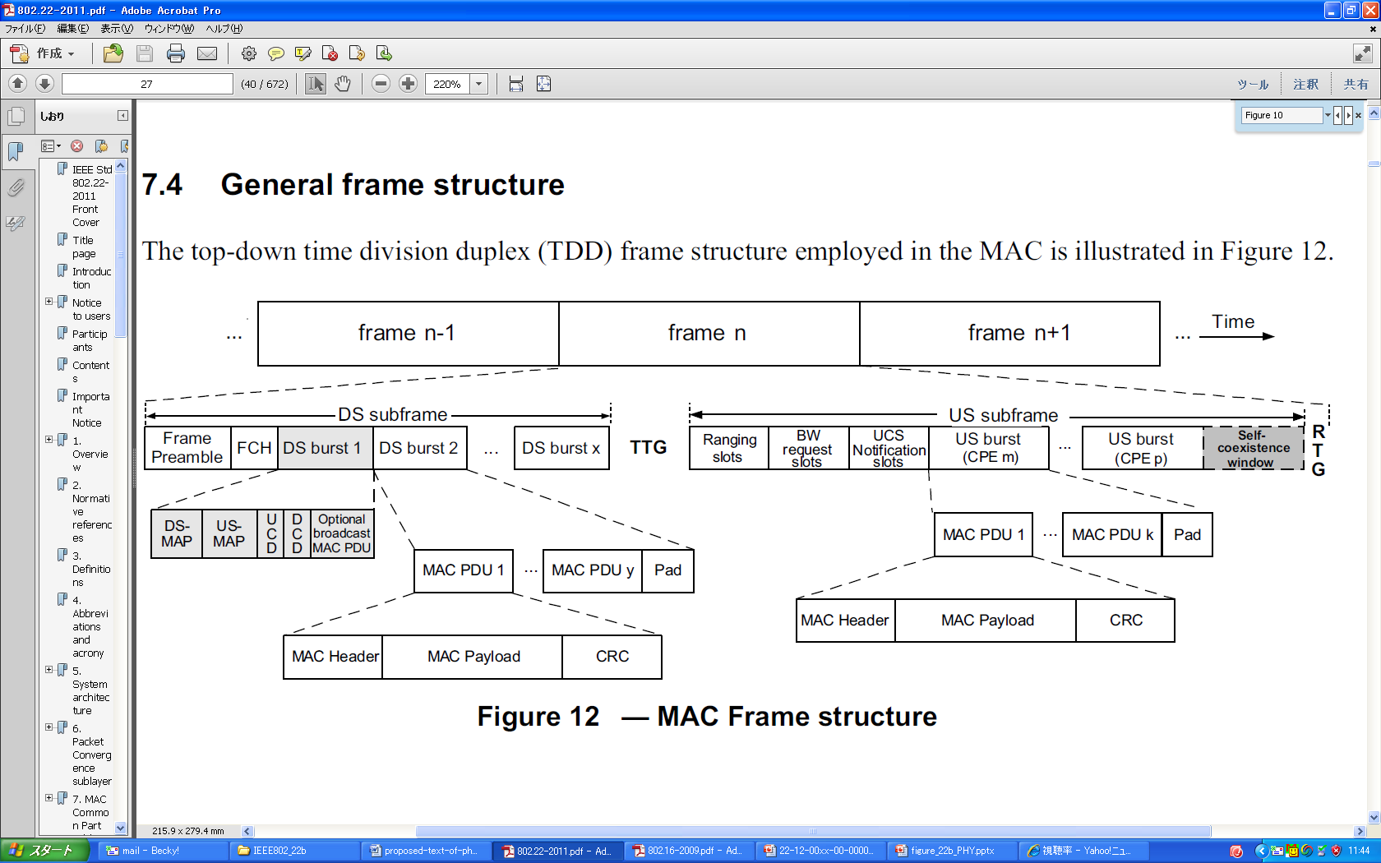

**Figure 9.X.4-1 —Basic frame structure**

Each frame contains a preamble, header, and data bursts.

For both normal and self-coexistence operational modes, the first symbol shall be the frame preamble. The second to fifth symbols shall contain the FCH, and DS-MAP, US-MAP, when needed, DCD and UCD, and data bursts if there is some room left. The FCH specifies the length of the first MAP that will immediately follow the FCH.

In each frame, a TTG shall be inserted between the downstream and upstream bursts to allow the CPE to switch between the receive mode and transmit mode and to absorb the signal propagation time. A RTG shall be inserted at the end of each frame to allow the BS to switch between its receiving mode and transmit mode (see Figure Figure 9.X.4-2).



**Figure 9.X.4-2 —Example of a time/frequency structure of a frame**

The values indicated in Table 9.X.4-1 for the TTG and RTG shall be used for the specified cyclic prefixes and channel bandwidth options.

**Table 9.X.4-1— WRAN frame parameters**

|  |  |  |  |
| --- | --- | --- | --- |
| **Cyclic**  **Prefix** | **Number of symbols**  **per frame1** | **Transmit-receive**  **turnaround gap2 (TTG)** | **Receive-transmit**  **turnaround gap3 (RTG)** |
| **BW** | **6 MHz 7MH 8MHz** | **6 MHz 7MH 8MHz** | **6 MHz 7MH 8MHz** |
| 1/4 | 41  48  55 | 1185 TU  1382 TU  1579 TU | 1056 TU  1232 TU  1408 TU |
| 1/8 | 46  54  61 | 1185 TU  1382 TU  1579 TU | 672 TU  592 TU  1665 TU |
| 1/16 | 48  57  65 | 1185 TU  1382 TU  1579 TU | 1504 TU  848 TU  1280 TU |
| 1/32 | 50  59  67 | 1185 TU  1382 TU  1579 TU | 960 TU  592 TU  1280 TU |

NOTE 1—Indicates the DS/US payload symbols and symbols for FCH, DS/US MAP and DCD/UCD. Here, one frame preamble symbol is assumed. Different values may apply when the frame carries more header symbols.

NOTE 2—Example of TTG set to absorb the propagation delay NOTE 3—Portion of symbol left over to arrive at the 10 ms frame period.

**9.X.4.1 Preamble**

**~~9.X.4.1.1 Preamble definition~~**

(This subsection is deleted)

**~~9.X.4.1.2 Superframe preamble~~**

(This subsection is deleted)

**9.X.4.1.1 Frame preamble**

(This subsection describes the specifications as a new text.)

The first symbol of the DS transmission is the preamble. Three different preamble carriersets are defined, differing in the allocation of subcarriers. Those subcarriers are modulated using a boosted BPSK modulation with a specific pseudo-noise (PN) code.

The preamble carrier-sets are defined using Equation (9.X.4.1.1-1).

*PreambleCarrierSetn* = *n* + 3*k*  (9.X.4.1.1-1)

where

*PreambleCarrierSetn* specifies all subcarriers allocated to the specific preamble

*n* is the designating number of the preamble carrier-set indexed 0, 1, and 2

*k* is a running index. 0...283

Each segment uses a preamble composed of a single carrier-set in the following manner:

— Segment 0 uses preamble carrier-set 0 (*n* =0).

— Segment 1 uses preamble carrier-set 1 (*n* =1).

— Segment 2 uses preamble carrier-set 2 (*n* =2) .

In the case of segment 0, the DC carrier will not be modulated at all, and the appropriate PN will be discarded. Therefore, the DC carrier shall always be zeroed.

Each segment eventually modulates each third subcarrier. As an example, Figure 9.X.4.1.1-1 depicts the preamble of segment 0. In this figure, subcarrier 0 corresponds to the first subcarrier used in the preamble symbol.

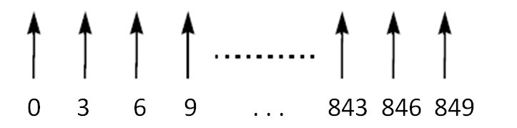

**Figure 9.X.4.1.1-1 —Example of basic structure of preamble (for the case of *n* =0)**

The PN series modulating the preamble carrier-set is defined in Table 9.X.4.1-1. The series modulated depends on the segment used and IDcell parameter. The defined series shall be mapped onto the preamble subcarriers in ascending order. Table 9.X.4.1.1-1 includes the PN sequence in an hexadecimal format. The value of the PN is obtained by converting the series to a binary series (*Wk*) and mapping the PN starting from the MSB of each symbol to the LSB (0 mapped to +1 and 1 mapped to –1). For example, for Index = 0, IDcell=0, and Segment = 0 (the first row of Table 9.X.4.1.1-1), *Wk* = 101001101111..., and the mapping shall follow: –1 +1 –1 +1 +1 –1 –1 +1 –1 –1 –1 –1....

For the preamble symbol, there will be 86 guard band subcarriers on each side of the spectrum.

The symbols in the DS preamble shall be modulated according to Equation (9.X.4.1-2).

$Re\left\{\text{PreambleModulated}\right\}=4∙\sqrt{2}∙\left(\frac{1}{2}-W\text{k}\right) , Im\left\{\text{PreambleModulated}\right\}=0$ (9.X.4.1-2)

**Table 9.X.4.1.1-1—Preamble modulation series per Cell ID and segment**

|  |  |  |  |
| --- | --- | --- | --- |
| **Index** | **Cell ID** | **Segment** | **Series to modulate (*Wk*)** |
| 0 | 0 | 0 | 0xA6F294537B285E1844677D133E4D53CCB1F182DE00489E53E6B6E77065C7EE7D0ADBEAF |
| 1 | 0 | 1 | 0x52849D8F020EA6583032917F36E8B62DFD18AD4D77A7D2D8EC2D4F20CC0C75B7D4DF708 |
| 2 | 0 | 2 | 0xD27B00C70A8AA2C036ADD4E99D047A376B363FEDC287B8FD1A7794818C5873ECD0D3D56 |
| 3 | 1 | 0 | 0x668321CBBE7F462E6C2A07E8BBDA2C7F7946D5F69E35AC8ACF7D64AB4A33C467001F3B2 |
| 4 | 1 | 1 | 0xCC53A152209DEC7E61A06195E3FA633076F7AE1BAFFE83CE565087C0507BA596E0BD990 |
| 5 | 1 | 2 | 0xE7FDDCEED8D31B2C0752D976DE92BEA241A713CF818C274AA1C2E3862C7EB7023AF35D4 |
| 6 | 2 | 0 | 0x1C75D30B2DF72CEC9117A0BD8EAF8E0502461FC07456AC906ADE03E9B5AB5E1D3F98C6E |
| 7 | 2 | 1 | 0x17D98A7E32CCA9B142FE32DB37B2BF726E25AA7A557FFB5C400B47A38B16CF18E1EDE63 |
| 8 | 2 | 2 | 0x87BF4954022D30549DF7348477EACB97AC3565B838460CC62F242883313B15C31370335 |
| 9 | 3 | 0 | 0x5F9A2E5CA7CC69A5227104FB1CC2262809F3B10D0542B9BDFDA4A73A7046096DF0E8D3D |
| 10 | 3 | 1 | 0xA5BA8C7E2C795C9F84EBBD425992766BDE5549A7A9F7EF7E44AFD941C6084568638FE84 |
| 11 | 3 | 2 | 0x82DD830BEDE4F13C76E4CF9AEF5E42609F0BDDCB000A742B6372DD5225B0C3114494746 |
| 12 | 4 | 0 | 0x82F8A0AB918138D84BB86224F6C342D81BC8BFE791CA9EB54096159D672E91C6E13032F |
| 13 | 4 | 1 | 0x33E57E78A5696255CA61AE36027036DA619E493A0A8F95D9915C6E61F3006CB9706BEBA |
| 14 | 4 | 2 | 0x4E06E4CF46E1F5691938D7F40179D8F79A85216775384BD97966DB4BBF49FB6FAB8F945 |
| 15 | 5 | 0 | 0xEE27E59B84CCF15BB1565EF90D478CD2C49EE8A70DE368EED7C9420B0C6FFAF9AF035FC |
| 16 | 5 | 1 | 0x09961E7309A9B7F3929C370C51910EBAB1B4F409FA976AE8679F354C84C4051F371F902 |
| 17 | 5 | 2 | 0x64164534569A5E670FDB390D09C04802DD6A16B022CADC77EDD7464AFED43C773A8DC76 |
| 18 | 6 | 0 | 0xC1DF5AE28D1CA6A8917BCDAF4E73BD93F931C44F93C3F12F0132FB643EFD5885C8B2BC |
| 19 | 6 | 1 | 0x508A9EBAEF3C7E09CFCFC0B6F444A09B45A130EFC8C5B22BCE87213854E7C9D329C9ADC |
| 20 | 6 | 2 | 0xFB8769A81AA9DB607F14A6A95948401F83057CDC9C9C3996BA5821403A49F00A4E35191 |
| 21 | 7 | 0 | 0xFCA36CCCF7F3E0602696DF745A68DB948C57DFA9575BEA1F05725C42155898F0A63A248 |
| 22 | 7 | 1 | 0xAACEEF9BCDC82E4AD525185B07CBABCB74861D16F7C25CFBA917B05463AD65391AF840D |
| 23 | 7 | 2 | 0x77710D6F40B4F79CC63F678551C3EC18FA9DF2C82E6C8F415DADFD63264B7513180070E |
| 24 | 8 | 0 | 0x024B0718DE6474473A08C8B151AED124798F15D1FFCCD0DE574C5D2C52A42EEF858DBA5 |
| 25 | 8 | 1 | 0x23060ACC5A125DAB207EEEE47B4EEE1E8466BD17DDA2EB3CD90D2AB7A758C213E6D7FE5 |
| 26 | 8 | 2 | 0x503F196BBF93C238BFD5E735E5AE52E0DAE64F5E2F4C3B92E553F51303C4A64C4403BF3 |
| 27 | 9 | 0 | 0xD4EBFCC3F5A0332BEA5B309ACB04685B8D1BB4CB49F9251461B4ABA255897148F0FF238 |
| 28 | 9 | 1 | 0xCA55521667BDA8B6F1B205201A51B3A0C05DE9EA06BC73268730A81A992777021F46055 |
| 29 | 9 | 2 | 0x5FD4A6894566678C95B9D5A59DDE5366799045FEB03A2BAA74094140E9068C61C2E972C |
| 30 | 10 | 0 | 0xEEA213F429EB926D1BDEC03ABB67D1DE47B4738F3E929854F83D18B216095E6F546DADE |
| 31 | 10 | 1 | 0x05ADFCA2F8207DC6FF8D1A85A1DD4694D4C48A838C4F833C532710021AC448A7B62B8DD |
| 32 | 10 | 2 | 0x95B584DC40C8B5DEAD63D48FCE65B1E61BAB4C597D921DB12677141E2FFE7C0AA3DA0D5 |
| 33 | 11 | 0 | 0xC03036FA9F253045DF6C0889A8B83BAEFCF90EB993C2D79BD911CA84075061AA43DA471 |
| 34 | 11 | 1 | 0x218C951223D7B712DC98F8B5217388A830003C5F2A00F232DD3475D2FC78C25B8D88FF9 |
| 35 | 11 | 2 | 0x985763AB6CC8934DB8A0BE738A7AF1D1FA3958C1F9E2D6A51A163E47A0A6E5FEB759FDD |
| 36 | 12 | 0 | 0x1E68EC22E5E2947FB0A29E4CC70597254B36C60331EACF779FE752D3F55DC41ABFC7DC9 |
| 37 | 12 | 1 | 0x79B94D24D721121EF678B7156F8D2666DE712BBF3837C85A9518781903146A7B4D42A28 |
| 38 | 12 | 2 | 0xFD8D45F00D943AD986BD353D61C6746DBF8A309B6AE1C173B880D957B76DC031A957E8D |
| 39 | 13 | 0 | 0x63A57E75A0434F035AAC4504B265081D497F10C77928B71797C5D6C6824DC0F23BE34EE |
| 40 | 13 | 1 | 0x58AABEF6A6BDE4011CAC583C5104B2C6FC5A2980F856373E5931A3C690245327581FA13 |
| 41 | 13 | 2 | 0xAE4323534F6EFB1A20169328417885EF304FA220389FA9C2607E5A406F4CE4A7498A39F |
| 42 | 14 | 0 | 0xC57C4612816DE981C58FD6F8DE9DD41F2422ADBC522B0CE31F9A6D5F2A126DC08F69FB1 |
| 43 | 14 | 1 | 0x427D1AD18E338E16FCE6E23B4AD6D82A2144D53048F2665AA94577AFABD26889FCB1F9F |
| 44 | 14 | 2 | 0xE5205579893BE184CB9948C28E2F9AAF699D47B6E5E0B219CBEAFE4BEC8D561BD809E34 |
| 45 | 15 | 0 | 0x978256AF184E7ED17789B33D324C711B36BFBCCE5446EB03687E9A0A839C7CE156104D2 |
| 46 | 15 | 1 | 0x337FE0E4C15A22471AE0F6B6F91161A7DE2E1403D73587D5C8355105D2F70642B2CE425 |
| 47 | 15 | 2 | 0xAB11D6941478D36D5695CE813070DC1E32122A39083E53FE373660AEB125D83383FBDCA |
| 48 | 16 | 0 | 0x011EC823157DD73150640CEB7DDB0A1F8F91E09599A851D5C7CAF687CFB752D297D82FC |
| 49 | 16 | 1 | 0xA3FCAA311B536AC9DB39FED9F4E996506B3181C58D6B7E04157A3FD463F60468765BCFD |
| 50 | 16 | 2 | 0x188A09C46F1F11206FF9F15CFB5F6CD2F26C4BF485EE37D3650A595064F76CE34E40EAD |
| 51 | 17 | 0 | 0xC6DE82BEB7F57B9120E8A376D85C8F70FDC65BC660402DAC4AE6002EA2740C4F9E5973C |
| 52 | 17 | 1 | 0xF484FD1F57F53A4A749B86148E0B1D0653667CE1393198875DDB0AE9179BBBDAAD53A11 |
| 53 | 17 | 2 | 0x4B1CDE25539A56CEDC45FE7F54C38CF155F4FB1AE868F6C3952D07014BF828E810BDE2D |
| 54 | 18 | 0 | 0x4C74929D6F9FAB9E5BB761026038E076F6824295E0AF397806ECEBC6DC713F03ACDC27C |
| 55 | 18 | 1 | 0xA3E9ECF1E6048562BC89DB6168E708855F0D4AD29F859EF36C9160DF407D85426233632 |
| 56 | 18 | 2 | 0x16CA8F8C6A879E865E3611EAC389D56AFA3E4E84CDBB73567BA4A160249C4B680A7D9BC |
| 57 | 19 | 0 | 0x13E1E85C2234D0F3418001A35F135E10C6C918C36BC659FDA9D655D288A0BDAA8BF489D |
| 58 | 19 | 1 | 0x890519376D1FFAA2894EABCD6663B0A3C2411982C17B01270E0FB0B289D4BC8C3B83D |
| 59 | 19 | 2 | 0x39D2B08AA0E2E8781476027B41AD72F8D9838B7001AADFD33A92D81E56ECBB2C9378D58 |
| 60 | 20 | 0 | 0xFD4AF2D8F4F08F1A7DF59291C9AEE788F641B8231CFB813376E0BEB68DFCFCBBE552445 |
| 61 | 20 | 1 | 0x09847B6187BB5F6F6728B4ED610088FAD9DADFC00748E9DCD8A0CE320D6C991654ABE05 |
| 62 | 20 | 2 | 0x8C258BC80D4AD125F335A5151EDF9E9A463E06C5C8D046F82E5DC3D73EF4D2231C5D14F |
| 63 | 21 | 0 | 0xEBBC77A493AA0C62C62F25EE5E8D0701F50386F49026FA31487C9FD5C5206CE4EB00576 |
| 64 | 21 | 1 | 0x3285AE0A3D196313659C37BE1C94D61D20F11FD49D9FDF9D1026FF5763F02CB78AE135C |
| 65 | 21 | 2 | 0x41A029C6356C825585179C5348EDF07A3AC2022539AC28DC4CD3C1DFADC8EE9644CD939 |
| 66 | 22 | 0 | 0x134F936F9E875842587ADCA92187F2FC6D62FFC3A833D8CDE465F9972ABAA83763AAEB7 |
| 67 | 22 | 1 | 0x0069D3F34D0D455AFB45FEFDF716333B785C6BDA90DA23F1CC68BC6A1DBC916C595DA3E |
| 68 | 22 | 2 | 0x0D70A77CBE9804913BFBEC4FBF917C5CD3580F6062BBAD3F99ECEBB4A9EBB87523AB722 |
| 69 | 23 | 0 | 0x3CD1DA70670BC73363D1B4A66D280FF6AA7636D07ECF32BA26101E5EBA1594FB8A0420A |
| 70 | 23 | 1 | 0xAA977A8BCA39381E7C35A1ACC7C4F60421C0862BFD6106C7C025B0676EA0EF68972DD8F |
| 71 | 23 | 2 | 0x6A00A30901F9FDE44B4F1ECED44E0BCB943B29519F313BE4496D34F39B154FC2384CB75 |
| 72 | 24 | 0 | 0x918296B2937C2B6F73CF98F85A81B723D1C69DBDF3E019749C582DA22E789562729D475 |
| 73 | 24 | 1 | 0xF310745C497094ABE56E0490C0800319DBE290553E696B6859635AF03B121F79D925D19 |
| 74 | 24 | 2 | 0x95351107A8BE6ABFC24C1292FE1A0FE677CBFD04F2E81178CAA9D294730EF9C946F676E |
| 75 | 25 | 0 | 0xC323981B8B2240865F48D61AE1B3B61D88522B7358952F949D4308CA15D1EE8FDFA683F |
| 76 | 25 | 1 | 0x964DFD350B9C7DFDC7F6F7C43283A76F0D613E48A5520D1DAF761C6F47E389B43A023F5 |
| 77 | 25 | 2 | 0x01F21470FD9B1E0B3C6B2F7C0412A15764C277D61BA2EE3B3769DE7ADACB2BB29918FB7 |
| 78 | 26 | 0 | 0x7514A6FA5FBB250C5C8CE96F791D676036C344A44B24284477B44CB3E758F8BCD58F05B |
| 79 | 26 | 1 | 0x6D767B88D28A455CC3B56C942BAFD8E465A50FD2C22FE6162E03A9AAC3C1CC899800610 |
| 80 | 26 | 2 | 0xA578ABFE155369440FA3D4DF757CCA596469B80A0E56BFE6010DD63E67CEDB86BB1EF39 |
| 81 | 27 | 0 | 0x84C7FEC6E977FA1EC0C7CC9E0D067C73D8F846F82ABB3456D2104E1448D5A58D5975152 |
| 82 | 27 | 1 | 0xC5491C6CA3D998906EC1482F815B74B7C2E3816B682ACC6009AB7EFF34BF0E9CE59C754 |
| 83 | 27 | 2 | 0x1E1CFFAB031836777DE5D168A9246C559574C74CCC06405EB406B8DDB7C9A6EF54A66A5 |
| 84 | 28 | 0 | 0x4841AFC277B86A0E067AF319422F501C87ACBFBDD66BFEA3644F879AE98BA8C5D605123 |
| 85 | 28 | 1 | 0x6D8EE32D30E19D93A0E5AD8226BAE9CF6FCBA17CF6E67FDC5A15A81ECB8908BEDD77C80 |
| 86 | 28 | 2 | 0x354149C2CA19A735F9CD04AF4922E8ECE6509B978B951F946FD4AD36C7F9C83624205E7 |
| 87 | 29 | 0 | 0xF35EA87318E459138A2CE69169AD5FD9F30B62DA04ED21320A9F59893F0D176752152FD |
| 88 | 29 | 1 | 0x98F8BFDF774C7A249418E6FF4723D6E6AB2F091CDE4DE1CE11D3BD463B509FB716940FD |
| 89 | 29 | 2 | 0x5A27E60DEA547D0D41897A03199F28A967AC51728E3B38325B4FBECF1B85A7EE9B04182 |
| 90 | 30 | 0 | 0xA0C5F35C5971CD3DC55D7D2B9FD27AA17A198583F580EB0800744EE5B6B3648DEA95840 |
| 91 | 30 | 1 | 0x65300BAD8FFA21BC7DC2C1F79FA97A9F469CCC9E270A61759F34D6276F57CBEB009CD21 |
| 92 | 30 | 2 | 0x784DA3B16B810FE3B851060AD7BD27D9D9457F6C8899A13D311E531B855C15ECE6D3A2F |
| 93 | 31 | 0 | 0xA6D3D33AD9B56862DBF076E3ACE6A3150510CCC8BE77DE4E6E10EB5FE163765647D07DF |
| 94 | 31 | 1 | 0x6F36BB6D5A7DC4FB720439E91FF0DE86DD6C4B93CFC4271F2BCC6169616E3AEAA19E360 |
| 95 | 31 | 2 | 0xD7DFBC65797633A8C13D3EEC781D48952338136063B579D69437B28B744B5A4BE18AFA9 |

**9.X.4.1.2 CBP preamble**

(TBD, need to modify the legacy CBP preamble for 1K-FFT based PHY)

**9.X.4.2 Control header and MAP definitions**

**9.4.2.1 Superframe Control header (SCH)**

(This subsection is deleted)

**9.X.4.2.1 Frame control header (FCH)**

The frame control header is transmitted as part of the downstream PDU in the DS subframe. The length of the FCH shall be 3 bytes and contain information as specified in Table XXX (to be described in MAC section). The FCH shall be sent in the first subchannel of the symbol immediately following the frame preamble symbol. The FCH shall be encoded using QPSK rate 1/2 with four repetitions using the binary convolutional channel coding . The FCH contains the downstream frame prefix as described in XXX(to be determined in MAC section), and specifies the length of the DS-MAP message that immediately follows the downstream frame prefix and the repetition coding used for the DS-MAP message.

**9.X.4.2.2 DS-MAP, US-MAP, DCD, and UCD**

The length of the DS-MAP PDU is variable and is defined in the FCH (9.X.4.2.1.1). This PDU shall be encoded using the binary convolutional channel coding specified in 9.X.7.2.1.1 and transmitted using the PHY mode 4 listed in Table 9.X.2-1 in the logical subchannel immediately following the FCH. The length of the US-MAP, DCD and UCD, when present, shall be specified at the beginning of the DS-MAP in that order. The number of subchannels required to transmit these fields shall be determined by their respective lengths in number of OFDM slots. These fields shall be transmitted using PHY mode 4. If this number exceeds the number of subchannels, the transmission of these PDUs will continue in the next slot starting with the first logical subchannel. The unused subchannels in the last slot of the frame header shall be used for DS transmissions.