IEEE P802.22
Wireless RANs
Proposed Text for the IEEE802.22b
Date: 2013-05-15
Author(s):
Name | Company | Address | Phone | email
Shigenobu Sasaki | Niigata University | 8050 Ikarashi 2-no-cho, Niigata, 950-2181 Japan | 81-25-262-6737 | kojiro@eng.niigata-u.ac.jp
Bingxuan Zhao | Niigata University | 8050 Ikarashi 2-no-cho, Niigata, 950-2181 Japan
Hidenori Watanabe | Niigata University | 8050 Ikarashi 2-no-cho, Niigata, 950-2181 Japan
Abstract
This document contains the proposed text for P802.22b.

I. Introduction
Notice: This document has been prepared to assist IEEE 802.22. It is offered as a basis for discussion and is not binding on the contributing individual(s) or organization(s). The material in this document is subject to change in form and content after further study. The contributor(s) reserve(s) the right to add, amend or withdraw material contained herein.

Release: The contributor grants a free, irrevocable license to the IEEE to incorporate material contained in this contribution, and any modifications thereof, in the creation of an IEEE Standards publication; to copyright in the IEEE’s name any IEEE Standards publication even though it may include portions of this contribution; and at the IEEE’s sole discretion to permit others to reproduce in whole or in part the resulting IEEE Standards publication. The contributor also acknowledges and accepts that this contribution may be made public by IEEE 802.22.

Patent Policy and Procedures: The contributor is familiar with the IEEE 802 Patent Policy and Procedures
<http://standards.ieee.org/guides/bylaws/sb-bylaws.pdf>, including the statement "IEEE standards may include the known use of patent(s), including patent applications, provided the IEEE receives assurance from the patent holder or applicant with respect to patents essential for compliance with both mandatory and optional portions of the standard." Early disclosure to the Working Group of patent information that might be relevant to the standard is essential to reduce the possibility for delays in the development process and increase the likelihood that the draft publication will be approved for publication. Please notify the Chair Apurva Mody <apurva.mody@ieee.org> as early as possible, in written or electronic form, if patented technology (or technology under patent application) might be incorporated into a draft standard being developed within the IEEE 802.22 Working Group. If you have questions, contact the IEEE Patent Committee Administrator at <patcom@ieee.org>.
This contribution provides the proposed text for the IEEE 802.22b draft on PHY.

II. Text Proposals

[Start of Proposed Text]
- PHY
[ Modify Table 198 as follows]

- System parameters for WRAN
Parameters | Specification | Remark
Frequency range | 54~862 MHz*
Channel bandwidth | 6, 7, or 8 MHz | According to regulatory domain (see Annex A).
Data rate | 4.54 to 31.78 Mbit/s | See Table 202
Spectral Efficiency | 0.76 to 5.30 bit/(s·Hz) | See Table 202
Payload modulation | QPSK, 16-QAM, 64-QAM  256-QAM, MD-TCM-QAM | BPSK used for preambles, pilots and CDMA codes.
Transmit EIRP | 4W maximum for CPEs. 4W maximum for BS’s in the USA regulatory domain. | Maximum EIRP for BS’s may vary in other regulatory domains.
Multiple Access | OFDMA
FFT Size (N_{FFT}) | 2048
Cyclic Prefix Modes | 1/4, 1/8, 1/16, 1/32
Duplex | TDD
* Frequency range allocated to the Television Broadcasting Service in various parts of the world. See Annex A for further details.
[End of Proposed Text]

[Start of Proposed Text]

9.2 PHY mode
[ Add additional PHY mode into Table 202]
Table 202 — PHY Modes and their related modulations, coding rates and data rates for T_{CP} = T_{FFT}/16
PHY Mode | Modulation | Coding Rate | Data rate (Mb/s) | Spectral Efficiency (for 6 MHz bandwidth)
(No change for PHY modes
1-16)
17 | 256-QAM | 1/2 | 18.16 | 3.03
18 | 256-QAM | 2/3 | 24.2 | 4.03
19 | 256-QAM | 3/4 | 27.24 | 4.54
20 | 256-QAM | 5/6 | 30.24 | 5.04
21 | 256-QAM | 7/8 | 31.78 | 5.30
22 | 4D-48TCM | 10/11 for  2 *2D symbol | 22.69 | 3.78
23 | 4D-192TCM | 14/15 for  2 *2D symbol | 31.78 | 5.30

[End of Proposed Text]

[Start of Proposed Text]
9.8 Constellation mapping and modulation
9.8.1 Data modulation

[Modify text above Fig. 150]
The output of the bit interleaver is entered serially to the constellation mapper. The input data to the mapper
is first divided into groups of number of coded bits per carrier, i.e., NCBPC (see Table 226) bits and then
converted into complex numbers representing QPSK, 16-QAM, 64-QAM or 256-QAM constellation points. The mapping for QPSK, 16-QAM and 64-QAM is performed according to Gray-coding constellation mapping,
as shown in Figure 150, Figure 151, Figure 152, and Fig. 152a respectively where b0 represents the most significant modulation bit for all constellations.

[ Add New Fig. 152a below Fig. 152]

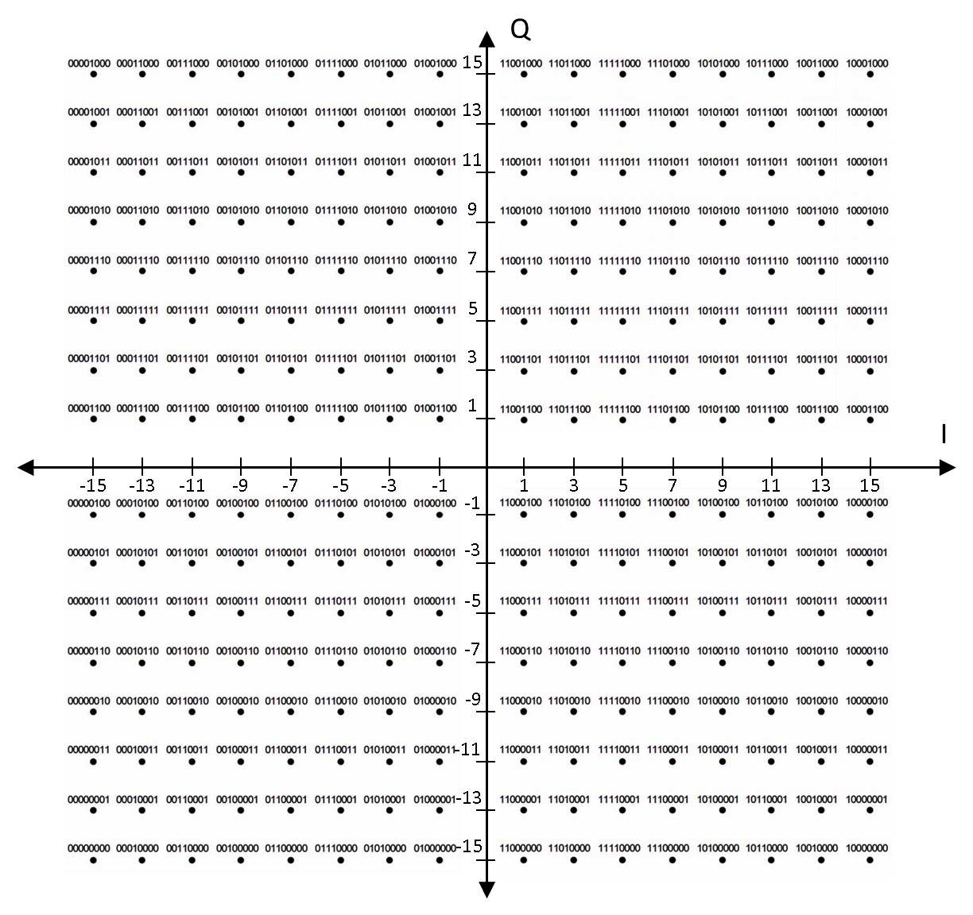
Fig. 152a Gray Mapping for 256QAM

[End of Proposed Text]

[Start of Proposed Text]

[Modify Table 226 and Table 227 as follows]

Table 226 — Number of coded bit per carrier and normalization factor for different modulation constellations
Modulation Type | N_{CBPC} | K_{MOD}
QPSK | 2 | 1/√2
16-QAM | 4 | 1/√10
64-QAM | 6 | 1/√42
256-QAM | 8 | TBD

Table 227 — Number of coded bits per OFDM slot (NCBPS) and corresponding number of data bits for different modulation constellation and coding rate combinations
Constellation type | Coding rate | NC_{BPS} | Corresponding number of data bits
QPSK | 1/2 | 48 | 24
QPSK | 2/3 | 48 | 32
QPSK | 3/4 | 48 | 36
QPSK | 5/6 | 48 | 40
16-QAM | 1/2 | 96 | 48
16-QAM | 2/3 | 96 | 64
16-QAM | 3/4 | 96 | 72
16-QAM | 5/6 | 96 | 80
64-QAM | 1⁄2 | 144 | 72
64-QAM | 2/3 | 144 | 96
64-QAM | 3/4 | 144 | 108
64-QAM | 5/6 | 144 | 120
256-QAM | 1/2 | 192 | 96
256-QAM | 2/3 | 192 | 128
256-QAM | 3/4 | 192 | 144
256-QAM | 5/6 | 192 | 160
256-QAM | 7/8 | 192 | 168

[End of Proposed Text]

References:
[1] IEEE Std. 802.22TM-2011, July 2011.

