IEEE P802.22
Wireless RANs
Proposed Text of PHY technical items related to Sections 9.7, 9.8 and 9.9 of the Std.802.22-2011
Date: 2013-04-18
Author(s):
Name | Company | Address | Phone | email
Masayuki Oodo | NICT | 3-4, Hikarino-oka, Yokosuka, 239-0847, Japan |  | moodo@nict.go.jp
Zhang Xin | NICT | 20 Science Park Road, #01-09A/10 TeleTech Park, Singapore |  | amy.xinzhang@ieee.org
Chunyi Song | NICT | 3-4, Hikarino-oka, Yokosuka, 239-0847, Japan |  | songe@ieee.org
Keiichi Mizutani | NICT | 3-4, Hikarino-oka, Yokosuka, 239-0847, Japan |  | songe@ieee.org
Chang-Woo Pyo | NICT | 3-4, Hikarino-oka, Yokosuka, 239-0847, Japan |  | cwpyo@nict.go.jp
Pin-Hsun Lin | NICT | 3-4, Hikarino-oka, Yokosuka, 239-0847, Japan |  | pslin@nict.go.jp
Gabriel Porto Vilardi | NICT | 3-4, Hikarino-oka, Yokosuka, 239-0847, Japan |  | gpvillardi@nict.go.jp
Hiroshi Harada | NICT | 3-4, Hikarino-oka, Yokosuka, 239-0847, Japan |  | harada@ieee.org
Abstract
This document contains the proposed text of PHY technical items related to Section 9.7, 9.8 and 9.9 of the current 802.22 standard.
Notice: This document has been prepared to assist IEEE 802.22. It is offered as a basis for discussion and is not binding on the contributing individual(s) or organization(s). The material in this document is subject to change in form and content after further study. The contributor(s) reserve(s) the right to add, amend or withdraw material contained herein.

Release: The contributor grants a free, irrevocable license to the IEEE to incorporate material contained in this contribution, and any modifications thereof, in the creation of an IEEE Standards publication; to copyright in the IEEE’s name any IEEE Standards publication even though it may include portions of this contribution; and at the IEEE’s sole discretion to permit others to reproduce in whole or in part the resulting IEEE Standards publication. The contributor also acknowledges and accepts that this contribution may be made public by IEEE 802.22.

Patent Policy and Procedures: The contributor is familiar with the IEEE 802 Patent Policy and Procedures
<http://standards.ieee.org/guides/bylaws/sb-bylaws.pdf>, including the statement "IEEE standards may include the known use of patent(s), including patent applications, provided the IEEE receives assurance from the patent holder or applicant with respect to patents essential for compliance with both mandatory and optional portions of the standard." Early disclosure to the Working Group of patent information that might be relevant to the standard is essential to reduce the possibility for delays in the development process and increase the likelihood that the draft publication will be approved for publication. Please notify the Chair Apurva N. Mody <apurva.mody@ieee.org> as early as possible, in written or electronic form, if patented technology (or technology under patent application) might be incorporated into a draft standard being developed within the IEEE 802.22 Working Group. If you have questions, contact the IEEE Patent Committee Administrator at <patcom@ieee.org>.
Summary of this document

In this document, based on the proposed (1K FFT-based) PHY, detailed texts regarding “OFDM slot concatenation” , “data modulation” , and “CDMA bursts” are proposed. These items correspond to Section 9.7.2.1.3, 9.8.1 and 9.9.3.1, respectively as shown below. (Some marks have been modified from Doc.IEEE 22-13-0031-02-000b)

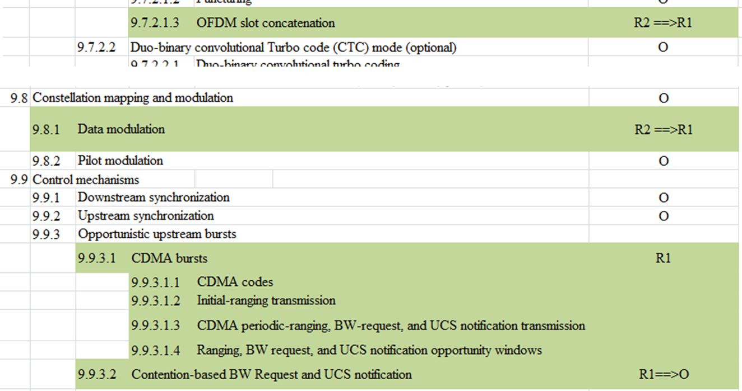

In this document, texts are described with revision marks based on the current IEEE802.22 standard.

9.X.7.2.1.3 OFDM slot concatenation
The encoding block size shall depend on the number of OFDMslots allocated and the modulation specified for the current transmission. Concatenation of a number of OFDM slots shall be performed in order to allow for transmission of larger blocks of coding where it is possible, with the limitation of not exceeding the largest block size for the corresponding modulation and coding. Table 9.X.7.2.1.3-1 specifies the concatenation index for different modulations and coding.

For any modulation and coding, the following parameters are defined:

— j : index dependent on the modulation level and FEC rate
— n : number of allocated OFDM slots
— k : floor (n / j)
— m : n mod j

Table 9.X.7.2.1.3-2 shows the rules used for OFDM slot concatenation.

Table 9.X.7.2.1.3-1— Concatenation index for different modulations and coding

Modulation and Rate | j
QPSK 1/2 | 6
QPSK 2/3 | 4
QPSK 3/4 | 4
QPSK 5/6 | 3
16-QAM 1/2 | 3
16-QAM 2/3 | 2
16-QAM 3/4 | 2
16-QAM 5/6 | 1
64-QAM 1/2 | 2
64-QAM 2/3 | 1
64-QAM 3/4 | 1
64-QAM 5/6 | 1

Table 9.X.7.2.1.3-2— OFDM slot concatenation rule
Number of slots | Slots concatenated
$$n≤j$$ | 1 block of n slots
$$n>j$$ | If (n mod j = 0)  k blocks of j slots  else  $(k-1)$ blocks of j slots  1 block of ceil(($m+j)/2)$ slots  1 block of floor(($m+j)/2)$ slots

Table 9.X.7.2.1.3-3 defines the basic sizes of the useful data payloads (in bytes) to be encoded in relation with the selected modulation type, encoding rate, and concatenation rule.

Table 9.X.7.2.1.3-3—Useful data payload for an FEC Block
 | QPSK |  |  |  | 16-QAM |  |  |  | 64-QAM
Encoding rate | 1/2 | 2/3 | 3/4 | 5/6 | 1/2 | 2/3 | 3/4 | 5/6 | 1/2 | 2/3 | 3/4 | 5/6
Data Payload (byte) | 6
 |  | 8
 |  |  | 9
 |  |  |  | 10 |  |  |  | 20
 | 12 |  |  |  | 12
 |  | 16 |  |  |  | 16
 | 18 |  | 18 |  |  |  | 18 |  | 18
 |  |  |  | 20
 | 24 | 24 |  |  | 24 |  |  |  |  | 24
 |  |  | 27 |  |  |  |  |  |  |  | 27
 | 30 |  |  |  |  |  |  |  |  |  |  | 30
 |  | 32 |  |  |  | 32
 | 36 |  | 36 |  | 36 |  | 36 |  | 36
9.X.8.1 Data modulation

(only Table 227 is modified as follows)

Table 9.X.8.1 — Number of coded bits per OFDM slot (N_{CBPS}) and corresponding number of
data bits for different modulation constellation and coding rate combinations

Constellation type | Coding rate | N_{CBPS} | corresponding number of data bits
QPSK | 1/2 | 96 | 48
QPSK | 2/3 | 96 | 64
QPSK | 3/4 | 96 | 72
QPSK | 5/6 | 96 | 80
16-QAM | 1/2 | 192 | 96
16-QAM | 2/3 | 192 | 128
16-QAM | 3/4 | 192 | 144
16-QAM | 5/6 | 192 | 160
64-QAM | 1/2 | 288 | 144
64-QAM | 2/3 | 288 | 192
64-QAM | 3/4 | 288 | 216
64-QAM | 5/6 | 288 | 240
9.X.9.3 Opportunistic upstream bursts

A ranging channel is composed of one or two groups of six adjacent subchannels, using the symbol structure defined in 9.X.6.3.1, where the groups are defined starting from the first subchannel. Subchannels are considered adjacent if they have successive logical subchannel numbers. The indices of the subchannels that compose the ranging channel are specified in the US-MAP message. BS shall allocate ranging, bandwidth (BW) request or UCS notification allocation within 6 or 12 subchannels.

9.X.9.3.1 CDMA bursts

The number of subchannels for the ranging channel and the number of symbols for each transmission (CDMA initial ranging, CDMA periodic ranging, CDMA BW request and CDMA UCS notification) are specified in the US-MAP_IE Table 35.

CPEs are allowed to collide on the ranging channel. To still provide reliable transmission, each CPE randomly chooses one ranging code from the subgroup of specified binary codes that is defined in 9.X.9.3.1.1. These codes are then BPSK modulated onto the subcarriers in the ranging channel. The length of these binary codes is the same as the number of subcarriers in the ranging channel.

9.X.9.3.1.1 CDMA codes

The binary codes shall be the pseudo-noise codes produced by the PRBS generator described in Figure 9.X.9.3.1.1-1, which illustrates the following polynomial generator: 1+ x¹ + x⁴+ x⁷+ x¹⁵. The PRBS generator shall be initialized by the seed b15...b1 = 0,0,1,0,1,0,1,1,s0,s1,s2,s3,s4,s5,s6 where s6 is the LSB of the PRBS seed, and s6:s0=US_PermBase, where s6 is the MSB of the US_PermBase.

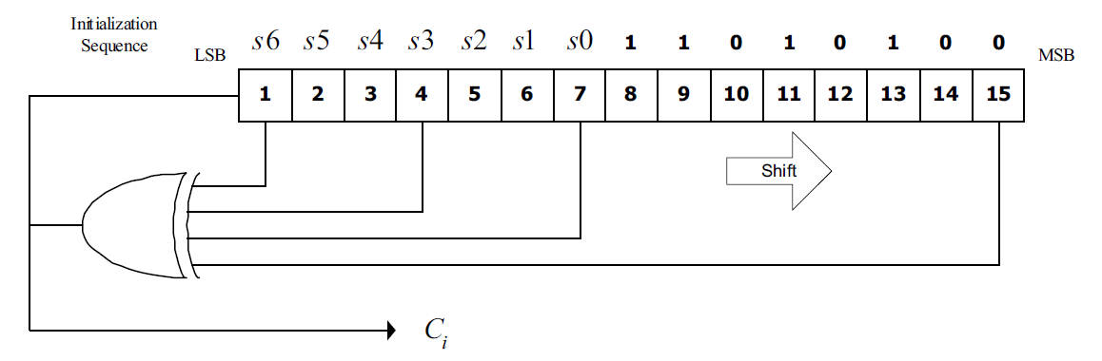

Figure 9.X.9.3.1.1-1— PRBS generator for ranging code generation

The binary ranging codes shall be subsequences of the pseudo-noise sequence appearing at its output C_{i}. The length of each ranging code is 144 bits. These bits are used to modulate the subcarriers in a group of six adjacent subchannels. The bits are mapped to the subcarriers in increasing frequency order of the logical subcarriers, such that the lowest indexed bit modulates the subcarrier with the lowest subcarrier index and the highest indexed bit modulates the subcarrier with the highest index. The index of the lowest numbered subchannel in the six shall be an integer multiple of six.

For example, the first 144 bit obtained by clocking the PN generator as specified and by setting US_PermBase = 0, the first code shall be 00110000010001... The next ranging code is produced by taking the output of the 145th to 288th clock of the PRBS generator, etc.

The number of available codes is 256, numbered 0...255. Each BS uses a subset of these codes, where the subgroup is defined by a number S, 0<S<255. The group of codes shall be between S and (S+O+N+M+L) mod 256

- The first N codes produced are for initial ranging. Clock the PRBS generator 144 × (S mod 256) times to 144 × ((S + N) mod 256) – 1 times.
- The next M codes produced are for periodic ranging. Clock the PRBS generator 144 × ((N + S) mod 256) times to 144 × ((N + M + S) mod 256) – 1 times.
- The next L codes produced are for BW request. Clock the PRBS generator 144 × ((N + M + S) mod 256) times to 144 × ((N + M + L + S) mod 256) – 1 times.
- The next O codes produced are for UCS notification. Clock the PRBS generator 144 × ((N + M + L + S) mod 256) times to 144 × ((N + M + L + O + S) mod 256) – 1 times.

The BS shall separate colliding codes and extract timing (ranging) and power information by using a correlation function. The time (ranging) and power measurements shall be used by the system to compensate for the various BS-CPE-BS propagation distances. In the process of CPE code detection, the BS will also get the Channel Impulse Response (CIR) for the transmission link from the specific CPE. The precise timing offset shall be estimated by terrestrial ranging (see 10.5.2).

9.X.9.3.1.2 Initial-ranging transmission

The initial ranging transmission shall be used by all CPEs to synchronize to the system when attempting to associate. The initial ranging transmission will be used for detecting and adjusting the timing offset and adjusting the transmission EIRP level. The initial-ranging transmission is performed using two or four consecutive symbols starting, as indicated in the US-MAP for the CPE, on the first symbol after the TTG.

These symbols shall be generated according to Equation (9.X.9.3.1.2-1) , except that $0≤t≤2T_{s}$. A time-domain illustration used for the initial-ranging transmission is shown in Figure 9.X.9.3.1.2-1.

$$s\left(t\right)=Re\left\{e^{j2πf_{c} t}\sum_{k=-\frac{N_{used}-1}{2},k≠0}^{\frac{N_{used}-1}{2}}{c_{k} ∙e^{j2πk∆f(t-T_{g})}}\right\}$$
(Eq.9.X.9.3.1.2-1)
where
- t is the time, elapsed since the beginning of the subject OFDMA symbol
- c_{k} is a complex number; the data to be transmitted on the subcarrier whose frequency offset index is k, during the subject OFDMA symbol. It specifies a point in a QAM constellation
- T_{g} is the guard time
- T_{s} is the OFDMA symbol duration, including guard time
- Δf is the subcarrier frequency spacing

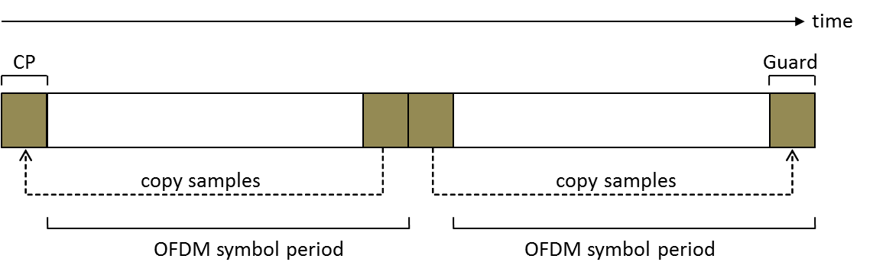

Figure 9.X.9.3.1.2-1 —Initial-ranging transmission

The BS can allocate two consecutive initial ranging slots; onto those slots, the CPE shall transmit the two consecutive initial ranging codes (starting code shall always be a multiple of 2), as illustrated in Figure 9.X.9.3.1.2-2.

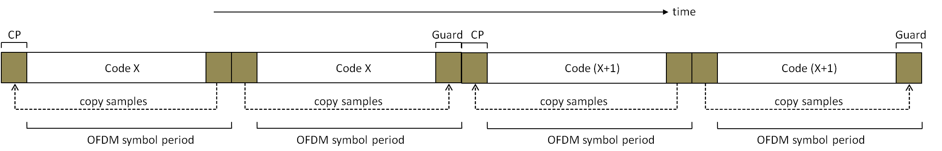

Figure 9.X.9.3.1.2-2 —Initial-ranging transmission, using two consective initial ranging codes

9.X.9.3.1.3 CDMA periodic-ranging, BW-request, and UCS notification transmission

Periodic-ranging transmissions shall be sent periodically by CPEs identified by the BS for system periodic ranging. Bandwidth-request transmissions shall be for requesting upstream allocations from the BS. UCS notification transmissions shall be used for reporting detection of an incumbent. These transmissions shall be sent only by CPEs that have already associated with the base station. To perform periodic-ranging, bandwidth-request or UCS notification transmission, the CPE can send a transmission in one of the following manners.

- Modulate one ranging code on the ranging subchannel for a period of one OFDM symbol. Ranging subchannels shall be dynamically allocated by the MAC layer at the BS and indicated by the number of subchannels in the US-MAP_IE. A time domain illustration of the periodic-ranging, bandwidth-request or UCS notification transmission is shown in Figure 9.X.9.3.1.3-1.
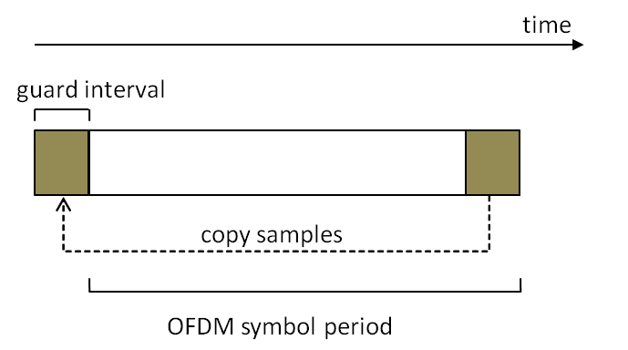
Figure 9.X.9.3.1.2-1 —Periodic-ranging/Bandwidth-request/UCS notification transmission using one code

- Modulating three consecutive ranging codes (starting code shall always be a multiple of three) on the ranging subchannel for a period of three OFDMA symbols (one code per symbol). Ranging subchannels are dynamically allocated by the MAC and indicated in the US-MAP. A time-domain illustration of the periodic ranging, BW-request, or UCS notification transmission is shown in Figure 9.X.9.3.1.3-2.

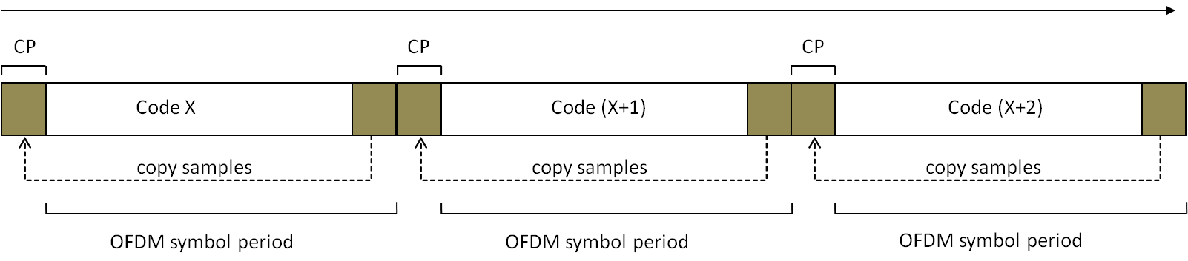

Figure 9.X.9.3.1.3-2 — Periodic-ranging/Bandwidth-request/UCS notification transmission using three consecutive codes

9.X.9.3.1.4 Ranging, BW request, and UCS notification opportunity windows

For CDMA ranging, BW-request and UCS notification transmission, the ranging opportunity size is the number of symbols required to transmit the appropriate ranging/BW-request/UCS notification code (1, 2, 3, or 4 symbols), and is denoted N₁. N₂ denotes the number of subchannels required to transmit a ranging code. In each allocation of ranging/BW-request/UCS notification, the opportunity size (N₁) is fixed and conveyed by the corresponding US-MAP IE that defines the allocation.

The ranging allocation is subdivided into slots of N₁ OFDMA symbols by N₂ subchannels, in a time first order, i.e., the first opportunity begins on the first symbol of the first subchannel of the ranging allocation, the next opportunities appear in ascending order in the same subchannel, until the end of the ranging/BW-request/UCS notification (or until there are less than N₁ symbols in the current subchannel), and then the number of subchannel is incremented by N₂. The ranging allocation is not required to be a whole multiple of N₁ symbols, so a gap may be formed (that can be used to mitigate interference between ranging and data transmissions). Each CDMA code shall be transmitted at the beginning of the corresponding slot. See Figure 9.X.9.3.1.4-1.

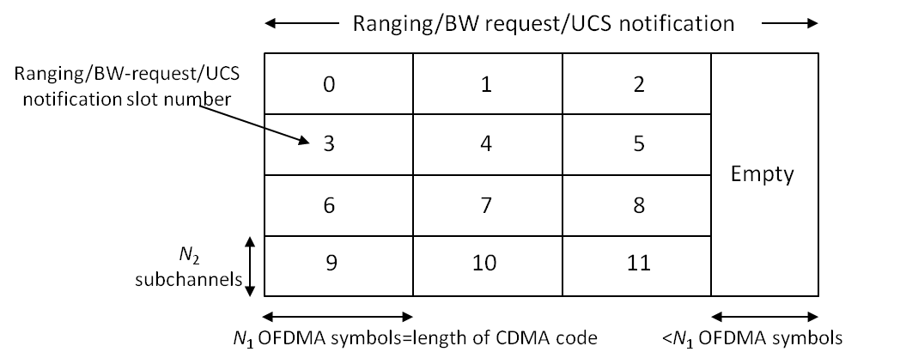

Figure 9.X.9.3.1.4-1 — Example of Ranging/BW request/UCS notification opportunities windows

