IEEE P802.22  
Wireless RANs

|  |  |  |  |  |
| --- | --- | --- | --- | --- |
| Proposed resolution to comment no. 257: Part 2-Sensing methods for DVB-T | | | | |
| Date: 2011-02-16 | | | | |
| Author(s): | | | | |
| Name | Company | Address | Phone | email |
| Chunyi Song | NICT | 3-4 Hikari no oka, Yokosuka, Kanagawa, Japan | +81-46-847-5095 | songe@nict.go.jp |
| M. Azizur Rahman | NICT | 3-4 Hikari no oka, Yokosuka, Kanagawa, Japan |  |  |
| Hiroshi Harada | NICT | 3-4 Hikari no oka, Yokosuka, Kanagawa, Japan |  |  |

Abstract

This document presents spectrum sensing methods for TV signals of DVB-T Standard to partially resolve comment number 257 as listed in P802.22 D1 Sponsor Ballot Comments Database, IEEE 802.22-11-2r5.

**The Comment**

**Notice:** This document has been prepared to assist IEEE 802.22. It is offered as a basis for discussion and is not binding on the contributing individual(s) or organization(s). The material in this document is subject to change in form and content after further study. The contributor(s) reserve(s) the right to add, amend or withdraw material contained herein.

**Release:** The contributor grants a free, irrevocable license to the IEEE to incorporate material contained in this contribution, and any modifications thereof, in the creation of an IEEE Standards publication; to copyright in the IEEE’s name any IEEE Standards publication even though it may include portions of this contribution; and at the IEEE’s sole discretion to permit others to reproduce in whole or in part the resulting IEEE Standards publication. The contributor also acknowledges and accepts that this contribution may be made public by IEEE 802.22.

**Patent Policy and Procedures:** The contributor is familiar with the IEEE 802 Patent Policy and Procedures

<[**http://standards.ieee.org/guides/bylaws/sb-bylaws.pdf**](http://standards.ieee.org/guides/bylaws/sb-bylaws.pdf)>, including the statement "IEEE standards may include the known use of patent(s), including patent applications, provided the IEEE receives assurance from the patent holder or applicant with respect to patents essential for compliance with both mandatory and optional portions of the standard." Early disclosure to the Working Group of patent information that might be relevant to the standard is essential to reduce the possibility for delays in the development process and increase the likelihood that the draft publication will be approved for publication. Please notify the Chair Apurva Mody <[apurva.mody@ieee.org](mailto:apurva.mody@ieee.org)> as early as possible, in written or electronic form, if patented technology (or technology under patent application) might be incorporated into a draft standard being developed within the IEEE 802.22 Working Group. **If you have questions, contact the IEEE Patent Committee Administrator at <**[**patcom@ieee.org**](mailto:patcom@ieee.org)**>**.

No good sensing techniques seen for DVB-T, PAL, NTSC. We cannot neglect analog TVs, as those continue to be used in many countries.

Add easily implementable techniques for DVB-T, PAL, and NTSC. Actually, the energy detection method itself is not good enough in many cases. Modification may be needed to improve its performance. If needed, such contributions can be supplied from the commenter.

**Proposed Resolution Part 2:**

We propose the following text, equations and figures regarding DVB-T sensing be added in Annex C of P802.22 D1 to partially resolve the comment.

**1. DVB-T Signal Specification**

The DVB-T standard was developed by European Telecommunications Standards Union (ETSI) for the terrestrial broadcasting of digital TV. It is currently widely adopted by more than 30 countries. The DVB-T uses orthogonal frequency division multiplexing (OFDM) modulation and is organized in frames. One DVB-T signal super frame consists of 4 consecutive frames, each frame consisting of 68 OFDM symbols.

In DVB-T signals, pilots consist of around 10% of the total used subcarriers. Pilots are transmitted at a higher power by about 2.5dB compared to the data subcarriers. These boosted pilots include continual pilots (CP) and scattered pilots (SP). The CPs are placed at fixed sub-carrier locations and their locations do not vary from symbol to symbol, while the SPs are distributed at the positions if *k*-3×(*l* mod 4) (the operation ‘mod’ calculates the modulus after division) is divisible by 12, where *k* is the subcarrier location and *l* is the symbol number. In consequence, as shown in Fig.1, the pattern of boosted pilots (CPs and SPs) repeats every four OFDM symbols.

## The features of boosted pilot sub-carriers as shown in the Fig.1 are exploited to achieve reliable detection of DVB-T signals. We generate a reference sequence by conducting inverse Fourier transform (IFFT) of a vector that is only composed of such pilot sub-carriers, defined as *sp*(t).

## Let us define the sequence achieved by sampling the *sp*(*t*) over 4*T* (*T*: one OFDM symbol duration) as

 , *n*=0,1,…*NCPPP*-1 (1)

where 1/*Tsp* is the sampling rate, and *NCPPP* is the sequence length of one *cycle period of pilot pattern*.

図14.emf

1. Locations of scattered boosted sub-carriers in DVB-T OFDM symbols. The horizontal axis represents the sub-carrier number (frequency) and the vertical axis represents the symbol number (time).
2. **Improved cross correlation method**
   1. **Description of the method**

The system block diagram is as shown in Fig.2. Sensing is achieved through following the steps as shown below:

* + - 1. The received DVB-T signal that also contains noise is passed through RF front end and LNA;
      2. The above signal is sampled and converted to digital sequence by ADC;
      3. The above sequence is stored in a buffer;
      4. Averaging of the samples is done over a time span equal to multiple of *NCPPP*

As described in Fig.1 and (1), the pilot pattern of DVB-T sequence repeats with a periodicity of *NCPPP*; we then average the received DVB-T sequence based on *NCPPP*, as

 , *n*= 0,…, *NCPPP*. (2)

* + - 1. Frequency offset estimation and correction is performed. This is an optional step and the block is shown using dotted lines
      2. Time offset estimation and correction are done;

The purpose of conducting time offset correction is to find the same starting point of the DVB-T sequence and the pilot sequence that is used as a reference in a latter step. Assuming the estimation result shows that the synchronization point locates between the *M*1-*th* sample and the *M*2-*th* sample (*M*2*≥M*1) of the *NCPPP* samples, i.e. locates inside the window of [*M*1, *M*2], then the window size represents the time synchronization level and it is expressed using a metric, *Γ*, as:

 . (3)

* + - 1. According to the synchronization level, either correlation or sliding correlation over a specific window is applied:

when the time synchronization level *Γ=*1 *,*i.e. *M*1=*M*2, correlation is applied, as:

 , (4)

otherwise (*Γ<*1), sliding correlation is applied over the window of [*M*1, *M*2], as:

 , *m*= *M*1,…, *M*2 . (5)

where *x* is the DVB-T sequence and *sp*(*n*) is the pilot sequence obtained in (1).

The computation in (5) is called the selective sliding correlation here since the sliding window of [*M*1, *M*2] is selectively decided according to synchronization level achieved in (2).

* + - 1. Compare the correlation output (if *Γ=*1) or the maximum of the *M*2-*M*1+1 correlation outputs (if *Γ<*1) with pre-decided threshold and judge presence/absence of TV signal: if the output is above the threshold, the presence of DVB-T signal is judged.
  1. **Simulation results**

Clean DVB-T signals (SNR>30dB) generated by DVB-T signal generator (SG) are used as source data in the computer simulation. The DVB-T is the 2*K* mode with *TCP*=*T*/32 (*TCP* is the cyclic prefix duration).

Fig.3 shows the Probability of Detection (*PD*) vs. SNR by fixing False Alarm Probability (*PFA*) to 0.01and Fig.4 shows the receiver operating characteristic (ROC) curves. Sensing performance of the improved cross correlation detection is directly proportional to the time synchronization level, *Γ*; it can also be improved by averaging the received DVB-T sequence over the duration of *NCPPP*. To achieve the sensing performance of *PD*≥0.9 and *PFA*=0.01 at SNR=-20dB in AWGN, the improved cross correlation at both *Γ*=0.975 and *Γ*=1.0 requires the same sensing time of 4OFDM symbol duration, which is around 1.2 ms.

図1.wmf

1. Simplified block diagram of the improved cross correlation method. The pilot sequence is the clean *sp*(*n*) generated in (1).

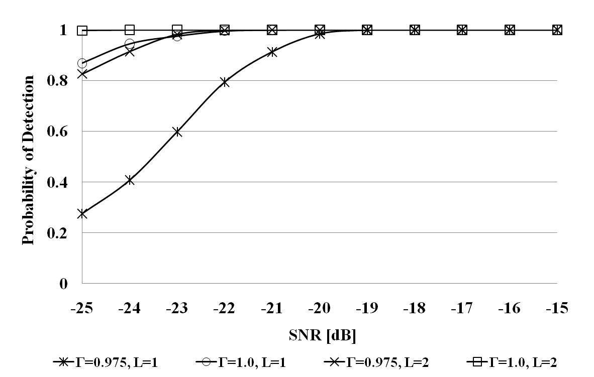

1. Probability of Detection (*PD*)vs. SNR in AWGN: *PFA*=0.01. The *Γ* is the time synchronization level defined in (3), *L* is the conducted number of average operation defined in (2).

図7.emf

1. ROC curve in AWGN: the improved cross correlation: *Γ*=0.975, SNR=-20dB.
2. **Combined feature and energy detection**
   1. **Description of the method**

As shown in Fig.5, the combined feature and energy detection method consists of following steps:

* + - 1. The received DVB-T signal that also contains noise is passed through RF front end and LNA;
      2. The above signal is sampled and converted to digital sequence by an ADC;
      3. Frequency offset correction is performed. This is an optional step the block is shown using dotted lines;
      4. The sequences with length of *NCPPP* are firstly multiplied with the pilot sequence generated in (1) and then their absolute products are integrated, as:

 . (6)

* + - 1. Conduct computation of (6) for ***κ***(***κ***≥1) times while shifting the sequence timing by a random interval, *τ*, and calculates the average value, as:

 , (7)

subjects to

 . (8)

* + - 1. Compare the output in (7) with pre-decided threshold and judge presence/absence of DVB-T signal: if the output is above the threshold, the presence of DVB-T signal is judged.
  1. **Simulation Results**

Clean DVB-T signals (SNR>30dB) generated by DVB-T SG are used as source data in the computer simulation. The DVB-T is the 8*K* mode with *TCP*=*T*/8.

Fig.6 shows *PD* vs. SNR by fixing *PFA* to 0. 1. The sensing performance is significantly improved by increasing operation times, ***κ****,* defined in (7). This feature is attractive since as shown in (8), the increase of ***κ*** may not increase the sensing time considerably. Therefore, to achieve the sensing performance of *PD*≥0.9 and *PFA*=0.1 at SNR=-20dB in AWGN, the sensing technique requires sensing time of 8 OFDM symbol duration (***κ****≥*8), which is equivalent of around 8 *ms*.

図11.wmf

1. Simplified block diagram of the combined feature and energy detection.

図9.emf

1. *PD* vs.SNR in AWGN: *PFA*=0.1. The ***κ*** is the operation times defined in (7).
   1. **Test results of hardware sensing prototype**

Sensing performance of the combined feature and energy detection is also verified by hardware tests. In the hardware tests, the8*K* mode DVB-Tsignals (*TCP*=*T*/8) generated by SG are tuned to -120dBm/8MHz using attenuators and then input into the hardware sensing prototype through a cable.

We conducted 5,000 runs of tests for each *PFA* shown in Fig.7. Although the results are degraded in comparison with simulation results shown in Fig.6, they have verified that using the combined feature and energy detection we can achieve *PD*≥0.9 and *PFA*=0.1 in the very low SNR regime. Please note that the ***κ***=32 operations are conducted for DVB-T sequence of 8 OFDM symbol duration as shown in (7)-(8). .

図12.emf

1. Hardware test results: ROC curve: DVB-T input level=-120dBm/8MHz, ***κ***=32.

**References:**

1. C. Song, M. A. Rahman, R. Funada and H. Harada, "Robust Spectrum Sensing of DVB-T Signals," IEICE Technical Report, SR2010-63, pp. 161-168, Oct. 29, 2010.
2. ETSI EN 300 744 V1.6 .1 (2009-01), "Digital video broadcasting (DVB) ; framing structure, channel coding and modulation for digital terrestrial television ," ETSI, Tech. Rep., 2009.