Project | IEEE 802.21 Working Group for Media Independent Services  <http://www.ieee802.org/21/>
Title | A White Paper on Use Cases and requirements for supporting HMD-based VR Applications
DCN | 21-18-0061-02-0000
Date Submitted | November 15, 2018
Source(s) | Sangkwon Peter Jeong ceo@joyfun.kr (JoyFun Inc.,)  Dongil Dillon Seo dillon@volercreative.com (VoleRCreative)  Minseok OH msoh@kgu.ac.kr (Kyonggi University)  Namgi KIM ngkim@kgu.ac.kr (Kyonggi University)  GookHwan Lee ghlee@joyfun.kr (JoyFun Inc.,)
Re: | IEEE 802.21 Session #88 in Bangkok, Thailand
Abstract | This document identifies the issues related to networking that users are experiencing while using the Virtual Reality (VR) system and is produced by the Interest Group in IEEE 802.21.
Purpose | Present the networking issues for replacing the wired link with the wireless link by providing some use cases and identify the high-level networking requirements for the purpose of creating further standards.
Notice | This document has been prepared to assist the IEEE 802.21 Working Group. It is offered as a basis for discussion and is not binding on the contributing individual(s) or organization(s). The material in this document is subject to change in form and content after further study. The contributor(s) reserve(s) the right to add, amend or withdraw material contained herein.
Release | The contributor grants a free, irrevocable license to the IEEE to incorporate material contained in this contribution, and any modifications thereof, in the creation of an IEEE Standards publication; to copyright in the IEEE’s name any IEEE Standards publication even though it may include portions of this contribution; and at the IEEE’s sole discretion to permit others to reproduce in whole or in part the resulting IEEE Standards publication. The contributor also acknowledges and accepts that IEEE 802.21 may make this contribution public.
Patent Policy | The contributor is familiar with IEEE patent policy, as stated in Section 6 of the IEEE-SA Standards Board bylaws <http://standards.ieee.org/guides/bylaws/sect6-7.html#6> and in Understanding Patent Issues During IEEE Standards Development http://standards.ieee.org/board/pat/faq.pdf

Table of Contents

- Scope
- Purpose
- Problems related to Delivering Seamless and Optimal VR Content Service
- Terms and Definition
- Use Cases
5.1 Case 1: A Single VR System Connected via a LAN
5.2 Case 2: A Single VR System Connected via a WAN
5.3 Case 3: Multiple VR Systems Connected via a LAN
5.4 Case 4: Multiple VR Systems Connected via a WAN
5.5 Case 5: Special Use Case – Change of Network
- Network Requirements
- Current Limitations and Candidate Technologies
7.1 Wireless Transmission Technologies
7.2 Gap Analyses
- Considerations for Standardization
- Conclusion
- References
- Scope
The scope of this paper is to identify the issues related to networking that users are experiencing while using the Virtual Reality (VR) system. In particular, it discusses what network environments and requirements are necessary to deliver the seamless and optimal VR content services using the current industry best practices VR systems.
- Purpose
The purpose of this white paper is to first present the use case scenarios of VR systems where either a single or a multi-party content is delivered to users through the existing networks and its capabilities. Second, this report identifies the networking issues and limitations of replacing the wireline access network with a wireless link for providing the optimal VR user experience. Finally, this paper identifies the high level networking requirements with a gap analysis and argues the need for further standardization.
- Problems related to Delivering Seamless and Optimal VR Content Service
When the first commercial versions of Virtual Reality Head Mounted Display (VR HMD) came out in the market during 2016, people who have tried the VR for the first time started to report that they could not wear the VR HMD more than a few minutes because they feel nauseated and sick. This is known as VR sickness. Also, the mobility of the user was limited due to the cable connected between the VR HMD and the content server. Out of all the issues, the VR sickness and the mobility of VR HMD quickly became the major issues why people are not willing to try the VR content and why the world is not embracing the VR as quickly as some of the top marketing firms have predicted. The industry professionals have identified the components from both hardware and software where they can improve to minimize the effect of VR sickness. For the purpose of this study, this paper focuses on how to deliver the VR HMD applications using a wireless access network.
- Terms and Definitions
360-degree camera
A camera designed to capture 360-degree spherical surfaces.
4K Ultra High Definition (4K UHD)
A term referring to high-definition resolution with a horizontal resolution in the order of 4,000 pixels.
8K ultra high definition (8K UHD)
A term referring to high-definition resolution with a horizontal resolution in the order of 8,000 pixels.

cybersickness
Psychological and physiological symptoms similar to those of motion sickness. Cybersickness symptoms include discomfort, stomach awareness, nausea, pallor, cold sweating, eye fatigue, and disorientation during or as a result of experiencing virtual environments, especially using head-mounted displays. Virtual Reality (VR) Sickness is also the same as cybersickness.
field of view (FOV)
The angular width of a screen that fills the user’s visual field. Angles indicate the range of horizontal, vertical, or diagonal directions over which the camera can hold an image through the lens.
frames per second (FPS)
The number of images that can be processed per second.
frame rate
The number of frames through a certain device or a transmission link per a fixed duration. The measurement unit is FPS.
head mounted display (HMD)
A generic term for display devices that are attached to the head.
head tracking
A technique that tracks the rotational and translational movement of the HMD.
jitter
The deviation from true periodicity of a presumably periodic signal, often in relation to a reference clock signal.
motion sickness
Psychological and physiological symptoms which are caused by discordance between visually perceived movement and sense of bodily movement in the vestibular organs.
motion-to-photon latency
Time delay from the HMD user’s movement to the change of view in HMD caused by the movement.
network latency
Amount of time that information takes to traverse a system (or from one node to another node).

packet error rate (PER)
The number of incorrectly received packets divided by the total number of received packets.
positional tracking
A technique that tracks the rotational and translational movement of all objects including head mounted display (HMD), controllers and peripheral devices.
refresh rate
The number of pictures that can be processed by the imaging device at one time. The measurement unit is Hertz (Hz).
six degrees of freedom (6 DOF)
Six operating elements of a moving object in three-dimensional space. 6 DOF can be used to describe rotational movements (roll, pitch, yaw) and translational movements (forward/back, left/right, up/down)
spatial three-dimensional (3D) sound
A technology that allows the user to identify the location of a sound source where sound is generated. In conjunction with head tracking of HMD, the sound is generated relative to the head direction.
stereoscopy
Three-dimensional vision with the illusion of depth from two-dimensional images using the visual difference of both eyes.
virtual reality (VR)
It refers to any specific environment, situation or technology itself that either simulates the actual reality or creates the virtual spaces and objects according to the imagination of human beings by using computer graphics or videos.

- Use Cases
  - Case 1: A Single VR System Connected via a LAN
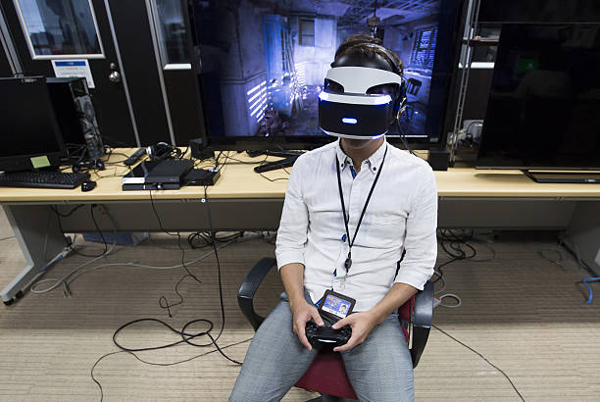
In the picture below, a user is playing a VR game using a VR HMD connected to a game console system known as PlayStation 4 with HDMI (High Definition Multimedia Interface) and USB (Universal Serial Bus) cables. The HDMI cable is delivering both video and audio for the VR game that are rendered in real time by the game console (shown in figure) to the VR HMD. The USB cable is delivering the head tracking data from the VR HMD to the game console to reflect the user’s head position so that the game console can render both the video and the audio of the VR game accordingly in real time.

A Single VR System Connected via LAN
The following is a simplified logical network connectivity diagram of the above use case scenario in which the VR HMD is communicating to a local content server (e.g., a PC or a gaming console) via a local area wired network (LAN). The VR content service is rendered or decoded in the local content server.
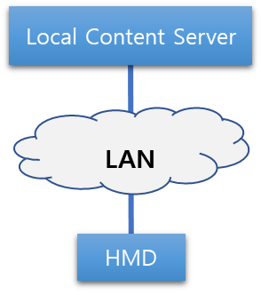

    - Issues/Limitations
The user mobility is limited due to the HDMI and the USB cables connecting to the VR HMD and to the local content server.
    - Recommendation
To increase the user mobility while playing a VR game, the wired LAN needs to be replaced with a wireless LAN. Since HDMI 2.0 cable is a fully dedicated and stable wire that can transfer 18 Gbps with less than 1 ms of latency, the wireless LAN that replaces the HDMI cable should be able to match the same conditions to support this use case scenario.

  - Case 2: A Single VR System Connected via a WAN
In the following picture, a user is watching a baseball game in a virtual reality environment using a mobile phone-based VR HMD system. The baseball game in this scenario is being captured with a 360-degree camera and it is being streamed to the VR HMD in real time. The head tracking data is also transferred to the camera via a mobile network to display the view where the user is looking at.
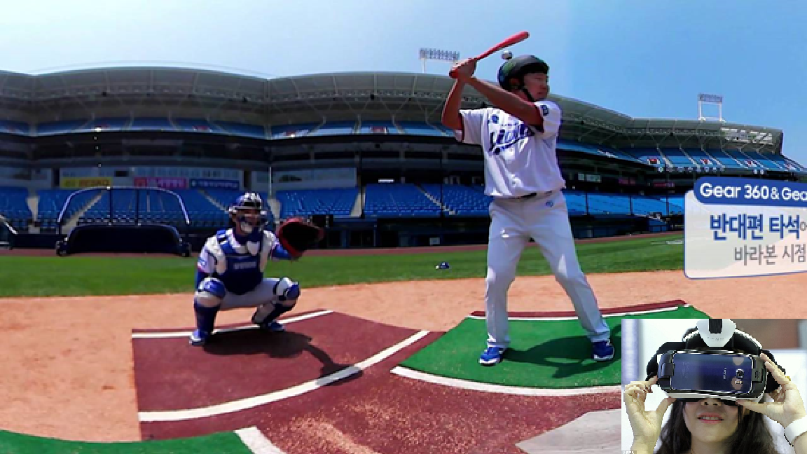
A Single VR System Connected via WAN
The following is a simplified logical network connectivity diagram of the above use case scenario in which the VR HMD is communicating to a remote content server (such as to a cloud service provider) and receiving the VR content service via a wide area mobile network. In this scenario, the VR content service is rendered or decoded in the remote content server. It is important to note that the remote content server is located outside the local network and wide area network (WAN) consists of both wired and wireless networks.
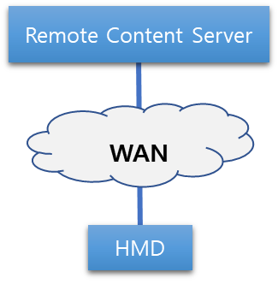

    - Issues/Limitations
Since the content server is located outside of the local area and the content data is traversing through multiple networks, the network latency is an important factor that will vary depending upon the network conditions. The increased latency may cause the poor video resolution quality and reduce the frame rate (e.g., due to network congestion). This drop of video quality results to VR sickness.
    - Recommendation
In order to maintain the optimal VR user experience, it is recommended that the video resolution quality should be remained as high as possible with a constant data transmission rate of 90 FPS. As the current commercial VR HMD supports the display resolution up to QHD (2,560 x 1,440) resolution and frame rate up to 90 FPS, the data transmission rate, which is calculated using the following equation,
$$Data Transmission Rate=Resolution x 24 bit \left(color\right) x Frame Rate$$
is roughly 8 Gbps uncompressed. Hence, the end-to-end network (Wired backbone and Wireless access) should be capable of transferring 8 Gbps of uncompressed data to support the use case scenario.

  - Case 3: Multiple VR Systems Connected via a LAN
In the following picture, a user is playing a virtual reality game and competing against other remote players using a VR HMD system that is connected to local server (e.g., a PC or a Laptop). The HDMI cable connecting the VR HMD system and the local server is used to receive the video and the audio data of the VR game content, the service of which is being rendered real time in the local server. The USB cable connecting the VR HMD and the local server is used to exchange the head tracking data so the server can render the video and the audio data accordingly. The remote content server is calculating the scores and the consequential data caused by the remote users’ input. These data are sent to the local content server so it can render the video and the audio of the VR game content accordingly.
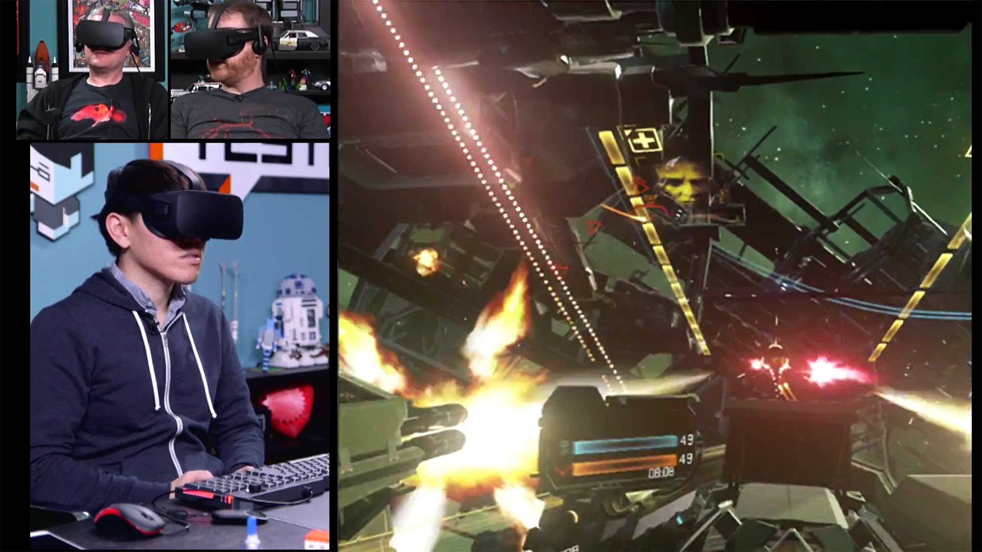
Multiple VR Systems Connected via LAN
The following is a simplified logical network connectivity diagram of the above use case scenario where multiple VR systems are connected to a remote content server. The VR HMD is receiving the VR content service rendered or decoded in the local content server. The remote content server is computing the data sent by the local content servers and redistributing the calculated data back to the local content servers.
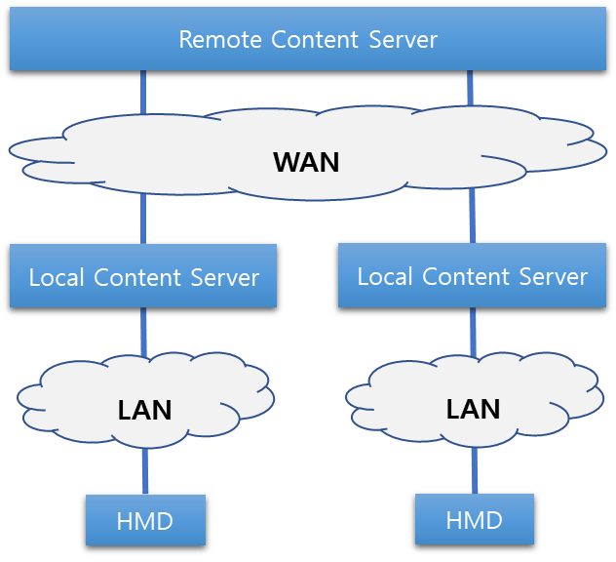

    - Issues/Limitations
The user mobility is limited due to the HDMI and the USB cables connecting to the VR HMD and to the local content server. The network between the remote content server and the local content servers may create some additional latency depending on the network conditions. The increased latency may cause the improper change of content and may create an incorrect impression of the certain events of the game. Also, it may drop the video quality and the frame rate. This drop of video quality results to VR sickness.
    - Recommendation
The wireless LAN connecting the VR HMD and the local content server should be capable of delivering the required bandwidth that VR content data demands and the link between the two should be always maintained. The WAN connecting the remote content server and the local content servers should provide very low latency to reflect the real-time changes made in VR content according to the users’ input.

  - Case 4: Multiple VR Systems Connected via a WAN
    - Use Case Scenario
In the following picture, two or more users are watching a live streamed video game match from their respective home using their mobile phone-based VR HMD systems. The users watching the same content in a virtual movie theater rendered in a cloud service provider and they are being represented as a form of a virtual avatar in the virtual reality theater. They are able to interact with each other and also can communicate via audio. The live-streamed video game match and the virtual reality theater are all being rendered in a remote server situated in the cloud service provider network and the VR HMD system is only running a small application for obtaining the cloud rendered VR content.
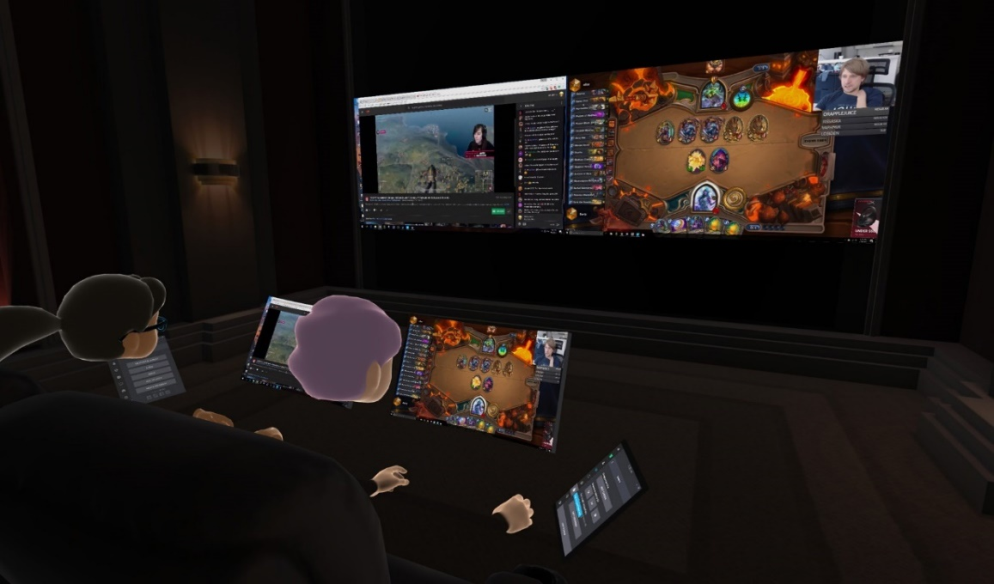
Multiple VR Systems Connected via WAN
The following is a simplified logical network connectivity diagram of the above use case scenario where more than one VR HMD systems are communicating to the remote content server and receiving the VR content service rendered or decoded in the remote content server.
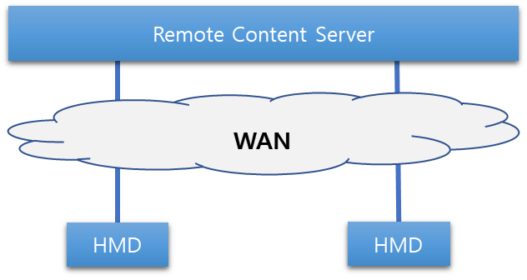

    - Issues/limitations
The network between the remote content server and the VR HMD systems may add additional latency to the content delivery depending on the network conditions (e.g., due to congestion). This increased latency may affect to the real-time effect in the content delivery that in turn may create an incorrect impression to the change of events. In addition, it may drop the video quality and the frame rate. This drop of video quality results to VR sickness.
    - Recommendation
The network connected to the remote content server where the VR content is being rendered or encoded should have required (e.g. 8 Gbps for uncompressed Quad High Definition (QHD) resolution video) data throughput to send a high-quality video and audio data with required frame rate (e.g., 90 FPS) to the remote VR HMDs. In addition, the network should provide very low latency to reflect the real-time changes made in VR content according to the users’ input.

  - Case 5: Special Use Case – Change of Network
In the following picture, a user is watching a streamed movie using a mobile phone-based VR HMD while travelling in a bus or a train. The movie is encoded in the remote server and sent to the VR HMD system via a wide area network. The VR HMD system is only decoding the content sent by the remote server.
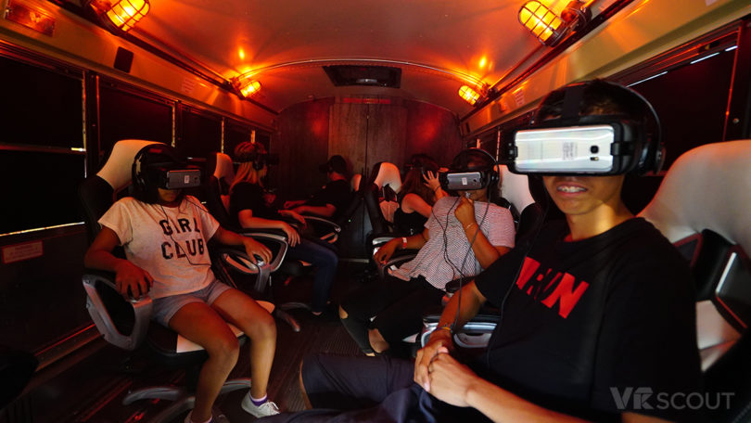
Multiple VR Systems Connected via LAN with Network Mobility
The following is a simplified logical network connectivity diagram of the above use case scenario where the VR HMD system is connected to either the bus or train Wi-Fi networks or connected directly to the mobile network depending upon the network conditions. Therefore, the network connection is switched between two local access networks that leads to a network handover condition.
    - Issues/Limitations
As the mobile network offers a limited amount of data usage depending on the personal mobile data plan, users normally prefer to use of Wi-Fi network when it is available. When the network connectivity moves from mobile network to Wi-Fi network, a network handover occurs and causes a drop of data, also known as data cliff, shown in the diagram below.
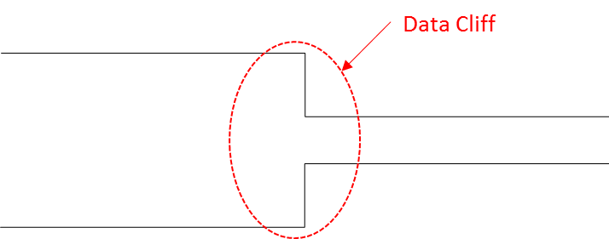
When this data cliff occurs, there is a good chance to lose the data header file of the application that contains the data packet structure. When the header file is lost, the network needs to resend the entire data packet and this creates additional latency. This increased latency may drop the video quality and the frame rate that results to VR sickness.

    - Recommendation
When the above handover results to moving from a higher throughput to a lower throughput network, the data cliff can be avoided if there is a way to make the network switching smooth as shown in the diagram below.
When the network handover occurs from the faster network to the slower network, maintaining both the high frame rate and the high resolution for the VR content may not be possible. In this case, maintaining the high frame rate needs to be considered as a higher priority as the frame rate is more critical issue for the VR sickness.

- Network Requirements
In recent years, the VR sickness caused by the VR content service is considered as one of the major problems for VR industry. In order for VR HMD to be accepted as a mass-market device, VR sickness needs to be addressed. To address this problem, several standards organizations, such as IEEE 802 [1], MPEG (Moving Picture Experts Group) [2], and 3GPP (Third Generation Project Partnership) [3], have identified both network and non-network related issues and functional requirements in their studies. It is evident that VR industry imposes new network requirements for the connectivity between the content server and the HMD device. These requirements are for example, higher frame rate, reducing the motion-to-photon latency, higher data transmission rate, low jitter, longer transmission range, better mobility, higher resolution and low packet error rate. Below we highlight few such important requirements:
- Peak data rate:
  - Peak data rate should be 1.5 Gbps for compressed 4K UHD 3840×2160 24 bits/pixel, 60 frames/s, 8 bits/color.
  - Peak data rate should be 8 Gbps for compressed 8K UHD 7,680×4,320 24 bits/pixel, 60 frames/s, 8 bits/color.
  - Peak data rate should 18 Gbps for uncompressed 4K UHD 3,840×2,160, 60 frames/s, 8 bits/color, (4:4:4) chroma subsampling.
  - Peak data rate should be 28 Gbps for uncompressed 8K UHD 7,680×4,320, 60 frames/s, 8 bits/color, (4:2:0) chroma subsampling [4].
- Jitter
- Jitter should be less than 5ms [1] since greater jitter can cause distortion in video and audio rendering.
- Transmission range
  - For an indoor environment, it should not exceed 5 m by 5 m.
  - For an outdoor environment, it may reach up to several hundred meters.
- Mobility of device and session
  - For an indoor environment, it should be s less than 4 km/h.
  - For an outdoor environment, it may reach up to 300 km/h.
  - Packet loss for session mobility during network handover should be as minimum as possible.
      - PER (Packet error rate)
        - PER should be less than ${10}^{-2}$
      - Resolution
  - 40 pixels/degree or 12K (11520x6480) is required [2].
  - While 4K UHD (3840x2160) seems to be sufficient to the current display technology, higher that 4K UHD is required. This is due to the fact that HMD is mounted very closely to the human eyes and the display tends to be enlarged.
      - Frame rate
  - 90 fps (frames per second).
It is important to note that the frame rate is directly related to motion-to-photo latency. A lower frame rate allows a user’s reaction to be rendered in HMD after a reciprocal of the frame rate. The less the frame rate is, the more it can cause fatigue and motion sickness. The total motion-to-photon/audio latency in the VR system should be less than or equal to 20 ms [3]. This leaves the motion-to-photon latency for the wireless medium should be less than 5 ms, i.e., between two wireless transceivers [4].

- Quality of Experience (QoE)
QoE is a measure of the overall level of users’ satisfaction with a VR system. QoE is related to but differs from Quality of Service (QoS), which refers to any technology that manages data traffic to reduce packet loss, latency, and jitter on the network transport of a VR system. QoS constitutes only the network portion of the QoE but QoE will be measured by the user. QoE is something that VR system or content developers must take into account to offer a high-quality user experience. The following table illustrates the QoS-related conditions needed to be considered for each use case described in the previous section.
Use Case | Network Requirements
 | Data TX rate | Motion-to-photon/audio latency | Jitter | TX range | Mobility | PER
- Single VR System via LAN |  |  |  |  |  | 
- Single VR System via WAN |  |  |  |  |  | 
- Multiple VR System via LAN |  |  |  |  |  | 
- Multiple VR System via WAN |  |  |  |  |  | 
- Network Mobility |  |  |  |  |  | 
strong: , average: , weak: 

- Current Limitations and Candidate Technologies
Today’s most immersive virtual reality systems, like the Oculus Rift and HTC Vive, rely on tethering for power and sending high-fidelity imagery to the headset. However, a dangling cable not only causes an inconvenience to users but also becomes an immersion detractor. The demand for a solution to this issue has spurred a series of new developments for a wireless access link between the server and the HMD or headset. The biggest caveat is that most powerful VR prototypes are inevitably needed to be wired with cables due to the amount of transmitted high-resolution video at high frame rates. The wired connection such as HDMI (High-Definition Multimedia Interface) and DisplayPort already provide transmission date rates of 18.0 Gbps and 32.4 Gbps, respectively with very negligible transmission delay. On the other hand, a wireless link between the computer and the HMD can provide the needed mobility for the user and solve the tethering problem. It is our belief that as the wireless transmission technologies evolve, their performance will come close to a point when the wireless link can replace the wired link without severe performance degradation. However, there are some limitations in the technologies that are currently under development. In the following, we list few such technologies that can be further studied and enhanced to fulfill the need for VR HMD industry.
  - Wireless Transmission Technologies
There are several wireless transmission technologies which are applicable to wireless VR HMDs today. Some technologies are already standardized, and some standards are still under development.
    - IEEE 802.11ax
IEEE 802.11ax, known as High Efficiency WLAN (HEW) Task Group, has started its standard development with a main goal to reduce the performance degradation in a Wi-Fi dense area. IEEE 802.11ax have accomplished Draft 2.0 in November 2017. The standard is expected to be completed by the end of 2019.
IEEE 802.11ax, which achieves four times as high as 802.11ac, is designed to operate in 2.4 GHz and 5G Hz spectrums. Through increased link efficiency in frequency domain, time domain, and modulation scheme, the 802.11ax can achieve as high as 12.01 Gbps in an ideal condition [6].
At the current development state, this technology does not satisfy the VR network considerations.
    - IEEE 802.11ay
To develop the follow-up of IEEE 802.11ad, IEEE 802.11ay is formed in May 2015 to achieve a maximum throughput of at least 20 Gbps using the unlicensed mm-Wave (60 GHz) band, while maintaining or improving the power efficiency per STA. They have completed Draft 1.0 in January 2018. The standard is planned to be completed in December 2019.
IEEE 802.11ay can provide a high throughput utilizing various technologies, such as channel bonding/aggregation, MIMO (multiple-input and multiple output), and multiple channel access, etc. [6].
At the current development state, the maximum throughput is satisfied but it needs to consider the device mobility due to the directional propagation of electromagnetic wave in 60 GHz band.
    - IEEE 802.21
** I think we should add the mobility and QoE limitation of current IEEE 802.21 here. Let’s discuss. ***

    - 3GPP
To reach a fully interconnected VR world, the VR HMD needs to be mobile even in an outdoor environment beyond the communication range of Wi-Fi. The only technology that can provide that kind of accessibility is through the LTE (Long Term Evolution), one of the 4G technologies, but the data transmission speed is not fast enough to provide a proper operation for a standalone HMD in outdoor environments. 5G, which is expected to be deployed in 2018 [7] and beyond, can be a most favorable candidate for nomadic HMD users. The 3GPP (3rd Generation Project Partnership) has completed a technical report on VR services over 3GPP in September 2017 [8].
  - Gap Analyses
In this section, we compare the capabilities of wireless transmission technologies with respect to the requirements of a wireless VR HMD system. This comparison will facilitate the understanding of what enhancements are needed to satisfy the current requirements of wireless VR HMDs.
Note: Requirements, such as resolution and frame rate, which cannot be directly satisfied by the transmission technologies, are omitted in this comparison
 |  | VR HMD Requirements | Capabilities
 |  |  | 802.11ax [5] | 802.11ay [4] | IMT-2020 [3]
Data transmission rate |  | ~ 20 Gbps [1] | ~10 Gbps (at least 4 times improvement over 802.11ac) | ~100 Gbps | 20 Gbps peak,  100 Mbps user-experience data rate
Latency |  | ~ 5 ms (at wireless medium) [1],  20 ms (motion-to-photon/audio) [2] | “A desirable level to meet QoS requirements in high dense deployment scenario” | 10 ms | 1 ms
Jitter |  | < 5 ms [1] | Not specified | Not specified | Not specified
Transmission range | Indoor | 5 m [1] | Not specified | 10 m indoor | Not specified
 | Outdoor | Several hundred meters |  | 100 m outdoor
Mobility | Indoor | Pedestrian speed < 4 km/h [1] | Not specified | 3 km/h | 500 km/h
 | Outdoor | 200 km/h
PER |  | ${10}^{-6}$ [1] | Not specified | $$\sim {10}^{-8}$$ | Not specified

From the above table, it is clear that none of the existing 802 or other technologies can fully satisfy the network requirements for VR industry.

- Considerations for Standardization
As mentioned in Section 5, at this moment none of the developed or developing wireless transmission technology standards does not meet the network requirements to offer a high-quality user experience in VR. IEEE 802.11ax and IMT-2020 both fall short of the required data rate, and IEEE 802.11ay does not provide a latency small enough for a high QoE. All other network requirements, such as jitter, TX range, mobility, and PER, seem to be satisfied. Therefore, to achieve a high QoE we need to have a new wireless transmission technology which provides both a high transmission data rate of 20 Gbps or beyond, and a small latency of 5 ms or below at least in the network portion of the QoE.

- Conclusion and Recommendation
HMD based VR content service is still at early stages of development but it is considered as an emerging area and a killer application for next generation networks and services. As it is evident from the above use cases and requirements, many technological challenges need to be addressed such as display quality, network latency, motion-to-photon latency, rendering latency and human factors (e.g., sickness) to make this industry successful. Among all these challenges, networking issues can be addressed in IEEE 802. As mentioned in Section 5, at this moment none of the developed or developing IEEE 802 wireless transmission technology standards satisfies the network requirements to offer a high-quality user experience for VR. For example, IEEE 802.11ax falls short of the required data rate, and IEEE 802.11ay does not provide sufficient latency for a high QoE It is important to note that latency is one of the critical issues for the VR industry to leap forward. IEEE 802.21 services and handover optimization and QoS mapping do not cover the issues related to VR network requirements. However, from the gap analysis, we find that IEEE 802 technologies can be a potential replacement of the wireline cable if they are either enhanced or additional capabilities are developed. Towards this, we recommend creating a study group where over all networking requirements can be further investigated and if suitable, a PAR and CSD can be developed.
- References
[1] IEEE 802.11 TGay Use Cases: https://mentor.ieee.org/802.11/dcn/15/11- 15-0625-07-00ay-ieee-802-11-tgay-usage-scenarios.pptx.
[2] Quality Requirements for VR, ISO/IEC JTC1/ SC29/WG11 MPEG 116 Std. m39532, 2016.
[3] IMT-Vision – Framework and overall objectives of the future development of IMT for 2020 and beyond, Recommendation ITU-R M.2083-0, Sep. 2015
[4] TGay Functional Requirements: https://mentor.ieee.org/802.11/dcn/15/11- 15-1074-00-00ay-11ayfunctional-requirements.docx.
[5] "IEEE P802.11ax/D3.0 Draft Standard: Wireless LAN Medium Access Control and Physical Layer Specifications – Amendment 6: Enhancements for High Efficiency WLAN", Jun. 2018
[6] "IEEE P802.11ay/D2.1 Draft Standard: Wireless LAN Medium Access Control and Physical Layer Specifications – Amendment 7: Enhanced throughput for operation in license-exempt bands above 45 GHz”, Oct. 2018.
[7] Timeline of 5G Standardization in ITU-R and 3GPP: https://www.netmanias. com/en/post/oneshot/11147/5g/timeline-of-5g-standardization-in-itu-r-and-3gpp/
[8] Technical Specification Group Services and System Aspects, Virtual (VR) media services over 3GPP, 3GPP Std. TR 26.918, 2017.

Appendix A
- Cause of VR Sickness
  - Characteristics of VR Content Service
    - Head Tracking (6 DOF)
      - Rotational Tracking
A key feature of an HMD is the ability to track the wearer's head rotations. The images shown on the display change according to the wearer's head movements. Head-tracking is an essential aspect of the HMD that allows the user to become immersed and feel presence.
      - Positional Tracking
Positional Tracking is often performed with sensors and cameras external to the HMD. These peripherals can track the position of the user's head, body and hands anywhere within the range of the devices. They can not only track the rotational movements like the inboard sensors but also translational movements. HMDs in the future will be able to track translational motion and perform positional tracking.
    - Wide FOV
VR HMDs have displays with large field of view (FOV) that comprise the entirety of the user's vision. With both eyes, humans have about 180 degrees FOV when looking in front of them. The display of a VR device should cover as much of the vision range as possible. A large FOV is important to create immersion for the wearer.
    - Stereoscopic
Most of VR content support stereoscopy, a technique for creating or enhancing the illusion of depth in an image. This feature gives the wearer to feel that he can reach out and interact with the environment.
    - 3D Positional Audio (Spatial 3D Sound)
To make the VR experience more immersive, 3D positional audio technique, simulating the changes of sound on its way from the source including reflections from walls and floors to the listener’s ear, is used with head related transfer functions and reverberation. This feature adds extra realism and immersion to the environment he is in.
  - Industrial Published Data
The table below is from the presentation made by Technicolor during the 116th MPEG meeting in October, 2016. The table shows the technical requirements needed to minimize the VR sickness.
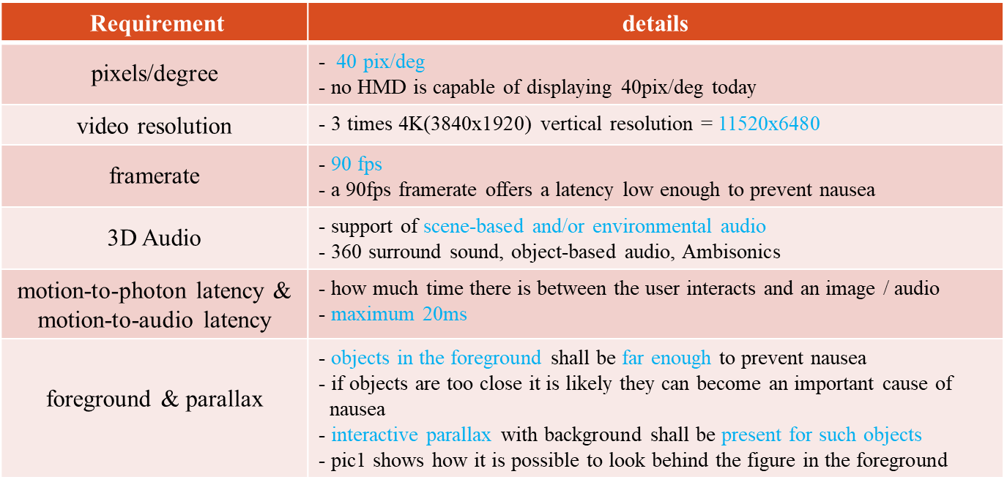
For the purpose of discussing the network requirements, this white paper focuses on the motion-to-photon latency. Some of the other requirements related to the motion-to-photon latency include video resolution and frame rate.
- Types of VR HMD
  - Motion-to-Photon Latency Diagrams
In today’s world of VR industry, there are two types of VR HMDs – standalone type and display type. In the future, there may exist more types but for now, we are focusing on what is available in the market today.
    - Stand-alone type
The standalone type is where the local content server is actually embedded in the HMD itself. Hence, the data processing unit actually exists in the HMD and creates very minimal latency when the data traverse in the VR system. The arrows in the diagram below represent the places where the motion-to-photon latency exist.
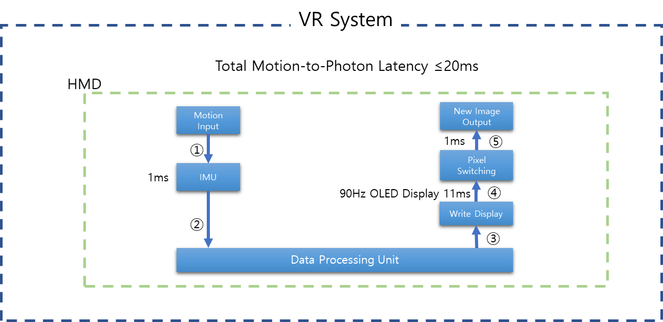
Since all connections that may create latency are embedded in the system, no network latency can be considered in this case.
    - Display type
The display type is where the local content server is actually outside of the HMD. The data processing unit may be connected to HMD via LAN or WAN and may create various latency when the data traverse in the VR system. The arrows in the diagram below represent the places where the motion-to-photon latency exist.
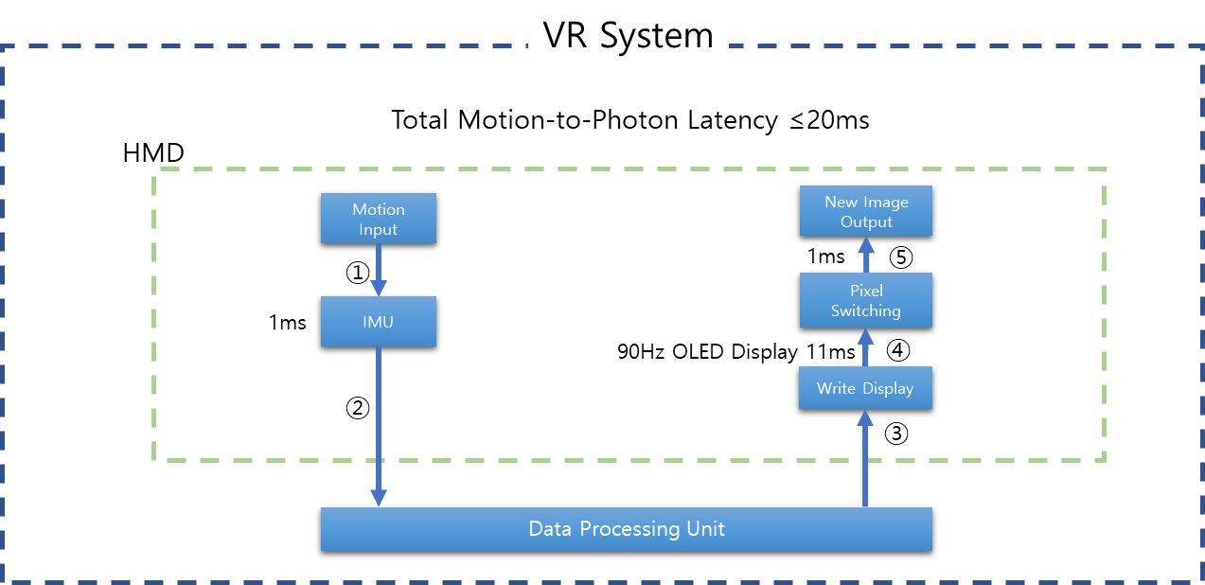
Network latency may occur at the connection points 2 and 3.

