Project | IEEE 802.21 Working Group for Media Independent Services  <http://www.ieee802.org/21/>
Title | White Paper Draft 0.7
DCN | 21-18-0053-00-0000
Date Submitted | September 12, 2018
Source(s) | Sangkwon Peter Jeong ceo@joyfun.kr (JoyFun Inc.,)  Dongil Dillon Seo dillon@volercreative.com (VoleRCreative)  Minseok OH msoh@kgu.ac.kr (Kyonggi University)  Namgi KIM ngkim@kgu.ac.kr (Kyonggi University)  GookHwan Lee ghlee@joyfun.kr (JoyFun Inc.,)
Re: | IEEE 802.21 Session #87 in Waikoloa, HI, USA
Abstract | This document provides the basic layout for table of contents that will be used to organize the thought process of new white paper for IG.
Purpose | Discuss the white paper for each different topic.
Notice | This document has been prepared to assist the IEEE 802.21 Working Group. It is offered as a basis for discussion and is not binding on the contributing individual(s) or organization(s). The material in this document is subject to change in form and content after further study. The contributor(s) reserve(s) the right to add, amend or withdraw material contained herein.
Release | The contributor grants a free, irrevocable license to the IEEE to incorporate material contained in this contribution, and any modifications thereof, in the creation of an IEEE Standards publication; to copyright in the IEEE’s name any IEEE Standards publication even though it may include portions of this contribution; and at the IEEE’s sole discretion to permit others to reproduce in whole or in part the resulting IEEE Standards publication. The contributor also acknowledges and accepts that IEEE 802.21 may make this contribution public.
Patent Policy | The contributor is familiar with IEEE patent policy, as stated in Section 6 of the IEEE-SA Standards Board bylaws <http://standards.ieee.org/guides/bylaws/sect6-7.html#6> and in Understanding Patent Issues During IEEE Standards Development http://standards.ieee.org/board/pat/faq.pdf

- Introduction
  - Purpose
This paper will closely examine what VR content service demands for optimal VR user experience by studying some of the use cases and discuss the network requirements to support these use cases.
  - Scope
This paper will discuss include some simple diagrams to demonstrate the network system required to deliver optimal VR experiences along with some use case scenarios to explain how these diagrams are reflecting the real-world situation. In addition, this paper will cover some of the network requirements that can make these scenarios possible.
  - Problems related to Virtual Reality
When the first commercial versions of VR HMD came out in the market during 2016, people who have tried the VR for the first time started to report that they could not wear the VR HMD more than a few minutes because they feel nauseated and sick. This quickly became one of the major issues why people are not willing to try the VR content and it has been one of the main problems why the world is not embracing the VR as quickly as some of the top marketing firms have predicted. This feeling of sickness has been identified as VR sickness and it is quite similar to the feelings of motion sickness. The industry professionals have identified the components from both hardware and software where they can improve to minimize the effect of VR sickness and one of the components that needs to be improved is the network. As the VR content service demands the faster transfer of bigger data compare to the most of the current content service, the current generation of network infrastructure is not enough to deliver the optimal VR service quality. This raised an issue that the next generation network infrastructure should consider what is needed to support the VR service as it will accelerate the embracement of VR service by the mass.
- Terms & Definitions
360-degree camera
A camera designed to capture 360-degree spherical surfaces.
4K Ultra High Definition (4K UHD)
A term referring to high-definition resolution with a horizontal resolution in the order of 4,000 pixels.
8K ultra high definition (8K UHD)
A term referring to high-definition resolution with a horizontal resolution in the order of 8,000 pixels.

Cybersickness
Psychological and physiological symptoms similar to those of motion sickness. Cybersickness symptoms include discomfort, stomach awareness, nausea, pallor, cold sweating, eye fatigue, and disorientation during or as a result of experiencing virtual environments, especially using head-mounted displays. Virtual Reality (VR) Sickness is also the same as cybersickness

field of view (FOV)
The angular width of a screen that fills the user’s visual field. Angles indicate the range of horizontal, vertical, or diagonal directions over which the camera can hold an image through the lens.

frames per second (FPS)
The number of images that can be processed per second.
Frame Rate
The number of frames through a certain device or a transmission link per a fixed duration. The measurement unit is FPS.

head mounted display (HMD)
A generic term for display devices that are attached to the head.
head tracking
A technique in which tracks the rotational and translational movement of the HD.

jitter
The deviation from true periodicity of a presumably periodic signal, often in relation to a reference clock signal.

motion sickness
Psychological and physiological symptoms which are caused by discordinance between visually perceived movement and sense of bodily movement in the vestibular organs.

motion-to-photon latency
Time delay from the HMD user’s movement and the change of view in HMD caused by the movement.

network latency
Amount of time that information takes to traverse a system (or from one node to another node).

packet error rate (PER)
The number of incorrectly received packets divided by the total number of received packets.

positional tracking
A technique in which tracks the rotational and translational movement of all objects including head mounted display (HMD), controllers and peripheral devices.

refresh rate
The number of pictures that can be processed by the imaging device at one time. The measurement unit is Hz (Hertz).

six degrees of freedom (6 DOF)
Six operating elements of a moving object in three-dimensional space. 6 DOF can be used to describe rotational movements (roll, pitch, yaw) and translational movements (forward/back, left/right, up/down)
spatial 3D sound
A technology that allows the user to identify the location of a sound source where sound is generated. In conjunction with head tracking of HMD, the sound is generated relative to the head direction.

stereoscopy
Three-dimensional vision with the illusion of depth from two-dimensional images using the visual difference of both eyes.

virtual reality (VR)
It refers to any specific environment, situation or technology itself that either simulates the actual reality or creates the virtual spaces and objects according to the imagination of human beings by using computer graphics or videos.

- Use Cases
  - Case 1: Single VR System Layout via LAN
A user is using a VR HMD connected to a gaming console system to play a VR game. The VR HMD is connected to the console with a HDMI cable to receive both video and audio for the content and the console is rendering the content in real time. The USB cable connected between the VR HMD and the console is exchanging the head tracking data to reflect the user’s head movement. For this single VR system layout, the network latency issue is negligible when LAN is configured as a wired network. However, when it is configured wireless, the network latency between the HMD and the console should be the same as a wired network or faster.
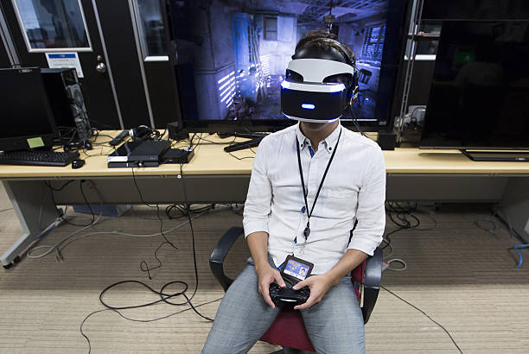

The following is the simplified diagram describing the use case scenario above.
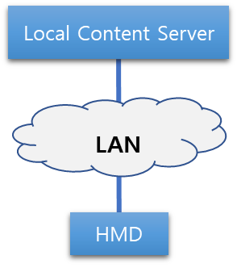 | - VR HMD is connected to a local content server such as a PC or a gaming console via LAN  - VR HMD is receiving VR content rendered or decoded in the local content server via LAN  - LAN: wired or wireless

  - Case 2: Single VR System Layout via WAN
A user is using a mobile phone based VR HMD to watch a baseball game in VR streamed through a local mobile network. The baseball game is being captured via 360-degree camera and the content is being streamed to the HMD in real time. The head tracking data is also transferred to the 360-degree camera via mobile network to show where the user intends to look. Since the content server is located outside of the local area and the content data is traversing through various types of network, the network latency will quickly be added as the data is traversing through multiple network configuration. The added latency may lower the video resolution quality and drop the frame rate. This video quality drop may generate VR sickness so it is necessary to consider not only the connectivity but also the quality of experience.
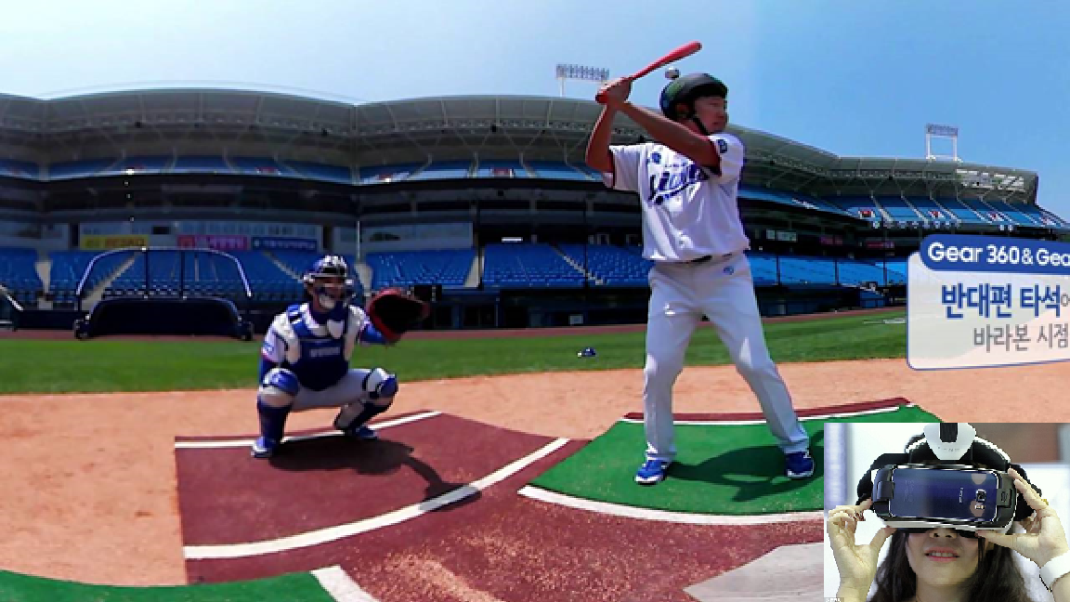
The following is the simplified diagram describing the use case scenario above.

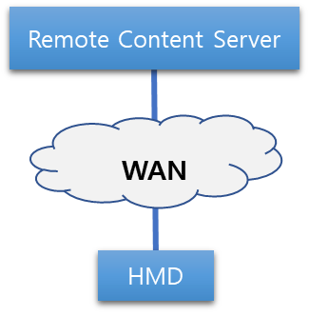 | - VR HMD is connected to a remote content server such as cloud via WAN  - VR HMD is receiving VR content rendered or decoded in the remote content server via WAN  - Remote content server is located outside of the local area  - WAN: wired and wireless

  - Case 3: Multiple VR System Layouts via LAN

A user is using a VR HMD connected to a PC to play a VR game and he is competing against with another player located remotely. The VR HMD is connected to the PC with both HDMI and USB cables to receive both video and audio for the content. The game content is being rendered real time in PC and reflecting the head tracking data sent from the VR HMD. The remote content server is rendering the arena where two remotely located users are playing against each other. The remote server is only calculating the scores and the consequential data caused by the user’s input. The data traversing in LAN, the latency problem can be easy to solve but the latency in WAN can be tricky to solve since it is difficult to determine how WAN is configured outside of the local area.
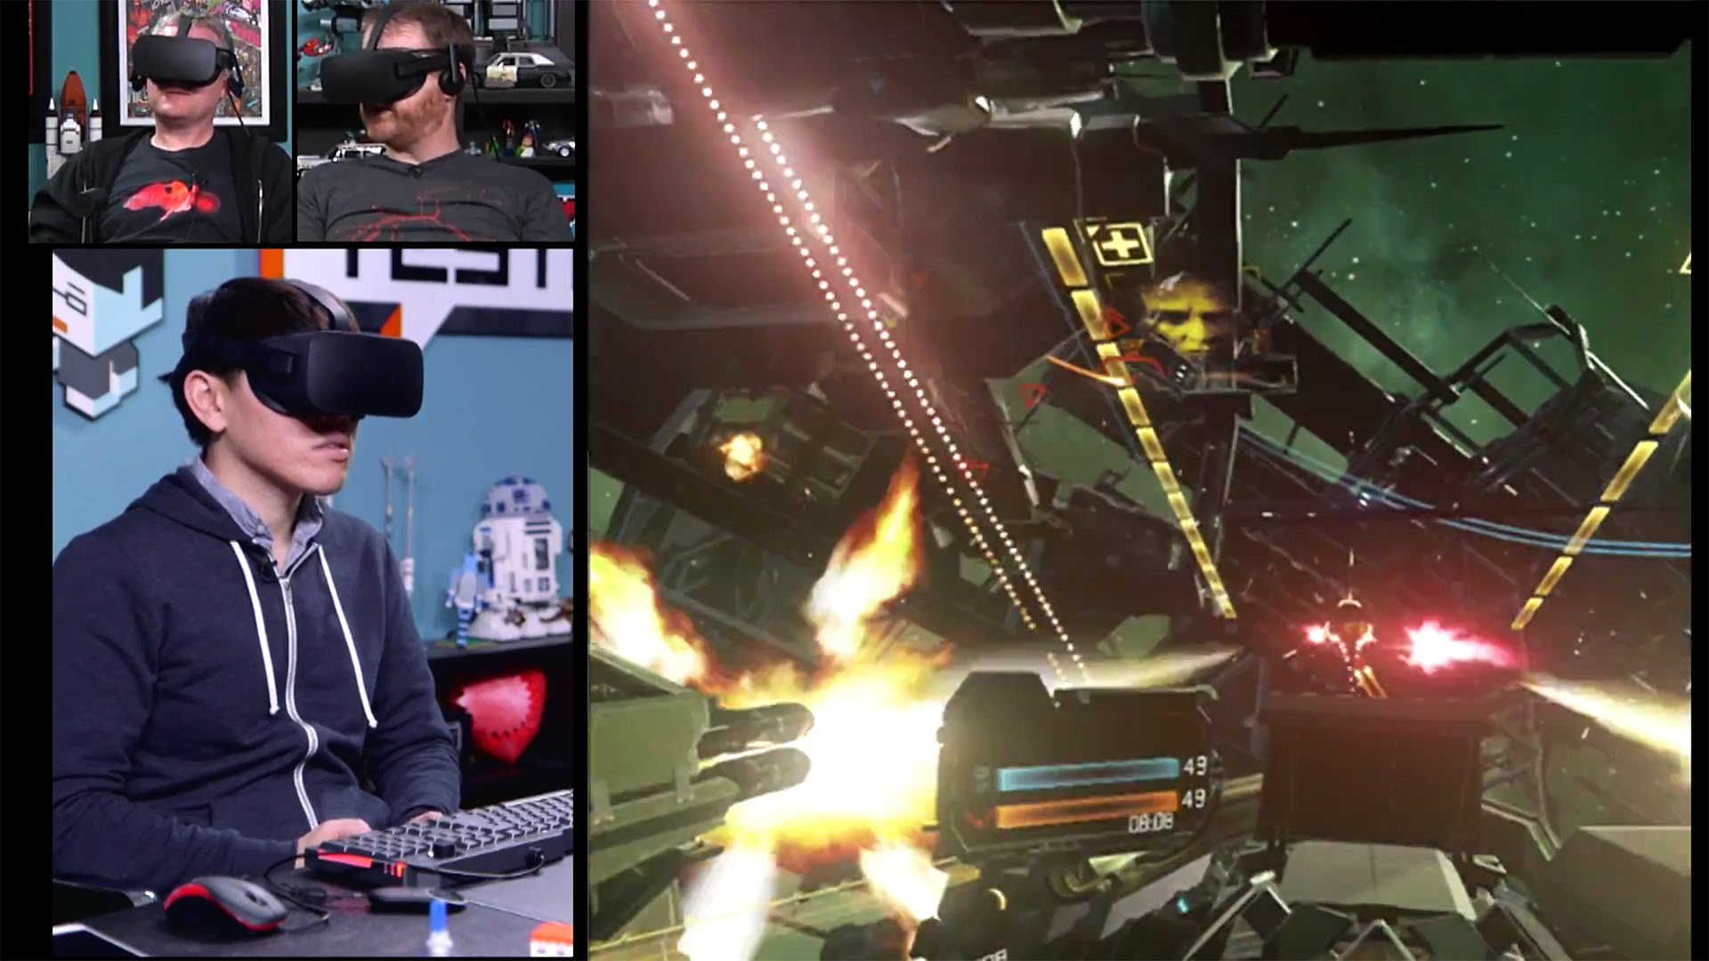
The following is the simplified diagram describing the use case scenario above.
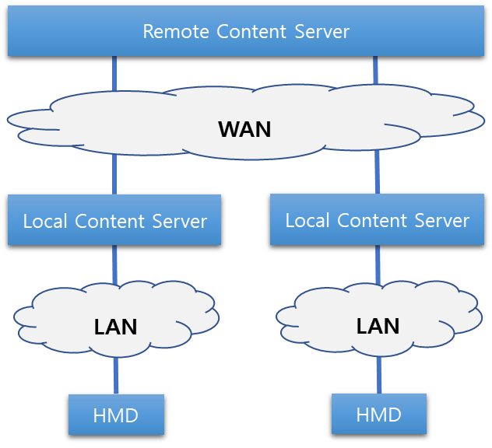 | - More than one VR systems are connected to the remote content server.  - VR HMD is receiving VR content rendered or decoded in the local content server.  - The remote content server is computing the content sent by the local content servers and redistributing the calculated data back to the local content servers.

  - Case 4: Multiple VR System Layouts via WAN
Two or more users are using their mobile phone-based VR HMDs to watch a streamed movie at their respective home. Their virtual avatars are present in a virtual theater to see each other and they are able to communicate either verbally or using emojis. The main movie content is being rendered in the the remote content server and sending the encoded data via WAN to the VR HMDs. The VR HMDs are receiving the remotely rendered content via WAN and decoding it locally. Since the content server is located outside of the local area and the content data is traversing through various types of network, the network latency will quickly be added as the data is traversing through multiple network configuration. The added latency may lower the video resolution quality and drop the frame rate. This video quality drop may generate VR sickness so it is necessary to consider not only the connectivity but also the quality of experience.
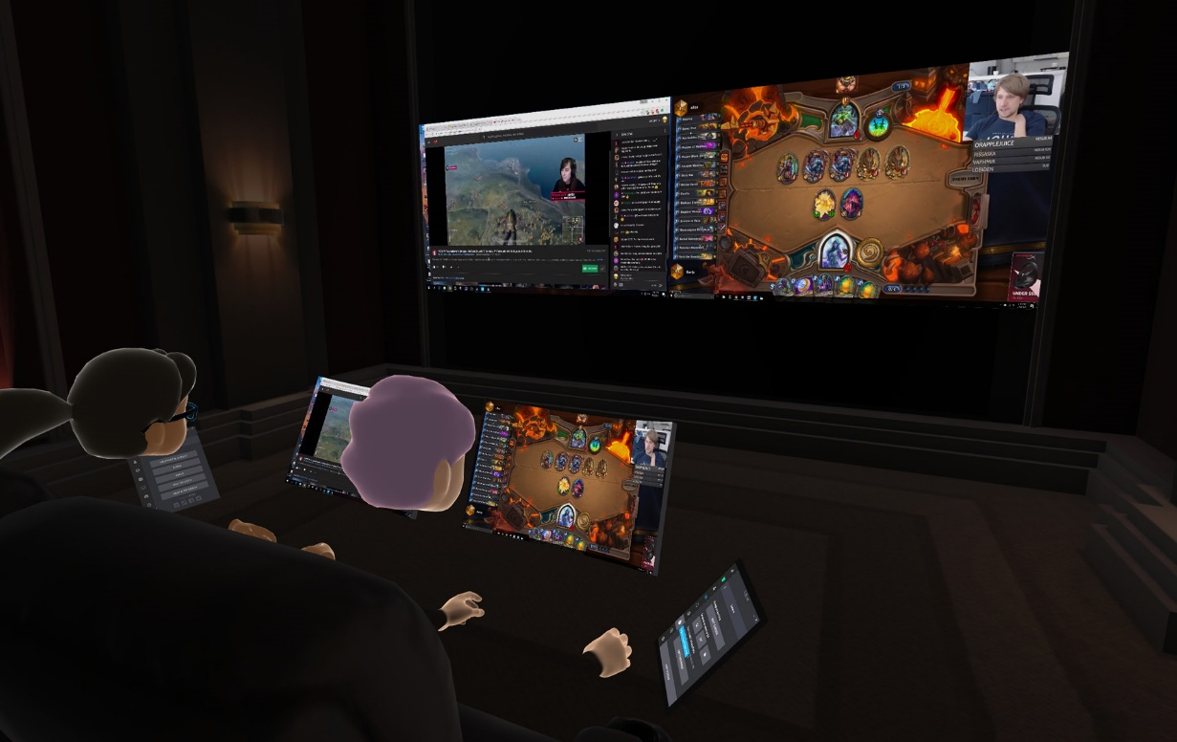
The following is the simplified diagram describing the use case scenario above.
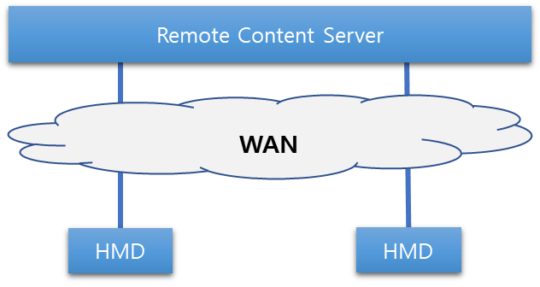 | - More than one VR HMDs are connected to the remote content server.  - VR HMD is receiving VR content rendered or decoded in the remote content server.

  - Case 5: More complicated extension (Change of Network)

A user is wearing a mobile phone-based VR HMD watching a streamed movie while travelling in a bus. The VR HMD is connected to the Wi-Fi network when available but it uses the mobile network when the Wi-Fi network is not available. As the mobile network offers a limited amount of data usage depending on the mobile data plan, the use of Wi-Fi network will be the first choice when it is available. When the VR HMD connection is seamlessly changed to the mobile network from the Wi-Fi network or vise versa, a network handover occurs. When the network is changed from a faster network to a slower network, the network handover causes a drop of data, also known as data cliff, shown in the diagram below.
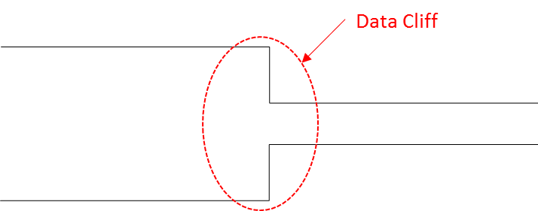
When this data cliff occurs, there is a good chance to lose the data header file which contains the data packet structure demonstrated in the diagram below.
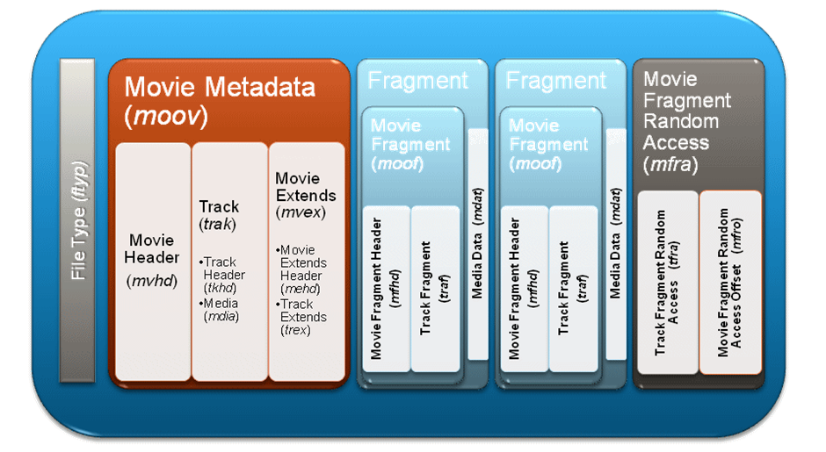
When the header file is lost, then the entire data packet needs to be resent and this causes the delay of the decoding work on the VR HMD. If the pre-downloaded data is not enough to cover this delay, the movie may stop playing and this will significantly drop the frame rate. The VR application may continue to maintain the frame rate by decreasing the content resolution but this scenario is assuming that the VR application is trying to maintain the original high resolution. The drop of frame rate may cause the user to feel VR sickness. To solve the data cliff issue, smoother network transition needs to happen as shown in the diagram below.
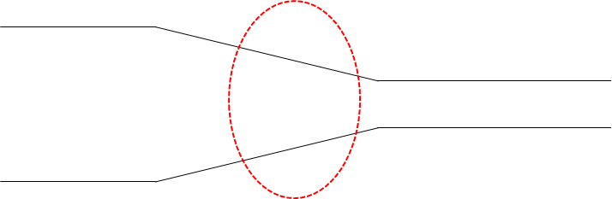
However, this still does not solve the frame rate decrease issue.

- Considerations

One of the major industrial problems for VR to be accepted by the mass is the VR sickness caused by the VR content service. To minimize this problem, several standardization organizations, such as IEEE 802.11, MPEG, and 3GPP, have recommended the following conditions in their use cases or functional requirements documents: frame rate, motion-to-photon latency, data transmission rate, jitter, transmission range, mobility, resolution, and packet error rate. The detailed explanations on these conditions are provided below.

- Data transmission rate should be at least 20 Gbps for 4K UHD with 60 frames per second which will be adopted in the next phase of HMD development according to [4]. However, the actual demanded frame rate for the VR content service is 90 frames per second [3].

  - 1.5 Gbps for compressed 4K UHD 3840×2160 24 bits/pixel, 60 frames/s, 8 bits/color.

  - 8 Gbps for compressed 8K UHD 7,680×4,320 24 bits/pixel, 60 frames/s, 8 bits/color.

  - 18 Gbps for uncompressed 4K UHD 3,840×2,160, 60 frames/s, 8 bits/color, (4:4:4) chroma subsampling.

  - 28 Gbps for uncompressed 8K UHD 7,680×4,320, 60 frames/s, 8 bits/color, (4:2:0) chroma subsampling [5].
  - Frame rate is directly related to motion-to-photo latency since a lower frame rate allows a user’s reaction to be rendered in HMD at earliest after a reciprocal of the frame rate. The less the frame rate is, the more it can cause fatigue and motion sickness.
- The total motion-to-photon/audio latency in the VR system should be less than or equal to 20 ms [6]. This leaves the motion-to-photon latency for the wireless medium should be less than 5 ms, i.e., between two wireless transceivers [5].

  - The motion-to-photon latency is known to be a main cause of motion sickness or nausea.
- Jitter should be less than 5 ms [4].
- Greater jitter can cause distortion in video and audio rendering.
- Transmission range

  - For an indoor environment, it may not exceed 5 m by 5 m [4].
  - For an outdoor environment, it may reach up to several hundred meters.
- Mobility of device
  - For an indoor environment, it is less than 4 km/h [4].
- For an outdoor environment, it may reach up to 300 km/h.

      - PER (Packet error rate) should be less than ${10}^{-2}$ in [4]. However, this value seems to be too extremely generous and chosen carelessly from IEEE 802.11 TGay and needs to be corrected.

The network professionals should also understand that the quality of experience (QoE) need to be satisfied as well as the quality of service (QoS) when considering the development of network specifications. The following table illustrates the conditions needed to be considered in order to provide the good QoE for each use case described in the previous section.

Use Case | Requirements
 | Data TX rate | Motion-to-photon/audio latency | Jitter | TX range | Mobility | PER
1 | √ | √ | √ | √ |  | √
2 | √ | √ | √ |  | √ | √
3 | √ | √ | √ | √ |  | √
4 | √ | √ | √ |  | √ | √
5 |  |  | √ |  |  | √

- Recommendation
Today’s most immersive virtual reality systems, like the Oculus Rift and HTC Vive, rely on a bothersome tether to send power and high-fidelity imagery to the headset. However, a dangling cable is not only annoying, it becomes an immersion detractor. The demand for a solution to this issue has spurred a series of new developments for a wireless link between the high-end host PC and the headset. The biggest caveat is that most powerful VR prototypes are inevitably needed to be wired with cables due to the amount of transmitted high-resolution video at high frame rates. The wired connection such as HDMI (High-Definition Multimedia Interface) and DisplayPort already provide transmission date rates of 18.0 Gbps and 32.4 Gbps, respectively, and negligible delay due to exclusive use of available medium. However, it is believed that as the wireless transmission technologies evolve, their performance has come almost close to the point which the wireless link can replace the wired link without a severe degradation and there is no doubt that all HMDs eventually become tetherless. But there are still some areas in wireless transmission technologies that require improvements specially when they are applied to VR HMDs.
  - Wireless Transmission Technologies
There are several wireless transmission technologies which are applicable to wireless VR HMDs today. Some technologies are already standardized, and some standards are still under development.
    - IEEE 802.11ax
IEEE 802.11ax, known as High Efficiency WLAN (HEW) Task Group, has started its standard development with a main goal to reduce the performance degradation in a Wi-Fi dense area. IEEE 802.11ax have accomplished Draft 2.0 in November 2017. The standard is expected to be completed by the end of 2019.

IEEE 802.11ax, which achieves four times as high as 802.11ac, is designed to operate in 2.4 GHz and 5G Hz spectrums. Through increased link efficiency in frequency domain, time domain, and modulation scheme, the 802.11ax can achieve as high as 12.01 Gbps in an ideal condition [7].
At the current development state, this technology does not satisfy the VR network considerations.
    - IEEE 802.11ay
To develop the follow-up of IEEE 802.11ad, IEEE 802.11ay is formed in May 2015 to achieve a maximum throughput of at least 20 Gbps using the unlicensed mm-Wave (60 GHz) band, while maintaining or improving the power efficiency per STA. They have completed Draft 1.0 in January 2018. The standard is planned to be completed in December 2019.
IEEE 802.11ay can provide a high throughput utilizing various technologies, such as channel bonding/aggregation, MIMO (multiple-input and multiple output), and multiple channel access, etc. [7].
At the current development state, the maximum throughput is satisfied but it needs to consider the device mobility due to the directional propagation of electromagnetic wave in 60 GHz band.
    - 3GPP
To reach a fully interconnected VR world, the VR HMD needs to be mobile even in an outdoor environment beyond the communication range of Wi-Fi. The only technology that can provide that kind of accessibility is through the LTE (Long Term Evolution), one of the 4G technologies, but the data transmission speed is not fast enough to provide a proper operation for a standalone HMD in outdoor environments. 5G, which is expected to be deployed in 2018 [8] and beyond, can be a most favorable candidate for nomadic HMD users. The 3GPP (3rd Generation Project Partnership) has completed a technical report on VR services over 3GPP in September 2017 [9].
  - Gap Analyses
The capabilities of wireless transmission technologies are comparable to the requirements of a wireless VR HMD system. This comparison will facilitate the understanding of what enhancements are needed in which areas, and what features already satisfy the current requirements of wireless VR HMDs. Note that the requirements, such as resolution and frame rate, which cannot be directly satisfied by the transmission technologies, are omitted.
 |  | VR HMD Requirements | Capabilities
 |  |  | 802.11ax [7] | 802.11ay [4] | IMT-2020 [8]
Data transmission rate |  | ~ 20 Gbps [3] | ~10 Gbps (at least 4 times improvement over 802.11ac) | ~100 Gbps | 20 Gbps peak,  100 Mbps user-experience data rate
Latency |  | ~ 5 ms (at wireless medium) [3],  20 ms (motion-to-photon/audio) [5] | “A desirable level to meet QoS requirements in high dense deployment scenario” | 10 ms | 1 ms
Jitter |  | < 5 ms [3] | Not specified | Not specified | Not specified
Transmission range | Indoor | 5 m [3] | Not specified | 10 m indoor | Not specified
 | Outdoor | Several hundred meters |  | 100 m outdoor
Mobility | Indoor | Pedestrian speed < 4 km/h [3] | Not specified | 3 km/h | 500 km/h
 | Outdoor | 200 km/h
PER |  | 10-6 [6] | Not specified | ~10-8 | Not specified

IEEE 802.11ax is not recommended because many of the requirements are unknown and the data transmission rate is only up to 10 Gbps.
IEEE 802.11ay is not recommended because it has the latency of 10 ms and the VR HMD requires 5 ms. Also, the mobility may be an issue due to the directional propagation of an electromagnetic wave in 60 GHz band even in a closed space (VR HMD: 4km/h versus 802.11ay: 3 km/h).
  - The target of 5G or IMT-2020 technical specifications is only capable of supporting a high-resolution video up to 8K in an ideal situation as its maximum data transmission rate is 20 Gbps. However, the wireless VR HMD may suffer from the poor image quality when it is used in a crowded area as its usable data transmission rate is only 100 Mbps.

10-2

 |  | 10-6 |  | ~10-8

- Conclusion
HMD based VR content service is still at early stage but it is considered as an area where we need to go as it solves many industrial efficiency and cost problems. As the technology and content design move forward, we are facing various technical challenges such as display quality, network latency, motion-to-photon latency, rendering latency and human factor studies. Among all these challenges, network latency is one of the critical issues for the VR industry to leap forward; therefore, it is important for all working groups in IEEE 802 to consider what VR industry requires to overcome these challenges. However, it would be ideal to form a separate study group to understand the bigger picture of the industrial demand first before each working group works on the technical development task as it will help to provide the right direction and how each working group can collaborate.
- References
[1] https://www.quora.com/What-causes-the-picture-delay-when-I-move-my-head-around-when-wearing-Oculus-or-Gear-VR
[2] Technicolor during the 116th MPEG meeting in October, 2016
[3] Oculus Rift vs. Vive Pro | Spec Comparison | Digital Trends. [Online]. Available: https://www.digitaltrends.com/virtual-reality/oculus-rift-vs-htc-vive/. [Accessed: Sep. 2018]
[4] IEEE 802.11 TGay Use Cases. [Online]. Available: https://mentor.ieee.org/802.11/dcn/15/11- 15-0625-07-00ay-ieee-802-11-tgay-usage-scenarios.pptx. [Accessed: Feb. 2018]
[5] TGay Functional Requirements. [Online]. Available: https://mentor.ieee.org/802.11/dcn/15/11- 15-1074-00-00ay-11ayfunctional-requirements.docx. [Accessed: Feb. 2018]
[6] Quality Requirements for VR, ISO/IEC JTC1/ SC29/WG11 MPEG 116 Std. m39532, 2016. (identical to [2]?)
[7] "IEEE P802.11ax/D3.0 Draft Standard: Wireless LAN Medium Access Control and Physical Layer Specifications – Amendment 6: Enhancements for High Efficiency WLAN", Jun. 2018
[8] Timeline of 5G Standardization in ITU-R and 3GPP. [Online]. Available: https://www.netmanias. com/en/post/oneshot/11147/5g/timeline-of-5g-standardization-in-itu-r-and-3gpp/. [Accessed: Jan. 2017]
[9] Technical Specification Group Services and System Aspects, Virtual (VR) media services over 3GPP, 3GPP Std. TR 26.918, 2017.

Appendix A
- Cause of VR Sickness
  - Characteristics of VR Content Service
    - Head Tracking (6 DOF)
      - Rotational Tracking
A key feature of an HMD is the ability to track the wearer's head rotations. The images shown on the display change according to the wearer's head movements. Head-tracking is an essential aspect of the HMD that allows the user to become immersed and feel presence.
      - Positional Tracking
Positional Tracking is often performed with sensors and cameras external to the HMD. These peripherals can track the position of the user's head, body and hands anywhere within the range of the devices. They can not only track the rotational movements like the inboard sensors but also translational movements. HMDs in the future will be able to track translational motion and perform positional tracking.
    - Wide FOV
VR HMDs have displays with large field of view (FOV) that comprise the entirety of the user's vision. With both eyes, humans have about 180 degrees FOV when looking in front of them. The display of a VR device should cover as much of the vision range as possible. A large FOV is important to create immersion for the wearer.
    - Stereoscopic
Most of VR content support stereoscopy, a technique for creating or enhancing the illusion of depth in an image. This feature gives the wearer to feel that he can reach out and interact with the environment.
    - 3D Positional Audio (Spatial 3D Sound)
To make the VR experience more immersive, 3D positional audio technique, simulating the changes of sound on its way from the source including reflections from walls and floors to the listener’s ear, is used with head related transfer functions and reverberation. This feature adds extra realism and immersion to the environment he is in.
  - Sensory Conflict
  - Industrial Published Data
The table below is from the presentation made by Technicolor during the 116th MPEG meeting in October, 2016. The table shows the technical requirements needed to minimize the VR sickness.
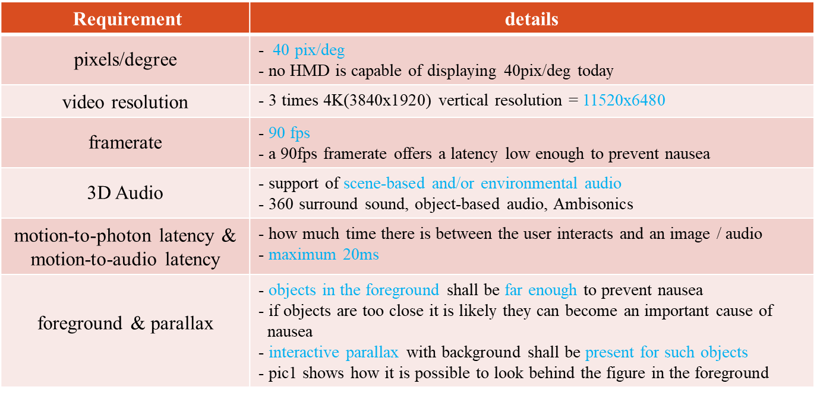
For the purpose of discussing the network requirements, this white paper focuses on the motion-to-photon latency. Some of the other requirements related to the motion-to-photon latency include video resolution and frame rate.
- Types of VR HMD
  - Motion-to-Photon Latency Diagrams
In today’s world of VR industry, there are two types of VR HMDs – standalone type and display type. In the future, there may exist more types but for now, we are focusing on what is available in the market today.
    - Stand-alone type
The standalone type is where the local content server is actually embedded in the HMD itself. Hence, the data processing unit actually exists in the HMD and creates very minimal latency when the data traverse in the VR system. The arrows in the diagram below represent the places where the motion-to-photon latency exist.
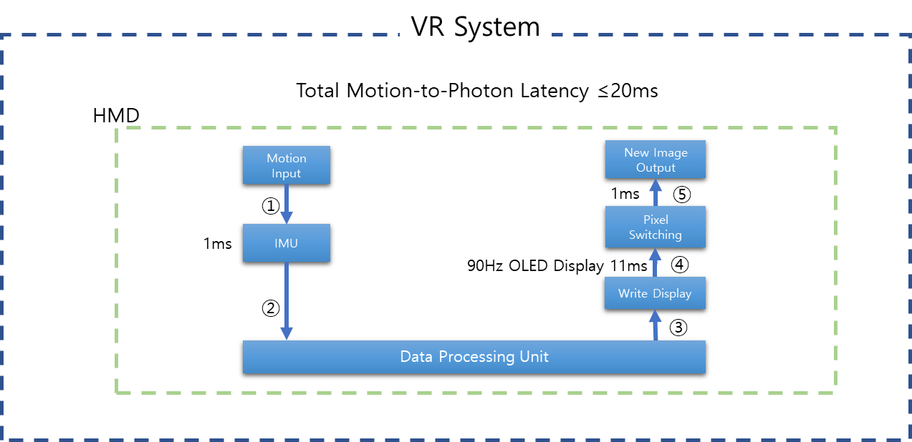
Since all connections that may create latency are embedded in the system, no network latency can be considered in this case.
    - Display type
The display type is where the local content server is actually outside of the HMD. The data processing unit may be connected to HMD via LAN or WAN and may create various latency when the data traverse in the VR system. The arrows in the diagram below represent the places where the motion-to-photon latency exist.
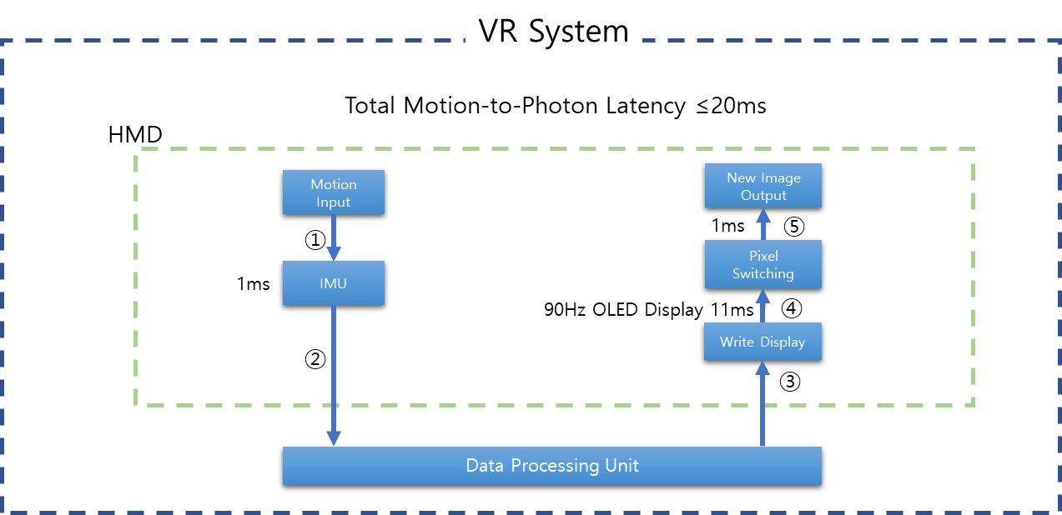
Network latency may occur at the connection points 2 and 3.

