Project | IEEE 802.21 Working Group for Media Independent Services  <http://www.ieee802.org/21/>
Title | White Paper Draft 0.5
DCN | 21-18-0044-00-0000
Date Submitted | August 16, 2018
Source(s) | Sangkwon Peter Jeong ceo@joyfun.kr (JoyFun Inc.,)  Dongil Dillon Seo dillon@volercreative.com (VoleRCreative)  Minseok OH msoh@kgu.ac.kr (Kyonggi University)  Namgi KIM ngkim@kgu.ac.kr (Kyonggi University)
Re: | IEEE 802.21 Session #87 in Waikoloa, HI, USA
Abstract | This document provides the basic layout for table of contents that will be used to organize the thought process of new white paper for IG.
Purpose | Discuss the white paper for each different topic.
Notice | This document has been prepared to assist the IEEE 802.21 Working Group. It is offered as a basis for discussion and is not binding on the contributing individual(s) or organization(s). The material in this document is subject to change in form and content after further study. The contributor(s) reserve(s) the right to add, amend or withdraw material contained herein.
Release | The contributor grants a free, irrevocable license to the IEEE to incorporate material contained in this contribution, and any modifications thereof, in the creation of an IEEE Standards publication; to copyright in the IEEE’s name any IEEE Standards publication even though it may include portions of this contribution; and at the IEEE’s sole discretion to permit others to reproduce in whole or in part the resulting IEEE Standards publication. The contributor also acknowledges and accepts that IEEE 802.21 may make this contribution public.
Patent Policy | The contributor is familiar with IEEE patent policy, as stated in Section 6 of the IEEE-SA Standards Board bylaws <http://standards.ieee.org/guides/bylaws/sect6-7.html#6> and in Understanding Patent Issues During IEEE Standards Development http://standards.ieee.org/board/pat/faq.pdf

- Introduction
  - Purpose
This paper will closely examine what VR content service demands for optimal VR user experience by studying some of the use cases and discuss the network requirements to support these use cases.
  - Scope
This paper will discuss include some simple diagrams to demonstrate the network system required to deliver optimal VR experiences along with some use case scenarios to explain how these diagrams are reflecting the real world situation. Also, this paper will cover some of the network requirements that can make these scenarios possible.
  - Problems related to Virtual Reality
In August 2014, Facebook, the social media giant, acquired a small American startup called Oculus VR, kickstarted from a crowd funding in August 2012, for $2.3 billion USD and this event grabbed the world’s attention to notice the potential of VR industry. When the first commercial versions of VR HMD came out in the market during 2016 from Oculus, HTC and Sony, people who have tried the VR for the first time started to report that they could not wear the VR HMD more than a few minutes because they feel nauseated and sick. This quickly became one of the major issues why people are not willing to try the VR content and it has been one of the main problems why the world is not embracing the VR as quickly as some of the top marketing firms have predicted. This feeling of sickness has been identified as VR sickness and it is quite similar to the feelings of motion sickness. The industry professionals have identified the components from both hardware and software where they can improve to minimize the effect of VR sickness and one of the components that needs to be improved is the network. As the VR content service demands the faster transfer of bigger data compare to the most of the current content service, the current generation of network infrastructure is not enough to deliver the optimal VR service quality. This raised an issue that the next generation network infrastructure should consider what is needed to support the VR service as it will accelerate the embracement of VR service by the mass.
- Terms & Definition
360 degree camera
A camera designed to capture 360 degree spherical surfaces.
4K Ultra High Definition (4K UHD)
A term referring to high-definition resolution with a horizontal resolution in the order of 4,000 pixels.
8K ultra high definition (8K UHD)
A term referring to high-definition resolution with a horizontal resolution in the order of 8,000 pixels.
accelerometer
A sensor for measuring linear acceleration or angular acceleration by measuring inertia-induced reaction.
angular resolution
A value of representing an interval between pixels of an image displayed by a HMD on the basis of an angle. The unit of measurement is PPD (Pixels Per Degree).
background complexity
The number of figures, colors, and sizes of objects, and the level of optical flow in background scene. The background complexity may have an effect on Cybersickness.
binocular disparity
Difference in image location of an object seen by left and right eye images.
Biomarker
A biomarker, or biological marker, generally refers to a measurable indicator of some biological state or condition.
Constant Bit Rate encoding (CBR encoding)
An encoding method that the rate at which a codec's output data is consumed constantly with respect to time.
chromatic aberration
An effect resulting from dispersion in which there is a failure of a lens to focus all colors to the same convergence point.
Contrast Ratio (CR)
The ratio of the luminance of the brightest color (white) to that of the darkest color (black).
Cybersickness
Psychological and physiological symptoms similar to those of motion sickness. Cybersickness symptoms include discomfort, stomach awareness, nausea, pallor, cold sweating, eye fatigue, and disorientation during or as a result of experiencing virtual environments, especially using head-mounted displays.
depth of field
The effective focus range or distance between the nearest and farthest objects in a moving scene used to ensure sharp images. Inadequet depth of field in rendered VR stereoscopic scene can cause the symptoms of VR sickness.
electroencephalogram (EEG)
Electrophysiological signals of the brain recorded noninvasively using electrodes placed along the scalp.
Electrogastrogram (EGG)
Electrophysiological signals of the stomach recorded using electrodes placed on the abominal skin.
Electrocardiogram (ECG)
Electrophysiological signals of the heart recorded over a period of time using electrodes placed on the skin.
exit pupils
The range of pupil size in the HMD. In a general optical system, it refers to a hole through which the light exits, an exit hole seen from the direction in which the optical system is seen from the eye, or a hole through which the image can be formed by the lens behind the optical system.
extensible 3D (X3D)
Royalty free ISO Standard for representing computer graphics.
eye dominance
The preference of processing visual input by the left or right eye.
eye relief
The distance between the eyepiece and the user’s eyes.
eye tracking
A technique to track the position of the eye by sensing the movement of the pupil.
fast motion sickness scale (FMS)
The FMS represents only the lowest (0) and the highest (20) scores. Motion sickness symptoms are reported verbally every minute, including general discomfort, and stomach awareness.
field of view (FOV)
The angular width of a screen that fills the user’s visual field. Angles indicate the range of horizontal, vertical, or diagonal directions over which the camera can hold an image through the lens.
fisheye lens
An ultra-wide angle lens with viewing angle over 100 degrees.
foveated rendering
An upcoming graphics rendering technique which uses an eye tracker integrated with a virtual reality headset to reduce the rendering workload by greatly reducing the image quality in the peripheral vision (outside of the zone gazed by the fovea).
frame of reference
Referential objects (e.g., trees, clouds, and frames) that are stationary in a moving scene.
Other similar definitions include Visual Guide and Point of Reference.
frame per second (FPS)
The number of images that can be processed per second.
Frame Rate
The amount of frames through a certain device or a transmission link per a fixed duration. The measurement unit is FPS.
full high definition (FHD)
A term created for a marketing purpose and has 1,920 x 1,080 resolution.
galvanic skin response (GSR)
One of the most sensitive markers of emotional arousal is galvanic skin response (GSR), also referred to as skin conductance (SC) or electro-dermal activity (EDA).
gyroscope
A sensor for measuring orientation and angular velocity.
It is also the term collectively refers to a device for measuring gravity using elastic deformation by gravity. In HMD, it refers to a gravity meter that works perpendicular to the center of the earth.
hand over
The process by which an HMD obtains facilities and preserves VR content traffic flow upon change from one link to another.
haptic interface
An interface that recreates the sense of touch and sense of movement by applying forces, vibrations, or motions to the user.
head mounted display (HMD)
A generic term for display devices that are attached to the head.
head tracking
A technique in which tracks the rotational and translational movement of the HMD.
Inter-ocular distance (IOD)
The distance between the ocular lens of HMD optical systems and eyes.
Interpupillary distance (IPD)
The distance between the centers of the pupils of the left and the right eyes.
jitter
The deviation from true periodicity of a presumably periodic signal, often in relation to a reference clock signal.
line-of-sight propagation (LOS propagation)
A propagating way of electromagnetic waves that travel in a straight line.
magnetometer
A sensor for measuring magnetism – the direction, strength and relative change of a magnetic field at a particular location.
misery scale (MISC)
A scale that measures cybersickness symptoms using a score between 0 and 10. The higher the MISC score reported, the more severe the cybersickness experienced.
motion blur
It is the apparent streaking of rapidly moving objects in a still image or a sequence of images such as a movie or animation.
motion feedback frequency
The frequency that an HMD sends collected data, mainly motion, to a VR server.
motion sickness
Psychological and physiological symptoms which are caused by discordinance between visually perceived movement and sense of bodily movement in the vestibular organs.
motion sickness susceptibility questionnaire (MSSQ)
Motion sickness susceptibility questionnaires, sometimes called motion history questionnaires, are useful instruments in the prediction of motion sickness due to a variety of provocative environments.
motion-to-audio latency
Time delay from the HMD user’s movement and the change of sound in HMD caused by the movement.
motion-to-photon latency
Time delay from the HMD user’s movement and the change of view in HMD caused by the movement.
nausea scale
A scale that measures a user’s symptoms of nausea using a score between 0 and 5. Nausea levels are reported verbally every minute.
network latency
Amount of time that information takes to traverse a system (or from one node to another node).
non-line of sight propagation (NLOS propagation)
Radio transmissions across a path that is partially obstructed, usually by a physical object in the innermost.
number of motion axes
The number of directional and rotational factors of optical flow. This number influences the magnitude of cybersickness and motion sickness.
objective measurement
Quantification of the user’s behavioral and physiological changes. In the study of cybersickness, objective measures include the user’s magnitude of postural sway and physiological signals, such as measured by an electroencephalogram (EEG), electrogastrogram (EGG), or electrocardiogram (ECG) etc.
ocularity (monocular, binocular, biocular)
Type of optical systems used in the HMD determined by the number of video signals.When the video signal is delivered to one eye, it is called monocular. When two different video signals are delivered to both eyes, it is called binocular. When a single video signal is delivered to both eyes, it is called biocular.
optical distortion
Distortion occurred by the optical system – often the distorted image is in a barrel or pincushion shape depending on the system.
optical flow
Apparent visual motions of objects, surfaces, and edges which are relative visual movements between the observer and a scene.
packet error rate (PER)
The number of incorrectly received packets divided by the total number of received packets.
photoplethysmography (PPG)
An optical measurement technique that can be used to detect blood volume changes in the microvascular bed of tissue.
pixels per inch (PPI)
A measurement of the pixel density of an electronic image device such as a computer monitor or television display.
polygons per second (PPS)
The number of polygons that can be processed per second.
positional tracking
A technique in which tracks the rotational and translational movement of all objects including head mounted display (HMD), controllers and peripheral devices.
postural stability
The ability to maintain balance using the muscles in your ankles, knees, and hips in response to movement. Postural stability decreases with fatigue, particularly in the knees and hips.
postural sway
The sense of the positions and movements of a person’s own limbs and trunk, plus the strength employed in such movements.
reality-virtual continuum
The level of mixture of real and virtual objects presented in display devices. Real environments are situated at one end of the continuum, and virtual environments are at the other end of the continuum.
reference object
A visual scene or component that provides stationary location or orientation cue, and which matches the vestibular signal.
refresh rate
The number of pictures that can be processed by the imaging device at one time. The measurement unit is Hz (Hertz).
response time
It is the amount of time a pixel in a display takes to change (It is measured in milliseconds (ms)).
sensory conflict theory
A working hypothesis to explain the physiological mechanism of motion sickness and cybersickness. Sensory disparity between the visual and the vestibular systems can induce symptoms of motion sickness and cybersickness.
sensory mismatch
The discrepancy between different sensations related to orientation and movement, especially from the visual and the vestibular organs, which causes motion sickness and cybersickness (VIMS, simulator sickness etc.).
simulator sickness
Psychological and physiological symptoms similar to those of motion sickness, typically experienced by pilots and drivers who receive simulator training.
simulator sickness questionnaire (SSQ)
A standard questionnaire used to measure the magnitude of simulator sickness symptoms.
six degrees of freedom (6 DOF)
Six operating elements of a moving object in three dimensional space. 6 DOF can be used to describe rotational movements (roll, pitch, yaw) and translational movements (forward/back, left/right, up/down)
spatial 3D sound
A technology that allows the user to identify the location of a sound source where sound is generated. In conjunction with head tracking of HMD, the sound is generated relative to the head direction.
spatial velocity
The velocity of virtual scene movement which represents the speed of the scene movement.
speed of VR content
One of the factors of optical flow. The faster the speed of an object, the larger the measurement of the optical flow.
stereoscopy
Three-dimensional vision with the illusion of depth from two-dimensional images using the visual difference of both eyes.
stitch
Technique to combine two or more videos to create 360 degree video and minimize the image distortion.
subjective measurement
Quantification of the user’s subjective experiences. In the study of cybersickness, subjective measures include scores on the Simulator Sickness Questionnaire (SSQ), Nausea scale, Fast motion sickness scale (FMS), and Misery scale (MISC) etc.
subjective visual vertical
An indicator of impaired sense of spatial orientation. It is determined by having subjects adjust a visible luminus line in complete darkness to what they consider to be upright, earth vertical.
three degrees of freedom (3 DOF)
Three rotational elements of moving objects in three dimensional space. Means the roll (x axis), pitch (y axis), and yaw (z axis) rotation operations on X, Y and Z axes.
time warping rendering
A technique in VR that warps the rendered image before sending it to the display to correct for the head movement occurred after the rendering. It is either used to reduce the latency or maintain the desired frame rate.
tracking sensor
A device for tracking the movement of the user to synchronize with the content.
ultra high definition (UHD)
A term created for a marketing purpose and has at least 3,840 x 2,160 resolution.
variable bit rate encoding (VBR encoding)
An encoding method, as opposed to the CBR encoding, that the rate at which a codec's output data is consumed inconsistantly with respect to time.
vection
Visually induced illusions of self-motion experienced by physically stationary observers in real environment or in virtual environment.
vestibular system
The sensory system that provides a sense of bodily movement and balance. It also provides the spatial orientation for the purpose of coordinating movement.
vestibulo-ocular reflex (VOR)
A reflex, where activation of the vestibular system causes eye movement.
video tracking
It is a computer vision technology for finding the position change of a specific object such as a person, an animal, or a car in a video shot by a camera.
viewing angle
The maximum side angle at which a normal screen can be seen on the display device.
virtual reality (VR)
It refers to any specific environment, situation or technology itself that either simulates the actual reality or creates the virtual spaces and objects according to the imagination of human beings by using computer graphics or videos.
virtual reality (VR) sickness
Same as Cybersickness
visually induced motion sickness (VIMS)
Sensations and perceptions similar to traditional motion sickness with limited or no physical movement.
VR fidelity
The level of similarity in sensation and perception between real and virtual environments.
wireless HMD access distance
The distance from the VR content server wireless module to the HMD wireless module, and within that distance the VR HMD should display without severe interruption.
- Use Case
  - Case 1: Single VR System Layout via LAN
    - Diagram
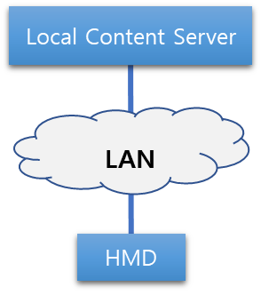 | - VR HMD is connected to a local content server such as a PC or a gaming console via LAN  - VR HMD is receiving VR content rendered or decoded in the local content server via LAN  - LAN: wired or wireless
    - Use Case Scenario
A user is using a PlayStation VR (PS VR) HMD connected to a PlayStation 4 (PS4) console system to play a VR game. PS VR is connected to PS4 with a HDMI cable to receive both video and audio for the content and PS4 is rendering the content in real time. The USB cable connected between the PS VR and the PS4 are exchanging the head tracking data to reflect the user’s head movement. For this single VR system layout, no network latency issue exists when LAN is configured as a wired network. However, when it is configured wireless, the network latency between the HMD and the local content server should be the same as a wired network or faster.
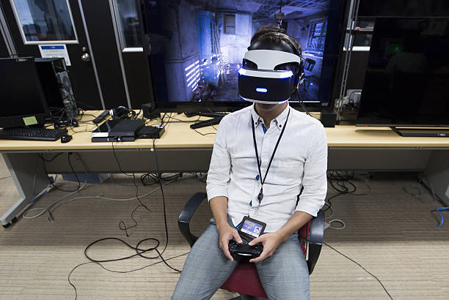
  - Case 2: Single VR System Layout via WAN
    - Diagram
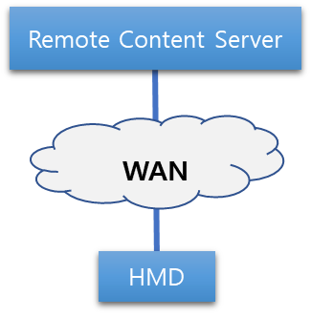 | - VR HMD is connected to a remote content server such as cloud via WAN  - VR HMD is receiving VR content rendered or decoded in the remote content server via WAN  - Remote content server is located outside of the local area  - WAN: wired and wireless
    - Use Case Scenario
A user is using Samsung Gear VR HMD to watch a baseball game in VR streamed through a local mobile network. The baseball game is being captured via 360 degree camera and the content is being streamed to the HMD in real time. The head tracking data is also transferred to the 360 degree camera via mobile network to show where the user intends to look. Since the content server is located outside of the local area and the content data is traversing through various types of network, the network latency will quickly be added as the data is traversing through multiple network configuration.
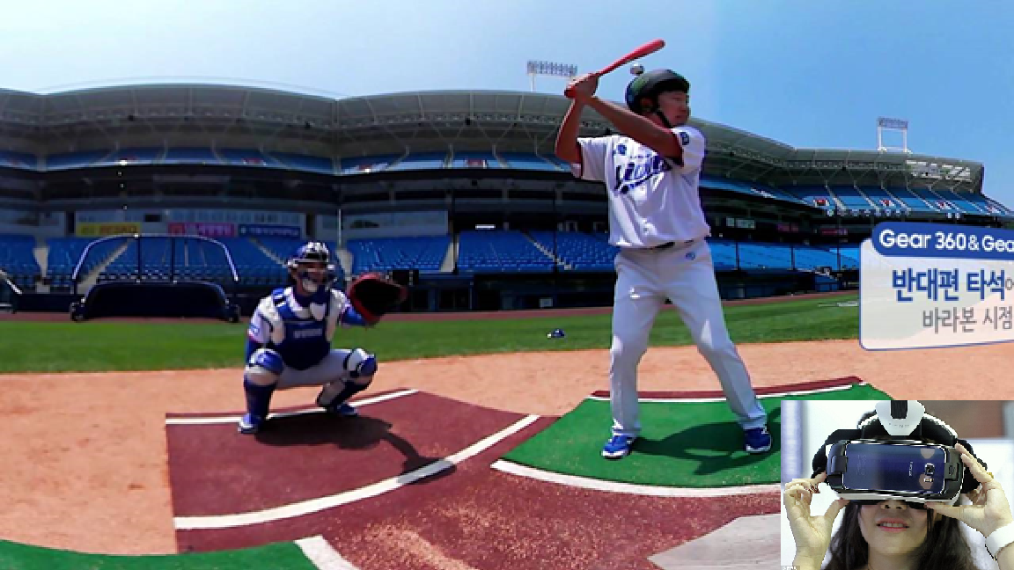
  - Case 3: Multiple VR System Layouts via LAN
    - Diagram
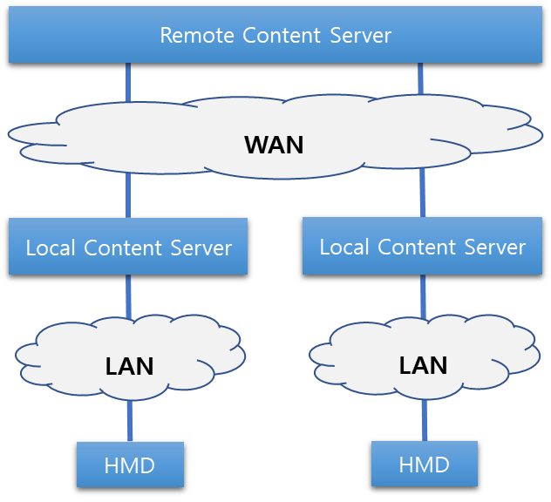 | - More than one VR systems are connected to the remote content server.  - VR HMD is receiving VR content rendered or decoded in the local content server.  - The remote content server is computing the content sent by the local content servers and redistributing the calculated data back to the local content servers.
    - Use Case Scenario
A user is using an Oculus Rift HMD connected to a PC to play a VR game and he is competing against with another player located remotely. Oculus Rift is connected to PC with HDMI and USB cables to receive both video and audio for the content which is rendered in PC and send the head tracking data from the VR HMD to PC. The game content is being rendered real time and reflecting the head tracking data from the VR HMD. The remote content server is rendering the arena where two remotely located users are playing against each other. The remote server is only calculating the scores and the consequential data caused by the user’s input. The data traversing in LAN, the latency problem can be easy to solve but the latency in WAN can be tricky to solve since it is difficult to determine how WAN is configured outside of the local area.
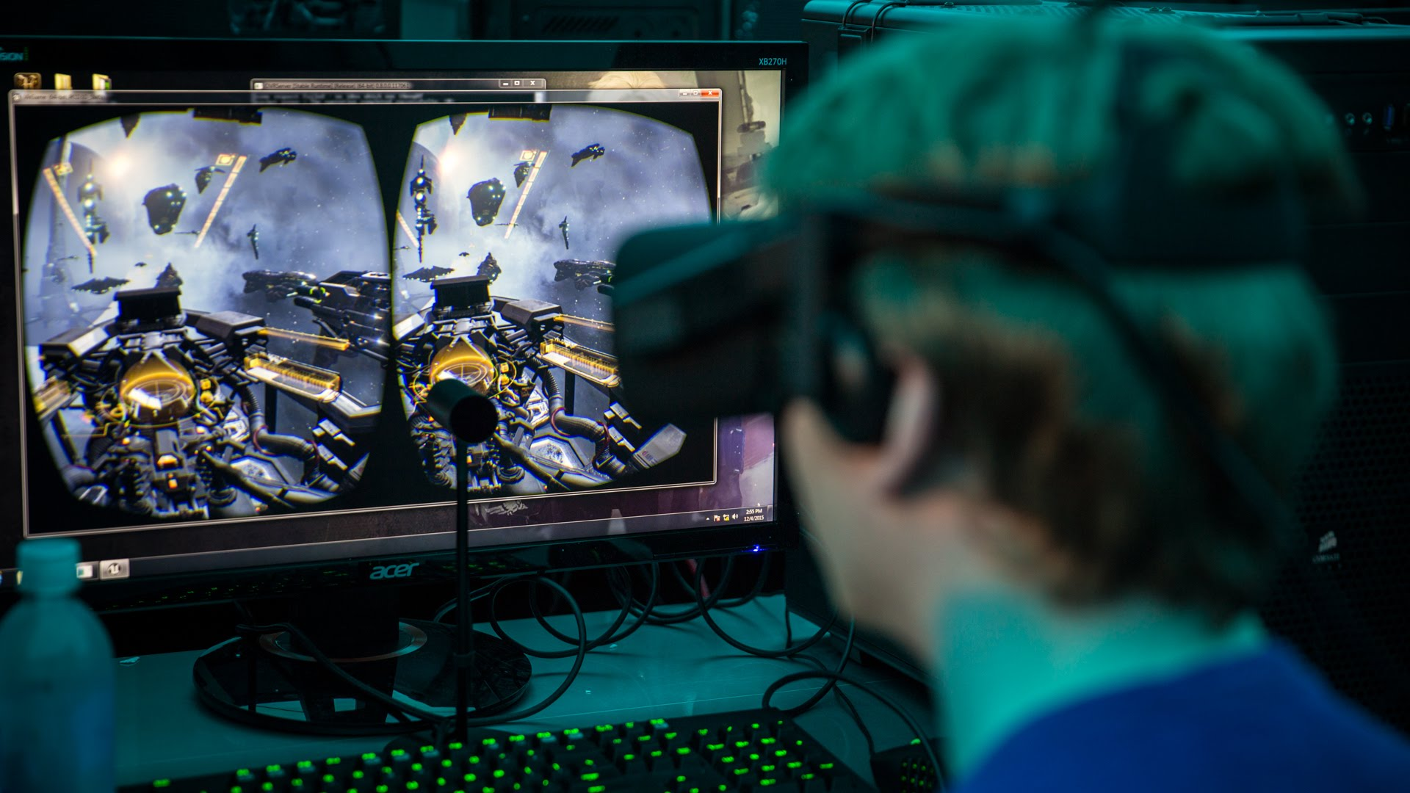
  - Case 4: Multiple VR System Layouts via WAN
    - Diagram
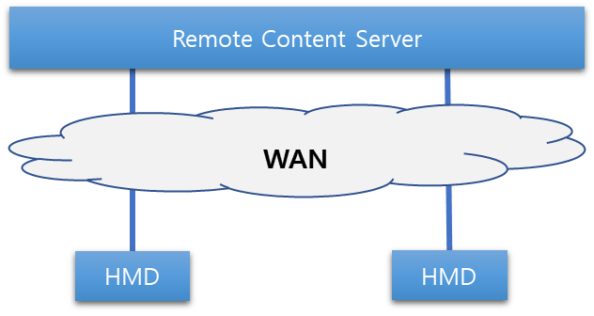 | - More than one VR HMDs are connected to the remote content server.  - VR HMD is receiving VR content rendered or decoded in the remote content server.
    - Use Case Scenario

  - Case 5: More complicated extension (Mobility of Network)
    - Diagram
    - Use Case Scenario
- Requirements
  - Pre-conditions
The VR industry currently demands the content to run at least 90 frames per second (FPS) with the resolution of 2,160 x 1,200 pixels. Also, the photo-to-motion latency must be less than 20 ms. These conditions are known to minimize the VR sickness caused by the content. Hence, it is important to understand that the network professionals must satisfy this quality of experience as well as the quality of service when considering the development of network specification.
  - Network Specifications
Several standardization organizations, such as IEEE 802.11, MPEG, and 3GPP, have recommended the requirements of VR HMDs in their use cases or functional requirements documents. Those can be summarized into eight requirements: data transmission rate, motion-to-photo/audio latency, jitter, transmission range, mobility, resolution, frame rate, and packet error rate. The following table shows how the use cases listed above are related to those requirements.
Requirements |  | Use case
 |  | 1 | 2 | 3 | 4 | 5
Data transmission rate | At least 20 Gbps [3]. 1.5 Gbps for compressed 4K UHD 3840×2160 24bits/pixel, 60 frames/s, 8 bits/color. 8 Gbps for compressed 8K UHD 7,680×4,320 24 bits/pixel, 60 frames/s, 8 bits/color. 18 Gbps for uncompressed 4K UHD 3,840×2,160, 60 frames/s, 8 bits/color, (4:4:4) chroma subsampling. 28 Gbps for compressed 8K UHD 7,680×4,320, 60 frames/s, 8 bits/color, (4:2:0) chroma subsampling [4]. | √ | √ | √ | √
Motion-to-photon/audio latency | Less than or equal to 20 ms [5] and less than 5ms for wireless medium, i.e., between two wireless transceivers [4]. The latency is a main cause of motion sickness or nausea. | √ | √ | √ | √
Jitter | less than 5 ms [3]. Greater jitter can cause distortion in video and audio rendering. | √ | √ | √ | √ | √
Transmission range | For an indoor environment, it may not exceed the dimension 5 m by 5 m [3]. | √ |  | √
 | For an outdoor environment, it may reach up to several hundred meters. |  | √ |  | √
Mobility | For an indoor environment, it is less than 4 km/h [3]. | √ |  | √
 | For an outdoor environment, it may reach up to 300 km/h. |  | √ |  | √
Resolution | 4K UHD (3,840×2,160) seems to be feasible according to the current display technology. However, an HMD is mounted so closely to the eyes, so the display tends to be enlarged, which results in the need of even higher resolution than 4K UHD. 40 pixels/degree or 12K (11,520×6,480) is required to satisfy this condition [5]. | √ | √ | √ | √
Frame rate (or refresh rate) | 90 fps (frames per second) [3]. It is directly related to motion-to-photo latency since a lower frame rate allows a user’s reaction to be rendered in HMD after some amount of time gap. And the less the frame rate is, the more it can cause fatigue and motion sickness, and even more so since the display is located close to the eyes. | √ | √ | √ | √
PER (Packet error rate) | ${10}^{-2}$ [3]. This requirement value seems to be too extremely generous and chosen carelessly from IEEE 802.11 TGay and needs to be corrected. A generally accepted PER value is ${10}^{-6}$ [6]. | √ | √ | √ | √ | √

- Recommendation
  - Wireless Transmission Technologies
There are several wireless transmission technologies which are applicable to wireless VR HMDs. Some technologies are already standardized, and some standards are still under development.
    - IEEE 802.11ax
The High Efficiency WLAN (HEW) Study Group started in March 2013 with a main goal to reduce the performance degradation in a Wi-Fi dense area. One year later the 802.11ax Task Group is formed to develop the standard in May 2014. They have accomplished Draft 2.0 in November 2017. The standard is expected to be completed by the end of 2019.
IEEE 802.11ax is designed to operate in 2.4GHz and 5GHz spectrums. The main goal of IEEE 802.11ax is to achieve four times as high as 802.11ac, the maximum throughput of which is 3.39Gbps, and provide means to prevent from the throughput deterioration in a high-density area.
Key technologies that the standard adopted to enhance the throughput are as follows. In addition to MIMO (Multiple-Input and Multiple-Output) adopted in IEEE 802.11n and downlink MU-MIMO (Multi-User MIMO) adopted in IEEE 802.11ac, the new amendment introduces UL (uplink) MU-MIMO and OFDMA (Orthogonal Frequency Division Multiple Access) to improve overall spectral efficiency. It increases the order of QAM modulation to 1024 from 256 QAM (Quadrature Amplitude Modulation) in 802.11ac for increased throughput of 9.607 Gbps theoretically [7].
    - IEEE 802.11ay
To develop the follow-up of IEEE 802.11ad, IEEE 802.11ay is formed in May 2015 to support a maximum throughput of 100 Gbps or even higher using the unlicensed mm-Wave (60 GHz) band, while maintaining or improving the power efficiency per STA. They have completed draft 1.0 in January 2018. The standard is planned to be completed in December 2019.
IEEE 802.11ay includes mechanisms for channel bonding and channel aggregation. In channel bonding, a single waveform covers at least two contiguous 2.16 GHz channels, whereas channel aggregation has a separate waveform for each aggregated channel. IEEE 802.11ay mandates that EDMG (Enhanced Directional Multi-Gigabit) STAs must support operation in 2.16 GHz channels as well as channel bonding of two 2.16 GHz channels. Channel aggregation of two 2.16GHz or two 4.32GHz (contiguous or non-contiguous) channels and bonding of three or four 2.16GHz channels are optional. To achieve both beamforming and multiplexing gain, IEEE 802.11ay defines new mechanisms to enable MIMO operation including both Single-User MIMO and downlink MU-MIMO. The maximum number of spatial streams per station is eight, and downlink MU-MIMO transmission can be made to up to eight stations [8].
    - 3GPP
To reach a fully interconnected VR world the VR HMD need to be mobile even in an outdoor environment beyond the communication range of Wi-Fi. The only technology that can provide that kind of accessibility is through the LTE (Long Term Evolution), a 4G candidate, but the data transmission speed is not fast enough to provide a proper operation for a standalone HMD in outdoor environments. 5G which is expected to be deployed in 2018 [9] and later can be a most favorable candidate for nomadic HMD users. The 3GPP (3rd Generation Project Partnership) has completed a technical report on VR services over 3GPP in September 2017 [10].
  - Gap Analyses
The capabilities that wireless transmission technologies can provide are compared with the requirements that a wireless VR HMD system may need. This comparison will help understand what more enhancements are needed in what areas, and what features already satisfies the requirements of wireless VR HMDs. Note that the requirements, such as resolution and frame rate, which cannot be directly satisfied by the transmission technologies, are omitted.
 |  | VR HMD Requirements | Capabilities
 |  |  | 802.11ax [7] | 802.11ay [4] | IMT-2020 [10]
Data transmission rate |  | ~ 20 Gbps [3] | ~10 Gbps (at least 4 times improvement over 802.11ac) | ~100 Gbps | 20 Gbps peak,  100 Mbps user-experience data rate
Latency |  | ~ 5 ms (at wireless medium) [3],  20 ms (motion-to-photon/audio) [5] | “A desirable level to meet QoS requirements in high dense deployment scenario” | 10 ms | 1 ms
Jitter |  | < 5 ms [3] | Not specified | Not specified | Not specified
Transmission range | Indoor | 5 m [3] | Not specified | 10 m indoor | Not specified
 | Outdoor | Several hundred meters |  | 100 m outdoor
Mobility | Indoor | Pedestrian speed < 4 km/h [3] | Not specified | 3 km/h | 500 km/h
 | Outdoor | 200 km/h
PER |  | ${10}^{-6}$ [6] | Not specified | $$\sim {10}^{-8}$$ | Not specified
With IEEE 802.11ax the data rate may not meet the wireless VR HMD’s requirement when the resolution is high, or the compression is low. If the VR HMD is used in an indoor environment, the 802.11ax technology is expected to suffice the rest of the requirements even though some capability values are missing.
With IEEE 802.11ay most of the wireless VR HMD requirements will be met except the latency (VR HMD: 5 ms versus 802.11ay: 10 ms). The latency requirement and 802.11ay’s capability must be carefully investigated to avoid undesirable user experiences. The 802.11ay’s 100 Gbps or higher, super-fast transmission rate using 802.11ay’s channel bonding and MIMO, will be enough to support 4K video or even higher resolution such as 8K. The mobility may be an issue due to the directional propagation of an electromagnetic wave in 60 GHz band even in a closed space (VR HMD: 4km/h versus 802.11ay: 3 km/h). It may be greatly associated to the beamforming algorithm, which requires further enhancement when it is used to applications that involves some degrees of mobilities.
The 5G or IMT-2020 technology can support a high-resolution video up to 8K if a compression is exerted. (VR HMD: 20 Gbps versus IMT-2020: 20 Gbps). But in an outdoor environment, especially in a crowded area, the wireless VR HMD may suffer from the poor image quality due to the limited throughput (VR HMD: 20 Gbps versus IMT- 2020: 100 Mbps). However, the 5G technology works effectively when the VR HMD is used in high mobility such as in a public transportation.
- Conclusion
HMD based VR content service is still at early stage but it is considered as an area where we need to go as it solves many industrial efficiency and cost problems. As the technology and content design move forward, we are facing various technical challenges. Hence, it is important for all working groups in IEEE 802 to consider what VR industry requires to overcome these challenges. However, it would be ideal to form a separate study group to understand the bigger picture of the industrial demand first before each working group works on the technical development task as it will help to provide the right direction and how each working group can collaborate.
- References
[1] https://www.quora.com/What-causes-the-picture-delay-when-I-move-my-head-around-when-wearing-Oculus-or-Gear-VR
[2] Technicolor during the 116th MPEG meeting in October, 2016
[3] IEEE 802.11 TGay Use Cases. [Online]. Available: https://mentor.ieee.org/802.11/dcn/15/11- 15-0625-07-00ay-ieee-802-11-tgay-usage-scenarios.pptx. [Accessed: Feb. 2018]
[4] TGay Functional Requirements. [Online]. Available: https://mentor.ieee.org/802.11/dcn/15/11- 15-1074-00-00ay-11ayfunctional-requirements.docx. [Accessed: Feb. 2018]
[5] Quality Requirements for VR, ISO/IEC JTC1/ SC29/WG11 MPEG 116 Std. m39532, 2016. (identical to [2]?)
[6] DSL Forum Technical Report "Triple-play Services QoE Requirements", https://www.broad band-forum.org/technical/download/TR-126.pdf. [Accessed: Feb. 2018]
[7] "IEEE P802.11ax/D3.0 Draft Standard: Wireless LAN Medium Access Control and Physical Layer Specifications – Amendment 6: Enhancements for High Efficiency WLAN", Jun. 2018
[8] "IEEE P802.11ay/D2.0 Draft Standard: Wireless LAN Medium Access Control and Physical Layer Specifications – Amendment 7: Enhanced throughput for operation in license-exempt bands above 45 GHz", Jul. 2018
[9] Timeline of 5G Standardization in ITU-R and 3GPP. [Online]. Available: https://www.netmanias. com/en/post/oneshot/11147/5g/timeline-of-5g-standardization-in-itu-r-and-3gpp/. [Accessed: Jan. 2017]
[10] Technical Specification Group Services and System Aspects, Virtual (VR) media services over 3GPP, 3GPP Std. TR 26.918, 2017.
Appendix A
- Cause of VR Sickness
  - Characteristics of VR Content Service
    - Head Tracking (6 DOF)
      - Rotational Tracking
A key feature of an HMD is the ability to track the wearer's head rotations. The images shown on the display change according to the wearer's head movements. Head-tracking is an essential aspect of the HMD that allows the user to become immersed and feel presence.
      - Positional Tracking
Positional Tracking is often performed with sensors and cameras external to the HMD. These peripherals can track the position of the user's head, body and hands anywhere within the range of the devices. They can not only track the rotational movements like the inboard sensors but also translational movements. HMDs in the future will be able to track translational motion and perform positional tracking.
    - Wide FOV
VR HMDs have displays with large field of view (FOV) that comprise the entirety of the user's vision. With both eyes, humans have about 180 degrees FOV when looking in front of them. The display of a VR device should cover as much of the vision range as possible. A large FOV is important to create immersion for the wearer.
    - Stereoscopic
Most of VR content support stereoscopy, a technique for creating or enhancing the illusion of depth in an image. This feature gives the wearer to feel that he can reach out and interact with the environment.
    - 3D Positional Audio (Spatial 3D Sound)
To make the VR experience more immersive, 3D positional audio technique, simulating the changes of sound on its way from the source including reflections from walls and floors to the listener’s ear, is used with head related transfer functions and reverberation. This feature adds extra realism and immersion to the environment he is in.
  - Sensory Conflict
  - Industrial Published Data
The table below is from the presentation made by Technicolor during the 116th MPEG meeting in October, 2016. The table shows the technical requirements needed to minimize the VR sickness.
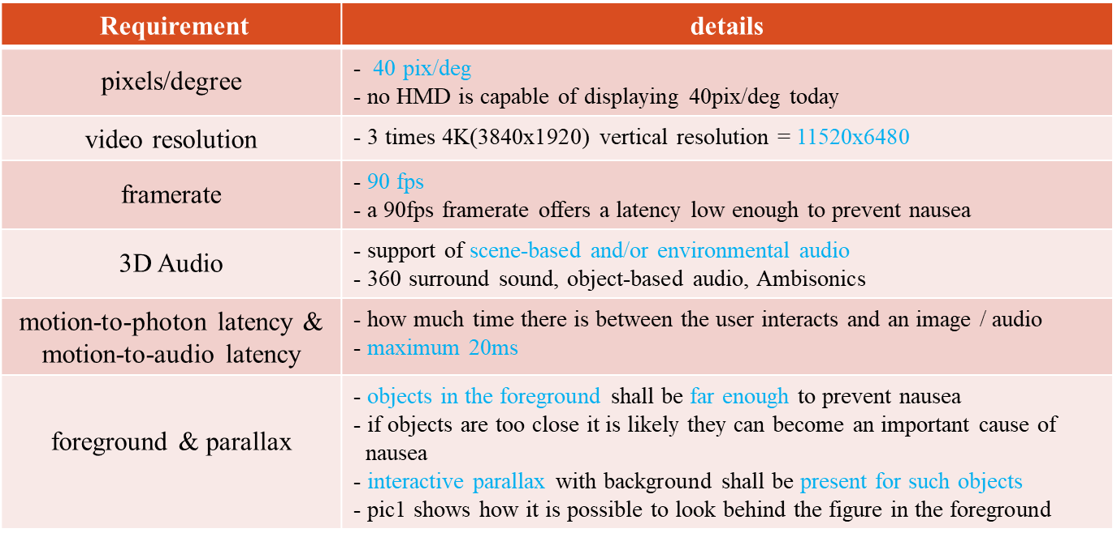
For the purpose of discussing the network requirements, this white paper focuses on the motion-to-photon latency. Some of the other requirements related to the motion-to-photon latency include video resolution and frame rate.
- Types of VR HMD
  - Motion-to-Photon Latency Diagrams
In today’s world of VR industry, there are two types of VR HMDs – standalone type and display type. In the future, there may exist more types but for now, we are focusing on what is available in the market today.
    - Stand-alone type
The standalone type is where the local content server is actually embedded in the HMD itself. Hence, the data processing unit actually exists in the HMD and creates very minimal latency when the data traverse in the VR system. The arrows in the diagram below represent the places where the motion-to-photon latency exist.
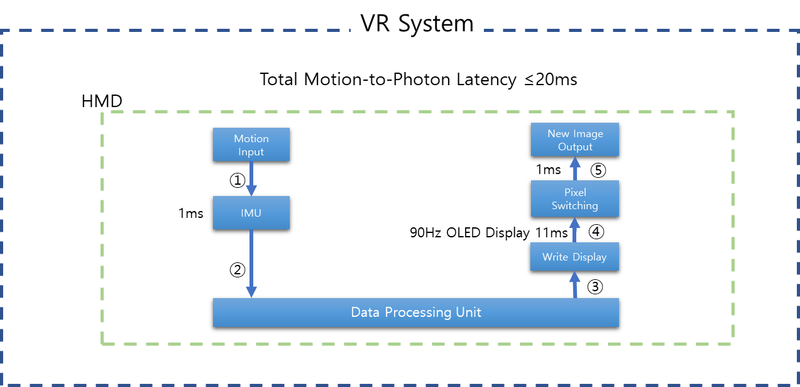
Since all connections that may create latency are embedded in the system, no network latency can be considered in this case.
    - Display type
The display type is where the local content server is actually outside of the HMD. The data processing unit may be connected to HMD via LAN or WAN and may create various latency when the data traverse in the VR system. The arrows in the diagram below represent the places where the motion-to-photon latency exist.
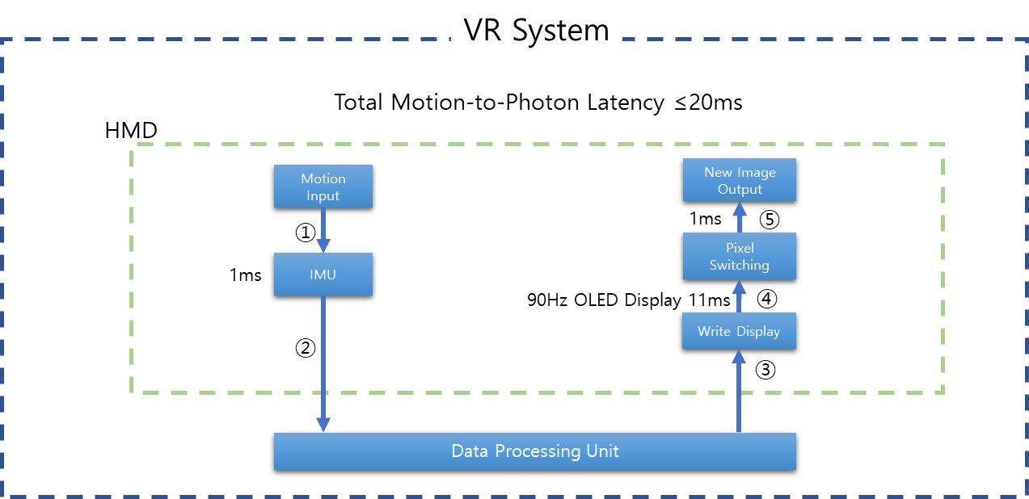
Network latency may occur at the connection points 2 and 3.

