Project | IEEE 802.21 Working Group for Media Independent Services  <http://www.ieee802.org/21/>
Title | White Paper for Network Enablers for seamless HMD based VR Content Service
DCN | 21-18-0029-02-0000
Date Submitted | June 19, 2018
Source(s) | Dongil Dillon Seo dillon@volercreative.com (VoleRCreative),  Sangkwon Peter Jeong ceo@joyfun.kr (JoyFun Inc.),  Minseok OH msoh@kgu.ac.kr (Kyonggi University)  Namgi KIM ngkim@kgu.ac.kr (Kyonggi University)
Re: | IEEE 802.21 Session #86 in San Diego, California, USA
Abstract | This document describes the use cases and technical requirements to be considered by the 802.21 group to address handovers with HMD based VR Services.
Purpose | Working Group Discussion for white paper
Notice | This document has been prepared to assist the IEEE 802.21 Working Group. It is offered as a basis for discussion and is not binding on the contributing individual(s) or organization(s). The material in this document is subject to change in form and content after further study. The contributor(s) reserve(s) the right to add, amend or withdraw material contained herein.
Release | The contributor grants a free, irrevocable license to the IEEE to incorporate material contained in this contribution, and any modifications thereof, in the creation of an IEEE Standards publication; to copyright in the IEEE’s name any IEEE Standards publication even though it may include portions of this contribution; and at the IEEE’s sole discretion to permit others to reproduce in whole or in part the resulting IEEE Standards publication. The contributor also acknowledges and accepts that IEEE 802.21 may make this contribution public.
Patent Policy | The contributor is familiar with IEEE patent policy, as stated in Section 6 of the IEEE-SA Standards Board bylaws <http://standards.ieee.org/guides/bylaws/sect6-7.html#6> and in Understanding Patent Issues During IEEE Standards Development http://standards.ieee.org/board/pat/faq.pdf

Introduction

In order to deliver a comfortable user experience, the HMD based virtual reality (VR) content need to satisfy certain conditions. A “comfortable user experience” can be defined in many ways but this paper defines it to be an experience where the user is not feeling any sickness during and/or after the experience. The VR experience is known to be very immersive as it produces very convincing visual and audio information. However, this immersive feeling often creates uncomfortable feelings known as cybersickness or VR sickness when the content fails to meet certain hardware and software design conditions. Such sickness makes people to stay away from using the VR HMD and hindering the industry to grow. Hence, it is important to understand the design requirements to minimize the sickness.
To provide more realistic visual quality, the VR HMD requires the use of a high-resolution display and fast refresh rate. Some of the published articles claim that the image resolution needs to be at least 4K and the display a refresh rate needs to be 90Hz or higher in order to minimize the VR sickness. Another important requirement is the motion-to-photon latency and it needs to be less than 20 ms to reduce the VR sickness.
To achieve the quantitative requirements stated above, this document presents some of the necessary network requirements with some of the use cases.
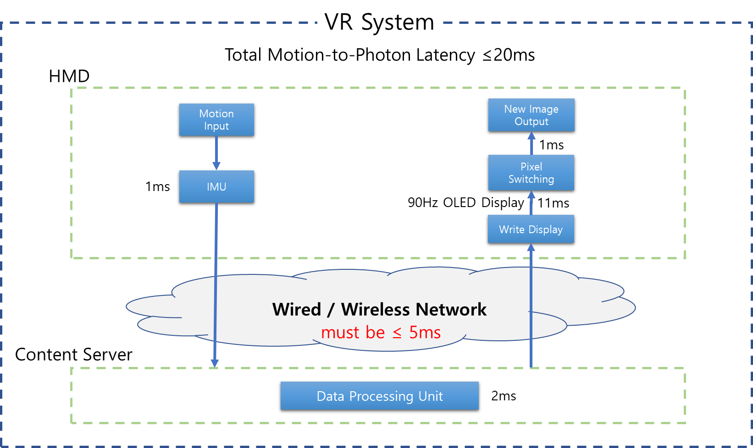

Overview

Purpose

The VR content provides its VR experience by using the HMD that displays two identical images from either a single panel display or two separate panels. It also provides spatial audio that corresponds to the user’s head movement. VR experience is very immersive and entertaining but often creates some discomfort when a sensory conflict between the eyes and the vestibular system occurs. Such discomfort, known as VR sickness, may cause symptoms like dizziness, stomach upset and headache. However, the level of intensity differs from a person to a person; hence, it is very difficult to completely remove VR sickness but it is possible to find a way to reduce or minimize it. Therefore, this whitepaper is presenting some of the network requirements that can help the user to feel minimal VR sickness when experiencing the VR content.

Scope

This whitepaper will examine the notions of motion-to-photon latency and motion-to-audio latency as they are known to affect the VR sickness. It is commonly known in the industry that the motion-to-photon latency needs to be less than 20 ms in order to minimize the VR sickness. This implies that there is a strong correlation between the time that needs for the human eyes to perceive the image data and the time that needs for the human brain to process the perceived image data.
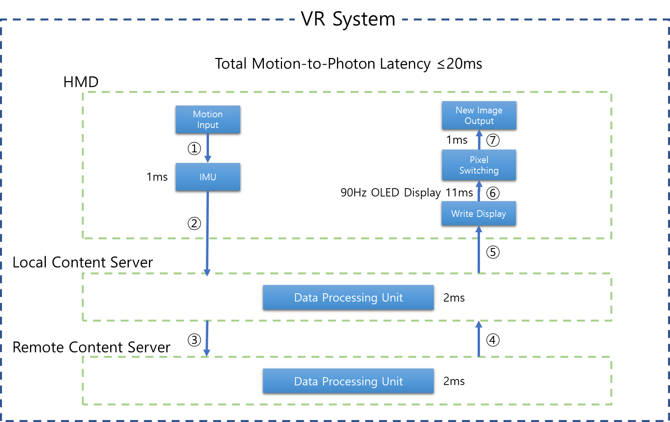
The diagram above illustrates that the time required to send the user movement information to the IMU (Inertial Measurement Unit) via USB cable is 1 ms. Then, this transferred user motion information is processed by CPU, GPU or AP in either the Local Content Server or Remote Content Server or both and reflected to the content. This data needs to run at 90 frames per second on the display panel and this translates to 11 ms of pixel switching time. The data contains 11,520 x 6,480 resolution and 40 pixels per degree; hence it is rather a big file and it takes 1 ms to be displayed in the HMD.
If we need to meet the 20 ms motion-to-photon latency requirement, only variables that we can control are the latency time in ②, ③, ④, and ⑤ since ①, ⑥, ⑦ are pretty much fixed constants. In other words, the fixed latency time is 13 ms (this is a summation of latency time from ①, ⑥, ⑦) and the data processing time requires 2 ms so the tolerable latency time that we need to manage is 5 ms. Hence, the network latency needs to be less than 5 ms in order to solve the VR sickness problem.

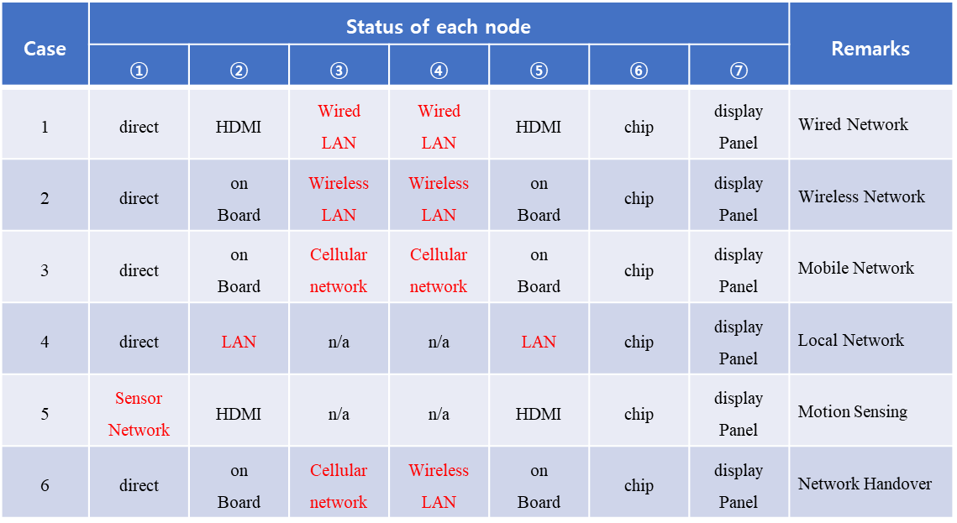
The table above is describing six possible situations where the network latency can affect the VR content service.
Case #1 describes a situation where the VR system is connected to a wired LAN. This usually can provide the fastest data transfer.
Case #2 describes a situation where the VR system is connected to a wireless LAN. In this case, the HMD supports the wireless network so the latency time in ② and ⑤ are negligible.
Case #3 is similar to Case #2 but it uses the cellular network instead of wireless LAN. In this case, the local content server is absent and the remote server is communicating with HMD directly.
Case #4 describes a situation where many HMDs are consuming the same content in the same local network. Therefore, no remote content server is required.
Case #5 describes a situation where the motion controllers used by the user to interact with the VR content are using the sensor network. In this case, the latency time between the motion controller sensors and motion detecting sensors need to be defined.
Case #6 describes a situation where HMD is connected to the remote content server via either wireless network or cellular network and network handover occurs.
In each of these six cases, the use case and technical requirements need to be defined for the network tolerable latency.

Definition

360 degree camera
A camera designed to capture 360 degree spherical surfaces.

4K Ultra High Definition
4K UHD
A term referring to high-definition resolution with a horizontal resolution in the order of 4,000 pixels

8K ultra high definition
8K UHD
A term referring to high-definition resolution with a horizontal resolution in the order of 8,000 pixels

accelerometer
A sensor for measuring linear acceleration or angular acceleration by measuring inertia-induced reaction.

angular resolution
A value of representing an interval between pixels of an image displayed by a HMD on the basis of an angle. The unit of measurement is PPD (Pixel Per Degree).

background complexity
The number of figures, colors, and sizes of objects, and the level of optical flow in background scene. The background complexity may have an effect on Cybersickness

binocular disparity
Difference in image location of an object seen by left and right eye images.

biomarker
A biomarker, or biological marker, generally refers to a measurable indicator of some biological state or condition.

body
A body frame that forms the overall shape of the HMD.

Constant Bit Rate encoding
CBR encoding
An encoding method that the rate at which a codec's output data is consumed constantly with respect to time.

chromatic aberration
An effect resulting from dispersion in which there is a failure of a lens to focus all colors to the same convergence point.

Contrast Ratio
CR
The ratio of the luminance of the brightest color (white) to that of the darkest color (black).

Controllability
The level of control over VR content, which can be either an active control experience or passive exposure to VR content. The more passive the VR experience is, the less controllability the user has.

Cybersickness
Psychological and physiological symptoms similar to those of motion sickness. Cybersickness symptoms include discomfort, stomach awareness, nausea, pallor, cold sweating, eye fatigue, and disorientation during or as a result of experiencing virtual environments, especially using head-mounted displays.

depth of field
The effective focus range or distance between the nearest and farthest objects in a moving scene used to ensure sharp images. Inadequet depth of field in rendered VR stereoscopic scene can cause the symptoms of VR sickness.

electroencephalogram
EEG
electrophysiological signals of the brain recorded noninvasively using electrodes placed along the scalp.

electrogastrogram
EGG
Electrophysiological signals of the stomach recorded using electrodes placed on the abominal skin.

electrocardiogram
ECG
Electrophysiological signals of the heart recorded over a period of time using electrodes placed on the skin.

exit pupils
The range of pupil size in the HMD.
In a general optical system, it refers to a hole through which the light exits, an exit hole seen from the direction in which the optical system is seen from the eye, or a hole through which the image can be formed by the lens behind the optical system.

extensible 3D
X3D
Royalty free ISO Standard for representing computer graphics.

eye dominance
The preference of processing visual input by the left or right eye.

eye relief
The distance between the eyepiece and the user’s eyes.

eye tracking
A technique to track the position of the eye by sensing the movement of the pupil.

fast motion sickness scale
FMS
The FMS represents only the lowest (0) and the highest (20) scores. Motion sickness symptoms are reported verbally every minute, including general discomfort, and stomach awareness.

field of view
FOV
The angular width of a screen that fills the user’s visual field. Angles indicate the range of horizontal, vertical, or diagonal directions over which the camera can hold an image through the lens.

fisheye lens
An ultra-wide angle lens with viewing angle over 100 degrees.

foam padding
A padding attached to the HMD to make the user feels more comfortable and to absorb any shock caused by any external impact.

foveated rendering
An upcoming graphics rendering technique which uses an eye tracker integrated with a virtual reality headset to reduce the rendering workload by greatly reducing the image quality in the peripheral vision (outside of the zone gazed by the fovea).

frame of reference
Referential objects (e.g., trees, clouds, and frames) that are stationary in a moving scene.
Other similar definitions include Visual Guide and Point of Reference.

frame per second
FPS
The number of images that can be processed per second.

Frame Rate
The amount of frames through a certain device or a transmission link per a fixed duration. The measurement unit is FPS.

full high definition
FHD
A term created for a marketing purpose and has 1920x1080 resolution.

galvanic skin response
GSR
One of the most sensitive markers of emotional arousal is galvanic skin response (GSR), also referred to as skin conductance (SC) or electro-dermal activity (EDA).

gyroscope
A sensor for measuring orientation and angular velocity.
It is also the term collectively refers to a device for measuring gravity using elastic deformation by gravity. In HMD, it refers to a gravity meter that works perpendicular to the center of the earth.

handover
The process by which an HMD obtains facilities and preserves VR content traffic flow upon change from one link to another.

haptic interface
An interface that recreates the sense of touch and sense of movement by applying forces, vibrations, or motions to the user.

head mounted display
HMD
A generic term for display devices that are attached to the head

head tracking
A technique in which tracks the rotational and translational movement of the HMD.

Inter-ocular distance
IOD
The distance between the ocular lens of HMD optical systems and eyes.

Interpupillary distance
IPD
The distance between the centers of the pupils of the left and the right eyes.

jitter
The deviation from true periodicity of a presumably periodic signal, often in relation to a reference clock signal.

line-of-sight propagation
LOS propagation
A propagating way of electromagnetic waves that travel in a straight line

magnetometer
A sensor for measuring magnetism – the direction, strength and relative change of a magnetic field at a particular location.

misery scale
MISC
A scale that measures cybersickness symptoms using a score between 0 and 10. The higher the MISC score reported, the more severe the cybersickness experienced.

motion blur
It is the apparent streaking of rapidly moving objects in a still image or a sequence of images such as a movie or animation.

motion feedback frequency
The frequency that an HMD sends collected data, mainly motion, to a VR server.

motion sickness
Psychological and physiological symptoms which are caused by discordinance between visually perceived movement and sense of bodily movement in the vestibular organs

motion sickness susceptibility questionnaire
MSSQ
Motion sickness susceptibility questionnaires, sometimes called motion history questionnaires, are useful instruments in the prediction of motion sickness due to a variety of provocative environments.

motion-to-audio latency
Time delay from the HMD user’s movement and the change of sound in HMD caused by the movement.

motion-to-photon latency
Time delay from the HMD user’s movement and the change of view in HMD caused by the movement.

nausea scale
A scale that measures a user’s symptoms of nausea using a score between 0 and 5. Nausea levels are reported verbally every minute.

network latency
Amount of time that information takes to traverse a system (or from one node to another node).

non-line of sight propagation
NLOS propagation
Radio transmissions across a path that is partially obstructed, usually by a physical object in the innermost.

number of motion axes
The number of directional and rotational factors of optical flow. This number influences the magnitude of cybersickness and motion sickness.

objective measurement
Quantification of the user’s behavioral and physiological changes. In the study of cybersickness, objective measures include the user’s magnitude of postural sway and physiological signals, such as measured by an electroencephalogram (EEG), electrogastrogram (EGG), or electrocardiogram (ECG) etc.

ocularity (monocular, binocular, biocular)
Type of optical systems used in the HMD determined by the number of video signals.When the video signal is delivered to one eye, it is called monocular. When two different video signals are delivered to both eyes, it is called binocular. When a single video signal is delivered to both eyes, it is called biocular.

optical distortion
Distortion occurred by the optical system – often the distorted image is in a barrel or pincushion shape depending on the system.

optical flow
Apparent visual motions of objects, surfaces, and edges which are relative visual movements between the observer and a scene.

packet error rate
PER
The number of incorrectly received packets divided by the total number of received packets.

photoplethysmography
PPG
An optical measurement technique that can be used to detect blood volume changes in the microvascular bed of tissue.

pixel per inch
PPI
A measurement of the pixel density of an electronic image device such as a computer monitor or television display.

polygon per second
PPS
The number of polygons that can be processed per second.

positional tracking
A technique in which tracks the rotational and translational movement of all objects including head mounted display (HMD), controllers and peripheral devices.

postural stability
The ability to maintain balance using the muscles in your ankles, knees, and hips in response to movement. Postural stability decreases with fatigue, particularly in the knees and hips.

postural sway
A means of detecting and predicting the magnitude of motion sickness and cybersickness. The more users experience symptoms of an illness, the more unstable their postural will be. It has been well established that when users experience severe cybersickness, the center of pressure against the gravity axis moves more.

postural sway
The sense of the positions and movements of a person’s own limbs and trunk, plus the strength employed in such movements.

reality-virtual continuum
The level of mixture of real and virtual objects presented in display devices. Real environments are situated at one end of the continuum, and virtual environments are at the other end of the continuum.

reference object
A visual scene or component that provides stationary location or orientation cue, and which matches the vestibular signal.

refresh rate
The number of pictures that can be processed by the imaging device at one time. The measurement unit is Hz (Hertz)

response time
It is the amount of time a pixel in a display takes to change (It is measured in milliseconds (ms)).

sensory conflict theory
A working hypothesis to explain the physiological mechanism of motion sickness and cybersickness. Sensory disparity between the visual and the vestibular systems can induce symptoms of motion sickness and cybersickness.

sensory mismatch
The discrepancy between different sensations related to orientation and movement, especially from the visual and the vestibular organs, which causes motion sickness and cybersickness (VIMS, simulator sickness etc.).

simulator sickness
Psychological and physiological symptoms similar to those of motion sickness, typically experienced by pilots and drivers who receive simulator training.

simulator sickness questionnaire
SSQ
A standard questionnaire used to measure the magnitude of simulator sickness symptoms.

six degrees of freedom
Six operating elements of a moving object in three dimensional space.
6DOF can be used to describe rotational movements (roll, pitch, yaw) and translational movements (forward/back, left/right, up/down)

spatial 3D sound
A technology that allows the user to identify the location of a sound source where sound is generated. In conjunction with head tracking of HMD, the sound is generated relative to the head direction.

spatial velocity
The velocity of virtual scene movement which represents the speed of the scene movement.

speed of VR content
One of the factors of optical flow. The faster the speed of an object, the larger the measurement of the optical flow.

stereoscopy
Three-dimensional vision with the illusion of depth from two-dimensional images using the visual difference of both eyes.

stitch
Technique to combine two or more videos to create 360 degree video and minimize the image distortion.

subjective measurement
Quantification of the user’s subjective experiences. In the study of cybersickness, subjective measures include scores on the Simulator Sickness Questionnaire (SSQ), Nausea scale, Fast motion sickness scale (FMS), and Misery scale (MISC) etc.

subjective visual vertical
An indicator of impaired sense of spatial orientation. It is determined by having subjects adjust a visible luminus line in complete darkness to what they consider to be upright, earth vertical.

three degrees of freedom
3DOF
Three rotational elements of moving objects in three dimensional space.
Means the roll (x axis), pitch (y axis), and yaw (z axis) rotation operations on X, Y and Z axes.

time warping rendering
A technique in VR that warps the rendered image before sending it to the display to correct for the head movement occurred after the rendering. It is either used to reduce the latency or maintain the desired frame rate.

tracking sensor
A device for tracking the movement of the user to synchronize with the content

ultra high definition
UHD
A term created for a marketing purpose and has at least 3840x2160 resolution.

variable bit rate encoding
VBR encoding
An encoding method, as opposed to the CBR encoding, that the rate at which a codec's output data is consumed inconsistantly with respect to time.

vection
Visually induced illusions of self-motion experienced by physically stationary observers in real environment or in virtual environment.

vestibular system
The sensory system that provides a sense of bodily movement and balance. It also provides the spatial orientation for the purpose of coordinating movement.

vestibulo-ocular reflex
VOR
A reflex, where activation of the vestibular system causes eye movement.

video tracking
It is a computer vision technology for finding the position change of a specific object such as a person, an animal, or a car in a video shot by a camera.

viewing angle
The maximum side angle at which a normal screen can be seen on the display device.

virtual reality (VR)
It refers to any specific environment, situation or technology itself that either simulates the actual reality or creates the virtual spaces and objects according to the imagination of human beings by using computer graphics or videos.

virtual reality (VR)
Same as Cybersickness

visually induced motion sickness
VIMS
Sensations and perceptions similar to traditional motion sickness with limited or no physical movement.

VR fidelity
The level of similarity in sensation and perception between real and virtual environments.

VR sickness
Another term for cybersickness

wireless HMD access distance
The distance from the VR content server wireless module to the HMD wireless module, and within that distance the VR HMD should display without severe interruption.

Use Cases of HMD based VR Services

High performance Bandwidth

Classification of user

User | User’s role
Player | - Playing VR content

Use Case Summary

Cases | Descriptions | Remarks
1 | A content server not in the same LAN is connected to an HMD through a series of wired networks | Wired Network
2 | A content server not in the same LAN is connected to an HMD through a series of wired networks with a mobile network as the last hop to the HMD | Mobile Network
3 | A content server not in the same LAN is connected to an HMD through a series of wired networks with a Wi-Fi network as the last hop to the HMD | Wireless Network
4 | Sensor signals composed of mainly user movements are collected by an HMD | Motion Sensing
6 | A content server in the same LAN is connected to an HMD through a LAN, which is either wireless or wired. (need to correct a diagram below) | Local Network
5 | Switching between heterogenous networks while using content service via wireless network | Network Handover

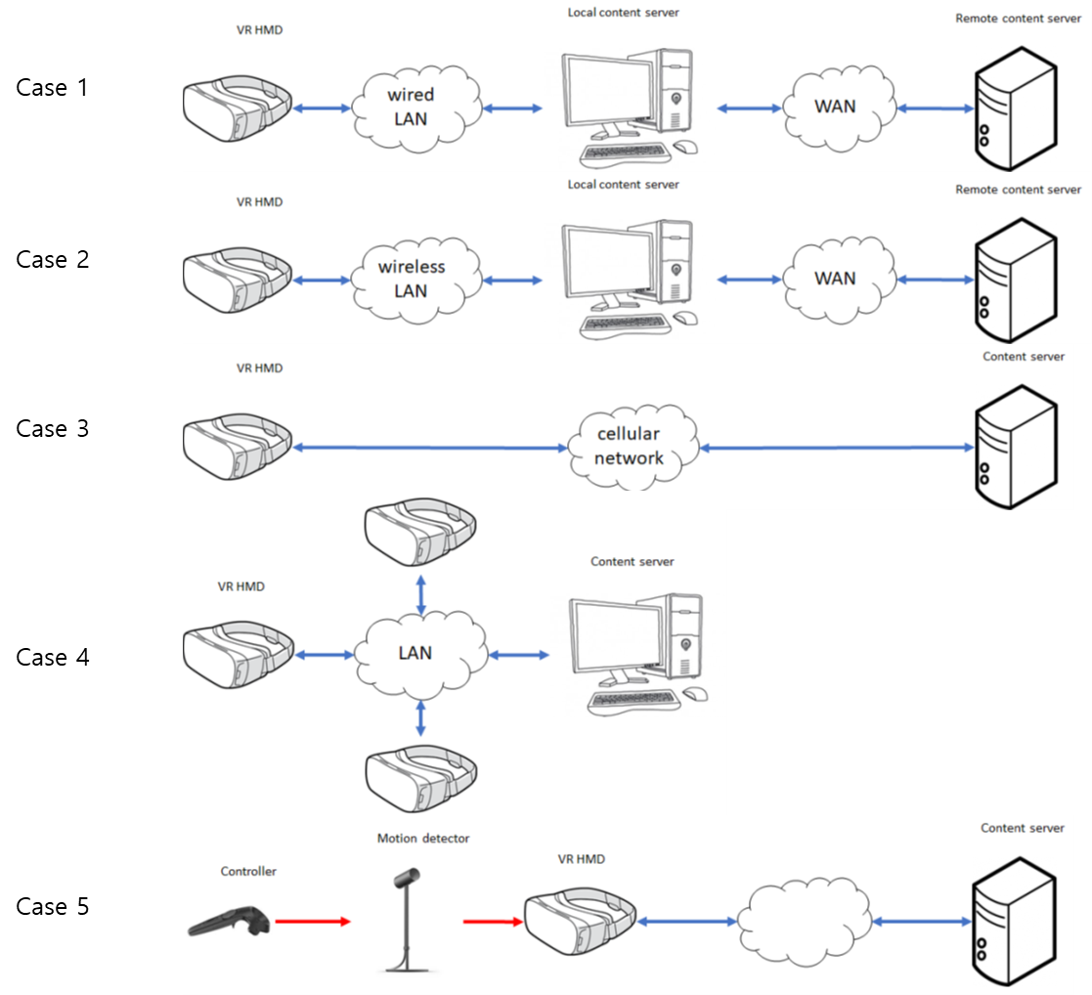

Use case 1

Use case name

Wired Network

Overview

A VR content server is not located in the same LAN as a VR HMD. The VR content is delivered through a wired connection such as HDMI and DisplayPort from a PC console which communicates with the VR content server over a series of wired networks, and the VR HMD is equipped with associated wired interface. The control signals from the HMD are sent back through the PC console to the VR content server which is not in the same LAN.

Related actor

The user(s) receiving the virtual reality content from the same content server located remotely,

Pre-condition

A VR HMD is connected to a terminal such as PC or console gaming device via wired network to reduce the motion-to-photon latency in multi-party communication between users, and the wired connection is used to control a high-performance HMD for VR service. The high-performance HMD may be equipped with a processing unit and a control management module.

Event Flow

- A user is connected to the VR content server using his/her PC connected to a network.
- Other users located remotely are connected to the same VR content server using their own PC connected to a network.
- All users consume the interactive VR content remotely located on the same VR content server.

Post-condition

- All users are having a good VR user experience without cybersickness while they are consuming the content on the server.

Requirements

Functional Requirements

Conditions | Requirements | Remarks
Distance between users | Unlimited
Video Quality | Stereoscopic 3D 4K | HDMI 2.0
HMD Movement | Neck Roll | 0.17 (s/60deg)
 | Neck Pitch | 0.14 (s/60deg)
 | Neck Yaw | 0.13 (s/60deg)
User Motion Recognition | Through motion sensors | Wired/Wireless
Device Mobility | Almost none
Response Time | Less than X ms

Non-functional Requirements

- No users can affect the network speed in the user’s local network. (???)

Use case 2

Use case name

Mobile Network

Overview

A VR content server is not located in the same LAN as a VR HMD. The VR content is delivered through a mobile network such as an LTE or a 5G network and the VR HMD is equipped with the associated mobile radio interface. The control signals from the HMD are sent back to the VR content server via the mobile network.

Related actor

May or may not have one. If there is one, it will the same as the Use case 1.

Pre-condition

A user is connected to a virtual reality content server through wireless Internet and experiencing the virtual reality content with a HMD while travelling at a high speed. In order to connect to the wireless Internet, the HMD is equipped with a high-speed communication module or a smart phone capable of high-speed mobile communication.

Event Flow

- The user is consuming the virtual reality content from the content server using a HMD connected to the mobile network.
- The user uses the communication module of the HMD to use the content or service in the remote server through the mobile communication repeater.

Post-condition

- All users are having a good VR user experience while they are consuming the content on the server.

Requirements

Functional Requirements

Conditions | Requirements | Remarks
Video Quality | Stereoscopic 3D 4K | HDMI 2.0
HMD Movement | Neck Roll | 0.17 (s/60deg)
 | Neck Pitch | 0.14 (s/60deg)
 | Neck Yaw | 0.13 (s/60deg)
User Motion Recognition | Through motion sensors | Wired/Wireless
Device Mobility | Unlimited
Response Time | Less than X ms

Non-functional Requirements

- No users can affect the network speed within the user’s repeater. (???)

Use case 3

Use case name

Wireless Network

Overview

A VR content server is not located in the same LAN as a VR HMD. The VR content is delivered through wireless LAN, for example, IEEE 802.15.3 and IEEE 802.11ax, from a PC console which communicates with the VR content server over a series of wired networks, and the VR HMD is equipped with the associated wireless interface. The control signals from the HMD are sent back through the PC console to the VR content server which is not in the same LAN.

Related actor

May or may not have one. If there is one, it will the same as the Use case 1.

Pre-condition

The user is using an HMD to connect to a server providing a VR service through wireless Internet indoors. In order to wirelessly connect to an indoor access point (AP), the HMD is equipped with a high-speed Ethernet module.

Event Flow

- The user is consuming the virtual reality content from the content server using a HMD connected to the wired network.
- The user uses the Ethernet communication module of the HMD to use content or service on the remote server through the indoor AP.

Post-condition

- All users are having a good VR user experience while they are consuming the content on the server.

Requirements

Functional Requirements

Conditions | Requirements | Remarks
Video Quality | Stereoscopic 3D 4K | HDMI 2.0
HMD Movement | Neck Roll | 0.17 (s/60deg)
 | Neck Pitch | 0.14 (s/60deg)
 | Neck Yaw | 0.13 (s/60deg)
User Motion Recognition | User Controllers | Wired/Wireless
Device Mobility | Pedestrian walking speed | Less than 4 km/hr
Response Time | Real Time

Non-functional Requirements

- No users can affect the network speed within the user’s wireless network AP (Access Point).

Use case 4

Use case name

Sensor Network (proper name?)

Overview

The control signals from a VR HMD may be sent through a PC console or directly to the VR content server whether it is located in the same LAN or not. If a PC console is used, the connection between the HMD and the PC console may be either wireless or wired.

Related actor

May or may not have one. If there is one, it will the same as the Use case 1.

Pre-condition

It is directly connected to a terminal such as a PC or a console game device and can use and control a high-performance HMD (HMD) for VR service. The high-performance HMD is equipped with all kinds of media content, processing unit and control management module that the user desires. The high-performance HMD is equipped with a sensor or sensors for sensing and analyzing all of the user movements. The sensor and the HMD or the sensor and the terminal (HMD connected to D2D) are connected to the sensor network. (???)

Event Flow

- Various types of sensors such as IrDA or Laser are sensing the user’s motion.
- Sensors are using the LAN such as Bluetooth or Zigbee to transfer the detected motion data to the HMD or the terminal with HMD connected.
- All users play motion-responsive content (eg social content such as games and movies connected to networks) using the HMD and the controller connected to the terminal for VR service.
- Users can be in the same space or separated by a long distance.
- A user is responding to another user’s response.
- All users respond relatively to each other's actions.

Post-condition

- All users are having a good VR user experience while they are consuming the content on the server.

Requirements

Functional Requirements

Conditions |  | Requirements | Remarks
Distance between the HMD and the Sensor |  | Less than 5 m | Depends on the Local Area Network module performance
Video Quality |  | Stereoscopic 3D 4K | HDMI 2.0
HMD Movement |  | Neck Roll | 0.17 (s/60deg)
 |  | Neck Pitch | 0.14 (s/60deg)
 |  | Neck Yaw | 0.13 (s/60deg)
Sensor Network | Distance | 10 m
 | Speed | Maximum 50 Mbps | Bluetooth 5.0
User Motion Recognition |  | Use Controller | Wired/Wireless
Device Mobility |  | None
Response Time |  | Real time

Non-functional Requirements

- The sensors measuring the user’s motion is not interfered with other sensors.

Use case 5

Use case name

Local Area Network

Overview

A VR content server is located in the same LAN as a VR HMD. The VR content in the content server is delivered through either a wired or a wireless connection to the VR HMD. The control signals from the HMD are sent back to the VR content server directly.

Related actor

None

Pre-condition

A high-performance HMD is wirelessly connected to a terminal such as a PC or a console game device by a local area high speed communication module. The high-performance HMD is equipped with all kinds of media content, processing unit and control management module that the user desires.

Event Flow

- Two users are consuming the virtual reality content using the HMD connected to the LAN or the HMD connected to the client.
- This HMD or the client are providing virtual reality content by exchanging the data locally between the HMD and the client.
- The user uses the communication module of the HMD to use the content or service in the remote server through the mobile communication repeater.

Post-condition

- No users can affect the network speed within the user’s wireless network AP (Access Point). (???)

Requirements

Functional Requirements

Conditions |  | Requirements | Remarks
Distance between the HMD and the Terminal |  | Less than 5 m | Depends on the wireless module capability
Video Quality |  | Stereoscopic 3D 4K | HDMI 2.0
HMD Movement |  | Neck Roll | 0.17 (s/60deg)
 |  | Neck Pitch | 0.14 (s/60deg)
 |  | Neck Yaw | 0.13 (s/60deg)
Local Area Network | Distance | 0.1m~10m | DLNA / Miracast
 | Speed | Maximum 5GHz | DLNA / Miracast
User Motion Recognition |  | Use controller | Wired/Wireless
Device Mobility |  | Pedestrian speed | Less than 4 km/hr
Response Time |  | Real time

Non-functional Requirements

- No users can affect the network speed within the user’s wireless network AP (Access Point).

Use case 6

Use case name

Network Handover

Overview

The users consuming the virtual reality content should be able to use the service without any network disconnection within the wireless and the mobile network. To satisfy this condition, the VR HMD should have a wireless ethernet and mobile network modem and it should be able to choose the network that provides the higher bandwidth and the network performance. When the connect network becomes weak, then it should be able to switch the network that provides the better condition.

Related actor

May or may not have one. If there is one, it will the same as the Use case 1.

Pre-condition

- The HMD is equipped with both wireless ethernet and mobile network modem.
- A user is connected to a server with VR service via wireless Internet using the HMD while he is travelling. The HMD is equipped with both high speed communication and Ethernet modules to connect to wireless Internet or a smart phone with various communication capabilities.

Event Flow

- The user is using the HMD with both wireless ethernet and mobile network modem and consuming the virtual reality content while travelling.
- The user environment has a high-performance Wi-Fi AP providing enough bandwidth and performance to provide good virtual reality user experience and the HMD is connected to this AP.
- The user is travelling and the HMD is moving away from this high-performance Wi-Fi AP. No other Wi-Fi AP is detected nearby
- The user’s VR HMD stops searching for the Wi-Fi AP and connected to the mobile network providing good bandwidth and network performance.
- The user uses the communication module of the HMD to use the content or service in the remote server through the mobile communication repeater.

Post-condition

- All users are having a good VR user experience while they are consuming the content on the server and no network disconnection occurs either in wireless or mobile network.

Requirements

Functional Requirements

Conditions | Requirements | Remarks
Video Quality | Stereoscopic 3D 4K | HDMI 2.0
HMD Movement | Neck Roll | 0.17 (s/60deg)
 | Neck Pitch | 0.14 (s/60deg)
 | Neck Yaw | 0.13 (s/60deg)
User Motion Recognition | Use controller | Wired/Wireless
Device Mobility | Unlimited
Response Time | Real time

Non-functional Requirements

- When the network handover occurs, the network bandwidth should still be enough to provide the virtual reality content service.

Scenario

Case 1 (Wired)

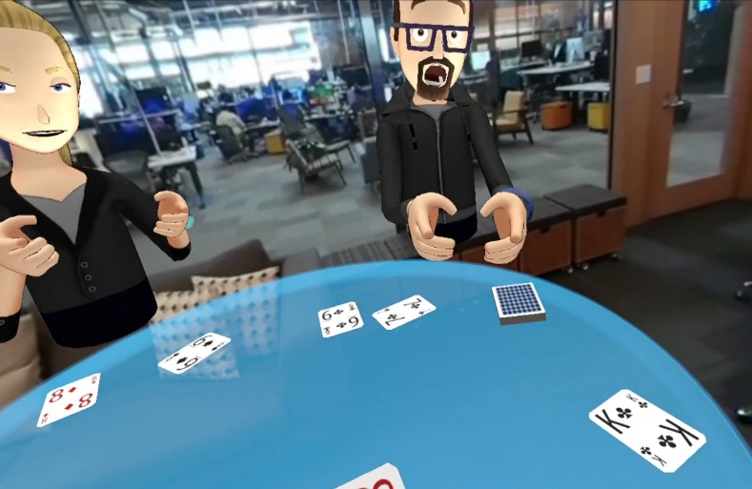
User A is wearing a wired HMD at home in California, USA and playing poker with his friends - user B, C, and D in VR. User B lives in Boston, USA, User C lives in Moscow, Russia, and User D lives in Tokyo, Japan, and they love to play poker together.

In order to create a VR environment that gives a good user experience without experiencing motion sickness, it requires a high resolution and big size 360-degree images and takes less than a 20 ms response time to all moving images. Therefore, it is necessary that the network speed of 10 Gbps or more is required for the HMD to recognize the action of the user, transmit it to the PC, and then the PC transmits the action information to the counterpart via the network and displays the reaction in real time.

Case 2 (Mobile Network)

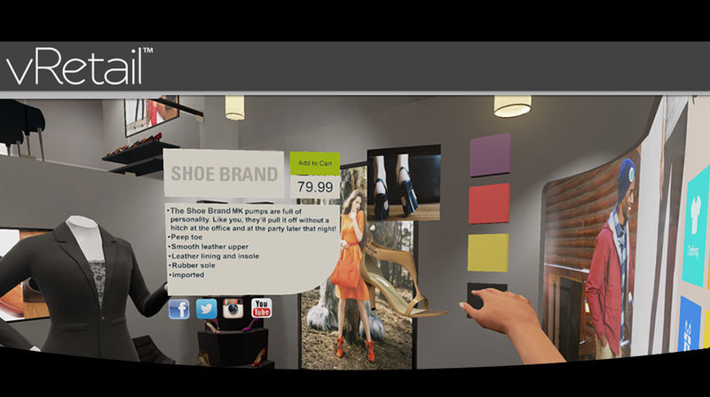
While User E rides the bus to the meeting place to meet his friend, she is watching the clothes she saw at the department store yesterday and doing VR shopping to make the purchase. VR is more realistic than online shopping malls because it gives the user the feeling that she is actually seeing things. Especially, the ability to unfold and view the clothes in three dimensions provides very important information when she selects the clothes.
At this moment, in order to express the detailed texture and the pattern of the clothes, it certainly requires a high resolution and big size images and also the response time to the change of images needs to be less than 20 ms to reflect the action in real time without feeling motion sick. Therefore, in order for the HMD to recognize the user's actions, send them to the PC, and then the PC needs to transmit the action information to the other party through the network in real time, the wireless network speed of 10 Gbps or more is required

Case 3 (Wireless Ethernet Telecommunication)

User F is from London, UK, user G is Bundang, Korea and user H is from Rio, Brazil. They all want to attend the meeting I. However, the user G urgently needs to deal with an important work from his company at the same time the meeting is scheduled but cannot miss the meeting either. To solve this dilemma, user G uses a VR HMD connected to the wireless Ethernet telecommunication to attend the meeting virtually while working on the company work. This was all possible because of the HMD mobility and the high-performance wireless Ethernet communication was possible.

Case 4 (Sensor Network)
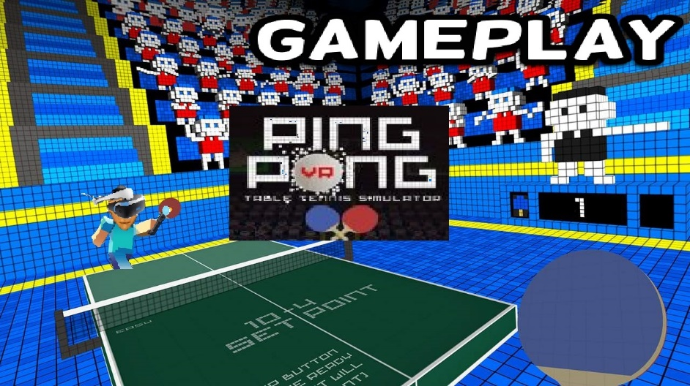
Table tennis is a very fast-paced game. User J likes to play table tennis in VR with user K, a girlfriend. In order for the user J and K to play games in VR, they must recognize the user's actions around the sensor and transmit the recognized information to the PC through the sensor network. Then, the PC computes the reaction information and transmits it back to the user's HMD display through the sensor network. The network delay time generated in this process should be almost none and it should work in real time.

Case 5 (Local Area Network)
User L is wearing a HMD at home in Busan, Korea and is dating with user M, his girlfriend, while looking at the Eiffel Tower in Paris' Marsei Square all in VR. User L's HMD is not a high-performance HMD, so it cannot render images in real time. However, the terminal he uses is capable of processing the image information very fast via the wired network. Since the QoS can be satisfying as long as the local area network speed for transmitting video, sound, and motion recognition information is fast enough, the user L is using the HMD which supports DLNA or Miracast to enjoy this happy date with user M.

Case 6 (Handover)

The HMD of the VR service user N is a smartphone-mounted HMD having both a high-speed mobile network module and a wireless Ethernet network module. User N is watching a movie using HMD in the bus. The bus route has a lot of Wi-Fi sections, but some sections do not have Wi-Fi. The user N uses his smartphone network setting to connect the wireless Ethernet network first and then connect to the mobile network. In other words, his HMD connects to Wi-Fi when it is available and connects to the mobile network when it is not available. In such situation, heterogeneous network handover occurs between the Wi-Fi and the wireless mobile network. During this network handover, the performance change may happen between the high-speed network and the low-speed network. This performance difference may prevent the data to be transferred reliably and may create a very uncomfortable situation, such as a nausea. In particular, when a heterogeneous network handover occurs in which network performance is significantly different, the data cliff phenomenon as shown in Figure 1 occurs.
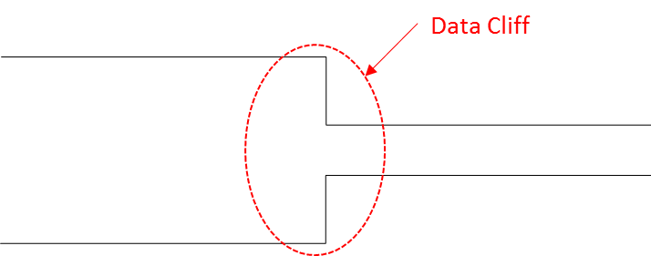
(Figure 1: Occurrence of data cliff between the heterogeneous networks)

In the process of transmitting the image file constructed as shown in Figure 2, there is a high possibility that the 'Movie Header' file containing the configuration information of the entire file is lost when the data cliff occurs. If the 'Movie Header' is lost, it is impossible to restore the whole image file even if another file is transferred.

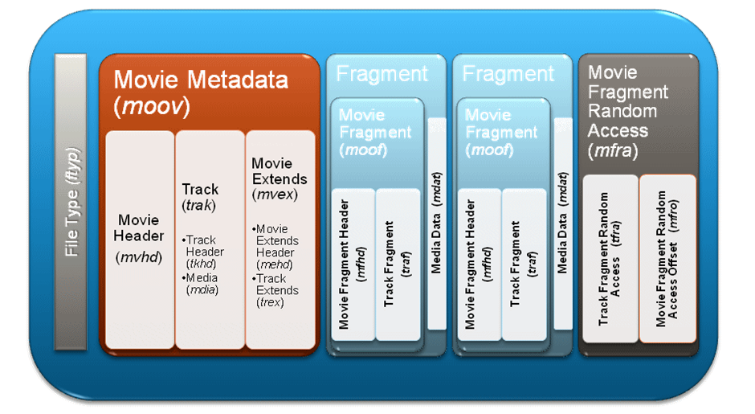
(Figure 2: Structure of movie file)

If the data cliff situation as described above occurs, the user cannot expect a good user experience, and may fail to receive the video service itself.

(Figure 3: Continuous Network Handover between heterogenous networks avoiding data cliff)

If the data cliff can be managed in the handover interval as shown in Figure 3, the user experience may not significantly improve but it will improve some and prevents the data transfer failure.

Network Requirements

Functional Level

Average throughput

In order to transfer the 11,520 x 6,480 resolution 360 degree image with 40 pixels per degree in 90 frames per second to 120 frames per second, the average throughput needs be 10 Gbps minimum and 20 Gbps maximum.

Link Speed and Bandwidth

The requirement is identical to average throughput.

Transmission Latency

It is known that the motion-to-photon and motion-to-audio latency in a VR system needs to be less than 20 ms. To meet this condition, the tolerable latency within the network should be less than 5 ms.

Quality of Experience (QoE)

The table below is from the presentation made by Technicolor during the 116th MPEG meeting in October, 2016. The table shows the technical requirements needed to minimize the VR sickness.
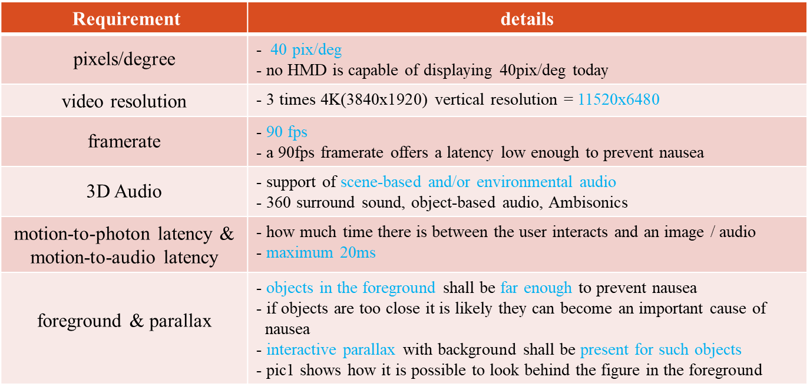
In this table, this whitepaper would like to discuss the motion-to-photon and motion-to-audio latency. The pixels/degree, video resolution and framerate are important factors to consider when we are discussing this latency.

Mobility

Case #2, #3 and #6 need to consider the mobility. Especially when the handover occurs, the packet loss caused by the sudden change of bandwidth should be prevented at all cost as it can create the VR sickness.

System Level

Operational Band

Density of Deployment

Indoor

Outdoor

Recommendation

High performance Bandwidth

Wired environment

The transfer speed of LAN used in Case #1 and Case #4 are very fast compared to the wireless LAN or cellular network. However, it still has a fixed latency. To provide an optimal VR user experience, the image that has 11,520 ⅹ 6,480 resolution with 40 pixels per degree and in 360 degree needs to run at 90 frames per second. In order to achieve this, over 10 Gbps bandwidth is required.

A high-speed wired network of 10 Gbps or more is required to transmit a large amount of data so that users of HMD-based virtual reality content have a good user experience.

Mobility environment

Case #2, #3 and #6 are considered if the user with HMD on would like to freely move around. In this case, it requires over 10 Gbps bandwidth.

Sensor network environment

As in Case #5, the motion controller input is the first section where it generates a latency.

In the HMD where the virtual reality content is served, the WPAN is used as a network between the HMD and the surrounding sensors. These sensors do not use high capacity data, but they should transmit state information of user or user environment to HMD, PC and Console at high speed. This is because latency occurs in the transmission interval of the sensor information, and this small latency can cause the user to feel uncomfortable in virtual reality.

Handover

In a heterogeneous wireless network environment, when handover occurs, the delivery of content data should occur seamlessly. In particular, when a handover occurs from a high-performance bandwidth to a low-performance bandwidth, header packets containing content information should not be lost (lost).

Conclusion

We know that HMD-based virtual reality service will be one of the most influential technology for the future industry. Many evidences are being observed from various areas. However, building the network environment, which is the core of the HMD-based virtual reality service infrastructure, will be a high enabler to accelerate the future, promote future content industry and create a better human life.

Therefore, it is necessary to establish standards for network-related infrastructures such as wired, wireless, and handover, and to promote industrial development through diffusion of core technologies.

It is very meaningful work for IEEE 802 to solve this problem and lead the future.

References

[1] https://www.quora.com/What-causes-the-picture-delay-when-I-move-my-head-around-when-wearing-Oculus-or-Gear-VR

[2] Technicolor during the 116th MPEG meeting in October, 2016

