Project | IEEE 802.21 Working Group for Media Independent Services  <http://www.ieee802.org/21/>
Title | Updates on Use cases and Network Requirements
DCN | 21-18-0025-00-0000
Date Submitted | May 09, 2018
Source(s) | Minseok msoh@kgu.ac.kr (Kyonggi University),  Dongil Dillon Seo dillon@volercreative.com (VoleRCreative),  Sangkwon Peter Jeong ceo@joyfun.kr (JoyFun Inc.)
Re: | IEEE 802.21 Session #85 in Warsaw, Poland
Abstract | This document updates the use cases and technical requirements to be considered with HMD based VR Services by clarifying the environments of each use case. The updates mainly focus on the “Overview” sections.
Purpose | “Network Enablers for seamless HMD based VR Content Service IG” discussion and acceptance
Notice | This document has been prepared to assist the IEEE 802.21 Working Group. It is offered as a basis for discussion and is not binding on the contributing individual(s) or organization(s). The material in this document is subject to change in form and content after further study. The contributor(s) reserve(s) the right to add, amend or withdraw material contained herein.
Release | The contributor grants a free, irrevocable license to the IEEE to incorporate material contained in this contribution, and any modifications thereof, in the creation of an IEEE Standards publication; to copyright in the IEEE’s name any IEEE Standards publication even though it may include portions of this contribution; and at the IEEE’s sole discretion to permit others to reproduce in whole or in part the resulting IEEE Standards publication. The contributor also acknowledges and accepts that IEEE 802.21 may make this contribution public.
Patent Policy | The contributor is familiar with IEEE patent policy, as stated in Section 6 of the IEEE-SA Standards Board bylaws <http://standards.ieee.org/guides/bylaws/sect6-7.html#6> and in Understanding Patent Issues During IEEE Standards Development http://standards.ieee.org/board/pat/faq.pdf

Introduction

The virtual reality contents using the HMD require various conditions in order to provide a good user experience. One of the most well-known cases is to reproduce the sense of sight and hearing from the virtual reality content to the user in order to avoid the sensory conflict. Therefore, it is necessary to provide the same visual and auditory information as the real world.
To make computer or camera generated image quality similar to the actual world image means that it requires a high-resolution display and strong rendering capability. It is also important to make the virtual reality audio to behave the same way it would behave in the real world in order to reduce the VR sickness caused by the sensory conflict. Some of the published articles claim that the image resolution needs to be at least 4K and the display a refresh rate needs to be 90Hz or higher in order to mimic the real-world movement. The audio information should also match with the user head movement. Another critical value is the motion-to-photon latency and it is said to be less than 20 ms to reduce the VR sickness caused by the sensory conflict.
To achieve the quantitative requirements stated above, this document presents some of the necessary network requirements by presenting some of the use cases under certain network types.

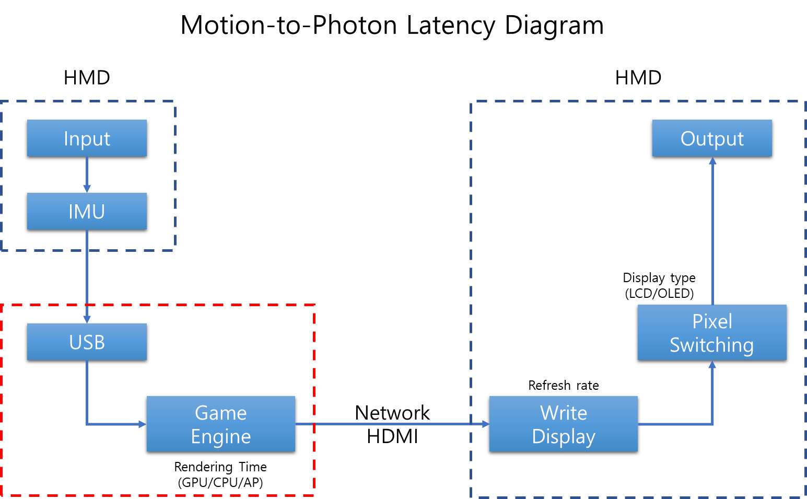

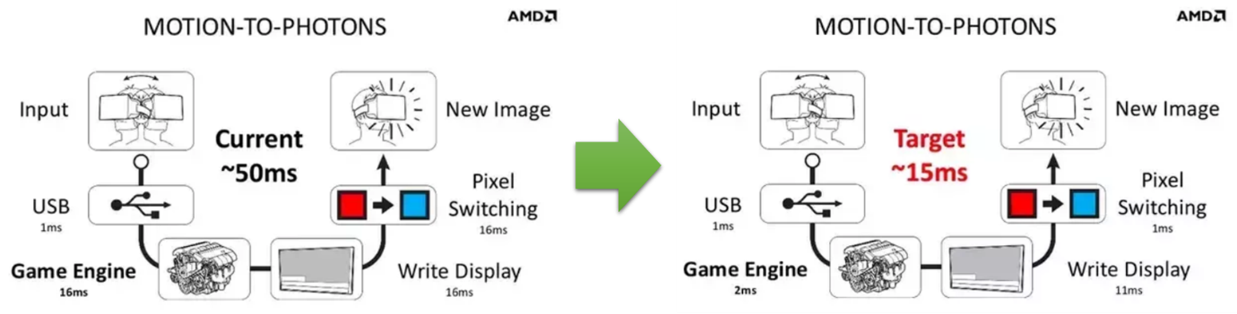

Overview

Purpose

This document presents detailed examples and scenarios for each network type, so they can be studied thoroughly to provide a guideline to define what network requirements are needed to provide a good virtual reality experience in HMD

Scope

This document will cover the following network types: Wired network, Wireless network, Mobile network, Local area network, Network handover and Sensory network used in motion sensing.
Use Case

Use case for Network

Classification of user

User | User’s role
Player | - Playing VR content

Use Case Summary

Cases | Descriptions | Remarks
1 | A content server not in the same LAN is connected to an HMD through a series of wired networks | Wired Network
2 | A content server not in the same LAN is connected to an HMD through a series of wired networks with a mobile network as the last hop to the HMD | Mobile Network
3 | A content server not in the same LAN is connected to an HMD through a series of wired networks with a Wi-Fi network as the last hop to the HMD | Wireless Network
4 | Sensor signals composed of mainly user movements are collected by an HMD | Motion Sensing
6 | A content server in the same LAN is connected to an HMD through a LAN, which is either wireless or wired. (need to correct a diagram below) | Local Network
5 | Switching between heterogenous networks while using content service via wireless network | Network Handover
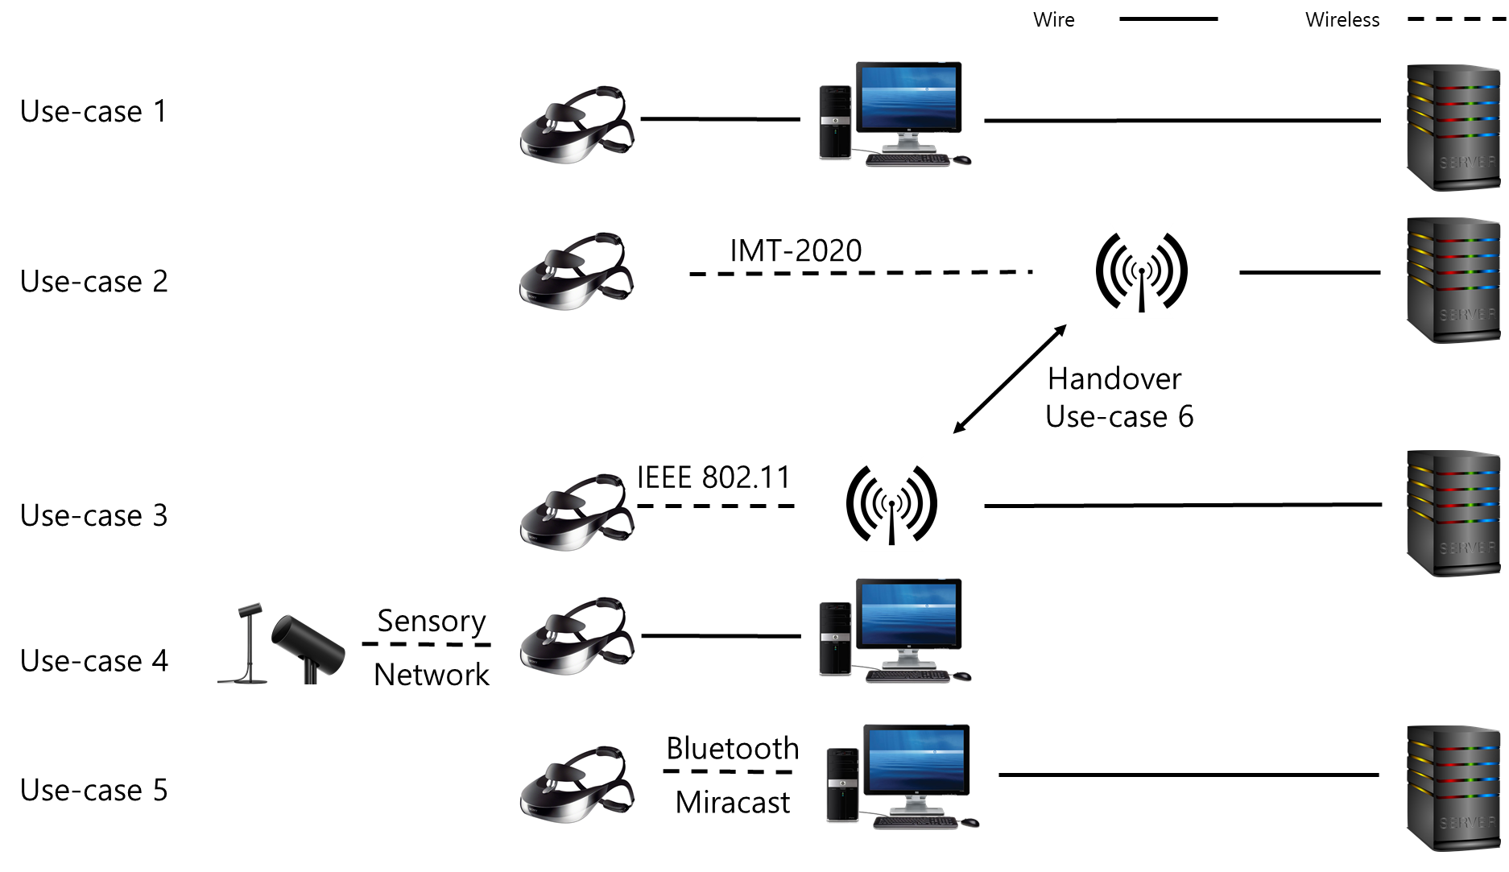

Use case 1

Use case name

Wired Network

Overview

A VR content server is not located in the same LAN as a VR HMD. The VR content is delivered through a wired connection such as HDMI and DisplayPort from a PC console which communicates with the VR content server over a series of wired networks, and the VR HMD is equipped with associated wired interface. The control signals from the HMD are sent back through the PC console to the VR content server which is not in the same LAN.

Related actor

The user(s) receiving the virtual reality content from the same content server located remotely,

Pre-condition

A VR HMD is connected to a terminal such as PC or console gaming device via wired network to reduce the motion-to-photon latency in multi-party communication between users, and the wired connection is used to control a high-performance HMD for VR service. The high-performance HMD may be equipped with a processing unit and a control management module.

Event Flow

- A user is connected to the VR content server using his/her PC connected to a network.
- Other users located remotely are connected to the same VR content server using their own PC connected to a network.
- All users consume the interactive VR content remotely located on the same VR content server.

Post-condition

- All users are having a good VR user experience without cybersickness while they are consuming the content on the server.

Requirements

Functional Requirements

Conditions | Requirements | Remarks
Distance between users | Unlimited
Video Quality | Stereoscopic 3D 4K | HDMI 2.0
HMD Movement | Neck Roll | 0.17 (s/60deg)
 | Neck Pitch | 0.14 (s/60deg)
 | Neck Yaw | 0.13 (s/60deg)
User Motion Recognition | Through motion sensors | Wired/Wireless
Device Mobility | Almost none
Response Time | Less than X ms

Non-functional Requirements

- No users can affect the network speed in the user’s local network. (???)

Use case 2

Use case name

Mobile Network

Overview

A VR content server is not located in the same LAN as a VR HMD. The VR content is delivered through a mobile network such as an LTE or a 5G network and the VR HMD is equipped with the associated mobile radio interface. The control signals from the HMD are sent back to the VR content server via the mobile network.

Related actor

May or may not have one. If there is one, it will the same as the Use case 1.

Pre-condition

A user is connected to a virtual reality content server through wireless Internet and experiencing the virtual reality content with a HMD while travelling at a high speed. In order to connect to the wireless Internet, the HMD is equipped with a high-speed communication module or a smart phone capable of high-speed mobile communication.

Event Flow

- The user is consuming the virtual reality content from the content server using a HMD connected to the mobile network.
- The user uses the communication module of the HMD to use the content or service in the remote server through the mobile communication repeater.

Post-condition

- All users are having a good VR user experience while they are consuming the content on the server.

Requirements

Functional Requirements

Conditions | Requirements | Remarks
Video Quality | Stereoscopic 3D 4K | HDMI 2.0
HMD Movement | Neck Roll | 0.17 (s/60deg)
 | Neck Pitch | 0.14 (s/60deg)
 | Neck Yaw | 0.13 (s/60deg)
User Motion Recognition | Through motion sensors | Wired/Wireless
Device Mobility | Unlimited
Response Time | Less than X ms

Non-functional Requirements

- No users can affect the network speed within the user’s repeater. (???)

Use case 3

Use case name

Wireless Network

Overview

A VR content server is not located in the same LAN as a VR HMD. The VR content is delivered through wireless LAN, for example, IEEE 802.15.3 and IEEE 802.11ax, from a PC console which communicates with the VR content server over a series of wired networks, and the VR HMD is equipped with the associated wireless interface. The control signals from the HMD are sent back through the PC console to the VR content server which is not in the same LAN.

Related actor

May or may not have one. If there is one, it will the same as the Use case 1.

Pre-condition

The user is using an HMD to connect to a server providing a VR service through wireless Internet indoors. In order to wirelessly connect to an indoor access point (AP), the HMD is equipped with a high-speed Ethernet module.

Event Flow

- The user is consuming the virtual reality content from the content server using a HMD connected to the wired network.
- The user uses the Ethernet communication module of the HMD to use content or service on the remote server through the indoor AP.

Post-condition

- All users are having a good VR user experience while they are consuming the content on the server.

Requirements

Functional Requirements

Conditions | Requirements | Remarks
Video Quality | Stereoscopic 3D 4K | HDMI 2.0
HMD Movement | Neck Roll | 0.17 (s/60deg)
 | Neck Pitch | 0.14 (s/60deg)
 | Neck Yaw | 0.13 (s/60deg)
User Motion Recognition | User Controllers | Wired/Wireless
Device Mobility | Pedestrian walking speed | Less than 4 km/hr
Response Time | Real Time

Non-functional Requirements

- No users can affect the network speed within the user’s wireless network AP (Access Point).

Use case 4

Use case name

Sensor Network (proper name?)

Overview

The control signals from a VR HMD may be sent through a PC console or directly to the VR content server whether it is located in the same LAN or not. If a PC console is used, the connection between the HMD and the PC console may be either wireless or wired.

Related actor

May or may not have one. If there is one, it will the same as the Use case 1.

Pre-condition

It is directly connected to a terminal such as a PC or a console game device and can use and control a high-performance HMD (HMD) for VR service. The high-performance HMD is equipped with all kinds of media content, processing unit and control management module that the user desires. The high-performance HMD is equipped with a sensor or sensors for sensing and analyzing all of the user movements. The sensor and the HMD or the sensor and the terminal (HMD connected to D2D) are connected to the sensor network. (???)

Event Flow

- Various types of sensors such as IrDA or Laser are sensing the user’s motion.
- Sensors are using the LAN such as Bluetooth or Zigbee to transfer the detected motion data to the HMD or the terminal with HMD connected.
- All users play motion-responsive content (eg social content such as games and movies connected to networks) using the HMD and the controller connected to the terminal for VR service.
- Users can be in the same space or separated by a long distance.
- A user is responding to another user’s response.
- All users respond relatively to each other's actions.

Post-condition

- All users are having a good VR user experience while they are consuming the content on the server.

Requirements

Functional Requirements

Conditions |  | Requirements | Remarks
Distance between the HMD and the Sensor |  | Less than 5 m | Depends on the Local Area Network module performance
Video Quality |  | Stereoscopic 3D 4K | HDMI 2.0
HMD Movement |  | Neck Roll | 0.17 (s/60deg)
 |  | Neck Pitch | 0.14 (s/60deg)
 |  | Neck Yaw | 0.13 (s/60deg)
Sensor Network | Distance | 10 m
 | Speed | Maximum 50 Mbps | Bluetooth 5.0
User Motion Recognition |  | Use Controller | Wired/Wireless
Device Mobility |  | None
Response Time |  | Real time

Non-functional Requirements

- The sensors measuring the user’s motion is not interfered with other sensors.

Use case 6

Use case name

Local Area Network

Overview

A VR content server is located in the same LAN as a VR HMD. The VR content in the content server is delivered through either a wired or a wireless connection to the VR HMD. The control signals from the HMD are sent back to the VR content server directly.

Related actor

None

Pre-condition

A high-performance HMD is wirelessly connected to a terminal such as a PC or a console game device by a local area high speed communication module. The high-performance HMD is equipped with all kinds of media content, processing unit and control management module that the user desires.

Event Flow

- Two users are consuming the virtual reality content using the HMD connected to the LAN or the HMD connected to the client.
- This HMD or the client are providing virtual reality content by exchanging the data locally between the HMD and the client.
- The user uses the communication module of the HMD to use the content or service in the remote server through the mobile communication repeater.

Post-condition

- No users can affect the network speed within the user’s wireless network AP (Access Point). (???)

Requirements

Functional Requirements

Conditions |  | Requirements | Remarks
Distance between the HMD and the Terminal |  | Less than 5 m | Depends on the wireless module capability
Video Quality |  | Stereoscopic 3D 4K | HDMI 2.0
HMD Movement |  | Neck Roll | 0.17 (s/60deg)
 |  | Neck Pitch | 0.14 (s/60deg)
 |  | Neck Yaw | 0.13 (s/60deg)
Local Area Network | Distance | 0.1m~10m | DLNA / Miracast
 | Speed | Maximum 5GHz | DLNA / Miracast
User Motion Recognition |  | Use controller | Wired/Wireless
Device Mobility |  | Pedestrian speed | Less than 4 km/hr
Response Time |  | Real time

Non-functional Requirements

- No users can affect the network speed within the user’s wireless network AP (Access Point).

Use case 6

Use case name

Network Handover

Overview

The users consuming the virtual reality content should be able to use the service without any network disconnection within the wireless and the mobile network. To satisfy this condition, the VR HMD should have a wireless ethernet and mobile network modem and it should be able to choose the network that provides the higher bandwidth and the network performance. When the connect network becomes weak, then it should be able to switch the network that provides the better condition.

Related actor

May or may not have one. If there is one, it will the same as the Use case 1.

Pre-condition

- The HMD is equipped with both wireless ethernet and mobile network modem.
- A user is connected to a server with VR service via wireless Internet using the HMD while he is travelling. The HMD is equipped with both high speed communication and Ethernet modules to connect to wireless Internet or a smart phone with various communication capabilities.

Event Flow

- The user is using the HMD with both wireless ethernet and mobile network modem and consuming the virtual reality content while travelling.
- The user environment has a high-performance Wi-Fi AP providing enough bandwidth and performance to provide good virtual reality user experience and the HMD is connected to this AP.
- The user is travelling and the HMD is moving away from this high-performance Wi-Fi AP. No other Wi-Fi AP is detected nearby
- The user’s VR HMD stops searching for the Wi-Fi AP and connected to the mobile network providing good bandwidth and network performance.
- The user uses the communication module of the HMD to use the content or service in the remote server through the mobile communication repeater.

Post-condition

- All users are having a good VR user experience while they are consuming the content on the server and no network disconnection occurs either in wireless or mobile network.

Requirements

Functional Requirements

Conditions | Requirements | Remarks
Video Quality | Stereoscopic 3D 4K | HDMI 2.0
HMD Movement | Neck Roll | 0.17 (s/60deg)
 | Neck Pitch | 0.14 (s/60deg)
 | Neck Yaw | 0.13 (s/60deg)
User Motion Recognition | Use controller | Wired/Wireless
Device Mobility | Unlimited
Response Time | Real time

Non-functional Requirements

- When the network handover occurs, the network bandwidth should still be enough to provide the virtual reality content service.

Scenario

Case 1 (Wired)

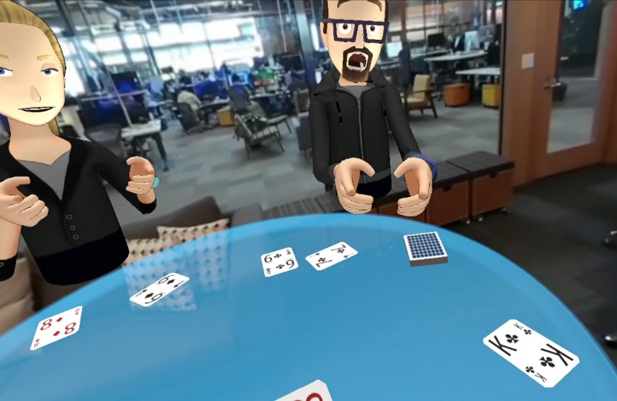
User A is wearing a wired HMD at home in California, USA and playing poker with his friends - user B, C, and D in VR. User B lives in Boston, USA, User C lives in Moscow, Russia, and User D lives in Tokyo, Japan, and they love to play poker together.

In order to create a VR environment that gives a good user experience without experiencing motion sickness, it requires a high resolution and big size 360-degree images and takes less than a 20 ms response time to all moving images. Therefore, it is necessary that the network speed of 10 Gbps or more is required for the HMD to recognize the action of the user, transmit it to the PC, and then the PC transmits the action information to the counterpart via the network and displays the reaction in real time.

Case 2 (Mobile Network)

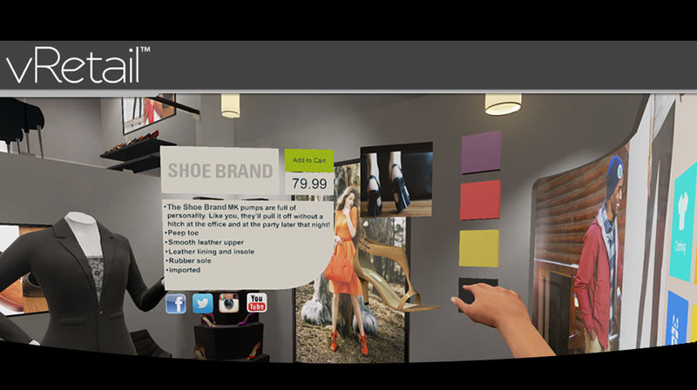
While User E rides the bus to the meeting place to meet his friend, she is watching the clothes she saw at the department store yesterday and doing VR shopping to make the purchase. VR is more realistic than online shopping malls because it gives the user the feeling that she is actually seeing things. Especially, the ability to unfold and view the clothes in three dimensions provides very important information when she selects the clothes.
At this moment, in order to express the detailed texture and the pattern of the clothes, it certainly requires a high resolution and big size images and also the response time to the change of images needs to be less than 20 ms to reflect the action in real time without feeling motion sick. Therefore, in order for the HMD to recognize the user's actions, send them to the PC, and then the PC needs to transmit the action information to the other party through the network in real time, the wireless network speed of 10 Gbps or more is required

Case 3 (Wireless Ethernet Telecommunication)

User F is from London, UK, user G is Bundang, Korea and user H is from Rio, Brazil. They all want to attend the meeting I. However, the user G urgently needs to deal with an important work from his company at the same time the meeting is scheduled but cannot miss the meeting either. To solve this dilemma, user G uses a VR HMD connected to the wireless Ethernet telecommunication to attend the meeting virtually while working on the company work. This was all possible because of the HMD mobility and the high-performance wireless Ethernet communication was possible.

Case 4 (Sensor Network)
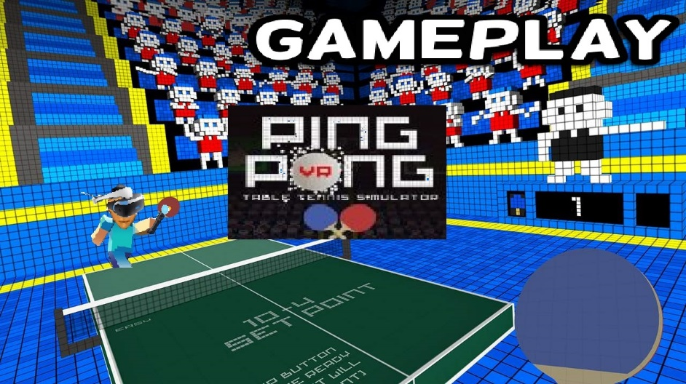
Table tennis is a very fast-paced game. User J likes to play table tennis in VR with user K, a girlfriend. In order for the user J and K to play games in VR, they must recognize the user's actions around the sensor and transmit the recognized information to the PC through the sensor network. Then, the PC computes the reaction information and transmits it back to the user's HMD display through the sensor network. The network delay time generated in this process should be almost none and it should work in real time.

Case 5 (Local Area Network)
User L is wearing a HMD at home in Busan, Korea and is dating with user M, his girlfriend, while looking at the Eiffel Tower in Paris' Marsei Square all in VR. User L's HMD is not a high-performance HMD, so it cannot render images in real time. However, the terminal he uses is capable of processing the image information very fast via the wired network. Since the QoS can be satisfying as long as the local area network speed for transmitting video, sound, and motion recognition information is fast enough, the user L is using the HMD which supports DLNA or Miracast to enjoy this happy date with user M.

Case 6 (Handover)

The HMD of the VR service user N is a smartphone-mounted HMD having both a high-speed mobile network module and a wireless Ethernet network module. User N is watching a movie using HMD in the bus. The bus route has a lot of Wi-Fi sections, but some sections do not have Wi-Fi. The user N uses his smartphone network setting to connect the wireless Ethernet network first and then connect to the mobile network. In other words, his HMD connects to Wi-Fi when it is available and connects to the mobile network when it is not available. In such situation, heterogeneous network handover occurs between the Wi-Fi and the wireless mobile network. During this network handover, the performance change may happen between the high-speed network and the low-speed network. This performance difference may prevent the data to be transferred reliably and may create a very uncomfortable situation, such as a nausea. In particular, when a heterogeneous network handover occurs in which network performance is significantly different, the data cliff phenomenon as shown in Figure 1 occurs.
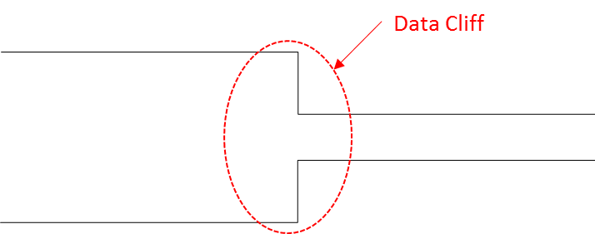
(Figure 1: Occurrence of data cliff between the heterogeneous networks)

In the process of transmitting the image file constructed as shown in Figure 2, there is a high possibility that the 'Movie Header' file containing the configuration information of the entire file is lost when the data cliff occurs. If the 'Movie Header' is lost, it is impossible to restore the whole image file even if another file is transferred.

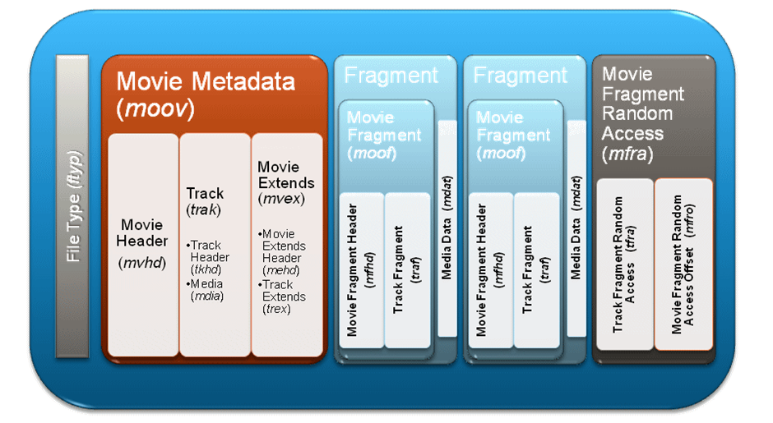
(Figure 2: Structure of movie file)

If the data cliff situation as described above occurs, the user cannot expect a good user experience, and may fail to receive the video service itself.

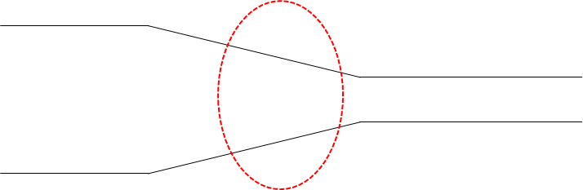
(Figure 3: Continuous Network Handover between heterogenous networks avoiding data cliff)

If the data cliff can be managed in the handover interval as shown in Figure 3, the user experience may not significantly improve but it will improve some and prevents the data transfer failure.

