Project | IEEE 802.21 Working Group for Media Independent Services  <http://www.ieee802.org/21/>
Title | Why the network is important for HMD based VR services
DCN | 21-18-0021-01-0000
Date Submitted | May 07, 2018
Source(s) | Dongil Dillon Seo dillon@volercreative.com (VoleRCreative),  Sangkwon Peter Jeong ceo@joyfun.kr (JoyFun Inc.)
Re: | IEEE 802.21 Session #85 in Warsaw, Poland
Abstract | This document explains why defining the network specification that guarantees the quality of experience for HMD based VR service is important.
Purpose | This document attempts to explain the service sections where the IEEE 802 network standards will be used for “Network Enablers for seamless HMD based VR Content Service IG” in greater details.
Notice | This document has been prepared to assist the IEEE 802.21 Working Group. It is offered as a basis for discussion and is not binding on the contributing individual(s) or organization(s). The material in this document is subject to change in form and content after further study. The contributor(s) reserve(s) the right to add, amend or withdraw material contained herein.
Release | The contributor grants a free, irrevocable license to the IEEE to incorporate material contained in this contribution, and any modifications thereof, in the creation of an IEEE Standards publication; to copyright in the IEEE’s name any IEEE Standards publication even though it may include portions of this contribution; and at the IEEE’s sole discretion to permit others to reproduce in whole or in part the resulting IEEE Standards publication. The contributor also acknowledges and accepts that IEEE 802.21 may make this contribution public.
Patent Policy | The contributor is familiar with IEEE patent policy, as stated in Section 6 of the IEEE-SA Standards Board bylaws <http://standards.ieee.org/guides/bylaws/sect6-7.html#6> and in Understanding Patent Issues During IEEE Standards Development http://standards.ieee.org/board/pat/faq.pdf

As shown in the table below, we have been trying to explain that there are various requirements we need to satisfy in order to minimize the VR sickness caused by the use of HMD based VR service.
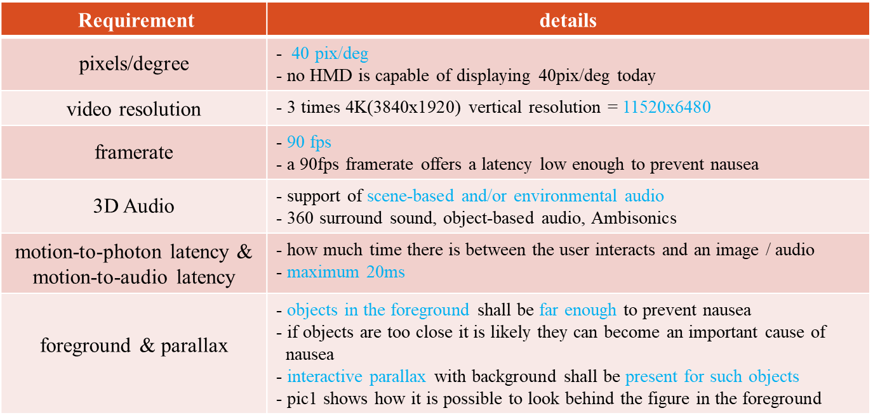
One of the most critical requirements to minimize the VR sickness is the motion-to-photon latency. It is commonly known in the industry that the motion-to-photon latency needs to be less than 20 ms in order to minimize the VR sickness. This implies that there is a strong correlation between the time that needs for the human eyes to perceive the image data and the time that needs for the human brain to process the perceived image data.
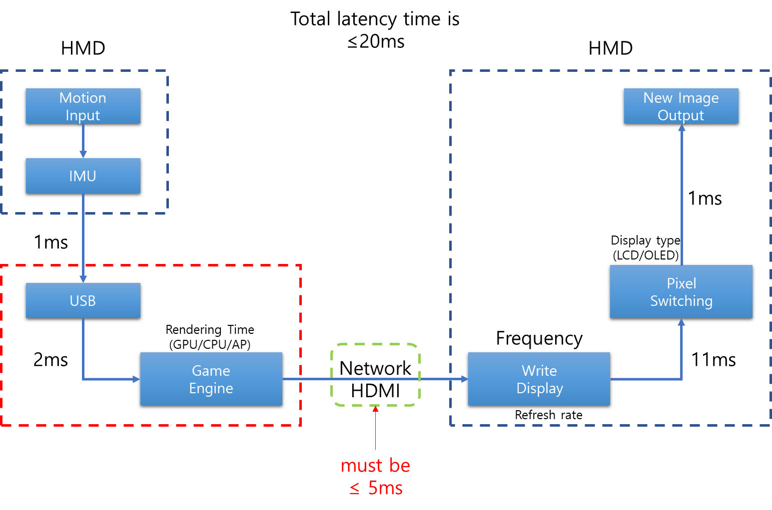
As shown in the diagram above, the time requires for the motion input to be delivered to the IMU (Inertial Measurement Unit) via USB is 1 ms. The time that this data is rendered by the game engine is 2 ms. We will consider these values to be default for the purpose of this document as we will be discussing the network as a variable. We will also consider the write display time and the pixel switching time to be default as well since the 90 Hz (which takes 11 ms to write the image on the display) OLED (which takes 1 ms to switch a pixel) display is the most commonly used display in the modern commercial HMDs. Given these default value, the tolerable latency for HDMI is approximately 5 ms and this is not difficult to achieve when it is a cable line. However, if we are talking about the network latency to be less than 5 ms, the story is different.

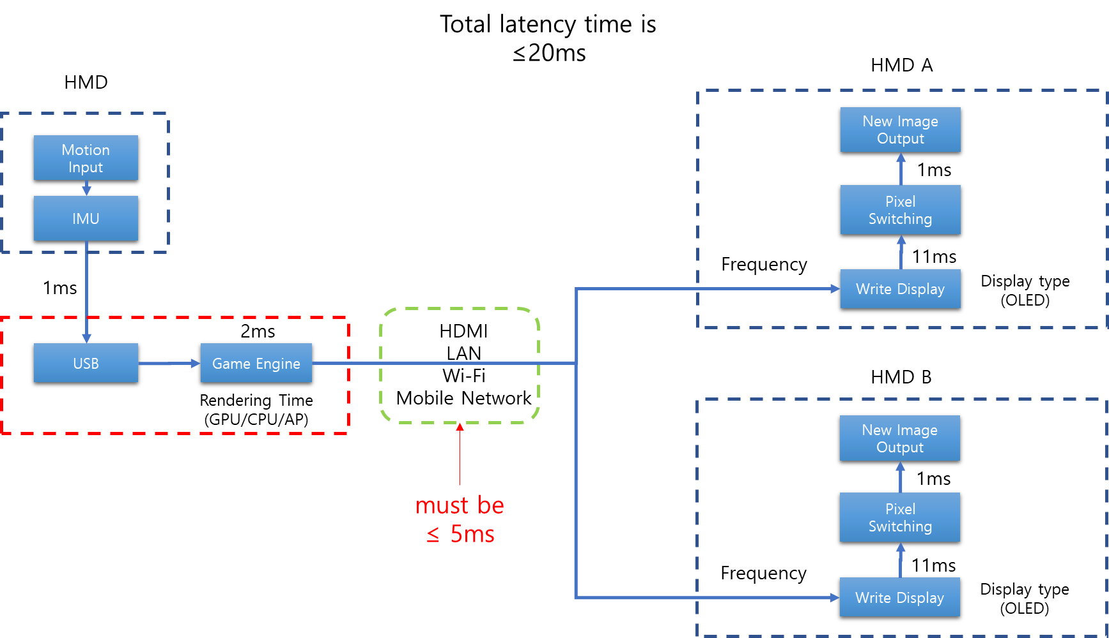
As shown in the diagram above, if we need to achieve the tolerable latency time for each HMD A and HMD B case to be less than 5 ms using the current LAN, Wi-Fi, mobile network and sensory network specifications, we will say it will be impossible to achieve. If we consider the network handover, it will definitely generate more latency. As we are fully aware of the current limitations, it is important to discuss how we can improve or modify the current network technology to overcome this challenge.
Therefore, this document will closely examine the six use-cases that were mentioned in the previous input contribution document and discuss these cases in more detail to understand the network requirements.

