Project | IEEE 802.21 Working Group for Media Independent Services  <http://www.ieee802.org/21/>
Title | Status of IEEE 3079
DCN | 21-18-0004-00-0000
Date Submitted | February 27, 2018
Source(s) | Sangkwon Peter Jeong ceo@joyfun.kr (JoyFun Inc.)  Dongil Dillon Seo dillon@volercreative.com (VoleRCreative),
Re: | IEEE 802.21 Session #84 in Chicago, Illinois, USA
Abstract | This document contains the current activities of IEEE P3079 WG
Purpose | This document is composed to share the information on current IEEE 3079 activities
Notice | This document has been prepared to assist the IEEE 802.21 Working Group. It is offered as a basis for discussion and is not binding on the contributing individual(s) or organization(s). The material in this document is subject to change in form and content after further study. The contributor(s) reserve(s) the right to add, amend or withdraw material contained herein.
Release | The contributor grants a free, irrevocable license to the IEEE to incorporate material contained in this contribution, and any modifications thereof, in the creation of an IEEE Standards publication; to copyright in the IEEE’s name any IEEE Standards publication even though it may include portions of this contribution; and at the IEEE’s sole discretion to permit others to reproduce in whole or in part the resulting IEEE Standards publication. The contributor also acknowledges and accepts that IEEE 802.21 may make this contribution public.
Patent Policy | The contributor is familiar with IEEE patent policy, as stated in Section 6 of the IEEE-SA Standards Board bylaws <http://standards.ieee.org/guides/bylaws/sect6-7.html#6> and in Understanding Patent Issues During IEEE Standards Development http://standards.ieee.org/board/pat/faq.pdf

IEEE 3079 has set the following schedule to publish its standard draft.

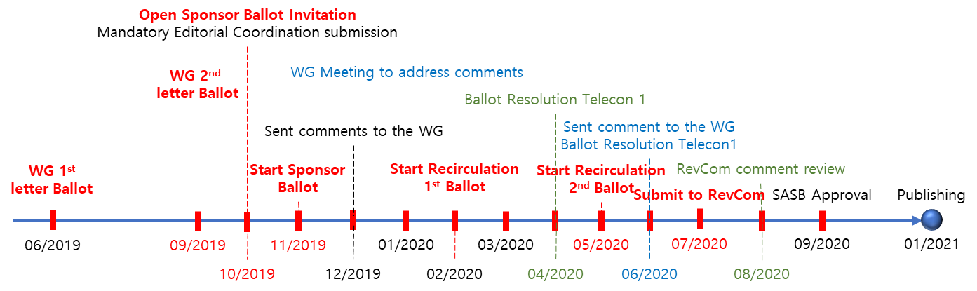

Main schedule is provided below.
- PAR approved: 12/2016
- Working Group 1st Letter Ballot: 06/2019 (20 days)
  - Before July meeting
- Working Group 2nd Letter Ballot: 09/2019 (20 days)
  - Before October meeting
- Open Sponsor Ballot Invitation: 10/2019 (30 days)
- Start Sponsor Ballot: 11/2019 (30 days)
- Start Recirculation 1st Ballot: 02/2020 (10 days)
- Start Recirculation 2nd Ballot: 05/2020 (10 days)
- Submit to RevCom: 07/2020
- Publishing: 01/2021Z

At the January meeting, we began discussing the standardization of 'Terms and definition' and 'use cases and scenario'. The discussions on standardization of 'Terms and definition' and 'use cases and scenario' will be further discussed at the next Tokyo meeting in April and will continue to be discussed whenever there is an issue. If there is are any terms and definition from IEEE 802.21 including IEEE 802 concerning network, those will be reflected in P3079 document.
In addition, IEEE 3079 decided to change the name of WG to 'Cybersickness Reduction Working Group', and decided to change the name of PAR to 'HMD based VR Sickness Reducing Technology'. This was done to clarify the task scope and the task of performing the PAR in the definition process of the IEEE 3079 WG.

