Project | IEEE 802.21 Working Group for Media Independent Services  <http://www.ieee802.org/21/>
Title | Network property for HMD based VR
DCN | 21-18-0004-00-0000
Date Submitted | February 27, 2018
Source(s) | Dongil Dillon Seo dillon@volercreative.com (VoleRCreative),  Sangkwon Peter Jeong ceo@joyfun.kr (JoyFun Inc.)
Re: | IEEE 802.21 Session #84 in Chicago, Illinois, USA
Abstract | This document presents the issue of how meaningful values and validated information are presented in the network attributes of each section in service of HMD-based virtual reality.
Purpose | This document is composed to request professional opinion and comments from the experts of IEEE 802 WG on these values of network attributes.
Notice | This document has been prepared to assist the IEEE 802.21 Working Group. It is offered as a basis for discussion and is not binding on the contributing individual(s) or organization(s). The material in this document is subject to change in form and content after further study. The contributor(s) reserve(s) the right to add, amend or withdraw material contained herein.
Release | The contributor grants a free, irrevocable license to the IEEE to incorporate material contained in this contribution, and any modifications thereof, in the creation of an IEEE Standards publication; to copyright in the IEEE’s name any IEEE Standards publication even though it may include portions of this contribution; and at the IEEE’s sole discretion to permit others to reproduce in whole or in part the resulting IEEE Standards publication. The contributor also acknowledges and accepts that IEEE 802.21 may make this contribution public.
Patent Policy | The contributor is familiar with IEEE patent policy, as stated in Section 6 of the IEEE-SA Standards Board bylaws <http://standards.ieee.org/guides/bylaws/sect6-7.html#6> and in Understanding Patent Issues During IEEE Standards Development http://standards.ieee.org/board/pat/faq.pdf

The following table is from the contribution document 21-18-0003-00-0000 from Prof. Minseok Oh

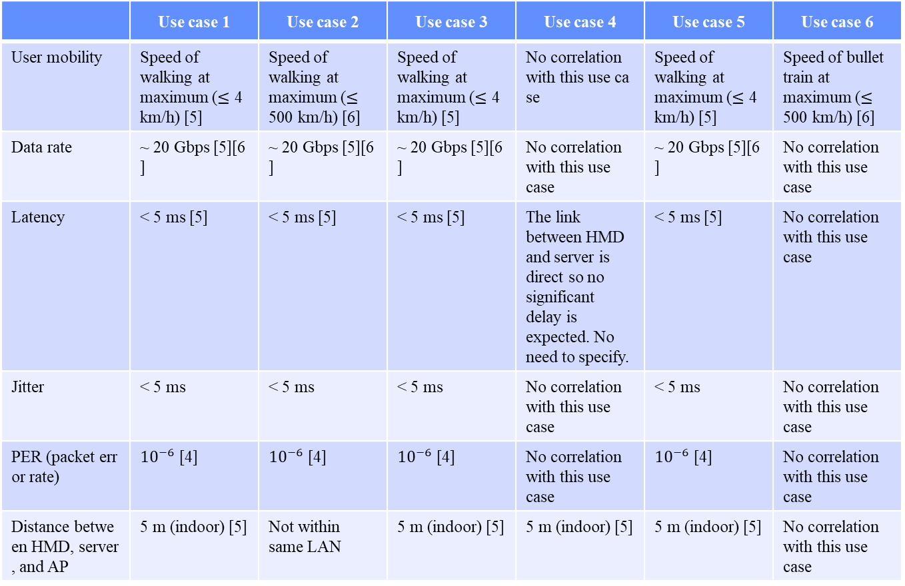

However, for each use case, the values ​​specified in the property are universally known or estimated values. We want to know the empirical values ​​that are validated and have real meaning for the values ​​written above because we are not experts in the field of networks.
The table demonstrates the required environment and conditions for each use case under the assumption that the user experiencing the content is not in discomfort state and VR content service is provided at its optimal state. For each use case, IEEE 802 experts should comment on how much performance can be provided for each network section and how to define the procedure for it.
If the optimal environment, performance, and conditions are presented through proven data, it will provide good guidelines for network operators who are struggling to develop network-based virtual reality content or to facilitate virtual reality services.

