Project | IEEE 802.21 Working Group for Media Independent Services  <http://www.ieee802.org/21/>
Title | Introducing for Virtual Reality
DCN | 21-17-0055-00-0000
Date Submitted | October 24, 2017
Source(s) | Dongil Dillon Seo dillon@volercreative.com (VoleRCreative),  Sangkwon Peter Jeong ceo@joyfun.kr (JoyFun Inc.)
Re: | IEEE 802.21 Session #83 in Orlando, Florida, USA
Abstract | This document describes the concept of Virtual Reality
Purpose | Before discussing the importance of networks in virtual reality services, this document will help you to understand the virtual reality and mixed reality clearly.
Notice | This document has been prepared to assist the IEEE 802.21 Working Group. It is offered as a basis for discussion and is not binding on the contributing individual(s) or organization(s). The material in this document is subject to change in form and content after further study. The contributor(s) reserve(s) the right to add, amend or withdraw material contained herein.
Release | The contributor grants a free, irrevocable license to the IEEE to incorporate material contained in this contribution, and any modifications thereof, in the creation of an IEEE Standards publication; to copyright in the IEEE’s name any IEEE Standards publication even though it may include portions of this contribution; and at the IEEE’s sole discretion to permit others to reproduce in whole or in part the resulting IEEE Standards publication. The contributor also acknowledges and accepts that IEEE 802.21 may make this contribution public.
Patent Policy | The contributor is familiar with IEEE patent policy, as stated in Section 6 of the IEEE-SA Standards Board bylaws <http://standards.ieee.org/guides/bylaws/sect6-7.html#6> and in Understanding Patent Issues During IEEE Standards Development http://standards.ieee.org/board/pat/faq.pdf

Concept of VR & MR
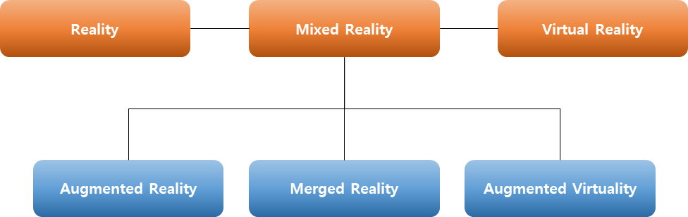
[Figure 1] Concept Figure of MR & VR

The picture above illustrates that Paul Milgram, professor at the University of Toronto in 1994, embodied the concept of virtual reality and mixed reality. In this picture, we can clearly see that virtual reality is clearly distinguishable from mixed reality.
Reality is literally pure reality. Reality is clearly bounded by time and space; hence, it is not possible for us to see beyond the current time and space nor the past because it is practically impossible to artificially change time and space.
On the contrary, Virtual Reality is completely separate from the present, completely free from time and space. It is the concept of virtual reality that allows you to experience the past and shape the future through virtual reality, and send a person in Seoul right now to Paris in 500 years ago.
In other words, virtual reality must be free of time and space, which is completely independent of reality from any device. This is the basic principle of virtual reality.
On the other hand, mixed reality is based on reality or based on virtual reality, overlapping time, space, and objects on the other side.
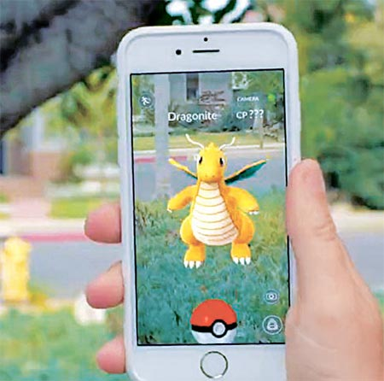
[Figure 2] Pokemon Go
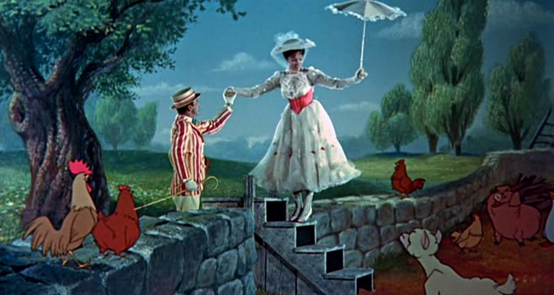
[Figure 3] Mary Poppins
The Augmented Reality, popularly known through the ‘Pokemon Go’ game, is a technique of superimposing virtual objects on real time and space. On the contrary, overlapping real objects in virtual world like in the movie called “Mary Poppins (1964)” is called "Augmented Virtuality." A representative technique of augmented virtuality is called 'chroma-key', and this technique is a very old and common.
However, as the technology of "Depth camera" and "Beam projector" which can recognize the motion is developed, a technology that obfuscates the boundary between reality and virtual begin to appear in various forms.

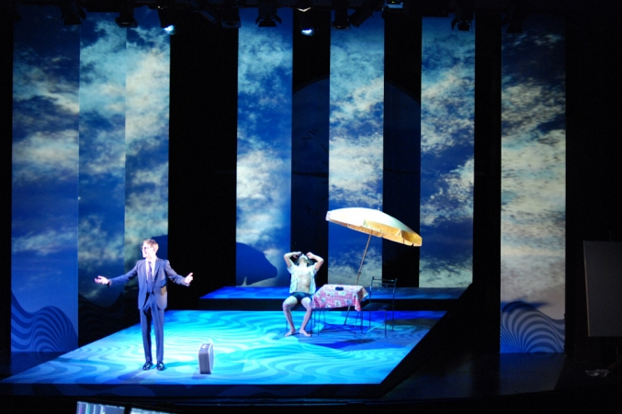
[Figure 4] Mixed Reality by Beam Projector

In other words, the HMD-based virtual reality service that we want to deal with is independent from time and space, unlike MR, so that people can be immersed in the new environment according to the intention of the content creator.

VR Content

“Digital Content "refers to the entire content of C (Content) -P (Platform) -N (Network) -D (Device). We have pasted the word 'digital' to distinguish it from analog content but when we actually discuss C-P-N-D, we rarely consider analog content. In other words, the range of digital content is very broad, and we can say that various platforms, networks, and devices ultimately exist for content.
“Digital Content” includes games, movies, music, electronic publishing and various other applications. Such content are consumed in various devices, but one of the main representative devices is 실감형 장치들.
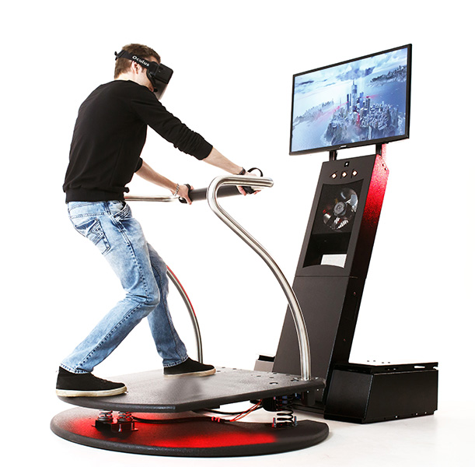
[Figure 5] Simulator for VR

Immersive devices increase the immersion with more realistic environment through the human five senses, thereby enhancing the usability of the content and enabling more effective user experience.

Because of these advantages, it is not so difficult to predict that various kinds of digital content will come out as Immersive content. However, in the process, we should not neglect the user's usability, safety, etc. Moreover, standardization will be carried out in all fields ranging from platforms, networks, and devices.

VR, which we are discussing at present, is one of the main representative Immersive content.

