Project | IEEE 802.21 Working Group for Media Independent Services  <http://www.ieee802.org/21/>
Title | White Paper for Use cases and Network Requirements for enabling HMD based 3D Content Motion Sickness Reducing Technology
DCN | 21-17-0054-01-0000
Date Submitted | October 19, 2017
Source(s) | Dongil Dillon Seo dillon@volercreative.com (VoleRCreative),  Sangkwon Peter Jeong ceo@joyfun.kr (JoyFun Inc.)
Re: | IEEE 802.21 Session #83 in Orlando, Florida, USA
Abstract | This document describes the use cases and technical requirements to be considered by the 802.21 group to address handovers with HMD based VR Services.
Purpose | Working Group Discussion and Acceptance
Notice | This document has been prepared to assist the IEEE 802.21 Working Group. It is offered as a basis for discussion and is not binding on the contributing individual(s) or organization(s). The material in this document is subject to change in form and content after further study. The contributor(s) reserve(s) the right to add, amend or withdraw material contained herein.
Release | The contributor grants a free, irrevocable license to the IEEE to incorporate material contained in this contribution, and any modifications thereof, in the creation of an IEEE Standards publication; to copyright in the IEEE’s name any IEEE Standards publication even though it may include portions of this contribution; and at the IEEE’s sole discretion to permit others to reproduce in whole or in part the resulting IEEE Standards publication. The contributor also acknowledges and accepts that IEEE 802.21 may make this contribution public.
Patent Policy | The contributor is familiar with IEEE patent policy, as stated in Section 6 of the IEEE-SA Standards Board bylaws <http://standards.ieee.org/guides/bylaws/sect6-7.html#6> and in Understanding Patent Issues During IEEE Standards Development http://standards.ieee.org/board/pat/faq.pdf

Introduction

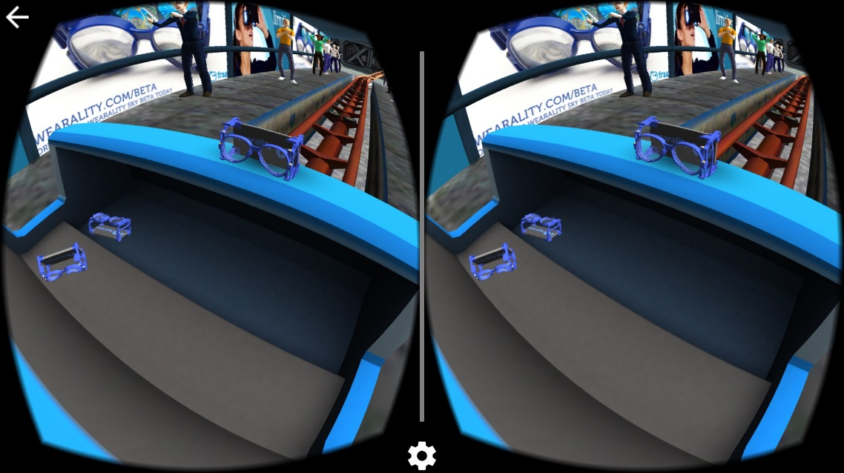
Figure 1 Stereoscopic image for VR HMD
HMD-based virtual reality began to gain global attention in 2014 when Facebook acquired Oculus, and three years later, it has become the most notable technology in the IT field.

Nevertheless, HMD-based virtual reality technology, unlike many people's interest and expectation, is not growing rapidly. This is closely related to the motion sickness associated with stereoscopic, one of the characteristics of HMD

The motion sickness is known to be caused by the difference between the visual perception and the information sensed by the actual sensory organ.

Therefore, in order to reduce the motion sickness caused while experiencing the HMD-based virtual reality content, it is necessary to solve the inconsistency of the information or change the user's sensory information more comfortably.

For this purpose, various research efforts have been made to change the user 's sensory information. As a result, it has become clear that the recognition of information that is very similar to the reality of the person is needed. In order to transmit the image information very similar to reality to the HMD, a very high-resolution 360-degree image is required, and such image data takes a lot of memory. Especially, since the spatial information and the sound information of the virtual world must be contained as a vector value, an extremely large data is required. Also, in order to transmit video and audio information of such a large capacity at a near real-time speed, a network infrastructure having a huge bandwidth is required.

Therefore, in this paper, we discuss the network environment needed to provide HMD based virtual reality service to users comfortably and suggest that it should be discussed within IEEE 802 and propose to define the technical standards.

Overview

Purpose
Define the functions that the network infrastructure should provide so that the users of HMD-based virtual reality content have a good experience and motion sickness is minimized

Scope

Definition

- Virtual Reality – This is a realization of a space similar to reality in which a space and objects according to human imagination are created using a computer. In this case, VR means a way to get a new experience getting away from a time and space constraint by using a VR HMD.
- HMD (Head Mounted Display) – A device that worn like a goggle or a helmet on a person's head and can see the image through a signal transmitted to the front display panel. Unlike other HMDs, sensors such as a gyro, an accelerometer, and a magnetometer are attached to respond to user's head movement.
- 4K UHD (4k Ultra High Definition) – Digital video format which the International Telecommunication Union (ITU) approves as one among the next generation high definition video quality standard corresponding to standard of the aspect ratio 16:9 and number of pixels 8,294,400 and screen resolution 3840X2160. 4K UHD applies for the video having the number of pixels of the quadruple in comparison with the Full HD.

Table 1 Display Resolution
Method | Pixel | Resolution
HD | 1,036,800 | 1,366 x 768
Full-HD | 2,073,600 | 1,920 x 1,080
4K UHD | 8,294,400 | 3,840 x 2,160
12K UHD | 74,649,600 | 11,520 x 6,480

- Bit Rate – the data size of the bit unit which has to handle per second. The bps (bit per second) is used as the unit.
- CBR (Constant Bit Rate) – the way that it compresses each frame comprising the video into the uniform capacity.
- VBR (Variable Bit Rate) – the way that it analyzes the difference of each frames and stores as the relative low capacity in the part the movement writing and stores as the high-capacity in the part which there is a lot of the movement. i.e. the way that it compresses into the capacity which is not fixed according to the movement of the image inside.
- Frame Rate: the size of the frame which it has to handle per second. It is the meaning like the fps (frame per second)

Use Cases of HMD based VR Services

High performance Bandwidth

Concept
In order to have a good user experience with HMD-based virtual reality content, it is known that the image displayed in the HMD should have a resolution of 12K (11,520 × 6,480).

Table 2. Quality Requirements for VR
Requirement | details
pixels/degree | - 40 pix/deg  - No HMD is capable of displaying 40pix/deg today
video resolution | - 3 times 4K(3840x1920) vertical resolution = 11,520 x 6,480
framerate | - 90 fps  - A 90fps framerate offers a latency low enough to prevent nausea
3D Audio | - Support of scene-based and/or environmental audio  - 360 surround sound, object-based audio, Ambisonics
motion-to-photon latency &  motion-to-audio latency | - How much time there is between the user interacts and an image / audio  - Maximum 20ms
Ref.) Technicolor, Oct. 2016 (m39532, MPEG 116th Meeting)

As shown in the table above, outputting a 12K image, which is three times the size of 4K, at a rate of more than 90 frames per second at 360 degrees requires a huge amount of data and transmitting such a large amount of data ideally with a latency of 20ms is a tremendous thing to do.

It does not matter whether it is a wired, a wireless, or a Wireless Personal Area Network (WPAN). In any network infrastructure, it is necessary to set the total latency of all segments to 20ms or less in transmitting content data. This is because the user's reaction takes place and the total time it takes for the content to react and display on the display.

Scenario

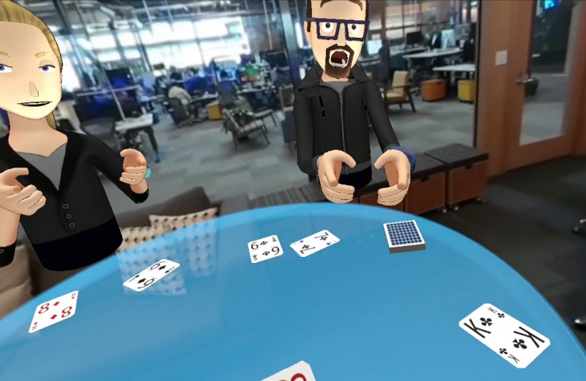
Wired case
User A wears a wired HMD at home in California, USA and is playing poker with his friends - user B, C, and D in VR. User B lives in Boston, USA, User C lives in Moscow, Russia, and User D lives in Tokyo, Japan, and they love to play poker together.

In order to create a VR environment that gives a good user experience without experiencing motion sickness, it requires a high resolution and big size 360 degree images and takes less than a 20ms response time to all moving images. Therefore, it is necessary that the network speed of 10Gbps or more is required for the HMD to recognize the action of the user, transmit it to the PC, and then the PC transmits the action information to the counterpart via the network and displays the reaction in real time.

Wireless case

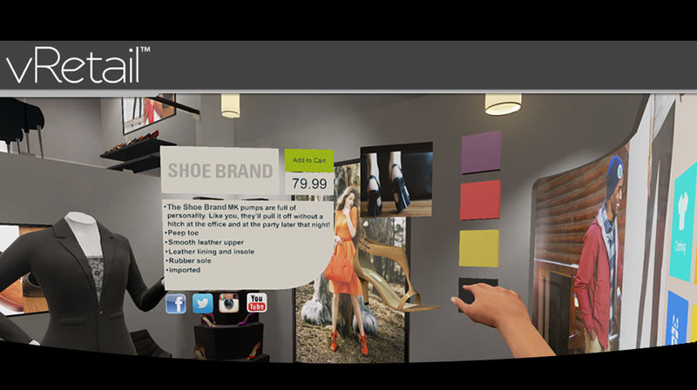
While User E rides the bus to the meeting place to meet his friend, she is watching the clothes she saw at the department store yesterday and doing VR shopping to make the purchase. VR is more realistic than online shopping malls because it gives the user the feeling that she is actually seeing things. Especially, the ability to unfold and view the clothes in three dimensions provides very important information when she selects the clothes.
At this moment, in order to express the detailed texture and the pattern of the clothes, it certainly requires a high resolution and big size images and also the response time to the change of images needs to be less than 20 ms to reflect the action in real time without feeling motion sick. Therefore, in order for the HMD to recognize the user's actions, send them to the PC, and then the PC needs to transmit the action information to the other party through the network in real time, the wireless network speed of 10 Gbps or more is required.

WPAN case

Table tennis is a very fast-paced game. User F likes to play table tennis in VR with user G, a girlfriend. In order for the user F and G to play games in VR, they must recognize the user's actions around the sensor and transmit the recognized information to the PC through the sensor network. Then, the PC computes the reaction information and transmits it back to the user's HMD display through the sensor network. The network delay time generated in this process should be less than 20ms to minimize the motion sickness caused by the display latency.

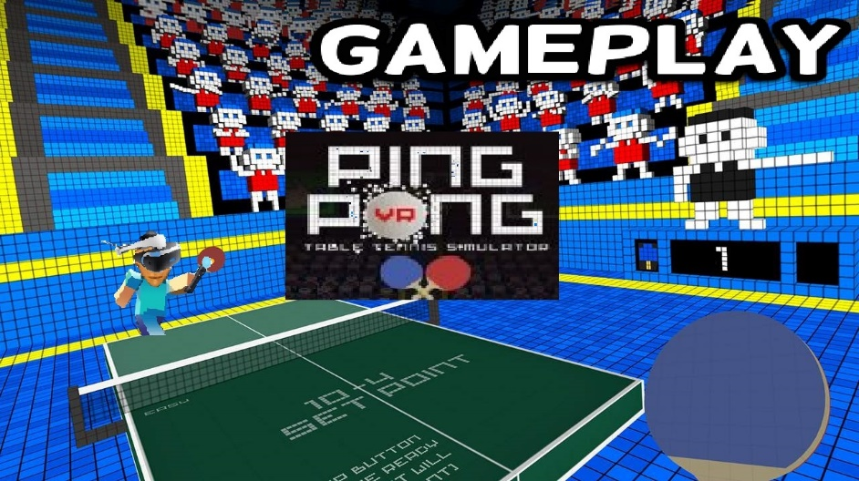

Handover

Concept
Moving users in a wireless environment implies that network handover will inevitably occur. Whether it is a horizontal handover in a homogeneous network or a vertical handover in a heterogeneous network, network handover will inevitably occur.
As mentioned above, in order to provide a good user experience, the HMD-based virtual reality content need a bandwidth infrastructure that can transmit a large amount of data. However, we cannot expect to have a high-performance bandwidth environment at all time. Therefore, a network handover from a high-performance bandwidth network such as IMT-2020 to a relatively low-performance bandwidth environment such as IMT-Advanced may occur.
In this case, there may be a case where data of VR content fails to be transmitted at the time of handover occurrence and especially, when an error occurs in a packet containing the header data which has a structural information of the entire transmitted data, it can be very fatal.

Scenario
User H is viewing a wireless streamed movie using a VR HMD in a bullet train moving at a speed of 100 km/h..

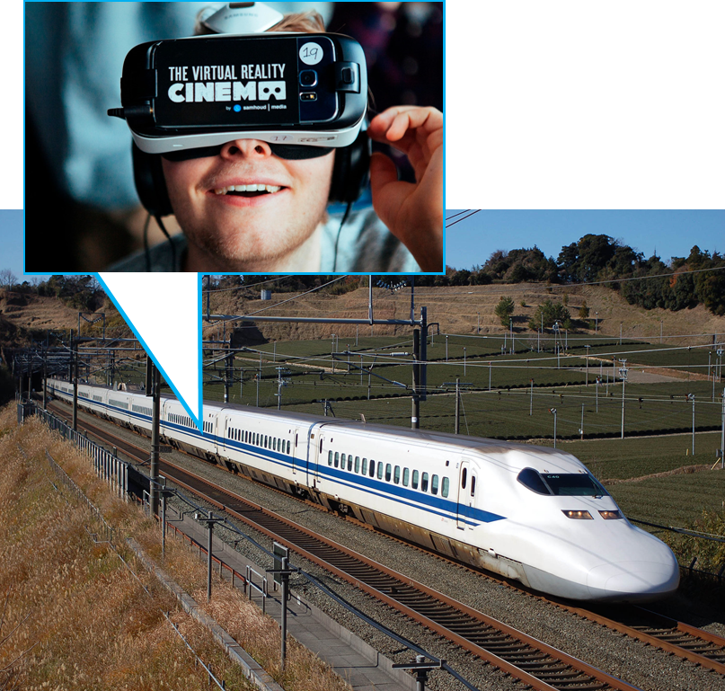
Figure 2. A user using a VR service in a bullet train

To provide an optimal VR service to a user, following conditions are required:
- Bit rate supporting over 90 FPS
- Display supporting over 12K resolution
- Network supporting 1Gbps with constant data transfer rate and connectivity
However, the bullet train will be under the following conditions:
- VR HMD is probably connected to 802.11 series Wi-Fi network connection provided by the train
- The train is probably utilizing 802.11 ad network also known as Wi-Gig(Wireless Gigabit Alliance) or something similar to this wireless network
- Horizontal and vertical network handover will constantly occur when the train is receiving the movie stream from the outside
- The train will try to maintain its data connection using the virtual IP or mobile IP during this handover occurrence.
- Performance difference is inevitable between the network transition
- Performance difference will interfere with the constant data transfer and this will cause the user experiencing the VR service to feel discomfort such as motion sickness.
- Especially, the vertical handover which causes a significant performance difference will experience a data cliff effect shown in the figure 2 below.
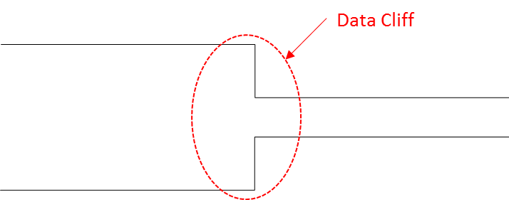
Figure 3. Data cliff occurrence due to the sudden network performance difference

- When the data cliff occurs, the video file consisted of various packets shown in the figure 3 below may lose its Movie Header file which contains the overall movie data structure information; and the packets without this Movie Header file will be useless as the device will not be able to recognize what the file is for.

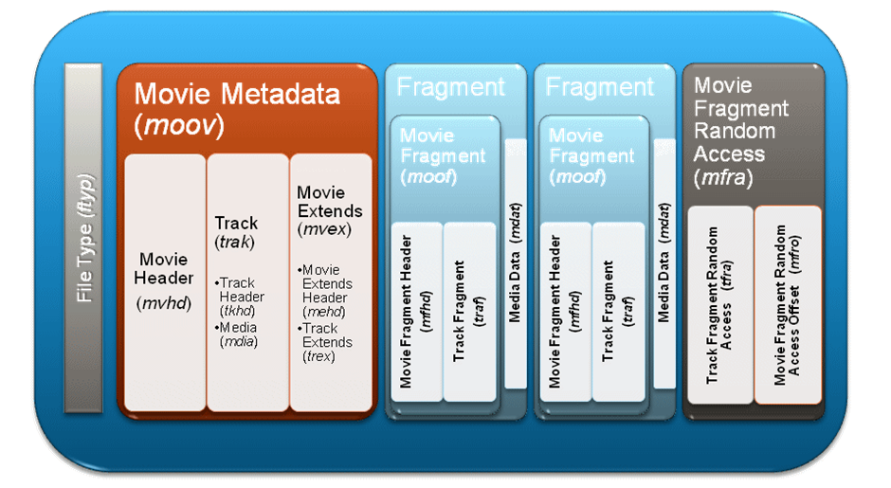
Figure 4. Video File Architecture
- In other words, most of the files transferred through a wireless network including the video file send the header packet first but its transfer safety is not perfectly guaranteed. When the data cliff shown in the figure 2 occurs, the probability of losing the header packet increases significantly.
When #8번 situation occurs, the user experiencing the VR service cannot experience optimal quality of the service and it will be difficult to use the movie service itself.
Figure 5. Situation where the network handover occurs gradually

At least, the situation in figure 4 needs to occur in order to protect the header packet data loss during the network handover.
In order to achieve this, the speed of network change should not be a sudden drop so that the header packet is securely transferred when the network signal connected to the 1 Gbps network is connected to the network with much lower speed.

Network Requirements

Functional Level

Average throughput

Link Speed and Bandwidth

Transmission Latency

Quality of Experience (QoE)

Mobility

System Level

Operational Band

Density of Deployment

Indoor

Outdoor

Recommendation

High performance Bandwidth

Wired environment
A high-speed wired network of 10 Gbps or more is required to transmit a large amount of data so that users of HMD-based virtual reality content have a good user experience.

Wireless environment
A high-speed wireless network of 10 Gbps or more is required to transmit a large amount of data so that users of HMD-based virtual reality content have a good user experience.

WPAN(Wireless Personal Area) environment
In the HMD where the virtual reality content is served, the WPAN is used as a network between the HMD and the surrounding sensors. These sensors do not use high capacity data, but they should transmit state information of user or user environment to HMD, PC and Console at high speed. This is because latency occurs in the transmission interval of the sensor information, and this small latency can cause the user to feel uncomfortable in virtual reality.

Handover

In a heterogeneous wireless network environment, when handover occurs, the delivery of content data should occur seamlessly. In particular, when a handover occurs from a high-performance bandwidth to a low-performance bandwidth, header packets containing content information should not be lost (lost).

Conclusion

We know that HMD-based virtual reality service will be one of the most influential technology for the future industry. Many evidences are being observed from various areas. However, building the network environment, which is the core of the HMD-based virtual reality service infrastructure, will be a high enabler to accelerate the future, promote future content industry and create a better human life.

Therefore, it is necessary to establish standards for network-related infrastructures such as wired, wireless, and handover, and to promote industrial development through diffusion of core technologies.

It is very meaningful work for IEEE 802 to solve this problem and lead the future.

