Project | IEEE 802.21 Working Group for Media Independent Services  <http://www.ieee802.org/21/>
Title | Use-case for handover occurrence while using the VR service
DCN | 21-17-0045-00-0000
Date Submitted | August 26, 2017
Source(s) | Sangkwon Peter Jeong (JoyFun Inc.) ceo@joyfun.kr  Dillon Seo (VoleR Creative) dillon@volercreative.com  GookHwan Lee ghlee@joyfun.kr (JoyFun Inc.)
Re: | IEEE 802.21 Session #82 in Hawaii, USA
Abstract | Hypothesize the handover occurrence case while using the VR service, examine the network situation during the service and discuss any possible problems that may occur
Purpose | To provide an optimal user experience that minimizes the motion sickness, simulate the use case for network handover and identify any possible problems that network professionals should consider and solve.
Notice | This document has been prepared to assist the IEEE 802.21 Working Group. It is offered as a basis for discussion and is not binding on the contributing individual(s) or organization(s). The material in this document is subject to change in form and content after further study. The contributor(s) reserve(s) the right to add, amend or withdraw material contained herein.
Release | The contributor grants a free, irrevocable license to the IEEE to incorporate material contained in this contribution, and any modifications thereof, in the creation of an IEEE Standards publication; to copyright in the IEEE’s name any IEEE Standards publication even though it may include portions of this contribution; and at the IEEE’s sole discretion to permit others to reproduce in whole or in part the resulting IEEE Standards publication. The contributor also acknowledges and accepts that IEEE 802.21 may make this contribution public.
Patent Policy | The contributor is familiar with IEEE patent policy, as stated in Section 6 of the IEEE-SA Standards Board bylaws <http://standards.ieee.org/guides/bylaws/sect6-7.html#6> and in Understanding Patent Issues During IEEE Standards Development http://standards.ieee.org/board/pat/faq.pdf

A user is viewing a wireless streamed movie using a VR HMD in a bullet train moving at a speed of 100 km/h..

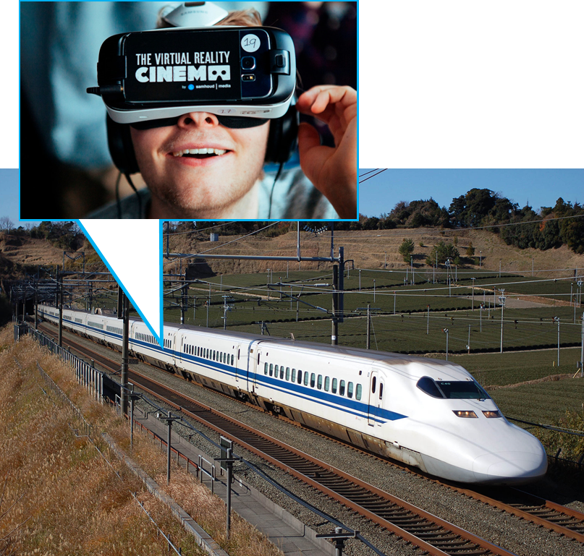
Figure 1. A user using a VR service in a bullet train

To provide an optimal VR service to a user, following conditions are required:
- Bit rate supporting over 90 FPS
- Display supporting over 12K resolution
- Network supporting 1Gbps with constant data transfer rate and connectivity
However, the bullet train will be under the following conditions:
- VR HMD is probably connected to 802.11 series Wi-Fi network connection provided by the train
- The train is probably utilizing 802.11 ad network also known as Wi-Gig(Wireless Gigabit Alliance) or something similar to this wireless network
- Horizontal and vertical network handover will constantly occur when the train is receiving the movie stream from the outside
- The train will try to maintain its data connection using the virtual IP or mobile IP during this handover occurrence.
- Performance difference is inevitable between the network transition
- Performance difference will interfere with the constant data transfer and this will cause the user experiencing the VR service to feel discomfort such as motion sickness.
- Especially, the vertical handover which causes a significant performance difference will experience a data cliff effect shown in the figure 2 below.
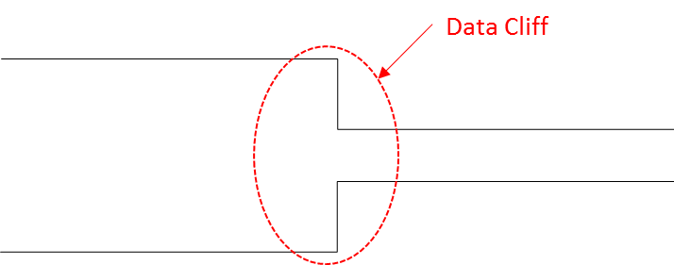
Figure 2. Data cliff occurrence due to the sudden network performance difference

- When the data cliff occurs, the video file consisted of various packets shown in the figure 3 below may lose its Movie Header file which contains the overall movie data structure information; and the packets without this Movie Header file will be useless as the device will not be able to recognize what the file is for.

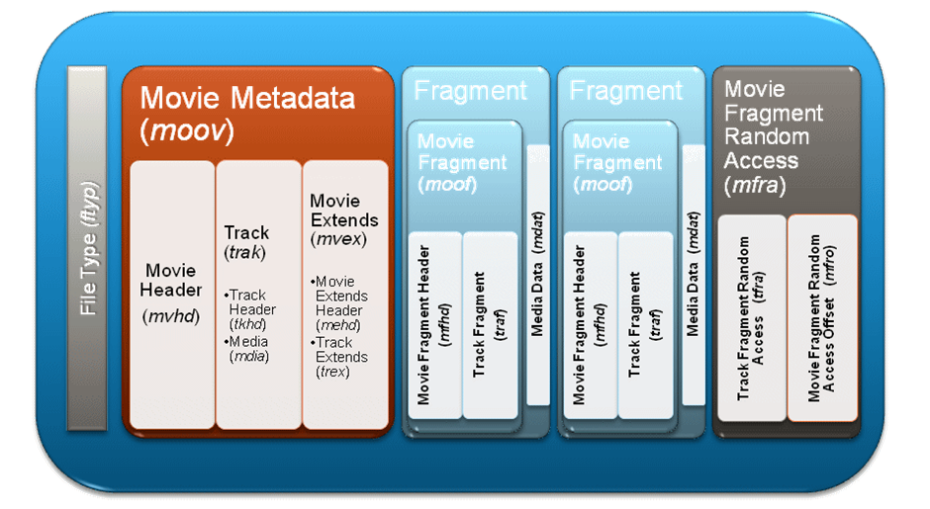
Figure 3. Video File Architecture
- In other words, most of the files transferred through a wireless network including the video file send the header packet first but its transfer safety is not perfectly guaranteed. When the data cliff shown in the figure 2 occurs, the probability of losing the header packet increases significantly.
When #8번 situation occurs, the user experiencing the VR service cannot experience optimal quality of the service and it will be difficult to use the movie service itself.
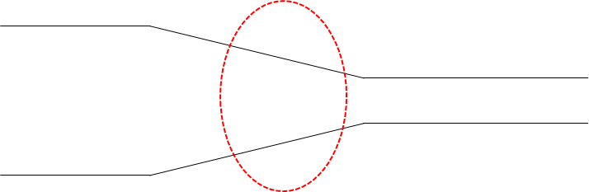
Figure 4. Situation where the network handover occurs gradually

At least, the situation in figure 4 needs to occur in order to protect the header packet data loss during the network handover.
In order to achieve this, the speed of network change should not be a sudden drop so that the header packet is securely transferred when the network signal connected to the 1 Gbps network is connected to the network with much lower speed.

