Project | IEEE 802.21 Working Group for Media Independent Services  <http://www.ieee802.org/21/>
Title | Network Requirement according to compression CODEC for 4K UHD Service
DCN | 21-17-0032-00-0000
Date Submitted | July 6, 2017
Source(s) | HyeonWoo Nam hwnam@dongduk.ac.kr (Dongduk Women’s University)  JinHo Jeong jiniehee@gmail.com (Greencloud Co., Ltd.)  Sangkwon Peter Jeong ceo@joyfun.kr (JoyFun Inc.,)
Re: | Session #81, Berlin, Germany
Abstract | It is the fact that it is sympathizing altogether between the VR professionals that 4K UHD quality is needed for the VR service in which QoE(Quality of experience) is guaranteed. And for this, it is natural that the network environment of the mass and high efficiency is needed.  Therefore, it has to know whether the some transfer rate is required for the transmission of the ultra high resolution video data more than 4K UHD. At this time, the compression due to codec of the video file has to be considered.  This contribution text provides and shares the information for this.
Purpose | Necessary on transfer rate is made an inquiry in order to send video data of the ultra high resolution like the VR contents. And when Handover occurs on network, the possibly generate Issue and the provision about this are trying to be recognized.
Notice | This document has been prepared to assist the IEEE 802.21 Working Group. It is offered as a basis for discussion and is not binding on the contributing individual(s) or organization(s). The material in this document is subject to change in form and content after further study. The contributor(s) reserve(s) the right to add, amend or withdraw material contained herein.
Release | The contributor grants a free, irrevocable license to the IEEE to incorporate material contained in this contribution, and any modifications thereof, in the creation of an IEEE Standards publication; to copyright in the IEEE’s name any IEEE Standards publication even though it may include portions of this contribution; and at the IEEE’s sole discretion to permit others to reproduce in whole or in part the resulting IEEE Standards publication. The contributor also acknowledges and accepts that IEEE 802.21 may make this contribution public.
Patent Policy | The contributor is familiar with IEEE patent policy, as stated in Section 6 of the IEEE-SA Standards Board bylaws <http://standards.ieee.org/guides/bylaws/sect6-7.html#6> and in Understanding Patent Issues During IEEE Standards Development http://standards.ieee.org/board/pat/faq.pdf

- Definition
  - Full-HD (Full High Definition): a set of HDTV high-definition video modes characterized by 1080 horizontal lines of vertical resolution for progressive scan.
  - 4K UHD (4k Ultra High Definition): the digital video format which the International Telecommunication Union (ITU) approves as one among the next generation high definition video quality standard corresponding to standard of the aspect ratio 16:9 and number of pixels 8,294,400 and screen resolution 3840X2160. 4K UHD applies for the video having the number of pixels of the quadruple in comparison with the Full HD.
NOTE. Table 1 shows the result that it compares HD, Full-HD, and 4K UHD.
Table 1 Comparison of Pixel and Resolution
Method | Pixel | Resolution
HD | 1,036,800 | 1,366 x 768
Full-HD | 2,073,600 | 1,920 x 1,080
4K UHD | 8,294,400 | 3,840 x 2,160
NOTE. Figure 1 shows the video quality of the Full-HD and 4K UHD. It can know that video quality of 4K UHD is superior.
Figure 1 Quality Comparison of Full-HD and 4K UHD
NOTE. Table 2 shows that resolution of the most of latest smart phones can apply for 4K UHD.
Table 2 Resolution Comparison of Typical Smartphone
 | SAMSUNG |  |  | LG |  | APPLE
Product | Galaxy S8 | Galaxy S8+ | Galaxy Note 8 | G6 | G6+ | iphone 7 | iphone 7+
Resolution | 2960x1440 | 2960x1440 | 2560x1440 | 2880x1440 | 2880x1440 | 1920x1080 | 1920x1080

  - Bit Rate: the data size of the bit unit which has to handle per second. The bps (bit per second) is used as the unit.
NOTE. The bit rate of the video is the sum of the video area bit rate and audio area bit rate. The bit rate of the video which is not compressed can be calculated with the following equation.
Video Area Bit Rate=(Y Resolution+Cb Resolution+Cr Resolution)×# of Quantization Bit×fps (1)
Audio Area Bit Rate=Sampling Rate×Sampling Bit×# of Channel (2)
Video Bit Rate=Video Area Bit Rate+Audio Area Bit Rate (3)
EXAMPLE. The following equation is the example of computation of the bit rate of the non-compressed 4KU HD video made of (Stereo, 16bit, 48KHz) audio and (8bit, YCbCr 4:2:2 sampling, 29.97 fps) video. At this time, the bit rate gets to become larger if the bit depth becomes larger.

Video Area Bit Rate: (3840×2160+1920×2160+1920×1080)×8×90=10,450,944,000≒10.451 Gbps

Audio Area Bit Rate: 48000×16×2=1536000bps=1500Kbps≒1.46 Mbps

Video Bit Rate: 10.451Gbps+1.46Mbps≒10.452 Gbps
  - CBR (Constant Bit Rate): the way that it compresses each frame comprising the video into the uniform capacity.
  - VBR (Variable Bit Rate): the way that it analyze the difference of each frames and stores as the relative low capacity in the part the movement writing and stores as the high-capacity in the part which there is a lot of the movement. i.e. the way that it compresses into the capacity which is not fixed according to the movement of the image inside.
NOTE. When encoding the video files of which the content and size is the same, the quality of the video is higher than VBR to apply CBR but the operation time and performance which is high in the encoding and decoding process is needed.
  - Frame Rate: the size of the frame which it has to handle per second. It is the meaning like the fps (frame per second).

- Kind of Compression Codec
  - H.264 (MPEG-4 AVC (Advanced Video Coding)): the most widely used file format for the recording, compression and distribution of the video.
Table 3 level-wise feature of the H.264
Level | Maximum Bitrate for Profile (Kbps) |  |  | Maximum Resolution@Maximum Frame Rate
 | BS, Main, Extended | High | High 10
1.0 | 64 | 80 | 192 | 128×96@30.9, 176×144@15.0
1b | 128 | 160 | 384 | 128×96@30.9, 176×144@15.0
1.1 | 192 | 240 | 576 | 176×144@30.3, 320×240@10.0, 352×288@7.5
1.2 | 384 | 480 | 1,152 | 320×240@20.0, 352×288@15.2
1.3 | 768 | 960 | 2,304 | 320×240@36.0, 352×288@30.0
2.0 | 2,000 | 2,500 | 6,000 | 320×240@36.0, 352×288@30.0
2.1 | 4,000 | 5,000 | 12,000 | 352×480@30.0, 352×576@25.0
2.2 | 4,000 | 5,000 | 12,000 | 352×480@30.7, 352×576@25.6,  720×480@15.0, 720×576@12.5
3.0 | 10,000 | 12,500 | 30,000 | 352×480@61.4, 352×576@51.1,  720×480@30.0, 720×576@25.0
3.1 | 14,000 | 17,500 | 42,000 | 720×480@80.0, 720×576@66.7, 1280×720@30.0
3.2 | 20,000 | 25,000 | 60,000 | 1280×720@60.0, 1280×1024@42.2
4.0 | 20,000 | 25,000 | 60,000 | 1280×720@68.3, 1920×1080@30.1, 2048×1024@30.0
4.1 | 50,000 | 62,500 | 150,000 | 1280×720@68.3, 1920×1080@30.1, 2048×1024@30.0
4.2 | 50,000 | 62,500 | 150,000 | 1280×720@145.1, 1920×1080@64.0, 2048×1080@60.0
5.0 | 135,000 | 168,750 | 405,000 | 1920×1080@72.3, 2048×1024@72.0, 2048×1080@67.8, 2560×1920@30.7, 3672×1536@26.7
5.1 | 240,000 | 300,000 | 720,000 | 1920×1080@120.5, 2560×1920@51.2, 3840×2160@31.7, 4096×2048@30.0, 4096×2160@28.5, 4096×2304@26.7
5.2 | 240,000 | 300,000 | 720,000 | 1920×1080@172.0, 2560×1920@108.0, 3840×2160@66.8, 4096×2048@63.3, 4096×2160@60.0, 4096×2304@56.3

NOTE. When the Frame Rate of 5.1 and 5.2 level supporting 4K UHD from H.264 is 31.7 fps and 66.8 fps, the Bit Rate needs 240 Mbps, 300 Mbps, 720 Mbps. If the Frame Rate of the video used in VR contents service is 90 fps, the maximum bit rate, as to the treble gets to grow bigger than the value in Table 3.
  - H.265 (HEVC, High Efficiency Video Coding): a video compression standard, one of several potential successors to the widely used AVC (H.264 or MPEG-4 Part 10). In comparison to H.264, H.265 offers about double the data compression ratio at the same level of video quality, or substantially improved video quality at the same bit rate. It supports resolutions up to 8192×4320, including 8K UHD.
Table 4 level-wise feature of the HEVC
Level | Maximum Bit Rate(Kbps) |  | Maximum Resolution@Maximum Frame Rate
 | Average VBR | Maximum VBR
1 | 128 | - | 128×96@33, 176×144@15.0
2 | 1,500 | - | 176×144@100.0, 352×288@30.0
2.1 | 3,000 | - | 352×288@60.0, 640×360@30.0
3 | 6,000 | - | 640×360@67.5, 720×576@37.5, 960×540@30.0
3.1 | 10,000 | - | 720×576@75.0, 960×540@60.0, 1280×720@33.7
4 | 12,000 | 30,000 | 1280×720@68.0, 1920×1080@32.0, 2048×1080@30.0
4.1 | 20,000 | 50,000 | 1280×720@136.0, 1920×1080@64.0, 2048×1080@60.0
5 | 25,000 | 100,000 | 1920×1080@128.0, 3840×2160@32.0, 4096×2160@30.0
5.1 | 40,000 | 160,000 | 1920×1080@256.0, 3840×2160@64.0, 4096×2160@60.0
5.2 | 60,000 | 240,000 | 1920×1080@300.0, 3840×2160@128.0, 4096×2160@120.0
6 | 60,000 | 240,000 | 3840×2160@128.0, 7680×4320@32.0, 8192×4320@30.0
6.1 | 120,000 | 480,000 | 3840×2160@256.0, 7680×4320@64.0, 8192×4320@60.0
6.2 | 240,000 | 800,000 | 3840×2160@300.0, 7680×4320@128.0, 8192×4320@120.0

NOTE. H.265 supports the maximum 300 fps and the maximum bit rate is the value based on 4:2:0 profile. If it is the profile supporting 4:2:2 and 4:4:4, the maximum bit rate, as to 1.25 times and 1.5 times get to grow bigger than the value of the Table 4.
NOTE. When the Frame Rate of 6, 6.1 and 6.2 level supporting 4K UHD from H.265 is 128 fps, 256 fps, 300 fps, the bit rate which is less than H.264 is needed. However, when comparing with H.264, it is on the rise as the problem that operation capacity more than the five times and two times is required in the encoding and decoding process.

The compression is needed so that the user can take advantage of VR contents smoothly. The H.264 and H.265 can be considered in order to compress the high definition high-quality video. If the HD channel 2 streams can be transmitted from 6MHz bandwidth which generally H.264 uses for the broadcasting, H.265 can transmit the HD channel 4 streams from 6MHz same bandwidth. Moreover, the H.265/MVC for 3D broadcasting is ready.
The operation capacity additionally needed for codec is not issued on network. However, it is needed for the transmission without any error of the video file on network to understand codec and compression file system.

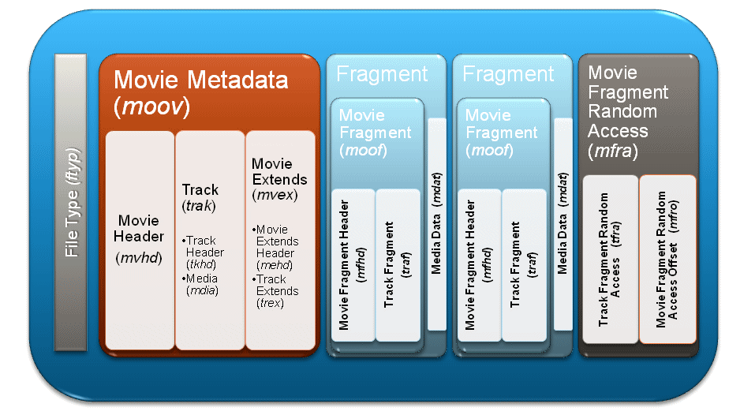
Figure 2 Architecture of Video File

The network of the good quality in which the contents can be steadily transmitted is needed in order to serve the stable QoE for the virtual reality service user.
When the data file is divided into the packet unit and it is transmitted, it has to be careful so that lost doesn't may come to the packet in which MVHD (Movie Header) is contained. But when File is transmitted from network, network doesn't have the way in which it can recognize the packet lost. Therefore, it is the best way that it guarantees so that the total packet can be altogether normally transmitted.
It is the alternative would better securing the large-scale buffer for the stable mass file streaming. However, the memory Issue of the device has to be together considered. Particularly, IEEE 802.21 is the committee dealing the Handover issue. Therefore, the encoding problem and decoding problem that it can be generated in Handover is considered, it is necessary to suggest the solutions.
In the encoding problem and decoding problem that it can be generated in Handover, is there what?

