Project | IEEE 802.21 Working Group for Media Independent Services  <http://www.ieee802.org/21/>
Title | Network Requirement for HMD based VR Service
DCN | 21-17-0030-00-0000
Date Submitted | June 29, 2017
Source(s) | Sangkwon Peter Jeong ceo@joyfun.kr (JoyFun Inc.)  Dongil Dillon Seo dillon@volercreative.com (VoleRCreative)
Re: | Session #81, Berlin, Germany
Abstract | In order to minimize the motion sickness a user experience while using a VR HMD, the current hardware manufacturers suggest that we need to run the VR content at least over 90 Hz and to minimize the screen door effect while looking at the display screen, the display resolution should be at least 4K UHD. Also, to create more immersive and uninterrupted VR experience, wireless HMD is required. However, such conditions are currently difficult to achieve because of the unreadiness of hardware and the unavailability of fast and stable wireless network. Hence, it is important to discuss what specifications for wireless network are required to create an ideal VR service environment.
Purpose | Provide specific network requirements for VR service and reflect these technical requirements to IEEE 802.21 standards.
Notice | This document has been prepared to assist the IEEE 802.21 Working Group. It is offered as a basis for discussion and is not binding on the contributing individual(s) or organization(s). The material in this document is subject to change in form and content after further study. The contributor(s) reserve(s) the right to add, amend or withdraw material contained herein.
Release | The contributor grants a free, irrevocable license to the IEEE to incorporate material contained in this contribution, and any modifications thereof, in the creation of an IEEE Standards publication; to copyright in the IEEE’s name any IEEE Standards publication even though it may include portions of this contribution; and at the IEEE’s sole discretion to permit others to reproduce in whole or in part the resulting IEEE Standards publication. The contributor also acknowledges and accepts that IEEE 802.21 may make this contribution public.
Patent Policy | The contributor is familiar with IEEE patent policy, as stated in Section 6 of the IEEE-SA Standards Board bylaws <http://standards.ieee.org/guides/bylaws/sect6-7.html#6> and in Understanding Patent Issues During IEEE Standards Development http://standards.ieee.org/board/pat/faq.pdf

VR HMD(Virtual Reality Head Mounted Display) display two separate but identical images for left and right eye respectively in order to create stereoscopic image. Also, it uses a pair of fish eye lenses to maximize the field of view so that the user does not see the display edges and believes that he is seeing the virtual world with his own eyes, not through a display. This usage of fish eye lenses distorts the images displayed on the screen life Figure 1 and enlarges field of view, we are only perceiving 45% of the actual screen resolution. This is the reason why the VR HMD manufacturers are suggesting to use 4K UHD display to provide the visual fidelity we are commonly seeing from most popular TV sets, which is 1080p FHD display.

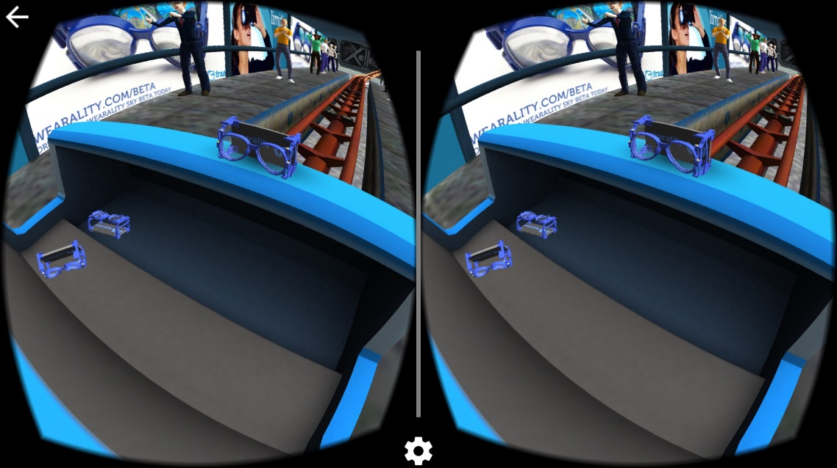
Figure 1. Stereoscopic image for VR HMD
4K UHD resolution offers 3840 x 2160 pixels. It means that an image requires 1G size and the VR content service which requires 90 FPS would require 18 Gbps data transfer rate.

Equation: resolution × 24bit (color) × frame rate = data capacity

Even if the movie clip data is compressed, 1 Gbps data transfer rate needs to be guaranteed
Table 1. IMT-2020 vs WLAN vs IMT-Advanced
 | IMT-Advanced | WLAN(802.11ac) | IMT-2020
Peak data rate | 1 Gbps | 7Gbps | 20 Gbps
User experienced data rate | 10 Mbps  (urban/suburban) | 300Mpbs  (urban/suburban) | 100 Mbps (urban/suburban), 1Gbps (hotspots)
Mobility | 350 Km/h | N/A | 500 Km/h
Area traffic capacity | 0.1 Mbps/ m2 | N/A | 10 Mbps/ m2

Refer to Table 1, minimal data transfer rate for VR service would require at least IMT-Advanced wireless network; and 802.11ac or above WLAN or IMT-2020 wireless network will be necessary to create smooth VR service environment.
However, only IMT-2020 specifications are available and its technological implementation standards are not yet ready whereas VR already has commercial services ready. Hence, we are currently facing a situation where content is ready to be served but the network infrastructure is not ready to accommodate the needs. Therefore, it would be great if IEEE 802 can examine the industry requirements and provide standards for a secured and stable wireless network infrastructure that the industry can use to provide VR content services.
Especially, IEEE 802.21 is working on network handover issues and it would be worthwhile to examine different cases where VR service may leverage its standards on network handover.

