Project | IEEE 802.21 Working Group for Media Independent Services  <http://www.ieee802.org/21/>
Title | Introduction to IEEE P3333.3
DCN | 21-16-0112-00-0000
Date Submitted | November 2, 2016
Source(s) | Sangkwon Peter Jeong ceo@joyfun.kr, Gookhwan Lee, Hyunsam Kang (JoyFun Inc.)  Hyeong-Ho Lee (ETRI) holee@etri.re.kr  Minseok Oh (Kyonggi Univ.) msoh@kgu.ac.kr
Re: | Session #77, San Antonio, TX, USA
Abstract | In the last meeting, we proposed for the virtual reality service that an enhanced media independent service function is needed to prevent data packet losses, which will happen when vertical handover takes place from faster mobile communication environment like IMT-2020 to much slower mobile communication environment. As to the human factor that is another issue of the virtual reality service, the standardization is progressing in the Computer Society/Standards Activities Board (C/SAB) of IEEE. We introduce the new standardization activity on IEEE P3333.3 “HMD based 3D Content Motion Sickness Reducing Technology”.
Purpose | To introduce the proposed IEEE P3333.3 for virtual reality service
Notice | This document has been prepared to assist the IEEE 802.21 Working Group. It is offered as a basis for discussion and is not binding on the contributing individual(s) or organization(s). The material in this document is subject to change in form and content after further study. The contributor(s) reserve(s) the right to add, amend or withdraw material contained herein.
Release | The contributor grants a free, irrevocable license to the IEEE to incorporate material contained in this contribution, and any modifications thereof, in the creation of an IEEE Standards publication; to copyright in the IEEE’s name any IEEE Standards publication even though it may include portions of this contribution; and at the IEEE’s sole discretion to permit others to reproduce in whole or in part the resulting IEEE Standards publication. The contributor also acknowledges and accepts that IEEE 802.21 may make this contribution public.
Patent Policy | The contributor is familiar with IEEE patent policy, as stated in Section 6 of the IEEE-SA Standards Board bylaws <http://standards.ieee.org/guides/bylaws/sect6-7.html#6> and in Understanding Patent Issues During IEEE Standards Development http://standards.ieee.org/board/pat/faq.pdf

The virtual reality service is drawing much more attention recently.
Since VR uses a half of the display screen the resolution reduces to a half, and so in order to view the Full HD class video in VR, a 4K class UHD display panel is required. The display panel manufacturers who have been selling the ultra-high resolution panel like UHD now find a new market for small display for smartphones thank to VR. In addition, the manufacturers of other related hardware such as CPU, RAM, and GPU may expand their sales along with the growth of the 4K class UHD market.

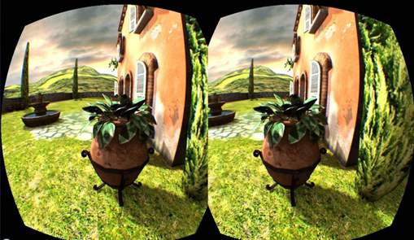
<Dual Display for Stereoscopic Image>
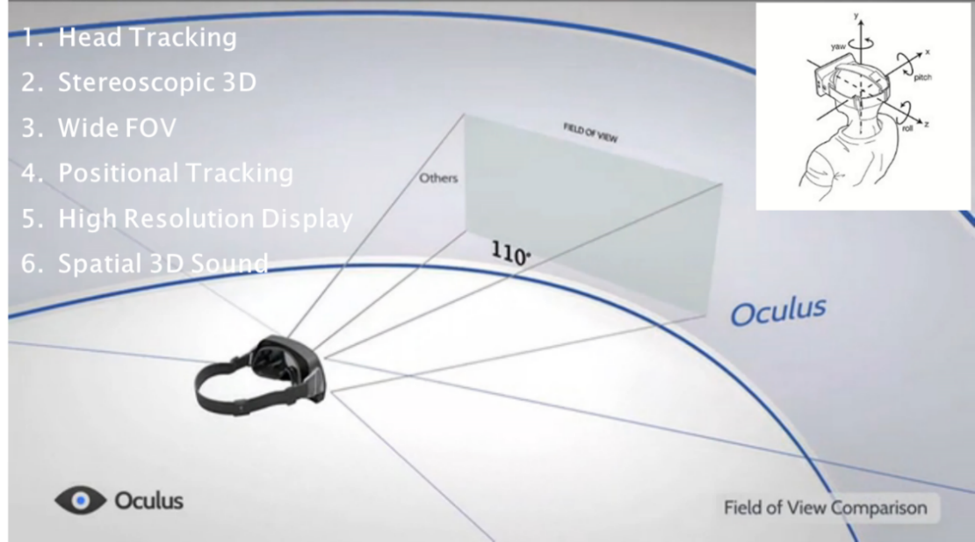
<HMD Properties for VR>
While the multimedia data streaming of the Full HD class can be handled using the IMT-Advanced network, many virtual reality applications require IMT-2020 technologies as already presented in detail at the Warsaw meeting held in September 2016.
Therefore, the virtual reality service itself could bring a great influence on the related industries. And as the demands of the VR services grow, the relevant markets may grow as well.
But, the virtual reality service has some problems to be solved to move forward.
Firstly, when an HMD (head-mounted display) is used as a tool for the virtual reality service, it contacts the user’s face directly, and it may give an unpleasant feeling to other users sharing the same device. For example, when a woman having thick makeup uses the device, it can leave some cosmetic residue in the device and likewise a man may leave some sweat in the device after using it. Therefore it is not appropriate to share the device. However, the HMD is an expensive personal device which costs at least $200.
Secondly, there is a problem called a VR sickness. People view stereoscopic images, by the parallax from both eyes. Therefore, a little VR sickness is difficult to avoid due to the created phase difference. The level of the VR sickness may be different person to person, but we hope that some solution for that can be found soon.
Thirdly, there is a problem called the reset syndrome. The reset syndrome is a symptom that a person cannot escape from the VR which he or she has just experienced, and stays in the VR for a while and cause some troubles. This symptom may sometimes include a violence, which causes social problems such as self-injury and suicide.
Even though the VR provides great benefits to consumers, these problems had better be solved, well before the virtual reality service proliferates.
The PAR of IEEE P3333.3 was submitted to solve the Human Factor problem of HMD based 3D content. Its approval of the Sponsor Group was already completed, and the decision will be made at the NesCom meeting on December 6, 2016.
Therefore, we introduce the proposed IEEE P3333.3.

Introduction to IEEE P3333.3

P3333.3 (New)
Submitter Email:ceo@joyfun.kr
Type of Project:New IEEE Standard
PAR Request Date: 10-Aug-2016
PAR Approval Date:
PAR Expiration Date:
Status: Unapproved PAR, PAR for a New IEEE Standard

1.1 Project Number:P3333.3
1.2 Type of Document: Standard
1.3 Life Cycle: Full Use

2.1 Title:
HMD based 3D Content Motion Sickness Reducing Technology
3.1 Working Group: Working Group of Technology for 3D Sickness protection based on HMD (C/SAB/P3333.3_WG)
Contact Information for Working Group Chair
Name:Dongil Seo
Email Address:dillon@volercreative.com
Phone:+82-10-3135-3194
Contact Information for Working Group Vice-Chair
None
Contact Information for Working Group Secretary
Name:Sangkwon Jeong
Email Address:ceo@joyfun.kr
Phone:+82-10-8667-7329

3.2 Sponsoring Society and Committee: IEEE Computer Society/Standards Activities Board (C/SAB)
Contact Information for Sponsor Chair
Name:
Email Address:
Phone:
Contact Information for Standards Representative
Name:
Email Address:
Phone:

4.1 Type of Ballot: Individual
4.2 Expected Date of submission of draft to the IEEE-SA for Initial Sponsor Ballot: Dec / 2016
4.3 Projected Completion Date for Submittal to RevCom: Oct / 2018

5.1 Approximate number of people expected to be actively involved in the development of this project: 40

5.2 Scope: This standard is setting a technical guidance to resolve VR sickness caused by the visual mechanism set by the HMD based 3D content motion sickness through the study of:

visual response to the focal distortion
visual response to the lens materials
visual response to the lens refraction ratio
visual response to the frame rate

5.3 Is the completion of this standard dependent upon the completion of another standard: No
5.4 Purpose: This document will not include a Purpose clause

5.5 Need for the Project: HMD based 3D content is being used in various fields such as games, medical, education and art through Mixed Reality (VR and AR included) technology. However, a motion sickness, known as a 3D sickness and considered as one of the most critical problems, has not been resolved even though it is highly utilized.
Major companies from various regions such as the United States, Europe, Japan, China and Taiwan are releasing many devices and commercializing them but the industrial expansion will reach its limit if this 3D sickness problem is not resolved.
To overcome this limit, we are suggesting a minimum guideline as a standard by studying some of the 3D sickness originating factors such as focal distortion, lens materials, lese refraction and frame rates per second.
Moreover, our attempt to resolve this 3D sickness problem will facilitate the development of HMD based 3D content and will influence the 3D content developers, service providers, HMD manufacturers, HMD based content service providers and 3D display panel manufacturers very positively in developing a healthy ecosystem.
Therefore, a standard to reduce the motion sickness caused by HMD based 3D content needs to be established in order to protect the user’s health and safety and develop the ecosystem.

5.6 Stakeholders for Standards: 3D Content, 3D Games, 3D Display Content, 3D Educational Content, 3D Movie Producers, 3D Monitors, 3D Display Panel and 3D Device Manufacturers;
.

Intellectual Property
6.1.a. Is the Sponsor aware of any copyright permissions needed for this project?:No
6.1.b. Is the Sponsor aware of possible registration activity related to this project?:No

7.1 Are there other standards or projects with a similar scope?: No
7.2 Joint Development
Is it the intent to develop this document jointly with another organization?:No

8.1Additional Explanatory Notes (Item Number and Explanation):
In order to support this research, we need to collaborate with many International Experts. Technically, we also need a working group and a project related to this group. This project will be a technical sponsor that determines the importance of this technology standard problem. This project will be available world-wide so many industrial circles and academia are expected to participate.
In Korea, HMD based 3D content developers consider this 3D sickness as a serious problem and many research projects are being conducted to resolve this. Also, it is known that many global companies are conducting the same research.
When WG starts, this will open to everyone. We will encourage many companies related to MR, VR service as well as many R&D centers from academia to participate and expect them to join this project.
The main objective for this standard is to establish a minimum guideline that can create an environment for users to use the HMD based MR, VR service 3D content safely.
The variables this standard include focal distortion, lens materials, lens refraction and FPS. Also, the project will provide the minimum guideline for these variables.

