|  |  |
| --- | --- |
| Project | **IEEE 802.21.1 Media Independent Services**  **<**[**http://www.ieee802.org/21/**](http://www.ieee802.org/21/)**>** |
| Title | **Proposed remedy for SB comments # i-7 and i-15 of P802.21.1/D04 draft** |
| DCN | **21-16-0107-00-SAUC** |
| Date Submitted | **September 13, 2016** |
| Source(s) | Hyeong-Ho Lee (ETRI) |
| Re: | Session #76, Warsaw, Poland |
| Abstract | This contribution proposes to modify Figure M.1 and related text of Annex M in IEEE P802.21.1/D04 draft. To resolve the SB comments # i-7 and i-15 of IEEE P802.21.1/D04 draft, IEEE 802.11u in the text has been changed to IEEE Std 802.11-2012, and IEEE 802.11u in Figure M.1 has been changed to IEEE 802.11. |
| Purpose | Disposition details for SB comments # i-7 and i-15 of P802.21.1/D04 draft. |
| Notice | This document has been prepared to assist the IEEE 802.21 Working Group. It is offered as a basis for discussion and is not binding on the contributing individual(s) or organization(s). The material in this document is subject to change in form and content after further study. The contributor(s) reserve(s) the right to add, amend or withdraw material contained herein. |
| Release | The contributor grants a free, irrevocable license to the IEEE to incorporate material contained in this contribution, and any modifications thereof, in the creation of an IEEE Standards publication; to copyright in the IEEE’s name any IEEE Standards publication even though it may include portions of this contribution; and at the IEEE’s sole discretion to permit others to reproduce in whole or in part the resulting IEEE Standards publication. The contributor also acknowledges and accepts that IEEE 802.21 may make this contribution public. |
| Patent Policy | The contributor is familiar with IEEE patent policy, as stated in [Section 6 of the IEEE-SA Standards Board bylaws](http://standards.ieee.org/guides/opman/sect6.html#6.3) <[http://standards.ieee.org/guides/bylaws/sect6-7.html#6](http://127.0.0.1:4664/cache?event_id=757737&schema_id=1&s=5X0vID10lu_E6yrIkWkNd4Wz2H8&q=hancock)> and in *Understanding Patent Issues During IEEE Standards Development* <http://standards.ieee.org/board/pat/faq.pdf> |

**Comment # i-7**

IEEE 802.11u was superseded by IEEE 802.11-2012 in 2012, so this reference is no longer valid. Within IEEE 802.11REVmc D6.0, the term ANQP request is now used as opposed to ANQP query.

In addition, this clause does not state what an ANQP query is used for.

Change the following text on P209L4 from "IEEE 802.11u(TM) defines a mechanism for the AP to contact an external information service upon receiving an ANQP query from an MN." to "IEEE 802.11 defines a mechanism for the AP to contact an external information service upon receiving from an MN, an ANQP request for data associated with network resources."

**Comment # i-15**

IEEE 802.11u in the text and Figure M.1 should be IEEE 802.11 or IEEE 802.11-2012.

**Disposition Detail:**

IEEE 802.11™-2012 defines a mechanism for the AP to contact an external information service upon receiving from MN, an ANQP query for data associated with network resources. The functionality of the proxy information server is used to simplify the interaction of the AP with heterogeneous information services such as MIIS or ANDSF.

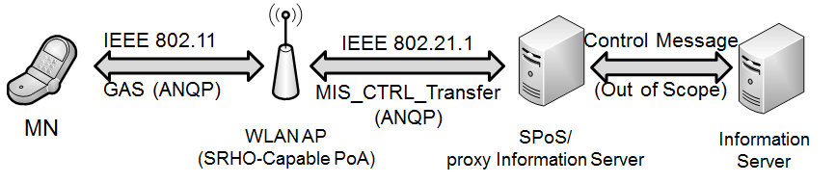

**Figure M.1—ANQP message transfer using proxy information server**