Project | IEEE 802.21.1 Media Independent Services  <http://www.ieee802.org/21/>
Title | Proposed remedy for SB comment # i-2 on Figure B.4 in P802.21.1/D04 draft
DCN | 21-16-0106-02-SAUC
Date Submitted | September 13, 2016
Source(s) | Hyeong-Ho Lee (ETRI)
Re: | Session #76, Warsaw, Poland
Abstract | To resolve the SB comment # i-2 of IEEE P802.21.1/D04 draft, this contribution proposes to modify Figures B.3 and B.4, and related texts of Annex B in IEEE P802.21.1/D04 draft.
Purpose | Disposition details for SB comment # i-2 on Figure B.4 in P802.21.1/D04 draft.
Notice | This document has been prepared to assist the IEEE 802.21 Working Group. It is offered as a basis for discussion and is not binding on the contributing individual(s) or organization(s). The material in this document is subject to change in form and content after further study. The contributor(s) reserve(s) the right to add, amend or withdraw material contained herein.
Release | The contributor grants a free, irrevocable license to the IEEE to incorporate material contained in this contribution, and any modifications thereof, in the creation of an IEEE Standards publication; to copyright in the IEEE’s name any IEEE Standards publication even though it may include portions of this contribution; and at the IEEE’s sole discretion to permit others to reproduce in whole or in part the resulting IEEE Standards publication. The contributor also acknowledges and accepts that IEEE 802.21 may make this contribution public.
Patent Policy | The contributor is familiar with IEEE patent policy, as stated in Section 6 of the IEEE-SA Standards Board bylaws <http://standards.ieee.org/guides/bylaws/sect6-7.html#6> and in Understanding Patent Issues During IEEE Standards Development http://standards.ieee.org/board/pat/faq.pdf

Comment # i-2
Within Figure B.4 what does the message "Query Content - List of SSPNs?" mean? There doesn't appear to be any corresponding message of that name within IEEE 802.11 or IEEE 802.21.
Add a reference or note to the Figure explaining where the message "Query Content" is defined.

Disposition detail:
In Figure B.3, change SSPN #1 and SSPN #2 to SP #1 and SP #2 respectively, since IEEE 802.21 defines service provider (SP) IE instead of subscription service provider network (SSPN) IE.
In Figure B.4, change "GAS initial request (request IE, APID) Query content (“list of SSPNs?”)" to "GAS initial request (Request element, APID, Query Request (list of SP_IDs))".
In Figure B.4, change "Interworking IE" and "request IE" to "Interworking element" and "Request element", respectively.
Change the title of Figure B.4 from "Use case: query SSPN list" to "Use case: query Service Provider list"
On page 178 line 13, change "subscription service provider networks (SSPNs)" and “SSPNs” to "Service Providers (SPs)" and "SPs", respectively.

Page 178 line 13:

  - Query list of service providers (SPs): The STA sends out a query asking for a list of available SPs. The query is defined using an IEEE 802.21 specific MIS frame. The MIS frame is then relayed by the AP to the MIIS. Meanwhile the AP sends out the initial GAS response to the STA with initial delay (comeback delay).

Page 12 line 11: add the following.
SP service provider

Page 178 Figure B.3: modify the figure as following.

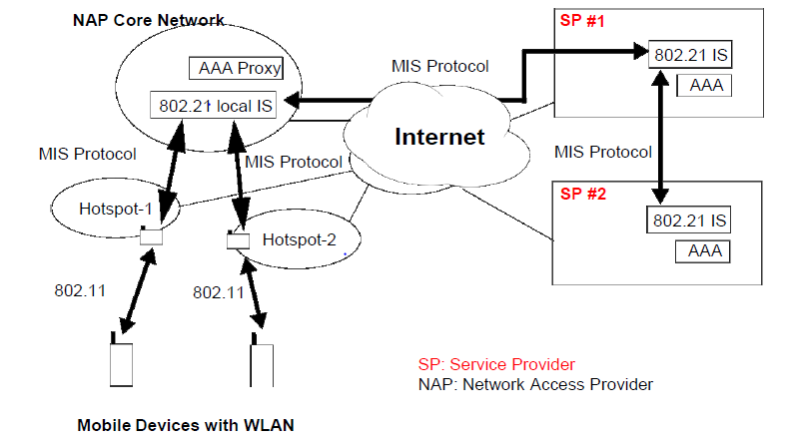
Figure B.3—Network selection in WLAN with IEEE 802.11 and IEEE 802.21

Page 178 Figure B.4: modify the figure as following.
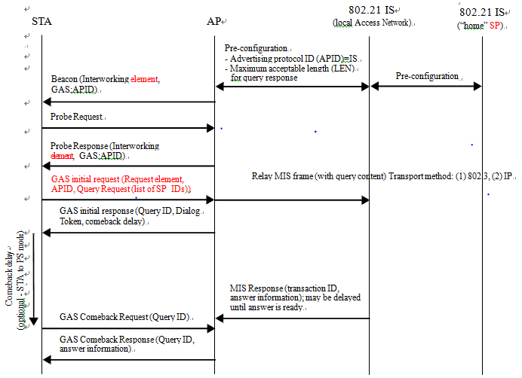

Figure B.4—Use case: query Service Provider list

