Project | IEEE 802.21.1 Media Independent Services  <http://www.ieee802.org/21/>
Title | Proposed remedy for SB comment # i-2 on Figure B.4 in P802.21.1/D04 draft
DCN | 21-16-0106-00-SAUC
Date Submitted | September 13, 2016
Source(s) | Hyeong-Ho Lee (ETRI)
Re: | Session #76, Warsaw, Poland
Abstract | This contribution proposes to modify Figure B.4 of Annex B in IEEE P802.21.1/D04 draft. To resolve the SB comment # i-2 of IEEE P802.21.1/D04 draft, "GAS initial request (request IE, APID) Query content (“list of SSPNs?”)" has been changed to "GAS initial request (request IE, APID, Query content (“list of SSPNs?”))" in Figure B.4.
Purpose | To propose remedy for SB comment # i-2 on Figure B.4 in P802.21.1/D04 draft.
Notice | This document has been prepared to assist the IEEE 802.21 Working Group. It is offered as a basis for discussion and is not binding on the contributing individual(s) or organization(s). The material in this document is subject to change in form and content after further study. The contributor(s) reserve(s) the right to add, amend or withdraw material contained herein.
Release | The contributor grants a free, irrevocable license to the IEEE to incorporate material contained in this contribution, and any modifications thereof, in the creation of an IEEE Standards publication; to copyright in the IEEE’s name any IEEE Standards publication even though it may include portions of this contribution; and at the IEEE’s sole discretion to permit others to reproduce in whole or in part the resulting IEEE Standards publication. The contributor also acknowledges and accepts that IEEE 802.21 may make this contribution public.
Patent Policy | The contributor is familiar with IEEE patent policy, as stated in Section 6 of the IEEE-SA Standards Board bylaws <http://standards.ieee.org/guides/bylaws/sect6-7.html#6> and in Understanding Patent Issues During IEEE Standards Development http://standards.ieee.org/board/pat/faq.pdf

Comment # i-2
Within Figure B.4 what does the message "Query Content - List of SSPNs?" mean? There doesn't appear to be any corresponding message of that name within IEEE 802.11 or IEEE 802.21.
Add a reference or note to the Figure explaining where the message "Query Content" is defined.

Proposed remedy:
In Figure B.4, "GAS initial request (request IE, APID) Query content (“list of SSPNs?”)" has been changed to "GAS initial request (request IE, APID, Query content (“list of SSPNs?”))"

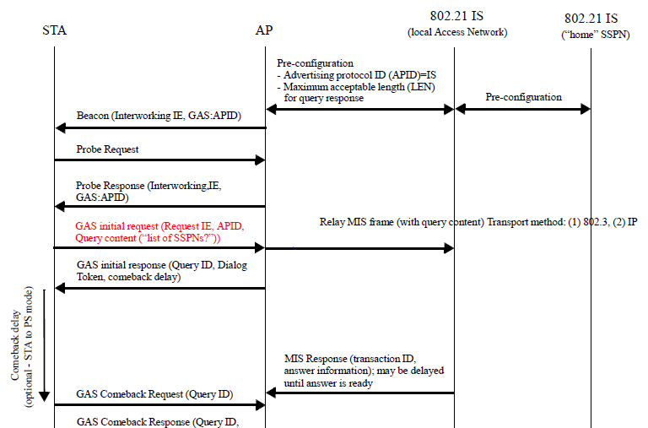

Figure B.4—Use case: query SSPN list

