IEEE P802.21.1
Media Independent Services
Comment and Proposed Remedy
on Radio Resource Management
of IEEE P802.21.1/D04 Draft
Date: 2016-09-10
Author(s):
Name | Affiliation | Address | Phone | email
Hyunho Park,  Hyeong-Ho Lee | ETRI |  |  | hyunhopark@etri.re.kr,  holee@etri.re.kr
Abstract
This document provides a comment and proposed remedy on radio resource management of IEEE P802.21.1/D04 draft to support radio resource management. We propose to modifiy Figure 26 of IEEE P802.21.1/D04 draft for consistency with its texts.

Comment and Proposed Remedy on Radio Resource Management of IEEE P802.21.1/D04 Draft

1. Modifications of Figure 26 (in page 118) for radio resource management
- Please change “Report of stataus or resource allocation of PoS(PoA)-A’s link layer” into “Report of stataus or resource allocation of PoS(PoA)-B’s link layer.”
- Please change two arrows that locate between MN-A and PoS(PoA)-A into an arrow.
- Please change “PoS-A” in description of MN-A into “PoS(PoA)-A.”
- The following figure shows modification of Figure 26 with red marks reflecting the above comments.

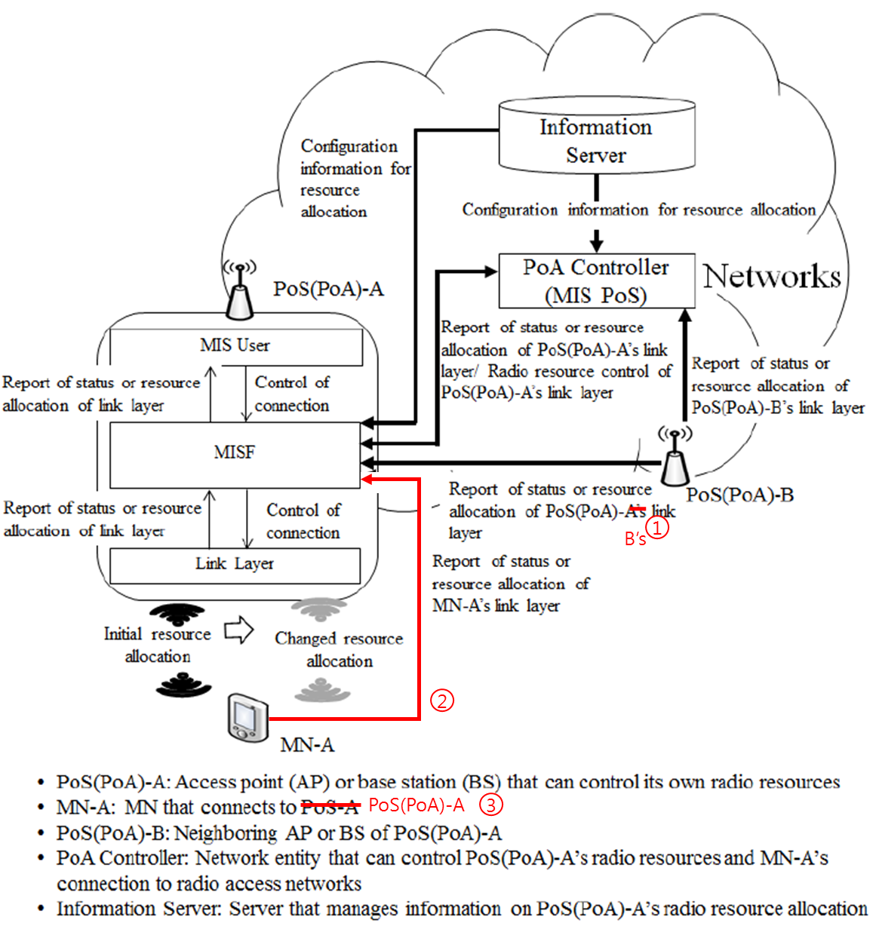
<Modified Figure 26>

