Project | IEEE 802.21.1 Media Independent Services  <http://www.ieee802.org/21/>
Title | MIH for VR Content based HMD
DCN | 21-16-0097-00-0000
Date Submitted | Aug 25, 2016
Source(s) | Sangkwon Peter Jeong, Gookhwan Lee, Hyunsam Kang (JoyFun Inc.,)  Heeseob Lee (SecuAce)  Changhwa Lyou (Seeroo Infomation)  Junghun Kim (TTA)
Re: | Session #76, Warsaw, Poland
Abstract | This document suggests utilizing MIHF to prevent Data Packet Losses that happens when Vertical Handover takes place from faster mobile communication environment like IMT-2020 to much slower mobile communication environment.
Purpose | Propose to new use case
Notice | This document has been prepared to assist the IEEE 802.21 Working Group. It is offered as a basis for discussion and is not binding on the contributing individual(s) or organization(s). The material in this document is subject to change in form and content after further study. The contributor(s) reserve(s) the right to add, amend or withdraw material contained herein.
Release | The contributor grants a free, irrevocable license to the IEEE to incorporate material contained in this contribution, and any modifications thereof, in the creation of an IEEE Standards publication; to copyright in the IEEE’s name any IEEE Standards publication even though it may include portions of this contribution; and at the IEEE’s sole discretion to permit others to reproduce in whole or in part the resulting IEEE Standards publication. The contributor also acknowledges and accepts that IEEE 802.21 may make this contribution public.
Patent Policy | The contributor is familiar with IEEE patent policy, as stated in Section 6 of the IEEE-SA Standards Board bylaws <http://standards.ieee.org/guides/bylaws/sect6-7.html#6> and in Understanding Patent Issues During IEEE Standards Development http://standards.ieee.org/board/pat/faq.pdf

< IMT-2020 vs WLAN vs IMT-Advanced>
 | IMT-Advanced | WLAN(802.11ac) | IMT-2020
Peak data rate | 1 Gbps | 7Gbps | 20 Gbps
User experienced data rate | 10 Mbps  (urban/suburban) | 300Mpbs  (urban/suburban) | 100 Mbps (urban/suburban), 1Gbps (hotspots)
Mobility | 350 Km/h | N/A | 500 Km/h
Area traffic capacity | 0.1 Mbps/ m2 | N/A | 10 Mbps/ m2
Generally, most contents and application services have an advantage that can service in a better condition if the transmission speed of network is fast, but there is no case that service is unavailable as the net speed is slow.
However, Virtual Reality(VR) Service based on HMD become unavailable.
In case of Google, VR service based on HMD requires the service environment at least higher than 4K UHD graphics resolution and faster than 90Frame video playback speed per seconds. To meet these requirements, mobile communication environment should ensure at least IMT-Advanced.
The mobile communication environments that can serve VR service based on HMD are limited to Wi-Fi, IMT-Advanced and IMT-2020. Most experts anticipate that IMT-2020 will be the optimum environment.
Therefore, in IEEE 802.21 WG, only six cases needs to be paid attention in the perspective of Vertical Handover.
IMT-Advanced to IMT-2020
WLAN to IMT-2020
IMT-Advanced to WLAN
WLAN to IMT-Advanced
IMT-2020 to IMT-Advanced
IMT-2020 to WLAN

However, when Vertical Handover occurs from an environment with relatively slower data transfer speed to an environment with faster data transfer speed, there is no problem. Still, when an abrupt change in data transfer speed occurs, for example, Vertical Handover from IMT-2020 to IMT-Advanced, a communication environment with more than 10 times the speed of IMT-2020, severe problems emerge. Data process capacity is reduced to one-hundredth, resulting in sudden data packet losses.
In this situation, connection to Wireless Internet can be meaningless.
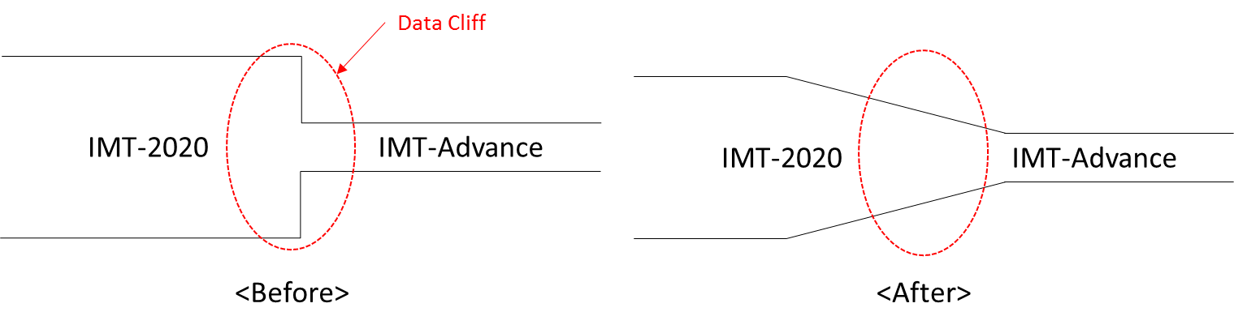

Therefore, when Virtical Handover happens from the IMT-2020 environment to IMT-Advanced or WLAN, to prevent Packet damage occurred from rapid change of Data Rate and Capacity, it is meaningful to make the change of Data Rate and Capacity smooth by using MIHF(Media Independent Handover Function).
Once the final speed has been reduced, the data transfer speed is adjusted with respect to the initial speed. Then, MIHF only has to intervene at the time of data change occurs. Thereafter, only thorough data packet management is needed to provide smooth VR services.
MIHF only takes charge of command control and not directly controls packet data. Therefore, make a setting to control packet data by utilizing MIHF. Consequently enable to control if the speed of the network is reduced below a certain level.
Considering that MIHF made the role of Management such as Data Repository and Time Scheduler possible, it is possible enough.

Proposal
​This suggester is not a network specialist but a service provider, so doesn't have enough expert knowledge.
Thus brings up a problem as a service provider, and hopes the network specialists on Heterogeneous handover offer a solution to this problem. If the standard which reflects the needs of the service industry is created, it will become a very valuable standard.

