Project | IEEE 802.21.1 Media Independent Services  <http://www.ieee802.org/21/>
Title | IMT-2020 Specification Report for New Proposal
DCN | 21-16-0090-00-SAUC
Date Submitted | July 25, 2016
Source(s) | Sangkwon Peter Jeong, Gookhwan Lee, Hyunsam Kang (JoyFun)  Jinho Jeong (GreenColud)  Hyounwoo Nam (Dongduk Women’s University)
Re: | Session #75, san Diego, USA
Abstract | MIH requirements specification for data transportation between IMT-2020 and other networks
Purpose | Propose to new use case
Notice | This document has been prepared to assist the IEEE 802.21 Working Group. It is offered as a basis for discussion and is not binding on the contributing individual(s) or organization(s). The material in this document is subject to change in form and content after further study. The contributor(s) reserve(s) the right to add, amend or withdraw material contained herein.
Release | The contributor grants a free, irrevocable license to the IEEE to incorporate material contained in this contribution, and any modifications thereof, in the creation of an IEEE Standards publication; to copyright in the IEEE’s name any IEEE Standards publication even though it may include portions of this contribution; and at the IEEE’s sole discretion to permit others to reproduce in whole or in part the resulting IEEE Standards publication. The contributor also acknowledges and accepts that IEEE 802.21 may make this contribution public.
Patent Policy | The contributor is familiar with IEEE patent policy, as stated in Section 6 of the IEEE-SA Standards Board bylaws <http://standards.ieee.org/guides/bylaws/sect6-7.html#6> and in Understanding Patent Issues During IEEE Standards Development http://standards.ieee.org/board/pat/faq.pdf

<Last Proposal>
VR content streaming service in IMT-2020
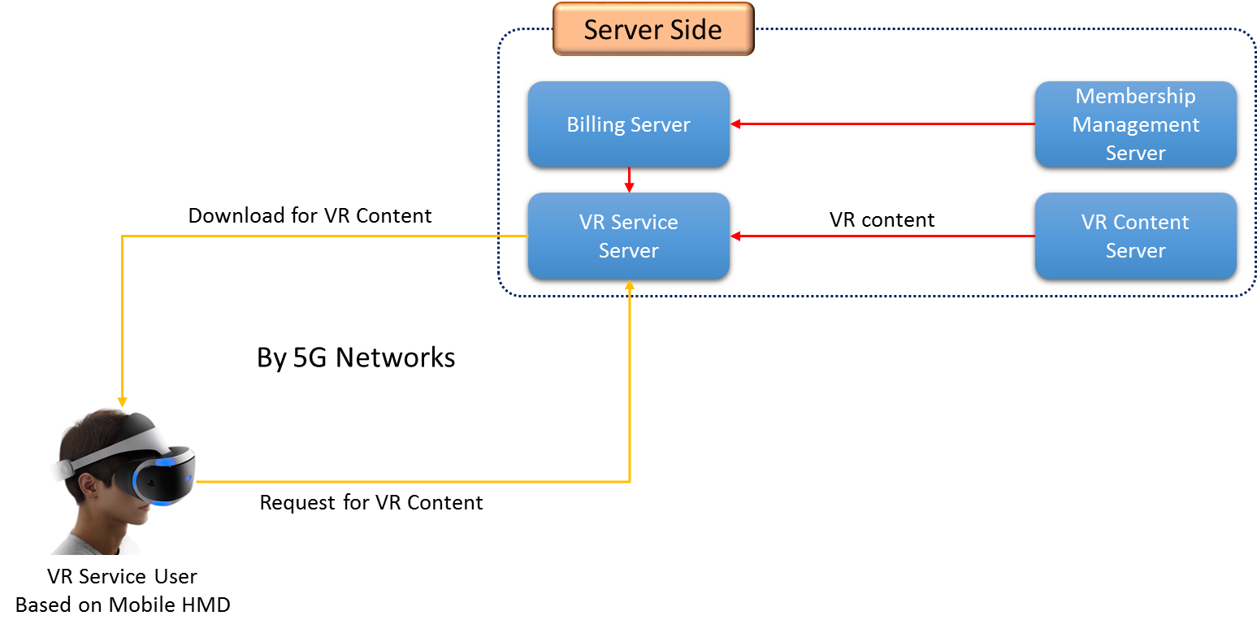
- —VR Content streaming service in IMT-2020

Recently, IMT-2020 network has attracted attention.
In specially, the need for IMT-2020 network has been further emphasized while receiving a lot of attention HMD-based VR services.
According to this trend, it is believed that would not require that the response in IEEE802.21.
For example, simulate a composed process HMD-based VR services, and what's what things in this process, and, IMT-2020 and vertical handover is if there are any advantages to be used by MIH and MIS in network environments where occur discussion let's do this.
I think that the proposal to require new standards for the handover to the service from IMT-2020 environment.

IMT-2020 Specification

- IMT-2020 Parameters
  - User experienced data rate: 100 Mbps (urban/suburban), 1Gbps (hotspots)
  - Peak data rate: 20 Gbps
  - Mobility: 500 Km/h
  - Latency: 1 ms (radio interface)
  - Connection density: 10⁶/Km²
  - Energy efficiency: 100 times vs 4G
  - Spectrum efficiency: 3 times vs 4G
  - Area traffic capacity: 10 Mbps/ m²

- IMT-2020 Service scenarios
  - Enhanced Mobile Broadband
  - Massive machine type communications
  - Ultra-reliable and low latency communications

- Compare with IMT-Advanced(4G)
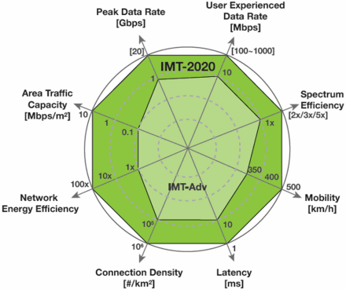
Figure 2 Enhancement of key capabilities from IMT-Adv (4G) to IMT-2020 (5G)
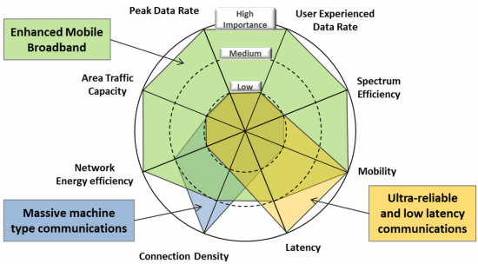
Figure 3 The importance of key capabilities in different usage scenarios

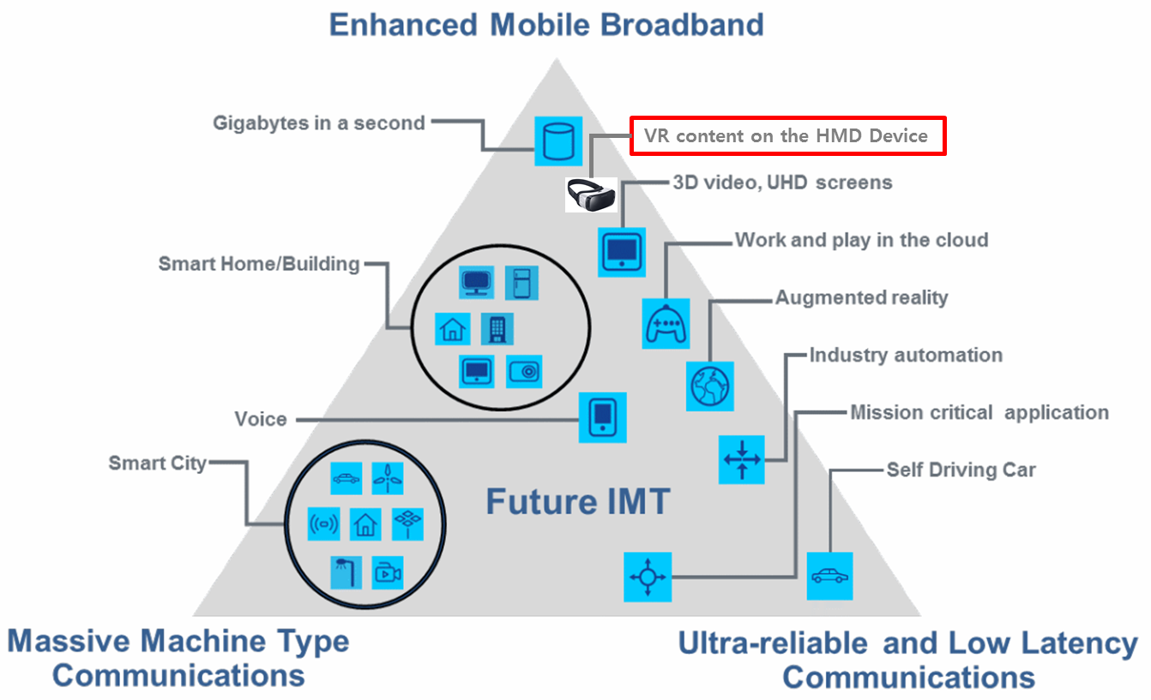
Figure 4 usage Scenarios of IMT for 2020 and beyond.

VR content based HMD don’t available under IMT-Advance(4G) speed.
Because, VR content need a 4K graphics resource.
Therefore, we don’t have consider to other cases.
We should consider to just 3 cases scenario.
- Between IMT-2020 and Wi-Fi.
- Between IMT-2020 and IMT-Advance.
- Between Wi-Fi and IMT-Advance.
These case are very simple.

Recommendation ITU-R M.[IMT.Vision], document 5/199, “Framework and overall objectives of the future development of IMT for 2020 and beyond” [adopted in July 2015]

