|  |  |
| --- | --- |
| Project | **IEEE 802.21.1 Media Independent Services**  **<**[**http://www.ieee802.org/21/**](http://www.ieee802.org/21/)**>** |
| Title | **Proposed remedy for Cmt #4 of LB11** |
| DCN | **21-16-0074-02-SAUC** |
| Date Submitted | **May 16, 2016** |
| Source(s) | Yoshikazu Hanatani (Toshiba), Lily Chen (NIST), Subir Das (ACS) |
| Re: | Session #74, Big Island, HI, USA |
| Abstract | Figure 2 in 21.1 draft describes a general model of Single radio handover functional model. To solve Cmt #4, this contribution proposes to add an explanation text for a special case. |
| Purpose | Suggested remedy for Cmt #4 in LB11. |
| Notice | This document has been prepared to assist the IEEE 802.21 Working Group. It is offered as a basis for discussion and is not binding on the contributing individual(s) or organization(s). The material in this document is subject to change in form and content after further study. The contributor(s) reserve(s) the right to add, amend or withdraw material contained herein. |
| Release | The contributor grants a free, irrevocable license to the IEEE to incorporate material contained in this contribution, and any modifications thereof, in the creation of an IEEE Standards publication; to copyright in the IEEE’s name any IEEE Standards publication even though it may include portions of this contribution; and at the IEEE’s sole discretion to permit others to reproduce in whole or in part the resulting IEEE Standards publication. The contributor also acknowledges and accepts that IEEE 802.21 may make this contribution public. |
| Patent Policy | The contributor is familiar with IEEE patent policy, as stated in [Section 6 of the IEEE-SA Standards Board bylaws](http://standards.ieee.org/guides/opman/sect6.html#6.3) <[http://standards.ieee.org/guides/bylaws/sect6-7.html#6](http://127.0.0.1:4664/cache?event_id=757737&schema_id=1&s=5X0vID10lu_E6yrIkWkNd4Wz2H8&q=hancock)> and in *Understanding Patent Issues During IEEE Standards Development* <http://standards.ieee.org/board/pat/faq.pdf> |

Comment: The terminologies of "source network" PoS and "target network" PoS imply when an MN handovers from the source network to a target network, it essentially needs to handover the service. Is it possible that when an MN handovers from a source network PoA to a target network PoA, the same PoS can be used for such handover?

Suggested remedy:

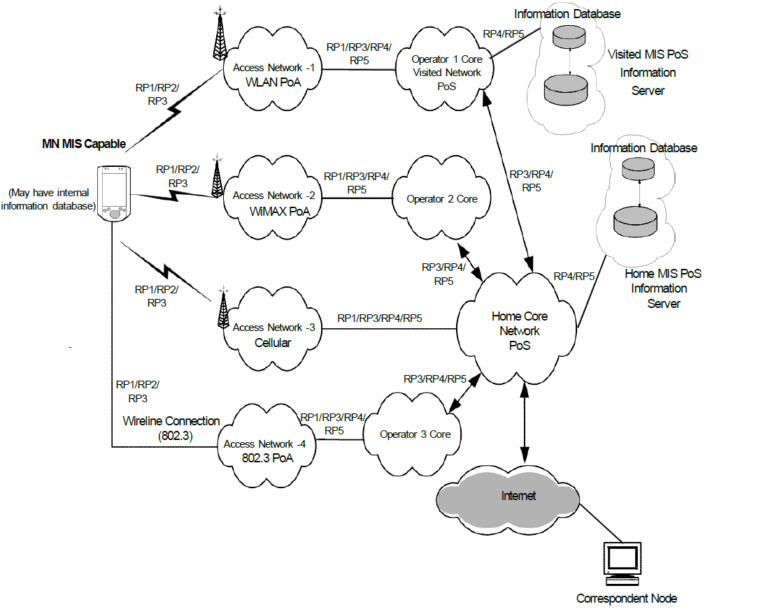

1. —Example of network model with MIS services

**5.3.3 Single radio handover functional model and signaling flow**

The functional model for single radio handover is shown in Figure 2.



**Figure 2 Single radio handover functional model**

~~The services in the source network are: SPoS (the source network PoS) and the proxy Information Server (see 5.5). The services in the target network are: TPoS and the proxy PoA.~~

In the above scenario, SPoS is providing the service to the source network users, in which the proxy information server (see 5.5) is co-located. Source network users are connected via source PoA. The TPoS belongs to the target network and provides the service to the target networks users that are connected via target PoA. It is not always necessary that a source PoA and a target PoA are need to be served by two different PoSes. A PoS may cover a plurality of networks. In that case, the source PoS and target PoS are collocated and an MN can handover from the source PoA to the target PoA using the same PoS. This scenario is captured in Figure 1 (Clause 5.3.1).