Project | IEEE 802.21.1 Media Independent Services  <http://www.ieee802.org/21/>
Title | New Proposal for Services and Use cases
DCN | 21-16-0067-00-SAUC
Date Submitted | May 15, 2016
Source(s) | Sangkwon Peter Jeong, Gookhwan Lee, Hyunsam Kang (JoyFun)  Heeseob Lee (SecuAce)  Changhwa Lyou (Seeroo Infomation)
Re: | Session #74, HI, USA
Abstract | When receiving the streaming content from the 5G networks, consider the case of vertical handover occurs service.
Purpose | Propose to new use case
Notice | This document has been prepared to assist the IEEE 802.21 Working Group. It is offered as a basis for discussion and is not binding on the contributing individual(s) or organization(s). The material in this document is subject to change in form and content after further study. The contributor(s) reserve(s) the right to add, amend or withdraw material contained herein.
Release | The contributor grants a free, irrevocable license to the IEEE to incorporate material contained in this contribution, and any modifications thereof, in the creation of an IEEE Standards publication; to copyright in the IEEE’s name any IEEE Standards publication even though it may include portions of this contribution; and at the IEEE’s sole discretion to permit others to reproduce in whole or in part the resulting IEEE Standards publication. The contributor also acknowledges and accepts that IEEE 802.21 may make this contribution public.
Patent Policy | The contributor is familiar with IEEE patent policy, as stated in Section 6 of the IEEE-SA Standards Board bylaws <http://standards.ieee.org/guides/bylaws/sect6-7.html#6> and in Understanding Patent Issues During IEEE Standards Development http://standards.ieee.org/board/pat/faq.pdf

VR content streaming service in 5G Networks
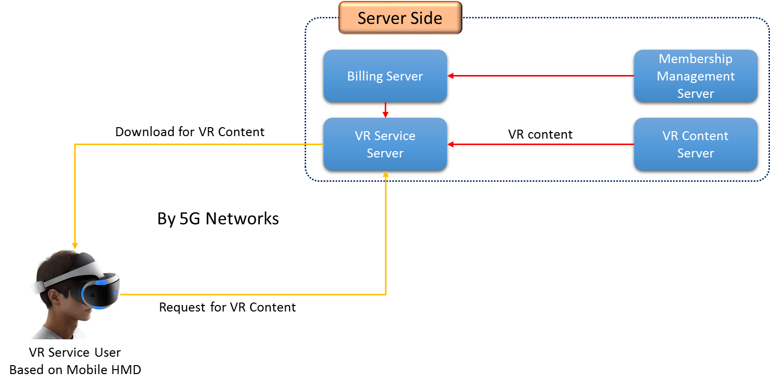
- —VR Content streaming service in 5G Networks

Recently, 5G network has attracted attention.
In specially, the need for 5G network has been further emphasized while receiving a lot of attention HMD-based VR services.
According to this trend, it is believed that would not require that the response in IEEE802.21.
For example, simulate a composed process HMD-based VR services, and what's what things in this process, and, 5G networks and vertical handover is if there are any advantages to be used by MIH and MIS in network environments where occur discussion let's do this.
I think that the proposal to require new standards for the handover to the service from 5G environment.

