IEEE P802.21.1
Media Independent Services
Proposed Modification of Figures 36 & 37 and Related Texts in IEEE P802.21.1 D01.1 Draft
Date: 2016-03-15
Author(s):
Name | Affiliation | Address | Phone | email
Hyeong-Ho Lee | ETRI |  |  | holee@etri.re.kr
Abstract
This document proposes modification of Figures 36 & 37 and related texts in IEEE P802.21.1 D01.1 draft.

8.2.3.2.1 Request for preparation of MN’s connection from PoS(PoA)
PoS(PoA) requests MN to prepare connection with newly allocated radio resources by using MIS_Link_Preparation primitive/message that is use case specific one, as shown in Figure 36. The primitive and message of MIS_Link_Preparation include information on PoS(PoA)’s newly allocated radio resources (e.g., frequency band and transmit power). The MN-A connects to PoS(PoA)-A, and thus MN-A can be requested to prepare connection with new radio resources by PoS(PoA)-A.
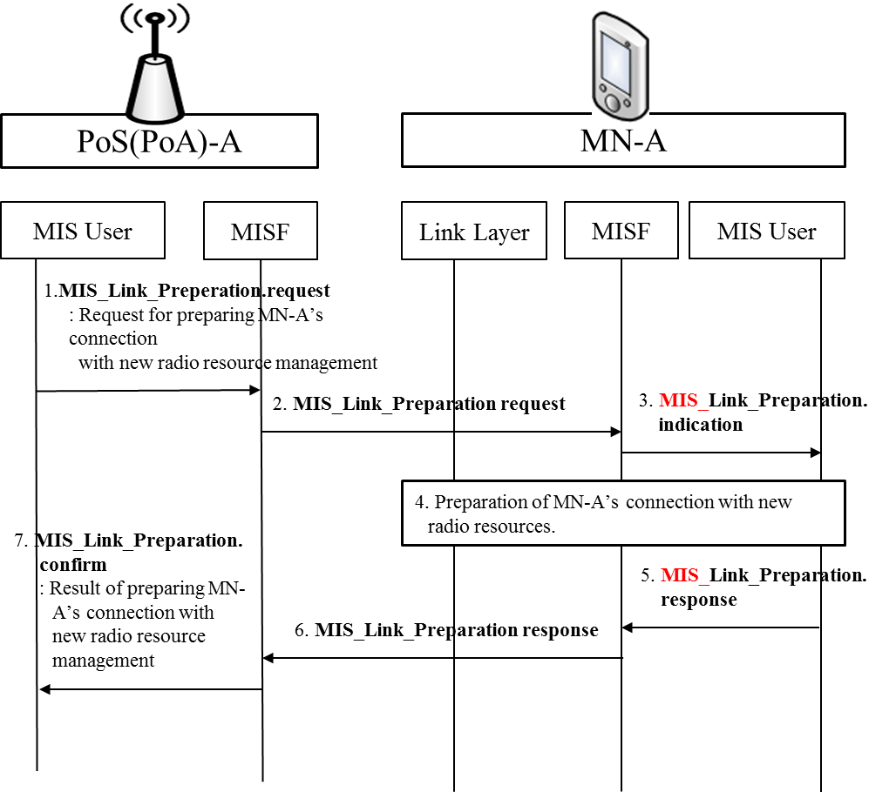
Figure 36—PoS(PoA)-A requests MN-A to prepare connection with newly allocated radio resources

- PoS(PoA)-A’s MIS user sends MIS_Link_Preperation.request primitive to PoS(PoA)-A’s MISF.
- PoS(PoA)-A’s MISF sends MIS_Link_Preparation request message to MN-A’s MISF.
- MN-A’s MIS user is informed of new radio resources to prepare MN’s connection by MIS_Link_Preparation.indication primitive.
- MN-A prepares the connection with new radio resources.
- MN-A’s MIS user sends MIS_Link_Preparation.response to MN-A’s MISF.
- MN-A’s MISF sends MIS_Link_Preparation response message to PoS(PoA)-A’s MISF.
- PoS(PoA)-A’s MIS user receives result of preparing MN-A’s connection with new radio resources by MIS_Link_Preparation.confirm.

8.2.3.2.2 Request for preparation of MN’s connection from PoA Controller
PoA Controller also can request MN to prepare connection with newly allocated resources by using MIS_Link_Preparation primitive/message that is use case specific one, as shown in Figure 37.
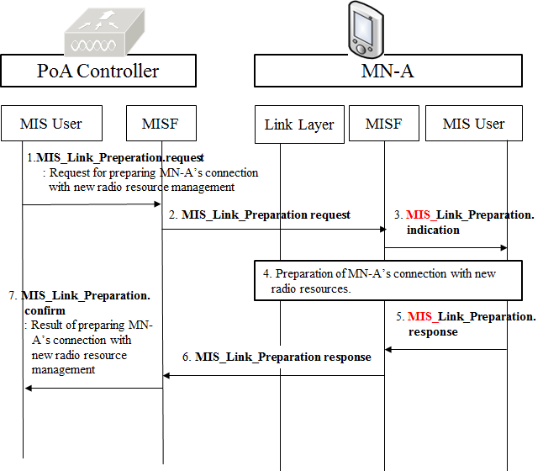
Figure 37—PoA Controller requests MN-A to prepare connection with newly allocated radio resources

- MIS user of PoA Controller sends MIS_Link_Preperation.request primitive to MISF of PoA Controller.
- MISF of PoA Controller sends MIS_Link_Preparation request message to MN-A’s MISF.
- MN-A’s MIS user is informed of new radio resources to prepare MN’s connection by MIS_Link_Preparation.indication primitive.
- MN-A prepares the connection with new radio resources.
- MN-A’s MIS user sends MIS_Link_Preparation.response to MN-A’s MISF.
- MN-A’s MISF sends MIS_Link_Preparation response message to MISF of PoA Controller.
- MIS user of PoA Controller receives result of preparing MN-A’s connection with new radio resources by MIS_Link_Preparation.confirm.

