IEEE P802.21.1
Media Independent Services
Proposed Remedy and Response for Comments #115, #152, and #155 of the WG LB9 on IEEE P802.21.1/D01 draft
Date: 2016-02-04
Author(s):
Name | Affiliation | Address | Phone | email
Hyeong-Ho Lee,  Hyunho Park | ETRI |  |  | holee@etri.re.kr  hyunhopark@etri.re.kr
Abstract
This document contains proposed remedy and response for comments #115, #152, and #155 of the WG LB9 on IEEE P802.21.1/D01 draft based on the LB9 comments file (DCN: 21-16-0008-04-SAUC).

Proposed Remedy and Response for Comment #115, #152, and #155 of the WG LB9 on IEEE P802.21.1/D01 draft
Comment #115 (Clause 5.5.2, Page 26, Line 30). MIS user is not shown in the figure. Suggest to add MIS user on top of SPoS or mention that MIS user is not shown in the figure. Also delete 'a' before MIS user. Finally, the figure is not that legible and drawing should be improved.
- Remedy: Description for step c of Fig. 4 is modified, and Fig. 4 is modified.
  - Modified description for step c of Fig. 4
c) The proxy Information Server extracts a non-MIS message (e.g., ANQP query) from the MIS_CTRL_Transfer request message, and then exchanges signaling with the Information Server by using the extracted non-MIS message. Note that signaling (e.g., ANQP and ANDSF) between the proxy Information Server and the Information Server is out of scope in this specification.
  - Modified Fig. 4
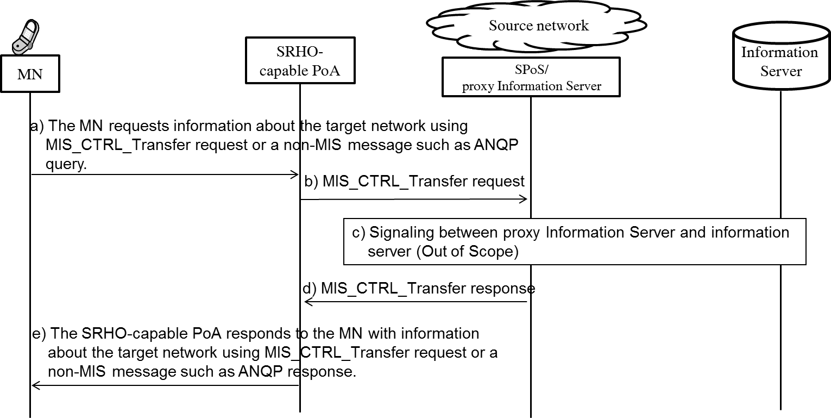

Comment#152 (Clause 8.3.1.1.2, Page 148, Line 8). Resource_Config parameter uses LINK_ID, which implies that a resource is specific to a link. Why the granurality of a resouce cannot also be per a pair of end-points? Consider to replace LINK_ID in Resource_Config parameter with LINK_TUPLE_ID.
- Response: We accept this comment. LINK_TUPLE_ID includes the LINK_ID of both sides of the link, the MN and the PoA. In IEEE P802.21.1/D01 Draft. the LINK_ID is used in Resource_Config parameter (Page 148 Line 8), Resource_Config_List parameter (Page 149 Line 24, Page 150 Line 15, Page 154 Line 24, Page 155 Line 14, Page 205 Table G.2 TLV Type Value 105), and Resource_Info parameter (Page 152 Line 10 and 24, Page 205 Table G.2 TLV Type Value 106). Replace the LINK_ID used in these parameters with LINK_TUPLE_ID.

Comment#155 (Clause 9.3.1, Page 172, Line 7). From protocol design point of view, it is better to add D2D-specific parameters to the existing MIS_Registration primitives instead of defining new MIS_D2D_Registration primitives. Consider to use MIS_Registration primitives for D2D registration.
- Response: We accept this comment, and agree to add D2D-specific parameters to the existing MIS_Register primitives and messages. If MIS_Register primitives or messages include the following parameters, the primitives or messages can be used for registering D2D devices.
Name | Data type | Description
D2D_Techlist | LIST(D2D_TECH) | List of available D2D technologies
Config_Info | LIST(LOCATION, FREQ_ID) | Configuration information for making a D2D connection

If this remedy is accepted, further contribtion will be submitted to modify the texts of IEEE P802.21.1 draft.

