Project | IEEE 802.21.1 Media Independent Services  <http://www.ieee802.org/21/>
Title | Suggested remedy for #61 to 70 and #141 to 149 in LB9
DCN | 21-16-0026-02-SAUC
Date Submitted | February 16, 2016
Source(s) | Yusuke Shimizu, Tomoki Takazoe, Yuji Unagami (Panasonic)
Re: | Session #71, Atlanta
Abstract | This contribution suggests a remedy on HEMS use case
Purpose | Suggested remedy for Cmt #61 to 70 and #141 to 149 in LB9.
Notice | This document has been prepared to assist the IEEE 802.21 Working Group. It is offered as a basis for discussion and is not binding on the contributing individual(s) or organization(s). The material in this document is subject to change in form and content after further study. The contributor(s) reserve(s) the right to add, amend or withdraw material contained herein.
Release | The contributor grants a free, irrevocable license to the IEEE to incorporate material contained in this contribution, and any modifications thereof, in the creation of an IEEE Standards publication; to copyright in the IEEE’s name any IEEE Standards publication even though it may include portions of this contribution; and at the IEEE’s sole discretion to permit others to reproduce in whole or in part the resulting IEEE Standards publication. The contributor also acknowledges and accepts that IEEE 802.21 may make this contribution public.
Patent Policy | The contributor is familiar with IEEE patent policy, as stated in Section 6 of the IEEE-SA Standards Board bylaws <http://standards.ieee.org/guides/bylaws/sect6-7.html#6> and in Understanding Patent Issues During IEEE Standards Development http://standards.ieee.org/board/pat/faq.pdf

Suggested remedy:
Change as follows.
- Home energy management system (HEMS)
  - Introduction
This sub-clause explains a general overview of the home energy management system (HEMS) use case.
HEMS is the system to manage the energy usage in home. HEMS with connecting devices (i.e. home appliances or equipments) realizes the "visualization" of electricity or gas consumption and the "auto control" of devices.
HEMS typically includes home gateway (HGW) and the various devices as follows;
・Air conditioning system
・Lighting
・Smart meter
・Photovoltaics (PV)
・Home security
HGW and devices are connected in home by wired or wireless network. HGW controls home appliances and collects usage information through the network.
For example, user operates HGW, and HGW can execute the collective lightings power off and the centralized control of the air conditioning system. Moreover, devices send usage state of electricity to HGW, and HGW displays the amounts of electric energy in home.
Figure 17 shows structure example of HEMS. HGW connects to devices such as PV, Air conditioning system, and lighting devices by home area network. In this example, HGW and terminal devices are connected via the cloud server, and user can control HGW by using the terminal device. HGW may collectively send a control message to the devices using a multicast transport, and the devices sends usage information to HGW in response to the control message. In this use case, media independent service framework (MIS) of IEEE802.21 specifications is applied to the Interface between the HGW and the devices. HEMS performs the collective control of the devices and the acquisition of usage information. The controlling system of HGW by using the terminal devices via cloud server (dotted line in Figure 17) is out of scope of this use case.
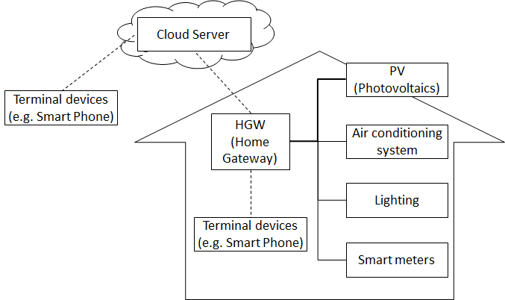
- — Structure example of HEMS
  - Service scenarios and signaling flows
This sub-clause describes the service scenario and IEEE 802.21 signaling flows.
Figure 18 shows MIS reference model corresponding to HEMS structure and Figure 19, Figure 20, and Figure 22 show the command flows corresponding to the different types of communication.
In this case, HGW as “PoS with GM” operates the connecting devices as “PoS”. HGW controls the power switch or settings of devices and collects the state of them. HGW operates Multicast Group Management described in IEEE 802.21.m as PoS with GM.
PoS with GM transmits control commands to PoSes and controls them. When the PoS with GM collectively controls PoSes, it sends the control command by a multicast transport. PoS sends usage information regularly to the PoS with GM. And PoS, when receiving the acquisition command of the usage information from the PoS with GM, sends the usage information of the device to the PoS with GM.
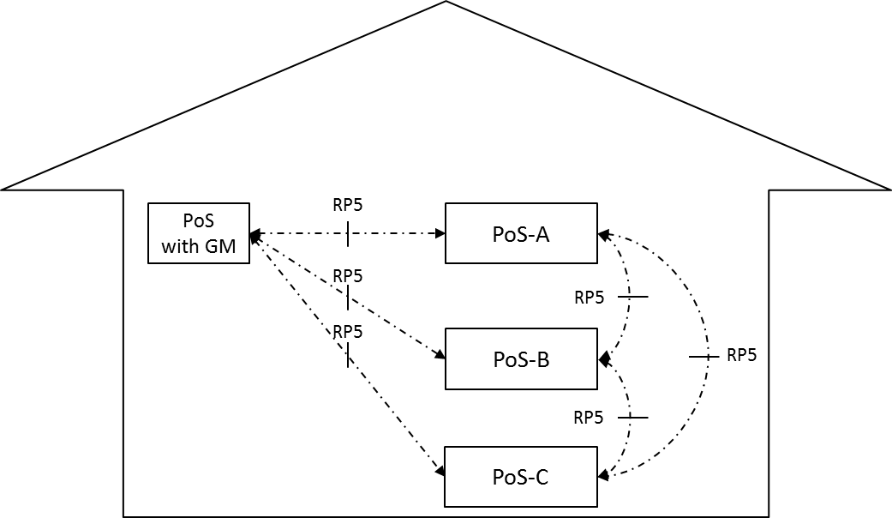
- — MIS reference model for HEMS use case
Table 12 shows the list of Service management primitives used in HEMS use case. This use case can be realized by the current defined primitives. MIS_LINK_SAPs used in Link layer are not required, since the control command transmission and the usage information acquisition in HEMS are independent of the media. PoS with GM manages all the group membership in the system. When PoS needs to be updated its group membership, PoS sends MIS_Pull_Group_Manipulate to PoS with GM and PoS with GM update the membership according to the request. On the other hand, PoS with GM decides to update the membership of PoS, PoS with GM sends MIS_Push_Group_Manipulate to PoS.

- —Service management primitives for HEMS use case
Service management primitive | Comments | Defined in
MIS_ Configuration_Update | This command is sent by a PoS to a group of other PoS(es) to update their configuration.  In the use case of HEMS, PoS sends the HEMS control command and the usage information. | 7.4.19 of  IEEE Std 802.21-XXXX
MIS_Pull_Group_Manipulate | This command is sent by a PoS to another PoS to create, delete or update the group membership. | 7.4.20 of  IEEE Std 802.21-XXXX
MIS_Push_Group_Manipulate | This command is sent by a PoS to a group of other PoS(es) to create, delete or update a group membership. | 7.4.21 of  IEEE Std 802.21-XXXX
MIS_Push_Certificate | This command is sent by a PoS to another PoS or an MN and it is used for sending of a certificate. | 7.4.22 of  IEEE Std 802.21-XXXX
MIS_Revoke_Certificate | This command is sent by a PoS to a group of PoS(es) and/or an MN to revoke a certificate previously issued by the PoS. | 7.4.24 of  IEEE Std 802.21-XXXX

Figure 19 shows the control command flow from PoS with GM to each PoS. When the connecting device (i.e. PoS) in the home is operated remotely, home gateway (i.e. PoS with GM) use MIS_Configuration_Update to send command flow to each connecting device (i.e. PoS).
PoS with GM sends control commands to each PoS. Protected control message of control commands uses MIS_Configuration_Update. Multicast protected control message from PoS with GM to each PoS uses the MIS protocol protection.
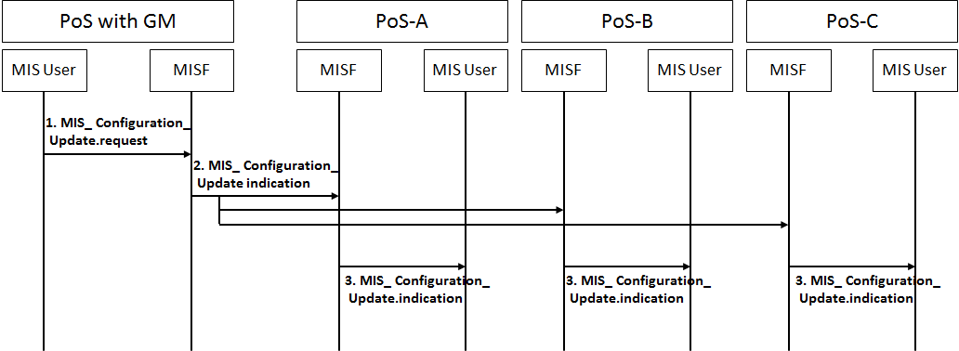
- —Transmission of the control command

- MIS User of PoS with GM generates the HEMS control commands for PoS, and sends it to the local MISF using the MIS_Configuration_Update.request primitive.
- MISF of PoS with GM sends the HEMS control commands for PoS using the MIS_Configuration_Update indication message.
- MISF of PoS receives the MIS_Configuration_Update indication message, and sends it to the MIS User using the MIS_Configuration_Update.indication primitive.
- MIS User of PoS receives the MIS_Configuration_Update.indication primitive, and runs the control command.

Figure20 shows the notification command flow from each PoS to PoS with GM. This command flow is used periodically when the connecting devices (i.e. PoS) notify their usage state information to the home gateway (i.e. PoS with GM).
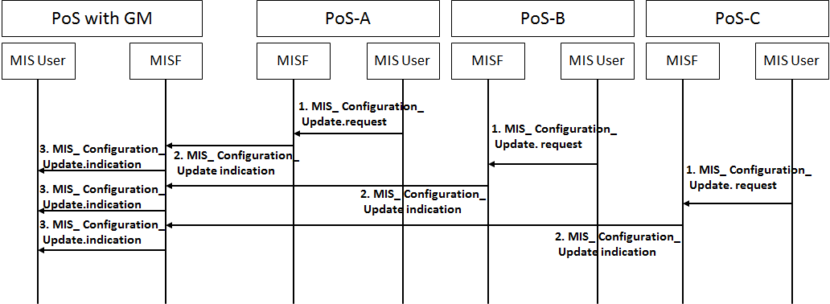
- —Transmission of the usage information

- MIS User of PoS generates the usage information, and sends it to the local MISF using the MIS_Configuration_Update.request primitive.
- MISF of PoS sends the usage information to the PoS with GM using MIS_Configuration_Update indication message.
- MISF of PoS with GM receives the MIS_Configuration_Update indication message, and sends it to the MIS User of PoS with GM using the MIS_Configuration_Update indication primitive.
- MIS User of PoS with GM receives MIS_Configuration_Update.indication primitive, and collects the usage information.

Figure 21 shows the command flow of updating the group membership initiated by the connecting device. In this figure, the connecting device (i.e. PoS) use MIS_Pull_Group Manipulate to request the updated membership to the home gateway (i.s. PoS with GM), then, to receive the updated membership.
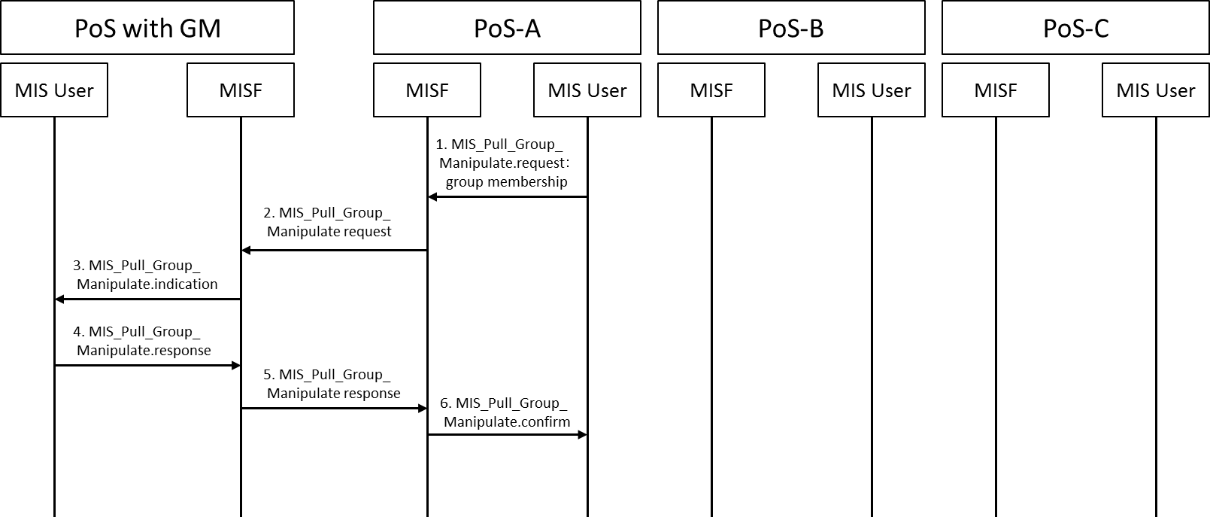
- —Transmission of group membership

- MIS User of PoS generates group membership for PoS with GM, and sends it to the local MISF using the MIS_Pull_Group_Manipulate.request primitive.
- MISF of PoS sends group membership for PoS with GM using the MIS_Pull_Group_Manipulate request message.
- MISF of PoS with GM receives the MIS_Pull_Group_Manipulate request message, and sends it to the MIS User using the MIS_Pull_Group_Manipulate.indication primitive.
- MIS User of PoS with GM receives the MIS_Pull_Group_Manipulate.indication primitive, and generates the acknowledge receipt, and sends it the local MISF using the MIS_Pull_Group_Manipulate.response primitive.
- MISF of PoS with GM sends the acknowledge receipt to the PoS using MIS_Pull_Group_Manipulate response message.
- MISF of PoS receives the MIS_Pull_Group_Manipulate response message, and sends it to the MIS User of PoS using the MIS_Pull_Group_Manipulate.confirm primitive.

Figure 22 shows the command flow of updating the group membership initiated by the home gateway. In this figure, the home gateway (i.e. PoS with GM) use MIS_Push_Group_Manipulate to send the updated the membership to each connecting device (i.e. PoS).
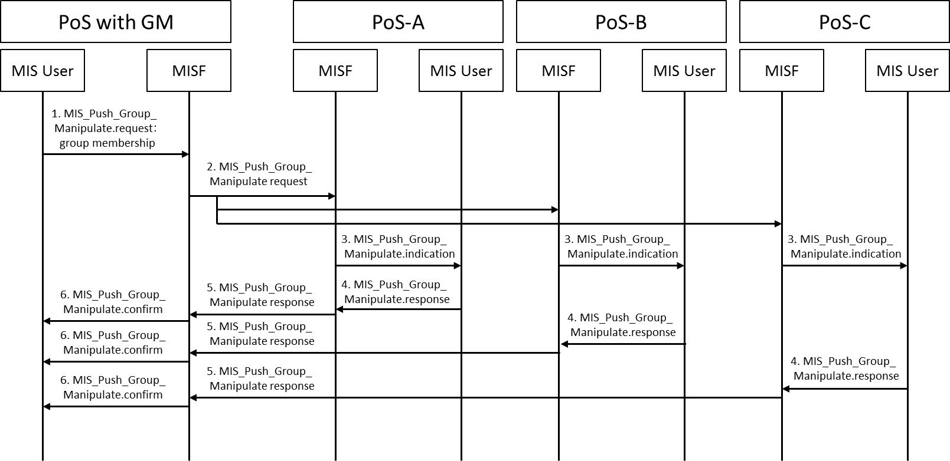
- —Transmission of group membership

- MIS User of PoS with GM generates group membership for PoS, and sends it to the local MISF using the MIS_Push_Group_Manipulate.request primitive.
- MISF of PoS with GM sends group membership for PoS using the MIS_Push_Group_Manipulate request message.
- MISF of PoS receives the MIS_Push_Group_Manipulate request message, and sends it to the MIS User using the MIS_Push_Group_Manipulate.indication primitive.
- MIS User of PoS receives the MIS_Push_Group_Manipulate.indication primitive, and generates the acknowledge receipt, and sends it the local MISF using the MIS_Push_Group_Manipulate.response primitive.
- MISF of PoS sends the acknowledge receipt to the PoS with GM using MIS_Push_Group_Manipulate response message.
- MISF of PoS with GM receives the MIS_Push_Group_Manipulate response message, and sends it to the MIS User of PoS with GM using the MIS_Push_Group_Manipulate.confirm primitive.

Figure 23 shows the command flow of sending the certificate from the home gateway to each connecting device. In this figure, the home gateway (i.e. PoS with GM) use MIS_Push_Certificate to send the certificate to each connecting devices (i.e. PoS).
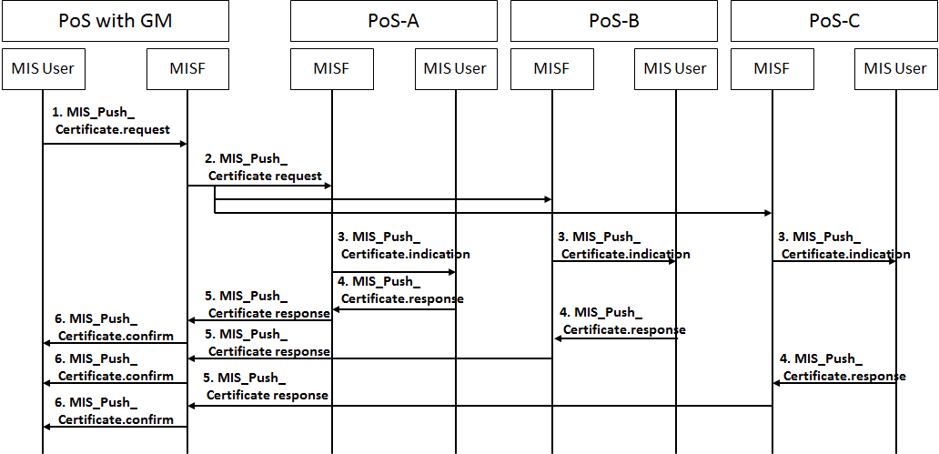
- —Transmission of certificate

- MIS User of PoS with GM shares the certificate, and sends it to the local MISF using the MIS_Push_Certificate.request primitive.
- MISF of PoS with GM sends the certificate the MIS_Push_Certificate request message.
- MISF of PoS receives the MIS_Push_Certificate request message, and sends it to the MIS User using the MIS_Push_Certificate.indication primitive.
- MIS User of PoS receives the MIS_Push_Certificate.indication primitive, and generates the acknowledge receipt, and sends it the local MISF using the MIS_Push_Certificate.response primitive.
- MISF of PoS sends the acknowledge receipt to the PoS with GM using MIS_Push_Certificate response message.
- MISF of PoS with GM receives the MIS_Push_Certificate response message, and sends it to the MIS User of PoS with GM using the MIS_Push_Certificate.confirm primitive.

Figure 24 describes CRL sharing in home area network. In this example, PoS-A having the latest CRL directly sends it with other PoS and PoS with GM under the same home area network.
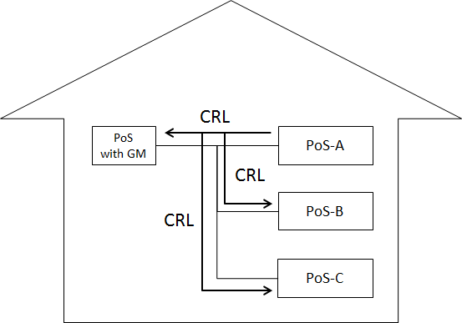
- —CRL sharing in home area network
Figure 25 shows the command flow described in Figure 24.
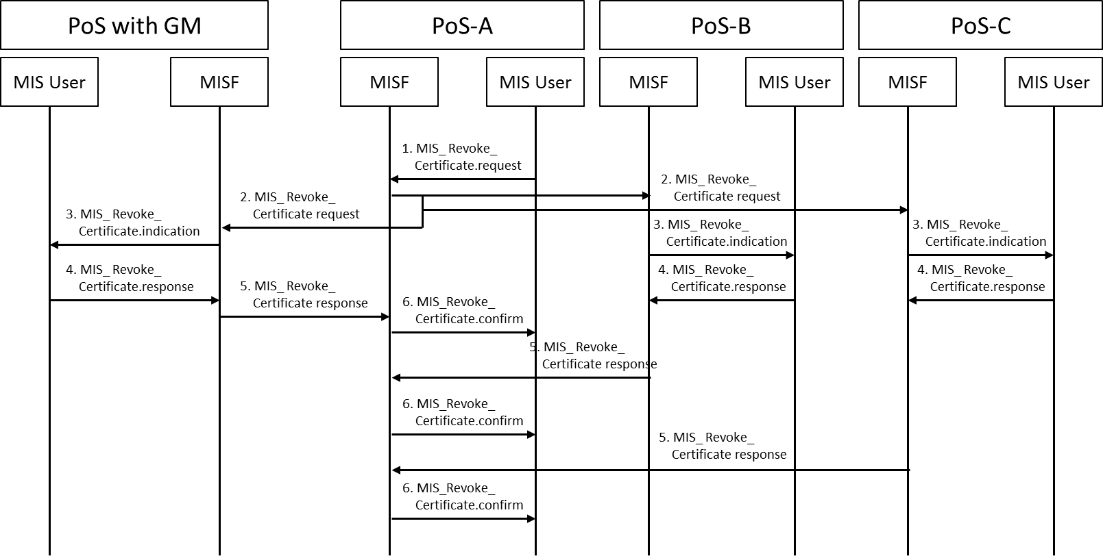
- —Transmission of CRL
- If MIS User of PoS shares the CRL, and sends it to the local MISF using the MIS_Revoke_Certificate.request primitive.
- MISF of PoS sends the CRL to the other PoS using MIS_Revoke_Certificate request message.
- MISF of PoS receives the MIS_Revoke_Certificate request message, and sends it to the MIS User of PoS using the MIS_Revoke_Certificate.indication primitive.
- MIS User of PoS receives MIS_Revoke_Certificate.indication primitive, and generates the acknowledge receipt, and sends it the local MISF using the MIS_Revoke_Certificate.response primitive.
- MISF of PoS sends the acknowledge receipt to the PoS using MIS_Revoke_Certificate response message.
- MISF of PoS receives the MIS_Revoke_Certificate response message, and sends it to the MIS User of PoS using the MIS_Revoke_Certificate.confirm primitive.
CRL operational guideline for HEMS use case is described in Annex.N.
- Certificate revocation list (CRL) guideline
This annex describes the CRL operational guideline for HEMS use case.
  - CRL operation
CRL is a list of certificates for revoked devices. CRL is signed and distributed by certificate authority.
The policy of certificate authority is out of scope of this specification, however, this sub-section describes one concept of CRL operation for good understanding of applying to HEMS use case.
Although certificate authority is typically operated by a single service operator, in this use case, certificate authority might be managed by a joint administrative entity. This is because various devices developed by various manufactures need to connect to each other and connect to different service, and for assuring the interoperability, it might be easier for one joint administrative entity to operate certificate authority which is responsible for one revocation policy.
Revocation Policy is specified by this joint administrative entity. If the gross negligence occurred in the market, the joint administrative entity investigates the circumstances and decides the possibility of issuing CRL.
All devices should check CRL regularly and confirm the validity of their own device certificates.
CRL should be updated adequately depend on the policy of the certificate authority.
Certificate authority can remove the revoked certificate from the CRL depend on the life cycle of the device. For example, if maximum life time is considered to be 20 years, the certificate authority may remove revoked certificates from the CRL 20 years later.
  - CRL format
The CRL is compliant with the ITU-T X.509 version 2 CRL format shown in Table 13.
- —CRL format
tbsCertList |  | Discription
Field | Version | Version
 | Signature | Signature algorithm
 | Issuer | Issuer of CRL
 | thisUpdate | Update date or issue date of CRL
 | nextUpdate | Next update date of CRL
 | revokedCertificates | Revoked certificates list
 | crlExtensions | Extensions to provide methods for associating additional attributes with CRLs
signatureAlgorithm |  | Signature algorithm
Signature |  | Digital signature of CA

  - Distribution of CRL
All devices connected to the Internet should acquire the latest CRLs from CRL server periodically. Connection to the CRL server is established by HTTPS. Figure 26 shows the typical case where only PoS with GM can connect to the Internet. PoS with GM acquires the latest CRL from the CRL server and distributes it to the other PoS(es) .
The device has some timing flexibility to access randomly to CRL server for dispersing the peak connection to the CRL server.
If new joining device has the latest CRLs, that device can distribute the latest CRLs to the other devices as shown in Figure 24. In this case, other PoS or PoS with GM compare their CRL and the newly distributed CRL, then, replace to the latest CRL.
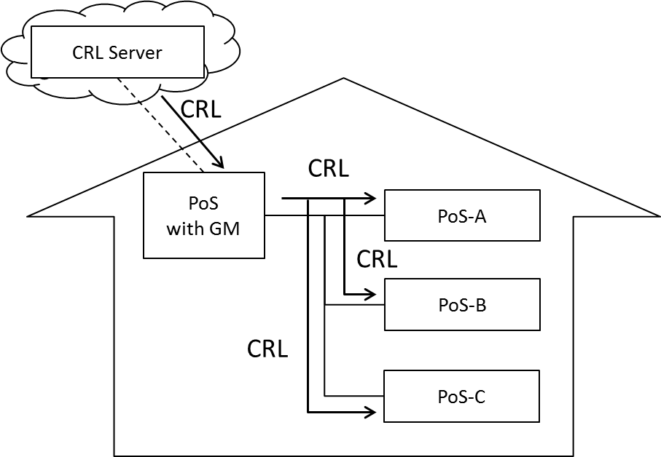
- —Distribution of CRL
  - CRL handling for resource limited device
Full CRL is the CRL which contains all revoked certificates in the single list. Full CRL is easy to be handled because device should check only one single data format. However, in the large-scaled system, the data size of CRL become huge and the load for device to acquire CRL would be increased.
In the HEMS use case, it is difficult for the devices to handle large size CRL. Therefore, the size limitation of CRL is needed. The size limitation usually depends on the operation policy. Generally it should be limited in the size as device can acquire and hold. As one example, several IPTV services for consumer TV limit the size less than 10kb.
It is necessary to increase the updating frequency in order to quickly notify the revocation information to the device. However, frequent updating leads to the burden for the device which should process the large size CRL frequently. Therefore, it is required to consider the reasonable balance between the load for the device and the potential risk.
The following sections are the recommendation how to reduce the size of CRL for a resource limited device.

    - Delta CRL
Delta CRL specified in IETF RFC 5280 is used to notify the revocation information quickly. Certificate Authority issues normal CRLs (base CRLs) periodically, and issues delta CRLs at shorter intervals.
The delta CRL describes the additional revocation information from the base CRL. Device acquires the delta CRL and the base CRL. Then obtain the latest revocation information by combining those. For example, the base CRL is issued once a week, and the delta CRL is issued as the list of revoked certificates during the 24 hours once every 24hours.

    - Operational policy for exceeding the size limit
The data size of full CRL simply increases due to the addition of revoked certificates. The expired certificates are deleted from the CRL at issuing new CRL, but if the size of CRL still exceeds the limit, the old CRL near expired period can be deleted from the latest CRL according to the operation policy.

