Project | IEEE 802.21.1 Media Independent Services  <http://www.ieee802.org/21/>
Title | Open SLMCP Service
DCN | 21-15-0093-00-SAUS
Date Submitted | September 4, 2015.
Source(s) | Sangkwon Jeong, Sunju Kwon, Chanyoung Kwon, JongWu Lee, Ilu Han(BlueCloud)  Changhwa Lyou(SeeRoo Information Inc.,)
Re:
Abstract | According to the “Proposed Text of “Open SLMCP Service” Section for IEEE 802.21.1 Draft Standard” (21-14-0159-00-SAUC), this document proposes modified text for explaining initiation of network assisted Open SLMCP for IEEE 802.21.1 Draft standard.
Purpose | To be part of 802.21.1 draft standard document.
Notice | This document has been prepared to assist the IEEE 802.21 Working Group. It is offered as a basis for discussion and is not binding on the contributing individual(s) or organization(s). The material in this document is subject to change in form and content after further study. The contributor(s) reserve(s) the right to add, amend or withdraw material contained herein.
Release | The contributor grants a free, irrevocable license to the IEEE to incorporate material contained in this contribution, and any modifications thereof, in the creation of an IEEE Standards publication; to copyright in the IEEE’s name any IEEE Standards publication even though it may include portions of this contribution; and at the IEEE’s sole discretion to permit others to reproduce in whole or in part the resulting IEEE Standards publication. The contributor also acknowledges and accepts that IEEE 802.21 may make this contribution public.
Patent Policy | The contributor is familiar with IEEE patent policy, as stated in Section 6 of the IEEE-SA Standards Board bylaws <http://standards.ieee.org/guides/bylaws/sect6-7.html#6> and in Understanding Patent Issues During IEEE Standards Development http://standards.ieee.org/board/pat/faq.pdf
Table of Content

5. 4
5.1 4
5.2 4
5.3 4
5.4 4
5.6 Open SLMCP service 4
5.6.1 Introduction 4
5.6.2 Service scenarios and call flows 4
5.6.2.1 Open SLMCP communication 4
7
a) A: Open SLMCP Development company 7
b) B: The SNS distributing company or development company 7
c) C: The professor client who provides the open social learning mobile content 7
d) D: The student client who study with Open SLMCP 7
a) iOS, Android and Web environment 7
b) The standard file format of the content which is designed to be able to cross browse in the separate OS 7
c) The provider of the open social learning mobile content 8

  - Open SLMCP service
    - Introduction
Open Social Learning Mobile Content Platform (Open SLMCP) service is social learning mobile content communication between Open SLMCP clients. Open SLMCP is the server platform of social learning mobile content using the Social Networking Services (SNS) such as Facebook, Kakaotalk, and Line etc. Users of Open SLMCP can be called Open SLMCP client. One of Open SLMCP client, who use Open SLMCP, can upload and download social learning content to and from Open SLMCP. Open SLMCP provides sharing social learning content between the users. Open SLMCP client could be a professor client or a student client or both of them, depending on the client’s action; uploading or downloading. Open SLMCP client can provide and take social learning mobile content and also share client’s content one another. This is attraction for the learners from social learning content and social learning content development companies in perspective of reducing the efforts to influx the users by using who are already existing in the social networking services, and maximizing the learning motivation of the learners.
Open SLMCP service makes the social learning content like game quest and the users can trade the social learning content one another with payment procedures, purchasing procedures, refund procedures and donation procedures in Open SLMCP. Open SLMCP uses social networking services’ authenticating, paying, purchasing, refunding and so on. The service increases the productivity of open mobile social learning content development companies by decreasing the cost for building social learning content platform. And the gamification of learning content is expected to magnify the market of learning content.
For Open SLMCP, media independent service (MIS) framework of IEEE 802.21 standard is able to help client to register and login Open SLMCP and upload and download social learning contents. Connection between Open SLMCP client and Open SLMCP, which uses SNS server frequently, need MIS framework. MIS framework of IEEE 802.21 standard is common platform to support interworking between networks using IEEE802 and non-IEEE802 technologies, so that MIS framework can be easily extended to a platform for Open SLMCP such as Wi-Fi Direct, 3GPP proximity service (ProSe), and IEEE 802.15.8 peer aware communication (PAC).
The MIS framework can apply to Open SLMCP Service with assistance of network entities such as a base station or an access point. For Open SLMCP Service with network assistance, network entities with MIS framework provide information for client to connect Open SLMCP, which uses SNS information. MIS framework can keep interworking between Open SLMCP and client through different types of point access that can offer the best quality of service (QoS) or quality of experience (QoE).
This section introduces service scenarios and call flows for Open SLMCP Service based on MIS.
    - Service scenarios and call flows
      - Open SLMCP communication
Social learning mobile content providers have interest in Open SLMCP because Open SLMCP can use SNS and reduce efforts to influx the users. By using Open SLMCP, clients of Open SLMCP can share content such as video clips, text, power point or Excel for social learning. Service providers of SLMCP can distribute social learning content also. But non service providers can also share their social learning content through Open SLMCP.
MIS framework, which is control plane of infrastructure network, can be the control plane for Open SLMCP. MIS framework provides network for clients to access Open SLMCP using SNS server’s paying, purchasing and billing information. By using point of service (PoS) and Information Server, which are defined in IEEE 802.21 standard as network-side instance of MIS framework and server that provides respectively network configuration information. Thus, MIS framework can provide information to Open SLMCP or SNS and controls client’s Open SLMCP connection with minor modification of Information Server and PoS.
        - Service architecture
System structure of Open SLMCP is as Figure 1. Open social learning mobile content platform has three parts, distribution NoSQL DB, distribution SQL DB and distribution file system. Open SLMCP require the compatibility between various social networks and client platform like PC, Smart TV, Smart phone based on iOS or Android. Figure 2 is the structure of standard interface for using Social network for Open SLMCP.
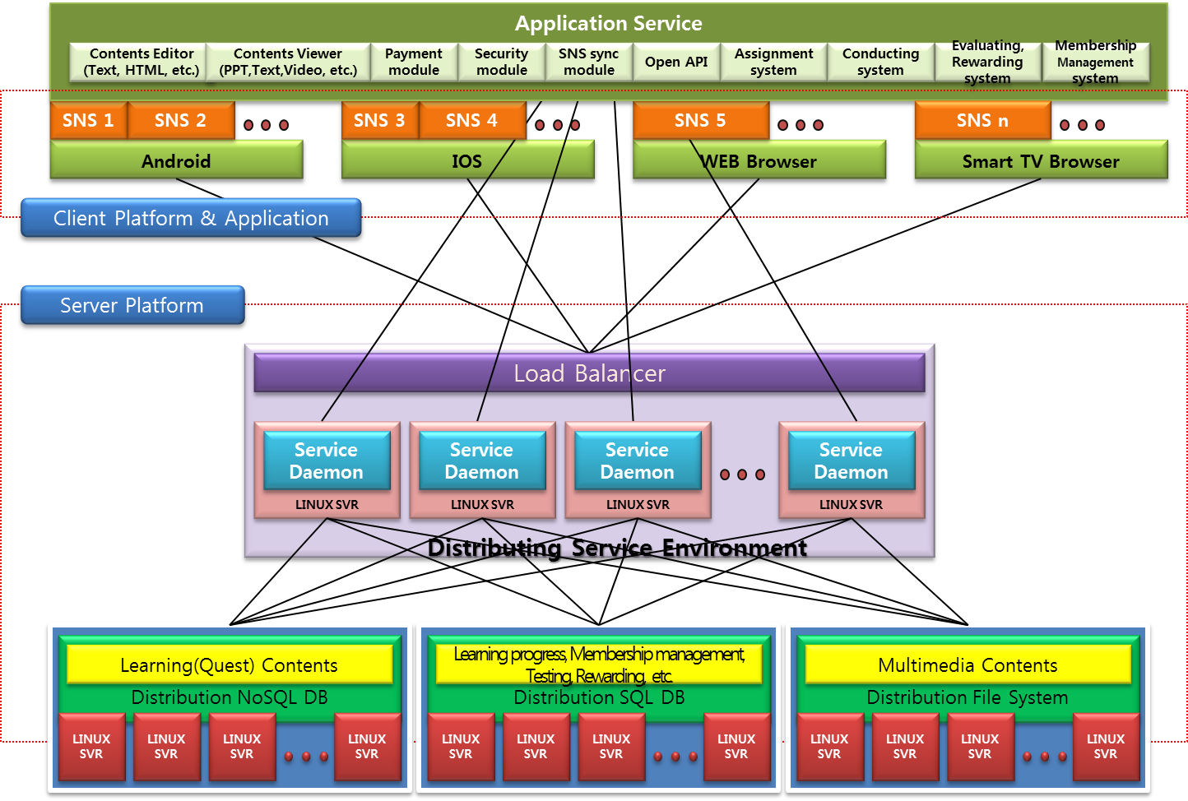
Figure 1— System Structure of Open Social Learning Mobile Content Platform (Open SLMCP)

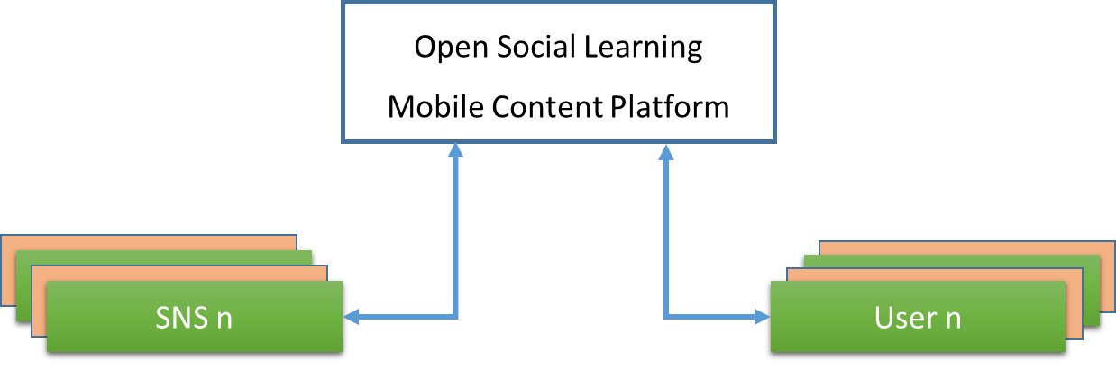
Figure 2—Outer Environment of Mobile Content Commercial Platform

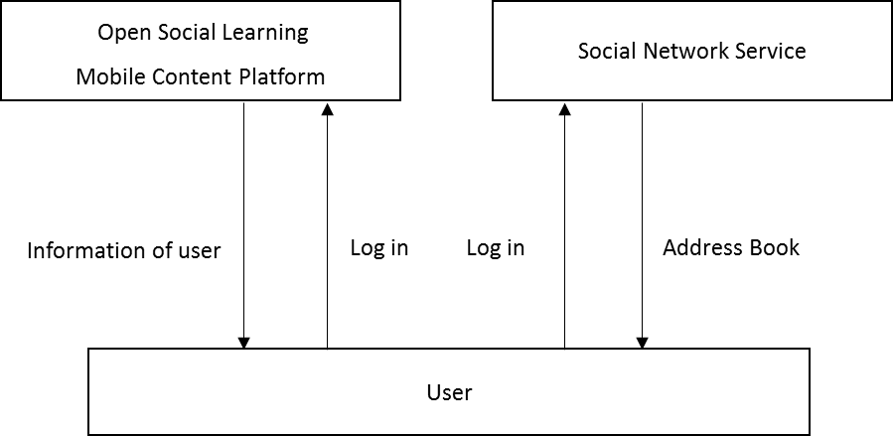
Figure 3—Outer platform interface of Open SLMCP

Open SLMCP has the structure of inner membership that user of Open SLMCP can be a student or a professor and need the payment, account and billing system for the distributing the profit and especially standard layer of the information security for protecting the personal information. It is as follows the interface of the information security module for sharing the members’ personal information, payment, bank account and billing data with social network communities.

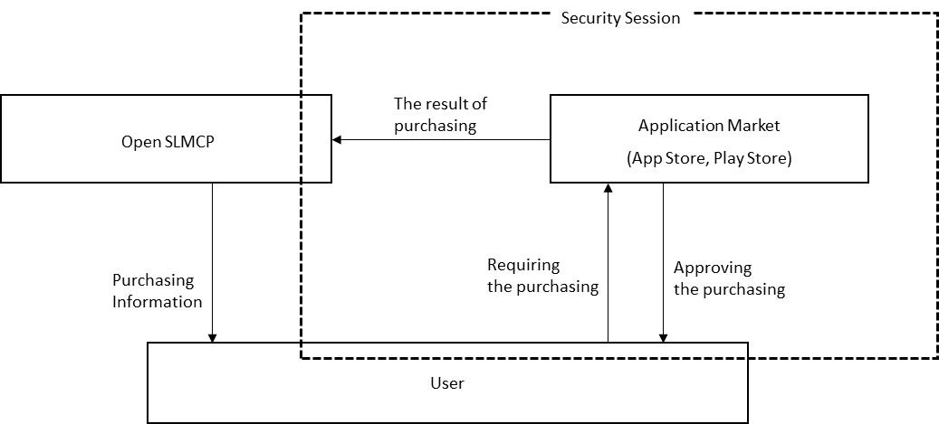
Figure 4—Security Session of Open SLMCP

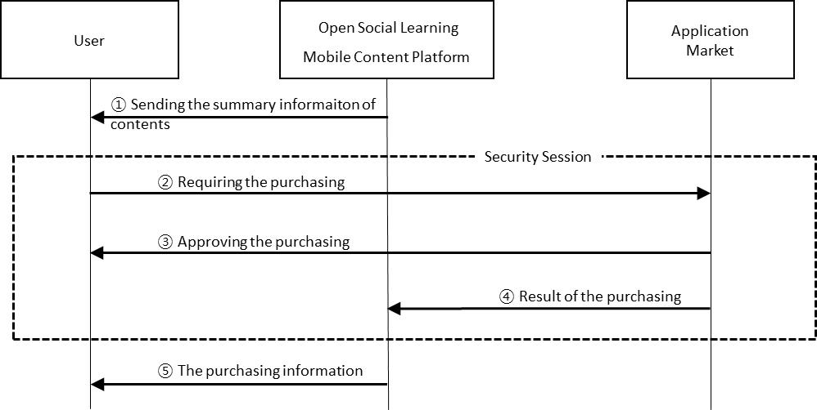
Figure 5—Process of the purchase point of Open SLMCP

        - Scenarios of Open SLMCP
Analyzing the scenarios of Open SLMCP shows the process of drawing the each requirement and the detail requirements can be defined. Open SLMCP consists of the server requirements and the device requirements. The server requires compatibility with the outer environment like social network platform, controls the server system, and the things about paying. The devices require the interface of authorizing the users, searching the content, payment and purchasing, and the security of information and paying security.

          - Scenario
            - Definition of the subjects concerning Open SLMCP
- A: Open SLMCP Development company
- B: The SNS distributing company or development company
- C: The professor client who provides the open social learning mobile content
- D: The student client who study with Open SLMCP
            - Definition of the development environment
- iOS, Android and Web environment
- The standard file format of the content which is designed to be able to cross browse in the separate OS
- The provider of the open social learning mobile content
            - Platform development Scenario
To develop Open SLMCP, the compatibility with SNS service platform is the most important. The social learning platform should be developed examining the OS of the SNS service platform and the environment of the device for the best quality of the service.
A (Open SLMCP development company) wants to develop the platform which can be compatible with the platform of B (The SNS distribution and Development Company) and provide the service.
C (The professor client who provides the open social learning mobile content) or D (The student client who studies with Open SLMCP) should be the members who registered the service which is provided by B. The payment of the charged service should be allowed, agreeing with the conditions which are suggested by B.
If C or D is the client of B, A approves to register Open SLMCP service as Open SLMCP client. But it needs the registration procedure of A.
For checking the errors in the procedure of developing the platform system and correcting the errors, ‘Checking error system’ would be active spontaneously. ‘Checking error system’ can find and correct the errors immediately, and C and D can be satisfied with the service.
C and D are able to progress the payment with the agreement of the conditions of B and A. A should get ready to have the compatibility with the system of B, providing the payment service actively.

            - Content provider(The professor client) Scenario
C wants to product and provide social learning mobile content for D to use the content of A.
For this, C made social learning content, named ‘Hiking the Inwang Mountain by the bicycle’. Before D buy the content, D can pre-use the content by the sample content made by C.
D tests the sample quest, satisfies the quality of the content and buys the full version content with the point. C would be given the point paid by D, deducted tax of the commission. C would get a refund the point as cash and marketable securities through the billing system.

            - Content customer (The student client) Scenario
D bought the full version content with the point, satisfying the sample quest of the content provided by C on the platform provided by A. D finished the quest content, named ‘Hiking the Inwang Mountain with the bicycle’, authenticated and evaluated the content with five stars meaning ‘Very Satisfied’.
But someday C bought other content with point, D’s device did not active the content properly and requested the refund of the content. The system checks the errors with error and refund the point to D.

        - High level illustration of call flows
Figure 6 shows control signaling for Open SLMCP. Open Social Mobile Content Platform (Open SLMCP) helps Open SLMCP Client to upload and download social learning mobile content through Mobile Network 2. Open SLMCP Client is MN. MN has MIHF and MAC. Open SLMCP can connect with SNS and request for information about authentication, purchasing, payment and billing.
Open SLMCP uses the information data about authentication, purchasing, payment, billing in wired network. But connection between Mobile Node and Open SLMCP or SNS needs media independent service through Mobile Network.
Open SLMCP registration, Figure 6 is as follows based on MIS Framework. MN requests SNS login and connects to SNS server through Mobile Network 1. SNS server responds authentication token to MN through Mobile Network 1. MN has the authentication token of SNS and the authentication token that MN responded could be noticed by Open SLMCP through Mobile Network 2. Then Open SLMCP requests for authentication to SNS with the token by MIH and would be responded authentication from SNS and Open SLMCP get ready to use. After Open SLMCP registration, MN can upload and download social learning mobile content to and from Open SLMCP platform through Mobile Network 2 for QoS and QoE.
MN has the MIHF. MN uses the Mobile Network. MN communicates with Open SLMCP and SNS through Mobile Network. Mobile Network includes PoA, and MIH user.

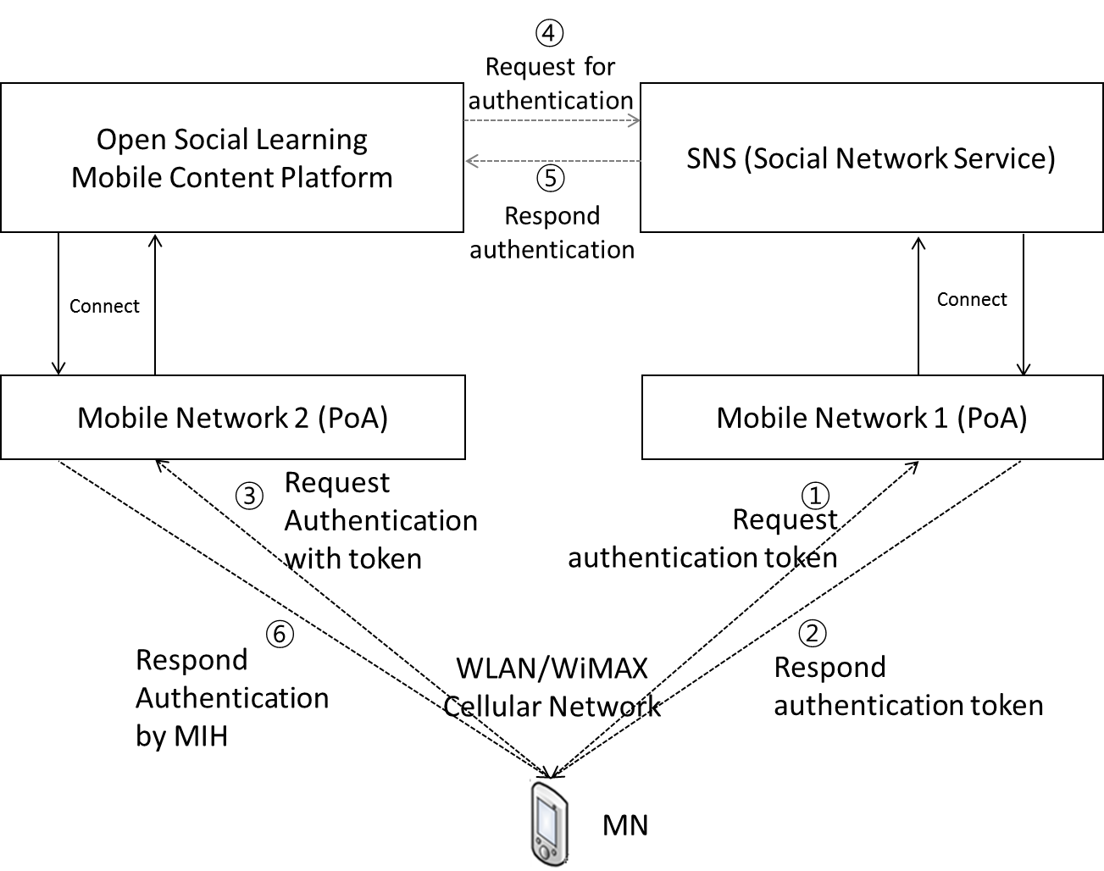
Figure 6—Open SLMCP registration and login procedure based on MIS Framework

          - Stages for Open SLMCP registration based on MIS Framework
Open SLMCP based on MIS framework comprises six stages as in Figure 7.
- In the first stage, MN connects SNS and requests authentication token through Mobile Network 1.
- In the second stage, SNS server responds authentication token to MN through Mobile Network 1.
- In the third stage, MN requests Open SLMCP’s registration with token through Mobile Network 2 by MIH.
- In the fourth stage, Open SLMCP requests for the authentication token to SNS server.
- In the fifth stage, the SNS’ Server responds authentication to Open SLMCP.
- In the sixth stage, Open SLMCP registers the client and approves the access and use of Open SLMCP.
SourceIdentifier is generated when MN requests authentication to SNS to identify the local MIHF
TargetNetworkInfo is generated when MN connects to other mobile networks to request authentication
Certificate is generated when Open SLMCP request for authentication to SNS to confirm the token that MN requested
LinkIdentifier is generated when SNS respond authentication token to MN
TransmissionStatus is generated when MN request authentication token to SNS. When MN matches with MN in SNS, it is Success. When MN doesn’t match with MN in SNS, it is Failure.
DestinationIdentifier is generated when Open SLMCP verifies the token and responds authentication to MN by MIH

Table 1—MIH primitives for registration of Open SLMCP
Name | Data type | Description
SourceIdentifier | MIHF_ID | This identifies the local MIHF.
TargetNetworkInfo | TGT_NET_INFO | This contains the target network information.
Certificate | CERTIFICATE | This is registered MN’s authentication token by SNS.
LinkIdentifier | LINK_TUPLE_ID | Identifier of the link for event unsubscription.
TransmissionStatus | BOOLEAN | Status of the transmitted token  True : Success  False : Failure
DestinationIdentifier | MIHF_ID | This identifies the remote MIHF.

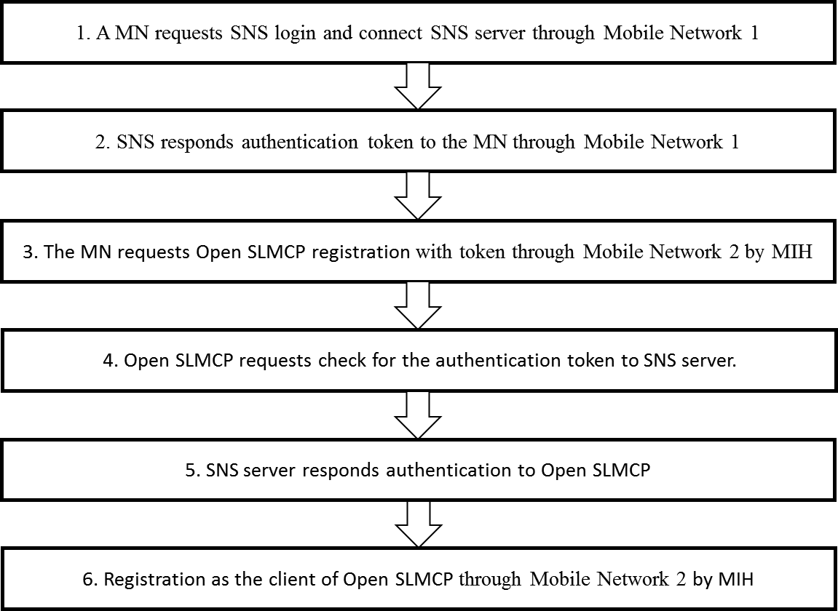
Figure 7—Stages for Open SLMCP registration based on MIS framework

          - Signal flows and primitives/messages
            - Uploading and downloading social learning mobile content
After Open Social Learning Mobile Content Platform (Open SLMCP) is activated, the client of Open SLMCP can upload or download social learning mobile content through Mobile Network 2. This stage also needs media independent service (MIS) for the best Qos and QoE. Signal flows shown in Figure 9 and 10 are as follows.
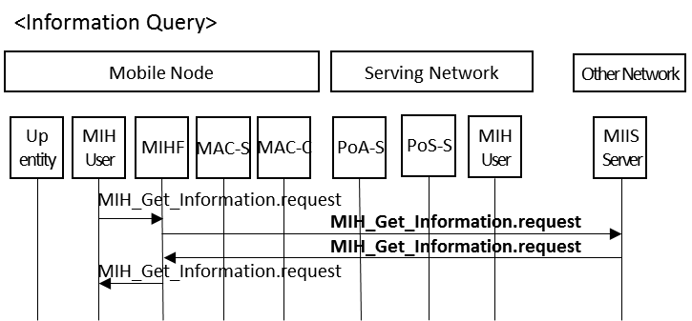
Figure 8—Information Query procedure

<Downloading>
- MN requests Information Query for downloading content in the DB. (Step1)
- Mobile Network 2 requests Content DB list check. (Step2)
- Open SLMCP server responds to Information Query. (Step3)
- Mobile Network 2 confirms downloading content. (Step4)
- MN requests downloading content to Open SLMCP server through Mobile Network 2. (Step5)
- MN downloads content from Open SLMCP server through Mobile Network 2. (Step6)
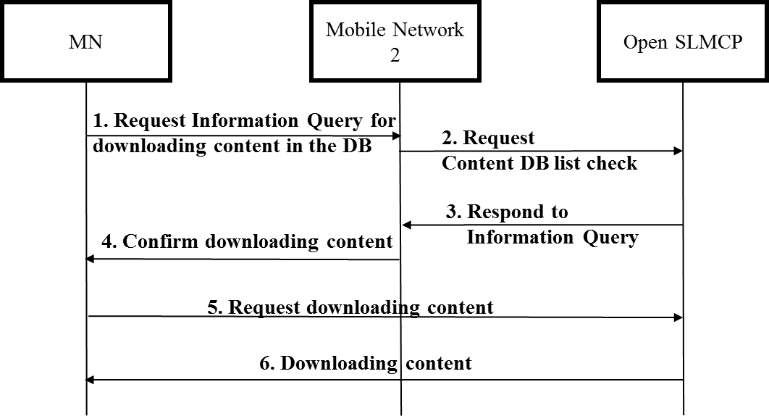
Figure 10—Downloading social learning content from Open SLMCP with MIS
SourceIdentifier is generated when MN requests Information Query for downloading content in the DB to identify the local MIHF
Status is generated when MN request Information Query for downloading content in the DB to Open SLMCP
TargetNetworkInfo is generated when MN connects to other mobile network to request Information Query
LinkIdentifier is generated when Open SLMCP respond to Information Query.
ResponseMIHEventList is generated when Open SLMCP respond to MN with Information Query.
DestinationIdentifier is generated when Open SLMCP respond to MN for Identifies.

Table 2—MIH primitives for download from Open SLMCP
Name | Data type | Description
SourceIdentifier | MIHF_ID | This identifies the local MIHF.
Status | STATUS | Status of operation.
TargetNetworkInfo | TGT_NET_INFO | This contains the target network information.
LinkIdentifier | LINK_TUPLE_ID | Identifier of the link for event unsubscription.
ResponseMIHEventList | MIH_EVT_LIST | List of successfully unsubscribed link events.
DestinationIdentifier | MIHF_ID | This identifies the remote MIHF.
<Uploading>
- MN notices information query for uploading content. (Step1)
- Mobile Network 2 requests information query. (Step2)
- Open SLMCP server responds to Information Query. (Step3)
- Mobile Network 2 confirms uploading content. (Step4)
- MN uploads the content to Open SLMCP server through Mobile Network 2. (Step5)
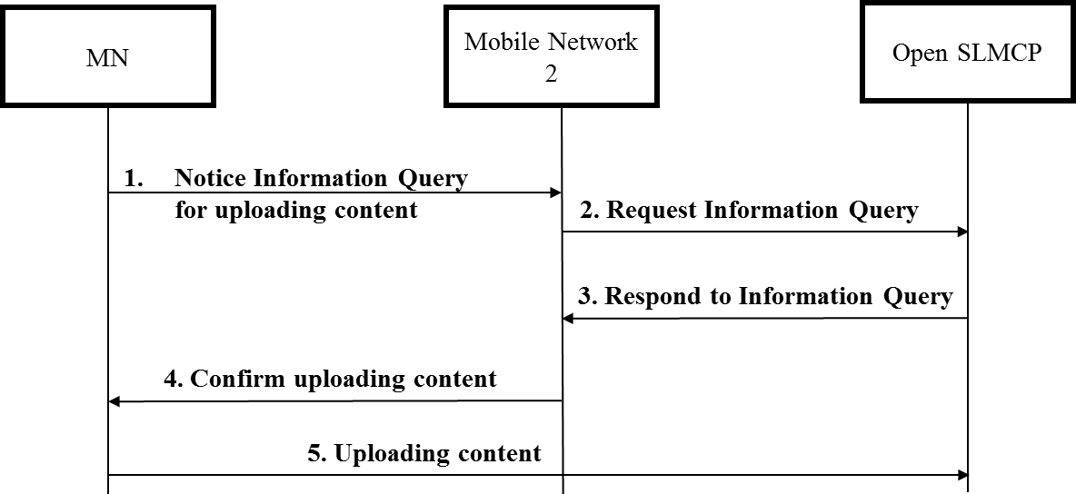
Figure 9—Uploading social learning content to Open SLMCP with MIS
SourceIdentifier is generated by Open SLMCP when MN notices Information Query for uploading content to Open SLMCP to identify the local MIHF
Status is generated by MN when MN notices Information Query for uploading content to Open SLMCP
TargetNetworkInfo is generated by MN when MN request Information Query to Open SLMCP
LinkIdentifier generated when Open SLMCP respond to Information Query.
SuggestedNewLink is generated when Mobile Network 2 is changed to other Mobile Networks.

Table 3—MIH primitives for Upload to Open SLMCP

Name | Data type | Description
SourceIdentifier | MIHF_ID | This identifies the local MIHF.
Status | STATUS | Status of operation.
TargetNetworkInfo | TGT_NET_INFO | This contains the target network information.
LinkIdentifier | LINK_TUPLE_ID | Identifier of the link for event unsubscription.
SuggestedNewLinkList | LIST(LINK_POA_LIST) | A list of Open SLMCP DB
DestinationIdentifier | MIHF_ID | This identifies the remote MIHF.

