Project | IEEE 802.21.1 Media Independent Services  <http://www.ieee802.org/21/>
Title | Revised Draft of “Radio Resource Management Service” Section for IEEE 802.21.1 Draft Standard
DCN | 21-15-0083-00-SAUC
Date Submitted | August 21, 2015
Source(s) | Hyeong-Ho Lee (ETRI), Hyunho Park (ETRI), Jin Seek Choi (Hanyang University, Korea Ethernet Forum),
Re: | IEEE 802.21m & IEEE 802.21.1 TGs Teleconference Meeting
Abstract | Based on the discussion of the contribution “Revised Update for “Radio Resource Management Service” Section for IEEE 802.21.1 Draft Standard” (DCN 21-15-0067-00-SAUC) in IEEE 802.21 Session #69, this document proposes revised text of “Radio Resource Management Service” Section for IEEE 802.21.1 Draft Standard. Service specific primitives and protocol features are defined in this contribution.
Purpose | To be part of 802.21.1 draft standard document.
Notice | This document has been prepared to assist the IEEE 802.21 Working Group. It is offered as a basis for discussion and is not binding on the contributing individual(s) or organization(s). The material in this document is subject to change in form and content after further study. The contributor(s) reserve(s) the right to add, amend or withdraw material contained herein.
Release | The contributor grants a free, irrevocable license to the IEEE to incorporate material contained in this contribution, and any modifications thereof, in the creation of an IEEE Standards publication; to copyright in the IEEE’s name any IEEE Standards publication even though it may include portions of this contribution; and at the IEEE’s sole discretion to permit others to reproduce in whole or in part the resulting IEEE Standards publication. The contributor also acknowledges and accepts that IEEE 802.21 may make this contribution public.
Patent Policy | The contributor is familiar with IEEE patent policy, as stated in Section 6 of the IEEE-SA Standards Board bylaws <http://standards.ieee.org/guides/bylaws/sect6-7.html#6> and in Understanding Patent Issues During IEEE Standards Development http://standards.ieee.org/board/pat/faq.pdf

Table of Contents

5.4 Radio resource management service 3
5.4.1 Introduction 3
5.4.2 Service scenarios and call flows 3
5.4.3 Service specific primitives 20
5.4.4 Service specific protocol features 28

Annex E (informative) Media Specific mapping for SAPs
Annex F (normative) Data type definition
Annex G (normative) Information element identifiers
Annex L (normative) MIH protocol message code assignments

  - Radio resource management service
    - Introduction
In recent days, networks with various communication technologies have appeared, interferences between wireless access networks have increased, and thus resource management in heterogeneous networks is needed. For example, 2.4GHz band is used by WLAN devices and WPAN devices such as Bluetooth devices, and 5GHz band is used by WLAN devices and cordless phones. Moreover, 5GHz band is considered for use of long term evolution (LTE) technology, and therefore interference in 5GHz band is expected to increase.
Media independent service (MIS) framework of IEEE 802.21 standard can be a common platform to support resource management in heterogeneous networks. MIS framework of IEEE 802.21 standard supports seamless handover in heterogeneous networks by using media independent event service (MIES), media independent command service (MICS), and media independent information service (MIIS). MIES primitives and messages help mobile node (MN) to monitor link status (e.g., signal strength and data rate), and MICS primitives and messages helps MN to control its link layers (physical layer and data link layer) for seamless handover in heterogeneous networks. It is possible to expect that MIS framework enables MN to monitor link status and control radio resources (e.g., frequency, time, and power) for radio resource management. MIIS primitives and messages are used to transfer network configuration information for handover in heterogeneous networks, and thus they can be used to provide network configuration for radio resource allocations in heterogeneous networks. Thus, MIS framework is appropriate for resource management in heterogeneous networks that use various communication technologies and various frequency bands.

    - Service scenarios and call flows
      - High level illustration
Figure 1 shows media independent service framework for resource management in heterogeneous networks. Point of attachment (PoA) Controller (i.e., access point (AP) controller) can control resources of PoS(PoA)s that use various communication technologies (e.g., WLAN, Wi-Fi Direct, Bluetooth, and LTE) by using MICS message. PoS(PoA)s can use different communication technologies and share its link status by using MIES message. PoA Controller can be implemented as MIS point of service (PoS).
The following entities are equipped with MIS function (MISF).
- MN-A: a user device, such as a smart phone, which equips radio interfaces of multiple radio access technologies
- PoS(PoA)A: a PoS with PoA, such as base station (BS) in cellular networks or access point (AP) in WLAN, which is a network entity that establishes link connection with the MN
- PoS(PoA)-B: PoS(PoA)-A’s neighboring PoS(PoA) that can interfere with MN or PoS(PoA)-A
- PoA Controller: a network entity that can manage radio resources of PoS(PoA)-A
- Information Server: a server that manages configuration information on PoS(PoA)s’ radio resource allocations
PoS(PoA)-A is able to trigger radio resource management of its own link based on monitored link status by MN, itself, or PoS(PoA)-B. PoA Controller is also able to trigger radio resource management of PoS(PoA)-A’s link.
- PoS(PoA)-A may manage its own radio resources based on its own link status.
- PoS(PoA)-A may manage its own radio resources based on link status of MN.
- PoS(PoA)-A may manage its own radio resources based on link status or resource allocations of PoS(PoA)-B.
- PoS(PoA)-A may manage its own radio resources based on configuration information from Information Server.
- PoA Controller may request radio resource management of PoS(PoA)-A based on link status or resource allocations of PoS(PoA)s (e.g., PoS(PoA)-A and PoS(PoA)-B) that are managed by PoA Controller.
- PoA Cntroller may request radio resource management of PoS(PoA)-A based on configuration information from Information Server.

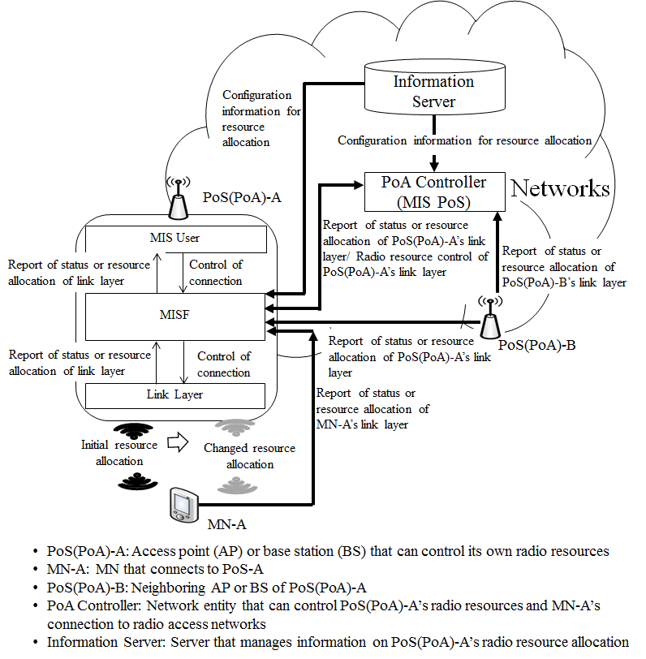
Figure 1—Media independent service framework for resource management in heterogeneous networks

      - Stages for radio resource allocations
Radio resource allocation of radio access network comprises four stages as shown in Figure 2.
- In the first stage, PoS(PoA)’s radio resource allocation is decided by PoS(PoA) or PoA Controller based on PoA’s link status or radio resource allocation of PoS(PoA)’s neighboring radio access networks.
- In the second stage, MN prepares to connect to radio access network with newly allocated radio resources.
- In the third stage, PoS(PoA)’s radio resources (e.g., frequency, time, and power) are allocated by PoS(PoA) or PoA Controller.
- In the last stage, PoS(PoA) reports its allocated radio resources to Information Server, PoA Controller, and neighboring PoS(PoA)s.

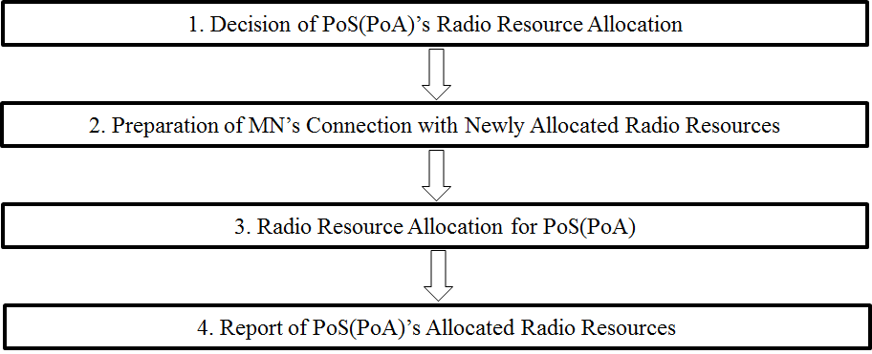
Figure 2—Stages for radio resource allocation of radio access network

      - Signal flows
        - Stage 1: decision of PoS(PoA)’s radio resource allocation
PoS(PoA) itself can decide allocation of its own radio resources. Otherwise, PoA Controller can decide radio resource allocations for PoS(PoA) on behalf of PoS(PoA). For this stage, Link_Resource_Report and MIS_Resource_Report primitives/messages are proposed as new primitives and messages.

          - Decision by PoS(PoA) based on link status of PoS(PoA)
PoS(PoA) (e.g., PoS(PoA)-A) can decide its radio resources based on its link status, as shown in Figure 3. For this case Link_Parameter_Report and MIS_Link_Parameter_Report primitives in IEEE 802.21 standard and messages can be used.

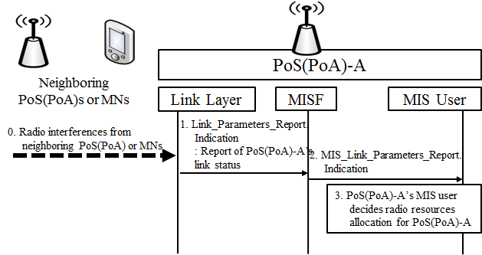
Figure 3—PoS(PoA)-A decides its radio resource allocation based on its link status

- Neighboring PoS(PoA)s or MNs may interfere with PoS(PoA)-A.
- PoS(PoA)-A’s link layer informs PoS(PoA)-A’s MISF (Media Independent Services Function) of bad link status (e.g., low data rate) by using Link_Paramters_Report.indication primitive.
- PoS(PoA)-A’s MISF informs PoS(PoA)-A’s MIS user of bad link status by using MIS_Link_Parameters_Report.indication primitive.
- Based on link status, PoS(PoA)-A’s MIS user determines radio resource allocation for PoS(PoA)-A.

- —Link events
Link event name | Link event type | Description | Defined in
Link_Parameters_Report | Link parameters | Link parameters have crossed pre-specified thresholds. | 7.3.4  IEEE 802.21 Revision

- —MIS events
MIS event name | (L) ocal  (R) emote | Description | Defined  in
MIS_Link_Parameters_Report | L, R | Link parameters have crossed a specified thresh- old and need to be reported. | 7.3.4  IEEE 802.21 Revision

          - Decision by PoS(PoA) based on link status of MN
PoS(PoA) (e.g., PoS(PoA)-A) can decide its radio resource allocation based on link status of MN. MN may experience bad link status due to some reasons (e.g., radio interference) as shown in Figure 4. In this case, if MN (e.g., MN-A) reports its link status to PoS(PoA) by using Link_Parameter_Report and MIS_Link_Parameter_Report primitives/messages in IEEE 802.21 standard, PoS(PoA) can allocate appropriate radio resources for MN.

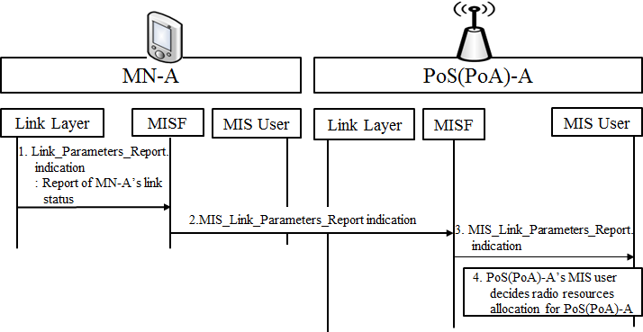
Figure 4—PoS(PoA)-A decides its radio resource allocation based on link status of MN

- MN-A is an MN connecting to PoS(PoA)-A that needs to allocate appropriate radio resources. MN-A’s link layer sends Link_Parameters_Report.indication primitive to MN-A’s MISF.
- MN-A’s MISF sends MIS_Link_Parameters_Report indication message to PoS(PoA)-A’s MISF.
- PoS(PoA)-A’s MISF informs PoS(PoA)-A’s MIS user of MN’s link status by using MIS_Link_Parameters_Report.indication primitive.
- PoS(PoA)-A’s MIS user can decide its radio resource allocation based on link status of MN-A.

          - Decision by PoS(PoA) based on reports from neighboring PoS(PoA)
PoS(PoA) can decide its radio resource allocations based on reports from neighbouring PoS(PoA) as shown in Figure 5. If PoS(PoA) (e.g., Pos(PoA)-A) and neighbouring PoS(PoA) (e.g., PoS(PoA)-B) use the same radio resources, they interfere with each other and need to reallocate their radio resources for improving their link status. The PoS(PoA)-B is neighbouring PoS(PoA) of PoS(PoA)-A that needs to allocate appropriate radio resources. PoS(PoA)-B can report its link status and radio resource allocation. To report PoS(PoA)-B’s link status, Link_Parameters_Report and MIS_Link_Parameters_Report primitives/messages in IEEE 802.21 standard are used as shown in Figure 5 a).
- PoS(PoA)-B’s link layer sends Link_Parameters_Report.indication primitive to PoS(PoA)-B’s MISF to report link status of PoS(PoA)-B.
- PoS(PoA)-B’s MISF sends MIS_Link_Parameters_Report indication message to PoS(PoA)-A’s MISF.
- PoS(PoA)-A’s MISF informs PoS(PoA)-A’s MIS user of PoS(PoA)-B’s link status by using MIS_Link_Parameters_Report.indication primitive.
- PoS(PoA)-A’s MIS user decides radio resource allocation for PoS(PoA)-A.

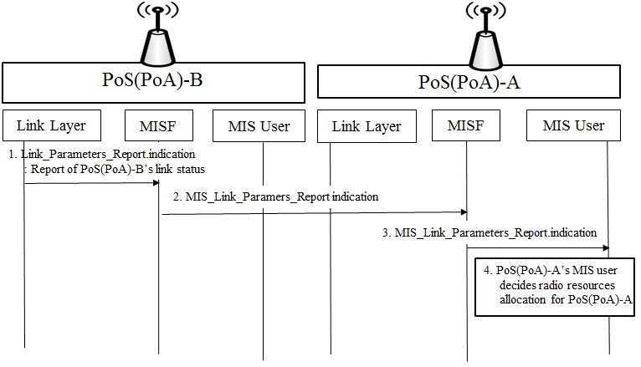
Figure 5 a)—PoS(PoA)-A decides its radio resource allocation based on link status reports of PoS(PoA)-B

To report information on PoS(PoA)-B’s allocated radio resources (e.g., frequency bands and transmit power), MIS_ Resource_Report primitive/message is proposed as a new primitive/message. PoS(PoA)-A decides its radio resource allocation based on radio resource allocation reports of PoS(PoA)-B as shown in Figure 5 b).
- PoS(PoA)-B’s MIS user sends MIS_Resource_Report.request to PoS(PoA)-B’s MISF to report allocated radio resources of PoS(PoA)-B.
- PoS(PoA)-B’s MISF sends MIS_Resource_Report request message to PoS(PoA)-A’s MISF.
- PoS(PoA)-A’s MISF informs PoS(PoA)-A’s MIS user of PoS(PoA)-B’s allocated radio resources by using MIS_Resource_Report.indication primitive.
- PoS(PoA)-A’s MIS user decides radio resource allocation for PoS(PoA)-A.
- PoS(PoA)-A’s MIS user sends MIS_Resource_Report.response to PoS(PoA)-A’s MISF.
- PoS(PoA)-A’s MISF sends MIS_Resource_Report response message to PoS(PoA)-B’s MISF.
- PoS(PoA)-B’s MIS user receives result of PoS(PoA)-A’s updating on allocated radio resources of PoS(PoA)-B by MIS_Resource_Report.confirm.

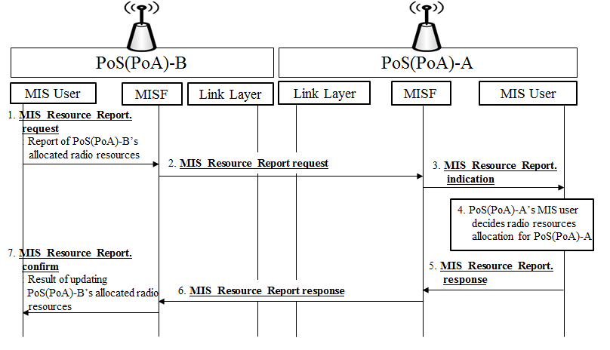

Figure 5 b)—PoS(PoA)-A decides its radio resource allocation based on radio resource allocation reports of PoS(PoA)-B

- New commands

- —MIS commands
MIS command | (L) ocal,  (R) emote | Description | Defined  in
MIS_ Resource_Report | L, R | Command to Indicate allocated radio resources (e.g., frequency, time, and transmit power) | 5.4.2.3.1  IEEE802.21.1

- New primitive/message

- —MIS_SAP primitives
Primitives/Messages | Service  category | Description | Defined  in
MIS_Resource_Report | command | This primitive/message is to Indicate allocated radio resources (e.g., frequency, time, and transmit power) | 5.4.2.3.1  IEEE802.21.1

          - Decision by PoS(PoA) based on configuration information from Information Server
PoS(PoA) can query configuration information to Information Server, and then allocate its own radio resources based on the configuration information as shown in Figure 6. PoS(PoA) can request configuration information such as network type (e.g., IEEE 802.11 and CDMA), frequency bands, and location information of neighboring PoS(PoA)s to Information Server. Based on configuration information from Information Server, PoS(PoA) can allocate its own radio resources. To query configuration information, MIS_Get_Information primitives/messages that are primitives/messages in IEEE 802.21-2009 standard can be used.

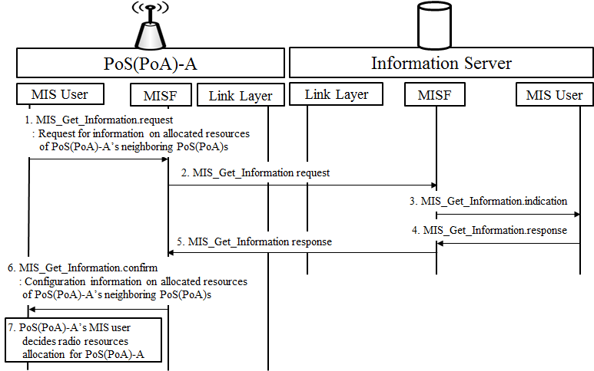
Figure 6—PoS(PoA)-A decides its radio resource allocation based on configuration information from Information Server

- PoS(PoA)-A’s MIS user sends MIS_Get_Information.request primitive to PoS(PoA)-A’s MISF for requesting information on allocated resources of PoS(PoA)-A’s neighboring PoS(PoA)s.
- PoS(PoA)-A’s MISF sends MIS_Get_information request message to MISF of Information Server.
- MIS user of Information Server recognizes that PoS(PoA)-A requests configuration information of PoS(PoA)s in neighborhood with PoS(PoA)-A by receiving MIS_Get_Information.indication primitive.
- MIS user of Information Server sends MIS_Get_Information.response primitive to MISF of Information Server.
- MISF of Information Server sends MIS_Get_Information response message to PoS(PoA)-A’s MISF.
- PoS(PoA)-A’s MIS user receives configuration information of PoS(PoA)-A’s neighboring PoS(PoA)s by MIS_Get_Information.confirm primitive.
- PoS(PoA)-A’s MIS user decides radio resource allocation for PoS(PoA)-A.

- —MIS_SAP primitives
Primitives/Messages | Service  category | Description | Defined  in
MIS_Get_Information | Information | Request to get information from repository | 7.4.25  IEEE802.21 Revision

          - Decision by PoA Controller based on reports from PoS(PoA)s
PoA Controller also can decide radio resource allocation for PoS(PoA) based on reports about link status or radio resource allocation of PoS(PoA)s controlled by PoA Controller, as shown in Figure 7. The PoS(PoA)-B is PoS(PoA) controlled by PoA Controller. PoS(PoA)-B can report its link status and radio resource allocation to PoA Controller, and then PoA Controller can allocate radio resources for PoS(PoA)-A. To report PoS(PoA)-B’s link status, Link_Parameters_Report and MIS_Link_Parameters_Report primitives/messages in IEEE 802.21 standard are used as shown in Figure 7 a).

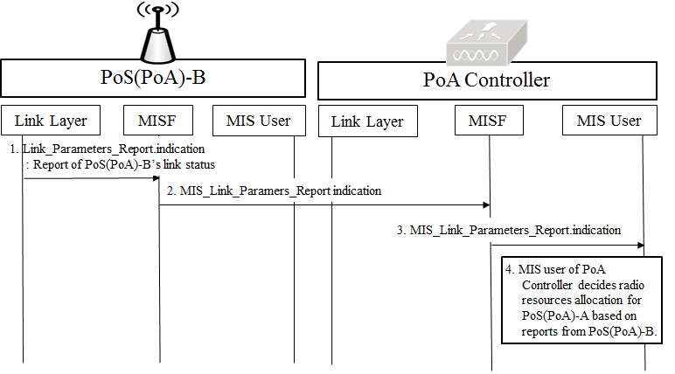
Figure 7 a)—PoA Controller decides PoS(PoA)-A’s radio resource allocation based on link status reports of PoS(PoA)-B

- PoS(PoA)-B’s link layer sends Link_Parameters_Report.indication primitive to PoA-B’s MISF for reporting link status of PoS(PoA)-B.
- PoS(PoA)-B’s MISF sends MIS_Link_Parameters_Report indication message to MISF of PoA Controller.
- PoA Controller’s MISF informs PoA Controller’s MIS user of PoS(PoA)-B’s link status by using MIS_Link_Parameters_Report.indication primitive.
- MIS user of PoA Controller can decide PoS(PoA)-A’s radio resource allocation based on link status of PoS(PoA)-B.

To report information on PoS(PoA)-B’s allocated radio resources (e.g., frequency bands and transmit power), MIS_Resource_Report primitive/message is proposed as a new primitive/message. PoA Controller decides PoS(PoA)-A’s radio resource allocation based on radio resource allocation reports of PoS(PoA)-B as shown in Figure 7 b).
- PoS(PoA)-B’s MIS user sends MIS_Resource_Report.request to PoS(PoA)-B’s MISF to report allocated radio resources of PoS(PoA)-B.
- PoS(PoA)-B’s MISF sends MIS_Resource_Report request message to MISF of PoA controller.
- PoA Controller’s MISF informs PoA controller’s MIS user of PoS(PoA)-B’s allocated radio resources by using MIS_Resource_Report.indication primitive.
- PoA Controller’s MIS user decides radio resource allocation for PoS(PoA)-A.
- PoA Controller’s MIS user sends MIS_Resource_Report.response to PoA Controller’s MISF.
- PoA Controller’s MISF sends MIS_Resource_Report response message to PoS(PoA)-B’s MISF.
- PoS(PoA)-B’s MIS user receives result of PoA Controller’s updating on allocated radio resources of PoS(PoA)-B by MIS_Resource_Report.confirm.
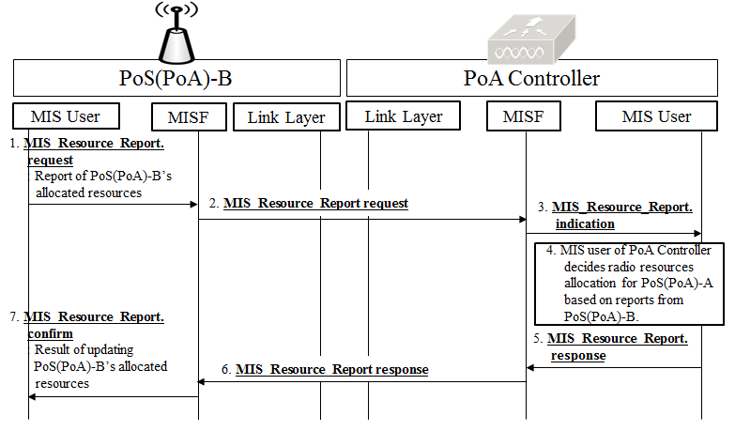

Figure 7 b)—PoA Controller decides PoS(PoA)-A’s radio resource allocation based on radio resource allocation reports of PoS(PoA)-B

          - Decision by PoA Controller based on configuration information from Information Server
PoA Controller can query configuration information to Information Server, and then allocate radio resources for PoS(PoA) as shown in Figure 8. PoA Controller can request configuration information such as network type frequency bands, and location information of PoS(PoA)s controlled by PoA Controller to Information Server. Based on configuration information from Information Server, PoA Controller can allocate appropriate radio resources of PoS(PoA). To query configuration information, MIS_Get_Information primitives/messages that are primitives/messages in IEEE 802.21-2009 standard can be used.
- MIS user of PoA Controller sends MIS_Get_Information.request primitive to MISF of PoA Controller.
- MISF of PoA Controller sends MIS_Get_information request message to MISF of Information Server.
- MIS user of Information Server recognizes that PoA Controller requests configuration information of PoS(PoA)s controlled by PoA Controller with MIS_Get_Information.indication primitive.
- MIS user of Information Server sends MIS_Get_Information.response primitive to MISF of Information Server.
- MISF of Information Server sends MIS_Get_Information response message to MISF of PoA Controller.
- MIS user of PoA Controller receives configuration information of PoS(PoA)s controlled by PoA Controller with MIS_Get_Information.confirm primitive.
- MIS user of PoA Controller decides radio resource allocation for PoS(PoA)-A.

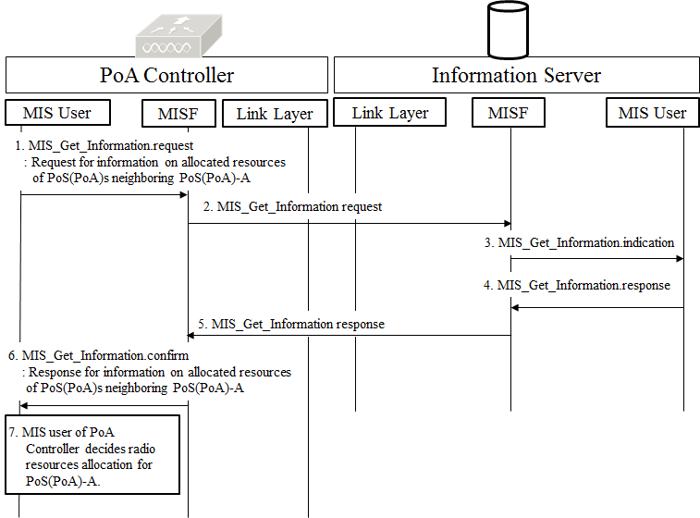
Figure 8—PoA Controller decides PoS(PoA)-A’s radio resource allocation based on configuration information from Information Server
        - Stage 2: preparation of MN’s connection with newly allocated radio resources
Before PoS(PoA) allocates new radio resources, MN needs to prepare changing its connection with newly allocated radio resources of PoS(PoA) that MN connects to. MN can receive information on new radio resources from PoA Controller or PoS(PoA) that MN connects to before performing radio resource allocation. For this stage, MIS_Link_Preparation primitive/message is proposed as new primitive and message.

          - Request for preparation of MN’s connection from PoS(PoA)
PoS(PoA) requests MN to prepare connection with newly allocated radio resources by using MIS_Link_Preparation primitive/message that is newly proposed, as shown in Figure 9. The primitive and message of MIS_Link_Preparation include information on PoS(PoA)’s newly allocated radio resources (e.g., frequency band and transmit power). The MN-A connects to PoS(PoA)-A, and thus MN-A can be requested to prepare connection with new radio resources by PoS(PoA)-A.

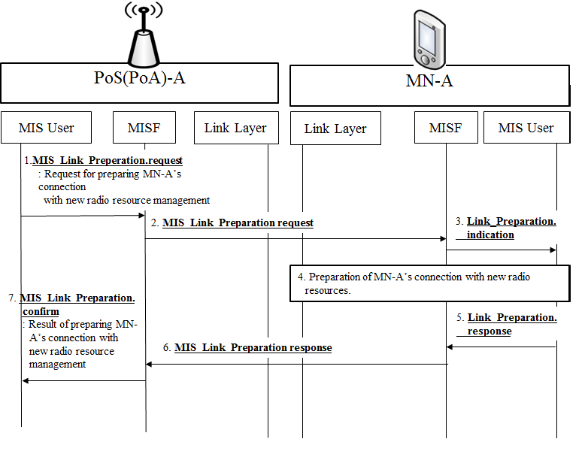
Figure 9—PoS(PoA)-A requests MN-A to prepare connection with newly allocated radio resources

- PoS(PoA)-A’s MIS user sends MIS_Link_Preperation.request primitive to PoS(PoA)-A’s MISF.
- PoS(PoA)-A’s MISF sends MIS_Link_Preparation request message to MN-A’s MISF.
- MN-A’s MIS user is informed of new radio resources to prepare MN’s connection by Link_Preparation.indication primitive.
- MN-A prepares the connection with new radio resources.
- MN-A’s MIS user sends MIS_Link_Preparation.response to MN-A’s MISF.
- MN-A’s MISF sends MIS_Link_Preparation response message to PoS(PoA)-A’s MISF.
- PoS(PoA)-A’s MIS user receives result of preparing MN-A’s connection with new radio resources by MIS_Link_Preparation.confirm.

- New commands

- —MIS commands
MIS command | (L) ocal,  (R) emote | Description | Defined  in
MIS_Link_Preparation | L, R | Command to request MN to prepare connection with newly allocated radio resources | 5.4.2.3.2  IEEE802.21.1

- New primitive/message

- —MIS_SAP primitives
Primitives/Messages | Service  category | Description | Defined  in
MIS_Link_Preparation | Command | This primitive/message is to request MN to prepare connection with newly allocated radio resources | 5.4.2.3.2  IEEE802.21.1

          - Request for preparation of MN’s connection from PoA Controller
PoA Controller also can request MN to prepare connection with newly allocated resources by using MIS_Link_Preparation primitive/message that is newly proposed, as shown in Figure 10.

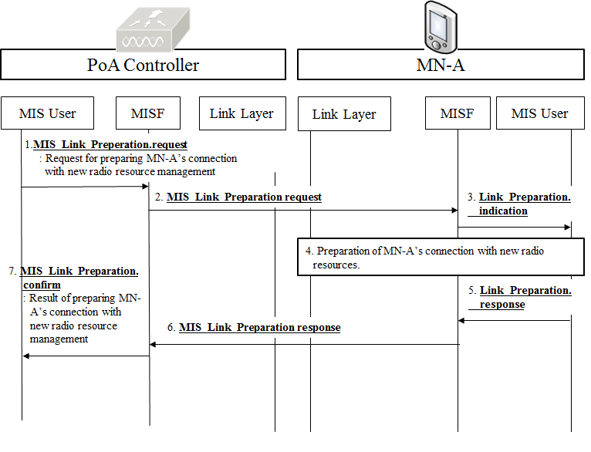
Figure 10—PoA Controller requests MN-A to prepare connection with newly allocated radio resources

- MIS user of PoA Controller sends MIS_Link_Preperation.request primitive to MISF of PoA Controller.
- MISF of PoA Controller sends MIS_Link_Preparation request message to MN-A’s MISF.

- MN-A’s MIS user is informed of new radio resources to prepare MN’s connection by Link_Preparation.indication primitive.
- MN-A prepares the connection with new radio resources.
- MN-A’s MIS user sends MIS_Link_Preparation.response to MN-A’s MISF.
- MN-A’s MISF sends MIS_Link_Preparation response message to MISF of PoA Controller.
- MIS user of PoA Controller receives result of preparing MN-A’s connection with new radio resources by MIS_Link_Preparation.confirm.

        - Stage 3: Allocation of PoS(PoA)’s Radio Resources
In this stage, PoS(PoA)’s radio resources are allocated by PoS(PoA) or PoA Controller. For this stage, MIS_Resource_Allocation and Link_Resource_Allocation primitives/messages are newly proposed for allocating radio resources of PoS(PoA).

          - PoS(PoA)’s radio resource allocation by PoS(PoA)
PoS(PoA) itself can allocate its radio resources, as shown in Figure 11. MIS_Resource_Allocation.request and Link_Resource_Allocation.request primitives are new primitives for allocating radio resources and include parameters that represent radio resources (e.g., frequency band, transmit power, and time slot).
- PoS(PoA)’s MIS user sends MIS_Resource_Allocation.request primitive to PoS(PoA)’s MISF.
- PoS(PoA)’s link layer receives information on radio resources for allocation by Link_Resource_Allocation.request primitive.
- PoS(PoA)’s link layer allocates its own radio resources.
- After PoS(PoA)’s link layer allocates radio resources, PoS(PoA)’s link layer sends Link_Resource_Allocation.confirm primitive to PoS(PoA)’s MISF.
- Result of radio resource allocation is reported to PoS(PoA)’s MIS user by MIS_Resource_Allocation.confirm primitive.
Link_Resource_Allocation.confirm and MIS_Resource_Allocation.confirm should include a parameter to present result (e.g., success or fail) of radio resource allocation.

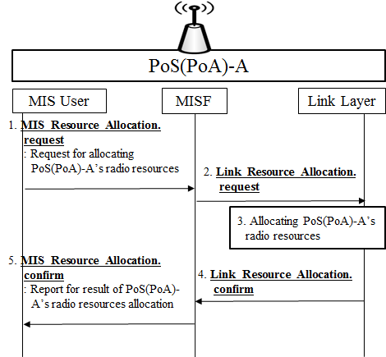
Figure 11—PoS(PoA) allocates its own radio resources

- New commands
- —Link commands
Link command | Description | Defined  in
Link_Resource_Allocation | Command to request for allocating radio resources (e.g., frequency, time, and transmit power) | 5.4.2.3.3  IEEE802.21.1

- —MIS commands
MIS command | (L) ocal,  (R) emote | Description | Defined  in
MIS_Resource_Allocation | L, R | Command to request for allocating radio resources (e.g., frequency, time, and transmit power) | 5.4.2.3.3  IEEE802.21.1

- New primitive/message
- —MIS_LINK_SAP primitives
Primitives | Service  category | Description | Defined  in
Link_Resource_Allocation | Command | request for allocating radio resources (e.g., frequency, time, and transmit power) | 5.4.2.3.3  IEEE802.21.1

- —MIS_SAP primitives
Primitives/Messages | Service  category | Description | Defined  in
MIS_Resource_Allocation | Command | This primitive/message is to request for allocating radio resources (e.g., frequency, time, and transmit power) | 5.4.2.3.3  IEEE802.21.1

          - PoS(PoA)’s radio resource allocation by PoA Controller
MIS user of PoA Controller can request PoS(PoA)’s link layer to allocate radio resources as shown in Figure 12. MIS_Resource_Allocation.request and Link_Resource_Allocation.request primitives are new primitives for PoS(PoA) Controller to allocate radio resources of PoS(PoA).
- MIS user of PoA Controller sends MIS_Resource_Allocation.request primitive to MISF of PoA Controller.
- MISF of PoA Controller sends MIS_Resource_Allocation request message to PoS(PoA)’s MISF.
- PoS(PoA)’s link layer receives information on radio resources for allocation by Link_Resource_Allocation.
- PoS(PoA)’s link layer allocates its own radio resources.
- PoS(PoA)’s link layer sends Link_Resource_Allocation.confirm to PoS(PoA)’s MISF.
- PoS(PoA)’s MISF sends MIS_Response_Allocation response message to MISF of PoA Controller.
- MIS user of PoA Controller receives report on the result of PoS(PoA)’s radio resource allocation.

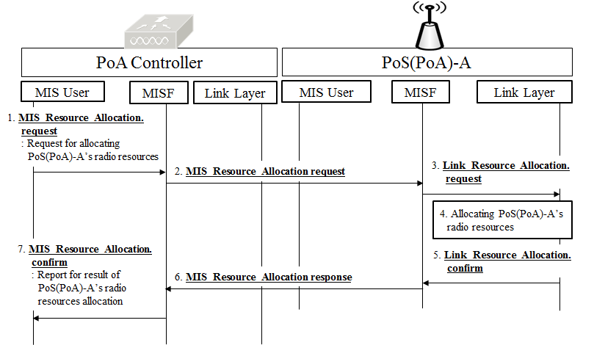
Figure 12—PoA Controller allocates radio resources for PoS(PoA)

        - Stage 4: Report of PoS(PoA)’s allocated radio resources
After radio resource allocation of PoS(PoA), PoS(PoA) should report its updated radio resources to other network entities such as neighboring PoS(PoA), PoA Controller, and Information Server, as shown in Figure 13. MIS_Resource_Report is new primitive/message for reporting PoS(PoA)’s updated radio resource allocation. This includes parameters that represent updated radio resources of PoS(PoA).
* Pre-existing Link_Parameter_Report and MIS_Link_Paramenter_Report primitives/messages are defined for indicating changes in link conditions that have crossed pre-configured threshold levels. However, MIS_Resource_Report primitive/message is defined for reporting allocated radio resources. Therefore, Pre-existing Link_Parameter_Report and MIS_Link_Paramenter_Report are totally different from MIS_Resource_Report primitive/message.

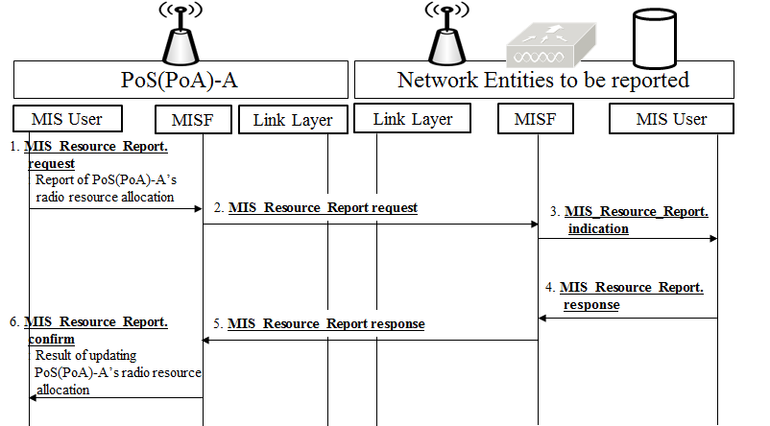
Figure 13—PoS(PoA) reports its radio resources to other its updated radio resources to other network entities

- PoS(PoA)’s MIS user sends MIS_Resource_Report.request primitive to PoS(PoA)’s MISF.
- PoS(PoA)’s MISF sends MIS_Resource_Report request message to MISF of other network entities (e.g., neighboring PoS(PoA), PoA Controller and Information Server).
- MIS user of other network entities updates information on PoS(PoA)’s radio resource allocation by MIS_Resource_Report.indication primitive.
- As response to update report, MIS user of other network entities sends MIS_Resource_Report.response to MISF of other network entities.
- MISF of other network entities sends MIS_Resource_Report response message to PoS(PoA)’s MISF.
- PoS(PoA)’s MIS user is informed by MIS_Resource_Report.confirm primitive whether other network entities update PoS(PoA)’s radio resource allocation or not.

    - Service specific primitives

      - MIS_LINK_SAP primitives

        - Link_Resource_Allocation
          - Link_Resource_Allocation.request
          - Link_Resource_Allocation.confirm

      - MIS_SAP primitives

        - MIS_Resource_Allocation
          - MIS_Resource_Allocation.request
            - Function
MIS_Resource_Allocation.request is used for an MIS user to request an MISF to allocate radio resources.
            - Semantics of service primitive
MIS_Resource_Allocation.request (
DestinationIdentifier,
Resource_Config
)
Parameters:
Name | Data type | Description
DestinationIdentifier | MISF_ID | This identifies PoS(PoA) to allocated radio resources.
Resource_Config |  | Configuration information for allocating radio resources.
            - When generated
This primitive is invoked by MIS user when it needs to allocate radio resources.
            - Effect on receipt
On receipt, the local MISF sends an MIS_Resource_Allocation request message to the destination MISF, or the local MISF sends an Link_Resource_Allocation.request primitive to the local link layer.

          - MIS_Resource_Allocation.indication
            - Function
This primitive is used by an MISF to notify an MIS user that an MIS_Resource_Allocation request message has been received.
            - Semantics of service primitive
MIS_Resource_Allocation.indication (
SourceIdentifier,
Resource_Config
)
Parameters:
Name | Data type | Description
SourceIdentifier | MISF_ID | This identifies the invoker of this primitive, which is a remote MISF.
Resource_Config |  | Configuration information for allocating radio resources
            - When generated
This primitive is generated by the remote MISF when an MIS_Resource_Allocation request message is received
            - Effect on receipt
The remote MIS user will perform necessary actions to process the radio resource allocation request and respond with an MIS_Resource_Allocation.response.

          - MIS_Resource_Allocation.response
            - Function
This primitive is used by an MIS user to send the processing status of a received resource allocation request.
            - Semantics of service primitive
MIS_Resource_Allocation.response (
DestinationIdentifier,
Status
)
Parameters:
Name | Data type | Description
DestinationIdentifier | MISF_ID | This identifies a remote MISF, which will be the destination of this response.
Status | STATUS | Status of operation
            - When generated
This primitive is invoked by the MIS user to report back the result after completing the processing of a resource allocation request.
            - Effect on receipt
Upon receipt, the local MISF sends an MIS_Resource_Allocation response message to the destination MISF.

          - MIS_ Resource_Allocation.confirm
            - Function
This primitive is used by the local MISF to convey the result of a resource allocation request to an MIS user.
            - Semantics of service primitive
MIS_Resource_Allocation.confirm (
SourceIdentifier,
Status
)
Parameters:
Name | Data type | Description
SourceIdentifier | MISF_ID | This identifies the invoker of this primitive, which is a remote MISF..
Status | STATUS | Status of operation

            - When generated
This primitive is used by an MISF to notify an MIS user the result of an MIS_Resource_Allocation.request.
            - Effect on receipt
Upon receipt, the MIS user can determine the result of resource allocation request.

        - MIS_Resource_Report
          - MIS_Resource_Report.request
            - Function
MIS_Resource_Report.request indicates information on allocated radio resources of a PoS(PoA).
            - Semantics of service primitive
MIS_Resource_Report.request (
DestinationIdentifier,
Resource_Info
)
Parameters:
Name | Data type | Description
DestinationIdentifier | MISF_ID | This identifies the remote MISF to receive information on allocated radio resources.
Resource_Info |  | Information on allocated radio resources
            - When generated
This primitive is invoked by an MIS user when it needs to report information on allocated radio resources.
            - Effect on receipt
On receipt, the local MISF sends an MIS_Resource_Report request message to the destination MISF.

          - MIS_Resource_Report.indication
            - Function
MIS_Resource_Report.indication is sent by the local MISF to a local MIS user to report information on radio resource allocation of PoS(PoA).
            - Semantics of service primitive
MIS_Resource_Report.indication (
SourceIdentifier,
Resource_Config
)
Parameters:
Name | Data type | Description
SourceIdentifier | MISF_ID | This identifies the invoker of this primitive, which is a remote MISF.
Resource_Info |  | Information on allocated radio resources
            - When generated
This primitive is generated by the remote MISF when an MIS_Resource_Report request message is received
            - Effect on receipt
The remote MIS user will perform necessary actions to process the resource report request and respond with an MIS_Resource_Report.response.

          - MIS_Resource_Report.response
            - Function
This primitive is used by an MIS user to send the processing status of received request.
            - Semantics of service primitive
MIS_Resource_Report.response (
DestinationIdentifier,
Status
)
Parameters:
Name | Data type | Description
DestinationIdentifier | MISF_ID | This identifies a remote MISF, which will be the destination of this response.
Status | STATUS | Status of operation
            - When generated
This primitive is invoked by the MIS user to report back the result after completing the processing of a report request.
            - Effect on receipt
Upon receipt, the local MISF sends an MIS_Resource_Report response message to the destination MISF.

          - MIS_Resource_Report.confirm
            - Function
This primitive is used by the local MISF to convey the result of a resource report request to an MIS user.
            - Semantics of service primitive
MIS_Resource_Report.confirm (
SourceIdentifier,
Status
)
Parameters:
Name | Data type | Description
SourceIdentifier | MISF_ID | This identifies the invoker of this primitive, which is a remote MISF..
Status | STATUS | Status of operation

            - When generated
This primitive is used by an MISF to notify an MIS user the result of an MIS_Resource_Report.request.
            - Effect on receipt
Upon receipt, the MIS user can determine the result of resource report request.

        - MIS_Link_Preparation
          - MIS_Link_Preparation.request
            - Function
MIS_ Link_Preparation.request is used for MIS user of PoS(PoA) or PoA controller to request MN to prepare connection with newly allocated radio resources.
            - Semantics of service primitive
MIS_Link_Preparation.request (
DestinationIdentifier,
Resource_Config
)
Parameters:
Name | Data type | Description
DestinationIdentifier | MISF_ID | This identifies PoS(PoA) to allocated radio resources.
Resource_Config |  | Configuration information for allocating radio resources
            - When generated
This primitive is invoked by MIS user when it needs to request MN to prepare connection with newly allocated radio resources.
            - Effect on receipt
On receipt, the local MISF sends an MIS_Link_Preparation request message to the destination MISF.

          - MIS_Link_Preparation.indication
            - Function
This primitive is used by an MISF to notify an MIS user that an MIS_Link_Preparation request message has been received.
            - Semantics of service primitive
MIS_Link_Preparation.indication (
SourceIdentifier,
Resource_Config
)
Parameters:
Name | Data type | Description
SourceIdentifier | MISF_ID | This identifies the invoker of this primitive, which is a remote MISF.
Resource_Config |  | Configuration information for allocating radio resources
            - When generated
This primitive is generated by the remote MISF when an MIS_Link_Preparation request message is received
            - Effect on receipt
The remote MIS user will perform necessary actions to process the link preparation request and respond with an MIS_Link_Preparation.response.

          - MIS_Link_Preparation.response
            - Function
This primitive is used by an MIS user to send the processing status of a received request.
            - Semantics of service primitive
MIS_Link_Preperation.response (
DestinationIdentifier,
Status
)
Parameters:
Name | Data type | Description
DestinationIdentifier | MISF_ID | This identifies a remote MISF, which will be the destination of this response.
Status | STATUS | Status of operation
            - When generated
This primitive is invoked by the MIS user to report back the result after completing the processing of a link prepartion request.
            - Effect on receipt
Upon receipt, the local MISF sends an MIS_Link_Preparation response message to the destination MISF.

          - MIS_Link_Preparation.confirm
            - Function
This primitive is used by the local MISF to convey the result of a link preparation request to an MIS user.
            - Semantics of service primitive
MIS_Link_Preparation.confirm (
SourceIdentifier,
Status
)
Parameters:
Name | Data type | Description
SourceIdentifier | MISF_ID | This identifies the invoker of this primitive, which is a remote MISF..
Status | STATUS | Status of operation

            - When generated
This primitive is used by an MISF to notify an MIS user the result of an MIS_Link_Preparation request.
            - Effect on receipt
Upon receipt, the MIS user can determine the result of link preparation request.

    - Service specific protocol features

      - MIS protocol messages for command service

        - MIS_Resource_Allocation
          - MIS_Resource_Allocation request
The corresponding MIS primitive of this message is defined in 5.4.3.2.1.1.
An MISF sends this message to request the allocation of radio resources.

MIS Header Fields (SID=3, Opcode=1, AID=xx)
Source Identifier = sending MISF ID
(Source MISF ID TLV)
Destination Identifier = receiving MISF ID
(Destination MISF ID TLV)
Resource_Config
(xxxxxx TLV)

          - MIS_Resource_Allocation response
The corresponding MIS primitive of this message is defined in 5.4.3.2.1.3.
This message returns the result of MIS_ Resource_Allocation request.

MIS Header Fields (SID=3, Opcode=2, AID=xx)
Source Identifier = sending MISF ID
(Source MISF ID TLV)
Destination Identifier = receiving MISF ID
(Destination MISF ID TLV)
Status
(Status TLV)

        - MIS_Resource_Report
          - MIS_Resource_Report request
The corresponding MIS primitive of this message is defined in 5.4.3.2.2.1.
An MISF sends this message to report information on allocated radio resources of a PoS(PoA)

MIS Header Fields (SID=3, Opcode=1, AID=xx)
Source Identifier = sending MISF ID
(Source MISF ID TLV)
Destination Identifier = receiving MISF ID
(Destination MISF ID TLV)
Resource_Info
(xxxxxx TLV)

          - MIS_Resource_Report response
The corresponding MIS primitive of this message is defined in 5.4.3.2.2.3.
This message returns the result of MIS_ Resource_Report request.

MIS Header Fields (SID=3, Opcode=2, AID=xx)
Source Identifier = sending MISF ID
(Source MISF ID TLV)
Destination Identifier = receiving MISF ID
(Destination MISF ID TLV)
Status
(Status TLV)
        - MIS_Link_Preparation
          - MIS_Link_Preparation request
The corresponding MIS primitive of this message is defined in 5.4.3.2.3.1.
An MISF sends this message to request MN to prepare connection with newly allocated radio resources

MIS Header Fields (SID=3, Opcode=1, AID=xx)
Source Identifier = sending MISF ID
(Source MISF ID TLV)
Destination Identifier = receiving MISF ID
(Destination MISF ID TLV)
Resource_Config
(xxxxxx TLV)

          - MIS_Link_Preparation response
The corresponding MIS primitive of this message is defined in 5.4.3.2.3.3.
This message returns the result of MIS_ Link_Preparation request.

MIS Header Fields (SID=3, Opcode=2, AID=xx)
Source Identifier = sending MISF ID
(Source MISF ID TLV)
Destination Identifier = receiving MISF ID
(Destination MISF ID TLV)
Status
(Status TLV)

Annex E
(informative)
Media Specific mapping for SAPs

Table E.2- MIH_LINK_SAP/IEEE 802.11/IEEE 802.3/IEEE 802.1ag primitives mapping
Primitives | IEEE Std 802.11 | IEEE Std 802.3 | IEEE Std 802.1ag[B19]
Link_Resource_Allocation | MLME-CHANNELSWITCH request,  MLME-TPCADAPT request  MLME-ADDTS  MLME-DELTS  MLME-DLS | N/A | N/A

Annex F
(normative)
Data type definition

Annex G
(normative)
Information element identifiers

Annex L
(normative)
MIH protocol message code assignments

Annex M
(normative)
Protocol implementation conformance statement (PICS) proforma

