Project | IEEE 802.21.1 Media Independent Services  <http://www.ieee802.org/21/>
Title | Revised Draft of “D2D Communications Service” Section for IEEE 802.21.1 Draft Standard
DCN | 21-15-0082-00-SAUC
Date Submitted | August 21, 2015.
Source(s) | Hyeong-Ho Lee (ETRI), Hyunho Park (ETRI), Jin Seek Choi (Hanyang University, Korea Ethernet Forum)
Re: | IEEE 802.21m & IEEE 802.21.1 TGs Teleconference Meeting
Abstract | Based on the discussion of the contribution “Proposed Update for “D2D Communications Service” Section of IEEE 802.21.1 Draft Standard” (DCN 21-15-0066-00-SAUC) in IEEE 802.21 Session #69, this document proposes revised text of “D2D Communication Service” Section for IEEE 802.21.1 Draft Standard. Service specific primitives and protocol features are defined with data type definitions, information element identifiers, and MIS protocol message code assignments.
Purpose | To be part of 802.21.1 draft standard document.
Notice | This document has been prepared to assist the IEEE 802.21 Working Group. It is offered as a basis for discussion and is not binding on the contributing individ ual(s) or organization(s). The material in this document is subject to change in form and content after further study. The contributor(s) reserve(s) the right to add, amend or withdraw material contained herein.
Release | The contributor grants a free, irrevocable license to the IEEE to incorporate material contained in this contribution, and any modifications thereof, in the creation of an IEEE Standards publication; to copyright in the IEEE’s name any IEEE Standards publication even though it may include portions of this contribution; and at the IEEE’s sole discretion to permit others to reproduce in whole or in part the resulting IEEE Standards publication. The contributor also acknowledges and accepts that IEEE 802.21 may make this contribution public.
Patent Policy | The contributor is familiar with IEEE patent policy, as stated in Section 6 of the IEEE-SA Standards Board bylaws <http://standards.ieee.org/guides/bylaws/sect6-7.html#6> and in Understanding Patent Issues During IEEE Standards Development http://standards.ieee.org/board/pat/faq.pdf
Table of Contents

5.5 D2D communications service 3
5.5.1 Introduction 3
5.5.2 Service scenarios and call flows 3
5.5.3 Service specific primitives 15
5.5.4 Service specific protocol features 21

Annex F (normative) Data type definition
Annex G (normative) Information element identifiers
Annex L (normative) MIS protocol message code assignments

  - D2D communications service
    - Introduction
Device-to-device (D2D) communication is direct data communication between mobile nodes (MNs) and attracts attentions in perspective of network resource management and communication service based on proximity. Applications of D2D communications can be social networking, advertisement, public safety, data sharing, and data offload.
For D2D communication, media independent service (MIS) framework of IEEE 802.21 standard is able to help an MN to search for and connect to its peer. MIS framework of IEEE 802.21 standard is common platform to support interworking between networks using IEEE802 and non-IEEE802 technologies, so that MIS framework can be easily extended to a platform for D2D communications such as Wi-Fi Direct, 3GPP proximity service (ProSe), and IEEE 802.15.8 peer aware communication (PAC).
The MIS framework can apply to D2D communication with or without assistance of network entities such as a base station or an access point. For D2D communication with network assistance, network entities with MIS framework provide configuration information for an MN to discover its peer and control D2D connections of MNs. For D2D communication without network assistance, MNs with MIS framework can find and select the most appropriate D2D technology that can offer the best quality of service (QoS) or quality of experience (QoE).
This section introduces discovery and connection for D2D communication based on MIS, and includes methods and signaling for supporting discovery and connection for D2D communication based on MIS.

    - Service scenarios and call flows
      - D2D communication with network assistance
Communication service providers and network operators have interest in D2D communication because D2D communication can provide communication between MNs in close proximity with a small amount of network resource. By using D2D communication, MNs in close proximity can share data such as video clips or local information. Service providers of D2D communication can distribute local advertisement information or emergency information such as location of emergency shelters. Network operators can save network resources by offloading data to D2D communication. For making a connection for D2D communication, it is difficult for an MN to discover its peer that is able to offer communication services (e.g., data sharing, local advertisement and emergency information) that the MN wants to receive.
Communication service providers and network operators will help an MN to search for and connect to its peer by assistance of network infrastructures. The D2D communication with network assistance can be called as network-assisted D2D communication (NADC).
MIS framework, which is control plane of infrastructure network, can be the control plane for NADC. MIS framework provides network configuration information for MN and controls MN’s connection to access network by using point of service (PoS) and Information Server, which are defined in IEEE 802.21 standard as network-side instance of MIS framework and server that provides network configuration information, respectively. Thus, with minor modification of Information Server and PoS, MIS framework can provide configuration information of MN’s peer for MN and controls MN’s D2D connection.
        - Service flows
For NADC, both MN and NADC provider is able to initiate D2D communication. Therefore, service flows for NADC needs to be classified into MN-initiated D2D communication and NADC provider-initiated D2D communication.
- Service flows of MN-initiated D2D communication
  - MN requests information to connect with its peer to Information Server.
  - Information Server responds to the MN with configuration information to connect with a candidate peer of the MN. The configuration information may be technology of D2D communication such as Wi-Fi Direct and PAC, identifier (e.g., MAC address and IP address) of the candidate peer, and frequency information that its candidate peer can use.
  - Based on configuration information from Information Server, the MN searches for and connects to its peer node.

- Service flows of NADC PoS-initiated D2D communication
  - NADC PoS that controls and manages D2D communications of MNs requests information for a peer node of MN to Information Server.
  - Information Server responds to NADC PoS with configuration information to connect with a candidate peer of the MN. The configuration information may be technology of D2D communication such as Wi-Fi Direct and PAC, identifier (e.g., MAC address and IP address) of the candidate peer, and frequency information that its candidate peer can use.
  - The NADC PoS sends the configuration information of a candidate peer to the MN.
  - The MN decides whether to use D2D communication. If the MN decides to use D2D communication, the MN tries to search for and connect to its peer node by using the configuration information from NADC PoS.

        - High level illustration
Figure 1 shows control signaling for NADC by using media independent service messages. Information Server provides configuration information for an MN’s peer. The configuration information of Information Server can be requested by MNs and PoS. PoS controls MNs’ connection of D2D communication by requesting MN to select D2D communication and assigning radio resource for D2D communication. NADC provider can operate its own PoS, and NADC PoS can communicate with other PoSes. MN and its peer, NADC PoS, and Information Server are equipped with MIS function (MISF) and the following assumptions apply to Fig. 1.
- MN’s peer can provide communication service that the MN wants to receive.
- MN and its peer should communicate by using the same D2D communication technology.
- Information Server should know proximity between mobile nodes.
- Information Server may derive proximity between MNs by using MNs’ location information (e.g., GPS information).
- Information Server should know communication services (e.g., local information service, file transmission, and voice call) that MNs can provide.
- Information Server should know D2D communication technologies that MNs can use.
- NADC PoS controls MNs’ D2D connection and control MNs’ radio resource for D2D communication.
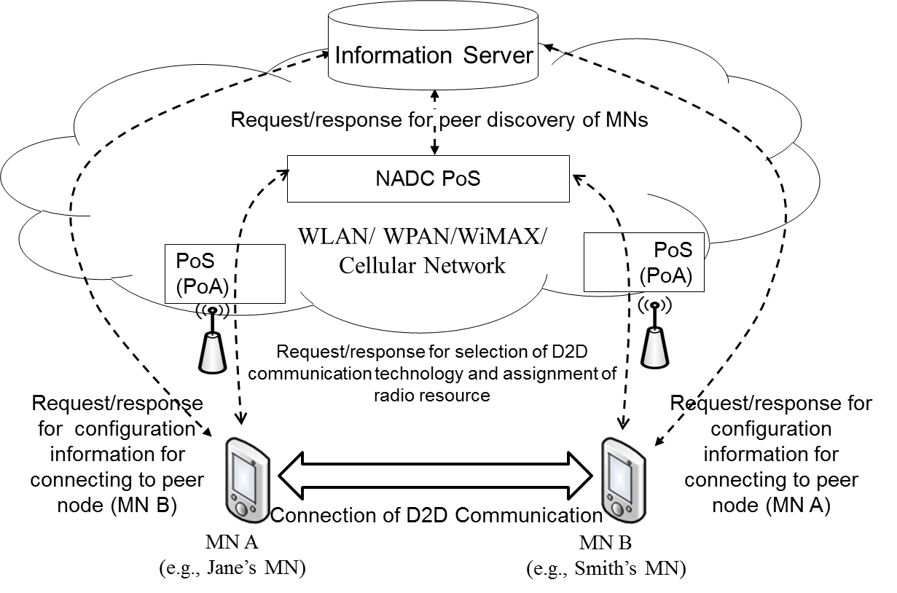
Figure 1—Control signaling of NADC.

        - Stages for NADC based on MIS Framework
NADC based on MIS framework comprises three stages as in Figure 2.
- In the first stage, D2D devices register to Information Server with their configuration information for D2D communications. The configuration information can be types of D2D technologies such as Wi-Fi Direct and 3GPP ProSe.
- In the second stage, NADC PoS discovers pairs for D2D communications.
- In the third stage, NADC PoS orders D2D devices to make D2D communications.

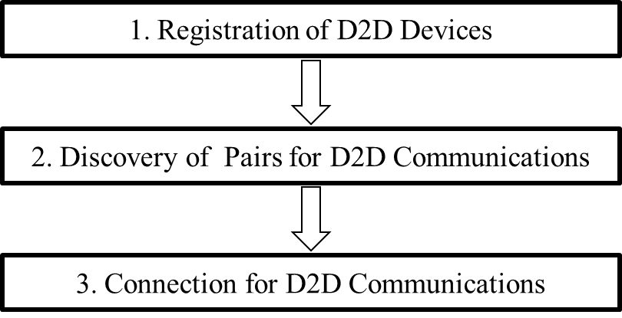
Figure 2—Stages for NADC based on MIS framework.

        - Signal flows and primitives/messages
          - Stage 1: registration of D2D devices
Information Server collects configuration information, which includes list of D2D communication technologies used by MN, for MNs’ registrations to Information Server. Signal flows shown in Figure 3 are as follows.
- MN’s MIS user sends MIS_D2D_Registration.request primitive to MN’s MISF.
- MN’s MISF requests registration to Information Server by sending MIS_D2D_Registration request message with its configuration information including its available D2D communication technologies (i.e., D2D_Techlist).
- Information Server’s MISF sends MIS_D2D_Registration.indication primitive to MIS user for registering MN as a D2D device.
- After Information Server’s MIS User registers the MN as a D2D device, the Information Server’s MIS user sends MIS_D2D_Registration.response to Information Server’s MISF for responding the registration request.
- Information Server’s MISF responds with MIS_D2D_Registration response message.
- MN’s MISF reports that the MN is registered to Information Server as a D2D device by sending MIS_D2D_Registration.confirm primitive to MN’s MIS user.

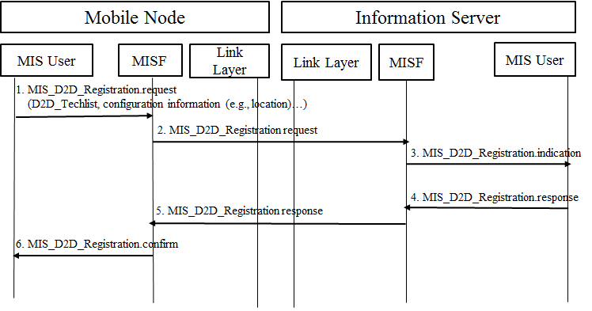
Figure 3—Registration of D2D devices with list of D2D technologies.

- New primitive/message

- —MIS_SAP primitives
Primitives/Messages | Service  category | Description | Defined  in
MIS_D2D_Registration | Command | This primitive/message is used for MN to register D2D devices | 5.5.2.1.4  IEEE802.21.1

- New parameter
Parameter | Description
D2D_Techlist | List of D2D communication technologies used by an MN
Config_Info | Information that includes location information and network connection information (e.g., radio frequency and network identification) of communication devices

          - Stage 2: discovery of pairs for D2D communications
Information Server provides configuration information that can help MN discover its peer. Signal flows shown in Figure 4 are as follows.
a) MN-initiated D2D communication
- MN’s MIS user sends MIS_Get_Information.request primitive to MN’s MISF with its location (QUERIER_LOC), communication service (QUERIER_D2D_SERVICE), and available D2D service communication (QUERIE_D2D_TECHLIST) and requests information of candidate peer for D2D communication.
- MN informs Information Server by sending MIS_Get_Information request message, .
- Information Server’s MISF sends MIS_Get_Information.indication to Information Server’s MIS user to request configuration information.
- Information Server’s MIS user responds for the configuration information request by sending MIS_Get_Infromation.response primitive.
- Information Server’s MISF sends MIS_Get_Information response message with the peer’s identity (IE_D2D_PEERID) and configuration information (IE_D2D_CONFIG) to discover the peer.
- MN’s MISF sends MIS_Get_Information.confirm to MN’s MIS user.

b) NADC PoS-initiated D2D communication
- NADC PoS’s MIS user sends MIS_Get Information.request primitive to NADC PoS’s MISF with its location (QUERIER_LOC), communication service (QUERIER_D2D_SERVICE), and available D2D service communication (QUERIE_D2D_TECHLIST) and requests information of candidate peer for D2D communication.
- NADC PoS informs Information Server by sending MIS_Get_Information request message.
- Information Server’s MISF sends MIS_Get_Information.indication to Information Server’s MIS user to request configuration information.
- Information Server’s MIS user responds for configuration information request by sending MIS_Get_Infromation.response primitive.
- Information Server sends MIS_Get_Information response message with the peer’s identity (IE_D2D_PEERID) and configuration information (IE_D2D_CONFIG) to discover the peer.
- NADC PoS’s MISF sends MIS_Get_Information.confirm to NADC PoS’s MIS user.

- NADC PoS’s MISF sends MIS_Get_Information.confirm to MN’s MIS user.

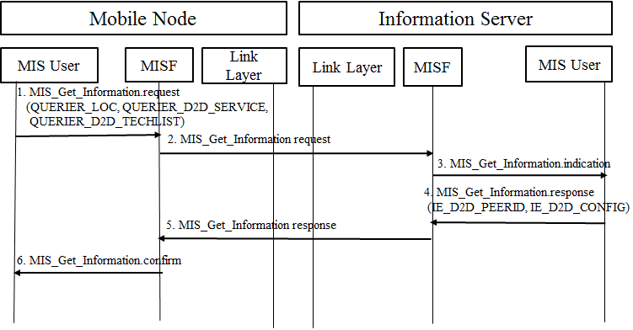
- MN-initiated D2D communication
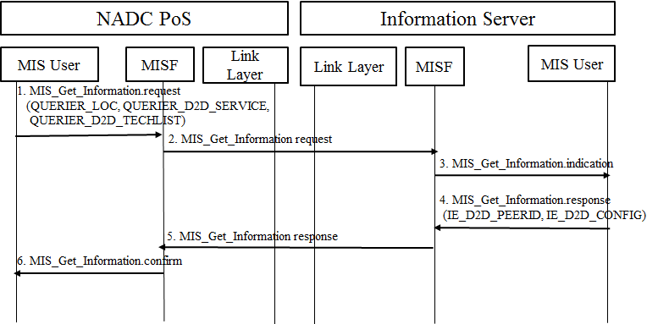
- NADC PoS-initated D2D communication
Figure 4—Discovery of D2D devices with list of D2D technologies.

- —MIS_SAP primitives
Primitives/Messages | Service  category | Description | Defined  in
MIS_Get_Information | Information | Request to get information from repository | 7.4.25  IEEE802.21 Revision
- New parameters
MIH_Get_Information primitive/message and QUERIER_LOC parameter have been defined in IEEE 802.21 standard, and new parameters (QUERIER_D2D_SERVICE, QUERIER_D2D_TECHLIST) are defined to be added in Table F.15 of Annex F in IEEE 802.21-2008.

- New information elements: Information elements to be added in Table 10- Information elements (Section 6.5.4 in IEEE 802.21-2008)
Data type name | Derived from | Definition
IE_D2D_PEERID | D2D_PEERID | Peer’s identity(e.g., MAC address, IP address, and IMSI(International Mobile Subscriber Identity))
IE_D2D_CONFIG | D2D_CONFIG | Configuration information(e.g., frequency band) to help the MN configure its peer

          - Stage 3: connection for D2D communications
MN or PoS can initiate to change communication technology of MN’s D2D connection. For example, MN or PoS initiate to change Wi-Fi Direct of MN’s D2D connection into IEEE 802.15.8 PAC. Signal flows shown in Figure 5 are as follows.
a) MN-initiated D2D communication
- MN requests its peer to change its D2D communication into other D2D communication technology (e.g., PAC) by sending MIS_D2D_Connection request message. (Step 1~Step 3)
- Changing D2D connection between MN and its peer by using other D2D communication (e.g., PAC): Out of Scope (Step 4)
- MN’s peer responds to MN with connection result (success or fail) by sending MIS_D2D_Connection response message. (Step 5~Step 7)
b) NADC PoS-initiated D2D communication
- NADC PoS requests MN to change its D2D communication technology into other D2D communication technology (e.g., PAC) by sending MIS_D2D_Connection request message. (Step 1~Step 3)
- MN requests its peer to change their D2D communication into other D2D communication technology (e.g., PAC) by sending MIS_D2D_Connection request message. (Step 4~Step 6)
- Changing D2D connection between MN and its peer by using other D2D communication (e.g., PAC): Out of Scope (Step 7)
- MN’s peer responds to MN with connection result (success or fail) by sending MIS_D2D_Connection response message. (Step 8~Step 10)
- MN responds to NADC PoS with connection result (success or fail) by sending MIS_D2D_Connection response message. (Step 11~Step 13)

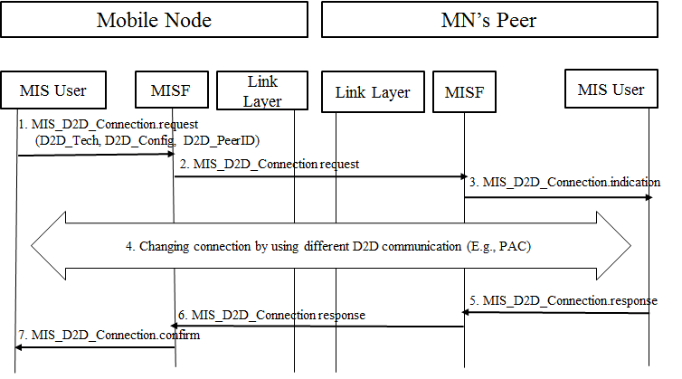
- MN- initiated D2D communication

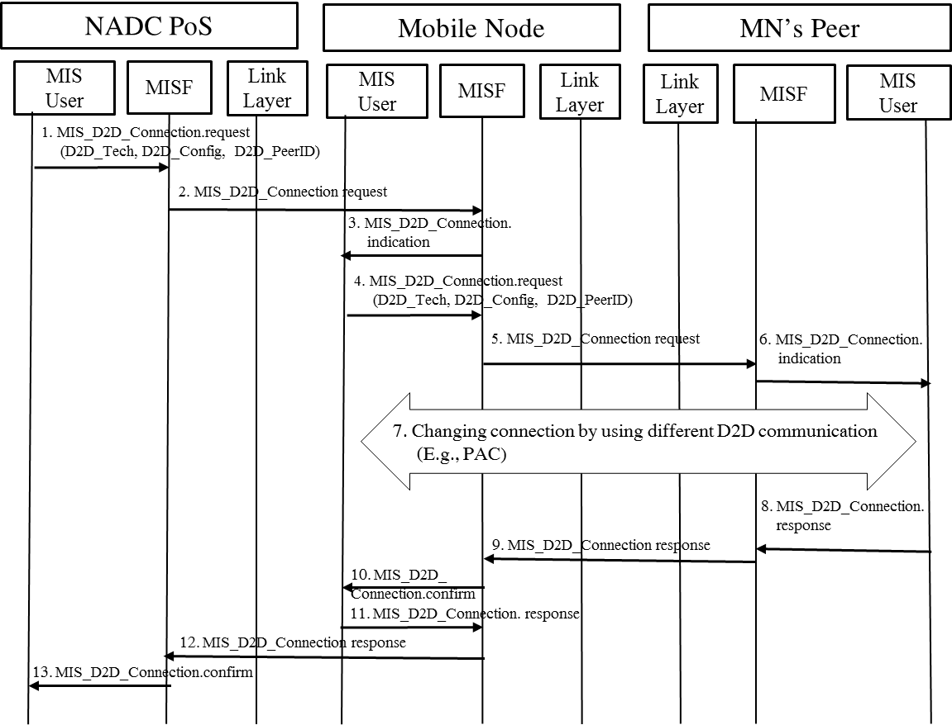

(b) NADC PoS-initiated D2D communication

Figure 5—Connection for D2D communications.
- New primitive/message
- —MIS_SAP primitives
Primitives/Messages | Service  category | Description | Defined  in
MIS_D2D_Connection | command | This primitive/message is used for an MN and its peer to make a connection of D2D communication technology. | 5.5.2.1.4  IEEE802.21.1

- New parameters
Parameter | Description
D2D_Tech | Information of D2D communication technologies that MN or its peer can use
D2D_Config | Configuration information(e.g., frequency band) to help the MN configure its peer
D2D_PeerID | Peer’s identity(e.g., MAC address, IP address, and IMSI)

      - D2D communication without network assistance

Various technologies for D2D communication have been developed recently. Smart devices such as smartphones and tablet PCs already implement Wi-Fi Direct. Future smart devices may implement developing technologies of D2D communication technologies such as 3GPP ProSe and PAC. For future smart devices, it is important for the smart devices to select the most appropriate technology of D2D communication that can support the best QoS or QoE.
By using D2D communication, smart MNs in close proximity can directly share data such as video clips or local information without network assistance. D2D communication can serve local advertisement information or emergency information such as location of emergency shelters.
MIS framework will support MNs to select appropriate technology of D2D communication without any network assistance. Existing MIS framework can enable MNs to monitor link status, which is status (e.g., signal strength and data rate) of physical layer and data link layer by using media independent event service (MIES) and can select the most appropriate access network by using media independent control service (MICS) even without network assistance. Therefore, if MIES and MICS are extended for supporting D2D communication, it will be possible for MNs to monitor link status of D2D communications and select the most appropriate technology of D2D communication without network assistance.

        - Service Flows
Jane is user of an MN that supports D2D communication. Smith is user of a peer node of Jane’s MN
- Jane’s MN and Smith’s MN transfer data through D2D communication “P” (e.g., Wi-Fi Direct).
- Jane’s MN detects that link status (e.g., signal strength and data rate) of D2D communication “P” is getting worse due to some reason such as radio interference.
- Jane’s MN discovers the most appropriate D2D communication “Q” (e.g., PAC) that is different from D2D communication “P” by monitoring link status of “Q.”
- Jane’s MN requests Smith’s MN to change D2D communication “P” into D2D communication “Q.”
- Jane’s MN and Smith’s MN make a connection by using D2D communication “Q.”
- Jane’s MN and Smith’s MN can transfer data through D2D communication “Q.”

        - High level illustration
Figure 6 shows control signaling for D2D communication without network assistance. The service flows are explained specifically in “5.5.2.2.1 Service flows.” The following assumptions apply to Fig. 6.
- MN’s peer can provide communication service that the MN wants to be served.
- MN and its peer should communicate by using the same D2D service communication technology.
- MN can monitors link status of D2D communication.
- MN and its peer can change their D2D communication technology without any network assistance.

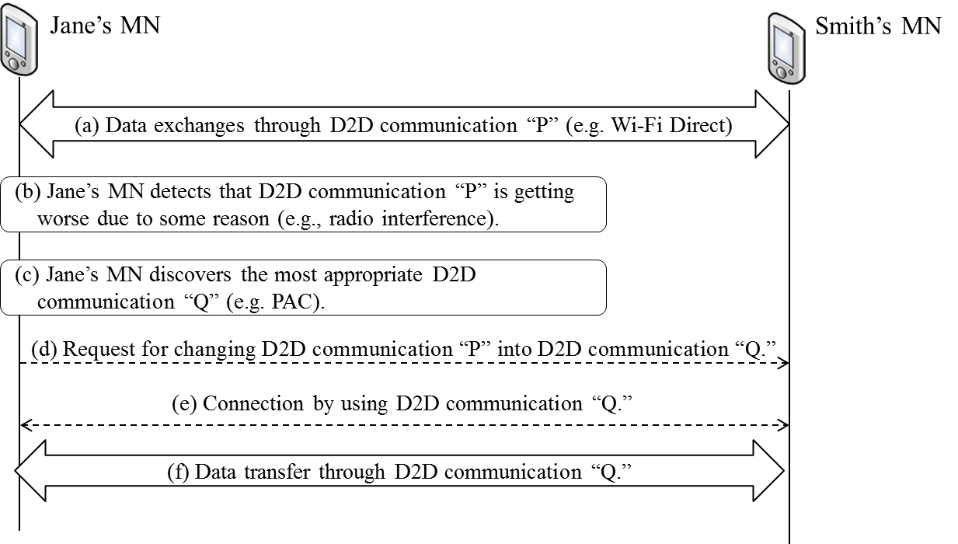
Figure 6—Control signaling of D2D communication without network assistance.

        - Stages for D2D communication without network assistance
- In the first stage, MN discovers pairs for D2D communications.
- In the second stage, MN orders D2D devices to make D2D communications.

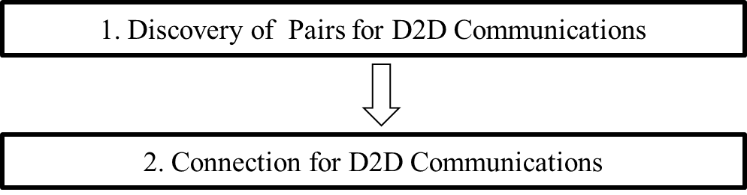

Figure 7— Stages for D2D communication without network assistance.

        - Signal flows and primitives/messages
          - Changing connection of D2D communication
MN changes communication technology of its D2D connection depending on its link status. For example, MN changes Wi-Fi Direct of MN’s D2D connection into IEEE 802.15.8 PAC depending on its link status. Signal flows shown in Figure 8 are as follows.
- Connection between MN and its peer by using D2D communication (e.g., Wi-Fi Direct): Out of Scope (Step 0)
- MN monitors its link status of current D2D communication technology and determines to change the D2D communication technology into other D2D communication technology. (Step 1)
- MN requests its peer to change their D2D communication into different D2D communication technology (e.g., PAC) by sending MIS_D2D_Connection request message. (Step 2~Step 4)
- Changing connection between MN and its peer by using other D2D communication technology (e.g., PAC): Out of Scope (Step 5)
- MN’s peer responds to MN with connection result (success or fail) by sending MIS_D2D_Connection response message. (Step 6~Step 8)

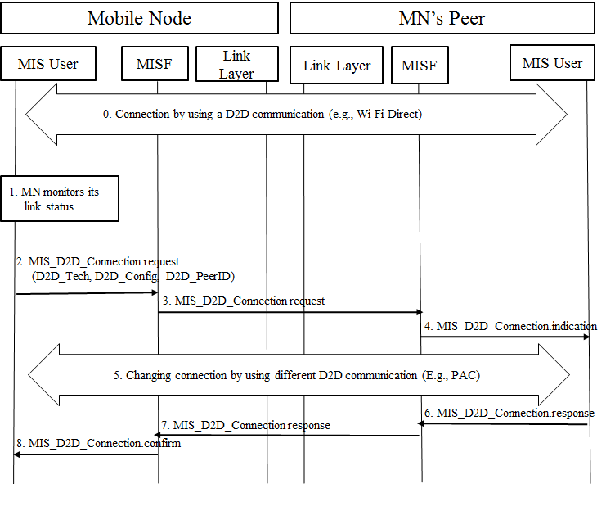
Figure 8—Changing connection of D2D communication.

- New primitive/message
MIS_D2D_Connection primitive/message is explained in “5.5.2.1.4.3 Stage 3: connection for D2D communications.”
- New parameters
D2D_Tech, D2D_Config, and D2D_PeerID are explained in “5.5.2.1.4.3 Stage 3: connection for D2D communications.”

    - Service specific primitives

      - MIS_SAP primitives

        - MIS_D2D_Registration
          - MIS_ D2D_Registration.request
            - Function
MIS_D2D_Registration is used for MN to request registration to Information Server by sending MIS_D2D_Registration request message with its configuration information including its available D2D communication technologies.
            - Semantics of service primitive
MIS_D2D_Registration.request (
DestinationIdentifier,
D2D_Techlist,
Config_Info
)
Parameters:
Name | Data type | Description
DestinationIdentifier | MISF_ID | This identifies a remote MISF that will be the destination of this request.
D2D_Techlist | LIST(D2D_TECH) | List of available D2D technologies
Config_Info | LIST(LOCATION, FREQ_ID) | Configuration information for making a D2D connection
            - When generated
This primitive is invoked by MIS user when it needs to register an MN to Information Server before making a D2D connection.
            - Effect on receipt
On receipt, the local MISF sends an MIS_D2D_Registration request message to the destination MISF.

          - MIS_ D2D_Registration.indication
            - Function
This primitive is used by an MISF to notify an MIS user that an MIS_D2D_Registration request message has been received.
            - Semantics of service primitive
MIS_D2D_Registration.indication (
SourceIdentifier,
D2D_Techlist,
Config_Info
)
Parameters:
Name | Data type | Description
SourceIdentifier | MISF_ID | This identifies the invoker of this primitive, which is a remote MISF.
D2D_Techlist | LIST(D2D_TECH) | List of available D2D technologies
Config_Info | LIST(FREQ_ID) | Configuration information for making a D2D connection
            - When generated
This primitive is generated by the local MISF when an MIS_D2D_Registration request message is received
            - Effect on receipt
The local MIS user will perform necessary actions to process the registration request and respond with an MIS_D2D_Registration.response.

          - MIS_D2D_Registration.response
            - Function
This primitive is used by an MIS user to send the processing status of a received registration request.
            - Semantics of service primitive
MIS_D2D_Registration.response (
DestinationIdentifier,
Status
)
Parameters:
Name | Data type | Description
DestinationIdentifier | MISF_ID | This identifies a remote MISF, which will be the destination of this response.
Status | STATUS | Status of operation
            - When generated
This primitive is invoked by the MIS user to report back the result after completing the processing of a registration request.
            - Effect on receipt
Upon receipt, the local MISF sends an MIS_D2D_Registration response message to the destination MISF.

          - MIS_ D2D_Registration.confirm
            - Function
This primitive is used by the local MISF to convey the result of a registration request to an MIS user.
            - Semantics of service primitive
MIS_D2D_Registration.confirm (
SourceIdentifier,
Status
)
Parameters:
Name | Data type | Description
SourceIdentifier | MISF_ID | This identifies the invoker of this primitive, which is a remote MISF..
Status | STATUS | Status of operation

            - When generated
This primitive is used by an MISF to notify an MIS user the result of an MIS_D2D_registration request.
            - Effect on receipt
Upon receipt, the MIS user can determine the result of the registration request.

        - MIS_D2D_Connection
          - MIS_ D2D_Connection.request
            - Function
MIS_D2D_Connection is used for an MIS user to request an MISF to make a D2D connection with its configuration information including its available D2D communication technologies.
            - Semantics of service primitive
MIS_D2D_Connection.request (
D2D_PeerID,
D2D_Tech,
D2D_Config
)
Parameters:
Name | Data type | Description
D2D_PeerID | MISF_ID | This identifies a peer for D2D communication.
D2D_Tech | LIST(D2D_TECH) | Technology for D2D communication
D2D_Config | LIST(FREQ_ID) | Configuration information for making a D2D connection
            - When generated
This primitive is invoked by MIS user when it needs to connect to its peer before making a D2D connection.
            - Effect on receipt
On receipt, the local MISF sends an MIS_D2D_Connection request message to the destination MISF.

          - MIS_ D2D_Connection.indication
            - Function
This primitive is used by an MISF to notify an MIS user that an MIS_D2D_Connection request message has been received.
            - Semantics of service primitive
MIS_D2D_Connection.indication (
SourceIdentifier,
D2D_Tech,
D2D_Config
)
Parameters:
Name | Data type | Description
SourceIdentifier | MISF_ID | This identifies the invoker of this primitive, which is a remote MISF.
D2D_Tech | LIST(D2D_TECH) | Technology for D2D communication
D2D_Config | LIST(FREQ_ID) | Configuration information for making a D2D connection
            - When generated
This primitive is generated by the remote MISF when an MIS_D2D_Connection request message is received
            - Effect on receipt
The remote MIH user will perform necessary actions to process the connection request and respond with an MIS_D2D_Connection.response.

          - MIS_ D2D_Connection.response
            - Function
This primitive is used by an MIS user to send the processing status of a received connection request.
            - Semantics of service primitive
MIS_D2D_Connection.response (
DestinationIdentifier,
Status
)
Parameters:
Name | Data type | Description
DestinationIdentifier | MISF_ID | This identifies a remote MISF, which will be the destination of this response.
Status | STATUS | Status of operation
            - When generated
This primitive is invoked by the MIS user to report back the result after completing the processing of a connection request.
            - Effect on receipt
Upon receipt, the local MISF sends an MIS_D2D_Connection response message to the destination MISF.

          - MIS_ D2D_Connection.confirm
            - Function
This primitive is used by the local MISF to convey the result of a connection request to an MIS user.
            - Semantics of service primitive
MIS_D2D_Registration.confirm (
SourceIdentifier
Status
)
Parameters:
Name | Data type | Description
SourceIdentifier | MISF_ID | This identifies the invoker of this primitive, which is a remote MISF.
Status | STATUS | Status of operation

            - When generated
This primitive is used by an MISF to notify an MIS user the result of an MIS_D2D_connection request.
            - Effect on receipt
Upon receipt, the MIS user can determine the result of the connection request.

    - Service specific protocol features

      - MIS protocol messages for command service

        - MIS_D2D_Registration
          - MIS_ D2D_Registration request
The corresponding MIS primitive of this message is defined in 5.5.3.2.1.1.
The MN’ MISF sends this message to the MISF of Information Server to request registration with its configuration information including its available D2D communication technologies.

MIS Header Fields (SID=3, Opcode=1, AID=12)
Source Identifier = sending MISF ID
(Source MISF ID TLV)
Destination Identifier = receiving MISF ID
(Destination MISF ID TLV)
D2D_Techlist
(D2D technology list for D2D registration TLV)
Config_Info
(Configuration information for D2D registration TLV)

          - MIS_ D2D_Registration response
The corresponding MIS primitive of this message is defined in 5.5.3.2.1.3.
This message returns the result of MIS_ D2D_Registration request.

MIS Header Fields (SID=3, Opcode=2, AID=12)
Source Identifier = sending MISF ID
(Source MISF ID TLV)
Destination Identifier = receiving MISF ID
(Destination MISF ID TLV)
Status
(Status TLV)

      - MIS_D2D_Connection
          - MIS_D2D_Connection request
The corresponding MIS primitive of this message is defined in 5.5.3.2.2.1.
An MISF sends this message to request the establishment of a D2D connection with its configuration information including its available D2D communication technologies.

MIS Header Fields (SID=3, Opcode=1, AID=13)
Source Identifier = sending MISF ID
(Source MISF ID TLV)
Destination Identifier = receiving MISF ID
(Destination MISF ID TLV)
D2D_PeerID
(MSIF ID TLV)
D2D_Tech
(D2D technology for D2D connection TLV)
D2D_Config
(Configuration information for D2D connection TLV)

          - MIS_D2D_Connection response
The corresponding MIS primitive of this message is defined in 5.5.3.2.2.3.
This message returns the result of MIS_ D2D_Connection request.

MIS Header Fields (SID=3, Opcode=2, AID=13)
Source Identifier = sending MISF ID
(Source MISF ID TLV)
Destination Identifier = receiving MISF ID
(Destination MISF ID TLV)
Status
(Status TLV)

Annex F
(normative)
Data type definition
Table F.15- Data Type of binary query
Data type name | Derived from | Definition
IQ_BIN_DATA | SEQUENCE(  CHOICE(NULL, QUERIER_LOC),  CHOICE(NULL, NET_TYPE_INC),  CHOICE(NULL, NETWK_INC),  CHOICE(NULL, RPT_TEMPL),  CHOICE(NULL, RPT_LIMIT),  CHOICE(NULL, CURR_PREF),  CHOICE(NULL, QUERIER_D2D_SERVICE),  CHOICE(NULL, QUERIER_D2D_TECHLIST)  ) | Represents a binary query.  There should exist at least one of the query data  type QUERIER_LOC, NET_TYPE_INC, or  NETWK_INC.  One CURR_PREF at most is included in an Info  Query Binary TLV. If included, it indicates to the  MIIS server the preferred currency the returned  cost should be represented in. If the MIIS server  cannot return the cost in the specified currency, it  can return the cost in other currencies.
QUERIER_D2D_SERVICE | D2D_SERVICE | A type to represent D2D communication services of a querier
QUERIER_D2D_TECHLIST | LIST(D2D_TECH) | A type to represent mobile node’s available list for d2d communications

Table F.xx-Data types for D2D communications
Data type name | Derived from | Definition
D2D_TECH | UNSIGNED_INT(1) | A type to represent d2d technology  0: Wi-Fi Direct  1: PAC  2: ProSe  3-: reserved
D2D_SERVICE | UNSIGNED_INT(1) | A type to represent d2d communication services  0: data sharing  1: local advertisement  2: emergency information  3-: reserved

Annex G
(normative)
Information element identifiers
Table G.1- information element identifier values (continued)
Name of information element or container | IE Identifier
IE_D2D_PEERID | 0x10000303
IE_D2D_CONFIG | 0x10000304

Annex L
(normative)
MIS protocol message code assignments

Table L.1—AID assignment
MIS messages | AID
MIS messages for Command Service
MIS_D2D_Registration | 12
MIS_D2D_Connection | 13

Table L.2—Type values for TLV encoding (continued)
TLV type name | TLV  type value | Data type
D2D technology list for D2D registration | 64 | LIST(D2D_TECH)
Configuration information for D2D registration | 65 | LIST(LOCATION, FREQ_ID)
D2D technology for D2D connection | 66 | D2D_TECH
Configuration information for D2D connection | 67 | LIST(FREQ_ID)

