Project | IEEE 802.21.1 Media Independent Services  <http://www.ieee802.org/21/>
Title | HEMS use case proposal for IEEE802.21.1 draft standard
DCN | 21-15-0079-00-SAUC
Date Submitted | July 29th, 2015
Source(s) | Yusuke Shimizu (Panasonic), Yuji Unagami (Panasonic)
Re: | IEEE 802.21.1 Teleconference
Abstract | This document describes the use case for applying IEEE802.21 to HEMS(Home Energy Management System).Home Gateway(HGW) as PoS with GM sends control command to each device as PoS and controls it.
Purpose | To propose the use case for applying IEEE802.21 to HEMS.
Notice | This document has been prepared to assist the IEEE 802.21 Working Group. It is offered as a basis for discussion and is not binding on the contributing individual(s) or organization(s). The material in this document is subject to change in form and content after further study. The contributor(s) reserve(s) the right to add, amend or withdraw material contained herein.
Release | The contributor grants a free, irrevocable license to the IEEE to incorporate material contained in this contribution, and any modifications thereof, in the creation of an IEEE Standards publication; to copyright in the IEEE’s name any IEEE Standards publication even though it may include portions of this contribution; and at the IEEE’s sole discretion to permit others to reproduce in whole or in part the resulting IEEE Standards publication. The contributor also acknowledges and accepts that IEEE 802.21 may make this contribution public.
Patent Policy | The contributor is familiar with IEEE patent policy, as stated in Section 6 of the IEEE-SA Standards Board bylaws <http://standards.ieee.org/guides/bylaws/sect6-7.html#6> and in Understanding Patent Issues During IEEE Standards Development http://standards.ieee.org/board/pat/faq.pdf

Table of Contents
1.1 HEMS use case 3
1.1.1 Introduction 3
1.1.2 Service scenarios and call flows 4
1.1.3 CRL 11
1.1.3.1 CRL operation 11
1.1.3.2 CRL format 12
1.1.3.3 Distribution of CRL 12

  - HEMS use case
    - Introduction
This sub-clause explains general overview of the HEMS(Home Energy Management System) use case.
HEMS is the system to manage the energy usage in home. HEMS with connecting devices (i.e. home appliances or equipments) realizes the "visualization" of electricity or gas consumption and the "auto control" of devices.

HEMS typically includes Home Gateway(HGW) and the various devices as follows;
・Air conditioning system
・Lighting
・Smart meter
・PV(Photovoltaics)
・Home security

HGW and devices are connected in home by wired or wireless network. HGW controls home appliances and collects usage information through the network.
For example, user operates HGW, and HGW can execute the collective lightings power off and the centralized control of the air conditioning system. Moreover, devices send usage state of electricity to HGW, and HGW displays the amounts of electric energy in home.
Figure 1 shows structure example of HEMS. HGW connects to devices such as PV, Air conditioning system, and lighting devices by home area network. In this example, HGW and terminal devices are connected via the cloud server, and user can control HGW by using the terminal device. HGW may collectively send a control message to the devices using a multicast transport, and the devices sends usage information to HGW in response to the control message. In this use case, Media independent service framework (MIS) of IEEE802.21 specifications is applied to the Interface between the HGW and the devices. HEMS performs the collective control of the devices and the acquisition of usage information. The controlling system of HGW by using the terminal devices via cloud server(dotted line in Figure.1) is out of scope of this use case.
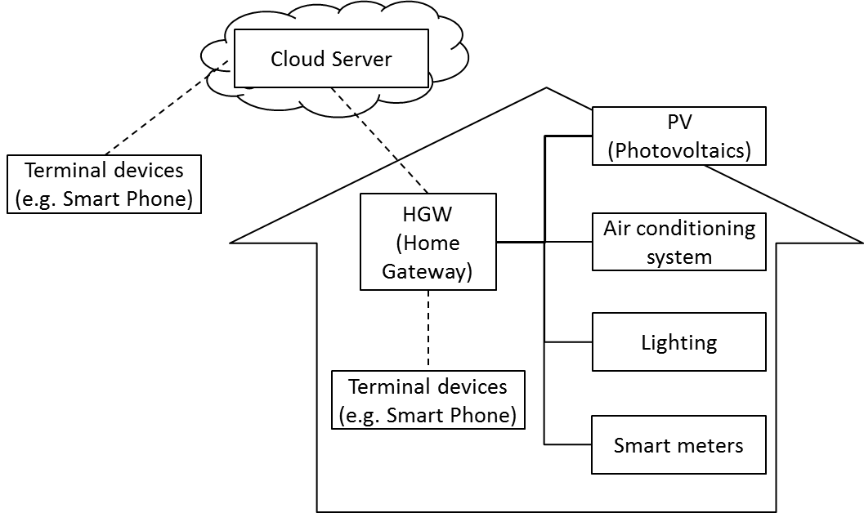
Figure 1— Structure example of HEMS

    - Service scenarios and call flows
This sub-clause describes the service scenario and IEEE 802.21 call flows.
Figure 2 shows the 802.21 system architecture in corresponding to HEMS structure and Figure 3, 4, and 5 shows the command flows corresponding to the different types of communication.
In this case, HGW as “PoS with GM” operates the connecting devices as “PoS”. HGW controls the power switch or settings of devices and collects the state of them. HGW operates Multicast Group Management described in IEEE 802.21.m as PoS with GM.
PoS with GM transmits control commands to PoSes and controls them. When the PoS with GM collectively controls PoSes, it sends the control command by a multicast transport. PoS sends usage information regularly to the PoS with GM. And PoS, when receiving the acquisition command of the usage information from the PoS with GM, sends the usage information of the device to the PoS with GM.

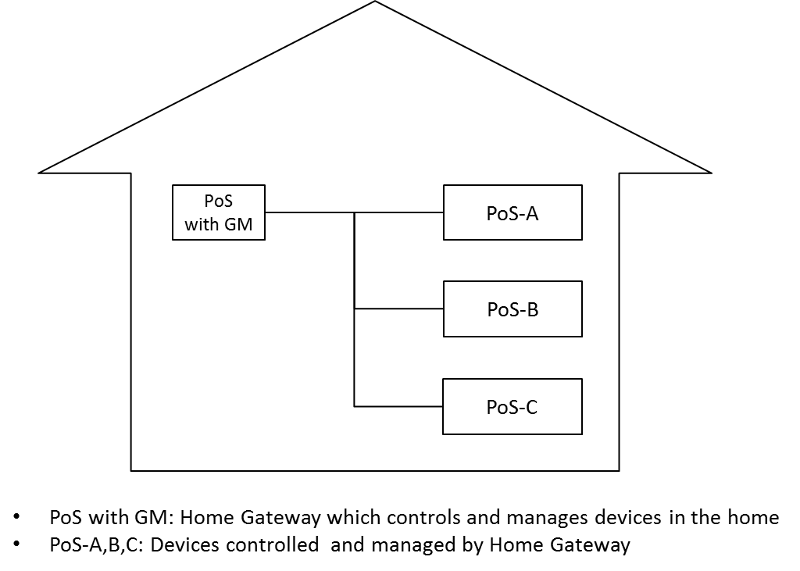
Figure 2—System architecture in 802.21

Table 1 shows the list of Service management primitives used in HEMS use case. MIH_LINK_SAPs used in Link layer are not required, since the control command transmission and the usage information acquisition in HEMS are independent of the media.
Table 1— Service management primitives for HEMS use case
Service management primitive | Comments | Defined in
MIH_ Configuration_Update | This command is sent by a PoS to a group of other PoS(es) to update their configuration.  In the use case of HEMS, PoS sends the HEMS control command and the usage information. | 7.4.34
MIH_Net_Group_Manipulate | This command is sent by a PoS to a group of other PoS(es) to create, delete or update a group membership. | 7.4.36
MIH_Push_Certificate | This command is sent by a PoS to another PoS or an MN and it is used for sending of a certificate. | 7.4.38
MIH_Revoke_Certificate | This command is sent by a PoS to a group of PoS(es) and/or an MN to revoke a certificate previously issued by the PoS. | 7.4.39

Figure 3 shows the control command flow from PoS with GM to each PoS and Figure 4 shows the notification command flow from each PoS to PoS with GM.
In Figure3, PoS with GM sends control commands to each PoS. Cipher communication of control commands uses MIH_Configuration_Update. Multicast cipher communication from PoS with GM to each PoS uses the MIH protocol protection.

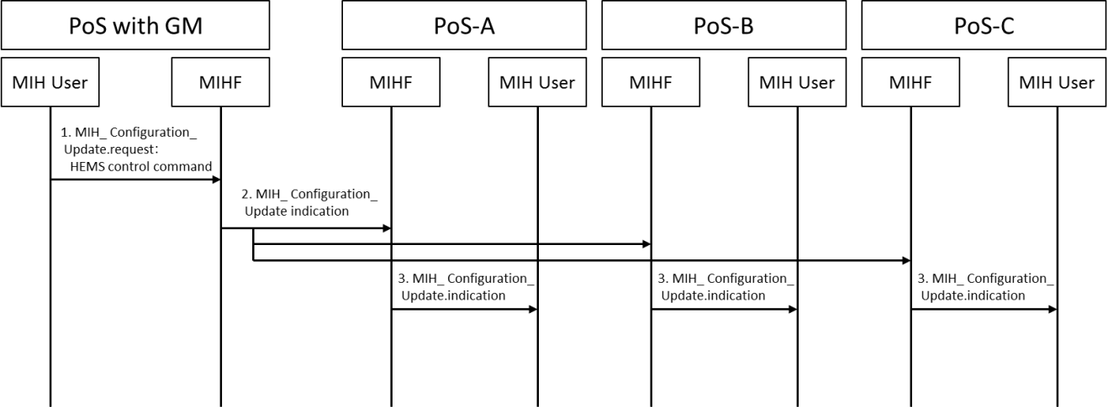
Figure 3—Transmission of the control command

- MIH User of PoS with GM generates the HEMS control commands for PoS, and sends it to the local MIHF using the MIH_Configuration_Update.request primitive.
- MIHF of PoS with GM sends the HEMS control commands for PoS using the MIH_Configuration_Update indication message.
- MIHF of PoS receives the MIH_Configuration_Update indication message, and sends it to the MIH User using the MIH_Configuration_Update.indication primitive.
- MIH User of PoS receives the MIH_Configuration_Update.indication primitive, and runs the control command.
In Figure 4, each PoS notify their usage state information to PoS with GM

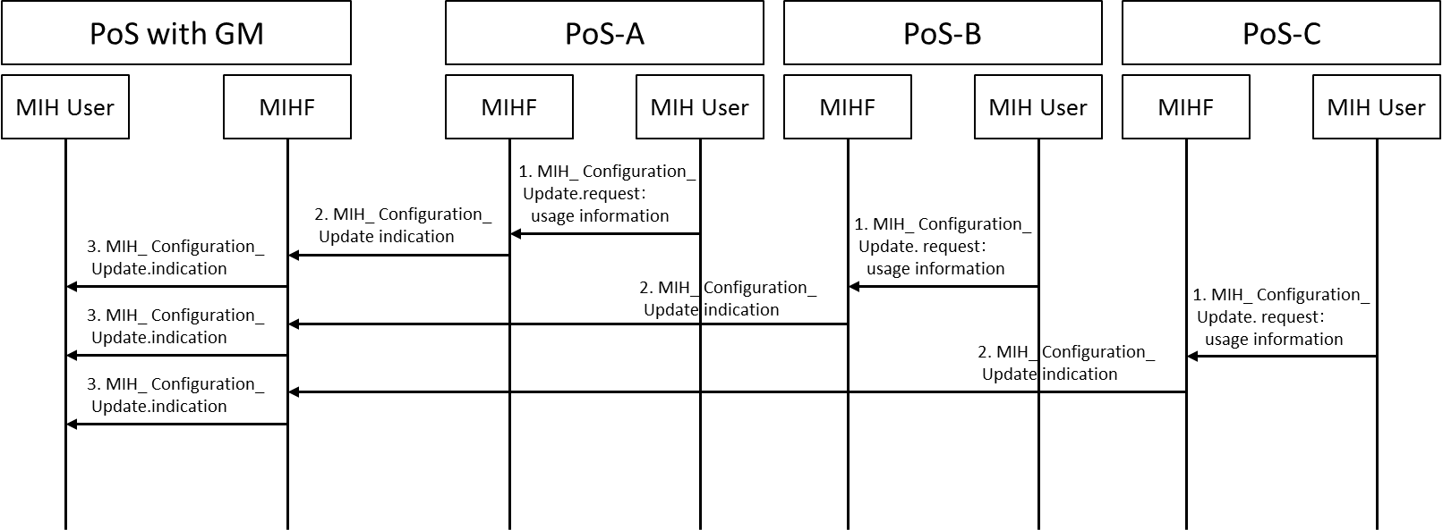
Figure 4—Transmission of the usage information

- MIH User of PoS generates the usage information, and sends it to the local MIHF using the MIH_Configuration_Update.request primitive.
- MIHF of PoS sends the usage information to the PoS with GM using MIH_Configuration_Update indication message.
- MIHF of PoS with GM receives the MIH_Configuration_Update indication message, and sends it to the MIH User of PoS with GM using the MIH_Configuration_Update indication primitive.
- MIH User of PoS with GM receives MIH_Configuration_Update.indication primitive, and collects the usage information.

In Figure 5, PoS with GM sends group membership to each PoS

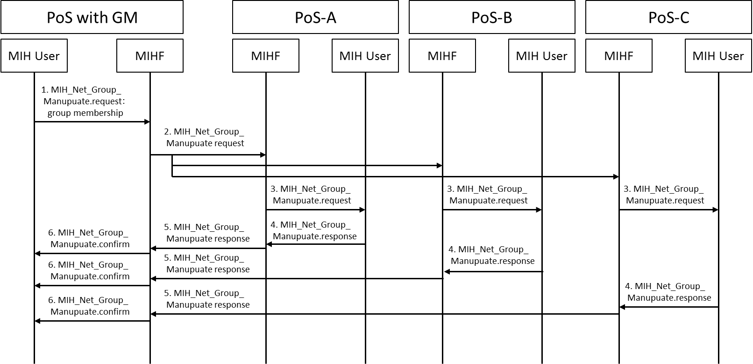
Figure 5—Transmission of group membership

- MIH User of PoS with GM generates group membership for PoS, and sends it to the local MIHF using the MIH_Net_Group_Manipulate.request primitive.
- MIHF of PoS with GM sends group membership for PoS using the MIH_Net_Group_Manipulate request message.
- MIHF of PoS receives the MIH_Net_Group_Manipulate request message, and sends it to the MIH User using the MIH_Net_Group_Manipulate.request primitive.
- MIH User of PoS receives the MIH_Net_Group_Manipulate.request primitive, and generates the acknowledge receipt, and sends it the local MIHF using the MIH_Net_Group_Manipulate.response primitive.
- MIHF of PoS sends the acknowledge receipt to the PoS with GM using MIH_Net_Group_Manipulate response message.
- MIHF of PoS with GM receives the MIH_Net_Group_Manipulate response message, and sends it to the MIH User of PoS with GM using the MIH_Net_Group_Manipulate.confirm primitive.

In Figure 6, PoS with GM sends the Certificate to each PoS

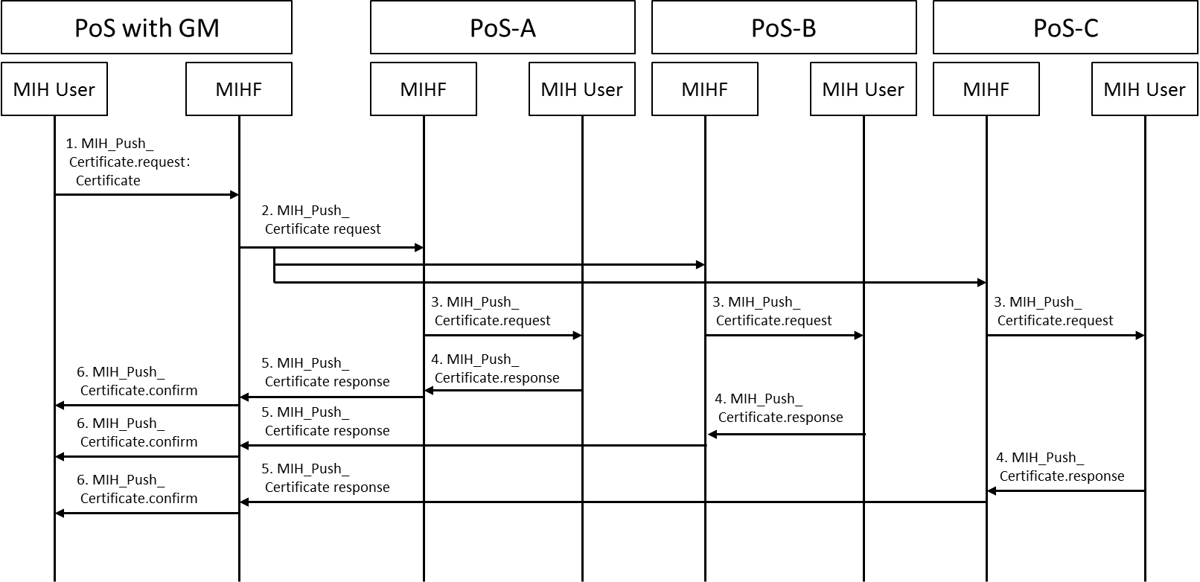
Figure 6—Transmission of Certificate

- MIH User of PoS with GM shares the Certificate, and sends it to the local MIHF using the MIH_Push_Certificate.request primitive.
- MIHF of PoS with GM sends the Certificate the MIH_Push_Certificate request message.
- MIHF of PoS receives the MIH_Push_Certificate request message, and sends it to the MIH User using the MIH_Push_Certificate.request primitive.
- MIH User of PoS receives the MIH_Push_Certificate.request primitive, and generates the acknowledge receipt, and sends it the local MIHF using the MIH_Push_Certificate.response primitive.
- MIHF of PoS sends the acknowledge receipt to the PoS with GM using MIH_Push_Certificate response message.
- MIHF of PoS with GM receives the MIH_Push_Certificate response message, and sends it to the MIH User of PoS with GM using the MIH_Push_Certificate.confirm primitive.

Figure 7 describes CRL sharing in Home Area Network. In this example, PoS-A having the latest CRL directly sends it with other PoS and PoS with GM under the same Home Area Network.

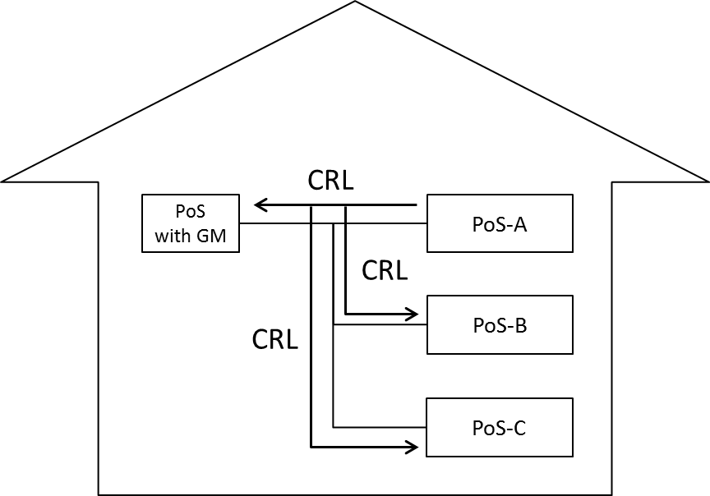
Figure 7—CRL sharing in Home Area Network

Figure 8 shows the command flow described in Figure 7.

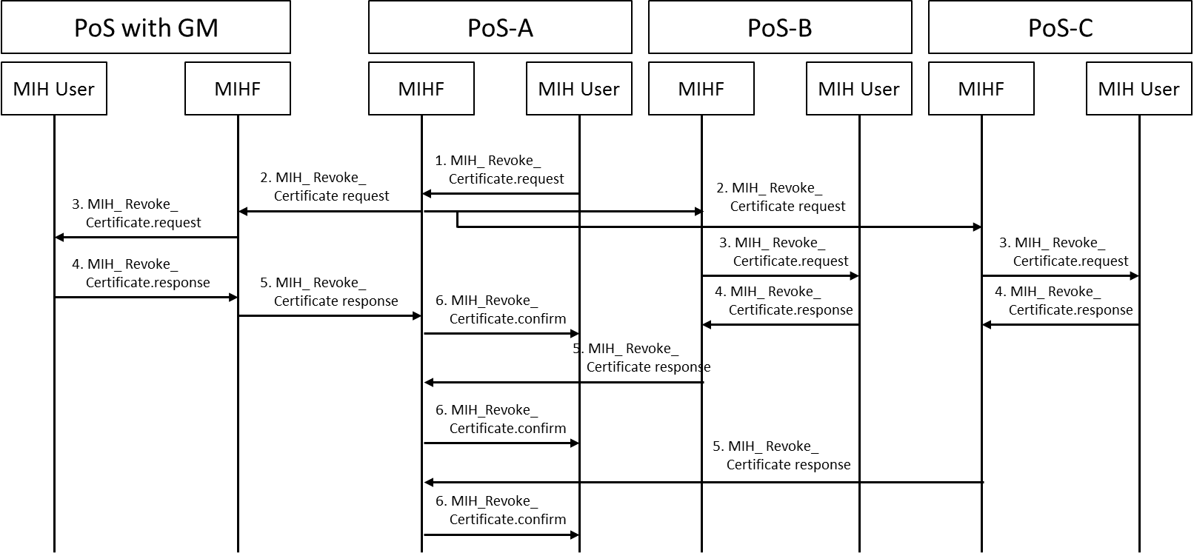
Figure 8—Transmission of CRL

- If MIH User of PoS shares the CRL, and sends it to the local MIHF using the MIH_Revoke_Certificate.request primitive.
- MIHF of PoS sends the CRL to the PoS using MIH_Revoke_Certificate request message.
- MIHF of PoS receives the MIH_Revoke_Certificate request message, and sends it to the MIH User of PoS using the MIH_Revoke_Certificate.request primitive.
- MIH User of PoS receives MIH_Revoke_Certificate.request primitive, and generates the acknowledge receipt, and sends it the local MIHF using the MIH_Revoke_Certificate.response primitive.
- MIHF of PoS sends the acknowledge receipt to the PoS using MIH_Revoke_Certificate response message.
- MIHF of PoS receives the MIH_Revoke_Certificate response message, and sends it to the MIH User of PoS using the MIH_Revoke_Certificate.confirm primitive.

    - CRL
This sub-clause describes the CRL operation for HEMS use case.

      - CRL operation
CRL: Certificate Revocation List is a list of certificates for revoked devices. CRL is signed and distributed by the Certificate Authority.

Although the Certificate Authority is typically operated by a single service operator, in this use case, the Certificate Authority might be managed by a joint legal entity. This is because various devices developed by various manufactures need to connect each other and connect to different service, and for assuring the interoperability, it might be easier for one joint legal entity to operate the Certificate Authority which is responsible for one revocation policy.

Revocation Policy is specified by this joint legal entity. If the gross negligence occurred in the market, the joint legal entity investigates the circumstances and decides the possibility of issuing CRL.

All devices should check the CRL regularly and confirm the validity of their own device certificates.

The CRL should be updated adequately depend on the policy of the Certificate Authority. If there should be the gross negligence in the market, the CRL would be updated more frequently than the regular policy.

The Certificate Authority can remove the revoked certificate from the CRL depend on the life cycle of the device. For example, if maximum life time is considered to be 20 years, the Certificate Authority may remove revoked certificates from the CRL 20 years later.

      - CRL format
The CRL is compliant with the X.509 version 2 CRL format shown in Table 2.

Table 2— CRL format
tbsCertList
 | Version | Version
 | Signature | Signature algorithm
 | Issuer | Issuer of CRL
 | thisUpdate | Update date or issue date of CRL
 | nextUpdate | Next update date of CRL
 | revokedCertificates | Revoked certificates list
 | crlExtensions | Extensions to provide methods for associating additional attributes with CRLs
signatureAlgorithm |  | Signature algorithm
Signature |  | Digital signature of CA

The maximum size of CRL should be limited since resource constrained device may not store the large CRL in their memories. If the size of CRL should exceed the limitation, the Certificate Authority would remove the old revoked certificate from the CRL.

      - Distribution of CRL
All devices connected to the Internet should acquire the latest CRLs from CRL server periodically. Connection to the CRL server is established by HTTPS. Figure 9 shows the typical case where only PoS with GM can connect to the Internet. PoS with GM acquires the latest CRL from the CRL server and distributes it to the other PoS(es) .
The device has some timing flexibility to access randomly to CRL server for dispersing the peak connection to the CRL server.

If new joining device has the latest CRLs, that device can distribute the latest CRLs to the other devices as shown in Fig.7. In this case, other PoS or PoS with GM compare their CRL and the newly distributed CRL, then, replace to the latest CRL.
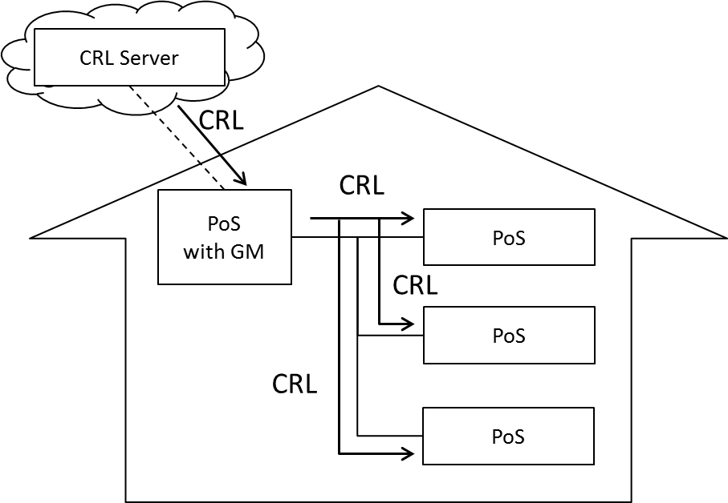
Figure 9—Distribution of CRL

