Project | IEEE 802.21.1 Media Independent Services  <http://www.ieee802.org/21/>
Title | HEMS use case proposal for IEEE802.21.1 draft standard
DCN | 21-15-0062-00-SAUC
Date Submitted | June 25th, 2015
Source(s) | Yusuke Shimizu (Panasonic), Yuji Unagami (Panasonic)
Re: | IEEE 802.21 Session #69 in Waikoloa, USA
Abstract | This document describes the use case for applying IEEE802.21 to HEMS(Home Energy Management System).Home Gateway(HGW) as PoS with GM sends control command to each device as PoS and controls it.
Purpose | To propose the use case for applying IEEE802.21 to HEMS.
Notice | This document has been prepared to assist the IEEE 802.21 Working Group. It is offered as a basis for discussion and is not binding on the contributing individual(s) or organization(s). The material in this document is subject to change in form and content after further study. The contributor(s) reserve(s) the right to add, amend or withdraw material contained herein.
Release | The contributor grants a free, irrevocable license to the IEEE to incorporate material contained in this contribution, and any modifications thereof, in the creation of an IEEE Standards publication; to copyright in the IEEE’s name any IEEE Standards publication even though it may include portions of this contribution; and at the IEEE’s sole discretion to permit others to reproduce in whole or in part the resulting IEEE Standards publication. The contributor also acknowledges and accepts that IEEE 802.21 may make this contribution public.
Patent Policy | The contributor is familiar with IEEE patent policy, as stated in Section 6 of the IEEE-SA Standards Board bylaws <http://standards.ieee.org/guides/bylaws/sect6-7.html#6> and in Understanding Patent Issues During IEEE Standards Development http://standards.ieee.org/board/pat/faq.pdf

Table of Contents
1.1 HEMS use case 3
1.1.1 Introduction 3
1.1.2 Service scenarios and call flows 4

  - HEMS use case
    - Introduction
HEMS (Home Energy Management System) is the system to manage the energy usage in home.

HEMS connects devices (i.e. home appliances or equipments) by network realizes the "visualization" of electricity or gas consumption and the "auto control" of devices.

HEMS includes following applications and devices;
・Air conditioning system
・Lighting
・Smart meter
・PV(Photovoltaics)
・EVPS(EV Power Station)
・Home security

This subclause describes the use case of HEMS.
In HEMS, Home gateway (HGW) and devices are connected in home, HGW controls home appliances through the network. HGW collectively manages devices in home, controls them and collects usage information.
For example, user operates HGW, and HGW executes the collective lightings power off and the centralized control of the air conditioning system. Moreover, devices send usage state of electricity to HGW, and HGW displays the amounts of electric energy in home.
Figure 1 shows structure example of HEMS. HGW connects to devices such as PV, Air conditioning system, lighting devices by home area network. HGW may collectively send a control message to the devices using a multicast transport, and the devices sends usage information to HGW in accordance with the control message. In the use case of HEMS, Media independent service framework (MIS) of IEEE802.21 specifications is applied to the Interface between the HGW and the devices, HEMS performs the collective control of the devices and the acquisition of usage information.
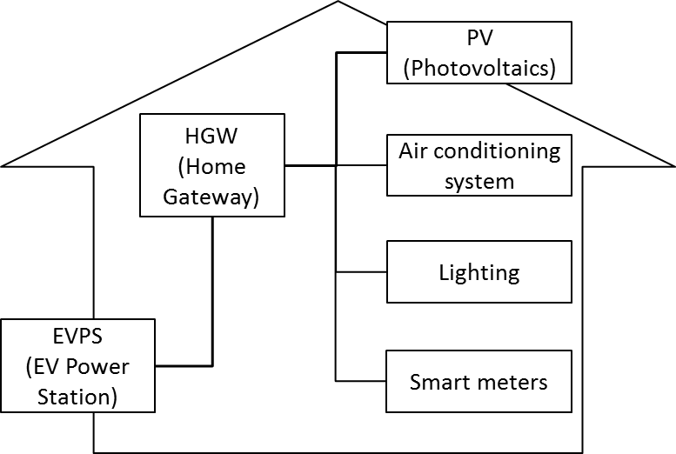
Figure 1— Structure example of HEMS

    - Service scenarios and call flows
In the use case of HEMS, HGW operates as “PoS with GM”, devices connect to HGW as “PoS”. HGW controls the power switch or settings of devices, and collects the state of them. HGW operates Multicast Group Management described in IEEE 802.21m as PoS with GM.
PoS with GM transmits control commands to PoSes as devices, and controls them. If the PoS with GM collectively controls PoSes, it sends the control command by a multicast transport. PoS sends usage information regularly or non-regularly to the PoS with GM. And, PoS, when receiving the acquisition command of the usage information from the PoS with GM, sends the usage state of the device to the PoS with GM.

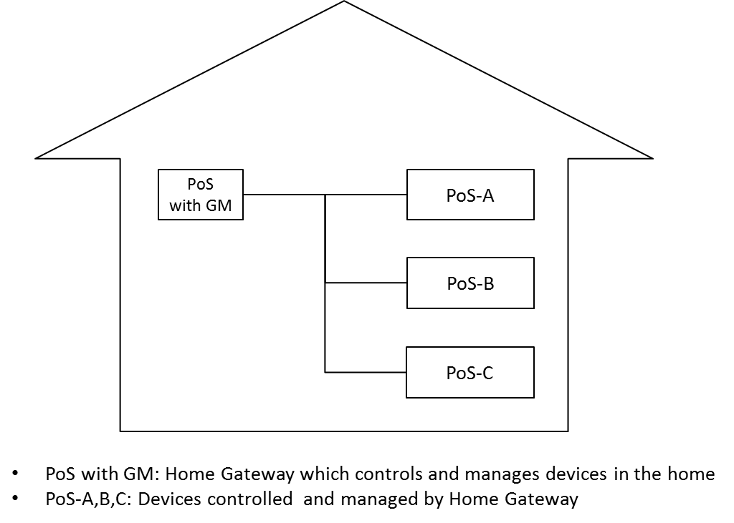
Figure 2—System architecture in 802.21

In the use case of HEMS, MIH_SAPs classified in the Service Management are used. MIH_LINK_SAPs used in Link layer are not required, since the control command transmission and the usage information acquisition in HEMS are independent of the media.

In the use case of HEMS, PoS with GM sends control commands to PoS. Cipher communication of control commands uses MIH_Configuration_Update. Multicast cipher communication from PoS with GM to each PoS uses the MIH protocol protection.

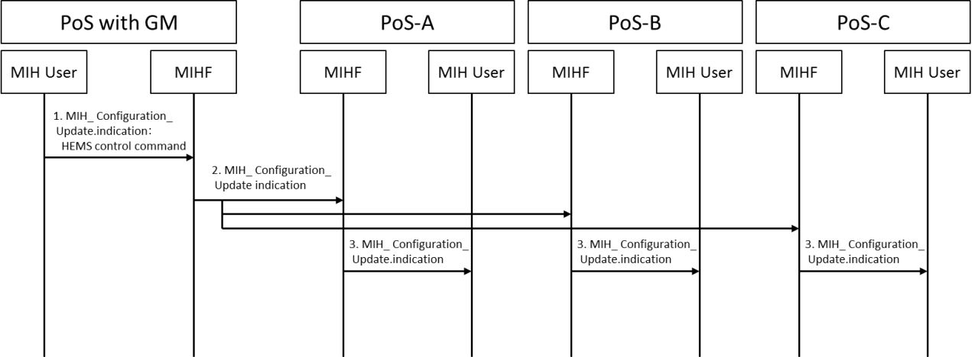
Figure 3—Transmission of the control command

- The MIH User of PoS with GM generates the HEMS control commands for the PoS, and sends it to the local MIHF using the MIH_Configuration_Update.indication primitive.
- MIHF of PoS with GM sends the HEMS control commands for the PoS using the MIH_Configuration_Update indication message.
- MIHF of PoS receives theMIH Configuration Update indication message, and sends it to the MIH User using the MIH_Configuration_Update.indication primitive.
- MIH User of PoS receives the MIH_Configuration_Update.indication primitive, and runs the control command.

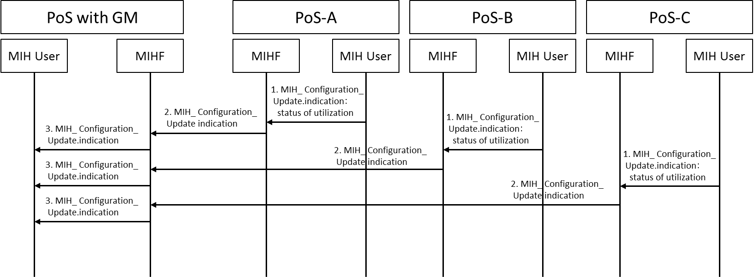
Figure 4—Transmission of the usage state

- The MIH User of PoS generates the usage information, and sends it to the local MIHF using the MIH_Configuration_Update.indication primitive.
- MIHF of PoS sends the usage information to the PoS with GM using MIH_Configuration_Update.indication message.
- MIHF of PoS with GM receives the MIH_Configuration_Update indication message, and sends it to the MIH User of PoS with GM using the MIH_Configuration_Update indication primitive.
- MIH User of PoS with GM receives MIH_Configuration_Update.indication primitive, and collects the usage information.

