Project | IEEE 802.21.1 Media Independent Services  <http://www.ieee802.org/21/>
Title | Update for “Radio Resource Management Service” Section of IEEE 802.21.1 Draft Standard
DCN | 21-15-0045-00-SAUC
Date Submitted | May 9, 2015.
Source(s) | Hyeong-Ho Lee (ETRI), Hyunho Park (ETRI), Myung-Ki Shin (ETRI), Jin Seek Choi (Hanyang University, Korea Ethernet Forum),
Re: | IEEE 802.21 Session #68 in Vancouver, Canada
Abstract | Based on the discussion of the contribution “Proposed update for “Radio Resource Management Service” Section for IEEE 802.21.1 Draft Standard” (DCN 21-15-0020-00-SAUC) in IEEE 802.21 Session #67, this document proposes update for “Radio Resource Management Service” Section of IEEE 802.21.1 Draft Standard.
Purpose | To be part of 802.21.1 draft standard document.
Notice | This document has been prepared to assist the IEEE 802.21 Working Group. It is offered as a basis for discussion and is not binding on the contributing individual(s) or organization(s). The material in this document is subject to change in form and content after further study. The contributor(s) reserve(s) the right to add, amend or withdraw material contained herein.
Release | The contributor grants a free, irrevocable license to the IEEE to incorporate material contained in this contribution, and any modifications thereof, in the creation of an IEEE Standards publication; to copyright in the IEEE’s name any IEEE Standards publication even though it may include portions of this contribution; and at the IEEE’s sole discretion to permit others to reproduce in whole or in part the resulting IEEE Standards publication. The contributor also acknowledges and accepts that IEEE 802.21 may make this contribution public.
Patent Policy | The contributor is familiar with IEEE patent policy, as stated in Section 6 of the IEEE-SA Standards Board bylaws <http://standards.ieee.org/guides/bylaws/sect6-7.html#6> and in Understanding Patent Issues During IEEE Standards Development http://standards.ieee.org/board/pat/faq.pdf

Table of Contents

5.4 Radio resource management service 3
5.4.1 Introduction 3
5.4.2 Service scenarios and call flows 3
5.4.3 Service specific primitives 20
5.4.4 Service specific protocol features 22

  - Radio resource management service
    - Introduction
In recent days, networks with various communication technologies have appeared, interferences between wireless access networks have increased, and thus resource management in heterogeneous networks is needed. For example, 2.4GHz band is used by WLAN devices and WPAN devices such as Bluetooth devices, and 5GHz band is used by WLAN devices and cordless phones. Moreover, 5GHz band is considered for use of long term evolution (LTE) technology, and therefore interference in 5GHz band is expected to increase.
Media independent service (MIS) framework of IEEE 802.21 standard can be a common platform to support resource management in heterogeneous networks. MIS framework of IEEE 802.21 standard supports seamless handover in heterogeneous networks by using media independent event service (MIES), media independent command service (MICS), and media independent information service (MIIS). MIES primitives and messages help mobile node (MN) to monitor link status (e.g., signal strength and data rate), and MICS primitives and messages helps MN to control its link layers (physical layer and data link layer) for seamless handover in heterogeneous networks. It is possible to expect that MIS framework enables MN to monitor link status and control radio resources (e.g., frequency, time, and power) for radio resource management. MIIS primitives and messages are used to transfer network configuration information for handover in heterogeneous networks, and thus they can be used to provide network configuration for radio resource allocations in heterogeneous networks. Thus, MIS framework is appropriate for resource management in heterogeneous networks that use various communication technologies and various frequency bands.

    - Service scenarios and call flows
      - High level illustration
Figure 1 shows media independent service framework for resource management in heterogeneous networks. Access Point (AP) Controller can control resources of APs that use various communication technologies (e.g., WLAN, Wi-Fi Direct, Bluetooth, and LTE) by using MICS message. APs can use different communication technologies and share its link status by using MIES message. AP Controller can be implemented as MIS point of service (PoS).
The following entities are equipped with MIS function (MISF).
- MN-A: a user device, such as a smart phone, which equips radio interfaces of multiple radio access technologies
- PoS-A: a base station (BS) in cellular networks or access point (AP) in WLAN, which is a network entity that establishes link connection with the MN
- PoS-B: PoS-A’s neighboring AP or BS that can interfere with MN or PoS-A
- AP Controller: a network entity that can manage radio resources of PoS-A
- Information Server: a server that manages configuration information on APs’ radio resource allocations
PoS-A is able to trigger radio resource management of its own link based on monitored link status by MN, itself, or PoS-B. AP Controller is also able to trigger radio resource management of PoS-A’s link.
- PoS-A may manage its own radio resources based on its own link status.
- PoS-A may manage its own radio resources based on link status of MN.
- PoS-A may manage its own radio resources based on link status or resource allocations of PoS-B.
- PoS-A may manage its own radio resources based on configuration information from Information Server.
- AP Controller may request radio resource management of PoS-A based on link status or resource allocations of APs (e.g., PoS-A and PoS-B) that are managed by AP Controller.
- AP Controller may request radio resource management of PoS-A based on configuration information from Information Server.

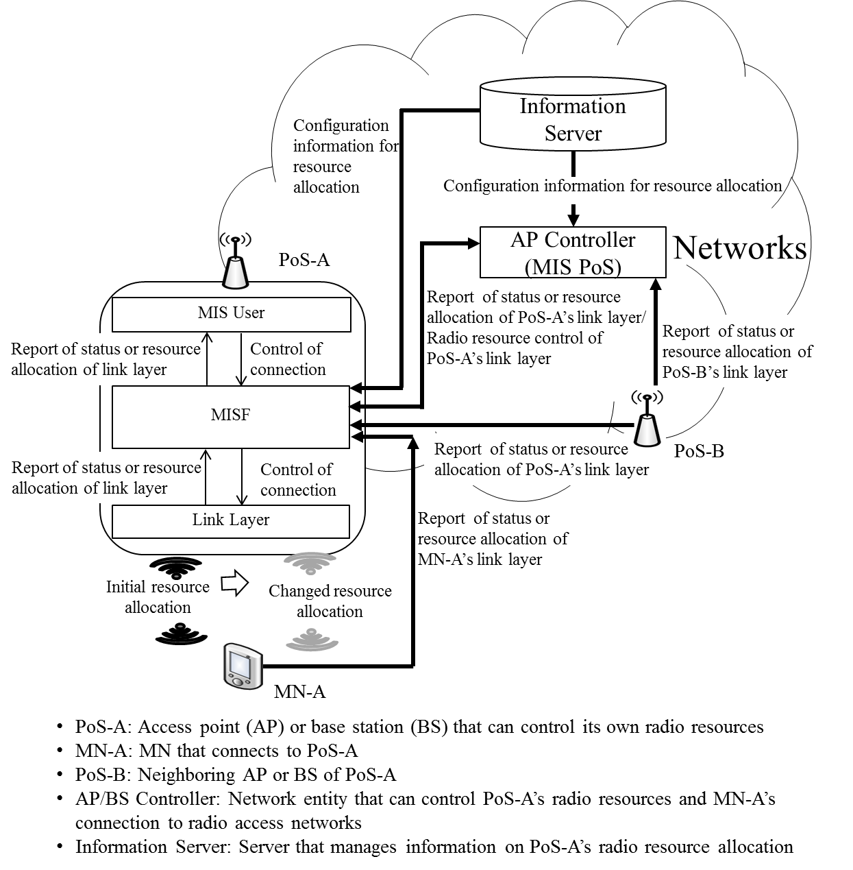
Figure 1—Media independent service framework for resource management in heterogeneous networks

      - Stages for radio resource allocations
Radio resource allocation of radio access network comprises four stages as shown in Figure 2.
- In the first stage, AP’s radio resource allocation is decided by AP or AP Controller based on AP’s link status or radio resource allocation of AP’s neighboring radio access networks.
- In the second stage, MN prepares to connect to radio access network with newly allocated radio resources.
- In the third stage, AP’s radio resources (e.g., frequency, time, and power) are allocated by AP or AP Controller.
- In the last stage, AP reports its allocated radio resources to Information Server, AP Controller, and neighboring APs.

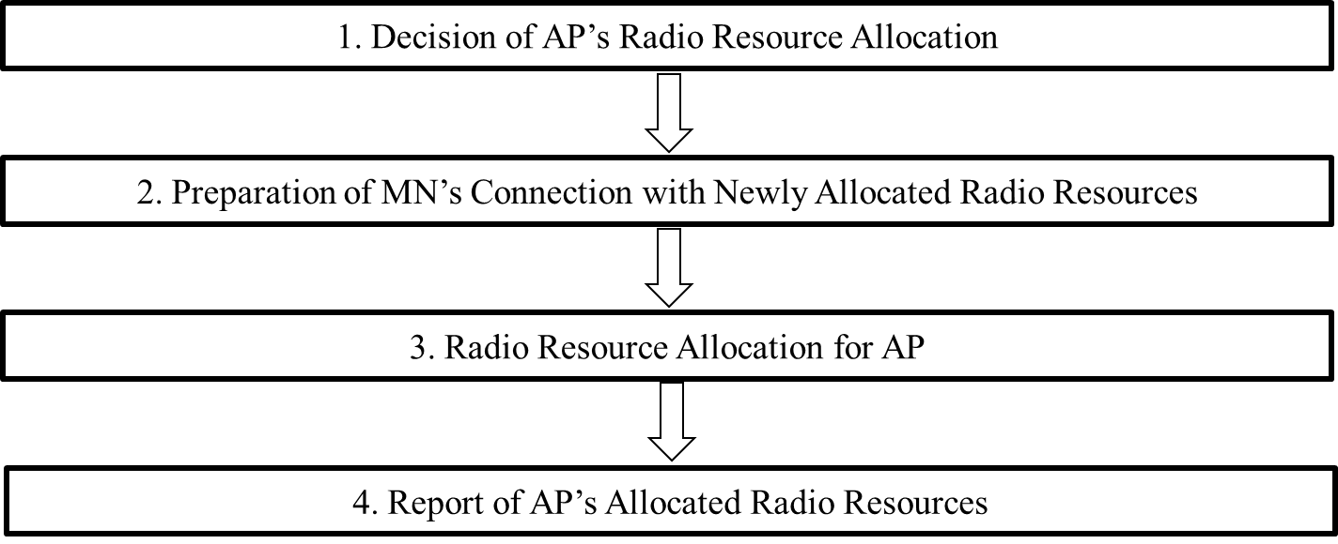
Figure 2—Stages for radio resource allocation of radio access network

      - Signal flows
        - Stage 1: decision of AP’s radio resource allocation
AP itself can decide allocation of its own radio resources. Otherwise, AP Controller can decide radio resource allocations for AP on behalf of AP. For this stage, Link_Resource_Report and MIS_Resource_Report primitives/messages are proposed as new primitives and messages.

          - Decision by AP based on link status of AP
AP (e.g., PoS-A) can decide its radio resources based on its link status, as shown in Figure 3. For this case Link_Parameter_Report and MIS_Link_Parameter_Report primitives in IEEE 802.21 standard and messages can be used.

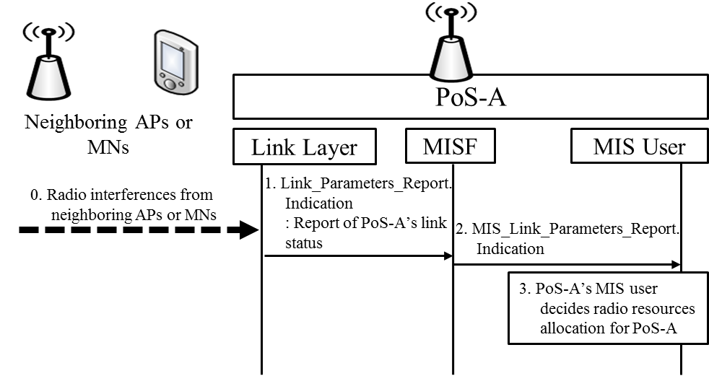
Figure 3—PoS-A decides its radio resource allocation based on its link status

- Neighboring APs or MNs may interfere with PoS-A.
- PoS-A’s link layer informs PoS-A’s MISF (Media Independent Services Function) of bad link status (e.g., low data rate) by using Link_Paramters_Report.indication primitive.
- PoS-A’s MISF informs PoS-A’s MIS user of bad link status by using MIS_Link_Parameters_Report.indication primitive.
- Based on link status, PoS-A’s MIS user determines radio resource allocation for PoS-A.

- —Link events
Link event name | Link event type | Description | Defined in
Link_Parameters_Report | Link parameters | Link parameters have crossed pre-specified thresholds. | 7.3.4  IEEE 802.21 Revision

- —MIS events
MIS event name | (L) ocal  (R) emote | Description | Defined  in
MIS_Link_Parameters_Report | L, R | Link parameters have crossed a specified thresh- old and need to be reported. | 7.3.4  IEEE 802.21 Revision

          - Decision by AP based on link status of MN
AP (e.g., PoS-A) can decide its radio resource allocation based on link status of MN. MN may experience bad link status due to some reasons (e.g., radio interference) as shown in Figure 4. In this case, if MN (e.g., MN-A) reports its link status to PoS-A by using Link_Parameter_Report and MIS_Link_Parameter_Report primitives/messages in IEEE 802.21 standard, PoS-A can allocate appropriate radio resources for MN.

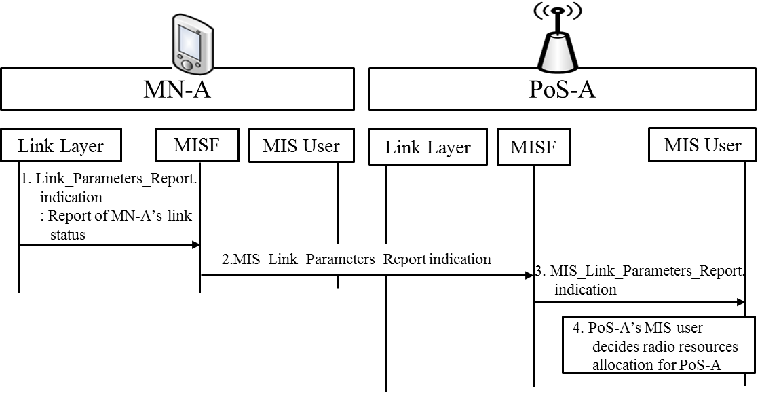
Figure 4—PoS-A decides its radio resource allocation based on link status of MN

- MN-A is an MN connecting to PoS-A that needs to allocate appropriate radio resources. MN-A’s link layer sends Link_Parameters_Report.indication primitive to MN-A’s MISF.
- MN-A’s MISF sends MIS_Link_Parameters_Report indication message to PoS-A’s MISF.
- PoS-A’s MISF informs PoS-A’s MISF of MN’s link status by using MIS_Link_Parameters_Report.indication primitive.
- PoS-A’s MIS user can decide its radio resource allocation based on link status of MN-A.

          - Decision by AP based on reports from neighboring AP
AP can decide its radio resource allocations based on reports from neighbouring AP as shown in Figure 5. If AP (e.g., PoS-A) and neighbouring AP (e.g., PoS-B) use the same radio resources, they interfere with each other and need to reallocate their radio resources for improving their link status. The PoS-B is neighbouring AP of PoS-A that needs to allocate appropriate radio resources. PoS-B can report its link status and radio resource allocation. To report information on PoS-B’s allocated radio resources (e.g., frequency bands and transmit power), Link_Resource_Report and MIS_ Resource_Report primitives/messages are proposed as new primitives/messages. To report PoS-B’s link status, Link_Parameters_Report and MIS_Link_Parameters_Report primitives/messages in IEEE 802.21 standard are used.
- PoS-B’s link layer sends Link_Parameters_Report.indication or Link_Resource_Report.indication primitive to PoS-B’s MISF to report link status or allocated radio resources of PoS-B.
- PoS-B’s link layer sends MIS_Link_Parameters_Report indication or MIS_Resource_Report indication message to PoS-A’s MISF.
- PoS-A’s MISF informs PoS-A’s MIS user of PoS-B’s link status or allocated radio resources by using MIS_Link_Parameters_Report.indication or MIS_Resource_Report .indication primitive.
- PoS-A’s MIS user decides radio resource allocation for PoS-A.

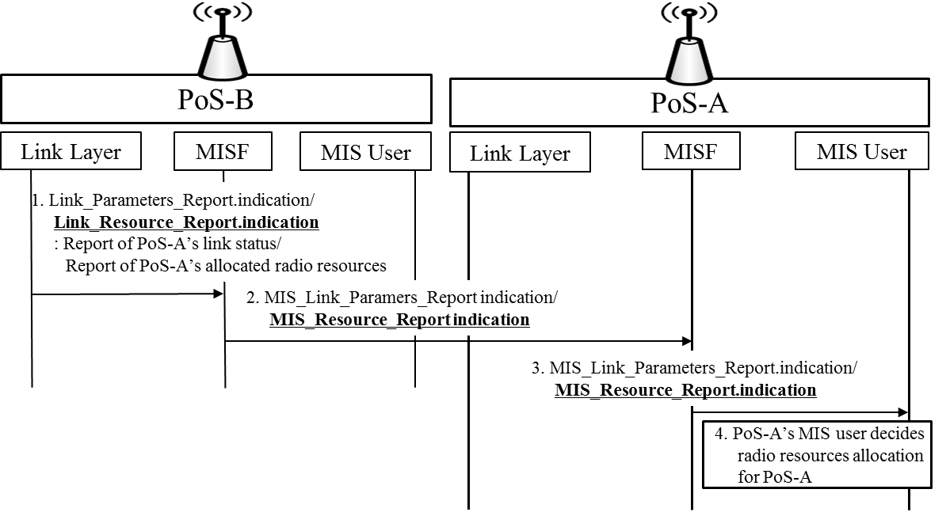
Figure 5—PoS-A decides its radio resource allocation based on reports of PoS-B

- New commands
- —Link commands
Link command | Description | Defined  in
Link_Resource_Report | Command to Indicate allocated radio resources (e.g., frequency, time, and transmit power) | 5.4.2.3.1  IEEE802.21.1

- —MIS commands
MIS command | (L) ocal,  (R) emote | Description | Defined  in
MIS_ Resource_Report | L, R | Command to Indicate allocated radio resources (e.g., frequency, time, and transmit power) | 5.4.2.3.1  IEEE802.21.1

- New primitive/message
- —MIS_LINK_SAP primitives
Primitives | Service  category | Description | Defined  in
Link_Resource_Report | Command | Indicate allocated radio resources (e.g., frequency, time, and transmit power) | 5.4.2.3.1  IEEE802.21.1

- —MIS_SAP primitives
Primitives/Messages | Service  category | Description | Defined  in
MIS_Resource_Report | Command | This primitive/message is to Indicate allocated radio resources (e.g., frequency, time, and transmit power) | 5.4.2.3.1  IEEE802.21.1

          - Decision by AP based on configuration information from Information Server
AP can query configuration information to Information Server, and then allocate its own radio resources based on the configuration information as shown in Figure 6. AP can request configuration information such as network type (e.g., IEEE 802.11 and CDMA), frequency bands, and location information of neighboring APs to Information Server. Based on configuration information from Information Server, PoS can allocate its own radio resources. To query configuration information, MIS_Get_Information primitives/messages that are primitives/messages in IEEE 802.21-2008 standard can be used.

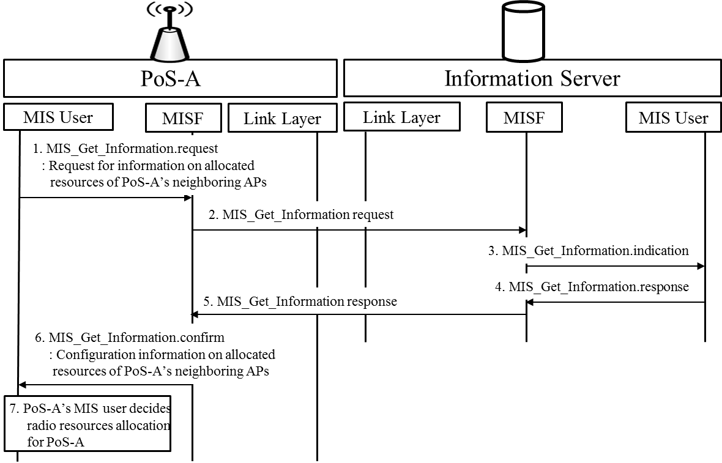
Figure 6—PoS-A decides its radio resource allocation based on configuration information from Information Server

- PoS-A’s MIS user sends MIS_Get_Information.request primitive to PoS-A’s MISF for requesting information on allocated resources of PoS-A’s neighboring PoSs.
- PoS-A’s MISF sends MIS_Get_information request message to MISF of Information Server.
- MIS user of Information Server recognizes that PoS-A requests configuration information of PoSs in neighborhood with PoS-A by receiving MIS_Get_Information.indication primitive.
- MIS user of Information Server sends MIS_Get_Information.response primitive to MISF of Information Server.
- MISF of Information Server sends MIS_Get_Information response message to PoS-A’s MISF.
- PoS-A’s MIS user receives configuration information of PoS-A’s neighboring PoSs by MIS_Get_Information.confirm primitive.
- PoS-A’s MIS user decides radio resource allocation for PoS-A.

- —MIS_SAP primitives
Primitives/Messages | Service  category | Description | Defined  in
MIS_Get_Information | Information | Request to get information from repository | 7.4.25  IEEE802.21 Revision

          - Decision by AP Controller based on reports from APs
AP Controller also can decide radio resource allocation for AP based on reports about link status or radio resource allocation of APs controlled by AP Controller, as shown in Figure 7. The PoS-B is AP controlled by AP Controller. PoS-B can report its link status and radio resource allocation to AP Controller, and then AP Controller can allocate radio resources for PoS-A. To report information on PoS-B’s allocated radio resources (e.g., frequency bands and transmit power), Link_Resource_Report and MIS_Resource_Report primitives/messages are proposed as new primitives/messages. To report PoS-B’s link status, Link_Parameters_Report and MIS_Link_Parameters_Report primitives/messages in IEEE 802.21 standard are used.

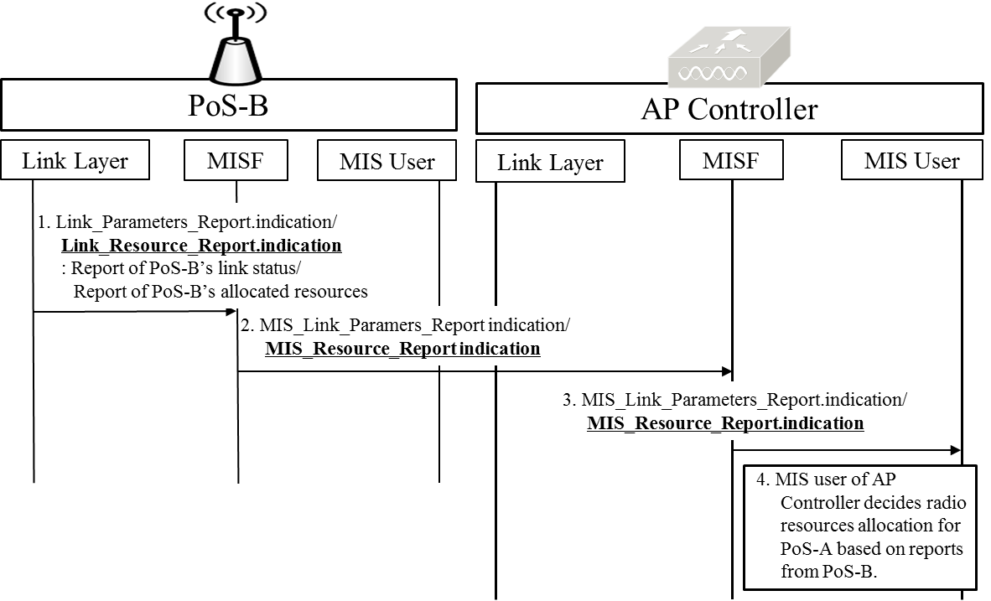
Figure 7—AP Controller decides PoS-A’s radio resource allocation based on reports of PoS-B

- PoS-B’s link layer sends Link_Parameters_Report.indication or Link_Resource_Report.indication primitive to PoS-B’s MISF for reporting link status or allocated resources of PoS-B.
- PoS-B’s MISF sends MIS_Link_Parameters_Report indication or MIS_Resource_Report indication message to MISF of AP Controller.
- AP Controller’s MISF informs AP Controller’s MIS user of PoS-B’s link status or allocated radio resources by using MIS_Link_Parameters_Report.indication primitive, or MIS_ Resource_Report.indication primitive.
- MIS user of AP Controller can decide PoS-A’s radio resource allocation based on link status or radio resource allocation of PoS-B.

          - Decision by AP Controller based on configuration information from Information Server
AP Controller can query configuration information to Information Server, and then allocate radio resources for AP as shown in Figure 8. AP Controller can request configuration information such as network type frequency bands, and location information of APs controlled by AP Controller to Information Server. Based on configuration information from Information Server, AP Controller can allocate appropriate radio resources of AP. To query configuration information, MIS_Get_Information primitives/messages that are primitives/messages in IEEE 802.21-2008 standard can be used.
- MIS user of AP Controller sends MIS_Get_Information.request primitive to MISF of AP Controller.
- MISF of AP Controller sends MIS_Get_information request message to MISF of Information Server.
- MIS user of Information Server recognizes that AP Controller requests configuration information of APs controlled by AP Controller with MIS_Get_Information.indication primitive.
- MIS user of Information Server sends MIS_Get_Information.response primitive to MISF of Information Server.
- MISF of Information Server sends MIS_Get_Information response message to MISF of AP Controller.
- MIS user of AP Controller receives configuration information of APs controlled by AP Controller with MIS_Get_Information.confirm primitive.
- MIS user of AP Controller decides radio resource allocation for PoS-A.

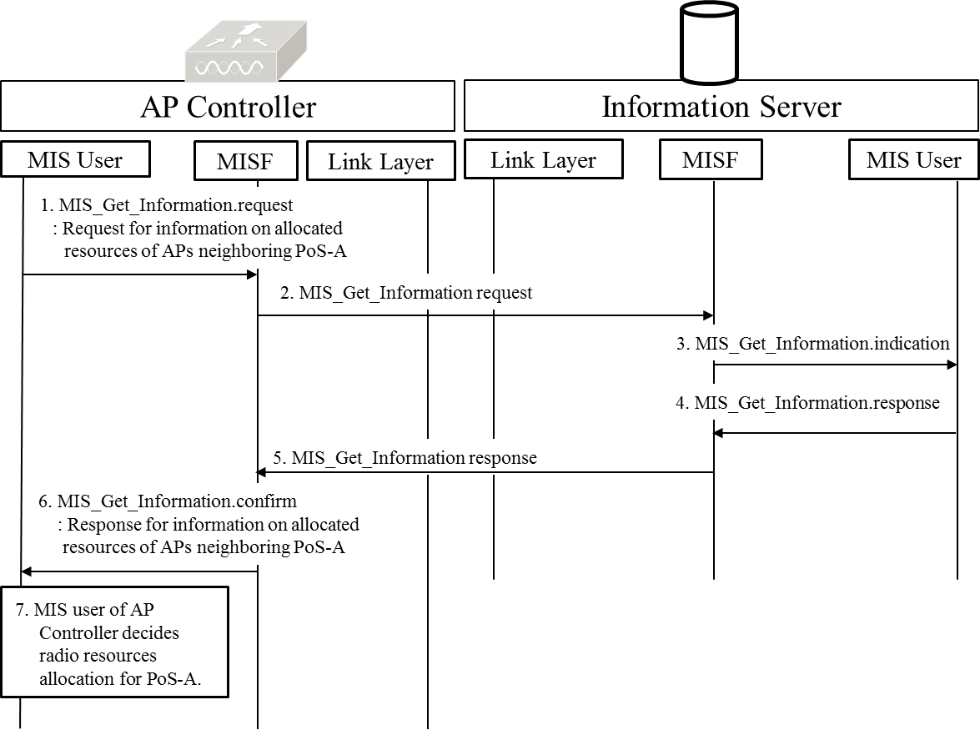
Figure 8—AP Controller decides PoS-A’s radio resource allocation based on configuration information from Information Server
        - Stage 2: preparation of MN’s connection with newly allocated radio resources
Before AP allocates new radio resources, MN needs to prepare changing its connection with newly allocated radio resources of AP that MN connects to. MN can receive information on new radio resources from AP Controller or AP that MN connects to before performing radio resource allocation. For this stage, MIS_Link_Preparation primitives/messages are proposed as new primitives and messages.

          - Request for preparation of MN’s connection from PoA
AP requests MN to prepare connection with newly allocated radio resources by using MIS_Link_Preparation primitives/messages that are newly proposed, as shown in Figure 9. The primitives and messages of MIS_Link_Preparation include information on AP’s newly allocated radio resources (e.g., frequency band and transmit power). The MN-A connects to PoS-A, and thus MN-A can be requested to prepare connection with new radio resources by PoS-A.

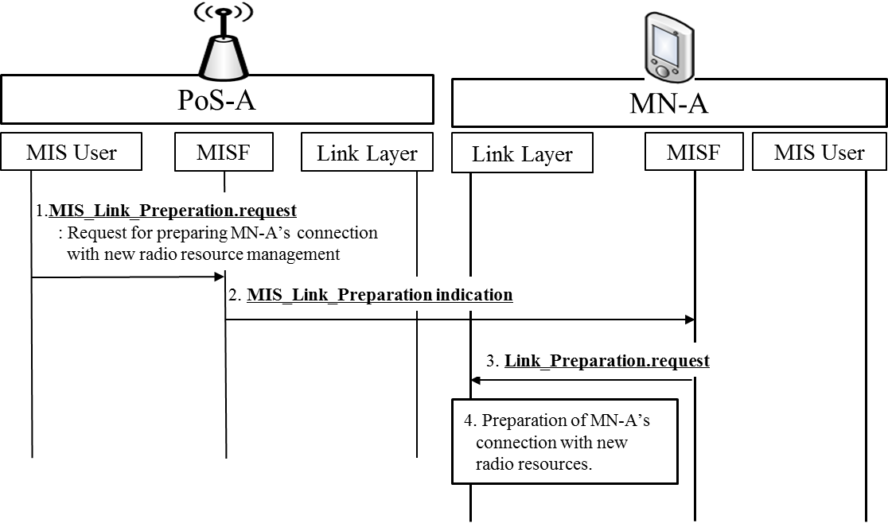
Figure 9—PoS-A requests MN-A to prepare connection with newly allocated radio resources
- PoS-A’s MIS user sends MIS_Link_Preperation.request primitive to PoS-A’s MISF.
- PoS-A’s MISF sends MIS_Link_Preparation indication message to MN-A’s MISF.
- MN-A’s link layer is informed of new radio resources to prepare MN’s connection by Link_Preparation.request primitive.
- MN-A’s link layer prepares the connection with new radio resources.

- New commands
- —Link commands
Link command | Description | Defined  in
Link_Preparation | Command to request MN to prepare connection with newly allocated radio resources | 5.4.2.3.2  IEEE802.21.1

- —MIS commands
MIS command | (L) ocal,  (R) emote | Description | Defined  in
MIS_Link_Preparation | L, R | Command to request MN to prepare connection with newly allocated radio resources | 5.4.2.3.2  IEEE802.21.1

- New primitive/message
- —MIS_LINK_SAP primitives
Primitives | Service  category | Description | Defined  in
Link_Preparation | Command | request MN to prepare connection with newly allocated radio resources | 5.4.2.3.2  IEEE802.21.1

- —MIS_SAP primitives
Primitives/Messages | Service  category | Description | Defined  in
MIS_Link_Preparation | Command | This primitive/message is to request MN to prepare connection with newly allocated radio resources | 5.4.2.3.2  IEEE802.21.1

          - Request for preparation of MN’s connection from AP Controller
AP Controller also can request MN to prepare connection with newly allocated resources by using MIS_Link_Preparation primitives/messages that are newly proposed, as shown in Figure 10.

Figure 10—AP Controller requests MN-A to prepare connection with newly allocated radio resources

- MIS user of AP Controller sends MIS_Link_Preperation.request primitive to MISF of AP Controller.
- MISF of AP Controller sends MIS_Link_Preparation indication message to MN-A’s MISF.
- MN-A’s link layer is informed of new radio resources to prepare MN’s connection by Link_Preparation.request primitive.
- MN-A’s link layer prepares connection with new radio resources.

        - Stage 3: Allocation of AP’s Radio Resources
In this stage, AP’s radio resources are allocated by AP or AP Controller. For this stage, MIS_Resource_Allocation and Link_Resource_Allocation primitives/messages are newly proposed for allocating radio resources of PoA.

          - AP’s radio resource allocation by PoA
AP itself can allocate its radio resources, as shown in Figure 11. MIS_Resource_Allocation.request and Link_Resource_Allocation.request primitives are new primitives for allocating radio resources and include parameters that represent radio resources (e.g., frequency band, transmit power, and time slot).
- PoS-A’s MIS user sends MIS_Resource_Allocation.request primitive to PoS-A’s MISF.
- PoS-A’s link layer receives information on radio resources for allocation by Link_Resource_Allocation.request primitive.
- PoS-A’s link layer allocates its own radio resources.
- After PoS-A’s link layer allocates radio resources, PoS-A’s link layer sends Link_Resource_Allocation.confirm primitive to PoS-A’s MISF.
- Result of radio resource allocation is reported to PoS-A’s MIS user by MIS_Resource_Allocation.confirm primitive.
Link_Resource_Allocation.confirm and MIS_Resource_Allocation.confirm should include a parameter to present result (e.g., success or fail) of radio resource allocation.

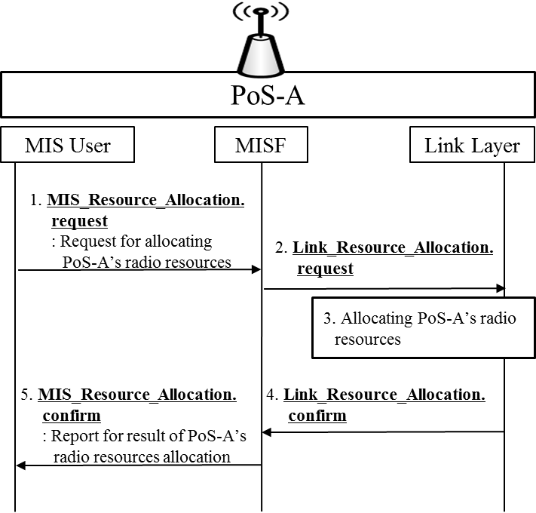
Figure 11—AP allocates its own radio resources

- New commands
- —Link commands
Link command | Description | Defined  in
Link_Resource_Allocation | Command to request for allocating radio resources (e.g., frequency, time, and transmit power) | 5.4.2.3.3  IEEE802.21.1

- —MIS commands
MIS command | (L) ocal,  (R) emote | Description | Defined  in
MIS_Resource_Allocation | L, R | Command to request for allocating radio resources (e.g., frequency, time, and transmit power) | 5.4.2.3.3  IEEE802.21.1

- New primitive/message
- —MIS_LINK_SAP primitives
Primitives | Service  category | Description | Defined  in
Link_Resource_Allocation | Command | request for allocating radio resources (e.g., frequency, time, and transmit power) | 5.4.2.3.3  IEEE802.21.1

- —MIS_SAP primitives
Primitives/Messages | Service  category | Description | Defined  in
MIS_Resource_Allocation | Command | This primitive/message is to request for allocating radio resources (e.g., frequency, time, and transmit power) | 5.4.2.3.3  IEEE802.21.1

          - AP’s radio resource allocation by AP Controller
MIS user of AP Controller can request AP’s link layer to allocate radio resources as shown in Figure 12. MIS_Resource_Allocation.request and Link_Resource_Allocation.request primitives are new primitives for AP Controller to allocate radio resources of PoA.
- MIS user of AP Controller sends MIS_Resource_Allocation.request primitive to MISF of AP Controller.
- MISF of AP Controller sends MIS_Resource_Allocation request message to PoS-A’s MISF.
- PoS-A’s link layer receives information on radio resources for allocation by Link_Resource_Allocation.
- PoS-A’s link layer allocates its own radio resources.
- PoS-A’s link layer sends Link_Resource_Allocation.confirm to PoS-A’s MISF.
- PoS-A’s MISF sends MIS_Response_Allocation response message to MISF of AP Controller.
- MIS user of AP Controller receives report on the result of PoS-A’s radio resource allocation.

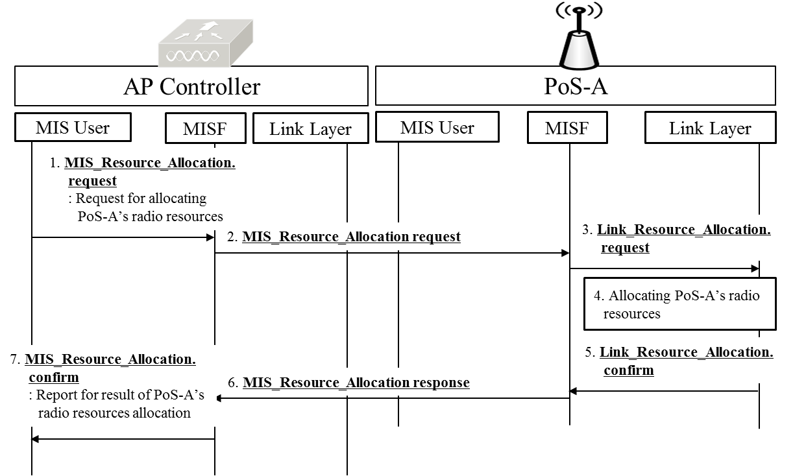
Figure 12—AP Controller allocates radio resources for PoA

        - Stage 4: Report of AP’s allocated radio resources
After radio resource allocation of PoA, AP should report its updated radio resources to other network entities such as neighboring PoA, AP Controller, and Information Server, as shown in Figure 13. MIS_Resource_Report and Link_Resource_Report are new primitives and messages for reporting PoS-A’s updated radio resource allocation. They include parameters that represent updated radio resources of PoA.
* Pre-existing Link_Parameter_Report and MIS_Link_Paramenter_Report primitives/messages are defined for indicating changes in link conditions that have crossed pre-configured threshold levels. However, Link_Resource_Report and MIS_Resource_Report primitives/messages are defined for reporting allocated radio resources. Therefore, Pre-existing Link_Parameter_Report and MIS_Link_Paramenter_Report are totally different from Link_Resource_Report and MIS_Resource_Report primitives/messages.

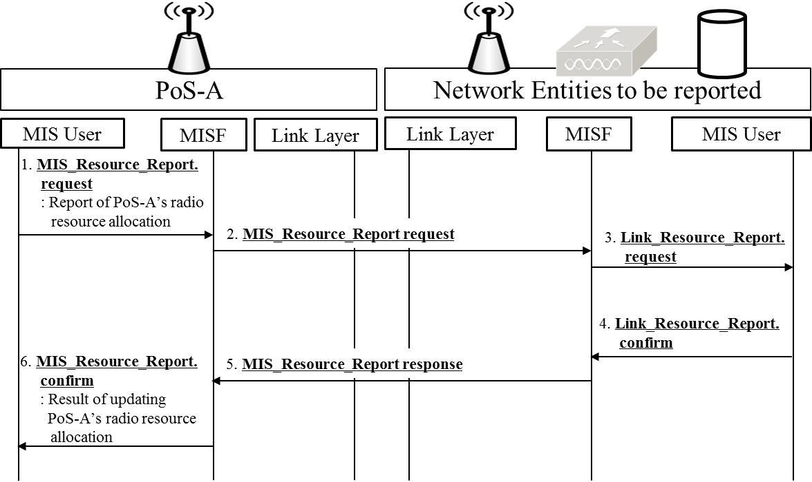
Figure 13—AP reports its radio resources to other its updated radio resources to other network entities

- PoS-A’s MIS user sends MIS_Resource_Report.request primitive to PoS-A’s MISF.
- PoS-A’s MISF sends MIS_Resource_Report request message to MISF of other network entities (e.g., neighboring PoA, AP Controller and Information Server).
- MIS user of other network entities updates information on PoS-A’s radio resource allocation by Link_Resource_Report.confirm primitive.
- As response to update report, Link_Resource_Report.confirm primitive, MIS_Resource_Report response message, and MIS_Resource_Report.confirm primitive can be used. MIS user of other network entities sends Link_Resource_Report.confirm to MISF of other network entities.
- MISF of other network entities sends MIS_Resource_Report response message to PoS-A’s MISF.
- PoS-A’s MIS user is informed whether other network entities update PoS-A’s radio resource allocation or not by -MIS_Resource_Report.confirm primitive.

    - Service specific primitives

      - MIS_SAP primitives

        - MIS_Resource_Allocation
          - MIS_Resource_Allocation.request
          - MIS_Resource_Allocation.confirm
          - MIS_Resource_Allocation.indication
          - MIS_Resource_Allocation.response

        - MIS_Resource_Report
          - MIS_Resource_Report.request
          - MIS_Resource_Report.confirm
          - MIS_Resource_Report.indication
          - MIS_Resource_Report.response

        - MIS_Link_Preparation
          - MIS_Link_Preparation .request
          - MIS_Link_Preparation .confirm
          - MIS_Link_Preparation .indication
          - MIS_Link_Preparation .response

      - MIS_LINK_SAP primitives

        - Link_Resource_Allocation
          - Link_Resource_Allocation.request
          - Link_Resource_Allocation.confirm
          - Link_Resource_Allocation.indication
          - Link_Resource_Allocation.response

        - Link_Resource_Report
            - Link_Resource_ Report.request
            - Link_Resource_ Report.confirm
            - Link_Resource_ Report.indication
            - Link_Resource_ Report.response

        - Link_Preparation
          - Link_Preparation.request
          - Link_Preparation.confirm
          - Link_Preparation.indication
          - Link_Preparation.response

    - Service specific protocol features

      - MIS protocol messages for command service

        - MIS_Resource_Allocation
          - MIS_Resource_Allocation request
          - MIS_Resource_Allocation indication
          - MIS_Resource_Allocation response

        - MIS_Resource_Report
          - MIS_Resource_Report request
          - MIS_Resource_Report indication
          - MIS_Resource_Report response

        - MIS_Link_Preparation
          - MIS_Link_Preparation request
          - MIS_Link_Preparation indication
          - MIS_Link_Preparation response

Table E.2- MIH_LINK_SAP/IEEE 802.11/IEEE 802.3/IEEE 802.1ag primitives mapping
Primitives | IEEE Std 802.11 | IEEE Std 802.3 | IEEE Std 802.1ag[B19]
Link_Resource_Allocation |  | N/A | N/A
Link_Resource_Report
Link_Preparation

