IEEE P802.21 Media Independent Handover Services
Meeting Minutes of the IEEE P802.21d Group Management Task Group
Chair: Yoshihiro Ohba
Editor: Antonio de la Oliva

Tuesday, AM2 Meeting, March 10, 2015

Meeting called to order by Chair at 10:30AM
Minutes are taken by Yoshihiro Ohba.

Meeting Agenda (21-15-0018-00) is presented by the Chair

Agenda was approved with no objections.

Meeting Minutes Approval
TGd January meeting minutes are included in WG January meeting minutes, approval of which is deferred until WG Closing Plenary on Thursday.

Opening Notes (21-15-0019-00) is presented by the Chair
Slides #1-#4 shown, Note Well, Duty to Inform.

Chair called for declaration of potentially essential IPR on 802.21d. There was no response to the call in the meeting.

Sponsor Ballot recirculation #2 has passed with 100% approval ratio.

There is one comment to resolve.

Commentary file: DCN 21-15-0017-00.

Sponsor Ballot comment resolution

The group discussed one comment and rejected it. The detailed resolution is captured in DCN 21-15-0017-01.

Closing Note by Chair

Chair presented closing note (DCN 21-15-0028-00).

The following two TG motions were taken.

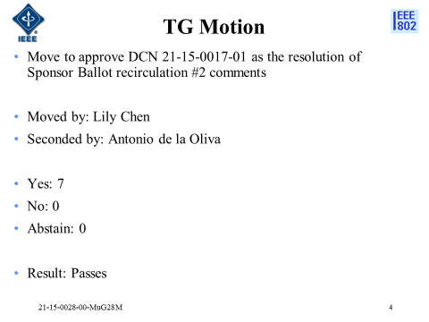

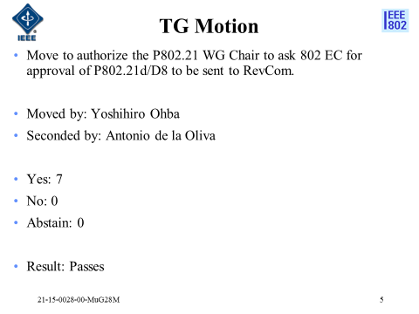

Meeting adjourned at 11:30am.

