Project | IEEE 802.21.1 Media Independent Services  <http://www.ieee802.org/21/>
Title | Proposed Text of “Software-defined mobile network (SDMN) service” Section for IEEE 802.21.1 Draft Standard
DCN | 21-15-0022-00-SAUC
Date Submitted | March 7, 2015
Source(s) | Jin Seek Choi (Hanyang University, Korea Ethernet Forum), Hyeong-Ho Lee (ETRI), Hyunho Park (ETRI)
Re: | IEEE 802.21 Session #67 in Berlin, Germany
Abstract | According to the “Proposed Table of Contents for IEEE 802.21.1 Draft Standard” (DCN 21-14-0113-01-SAUC), this document proposes text of “Software-defined mobile network (SDMN) service” Section for IEEE 802.21.1 Draft Standard. This document describes detailed use case and requirements on media independent service for mobility management in software-defined networking (SDN) networks, based on our contribution “Use cases of MIS framework to cooperate with SDN wireless access networks” (DCN 21-14-0157-01-SAUC) presented in the Nov. 2014 IEEE 802 Plenary meeting.
Purpose | To be part of 802.21.1 draft standard document.
Notice | This document has been prepared to assist the IEEE 802.21 Working Group. It is offered as a basis for discussion and is not binding on the contributing individual(s) or organization(s). The material in this document is subject to change in form and content after further study. The contributor(s) reserve(s) the right to add, amend or withdraw material contained herein.
Release | The contributor grants a free, irrevocable license to the IEEE to incorporate material contained in this contribution, and any modifications thereof, in the creation of an IEEE Standards publication; to copyright in the IEEE’s name any IEEE Standards publication even though it may include portions of this contribution; and at the IEEE’s sole discretion to permit others to reproduce in whole or in part the resulting IEEE Standards publication. The contributor also acknowledges and accepts that IEEE 802.21 may make this contribution public.
Patent Policy | The contributor is familiar with IEEE patent policy, as stated in Section 6 of the IEEE-SA Standards Board bylaws <http://standards.ieee.org/guides/bylaws/sect6-7.html#6> and in Understanding Patent Issues During IEEE Standards Development http://standards.ieee.org/board/pat/faq.pdf

Table of Contents

5.7 Software-defined mobile network (SDMN) service 3
5.7.1 Introduction 3
5.7.2 Service scenarios and call flows 3
5.7.3 Service specific primitives 19
5.7.4 Service specific protocol features 21

  - Software-defined mobile network (SDMN) service
    - Introduction
Software-defined networking (SDN), characterized by a clear separation of the control and data planes, has adopted as a paradigm for wired networking. In recent days, SDN-like paradigm has been interested in wireless mobile network and thus mobility management in Software-defined mobile network (SDMN) is needed. In this Section, we analyze the potential of applying the Media independent services (MIS) framework to SDMN. First, we identify use cases for seamless handover where a MIS approach could bring additional benefits in SDMNs. Then, we drive the main characteristics of a mobility management framework in SDMNs. In the framework, we are paying attention to the MIS functions and interfaces. In order to illustrate the operation of the framework, we introduce the high-level interactions required between the defined functions to support our use cases.
MIS framework of IEEE 802.21-2008 standard can be a common platform to support mobility management in heterogeneous networks. MIS framework supports seamless handover in heterogeneous networks by using MIES (Media Independent Event Service), MICS (Media Independent Command Service), and MIIS (Media Independent Information Service). MIES primitives and messages help MN (Mobile Node) to monitor link status (e.g., signal strength and data rate), and MICS primitives and messages helps MN to control its link layers (physical layer and data link layer) for seamless handover in heterogeneous networks.
It is possible to expect that MIS Framework enables MN to monitor link, allocate resource, and enables mobility management for MNs in SDMNs. The SDMN can be characterized by a clear separation of the MIS control and data planes. The SDMN is the simplest solution for future wireless mobile networks integration where various networks connected through gateways conserve their independence. The major inconvenience of this approach is the long handover delay.
MIIS primitives and messages can be used to transfer network configuration information for handover and mobility management via clear separated control plane in SDMNs, and thus they can be used to provide seamless network configuration for resource allocations in SDMNs while MN moving. Thus, MIS framework is appropriate for handover resource allocation and mobility management in SDMNs that use various heterogeneous switching by a clearly separation of the control and data plane.
In SDMN, MIS framework requires important modifications to the mobility management protocols, the interfaces and the services of the access networks to provide good handover performance.

    - Service scenarios and call flows
      - Service framework architecture
Our goal is to identify use cases for seamless handover where a MIS approach could bring additional benefits in SDMNs. Then, we drive the main characteristics of a MIS-based mobility management framework for SDMNs. The proposed framework is assumed to be operated by a single operator or by cooperating service providers. It’s based on the principal concepts of IEEE 802.21 for context information gathering and optimized handover decision making.
For handover execution phase, the crucial problem is the dependence on the media as well as the infrastructure network. For that reason, we designed a MIS framework for the handover execution phase to overcome the major issue of these dependencies. In the SDMN, radio access networks (RANs) have the capability to operate in 3GPP LTE, WiMAX and Wi-Fi interfaces, and are equipped with MISF supporting mobility like depicted in Fig. 1. As a consequence, in SDMN’s environment, vertical handover procedure becomes more challenging especially for seamless handover.

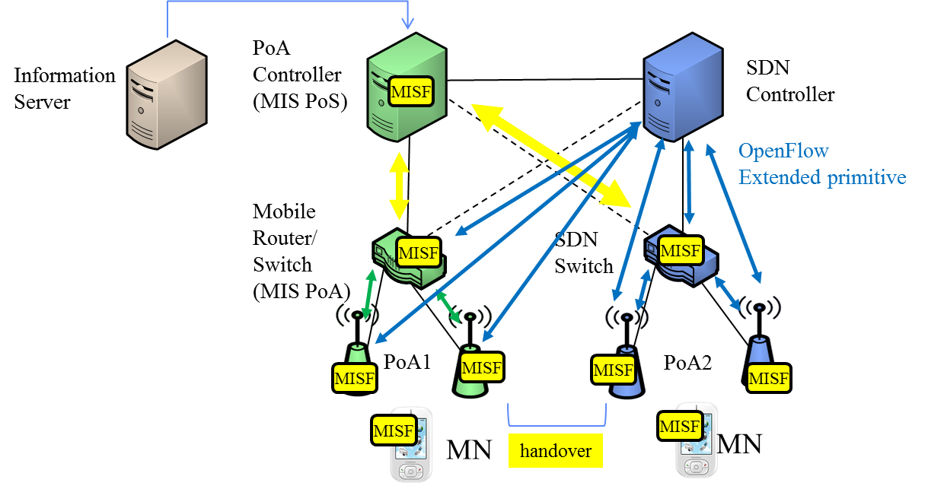

Figure 1—MIS framework use case in SDMNs

In SDMN, we assume that the PoA Controller (i.e., access point (AP) Controller) is able to connect a variety of different PoAs, and PoA selection is derived from a mixture of user preferences, access network conditions and operator policies in a full IP-based network. Radio access network acts as MIS PoA by achieving mobility management on behalf of attached MNs.
Each PoA and its related MNs are co-located in a specific area or vehicle including a wireless local area network such as Wi-Fi network, WiMAX network or any other wireless network. So that, each end-user of MN can reach internet or communicate with a corresponding node via its PoA.
Mobile router can also operate as a gateway between wireless network (or MNs) and a backhaul network. The latter is a cellular network and may be connected to any other network. Fig. 1 shows the main functional entities in the PoA Controller side and the architecture of the proposed handover management model. The Context aware Handover Controller at the PoA side interacts with the Handover Manager of the PoA Controller and plans the execution of the mobility management protocols at the higher layers. The PoA acts as a MIS user and makes use of MIS signaling messages to achieve handover initiation and preparation. The context information module at the PoA Controller is able to extract relevant information from received triggers based on MIS signaling. Each mobile user has a local repository of its own context information. Then the PoA periodically queries the mobile users to establish its connectivity. The MIIS in our system can be incorporated with the information server. The information server at the core network sends handover policies to the PoA Controller and receives context information of each PoA controller and its attached users.

      - High level illustration
Figure 2 shows MIS framework for handover control in SDMNs. PoA Controller can control resources of PoAs that use various communication technologies (e.g., WLAN, Wi-Fi Direct, Bluetooth, and LTE) by using MIES message. PoAs configure radio resources (e.g., frequency, time, and power) according to MIES message. The MIES message can be encapsulated by OpenFlow protocol or other control protocol. The following entities are equipped with MIS function (MISF).
- MN(Mobile Node)-A: A user device, such as a smart phone, which equips radio interfaces of multiple radio access technologies
- PoA-A: The PoA (Point of Attachment), such as mobile router in access network, base station in cellular networks, and access point in WLAN, which is a network entity that establishes link connection with the MN. It is responsible for medium access control that is expressed in terms of management information including the operating channel or the transmission power, the beacon interval or the contention parameters used by the medium access control.
- PoA-B: PoA-A’s neighboring PoA that can interfere with MN or PoA-A
- PoA Controller (or SDN Controller): A network entity that can manage resources of PoA-A. It is responsible for decision of the data traffic flow about where traffic is sent to, from the underlying PoA that forwards traffic to the selected destination, in a way that is related to the controlling flow of new incoming MN.
- Information Server: A server that manages mobility information of MNs on PoA. This server has a real-time view of the MN and is capable of the access control and resource allocations of MNs in a media-independent way.
PoA-A is able to trigger radio resource management of its own link based on monitored link status by MN, itself, or PoA-B. PoA Controller is also able to trigger radio resource management of PoA-A’s link.
- PoA-A may manage its own radio resources based on its own link status.
- PoA-A may manage its own radio resources based on link status of MN.
- PoA-A may manage its own radio resources based on link status or resource allocations of PoA-B.
- PoA-A may manage its own radio resources based on Handover information from PoA Controller.
- PoA-A may manage its own radio resources based on Mobility management information from Information Server.
- PoA Controller may request to Information Server radio resource management of PoA-A based on link status or resource allocations of PoAs (e.g., PoA-A and PoA-B) that are managed by PoA Controller.
- PoA Controller may request radio resource management of PoA-A based on configuration information from Information Server.

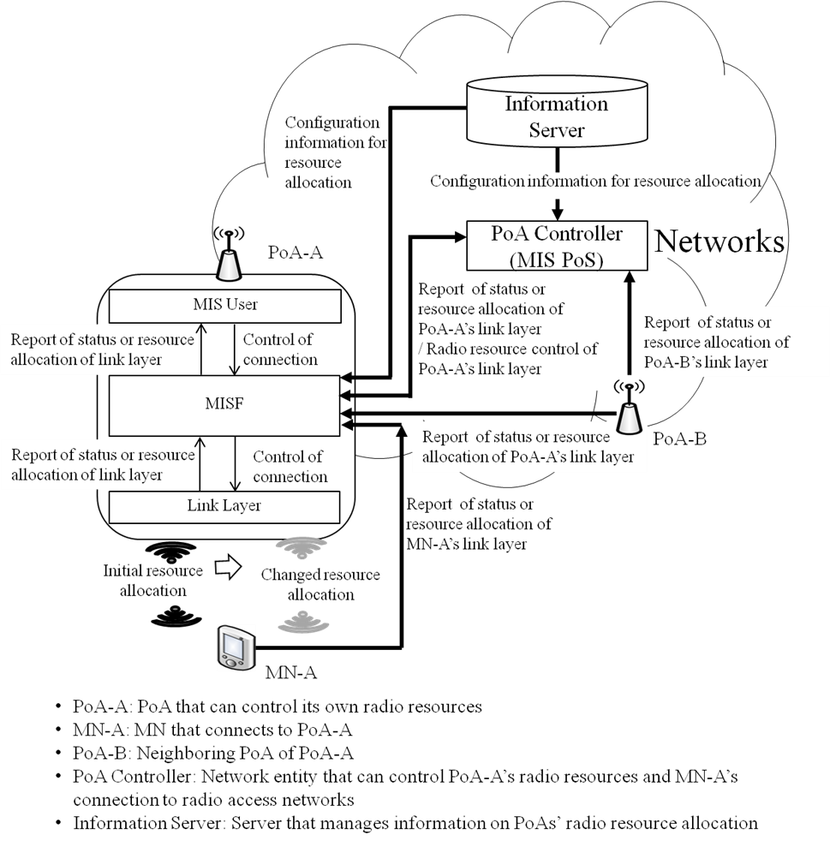
Figure 2— Stages for radio resource allocation of radio access network

      - Stages for handover procedure
Handover refers to the ability of transferring an ongoing call or data session from one radio access technology to another, without any interruption, to the ongoing services. Handover procedure for radio resource allocation comprises four stages as shown in Figure 3.
- In the first stage, handover initiation starts from the link corruption detection until the request for initiating a new link.
- In the second stage, handover preparation consists of all steps of link measurements, collection of information about neighboring networks, and exchange of information about QoS offered by these networks.
- In the third stage, handover decision is the procedure to decide whether the connection to be switched to a new network based on parameters collected in the handover initiation phase. PoA’s radio resource allocation is decided by PoA or PoA Controller based on PoA’s link status or radio resource allocation of PoA’s neighboring radio access networks.
- In the last stage, PoA’s radio resources (e.g., frequency, time, interface mode and power) are configured by PoA or PoA Controller. MN prepares to connect to radio access network with newly allocated radio resources as an action of Handover execution. After then, PoA reports its allocated radio resources to Information Server, PoA Controller (or SDN controller), and neighboring PoAs.

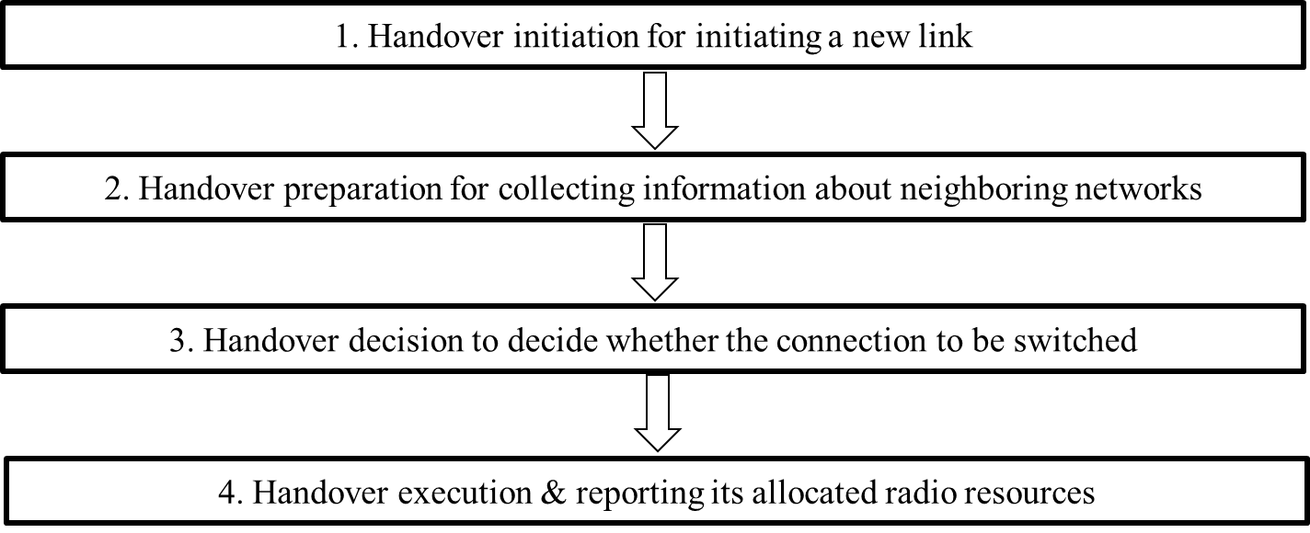
Figure 3—Stages for seamless handover in SDMNs

      - Signal flows
Handover triggers generated by the link layer are exploited by the MISF incorporated in the PoAs to make easy vertical handover. This procedure has the four phases described in previous Session (Handover Initiation, Handover preparation, Handover decision and Handover execution). Handover initiation starts from the link corruption detection until the request for initiating a new link. Handover preparation consists of all steps of link measurements, collection of information about neighboring networks, and exchange of information about QoS offered by these networks. Handover decision is the process executed in the PoA Controller to make decision on behalf of mobiles users towards which network to be selected for handover. Signal flows for handover procedure is shown in Fig. 4.
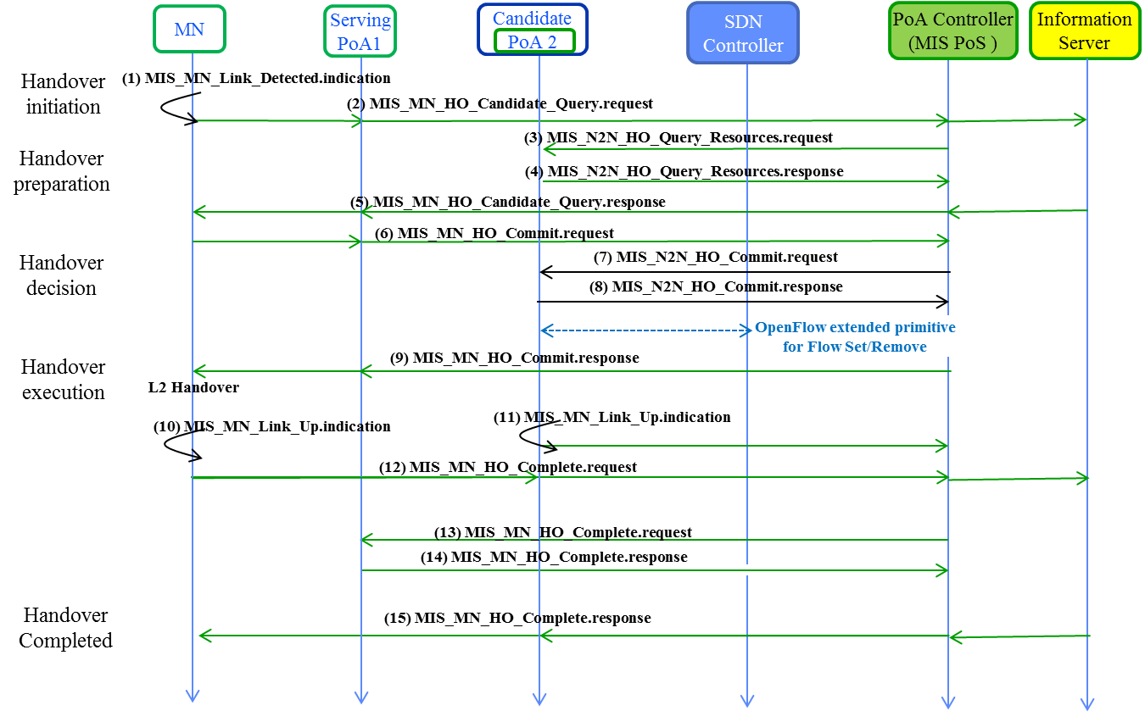
Figure 4—Signal flows for handover procedure

        - Stage 1: Handover Initiation
In the handover initiation phase, the PoA 1 extracts context information of both attached users and neighboring radio access networks from MIS_MN_Link_Detected_indication (Fig. 4 (1)). As mentioned in previous Section, this context will be stored in the PoA 1. The MISF in PoA 1 interacts with the Information Server and the PoA Controller at the access network to exchange network context information by MIS_MN_HO_Candidate_Query.Request and MIS_MN_HO_Candidate_Query.Response (Fig. 4 (2) and (5)), and generates handover policies. These policies can activate or trigger the handover. As well as link layer events originated from MN and policy exchange events, the degradations of application QoS metrics may also generate handover triggers.
Editor note: the detailed procedure will be added in the future.
- —Link events
Link event name | Link event type | Description | Defined in
Link_Detected | State change | Link of a new access network has been detected.  This event is typically generated on the MN when  the first PoA of an access network is detected. This  event is not generated when subsequent PoAs of the  same access network are discovered. | 7.3.1  IEEE 802.21 2008

- —MIS events
MIS event name | (L) ocal  (R) emote | Description | Defined  in
MIS_Link_Detected | L, R | Link of a new access network has been detected.  This event is typically generated on the MN when  the first PoA of an access network is detected.  This event is not generated when subsequent  PoAs of the same access network are discovered. | 7.3.6  IEEE 802.21 2008
- —Link commands
Link command | Description | Defined  in
Link_Capability_Discover | Query and discover the list of supported link-layer events and link-layer commands. | 7.3.9 IEEE 802.21 2008

- —MIS commands
MIS command | (L) ocal,  (R) emote | Description | Defined  in
MIS_MN_HO_Candidate_Query | R | Command used by MN to query and obtain handover related information about possible candidate networks. | 7.4.18 IEEE 802.21 2008

        - Stage 2: Handover Preparation
Before PoA allocates new radio resources, MN needs to prepare changing its connection with newly allocated radio resources of PoA that MN connects. PoA controller (i.e., MIS PoS) exchanges MIS_N2N_HO_Query_Resource.request and MIS_N2N_HO_Query_Resource.response messages, with both the serving and candidate PoAs. At first, The PoA Controller (MIS PoS) sends MIS_N2N_HO_Query_Resource.request message (Fig. 4 (3)) to the candidate PoA (PoA 2) asking for resource available information (resource availability) concerning the status of an active RAN. The candidate PoA responds with a MIS_HO_Query_Resource.response message (Fig. 4 (4)) to this request. A list of available resources including QoS requirements is available at the PoAs, and one or more candidate RAN can be selected. The network context information and handover policies are extracted from the PoA Controller (MIS PoS) and Information Server at the core network by applying the MIS_ N2N_HO_Query_Resource.response message primitives. MN can receive information on new radio resources from the PoA Controller or PoA that MN connects to before performing radio resource allocation.
Editor note: the detailed procedure will be added in the future.
- —Link commands
Link command | Description | Defined  in
Link_Capability_Discover | Query and discover the list of supported link-layer events and link-layer commands. | 7.3.9 IEEE 802.21 2008

- —MIS commands
MIS command | (L) ocal,  (R) emote | Description | Defined  in
MIS_N2N_HO_Query_Resources | R | This command is sent by the serving MISF entity to the target MIHF entity to allow for resource query. | 7.4.19 IEEE 802.21 2008

        - Stage 3: Handover Decision
In this stage, one or more candidate RANs can be selected. Until now the MISFs of all entities implicated in the handover are informed, the resource availability control of the candidate radio access networks (RANs) is performed, and the PoA Controller (MIS PoS) exchanges MIS_N2N_HO_Query_Resource.request and MIS_N2N_HO_Query_Resource.response messages, with both the serving and candidate PoAs. Thus, RANs and MN have enough information about the neighboring networks to make a handover decision based on policies and multi-criteria of decision in either MN or network centric approach.
After executing the selection mechanism and determining the preferred candidate target radio access network, MN requests PoA 1 to prepare connection with newly allocated radio resources by using MIS_MN_HO_Commit.request and MIS_MN_HO_Commit.response messages, as shown in Fig. 4. The MIS_MN_HO_Commit.request message (Fig. 4 (6)) will be forwarded to the PoA Controller (MIS PoS), that includes information on MN’s newly allocated radio resources (e.g., frequency band and transmit power). The PoA 2 can be requested to prepare connection with new radio resources by MIS_N2N_HO_Commit.request (Fig. 4 (7)) from the PoA Controller (MIS PoS). PoA 2 can reply to the PoA Controller (MIS PoS) by sending MIS_N2N_HO_Commit.response (Fig. 4 (8)) to prepare connection with newly allocated resources. The PoA Controller (MIS PoS) can respond to PoA 1 by sending MIS_MN_HO_Commit.response message (Fig. 4 (9)) to prepare connection with newly allocated resources and PoA 1 itself can allocate its radio resources.
Editor note: the detailed procedure will be added in the future.
- —Link commands
Link command | Description | Defined  in
Link_Capability_Discover | Query and discover the list of supported link-layer events and link-layer commands. | 7.3.9 IEEE 802.21 2008

- —MIS commands
MIS command | (L) ocal,  (R) emote | Description | Defined  in
MIS_MN_HO_Commit | R | Command used by MN to notify the serving network of the decided target network information | 7.4.20 IEEE 802.21 2008
MIS_N2N_HO_Commit | R | Command used by a serving network to inform a target network that an MN is about to move toward that network, initiate context transfer (if applicable), and perform handover preparation. | 7.4.22 IEEE 802.21 2008

        - Stage 4: Handover Execution
After radio link has been activated, PoA 2 should report its updated radio resources to other network entities such as neighboring PoA, PoA Controller, and Information Server, as shown in Fig. 4 (11). They include parameters that represent updated radio resources of PoA 2.
When the MN moves its attachment from a previous PoA (PoA 1) to a new PoA (PoA 2), to preserve connectivity to the corresponding PoA, two types of messages, MIS_MN_HO_Complete.request and MIS_MN_HO_Complete.response (Fig. 4 (12) and (15)) are exchanged between PoA 2 and the PoA Controller (MIS PoS), which are incorporated with PoA 1 (Fig. 4 (13) and (14)). The handover procedure is completed when MN receives MIS_MN_HO_Complete.response (Fig. 4 (15)) from PoA 2.
Editor note: the detailed procedure will be added in the future.
- —Link commands
Link command | Description | Defined  in
Link_Action | Request an action on a link-layer connection. | 7.3.14 IEEE 802.21 2008

- —MIS commands
MIS command | (L) ocal,  (R) emote | Description | Defined  in
MIS_MN_HO_Complete | R | Notification from MIHF of the MN to the target or source MIHF indicating the status of handover completion. | 7.4.23 IEEE 802.21 2008

    - Service specific primitives

      - MIS_SAP primitives

      - MIS_LINK_SAP primitives

    - Service specific protocol features

      - MIS protocol messages for command service

