Project | IEEE 802.21.1 Media Independent Services  <http://www.ieee802.org/21/>
Title | Proposed Text of “D2D Communications Service” Section for IEEE 802.21.1 Draft Standard
DCN | 21-14-0159-00-SAUC
Date Submitted | Oct. 31, 2014.
Source(s) | Hyeong-Ho Lee (ETRI), Hyunho Park (ETRI), Myung-Ki Shin (ETRI), Jin Seek Choi (Hanyang University, Korea Ethernet Forum)
Re: | IEEE 802.21 Session #65 in San Antonio, TX, USA
Abstract | According to the “Proposed Table of Contents for IEEE 802.21.1 Draft Standard” (21-14-0113-01-SAUC), this document proposes text of “D2D Communication Service” Section for IEEE 802.21.1 Draft Standard.
Purpose | To be part of 802.21.1 draft standard document.
Notice | This document has been prepared to assist the IEEE 802.21 Working Group. It is offered as a basis for discussion and is not binding on the contributing individual(s) or organization(s). The material in this document is subject to change in form and content after further study. The contributor(s) reserve(s) the right to add, amend or withdraw material contained herein.
Release | The contributor grants a free, irrevocable license to the IEEE to incorporate material contained in this contribution, and any modifications thereof, in the creation of an IEEE Standards publication; to copyright in the IEEE’s name any IEEE Standards publication even though it may include portions of this contribution; and at the IEEE’s sole discretion to permit others to reproduce in whole or in part the resulting IEEE Standards publication. The contributor also acknowledges and accepts that IEEE 802.21 may make this contribution public.
Patent Policy | The contributor is familiar with IEEE patent policy, as stated in Section 6 of the IEEE-SA Standards Board bylaws <http://standards.ieee.org/guides/bylaws/sect6-7.html#6> and in Understanding Patent Issues During IEEE Standards Development http://standards.ieee.org/board/pat/faq.pdf
Table of Contents

5.5 D2D communications service 3
5.5.1 Introduction 3
5.5.2 Service scenarios and call flows 3
5.5.3 Service specific primitives 13
5.5.4 Service specific protocol features 15

  - D2D communications service
    - Introduction
Device-to-device (D2D) communication is direct data communication between mobile nodes (MNs) and attracts attentions in perspective of network resource management and communication service based on proximity. Applications of D2D communications can be social networking, advertisement, public safety, data sharing, and data offload.
For D2D communication, media independent service (MIS) framework of IEEE 802.21 standard is able to help an MN to search for and connect to its peer. MIS framework of IEEE 802.21 standard is common platform to support interworking between networks using IEEE802 and non-IEEE802 technologies, so that MIS framework can be easily extended to a platform for D2D communications such as Wi-Fi Direct, 3GPP proximity service (ProSe), and IEEE 802.15.8 peer aware communication (PAC).
The MIS framework can apply to D2D communication with or without assistance of network entities such as a base station or an access point. For D2D communication with network assistance, network entities with MIS framework provide configuration information for an MN to discover its peer and control D2D connections of MNs. For D2D communication without network assistance, MNs with MIS framework can find and select the most appropriate D2D technology that can offer the best quality of service (QoS) or quality of experience (QoE).
This section introduces discovery and connection for D2D communication based on MIS, and includes methods and signaling for supporting discovery and connection for D2D communication based on MIS.

    - Service scenarios and call flows
      - D2D communication with network assistance
Communication service providers and network operators have interest in D2D communication because D2D communication can provide communication between MNs in close proximity with a small amount of network resource. By using D2D communication, MNs in close proximity can share data such as video clips or local information. Service providers of D2D communication can distribute local advertisement information or emergency information such as location of emergency shelters. Network operators can save network resources by offloading data to D2D communication. In addition, MNs can maintain privacy even though while performing social networking. For making a connection for D2D communication, it is difficult for an MN to discover its peer that is able to offer communication services (e.g., data sharing, local advertisement and emergency information) that the MN wants to receive.
Communication service providers and network operators will help an MN to search for and connect to its peer by assistance of network infrastructures. The D2D communication with network assistance can be called as network-assisted D2D communication (NADC).
MIS framework, which is control plane of infrastructure network, can be the control plane for NADC. MIS framework provides network configuration information for MN and controls MN’s connection to access network by using point of service (PoS) and Information Server, which are defined in IEEE 802.21 standard as network-side instance of MIS framework and server that provides network configuration information, respectively. Thus, MIS framework can provide configuration information of MN’s peer for MN and controls MN’s D2D connection with minor modification of Information Server and PoS.
        - Service flows
For NADC, both MN and NADC provider is able to initiate D2D communication. Therefore, service flows for NADC needs to be classified into MN-initiated D2D communication and NADC provider-initiated D2D communication.
- Service flows of MN-initiated D2D communication
  - MN requests information to connect with its peer to information server.
  - Information server responds to the MN with configuration information to connect with a candidate peer of the MN. The configuration information may be technology of D2D communication such as Wi-Fi Direct and PAC, identifier (e.g., MAC address and IP address) of the candidate peer, and frequency information that its candidate peer can use.
  - Based on configuration information from information server, the MN searches for and connects to its peer node.

- Service flows of NADC provider-initiated D2D communication
  - PoS of NADC provider requests information for a peer node of MN to information server.
  - Information server responds to PoS of NADC provider with configuration information to connect with a candidate peer of the MN. The configuration information may be technology of D2D communication such as Wi-Fi Direct and PAC, identifier (e.g., MAC address and IP address) of the candidate peer, and frequency information that its candidate peer can use.
  - The PoS of NADC provider sends the configuration information to the MN.
  - The MN decides whether to use D2D communication. If the MN decides to use D2D communication, the MN tries to search for and connect to its peer node by using the configuration information from PoS of NADC provider.

        - High level illustration
Figure 1 shows control signaling for NADC by using media independent service messages. Information server provides configuration information for an MN’s peer. The configuration information of information server can be requested by MNs and PoS. PoS controls MNs’ connection of D2D communication by requesting MN to select D2D communication and assigning radio resource for D2D communication. NADC provider can operate its own PoS, and PoS of NADC provider can communicate with other PoSes.
- MN’s peer can provide communication service that the MN wants to receive.
- MN and its peer should communicate by using the same D2D communication technology.
- Information server should know proximity between mobile nodes.
- Information server may derive proximity between MNs by using MNs’ location information (e.g., GPS information).
- Information server should know communication services (e.g., local information service, file transmission, and voice call) that MNs can provide.
- Information server should know D2D communication technologies that MNs can use.
- PoS controls MNs’ D2D connection and control MNs’ radio resource for D2D communication.

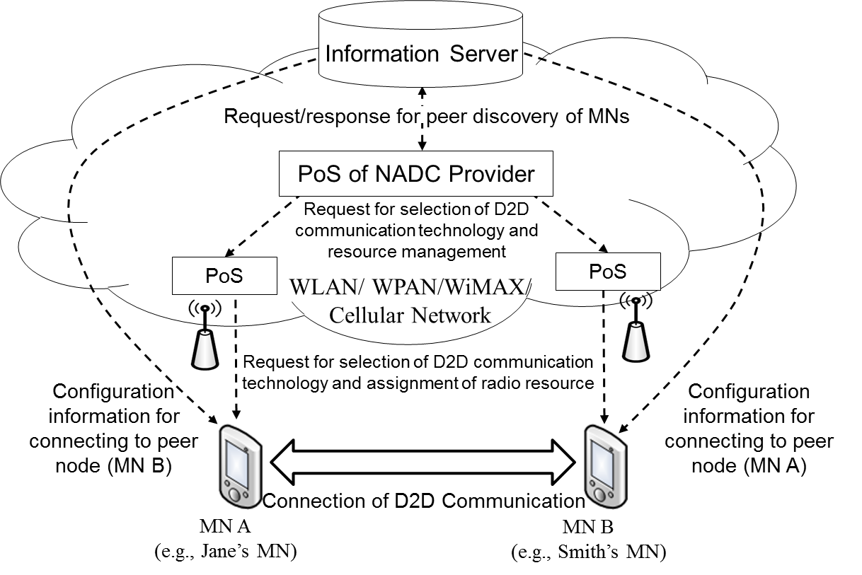
Figure 1—Control signaling of NADC.

        - Stages for NADC based on MIS Framework
NADC based on MIS framework comprises three stages as in Figure 2.
- In the first stage, D2D devices register to Information Server with their configuration information for D2D communications. The configuration information can be types of D2D technologies such as Wi-Fi Direct and 3GPP ProSe.
- In the second stage, PoS of NADC provider discovers pairs for D2D communications.
- In the third stage, PoS of NADC provider orders D2D devices to make D2D communications.

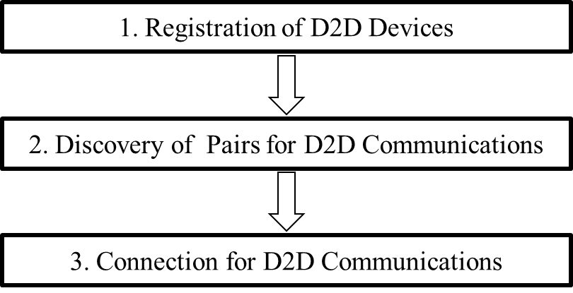
Figure 2—Stages for NADC based on MIS framework.

        - Signal flows and primitives/messages
          - Stage 1: registration of D2D devices
Information Server or PoS collects list of D2D communication technologies used by MN for MNs’ registrations to Information Server. Signal flows shown in Figure 3 are as follows.
- Information server or PoS requests list of MN’s available D2D communication technologies. (Step 1)
- MN responds with list (D2D_TechList) of MN’s available D2D communication technologies (e.g., LTE D2D, PAC, and Wi-Fi Direct). (Step 2)

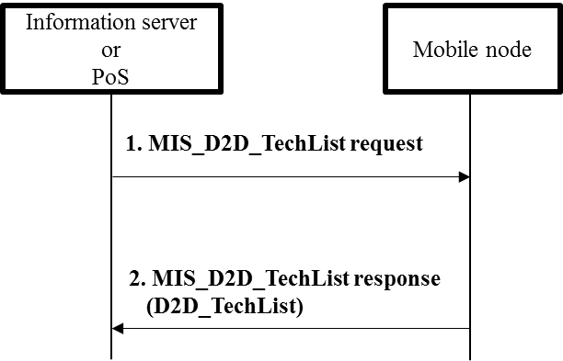
Figure 3—Registration of D2D devices with list of D2D technologies.

- New primitive/message

- —MIS_SAP primitives
Primitives/Messages | Service  category | Description | Defined  in
MIS_D2D_TechList | Command | This primitive/message is used for information server or PoS to know list of D2D communication technologies used by an MN | 5.5.2.1.4  IEEE802.21.1

- New parameter
Parameter | Description
D2D_TechList | List of D2D communication technologies used by an MN

          - Stage 2: discovery of pairs for D2D communications
Information Server provides configuration information that can help MN discover its peer. Signal flows shown in Figure 4 are as follows.
- MN informs of its location (QUERIER_LOC), communication service (QUERIER_D2D_SERVICE), and available D2D service communication (QUERIE_D2D_TECHLIST) and requests proximity service communication. (Step 1)
- Information server responds with the peer’s identity (IE_D2D_PEERID) and configuration information (IE_D2D_CONFIG) to discover the peer. (Step 2)

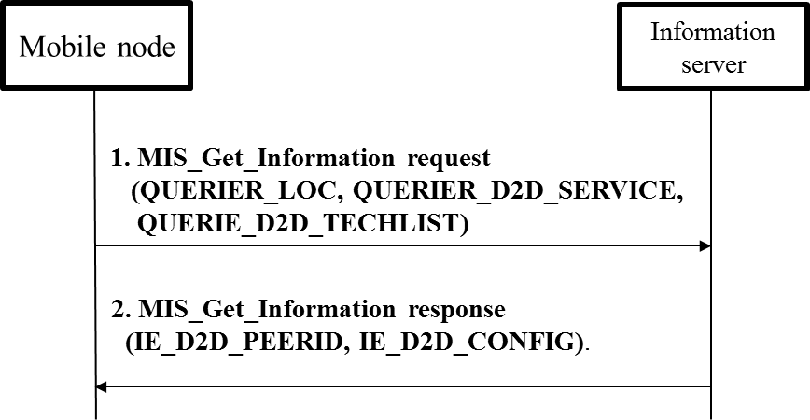
Figure 4—Registration of D2D devices with list of D2D technologies.

- —MIS_SAP primitives
Primitives/Messages | Service  category | Description | Defined  in
MIS_Get_Information | Information | Request to get information from repository | 7.4.25  IEEE802.21 Revision
- New parameters
MIH_Get_Information primitive/message and QUERIER_LOC parameter have been defined in IEEE 802.21 standard, and new parameters are defined as follows.

Name | Description
QUERIER_D2D_SERVICE | Communication services (e.g., local information service, file transmission, and voice call) that MN wants to be served
QUERIER_D2D_TECHLIST | Available proximity service communication list (e.g., LTE D2D, Wi-Fi Direct, and PAC) of the MN that wants proximity service

- New information elements
Name | Description
IE_D2D_PEERID | Peer’s identity(e.g., MAC address, IP address, and IMSI(International Mobile Subscriber Identity))
IE_D2D_CONFIG | Configuration information(e.g., frequency band) to help the MN configure its peer

          - Stage 3: connection for D2D communications
Information Server or PoS changes communication technology of MN’s D2D connection. For example, Information Server or PoS changes Wi-Fi Direct of MN’s D2D connection into IEEE 802.15.8 PAC. Signal flows shown in Figure 5 are as follows.
- Connection between MN and its peer by using D2D communication (e.g., Wi-Fi Direct): Out of Scope (Step 0)
- Information server or PoS requests MN to change its D2D communication technology into other D2D communication technology (e.g., PAC) by sending MIS_D2D_Connection request message. (Step 1)
- MN requests its peer to change its D2D communication into other D2D communication technology (e.g., PAC) by sending MIS_D2D_Connection request message. (Step 2)
- Changing D2D connection between MN and its peer by using other D2D communication (e.g., PAC): Out of Scope (Step 3)
- MN’s peer responds to MN with connection result (success or fail) by sending MIS_D2D_Connection response message. (Step 4)
- MN responds to information server or PoS with connection result(success or fail) by sending MIS_D2D_Connection response message. (Step 5)

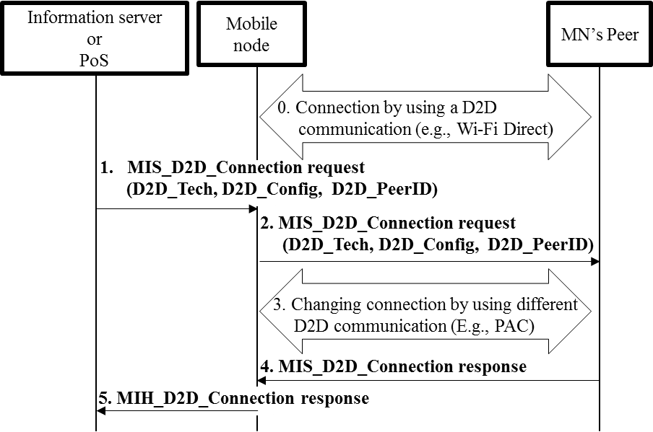
Figure 5—Connection for D2D communications.
- New primitive/message
- —MIS_SAP primitives
Primitives/Messages | Service  category | Description | Defined  in
MIS_D2D_Connection | command | This primitive/message is used for an MN and its peer to make a connection of D2D communication technology. | 5.5.2.1.4  IEEE802.21.1

- New parameters
Parameter | Description
D2D_Tech | Information of proximity service communication technologies that MN or its peer can use
D2D_Config | Configuration information(e.g., frequency band) to help the MN configure its peer
D2D_PeerID | Peer’s identity(e.g., MAC address, IP address, and IMSI)

      - D2D communication without network assistance

Various technologies for D2D communication have been developed recently. Smart devices such as smartphones and tablet PCs already implement Wi-Fi Direct. Future smart devices may implement developing technologies of D2D communication technologies such as 3GPP ProSe and PAC. For future smart devices, it is important for the smart devices to select the most appropriate technology of D2D communication that can support the best QoS or QoE.
By using D2D communication, smart MNs in close proximity can directly share data such as video clips or local information without network assistance. D2D communication can serve local advertisement information or emergency information such as location of emergency shelters.
MIS framework will support MNs to select appropriate technology of D2D communication without any network assistance. Existing MIS framework can enable MNs to monitor link status, which is status (e.g., signal strength and data rate) of physical layer and data link layer by using media independent event service (MIES) and can select the most appropriate access network by using media independent service (MICS) even without network assistance. Therefore, if MIES and MICS are extended for supporting D2D communication, it will be possible for MNs to monitor link status of D2D communications and select the most appropriate technology of D2D communication without network assistance.

        - Service Flows
Jane is user of an MN that supports D2D communication. Smith is user of a peer node of Jane’s MN
- Jane’s MN and Smith’s MN transfers data through D2D communication “P” (e.g., Wi-Fi Direct).
- Jane’s MN detects that link status (e.g., signal strength and data rate) of D2D communication “P” is getting worse due to some reason such as radio interference.
- Jane’s MN discovers the most appropriate D2D communication “Q” (e.g., PAC) that is different from D2D communication “P” by monitoring link status of “Q.”
- Jane’s MN requests Smith’s MN to change D2D communication “P” into D2D communication “Q.”
- Jane’s MN and Smith’s MN make a connection by using D2D communication “Q.”
- Jane’s MN and Smith’s MN can transfer data through D2D communication “Q.”

        - High level illustration
Figure 6 shows control signaling for D2D communication without network assistance. The service flows are explained specifically in “5.5.2.2.1 Service flows.”
- MN’s peer can provide communication service that the MN wants to be served.
- MN and its peer should communicate by using the same D2D service communication technology.
- MN can monitors link status of D2D communication.
- MN and its peer can change their D2D communication technology without any network assistance.

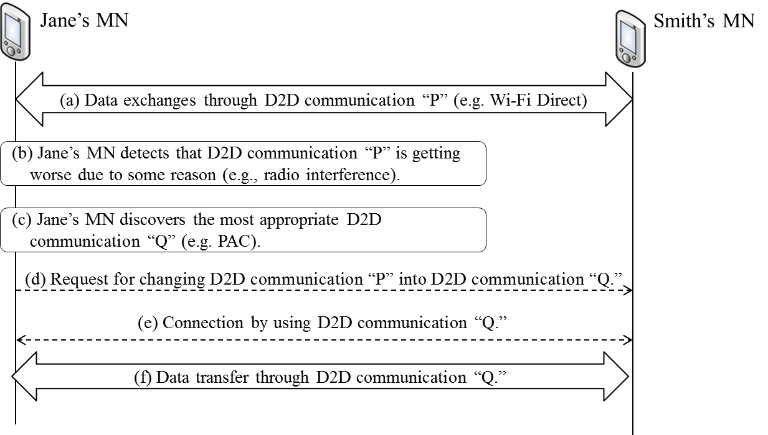
Figure 6—Control signaling of D2D communication without network assistance.

        - Signal flows and primitives/messages
          - Changing connection of D2D communication
MN changes communication technology of its D2D connection depending on its link status. For example, MN changes Wi-Fi Direct of MN’s D2D connection into IEEE 802.15.8 PAC depending on its link status. Signal flows shown in Figure 7 are as follows.
- Connection between MN and its peer by using D2D communication (e.g., Wi-Fi Direct): Out of Scope (Step 0)
- MN monitors its link status of current D2D communication technology and determines to change D2D communication technology into other D2D communication technology. (Step 1)
- MN requests its peer to change its D2D communication into different D2D communication technology (e.g., PAC) by sending MIS_D2D_Connection request message. (Step 2)
- Changing connection between MN and its peer by using other proximity service communication (e.g., PAC): Out of Scope (Step 3)
- MN’s peer responds to MN with connection result (success or fail) by sending MIS_D2D_Connection response message. (Step 4)

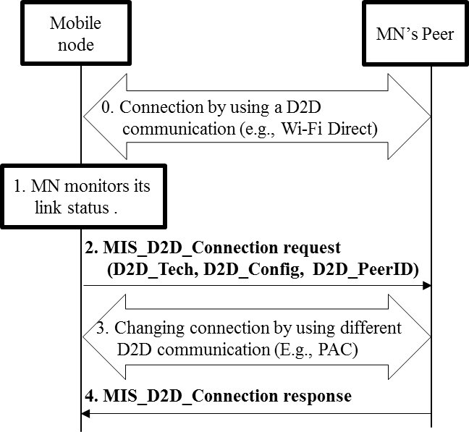
Figure 7—Changing connection of D2D communication.

- New primitive/message
MIS_D2D_Connection primitive/message is explained in “5.5.2.1.4.3 Stage 3: connection for D2D communications.”
- New parameters
D2D_Tech, D2D_Config, and D2D_PeerID are explained in “5.5.2.1.4.3 Stage 3: connection for D2D communications.”

    - Service specific primitives

      - MIS_SAP primitives

        - MIS_D2D_TechList
          - MIS_ D2D_TechList.request
          - MIS_ D2D_TechList.confirm
          - MIS_ D2D_TechList.indication
          - MIS_ D2D_TechList.response

        - MIS_D2D_Connection
          - MIS_D2D_Connection.request
          - MIS_D2D_Connection.confirm
          - MIS_D2D_Connection.indication
          - MIS_D2D_Connection.response

      - MIS_Get_Information
* Parameters and information elements will be added for D2D communication service.

      - MIS_LINK_SAP primitives

        - Link_D2D_TechList
          - Link_D2D_TechList.request
          - Link_D2D_TechList.confirm
          - Link_ D2D_TechList.indication
          - Link_ D2D_TechList.response

      - Link_D2D_Connection
          - Link_D2D_Connection.request
          - Link_D2D_Connection.confirm
          - Link_D2D_Connection.indication
          - Link_D2D_Connection.response

    - Service specific protocol features

      - MIS protocol messages for command service

        - MIS_D2D_TechList
          - MIS_ D2D_TechList request
          - MIS_ D2D_TechList indication
          - MIS_ D2D_TechList response

      - MIS_D2D_Connection
          - MIS_D2D_Connection request
          - MIS_D2D_Connection indication
          - MIS_D2D_Connection response

      - MIS protocol messages for information service

        - MIS_Get_Information
* Parameters and information elements will be added for D2D communication service.

