Project | IEEE 802.21.1 Media-Independent Service and Use Cases  <http://www.ieee802.org/21/>
Title | Media Independent Service for Radio Resource Management in Heterogeneous Networks
DCN | 21-14-0079-00-SAUC
Date Submitted | May 11th, 2014.
Source(s) | Hyunho Park (ETRI), Hyeong-Ho Lee (ETRI), Myung-Ki Shin (ETRI), Jin Seek Choi (Hanyang University, Korea Ethernet Forum)
Re: | IEEE 802.21 Session #62 in Hawaii, U.S.
Abstract | This document describes detailed use case and requirements on media independent service for resource management in heterogeneous networks, which is the revised version of the document “Use Case and Requirements on Media Independent Service for Radio Resource Management in Heterogeneous Networks” (DCN: 21-14-0040) that was presented in the March 2014 IEEE 802 plenary meeting.
Purpose | To be part of 802.21.1 technical requirements document.
Notice | This document has been prepared to assist the IEEE 802.21 Working Group. It is offered as a basis for discussion and is not binding on the contributing individual(s) or organization(s). The material in this document is subject to change in form and content after further study. The contributor(s) reserve(s) the right to add, amend or withdraw material contained herein.
Release | The contributor grants a free, irrevocable license to the IEEE to incorporate material contained in this contribution, and any modifications thereof, in the creation of an IEEE Standards publication; to copyright in the IEEE’s name any IEEE Standards publication even though it may include portions of this contribution; and at the IEEE’s sole discretion to permit others to reproduce in whole or in part the resulting IEEE Standards publication. The contributor also acknowledges and accepts that IEEE 802.21 may make this contribution public.
Patent Policy | The contributor is familiar with IEEE patent policy, as stated in Section 6 of the IEEE-SA Standards Board bylaws <http://standards.ieee.org/guides/bylaws/sect6-7.html#6> and in Understanding Patent Issues During IEEE Standards Development http://standards.ieee.org/board/pat/faq.pdf

Contents List
1. Description 3
2. Actors 3
3. Pre-conditions 4
4. Triggers 4
5. Stages for radio resource Allocations 5
6. Post-conditions 5
7. High Level Illustration 5
8. Signal Flows 7
8.1 Stage 1: Decision of PoA’s Radio Resource Allocation 7
8.1.1 Decision by PoA based on Link Status of PoA 7
8.1.2 Decision by PoA based on Link Status of MN 8
8.1.3 Decision by PoA based on Reports from Neighboring PoA 9
8.1.4 Decision by PoA based on Configuration Information from Information Server 11
8.1.5 Decision by Access Controller based on Reports from PoAs 12
8.1.6 Decision by Access Controller based on Configuration Information from Information Server 14
8.2 Stage 2: Preparation of MN’s Connection with Newly Allocated Radio Resources 16
8.2.1 Request for Preparation of MN’s Connection from PoA 16
8.2.2 Request for Preparation of MN’s Connection from Access Controller 17
8.3 Stage 3: Allocation of PoA’s Radio Resources 18
8.3.1 PoA’s Radio Resource Allocation by PoA 18
8.3.2 PoA’s Radio Resource Allocation by Access Controller 19
8.4 Stage 4: Report of PoA’s Allocated Radio Resources 20
9. Requirements 22
10. Relationship with IEEE 802.11ax HEW (High Efficiency WLAN) 22

- Description
In recent days, networks with various communication technologies have appeared, interferences between wireless access networks have increased, and thus resource management in heterogeneous networks is needed. For example, 2.4GHz band is used by WLAN devices and WPAN devices such as Bluetooth devices, and 5GHz band is used by WLAN devices and cordless phones. Moreover, 5GHz band is considered for use of LTE (Long Term Evolution) technology, and therefore interference in 5GHz band is expected to increase.
Media independent services framework of IEEE 802.21-2008 standard can be a common platform to support resource management in heterogeneous networks. Media independent services framework of IEEE 802.21-2008 standard supports seamless handover in heterogeneous networks by using MIES (Media Independent Event Service), MICS (Media Independent Command Service), and MIIS (Media Independent Information Service). MIES primitives and messages help MN (Mobile Node) to monitor link status (e.g., signal strength and data rate), and MICS primitives and messages helps MN to control its link layers (physical layer and data link layer) for seamless handover in heterogeneous networks. It is possible to expect that Media Independent Services Framework enables MN to monitor link status and control radio resources (e.g., frequency, time, and power) for radio resource management. MIIS primitives and messages are used to transfer network configuration information for handover in heterogeneous networks, and thus they can be used to provide network configuration for radio resource allocations in heterogeneous networks. Thus, media independent services framework is appropriate for resource management in heterogeneous networks that use various communication technologies and various frequency bands.

- Actors
- MN(Mobile Node)-A: A user device, such as a smart phone, which equips radio interfaces of multiple radio access technologies
- PoA-A: The PoA (Point of Attachment), such as base station in cellular networks and access point in WLAN, which is a network entity that establishes link connection with the MN
- PoA-B: PoA-A’s neighboring PoA that can interfere with MN or PoA-A
- AC (Access Controller): A network entity that can manage radio resources of PoA-A
- Information Server: A server that manages configuration information on PoAs’ radio resource allocations

- Pre-conditions
- MN and PoA-A are connected with each other.
- MN and PoA-A may interfere with other devices or network entities that use the same frequency band.
- MN can report its link status to PoA-A.
- PoA-B can report its link status and its allocated radio resources to PoA-A and AC.
- AC can monitor radio resources of PoA-A and PoA-B.
- AC may control network access of MN.
- AC can be implemented as MIS (Media Independent Services) PoS (Point of Service).
- PoA-A can manage its radio resources by itself.

- Triggers
PoA-A is able to trigger radio resource management of its own link based on monitored link status by MN, itself, or PoA-B. AC is also able to trigger radio resource management of PoA-A’s link.
- PoA-A may manage its own radio resources based on its own link status.
- PoA-A may manage its own radio resources based on link status of MN.
- PoA-A may manage its own radio resources based on link status or resource allocations of PoA-B.
- PoA-A may manage its own radio resources based on configuration information from Information Server.
- AC may request radio resource management of PoA-A based on link status or resource allocations of PoAs(e.g., PoA-A and PoA-B) that is managed by AC.
- AC may request radio resource management of PoA-A based on configuration information from Information Server.
- Stages for radio resource Allocations
Radio resource allocation of radio access network comprises four stages as shown in Fig. 1.
- In the first stage, PoA’s radio resource allocation is decided by PoA or Access Controller based on PoA’s link status or radio resource allocation of PoA’s neighboring radio access networks.
- In the second stage, MN prepares to connect to radio access network with newly allocated radio resources, as shown in the second stage.
- In the third stage, PoA’s radio resources are allocated by PoA or Access Controller.
- In the last stage, PoA reports its allocated radio resources to Information Server, Access Controller, and neighboring PoAs.

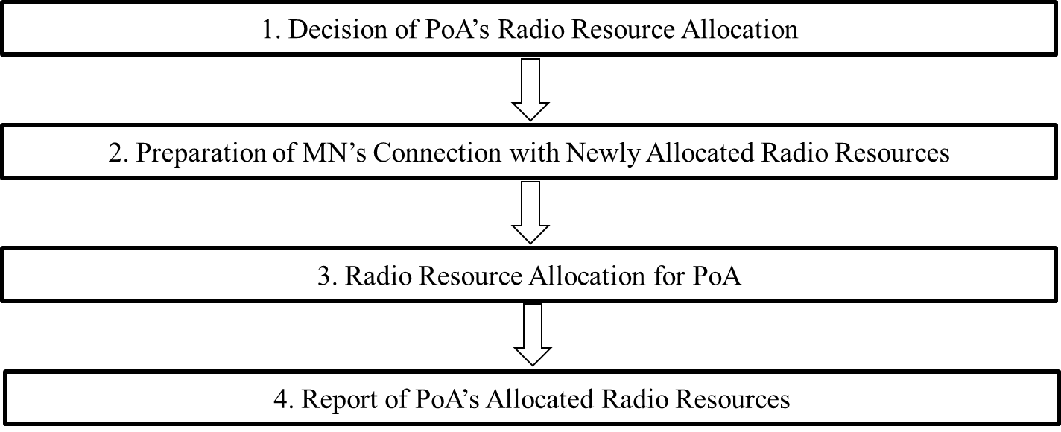
Fig. 1. Stages for radio resource allocation of radio access network

- Post-conditions
PoA-A changes its radio resource allocation.

- High Level Illustration
Figure 2 shows media independent service framework for resource management in heterogeneous networks. AC can control resources of PoAs that use various communication technologies (e.g., WLAN, Wi-Fi Direct, Bluetooth, and LTE) by using MICS message. PoAs can use different communication technologies and share its link status by using MIES message.

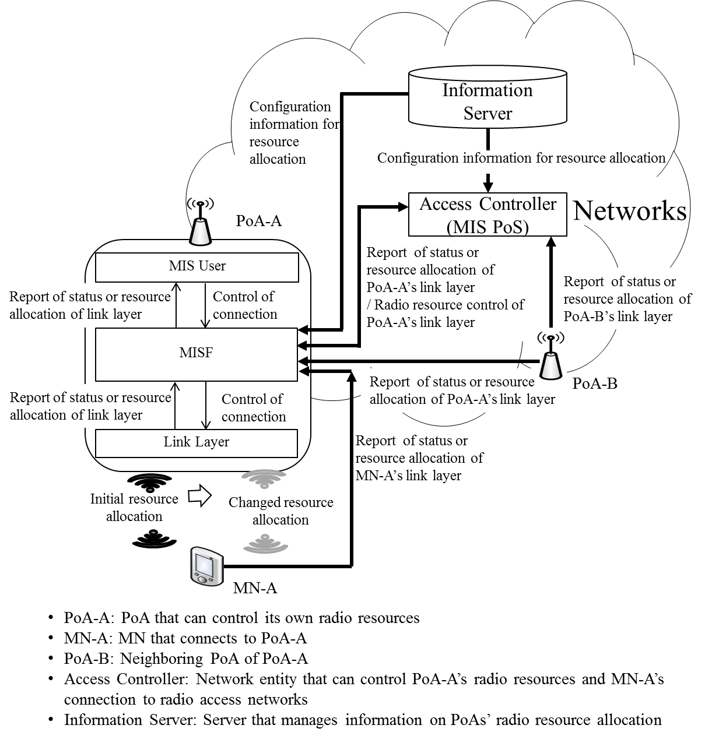
Fig. 2. Media independent service framework for resource management in heterogeneous networks.

- Signal Flows
  - Stage 1: Decision of PoA’s Radio Resource Allocation
PoA itself can decide allocation of its own radio resources. Otherwise, AC can decide radio resource allocations for PoA-A on behalf of PoA. For this stage, Link_Resource_Report and MIS_Link_Resource_Report primitives/messages are proposed as new primitives and messages.

    - Decision by PoA based on Link Status of PoA
PoA (e.g., PoA-A) can decide its radio resources based on its link status, as shown in Fig. 3. For this case Link_Parameter_Report and MIS_Link_Parameter_Report primitives in IEEE 802.21-2008 standard and messages can be used.

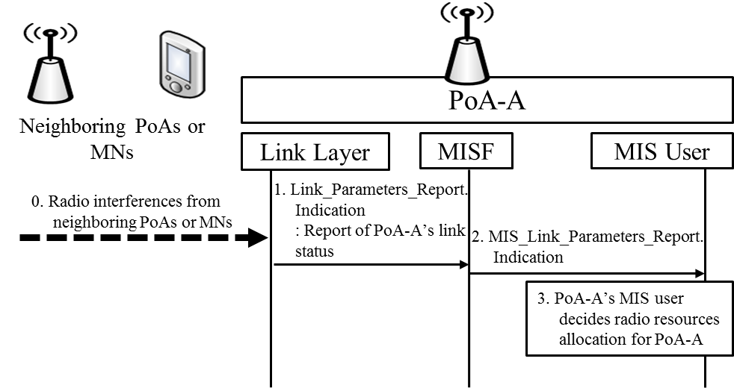
Fig. 3. PoA-A decides its radio resource allocation based on its link status.

- Neighboring PoAs or MNs may interfere with PoA-A.
- PoA-A’s link layer informs PoA-A’s MISF (Media Independent Services Function) of bad link status (e.g., low data rate) by using Link_Paramters_Report.indication primitive.
- PoA-A’s MISF informs PoA-A’s MIS user of bad link status by using MIS_Link_Parameters_Report.indication primitive.
- Based on link status, PoA-A’s MIS user determines radio resource allocation for PoA-A.

    - Decision by PoA based on Link Status of MN
PoA (e.g., PoA-A) can decide its radio resource allocation based on link status of MN. MN may experience bad link status due to some reasons (e.g., radio interference) as shown in Fig. 4. In this case, if MN (e.g., MN-A) reports its link status to PoA by using Link_Parameter_Report and MIS_Link_Parameter_Report primitives/messages in IEEE 802.21-2008 standard, PoA can allocate appropriate radio resources for MN.

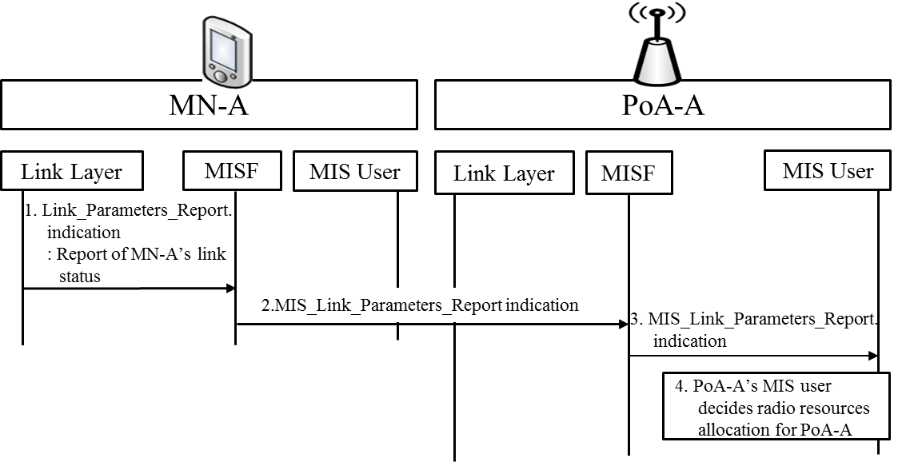
Fig. 4. PoA-A decides its radio resource allocation based on link status of MN.
- MN-A is an MN connecting to PoA-A that needs to allocate appropriate radio resources. MN-A’s link layer sends Link_Parameters_Report.indication primitive to MN-A’s MISF.
- MN-A’s MISF sends MIS_Link_Parameters_Report indication message to PoA-A’s MISF.
- PoA-A’s MISF informs PoA-A’s MISF of MN’s link status by using MIS_Link_Parameters_Report.indication primitive.
- PoA-A’s MIS user can decide its radio resource allocation based on link status of MN-A.

    - Decision by PoA based on Reports from Neighboring PoA
PoA can decide its radio resource allocations based on reports from neighbouring PoA as shown in Fig. 5. If PoA (e.g., PoA-A) and neighbouring PoA (e.g., PoA-B) use the same radio resources, they interfere with each other and need to reallocate their radio resources for improving their link status. The PoA-B is neighbouring PoA of PoA-A that needs to allocate appropriate radio resources. PoA-B can report its link status and radio resource allocation. To report information on PoA-B’s allocated radio resources (e.g., frequency bands and transmit power), Link_Resource_Report and MIS_Link_Resource_Report primitives/messages are proposed as new primitives/messages. To report PoA-B’s link status, Link_Parameters_Report and MIS_Link_Parameters_Report primitives/messages in IEEE 802.21-2008 standard are used.
- PoA-B’s link layer sends Link_Parameters_Report.indication or Link_Resource_Report.indication primitive to PoA-B’s MISF to report link status or allocated radio resources of PoA-B.
- PoA-B’s link layer sends MIS_Link_Parameters_Report indication or MIS_Link_Resource_Report indication message to PoA-A’s MISF.
- PoA-A’s MISF informs PoA-A’s MIS user of PoA-B’s link status or allocated radio resources by using MIS_Link_Parameters_Report.indication or MIS_Link_Resource_Report .indication primitive.
- PoA-A’s MIS user decides radio resource allocation for PoA-A.

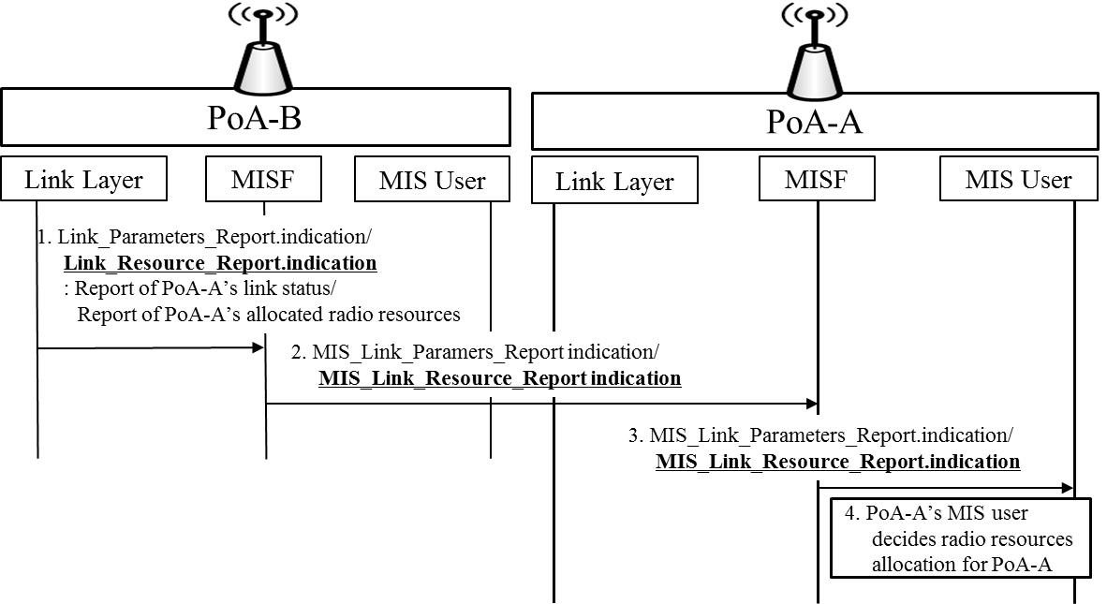
Fig. 5. PoA-A decides its radio resource allocation based on reports of PoA-B.

    - Decision by PoA based on Configuration Information from Information Server
PoA can query configuration information to Information Server, and then allocate its own radio resources based on the configuration information as shown in Fig. 6. PoA can request configuration information such as network type (e.g., IEEE 802.11 and CDMA), frequency bands, and location information of neighboring PoAs to Information Server. Based on configuration information from Information Server, PoA can allocate its own radio resources. To query configuration information, MIS_Get_Information primitives/messages that are primitives/messages in IEEE 802.21-2008 standard can be used.

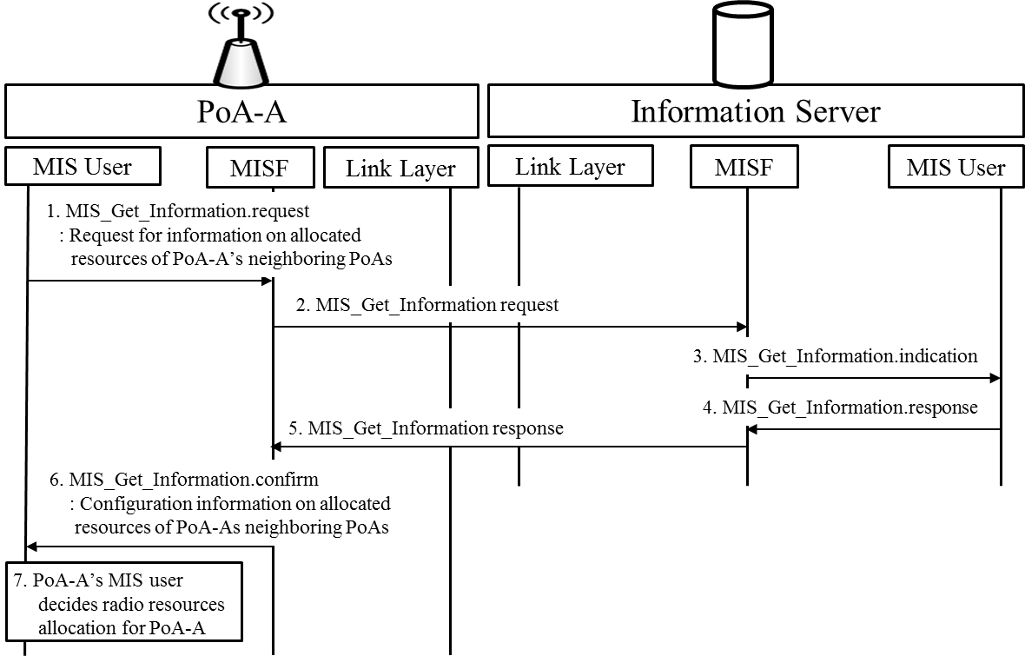
Fig. 6. PoA-A decides its radio resource allocation based on configuration information from Information Server.

- PoA-A’s MIS user sends MIS_Get_Information.request primitive to PoA-A’s MISF for requesting information on allocated resources of PoA-A’s neighboring PoAs.
- PoA-A’s MISF sends MIS_Get_information request message to MISF of Information Server.
- MIS user of Information Server recognizes that PoA-A requests configuration information of PoAs in neighborhood with PoA-A by receiving MIS_Get_Information.indication primitive.
- MIS user of Information Server sends MIS_Get_Information.response primitive to MISF of Information Server.
- MISF of Information Server sends MIS_Get_Information response message to PoA-A’s MISF.
- PoA-A’s MIS user receives configuration information of PoA-A’s neighboring PoAs by MIS_Get_Information.confirm primitive.
- PoA-A’s MIS user decides radio resource allocation for PoA-A.
    - Decision by Access Controller based on Reports from PoAs
Access Controller also can decide radio resource allocation for PoA based on reports about link status or radio resource allocation of PoAs controlled by Access Controller, as shown in Fig. 7. The PoA-B is PoA controlled by Access Controller. PoA-B can report its link status and radio resource allocation to Access Controller, and then Access Controller can allocate radio resources for PoA-A. To report information on PoA-B’s allocated radio resources (e.g., frequency bands and transmit power), Link_Resource_Report and MIS_Link_Resource_Report primitives/messages are proposed as new primitives/messages. To report PoA-B’s link status, Link_Parameters_Report and MIS_Link_Parameters_Report primitives/messages in IEEE 802.21-2008 standard are used.

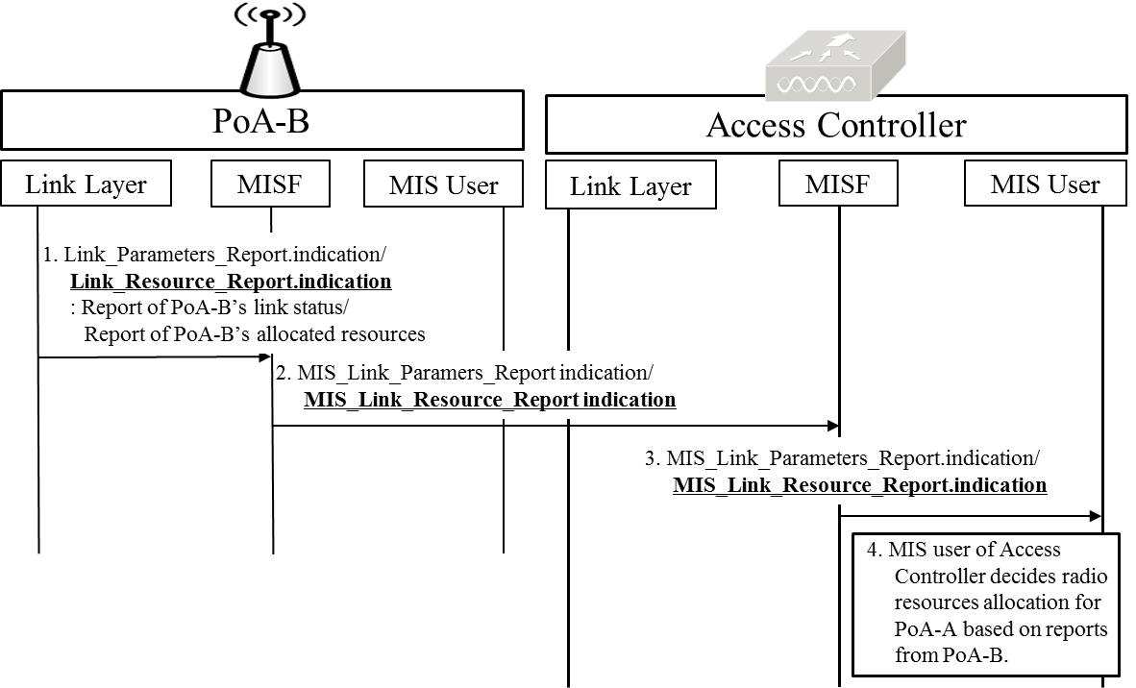
Fig. 7. Access Controller decides PoA-A’s radio resource allocation based on reports of PoA-B.

- PoA-B’s link layer sends Link_Parameters_Report.indication or Link_Resource_Report.indication primitive to PoA-B’s MISF for reporting link status or allocated resources of PoA-B.
- PoA-B’s MISF sends MIS_Link_Parameters_Report indication or MIS_Link_Resource_Report indication message to MISF of Access Controller.
- Access Controller’s MISF informs Access Controller’s MIS user of PoA-B’s link status or allocated radio resources by using MIS_Link_Parameters_Report.indication primitive, or MIS_Link_Resource_Report.indication primitive.
- MIS user of Access Controller can decide PoA-A’s radio resource allocation based on link status or radio resource allocation of PoA-B.

    - Decision by Access Controller based on Configuration Information from Information Server
Access Controller can query configuration information to Information Server, and then allocate radio resources for PoA as shown in Fig. 8. Access Controller can request configuration information such as network type frequency bands, and location information of PoAs controlled by Access Controller to Information Server. Based on configuration information from Information Server, Access Controller can allocate appropriate radio resources of PoA. To query configuration information, MIS_Get_Information primitives/messages that are primitives/messages in IEEE 802.21-2008 standard can be used.
- MIS user of Access Controller sends MIS_Get_Information.request primitive to MISF of Access Controller.
- MISF of Access Controller sends MIS_Get_information request message to MISF of Information Server.
- MIS user of Information Server recognizes that Access Controller requests configuration information of PoAs controlled by Access Controller with MIS_Get_Information.indication primitive.
- MIS user of Information Server sends MIS_Get_Information.response primitive to MISF of Information Server.
- MISF of Information Server sends MIS_Get_Information response message to MISF of Access Controller.
- MIS user of Access Controller receives configuration information of PoAs controlled by Access Controller with MIS_Get_Information.confirm primitive.
- MIS user of Access Controller decides radio resource allocation for PoA-A.

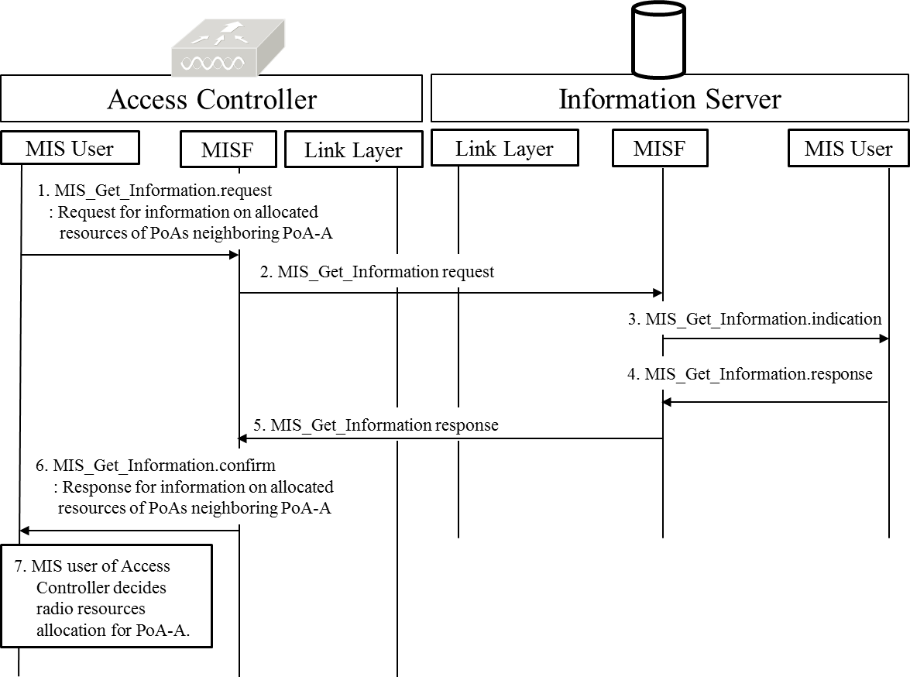
Fig. 8. Access Controller decides PoA-A’s radio resource allocation based on configuration information from Information Server.

  - Stage 2: Preparation of MN’s Connection with Newly Allocated Radio Resources
Before PoA allocates new radio resources, MN needs to prepare changing its connection with newly allocated radio resources of PoA that MN connects to. MN can receive information on new radio resources from Access Controller or PoA that MN connects to before performing radio resource allocation. For this stage, MIS_Link_Preparation primitives/messages are proposed as new primitives and messages.

    - Request for Preparation of MN’s Connection from PoA
PoA requests MN to prepare connection with newly allocated radio resources by using MIS_Link_Preparation primitives/messages that are newly proposed, as shown in Fig. 9. The primitives and messages of MIS_Link_Preparation include information on PoA’s newly allocated radio resources (e.g., frequency band and transmit power). The MN-A connects to PoA-A, and thus MN-A can be requested to prepare connection with new radio resources by PoA-A.

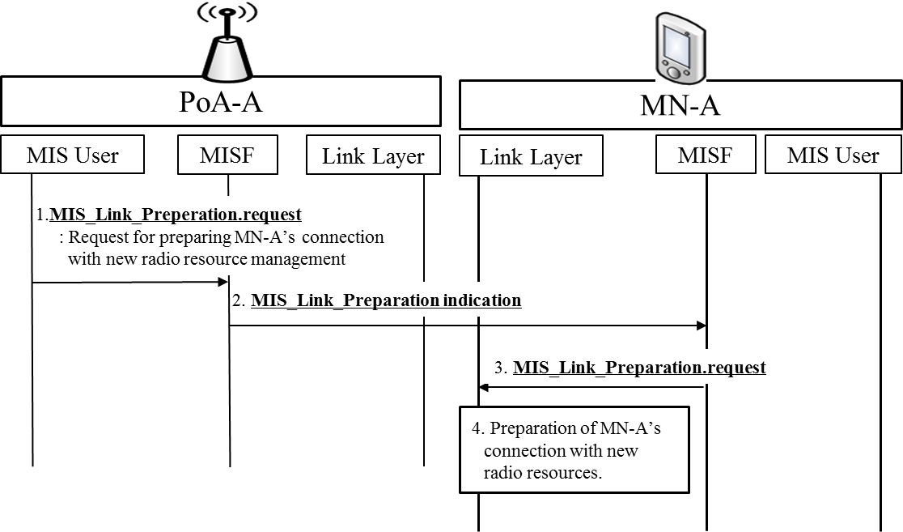
Fig. 9. PoA-A requests MN-A to prepare connection with newly allocated radio resources.
- PoA-A’s MIS user sends MIS_Link_Preperation.request primitive to PoA-A’s MISF.
- PoA-A’s MISF sends MIS_Link_Preparation indication message to MN-A’s MISF.
- MN-A’s link layer is informed of new radio resources to prepare MN’s connection by MIS_Link_Preparation.request primitive.
- MN-A’s link layer prepares the connection with new radio resources.

    - Request for Preparation of MN’s Connection from Access Controller
Access Controller also can request MN to prepare connection with newly allocated resources by using MIS_Link_Preparation primitives/messages that are newly proposed, as shown in Fig. 10.

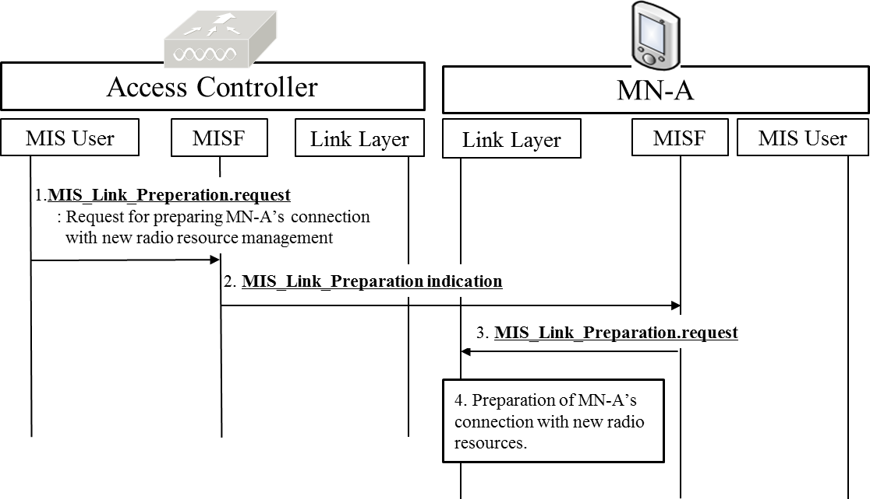
Fig. 10. Access Controller requests MN-A to prepare connection with newly allocated radio resources.

- MIS user of Access Controller sends MIS_Link_Preperation.request primitive to MISF of Access Controller.
- MISF of Access Controller sends MIS_Link_Preparation indication message to MN-A’s MISF.
- MN-A’s link layer is informed of new radio resources to prepare MN’s connection by MIS_Link_Preparation.request primitive.
- MN-A’s link layer prepares connection with new radio resources.

  - Stage 3: Allocation of PoA’s Radio Resources
In this stage, PoA’s radio resources are allocated by PoA or Access Controller. For this stage, MIS_Resource_Allocation and Link_Resource_Allocation primitives/messages are newly proposed for allocating radio resources of PoA.

    - PoA’s Radio Resource Allocation by PoA
PoA itself can allocate its radio resources, as shown in Fig. 11. MIS_Resource_Allocation.request and Link_Resource_Allocation.request primitives are new primitives for allocating radio resources and include parameters that represent radio resources (e.g., frequency band, transmit power, and time slot).
- PoA’s MIS user sends MIS_Resource_Allocation.request primitive to PoA’s MISF.
- PoA’s link layer receives information on radio resources for allocation by Link_Resource_Allocation.request primitive.
- PoA’s link layer allocates its own radio resources.
- After PoA’s link layer allocates radio resources, PoA’s link layer sends Link_Resource_Allocation.confirm primitive to PoA’s MISF.
- result of radio resource allocation is reported to PoA’s MIS user by MIS_Resource_Allocation.confirm primitive.
Link_Resource_Allocation.confirm and MIS_Resource_Allocation.confirm should include a parameter to present result (e.g., success or fail) of radio resource allocation.

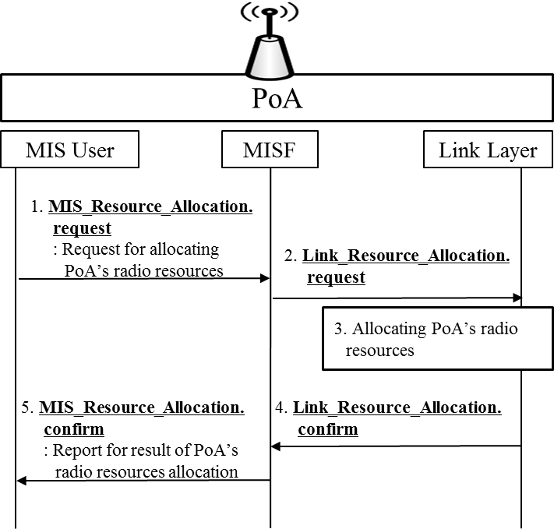
Fig. 11. PoA allocates its own radio resources.

    - PoA’s Radio Resource Allocation by Access Controller
MIS user of Access Controller can request PoA’s link layer to allocate radio resources as shown in Fig. 12. MIS_Resource_Allocation.request and Link_Resource_Allocation.request primitives are new primitives for Access Controller to allocate radio resources of PoA.
- MIS user of Access Controller sends MIS_Resource_Allocation.request primitive to MISF of Access Controller.
- MISF of Access Controller sends MIS_Resource_Allocation request message to PoA’s MISF.
- PoA’s link layer receives information on radio resources for allocation by Link_Resource_Allocation.
- PoA’s link layer allocates its own radio resources.
- PoA’s link layer sends Link_Resource_Allocation.confirm to PoA’s MISF.
- PoA’s MISF sends MIS_Response_Allocation response message to MISF of Access Controller.
- MIS user of Access Controller receives report on the result of PoA’s radio resource allocation.

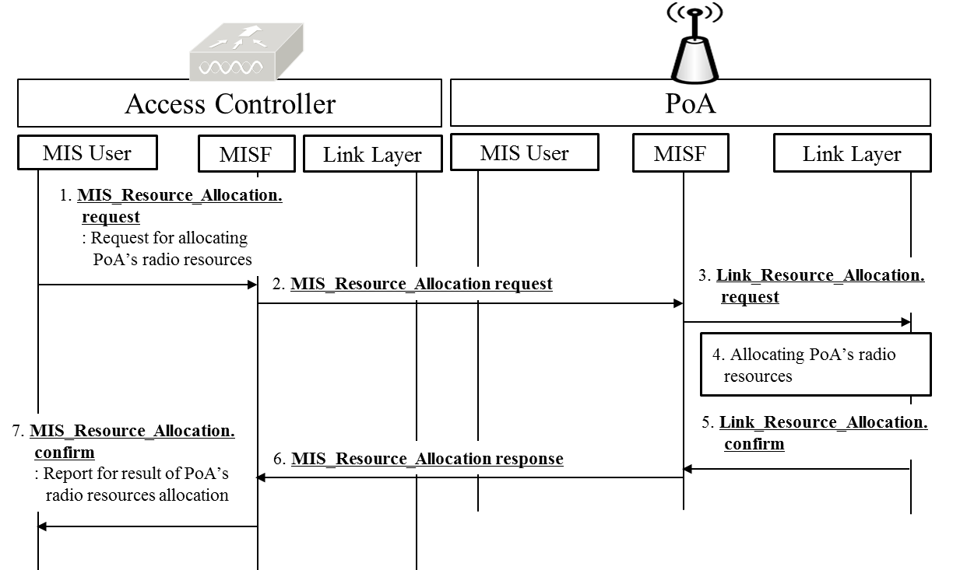
Fig. 12. Access Controller allocates radio resources for PoA.

  - Stage 4: Report of PoA’s Allocated Radio Resources
After radio resource allocation of PoA, PoA should report its updated radio resources to other network entities such as neighboring PoA, Access Controller, and Information Server, as shown in Fig. 13. MIS_Resource_Report and Link_Resource_Report are new primitives and messages for reporting PoA’s updated radio resource allocation. They include parameters that represent updated radio resources of PoA.

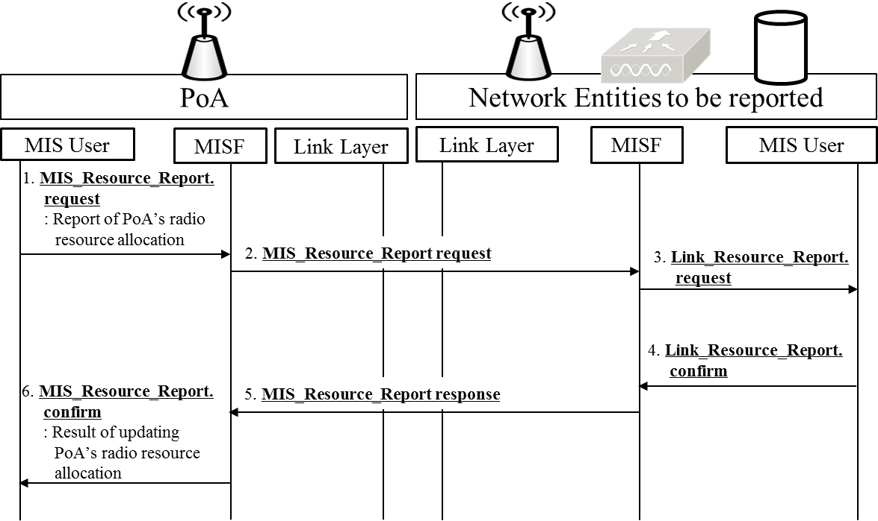
Fig. 13. PoA reports its radio resources to other its updated radio resources to other network entities.

- PoA’s MIS user sends MIS_Resource_Report.request primitive to PoA’s MISF.
- PoA’s MISF sends MIS_Resource_Report request message to MISF of other network entities (e.g., neighboring PoA, Access Controller and Information Server).
- MIS user of other network entities updates information on PoA’s radio resource allocation by Link_Resource_Report.confirm primitive.
- As response to update report, Link_Resource_Report.confirm primitive, MIS_Resource_Report response message, and MIS_Resource_Report.confirm primitive can be used. MIS user of other network entities sends Link_Resource_Report.confirm to MISF of other network entities.
- MISF of other network entities sends MIS_Resource_Report response message to PoA’s MISF.
- PoA’s MIS user is informed whether other network entities update PoA’s radio resource allocation or not by MIS_Resource_Report.confirm primitive.

- Requirements
[REQ1] MN can report its link status to PoA that MN connects to.
[REQ2] PoA can monitor its own link status.
[REQ3] PoAs can exchange their own link status between them.
[REQ4] PoA can report its link status and radio resource allocation to AC.
[REQ5] PoA can manage its own radio resources.
[REQ6] AC can manage radio resources of PoA.
[REQ7] AC may manage connection of MN.
[REQ8] Information Server can manage configuration information of radio resource allocations.

- Relationship with IEEE 802.11ax HEW (High Efficiency WLAN)
IEEE 802.11ax focuses on IEEE 802.11 physical layers (PHY) and the IEEE 802.11 Medium Access Control (MAC) layer that enable at least one mode of operation capable of supporting at least four times improvement in the average throughput per station (measured at the MAC data service access point) in a dense deployment scenario. The media independent service for radio resource management mainly focuses on radio resource management in heterogeneous networks, but is applicable for homogeneous networks that use same radio access technology. The media independent service can be one of solutions for IEEE 802.11ax HEW.

