Project | IEEE 802.21d  <http://www.ieee802.org/21/>
Title | Suggested Remedy for IEEE 802.21d Lb7b comments #58
DCN | 21-14-0075-00-MuGM
Date Submitted | April, 15th, 2014
Source(s) | Yoshikazu Hanatani, Toru Kambayashi (Toshiba)
Re: | IEEE 802.21 Session #61 in Beijing
Abstract
Purpose
Notice | This document has been prepared to assist the IEEE 802.21 Working Group. It is offered as a basis for discussion and is not binding on the contributing individual(s) or organization(s). The material in this document is subject to change in form and content after further study. The contributor(s) reserve(s) the right to add, amend or withdraw material contained herein.
Release | The contributor grants a free, irrevocable license to the IEEE to incorporate material contained in this contribution, and any modifications thereof, in the creation of an IEEE Standards publication; to copyright in the IEEE’s name any IEEE Standards publication even though it may include portions of this contribution; and at the IEEE’s sole discretion to permit others to reproduce in whole or in part the resulting IEEE Standards publication. The contributor also acknowledges and accepts that IEEE 802.21 may make this contribution public.
Patent Policy | The contributor is familiar with IEEE patent policy, as stated in Section 6 of the IEEE-SA Standards Board bylaws <http://standards.ieee.org/guides/bylaws/sect6-7.html#6> and in Understanding Patent Issues During IEEE Standards Development http://standards.ieee.org/board/pat/faq.pdf

Amend the primitives for the group manipulation commands as follows
~~~~~~~~~~~~~~~~~~~~~~~~~~~~~~~~~~~~~

      - MIH_MN_Group_Manipulate.response
        - Function
This primitive is generated by an MIH User in a PoS to acknowledge result of an MIH_MN_Group_Manipulate request from an MN.
        - Semantics of service primitive
MIH_MN_Group_Manipulate.response (
DestinationIdentifier,
TargetIdentifier,
MulticastAddress,
SubgroupRange,
UserSpecificData,
CompleteSubtree,
GroupKeyData,
GroupStatus
)
Parameters:
Name | Data Type | Description
DestinationIdentifier | MIHF_ID | Specifies the MIHF ID of the destination of the primitive.
TargetIdentifier | MIHF_ID | The target MIHF group identifier for the group operation.
MulticastAddress | TRANSPORT_ADDR | (Optional) Multicast address corresponding with the target group identifier.
SubgroupRange | SUBGROUP_RANGE | (Optional) Subgroup to process the command.ª
UserSpecificData^{b} | OCTET_STRING | (Optional) Auxiliary data.
Complement Flag | COMPLEMENT_FLAG | (Optional) Flag to indicate processing method of complete subtree data.
CompleteSubtree | COMPLETE_SUBTREE | (Optional) Complete Subtree data.
GroupKeyData | GROUP_KEY_DATA | (Optional )Encrypted group key.
GroupStatus | GROUP_STATUS | Status of the group operation.

ª SubgroupRange parameter shall be present for a fragmented GKB.
^{b} The UserSpecificData parameter can be used to convey additional information such as version information of the GKB used or additional credentials.

        - When generated
An MIH User at the PoS generates this primitive after receipt and processing of MIH_MN_Group_Manipulate request. This primitive returns the status of the action asked in the request. Optionally, it may respond with the security mechanisms required by the group.
        - Effect on receipt
MIH_MN_Group_Manipulate response message is sent back to the requester.

      - MIH_Net_Group_Manipulate.request
        - Function
This primitive is generated by the MIH User of a PoS to manipulate group membership of one or more MN(s) or other PoS(es).
        - Semantics of service primitive
MIH_Net_Group_Manipulate.request (
DestinationIdentifier,
ResponseFlag,
GroupKeyUpdateFlag,
TargetIdentifier,
MulticastAddress,
SubgroupRange,
UserSpecificData,
CompleteSubtree,
GroupKeyData
)
Parameters:
Name | Data Type | Description
DestinationIdentifier | MIHF_ID | Specifies group MIHF-ID of the remote MIHF peers. DestinationIdentifier may be different from TargetIdentifier.
ResponseFlagª | RESPONSE_FLAG | (Optional) Flag that represents whether or not a response is needed.
GroupKeyUpdateFlag | GROUP_KEY_UPDATE_FLAG | Flag that represents whether or not a group key in GroupKeyData is updated.
TargetIdentifier | MIHF_ID | The target MIHF group identifier for the group operation.
MulticastAddress | TRANSPORT_ADDR | (Optional) Multicast address corresponding with the target group identifier.
SubgroupRange | SUBGROUP_RANGE | (Optional) Subgroup to process the command
UserSpecificData | OCTET_STRING | (Optional) Auxiliary data.
Complement Flag | COMPLEMENT_FLAG | (Optional) Flag to indicate processing method of complete subtree data.
CompleteSubtree | COMPLETE_SUBTREE | Complete Subtree data.
GroupKeyData | GROUP_KEY_DATA | (Optional) Encrypted group key.

ª In case the ResponseFlag parameter is not present, the MIHF should always generate a request message, and otherwise the MIHF generates either a request or an indication message, based on the ResponseFlag parameter.
        - When generated
The MIH user generates this primitive to create, delete or modify group membership.
        - Effect on receipt
Upon receipt of this primitive, MIHF on the PoS sends the corresponding MIH_Net_Group_Manipulate indication message or MIH_Net_Group_Manipulate request message to the MN(s) or other PoS(es). The ResponseFlag TLV indicates which message shall be sent.

Amend the messages for the group manipulation commands as follows
~~~~~~~~~~~~~~~~~~~~~~~~~~~~~~~~~~~~~~~~~

      - MIH_MN_Group_Manipulate response
The corresponding MIH primitive of this message is defined in 7.4.31.3.
This message is used by the MIHF to supply the group status of MIH node(s) identified by the Source Identifier.
MIH Header Fields (SID=1, Opcode=2, AID=11 )
Source Identifier = sending MIHF ID
(Source MIHF ID TLV)
Destination Identifier = receiving MIHF ID
(Destination MIHF ID TLV)
TargetIdentifier
(Group Identifier TLV)
SequenceNumber (conditional)ª
(Sequence Number TLV)
MulticastAddress (Optional)
(Multicast Address TLV)
SubgroupRange (Optional)
(Subgroup_Range TLV)
UserSpecificData (Optional)
(Aux Data TLV)
ComplementFlag (Optional)
(Complement flag TLV)
CompleteSubtree (Optional)
(Complete Subtree TLV)
GroupKeyData (Optional)
(Group Key Data TLV)
GroupStatus
(Group Status TLV)
SecurityAssociationID (Optional)
(SAID TLV)
ª This parameter is only used in the case CCM encryption method is used and the group key is not updated.
      - MIH_Net_Group_Manipulate request
The corresponding MIH primitive of this message is defined in 7.4.32.1.
This message is used by the MIHF to manipulate group membership of MIH node(s) identified by the Destination Identifier.
MIH Header Fields (SID=1, Opcode=1, AID=12 )
Source Identifier = sending MIHF ID
(Source MIHF ID TLV)
Destination Identifier = receiving MIHF ID
(Destination MIHF ID TLV)
GroupKeyUpdateFlag
(Group Key Update Flag TLV)
TargetIdentifier
(Group Identifier TLV)
SequenceNumber (Optional)ª
(Sequence Number TLV)
MulticastAddress (Optional)
(Multicast Address TLV)
SubgroupRange (Optional)
(Subgroup Range TLV)
UserSpecificData (Optional)
(Aux Data TLV)
ComplementFlag (Optional)
(Complement flag TLV)
CompleteSubtree
(Complete Subtree TLV)
GroupKeyData (Optional)
(Group Key Data TLV)
SecurityAssociationID (Optional)
(SAID TLV)
ª This parameter is only used in the case CCM encryption method is used and the group key is not updated.
      - MIH_Net_Group_Manipulate indication
The corresponding MIH primitive of this message is defined in 7.4.32.2.
This message is used by the MIHF to manipulate group membership of MIH node(s) identified by the Destination Identifier.
MIH Header Fields (SID=1, Opcode=3, AID=12 )
Source Identifier = sending MIHF ID
(Source MIHF ID TLV)
Destination Identifier = receiving MIHF ID
(Destination MIHF ID TLV)
TargetIdentifier
(Group Identifier TLV)
GroupKeyUpdateFlag
(Group Key Update Flag TLV)
SequenceNumber (Optional)
(Sequence Number TLV)
MulticastAddress (Optional)
(Multicast Address TLV)
SubgroupRange (Optional)
(Subgroup Range TLV)
UserSpecificData (Optional)
(Aux Data TLV)
ComplementFlag (Optional)
(Complement flag TLV)
CompleteSubtree
(Complete Subtree TLV)
GroupKeyData (Optional)
(Group Key Data TLV)
SecurityAssociationID (Optional)
(SAID TLV)

Define new data type:
~~~~~~~~~~~~~~~~~~~~~~~~~~~~~~

Table F.24—Data type for security
Data type name | Derived from | Definition
COMPLEMENT_FLAG | BOOLEAN | This indicates the complete subtree specifies a complement set of group members or not.  0 (FALSE): Complete subtree specifies a set of group members  1 (TRUE): Complete subtree specifies a complement set of group members

Define new TLV:
~~~~~~~~~~~~~~~~~~

Table L.2 —Type values for TLV encoding
TLV type name | TLV type value | Data Type
ComplementFlag | 97 | COMPLEMENT_FLAG

Other modification requests:

Add explanation text on Complement Flag such as DCN 0061-01.

Change processing method of the group manipulation command
        - MIH user of a GMCS
# Modify step d)
- Define CompleteSubtree, SubgroupRange, and ComplementFlag:
  - If ComplementFlag = 0, the MIH User sends MIHF IDs of the group member, all Node Indices, and a threshold for fragmentation to the CreateCompleteSubtreeFragments procedure, and receive CompleteSubtree and SubGroupRange.
  - If ComplementFlag = 1, the MIH User sends MIHF IDs of the non-group member, all Node Indices, and a threshold for fragmentation to the CreateCompleteSubtreeFragments procedure, and receive CompleteSubtree and SubGroupRange.
  - If the CompleteSubtree is not fragmented, SubgroupRange is removed.

        - MIHF of a GMCS
# Add following step
X) If MIH_Net_Group_Manipulate.request contains a ComplementFlag, the MIHF generates a ComplementFlag TLV from the ComplementFlag.

      - Procedures for group manipulation command recipients (GMCR)
# Modify step g) to support ComplemetFlag (TBD)

- The MIHF processes the Complete Subtree TLV as described in 9.4.2.2. If the MIHF succeeds to find a matching pair of Node Indices, go to the next step. Otherwise, go to Step r).

# Add flow diagrams on the Complement Flag processing.
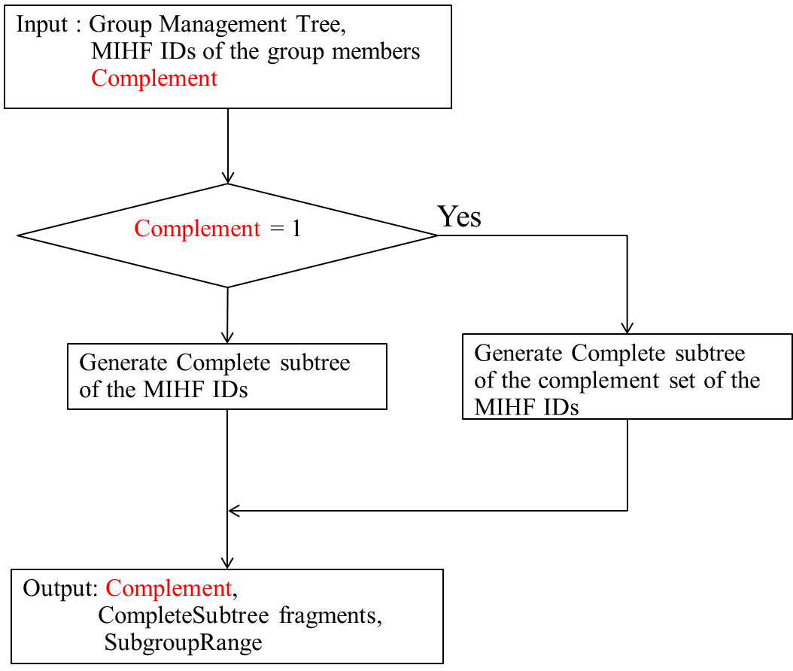
Figure X
Figure X is detail of the box of CreateCompleteSubtreeFragments Procedure in Figure 38.

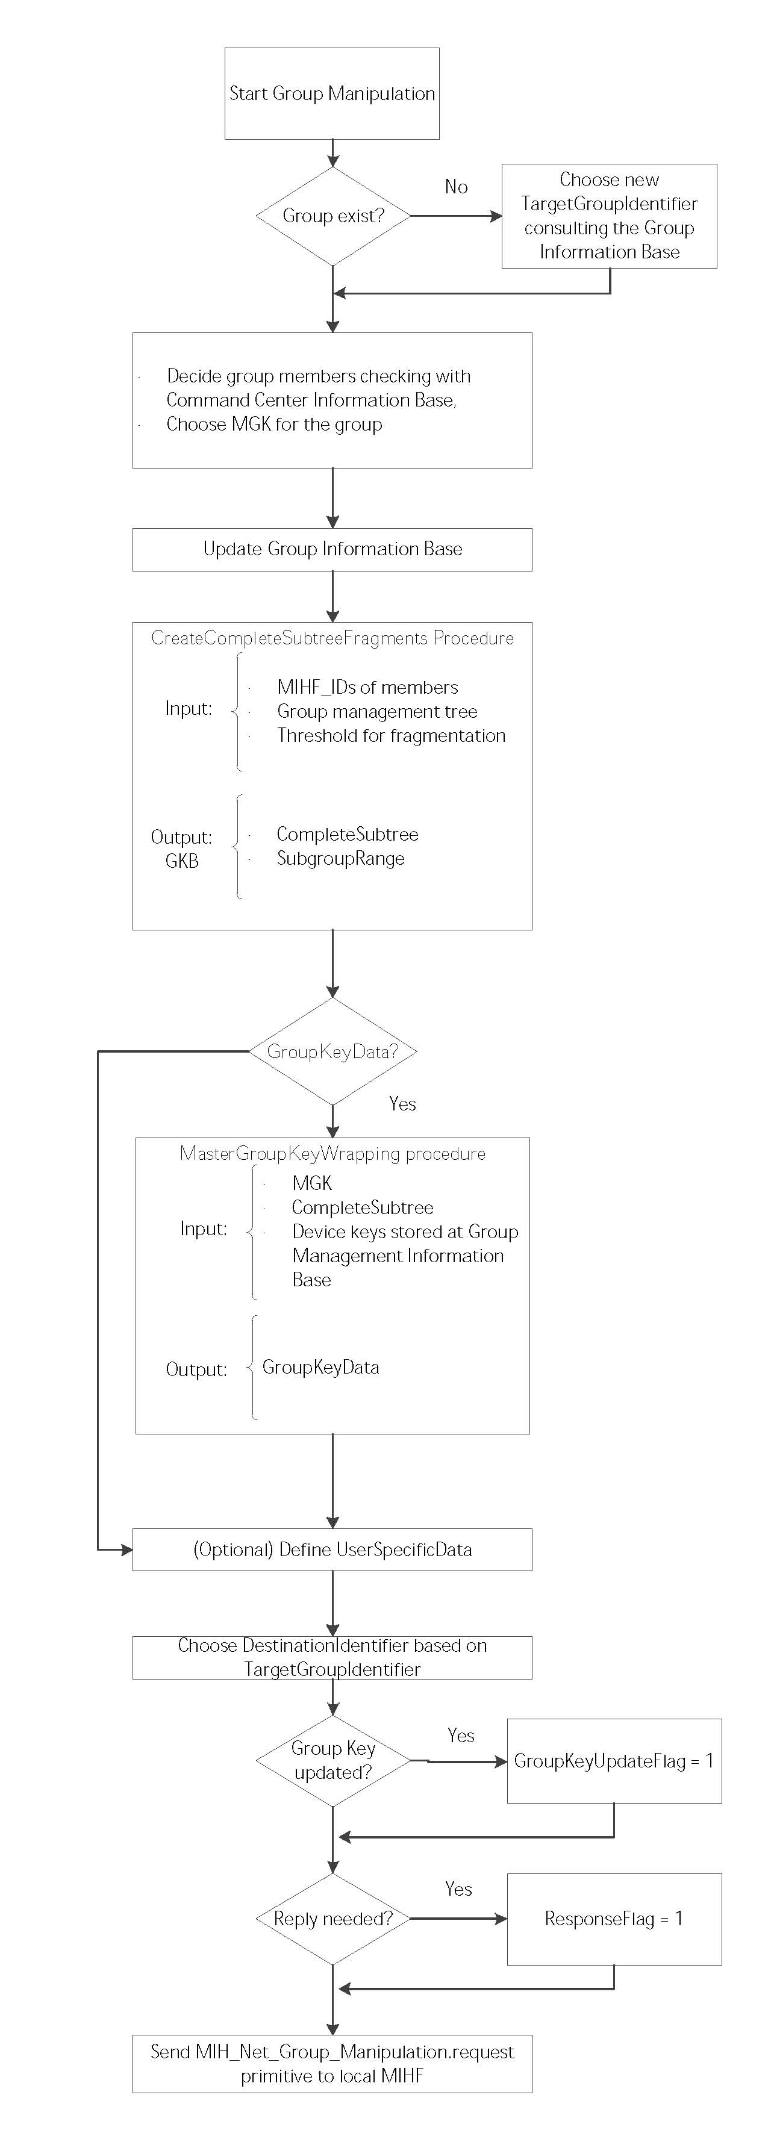
Here

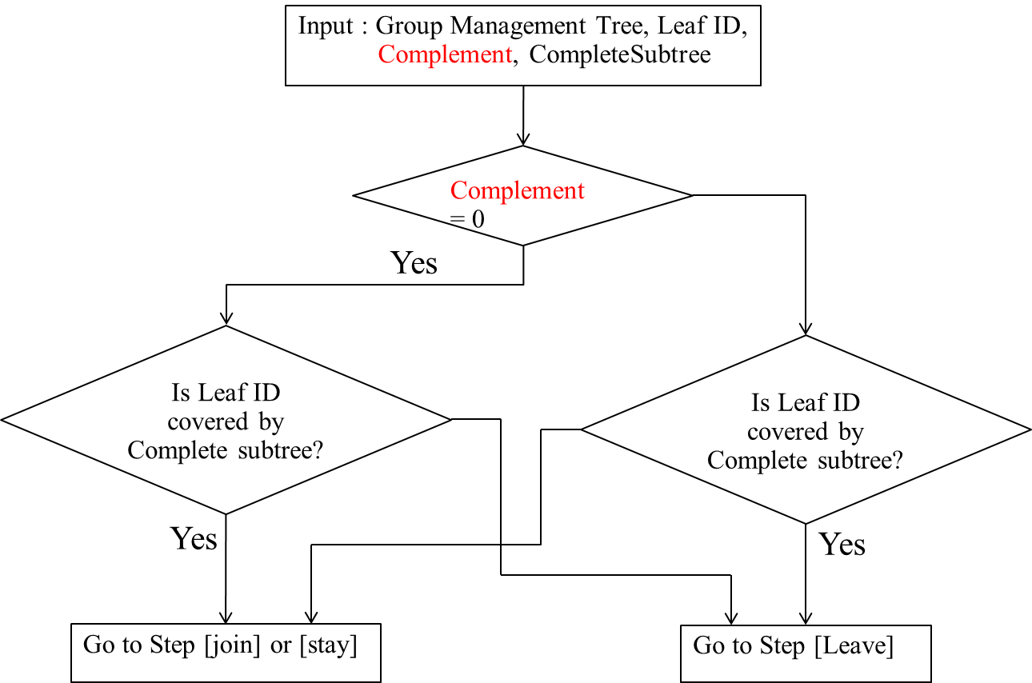
Figure Y: Flow diagram to judge a group membership from CompleteSubtree and ComplementFlag

Figure Y is detail of the box of “Matching pair of GKB indices (subclause 7.4.32.2) found?” in Figure 41.

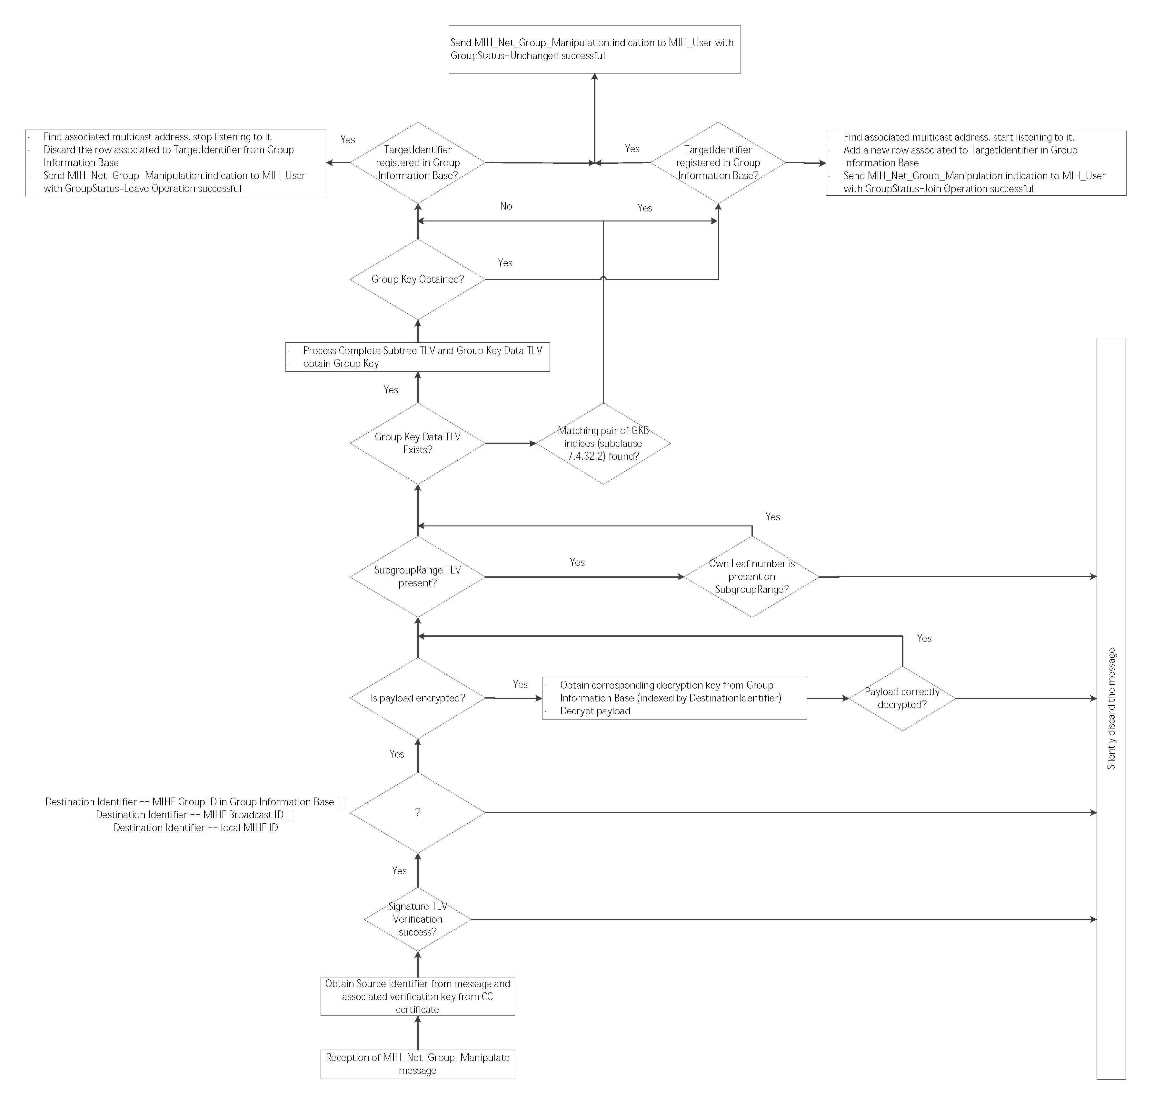
Here

