Project | IEEE 802.21.1 Media-Independent Service and Use Cases  <http://www.ieee802.org/21/>
Title | Use Case and Requirements on Media Independent Service for Radio Resource Management in Heterogeneous Networks
DCN | 21-14-0040-00-SAUC
Date Submitted | March 16th, 2014
Source(s) | Hyunho Park (ETRI),  Hyeong-Ho Lee (ETRI)
Re: | IEEE 802.21 Session #61 in Beijing, China
Abstract | This document describes detailed use case and requirements on media independent service for resource management in heterogeneous networks.
Purpose | To be part of 802.21.1 technical requirements document.
Notice | This document has been prepared to assist the IEEE 802.21 Working Group. It is offered as a basis for discussion and is not binding on the contributing individual(s) or organization(s). The material in this document is subject to change in form and content after further study. The contributor(s) reserve(s) the right to add, amend or withdraw material contained herein.
Release | The contributor grants a free, irrevocable license to the IEEE to incorporate material contained in this contribution, and any modifications thereof, in the creation of an IEEE Standards publication; to copyright in the IEEE’s name any IEEE Standards publication even though it may include portions of this contribution; and at the IEEE’s sole discretion to permit others to reproduce in whole or in part the resulting IEEE Standards publication. The contributor also acknowledges and accepts that IEEE 802.21 may make this contribution public.
Patent Policy | The contributor is familiar with IEEE patent policy, as stated in Section 6 of the IEEE-SA Standards Board bylaws <http://standards.ieee.org/guides/bylaws/sect6-7.html#6> and in Understanding Patent Issues During IEEE Standards Development http://standards.ieee.org/board/pat/faq.pdf

Contents List

1. Description 3
2. Actors 3
3. Pre-conditions 3
4. Triggers 4
5. Service Flows 4
6. Post-conditions 5
7. High Level Illustration 5
8. Signal Flows 6
8.1 Radio resource management based on link status of MN 6
8.2 Radio resource management based on link status of PoA-A 7
8.3 Radio resource management based on link status of PoA-B 8
8.4 Radio resource management by AC 9
9. Requirements 9

- Description
In recent days, networks with various communication technologies have appeared, interferences between wireless access networks have increased, and thus resource management in heterogeneous networks is needed. For example, 2.4GHz band is used by WLAN devices and WPAN devices such as Bluetooth devices, and 5GHz band is used by WLAN devices and cordless phones. Moreover, 5GHz band is considered for use of LTE (Long Term Evolution) technology, and therefore interference in 5GHz band is expected to increase.
Media independent services framework of IEEE 802.21-2008 standard can be a common platform to support resource management in heterogeneous networks. Media independent services framework of IEEE 802.21-2008 standard supports seamless handover in heterogeneous networks by using MIES (Media Independent Event Service) and MICS (Media Independent Command Service). MIES primitives and messages help MN to monitor link status (e.g., signal strength and data rate), and MICS primitives and messages helps MN to control its link layers (physical layer and data link layer) for seamless handover in heterogeneous networks. It is possible to expect that Media Independent Services Framework enables MN to monitor link status and control radio resources (e.g., frequency, time, and power) for radio resource management. Thus, media independent services framework is appropriate for resource management in heterogeneous networks that use various communication technologies and various frequency bands.
- Actors
- MN (Mobile Node): A user device, such as a smart phone, which equips radio interfaces of multiple radio access technologies
- PoA-A: The PoA (Point of Attachment), such as base station in cellular networks and access point in WLAN, which is a network entity that establishes link connection with the MN
- PoA-B: PoA-A’s neighboring PoA that can interfere with MN or PoA-A
- AC (Access Controller): A network entity that can manage radio resources of PoA-A
- Pre-conditions
- MN and PoA-A are connected with each other.
- MN and PoA-A may interfere with other devices or network entities that use the same frequency band.
- MN can report its link status to PoA-A.
- PoA-B can report its link status and its allocated radio resources to PoA-A and AC.
- AC can manage radio resources of PoA-A.
- PoA-A can manage its radio resources by itself.
- Triggers

PoA-A is able to trigger radio resource management of its own link based on monitored link status by MN, itself, or PoA-B. AC is also able to trigger radio resource management of PoA-A’s link.
- PoA-A may manage its own radio resources based on link status of MN.
- PoA-A may manage its own radio resources based on its own link status.
- PoA-A may manage its own radio resources based on link status of PoA-B.
- AC may request radio resource management of PoA-A based on link status of PoA-B.
- Service Flows

For radio resource management, PoA-A and AC are able to initiate radio resource management based on link status of MN, PoA-A, or PoA-B. Therefore, service flows can be classified into following four cases.
- Radio resource management based on link status of MN
- MN monitors its link status (e.g., signal strength and data rate) and reports its link status to PoA-A.
- Based on reported link status of MN, PoA-A can allocate the most appropriate resources (e.g., frequency band, transmission power, and time).
- Radio resource management based on link status of PoA-A
- PoA-A monitors its link status.
- Based on link status of PoA-A, PoA-A can allocate the most appropriate resources for MN.
- Radio resource management based on link status of PoA-B
- PoA-B monitors its link status and reports its link status to PoA-A.
- Based on reported link status of PoA-B, PoA-A can allocate the most appropriate resources.
- Radio resource management by AC
- PoA-B monitors its link status and reports its link status or its allocated radio resources to AC.
- AC decides to change radio resource allocation of PoA-A based on the report from PoA-B and requests PoA-A to change radio resource allocation.
- PoA-A changes its radio resource allocation.
- Post-conditions

PoA-A changes its radio resource allocation.
- High Level Illustration

Figure 1 shows media independent service framework for resource management in heterogeneous networks. AC can control resources of PoAs that use various communication technologies (e.g., WLAN, Wi-Fi Direct, Bluetooth, and LTE) by using MICS message. PoAs can use different communication technologies and share its link status by using MIES message.

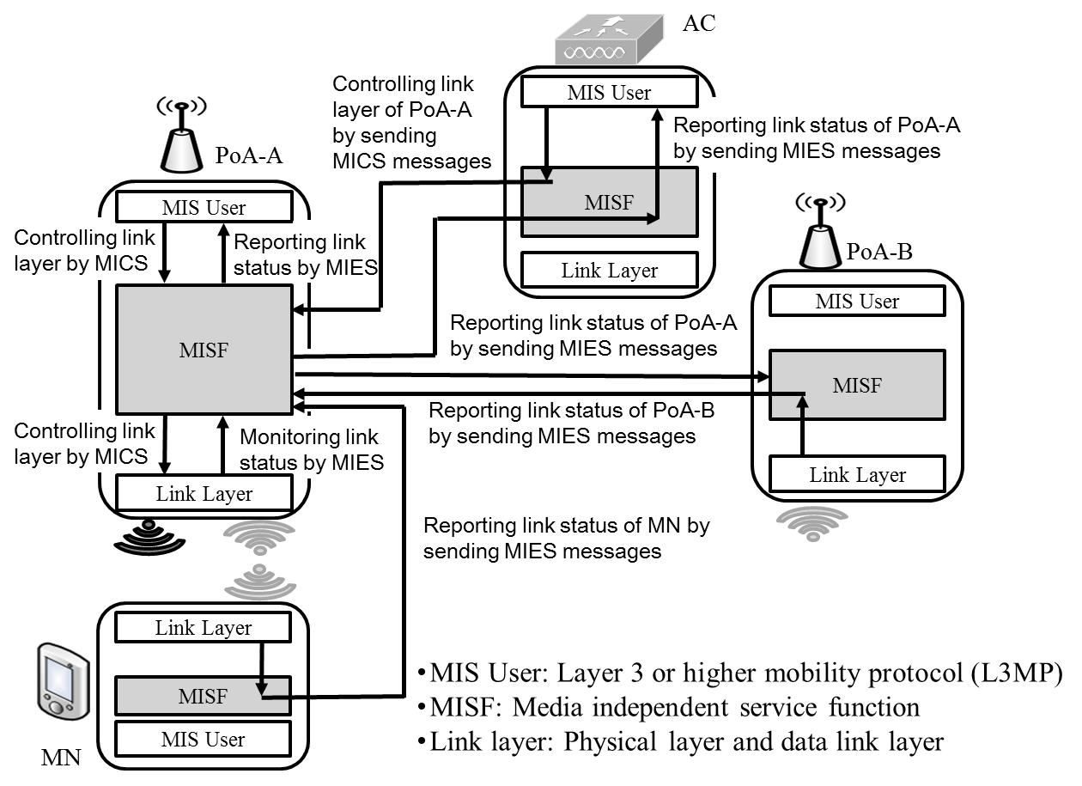

Fig. 1. media independent service framework for resource management in heterogeneous networks

- Signal Flows
  - Radio resource management based on link status of MN

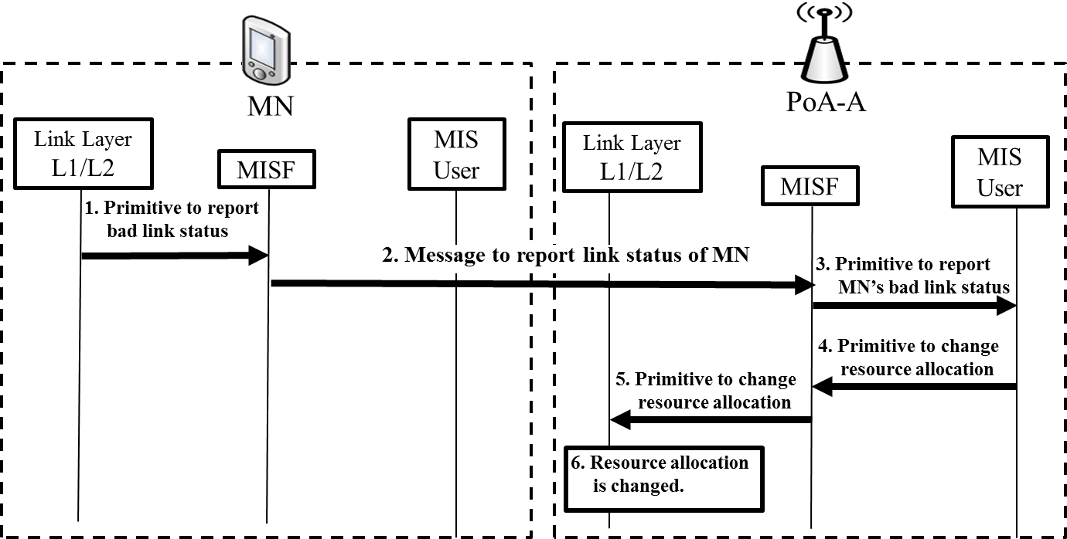
      - MN’s link layer reports its bad link. (New primitive to report bad link status should be defined.)
      - MISF of MN reports MN’s link status to PoA-A. (New message to report link status of MN should be defined.)
      - MISF of PoA-A reports MN’s link status to its own MIS User. (New primitive to report MN’s bad link status should be defined.)
      - MIS User of PoA-A decides to change radio resource allocation of PoA-A and requests changing radio resource allocation. (New primitive to change resource allocation should be defined.)
      - MISF of PoA-A requests link layer of PoA-A to change radio resource allocation. (New primitive to change resource allocation should be defined.)
      - Radio resource allocation of PoA-A is changed.
  - Radio resource management based on link status of PoA-A

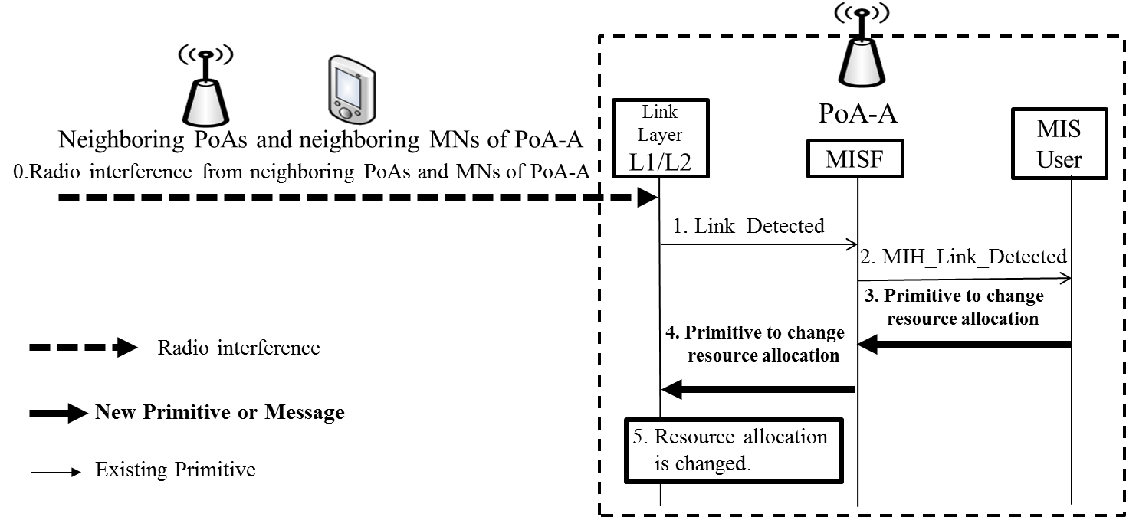
- PoA-A interferes with neighboring PoAs and MNs, and link layer of PoA-A detects that PoA-A’s link status becomes bad.
- PoA-A’s link layer reports bad link status to MISF. (Link_Detected primitive of IEEE 802.21-2008 standard can be used.)
- PoA-A’s MISF reports bad link status to MIS User. (MIH_Link_Detected primitive of IEEE 802.21-2008 standard can be used.)
- MIS User of PoA-A decides to change radio resource allocation of PoA-A and requests MISF to change radio resource allocation. (New primitive to change resource allocation should be defined.)
- MISF of PoA-A requests link layer to change radio resource allocation. (New primitive to change resource allocation should be defined.)
- Radio resource allocation of PoA-A is changed.
  - Radio resource management based on link status of PoA-B

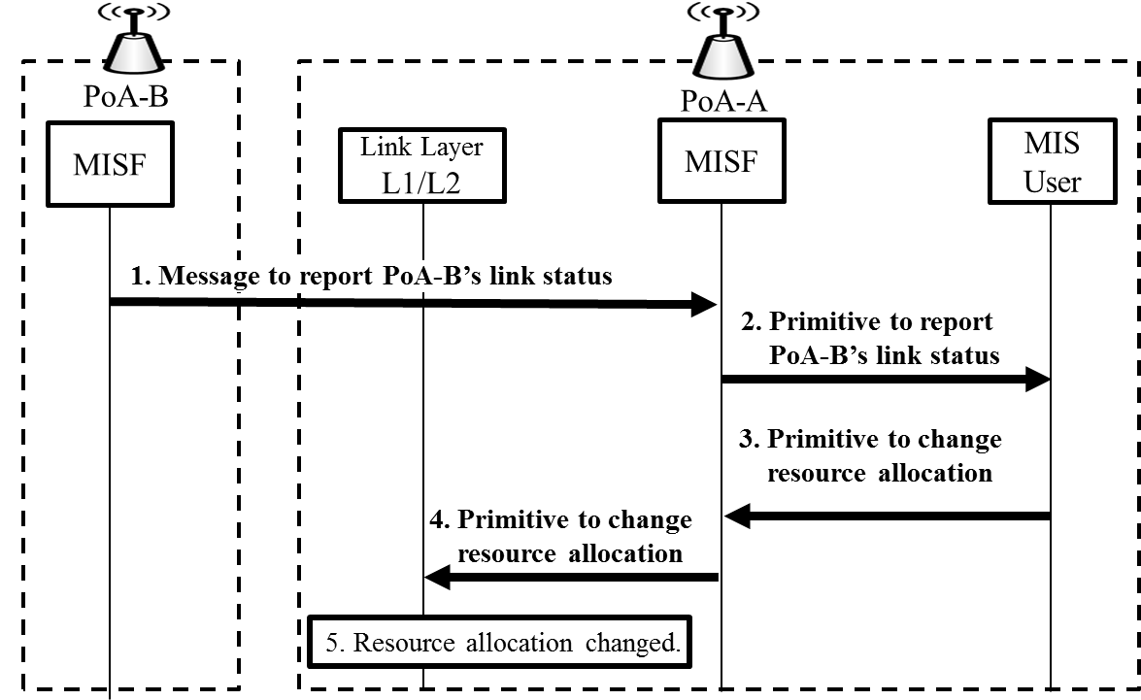
      - MISF of PoA-B reports PoA-B’s link status to PoA-A’s MISF. ( New message to report PoA-B’s link status should be defined.)
      - MISF of PoA-A reports PoA-B’s link status to MIS User of PoA-A. (New primitive to report PoA-B’s link status should be defined.)
      - MIS User of PoA-A requests MISF of PoA-A to change resource allocation of PoA-A. (New primitive to change resource allocation should be defined.)
      - MISF of PoA-A requests PoA-A’s link layer to change resource allocation. (New primitive to change resource allocation should be defined.)
      - Radio resource allocation of PoA-A is changed.
  - Radio resource management by AC

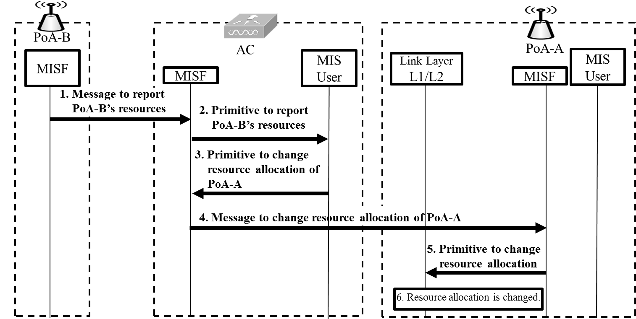
- MISF of PoA-B reports radio resources of PoA-B to MISF of AC. (New message to report of PoA-B’s resources should be defined.)
- MISF of AC reports radio resources of PoA-B to MIS User of AC. (New primitive to report PoA-B’s radio resources should be defined.)
- MIS User of AC decides to change radio resource allocation of PoA-A. (New primitive to change radio resource allocation of PoA-A should be defined.)
- MISF of AC requests PoA-A to change its radio resource allocation. (New message to change resource allocation of PoA-A should be defined.)
- MISF of PoA-A requests link layer of PoA-A to change radio resource allocation of PoA-A by using new primitive. (New primitive to change resource allocation should be defined.)
- Radio resource allocation of PoA-A is changed.
- Requirements

[REQ1] MN can report its link status to PoA that MN connects to.

[REQ2] PoA can monitor its own link status.

[REQ3] PoAs can exchange their own link status between them.

[REQ4] PoA can report its link status and radio resource allocation to AC.

[REQ5] PoA can manage its own radio resources.

